2
3
4
5
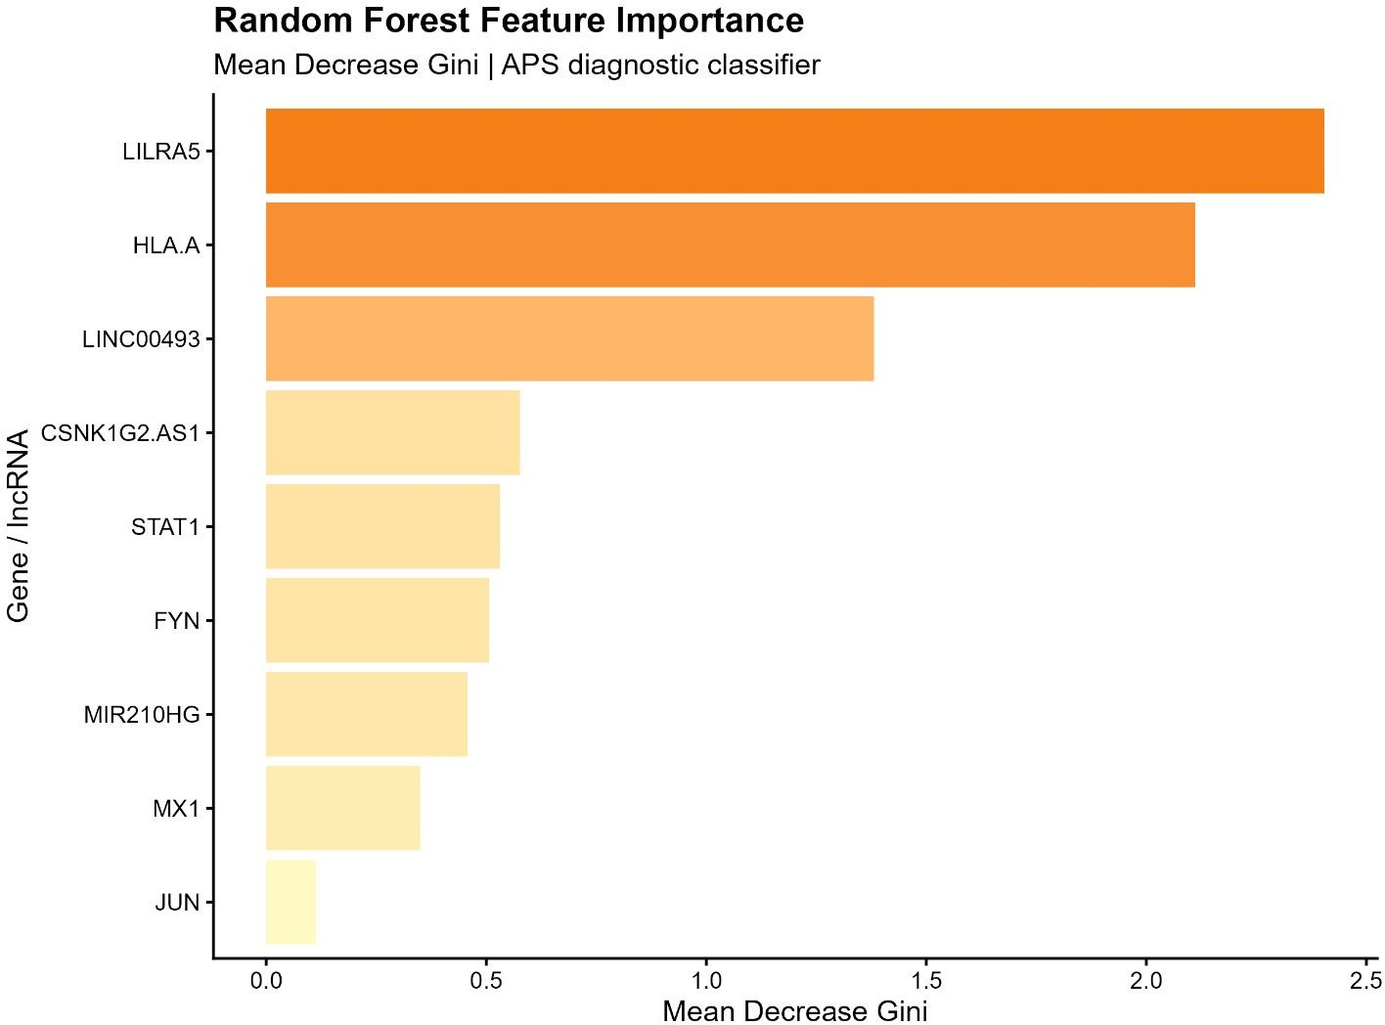
6
7
8
9
10
11
12
13
14
15
16
17
18
19
20
21
22
23
24
25
26
27
28
29
30
31
32
33
34
35
36
37 Supplementary Figure S1. Random Forest feature importance. Mean Decrease Gini for all 9
38
39 classifier features. LILRA5 (#1) and HLA-A (#2) are top mRNA features; LINC00493 (#3) and
40 CSNK1G2-AS1 (#4) are top lncRNA features.
41
42
43
44
45
46
47
48
49
50
51
52
53
54
55
56
57
58
59
60

1
2
3
4
5
6
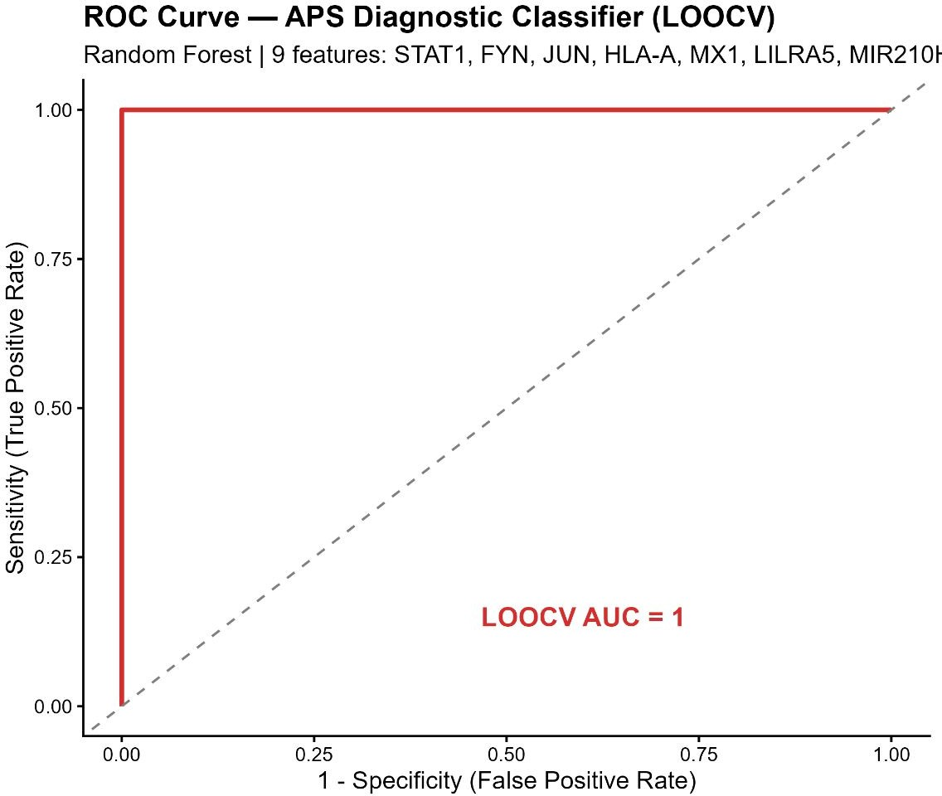
7
8
9
10
11
12
13
14
15
16
17
18
19
20
21
22
23
24
25
26
27
28
29
30
31
32
33
34 Supplementary Figure S2. ROC curve — APS diagnostic classifier (LOOCV).
35
36 LOOCV ROC for 9-feature Random Forest classifier. Features: STAT1, FYN, JUN, HLA-A, MX1,
37 LILRA5, MIR210HG, LINC00493, CSNK1G2-AS1. LOOCV AUC = 1.000.
38
39
40
41 Supplementary Table S1:
42
43
gene | baseMean | log2FoldChange | lfcSE | stat | pvalue | padj
LINC00493 | 250.54 | 1.02 | 0.19 | 5.41 | 0.00 | 0.00
CSNK1G2-AS1 | 69.59 | -1.34 | 0.31 | -4.34 | 0.00 | 0.00
MIAT | 2585.55 | -1.35 | 0.32 | -4.21 | 0.00 | 0.00
ZRANB2-AS1 | 18.43 | -1.28 | 0.31 | -4.12 | 0.00 | 0.00
LINC00476 | 59.82 | -1.31 | 0.32 | -4.10 | 0.00 | 0.00
LINC00299 | 39.89 | -1.40 | 0.37 | -3.80 | 0.00 | 0.00
SNHG7 | 124.80 | -1.22 | 0.32 | -3.78 | 0.00 | 0.00
EPB41L4A-AS1 | 86.27 | -1.20 | 0.32 | -3.71 | 0.00 | 0.00
LINC00515 | 3.45 | -3.38 | 0.93 | -3.64 | 0.00 | 0.00
LINC00514 | 31.12 | 1.04 | 0.30 | 3.48 | 0.00 | 0.00
ZEB2-AS1 | 26.08 | -1.53 | 0.44 | -3.46 | 0.00 | 0.00

44
45
46
47
48
49
50
51
52
53
54
55
56
57
58
59
60

1
2
3
WDFY3-AS2 | 24.52 | 1.64 | 0.48 | 3.43 | 0.00 | 0.00
MIR210HG | 5.13 | -1.83 | 0.55 | -3.34 | 0.00 | 0.00
MIR155HG | 66.44 | -2.25 | 0.68 | -3.31 | 0.00 | 0.01
LINC00282 | 568.13 | 1.01 | 0.32 | 3.11 | 0.00 | 0.01
CASC5 | 7.89 | -1.45 | 0.48 | -3.04 | 0.00 | 0.01
MFI2-AS1 | 1.92 | -3.23 | 1.07 | -3.01 | 0.00 | 0.01
AGPAT4-IT1 | 11.47 | -1.48 | 0.50 | -2.95 | 0.00 | 0.01
DANCR | 82.02 | -1.03 | 0.37 | -2.75 | 0.01 | 0.02
ANP32A-IT1 | 185.96 | -1.07 | 0.39 | -2.71 | 0.01 | 0.02
LINC00346 | 10.34 | -1.96 | 0.75 | -2.60 | 0.01 | 0.03
DNAJC27-AS1 | 11.19 | 1.41 | 0.55 | 2.56 | 0.01 | 0.03
ST7-AS1 | 4.11 | -1.43 | 0.56 | -2.54 | 0.01 | 0.03
FLVCR1-AS1 | 50.51 | 1.04 | 0.43 | 2.43 | 0.02 | 0.04

4
5
6
7
8
9
10
11
12
13
14
15
16
17
18
19
20
21
22
23
24
25
26
27
28
29
30
31
32
33
34
35
36
37
38
39
40
41
42
43
44
45
46
47
48
49
50
51
52
53
54
55
56
57
58
59
60

