Extended Data Table 1: Data sources for coral cover database.
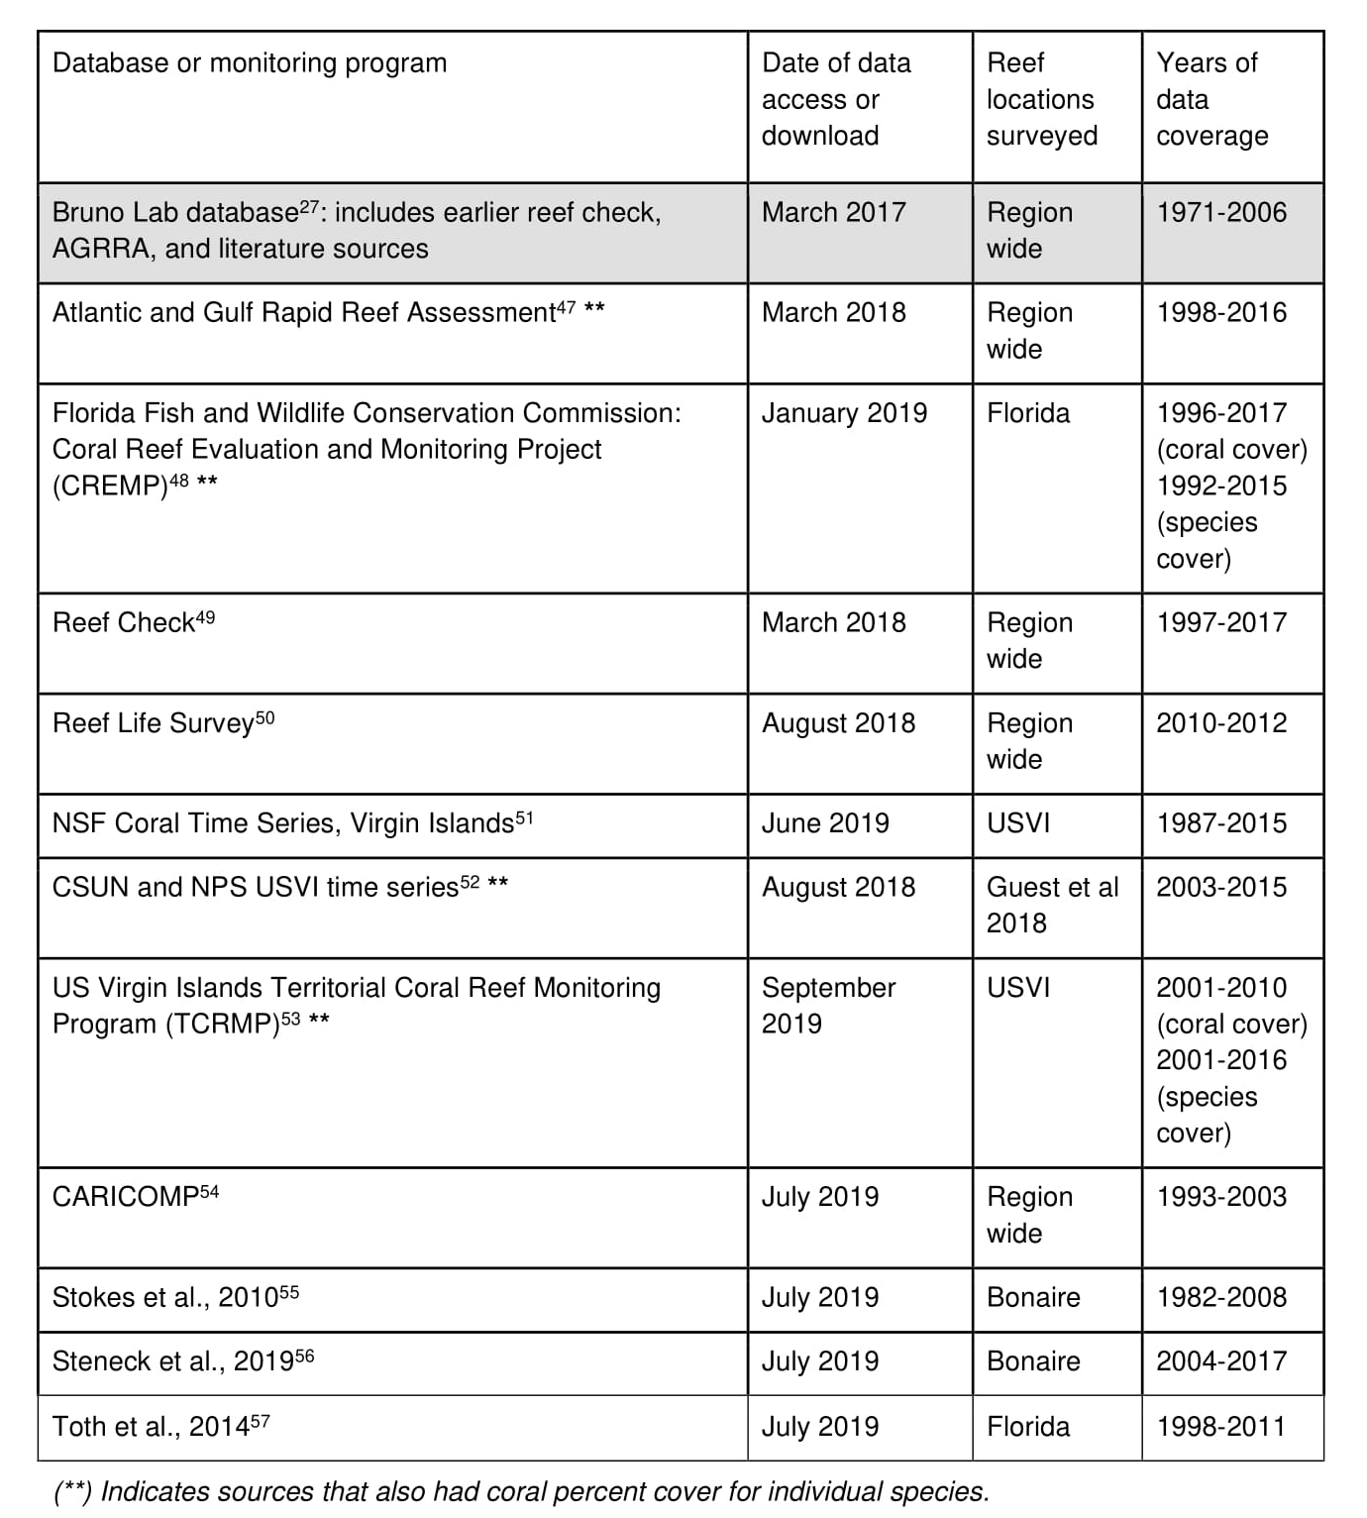

Extended Data Table 2: Classification of coral species by life history group.

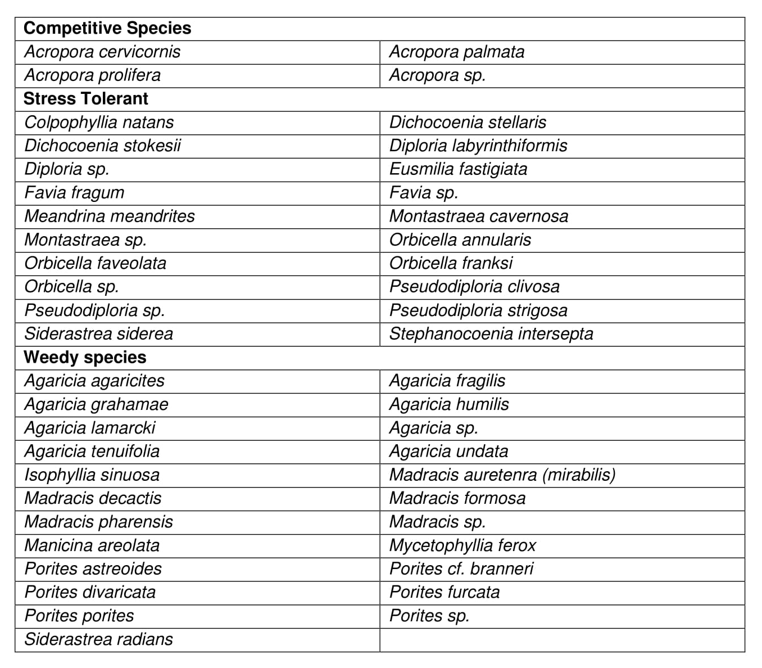

Extended Data Table 3: Effect of storm parameters on coral resistance and recovery. Estimated regression parameters, standard errors, confidence intervals, t-values, and p-values from linear mixed effects models on percent coral cover. For all models, reef location was treated as a random effect.
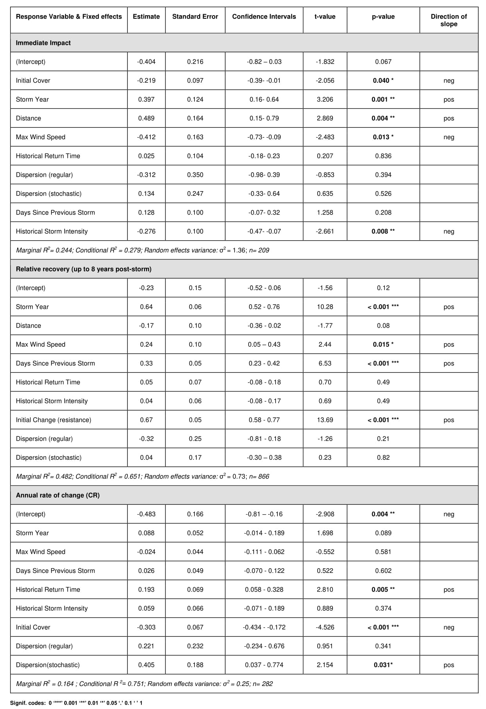
Extended Data Table 4: Effect of storm parameters on resistance and recovery to coral life history groups.
Estimated regression parameters, standard errors, confidence intervals, t-values, and p-values from the linear mixed-effects models on resistance and recovery of coral life history groups.
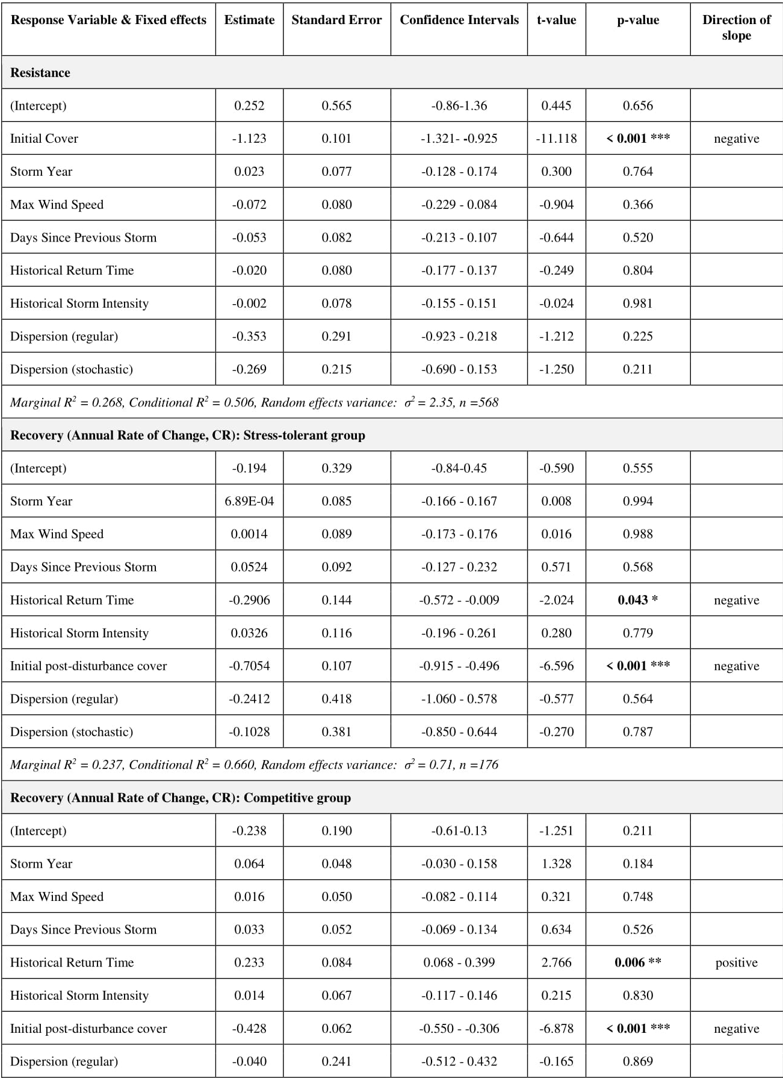

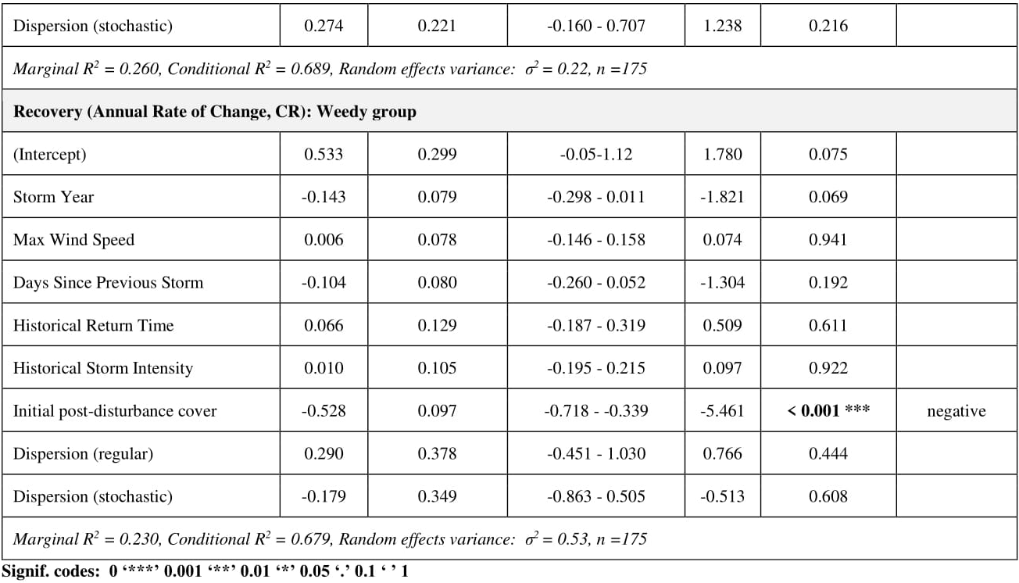

Extended Data Figure 1: Atlantic storm frequency by storm category.
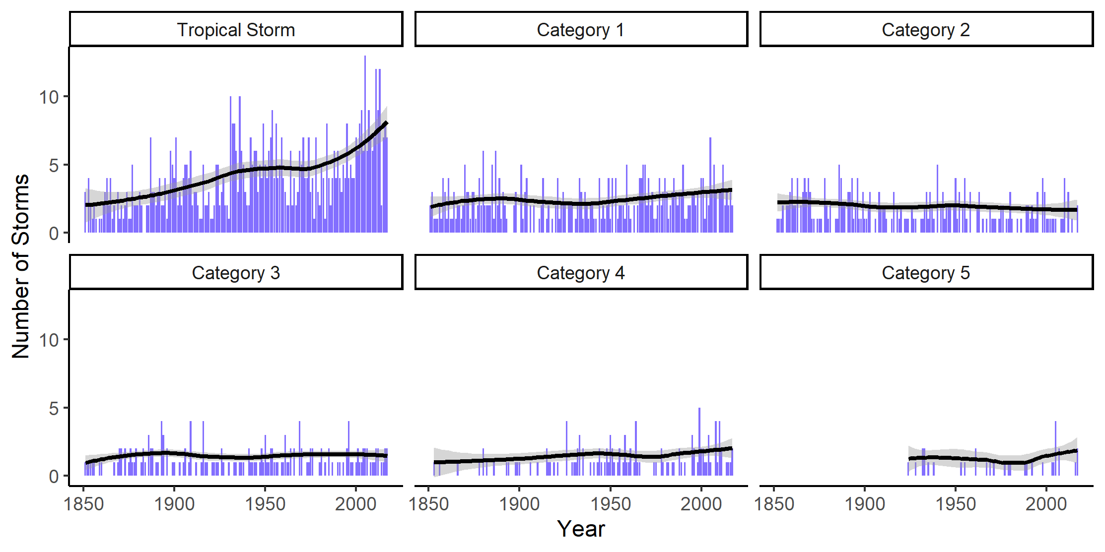
Extended Data Figure 2: Effect of storm parameters of coral resistance and recovery.
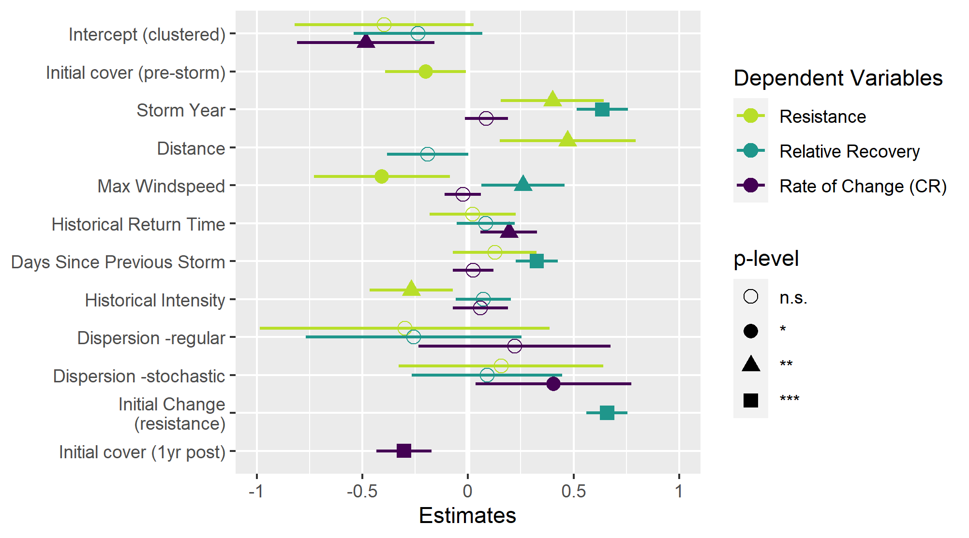
Model estimates are from linear mixed effects models in which all predictors were treated as fixed effects and site as a random effect. Dependent variables were cube root transformed and all fixed effects scaled prior to modeling. Signif. codes: 0 ‘***’ 0.001 ‘**’ 0.01 ‘*’ 0.05 ‘.’ 0.1 ‘ ’ 1

