The raw Western blot images are shown below.
Fig. 1. Isorhamnetin suppressed ZEA-induced apoptosis.
1. Protein is Bcl-2. The different treatments from left to right are Control, ZEA and ZEA+ISO respectively.
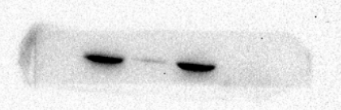
2. Protein is Bax-2. The different treatments from left to right are Control, ZEA and ZEA+ISO respectively.
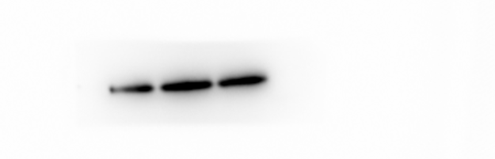
3. Protein is C-Casp3. The different treatments from left to right are Control, ZEA and ZEA+ISO respectively.
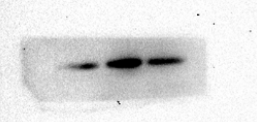
4. Protein is β-actin. The different treatments from left to right are Control, ZEA and ZEA+ISO respectively.
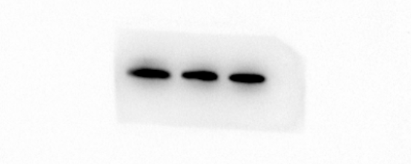
5. Protein is PGC-1. The different treatments from left to right are Control, ZEA and ZEA+ISO respectively.

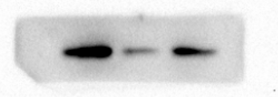
6. Protein is LC3. The different treatments from left to right are Control, ZEA and ZEA+ISO respectively.
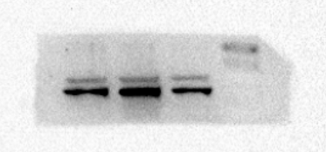
7. Protein is P62. The different treatments from left to right are Control, ZEA and ZEA+ISO respectively.
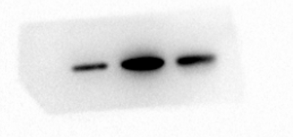
8. Protein is β-actin. The different treatments from left to right are Control, ZEA and ZEA+ISO respectively.
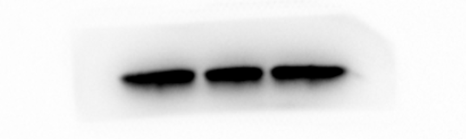
Fig. 2. Isorhamnetin relieved ZEA-induced ERS.
1. Protein is Casp12. The different treatments from left to right are Control, ZEA and ZEA+ISO respectively.
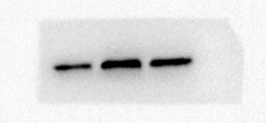
2. Protein is CHOP. The different treatments from left to right are Control, ZEA and ZEA+ISO respectively.
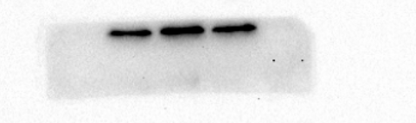
3. Protein is CalcineurinA. The different treatments from left to right are Control, ZEA and ZEA+ISO respectively.
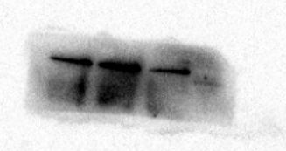
4. Protein is CaMKIIα. The different treatments from left to right are Control, ZEA and ZEA+ISO respectively.
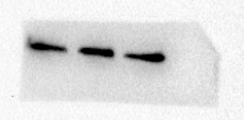
5. Protein is β-actin. The different treatments from left to right are Control, ZEA and ZEA+ISO respectively.
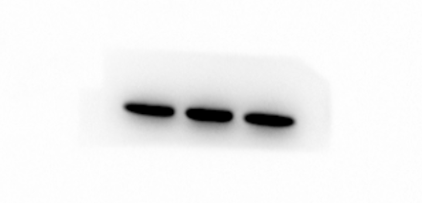
6. Protein is ATF6. The different treatments from left to right are Control, ZEA, ZEA+ISO and ZEA+4-PBA respectively.
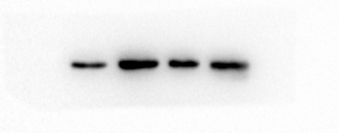
7. Protein is IRE1. The different treatments from left to right are Control, ZEA, ZEA+ISO and ZEA+4-PBA respectively.
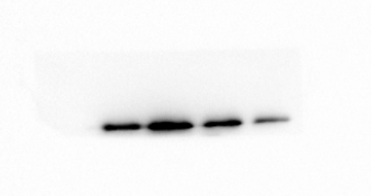
8. Protein is XBP1. The different treatments from left to right are Control, ZEA, ZEA+ISO and ZEA+4-PBA respectively.
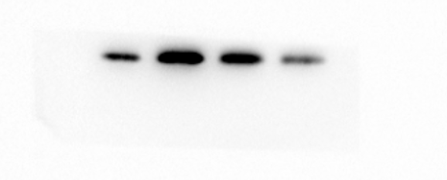
9. Protein is GRP78. The different treatments from left to right are Control, ZEA, ZEA+ISO and ZEA+4-PBA respectively.
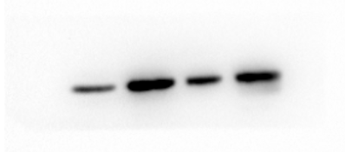
10. Protein is β-actin. The different treatments from left to right are Control, ZEA, ZEA+ISO and ZEA+4-PBA respectively.
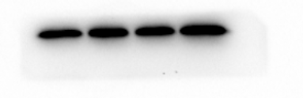
Fig. 3. Isorhamnetin ameliorated ZEA-induced cytotoxicity by attenuating oxidative stress.
1. Protein is SOD2. The different treatments from left to right are Control, ZEA and ZEA+ISO respectively.
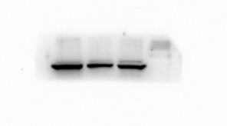
2. Protein is GPX1. The different treatments from left to right are Control, ZEA and ZEA+ISO respectively.

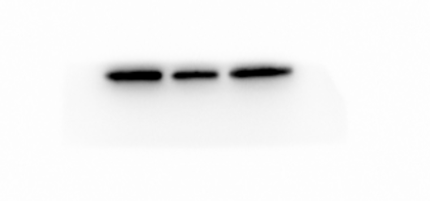
3. Protein is SOD1. The different treatments from left to right are Control, ZEA and ZEA+ISO respectively.
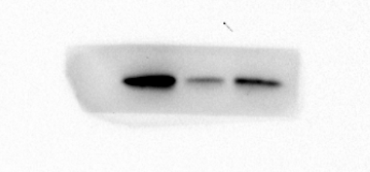
4. Protein is P-P38. The different treatments from left to right are Control, ZEA and ZEA+ISO respectively.
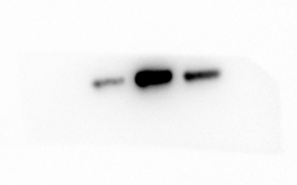
5. Protein is P38. The different treatments from left to right are Control, ZEA and ZEA+ISO respectively.
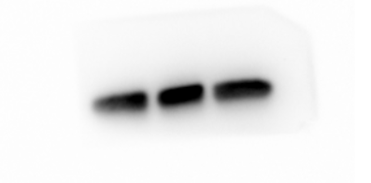
6. Protein is β-actin. The different treatments from left to right are Invalid band (It's probably due to protein diffusion), Control, ZEA and ZEA+ISO respectively.
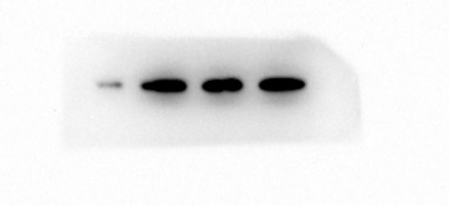
7. Protein is SOD2. The different treatments from left to right are Control, ZEA, ZEA+ISO and ZEA+SB203580 respectively.
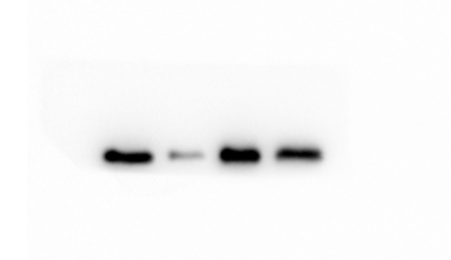
8. Protein is GPX1. The different treatments from left to right are Control, ZEA, ZEA+ISO and ZEA+SB203580 respectively.
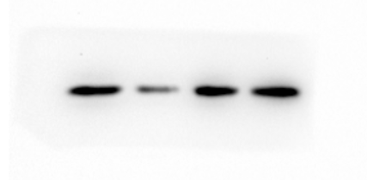
9. Protein is β-actin. The different treatments from left to right are Control, ZEA, ZEA+ISO and ZEA+SB203580 respectively.
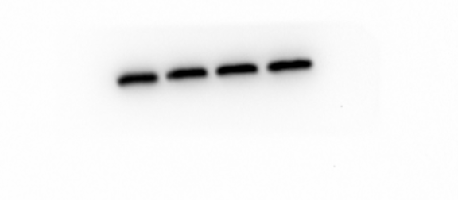
Fig. 4. Isorhamnetin recovered GCs proliferation caused by ZEA.
- Protein is PCNA. The different treatments from left to right are Control, ZEA and ZEA+ISO respectively.
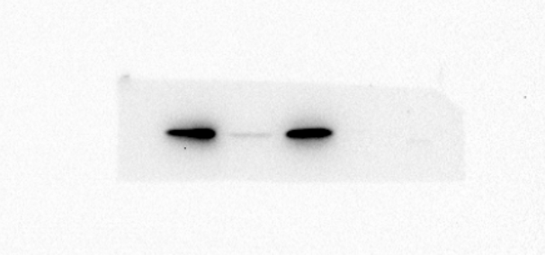
- Protein is C-myc. The different treatments from left to right are Control, ZEA and ZEA+ISO respectively.
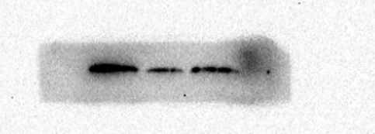
- Protein is P13k. The different treatments from left to right are Control, ZEA and ZEA+ISO respectively.
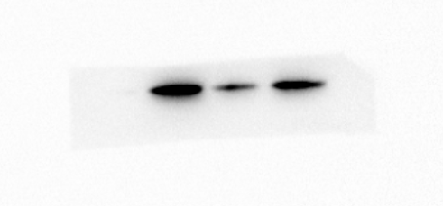
- Protein is P-Akt. The different treatments from left to right are Control, ZEA and ZEA+ISO respectively.
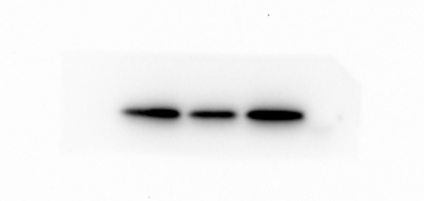
- Protein is Akt. The different treatments from left to right are Control, ZEA and ZEA+ISO respectively.

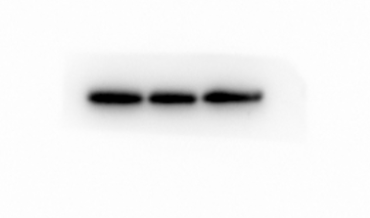
- Protein is β-actin. The different treatments from left to right are Control, ZEA and ZEA+ISO respectively.
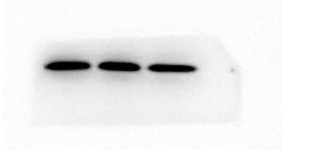
- Protein is CyclinD. The different treatments from left to right are Control, ZEA and ZEA+ISO respectively.
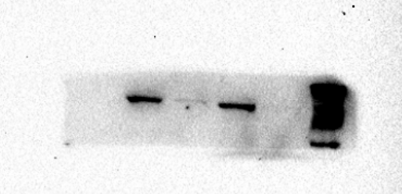
- Protein is CyclinA. The different treatments from left to right are Control, ZEA and ZEA+ISO respectively.
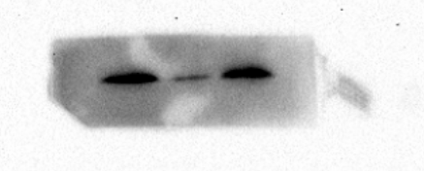
- Protein is β-actin. The different treatments from left to right are Invalid band (It's probably due to protein diffusion), Control, ZEA and ZEA+ISO respectively.
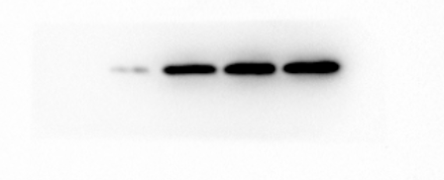
Fig. 5. Isorhamnetin prevented ZEA-induced steroid secretion disorder in a PI3K/Akt-dependent manner.
- Protein is FSH-R. The different treatments from left to right are Control, ZEA and ZEA+ISO respectively.
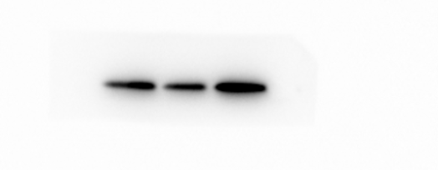
- Protein is CYP19A1. The different treatments from left to right are Control, ZEA and ZEA+ISO respectively.
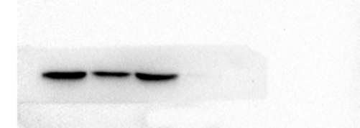
- Protein is β-actin. The different treatments from left to right are Control, ZEA and ZEA+ISO respectively.
