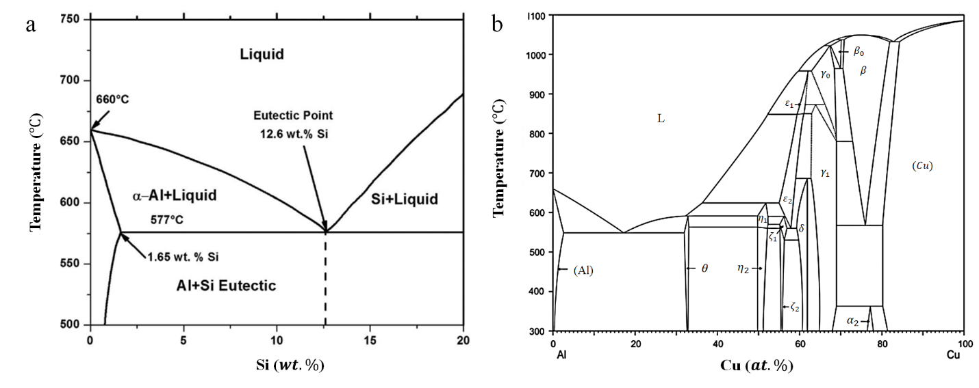
Fig. S1. (a) Al-Si and (b) Al-Cu binary phase diagrams, modified from Refs.[1] and [2], respectively.
References
1. Ladeiro C, Nunes F, Trindade M, Costa J (2024) Effect of Aging Heat Treatment in an Al-4008 Produced by Liquid Metal Printing. U Porto J Eng 10:45–58
2. Ponweiser N, Lengauer CL, Richter KW (2011) Re-investigation of phase equilibria in the system Al–Cu and structural analysis of the high-temperature phase η1-Al1− δCu. Intermetallics 19:1737–1746

