Harnessing superior haplotypes from landraces to breeding lines for enhanced yield in rice
Niranjani Gnanapragasam^{1,2}, Sonali Vijay Habde^{1,3}, Krishna Tesman Sundaram^{1,2}, Sruthi Remesan^{1,2}, Pronob Jyoti Paul^{1,2}, Manoj Pushkarnath^{1,2}, Ashmitha Ganesan^{1,2}, Vipin Kumar Pandey⁴, Shubha Banerjee⁴, Jyothi Badri⁵, Sanjay Kalia⁶, Arvind Kumar^{1,2,7}, Ajay Kohli¹, Uma Maheshwar Singh^{1,3}, Vikas Kumar Singh^{1,2*}, Pallavi Sinha^{1,2*}
¹ International Rice Research Institute, Los Banos, Laguna, 4031, Philippines
² International Rice Research Institute, South Asia Hub, Patancheru, 502324, India
³ International Rice Research Institute, South Asia Regional Centre, Varanasi, 221006 India
⁴ Indira Gandhi Krishi Vishwavidyalaya, Raipur, 492012, India
⁵Indian Institute of Rice Research, Hyderabad, India
⁶ Department of Biotechnology, 110003, New Delhi, India
⁷ Current Address: Prasad Seeds, R R District, 501401, India

* Author for Correspondence: p.sinha@cgiar.org; v.k.singh@cgiar.org
Running Title
Superior haplotype for higher grain yield in rice

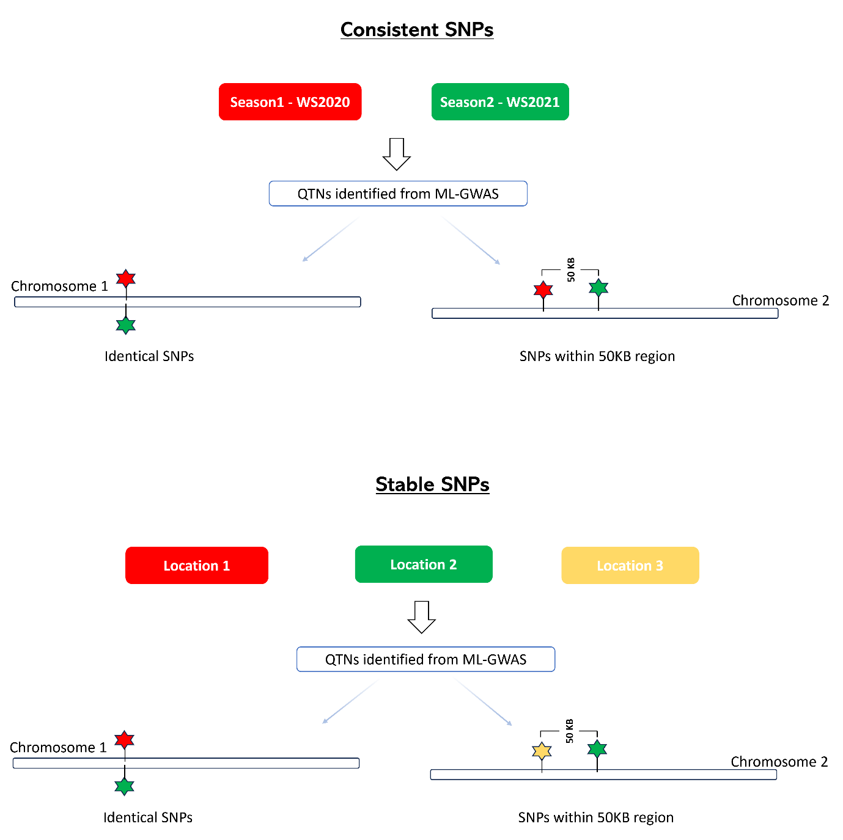

Figure 1: Visual representation of the QTN selection. A QTN is identified by two seasons in a single location, or two QTNs are identified by two seasons of a single location, present within a 50 KB region. In that case, it is considered a consistent QTN. Similarly, suppose two QTNs are identified (or within 50 KB region) by two or more locations in a single season. In that case, it is considered a stable QTN.

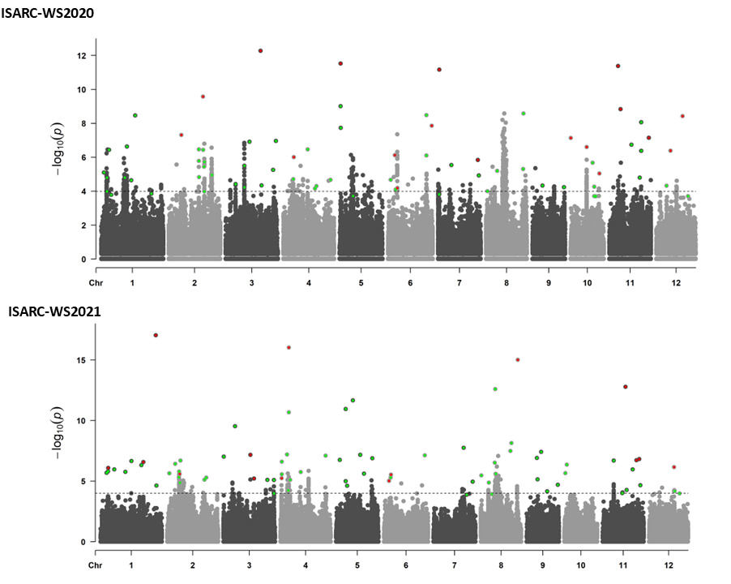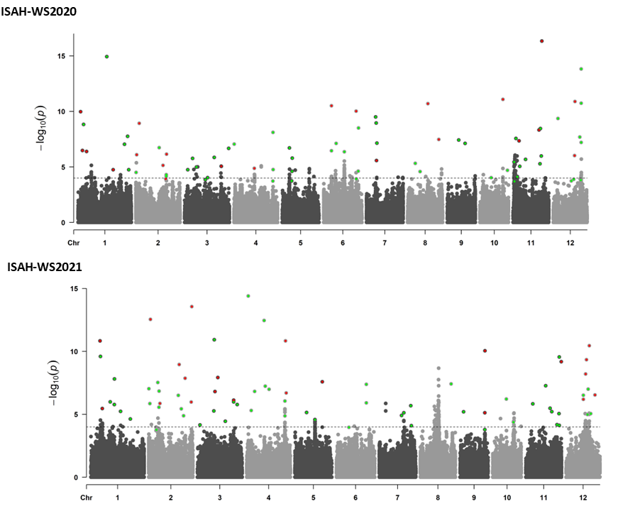

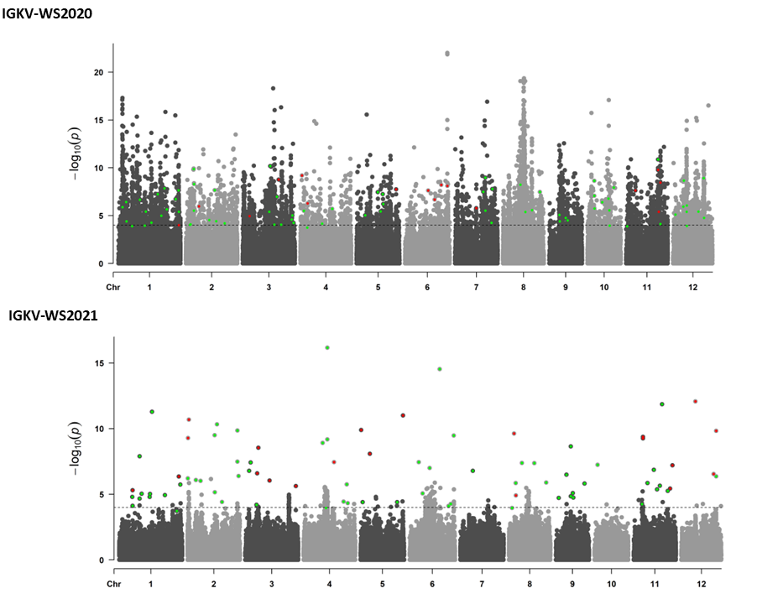

Figure 2: Manhattan plot showing significant QTNs associated with rice yield and yield related traits, identified across six environments using mrMLM, FASTmrMLM, FASTmrEMMA, pLARmEB and ISIS EM-BLASSO models. The -log10 (P-value) of SNP across the genome (y-axes) were plotted against their respective position on each chromosome (x-axis) for GY. The red dots represent all the QTNs commonly identified by more than two ML-GWAS models and the orange dots indicate QTNs identified by a single ML-GWAS model.

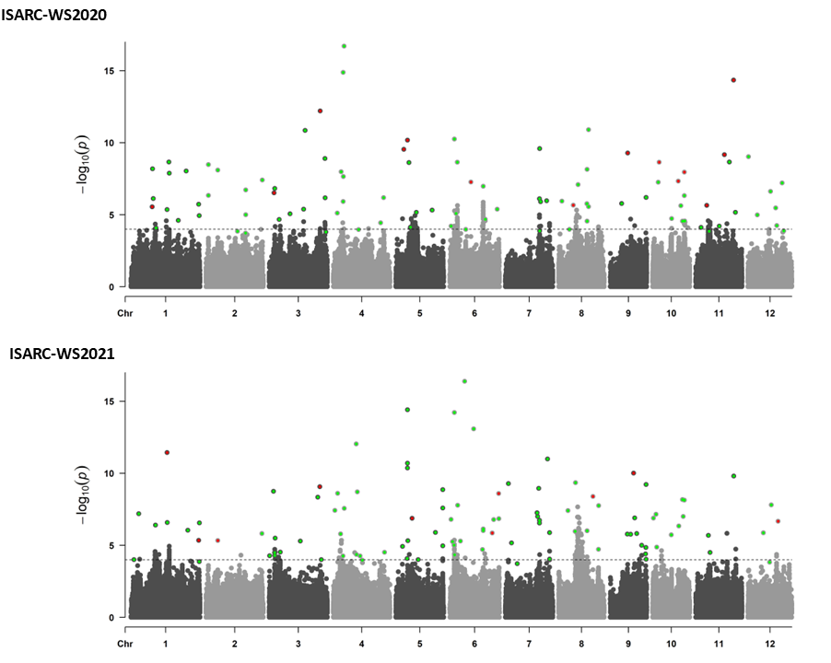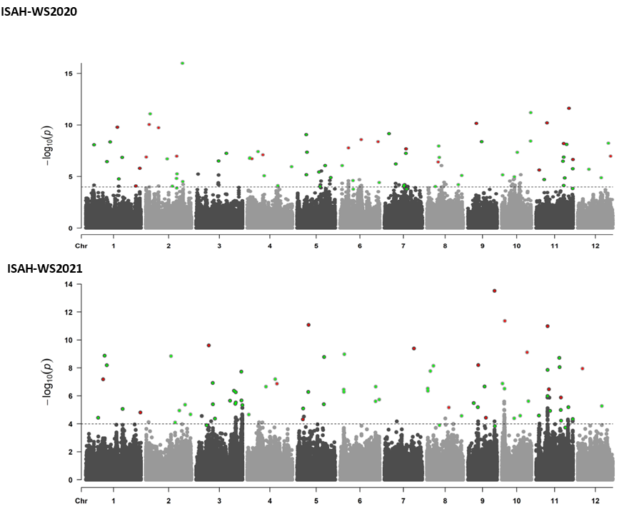

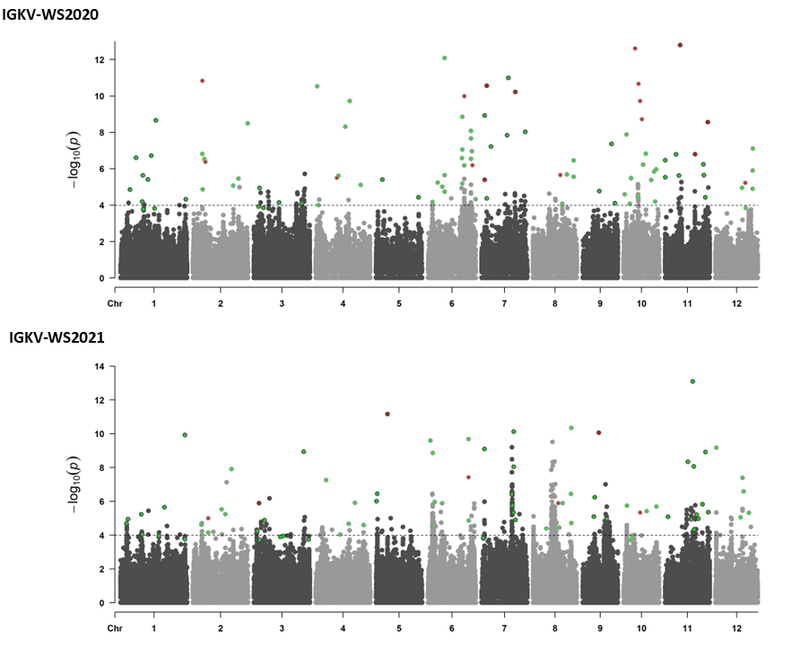

Figure 3: Manhattan plot showing significant QTNs associated with rice yield and yield related traits, identified across six environments using mrMLM, FASTmrMLM, FASTmrEMMA, pLARmEB and ISIS EM-BLASSO models. The -log10 (P-value) of SNP across the genome (y-axes) were plotted against their respective position on each chromosome (x-axis) for DTF. The red dots represent all the QTNs commonly identified by more than two ML-GWAS models and the orange dots indicate QTNs identified by a single ML-GWAS model.

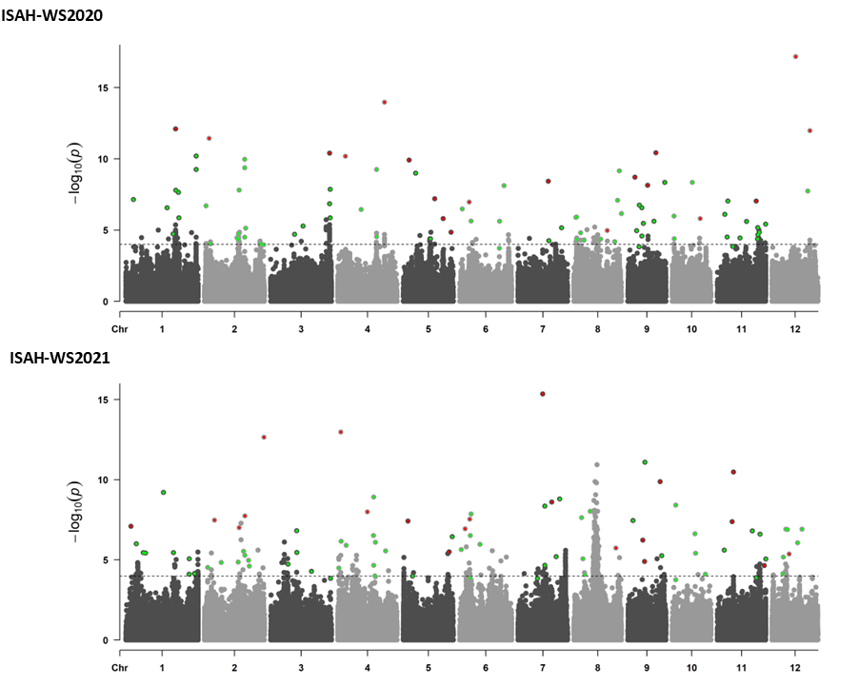
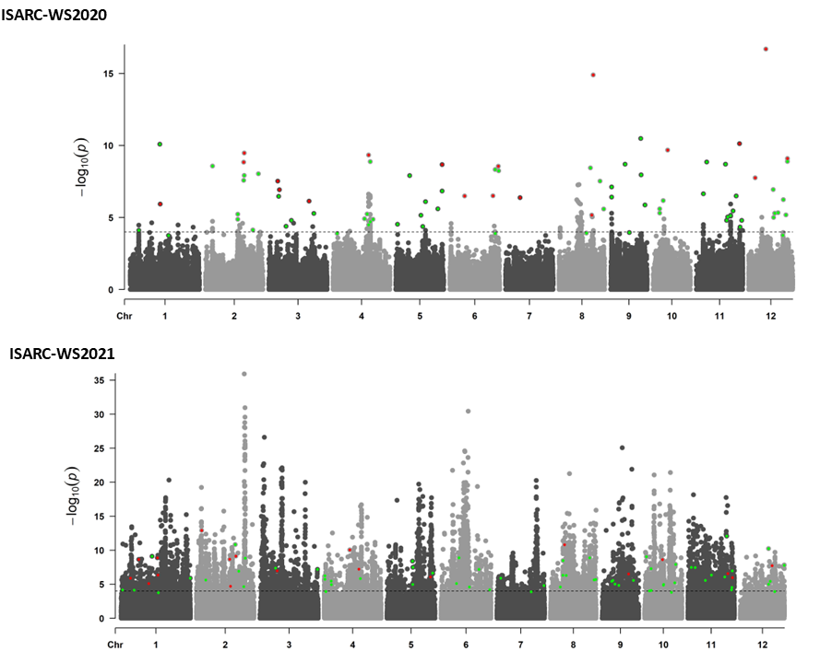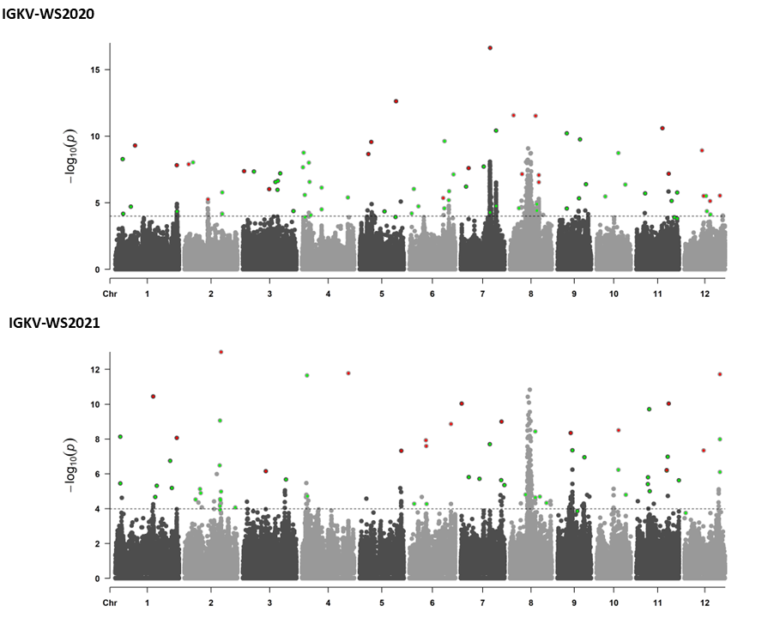

Figure 4: Manhattan plot showing significant QTNs associated with rice yield and yield related traits, identified across six environments using mrMLM, FASTmrMLM, FASTmrEMMA, pLARmEB and ISIS EM-BLASSO models. The -log10 (P-value) of SNP across the genome (y-axes) were plotted against their respective position on each chromosome (x-axis) for NPT. The red dots represent all the QTNs commonly identified by more than two ML-GWAS models and the orange dots indicate QTNs identified by a single ML-GWAS model.

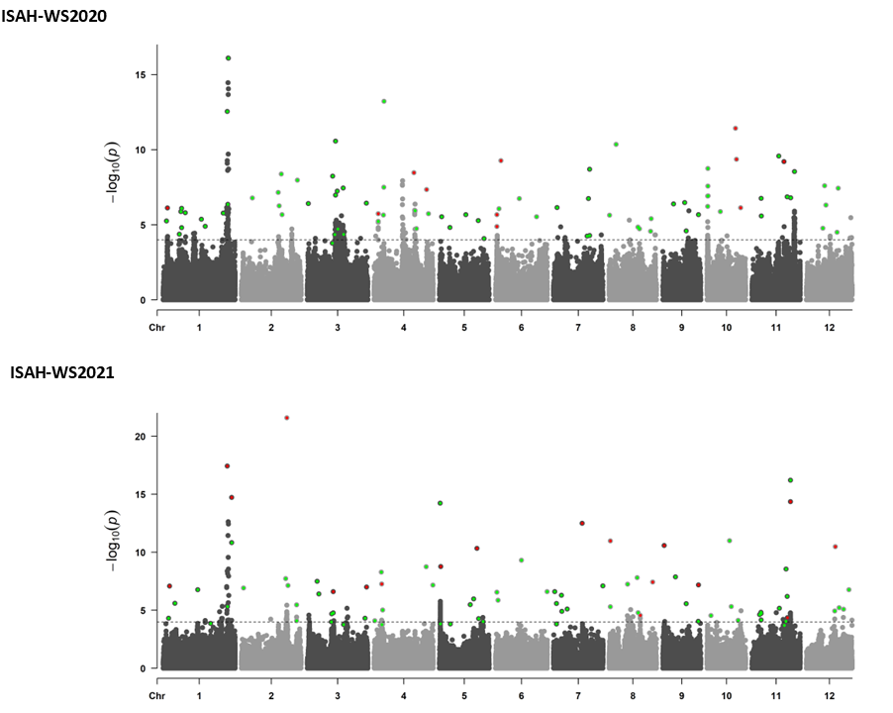

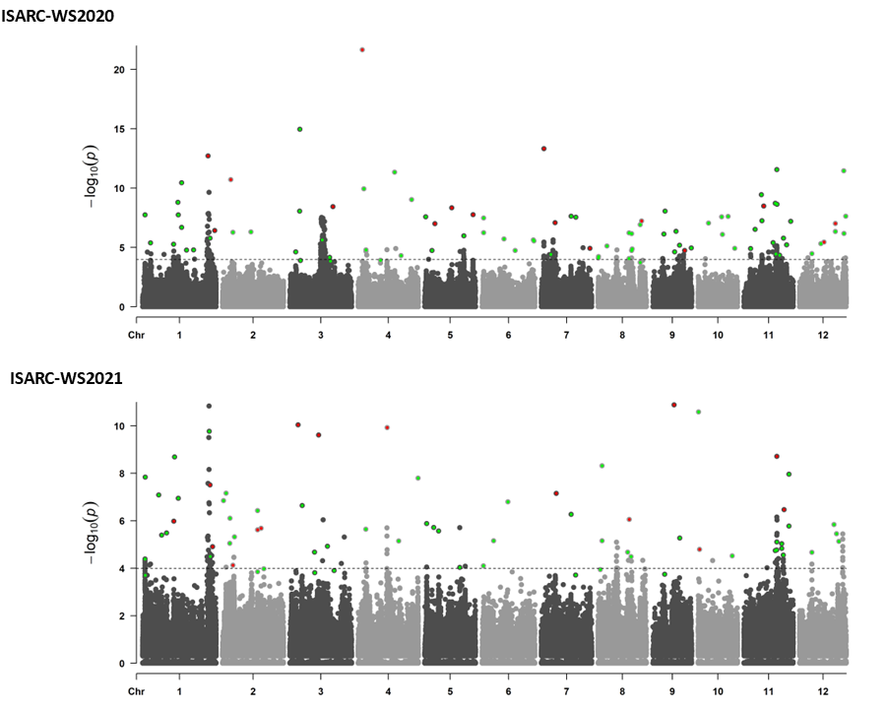
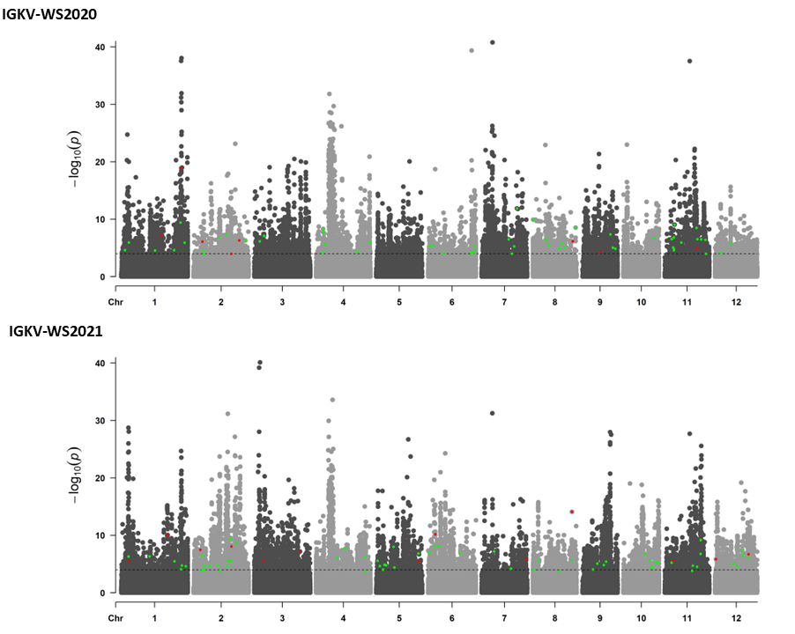

Figure 5: Manhattan plot showing significant QTNs associated with rice yield and yield related traits, identified across six environments using mrMLM, FASTmrMLM, FASTmrEMMA, pLARmEB and ISIS EM-BLASSO models. The -log10 (P-value) of SNP across the genome (y-axes) were plotted against their respective position on each chromosome (x-axis) for PH. The red dots represent all the QTNs commonly identified by more than two ML-GWAS models and the orange dots indicate QTNs identified by a single ML-GWAS model.

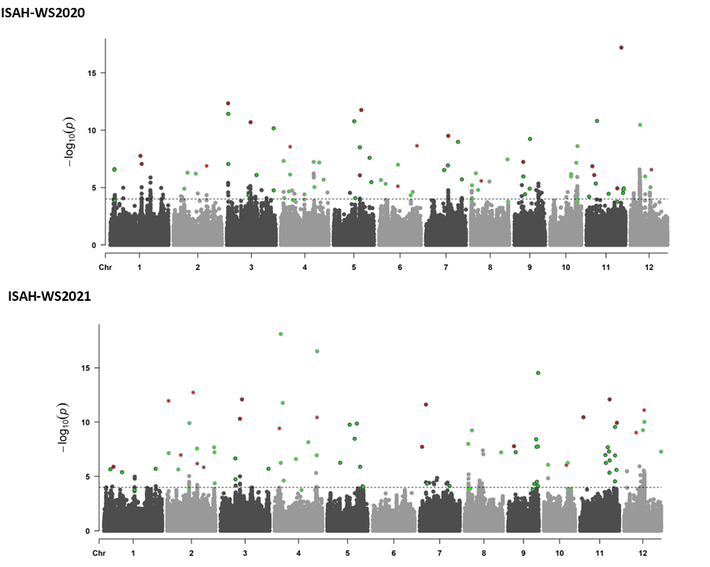

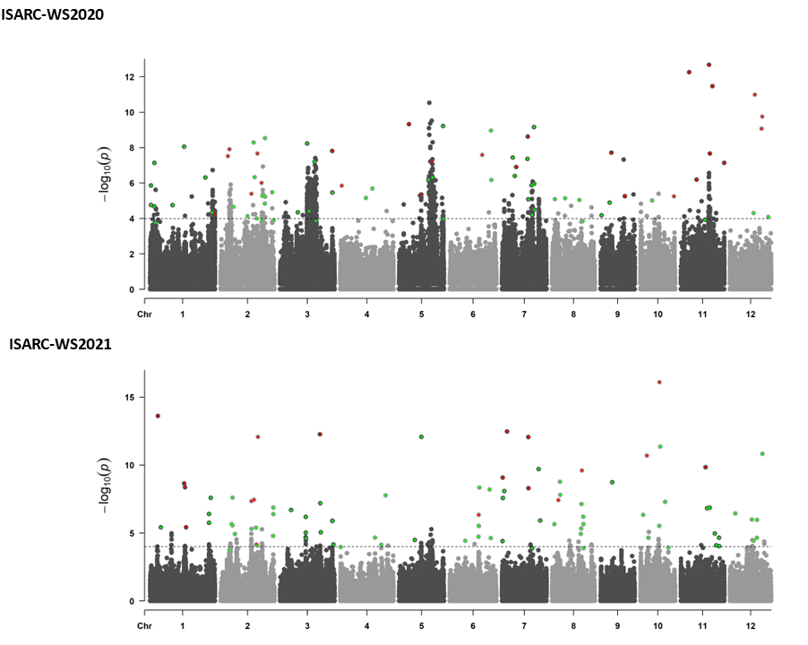
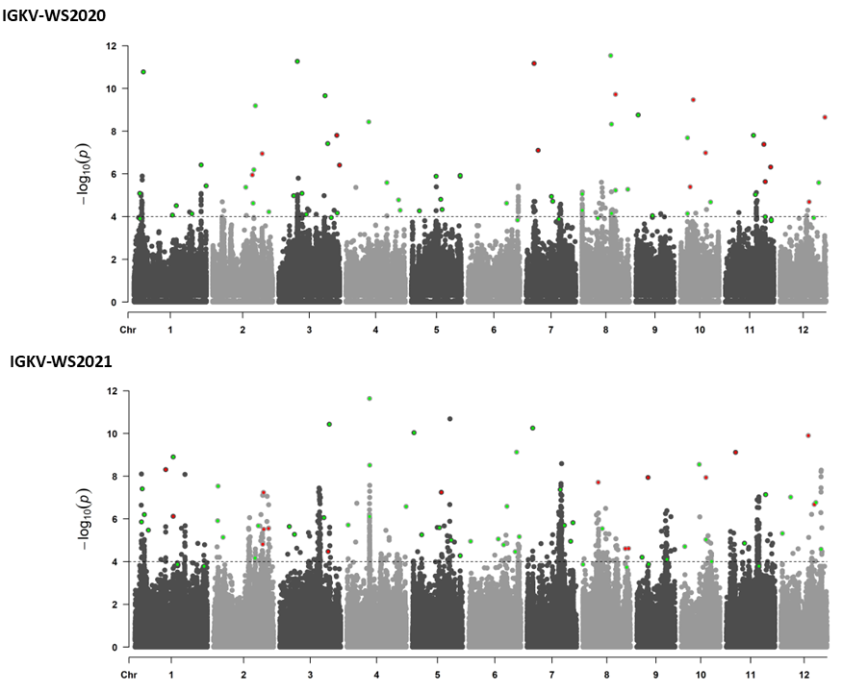

Figure 6: Manhattan plot showing significant QTNs associated with rice yield and yield related traits, identified across six environments using mrMLM, FASTmrMLM, FASTmrEMMA, pLARmEB and ISIS EM-BLASSO models. The -log10 (P-value) of SNP across the genome (y-axes) were plotted against their respective position on each chromosome (x-axis) for PL. The red dots represent all the QTNs commonly identified by more than two ML-GWAS models and the orange dots indicate QTNs identified by a single ML-GWAS model.

