Harnessing superior haplotypes from landraces to breeding lines for enhanced yield in rice
Niranjani Gnanapragasam^{1,2}, Sonali Vijay Habde^{1,3}, Krishna Tesman Sundaram^{1,2}, Sruthi Remesan^{1,2}, Pronob Jyoti Paul^{1,2}, Manoj Pushkarnath^{1,2}, Ashmitha Ganesan^{1,2}, Vipin Kumar Pandey⁴, Shubha Banerjee⁴, Jyothi Badri⁵, Sanjay Kalia⁶, Arvind Kumar^{1,2,7}, Ajay Kohli¹, Uma Maheshwar Singh^{1,3}, Vikas Kumar Singh^{1,2*}, Pallavi Sinha^{1,2*}

¹ International Rice Research Institute, Los Banos, Laguna, 4031, Philippines
² International Rice Research Institute, South Asia Hub, Patancheru, 502324, India
³ International Rice Research Institute, South Asia Regional Centre, Varanasi, 221006 India
⁴ Indira Gandhi Krishi Vishwavidyalaya, Raipur, 492012, India
⁵Indian Institute of Rice Research, Hyderabad, India
⁶ Department of Biotechnology, 110003, New Delhi, India
⁷ Current Address: Prasad Seeds, R R District, 501401, India

* Author for Correspondence: p.sinha@cgiar.org; v.k.singh@cgiar.org

Running Title
Superior haplotype for higher grain yield in rice

SUPPLEMENTARY FIGURES

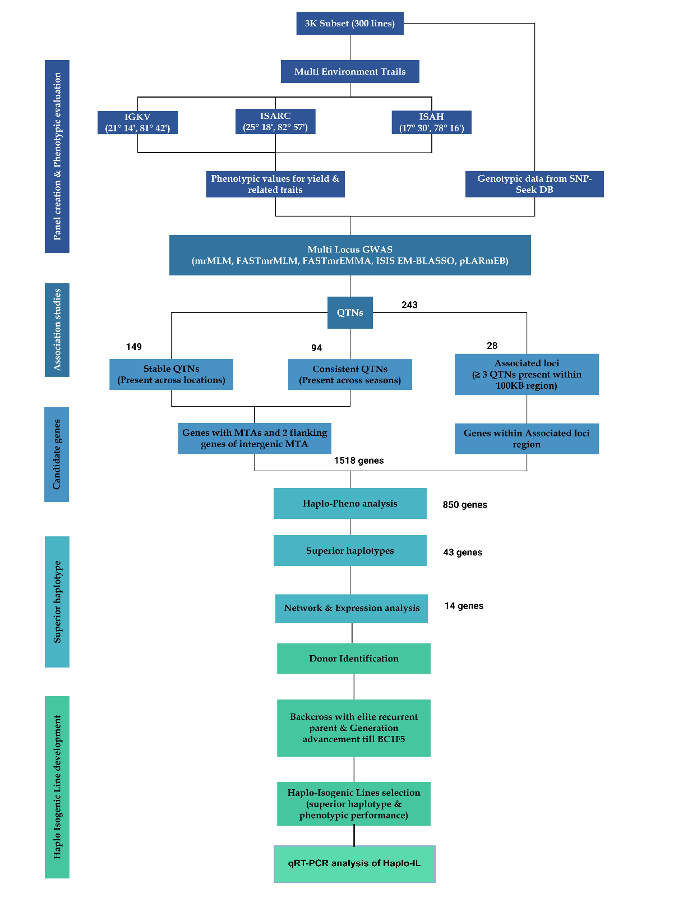

Supplementary Figure S1. The methodology flow of the study to identify candidate genes carrying superior haplotypes for yield and yield-related traits phenotyped from two seasons and three locations. Various parameters are followed in this flowchart.

Supplementary Figure S2. Population structure: A) The subset panel contains varieties from all subpopulations and principal component (PC) 1 separates the indica from japonica varieties. In contrast, PC2 separates aus from indica varieties. The left insert shows the count of each subpopulation in a pie chart, while the right-hand side insert shows the variation explained by each PC up to 20. (B) The same result was observed on the dendrogram of the diversity panel visualized using neighbour-joining tree.
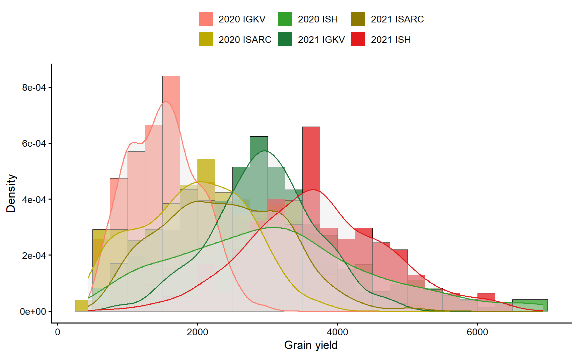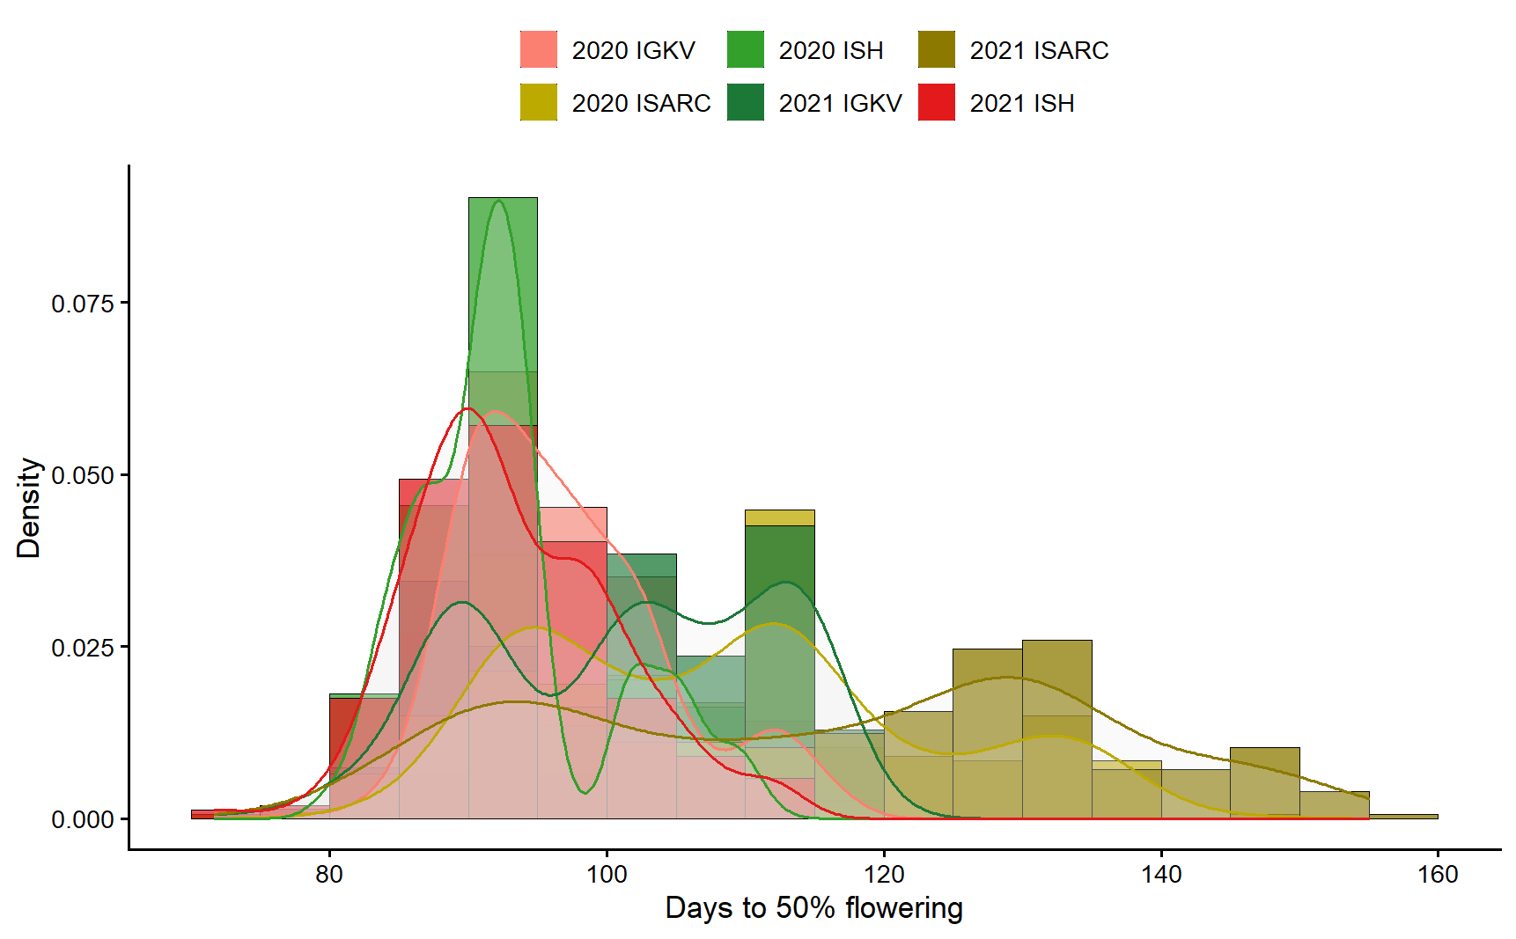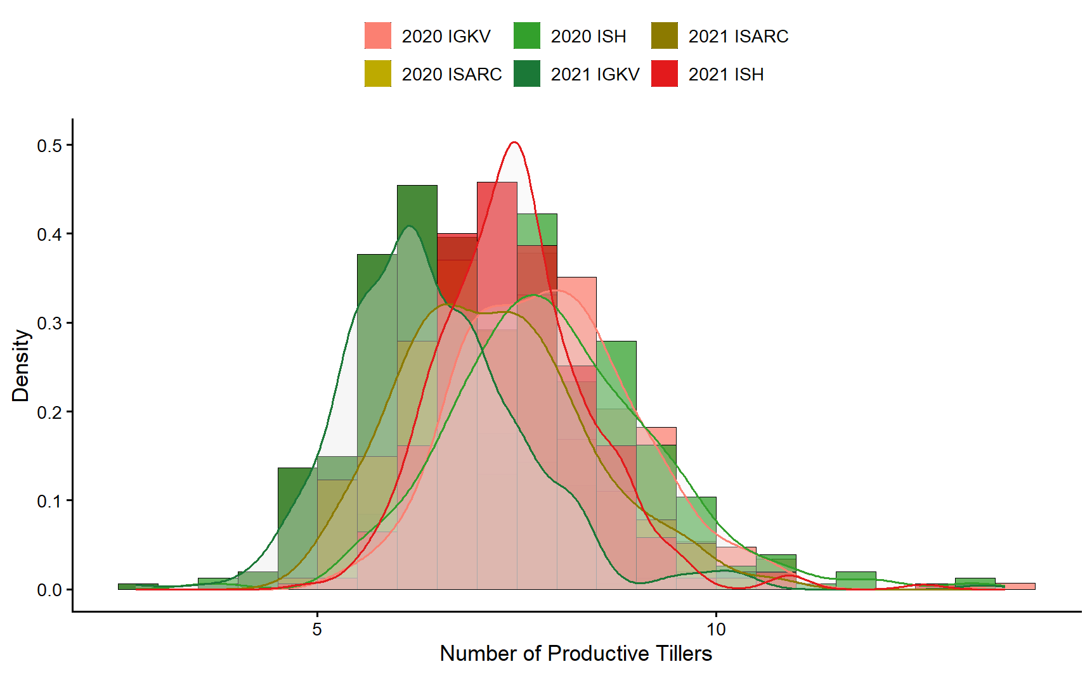
A
C
B

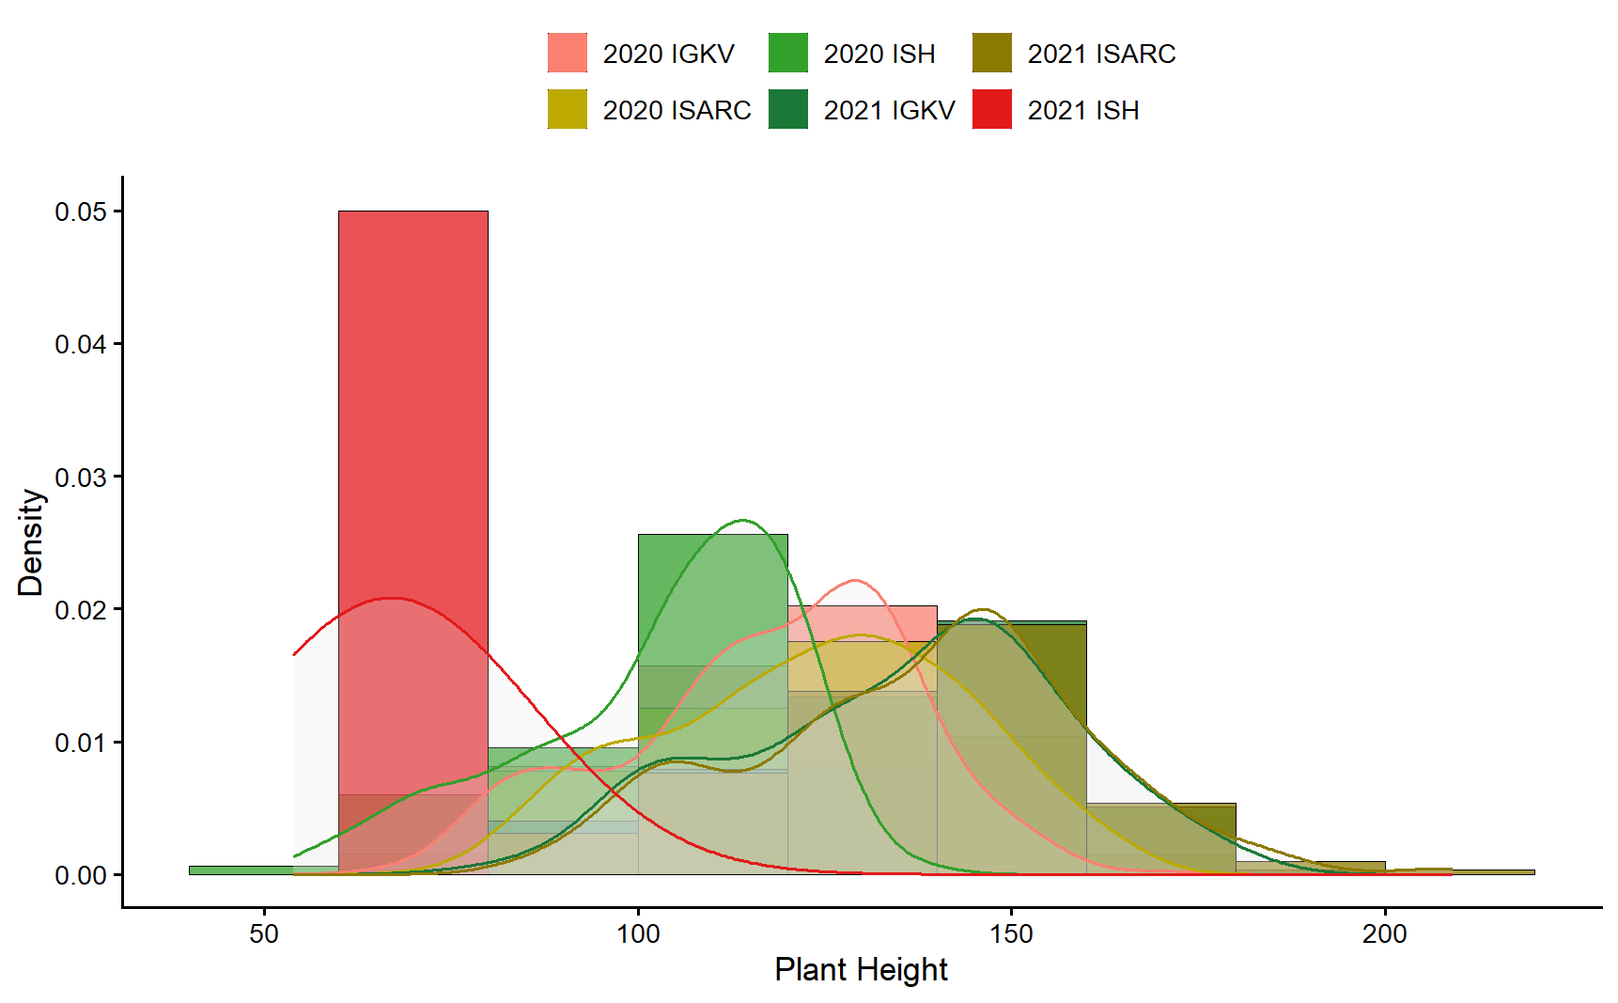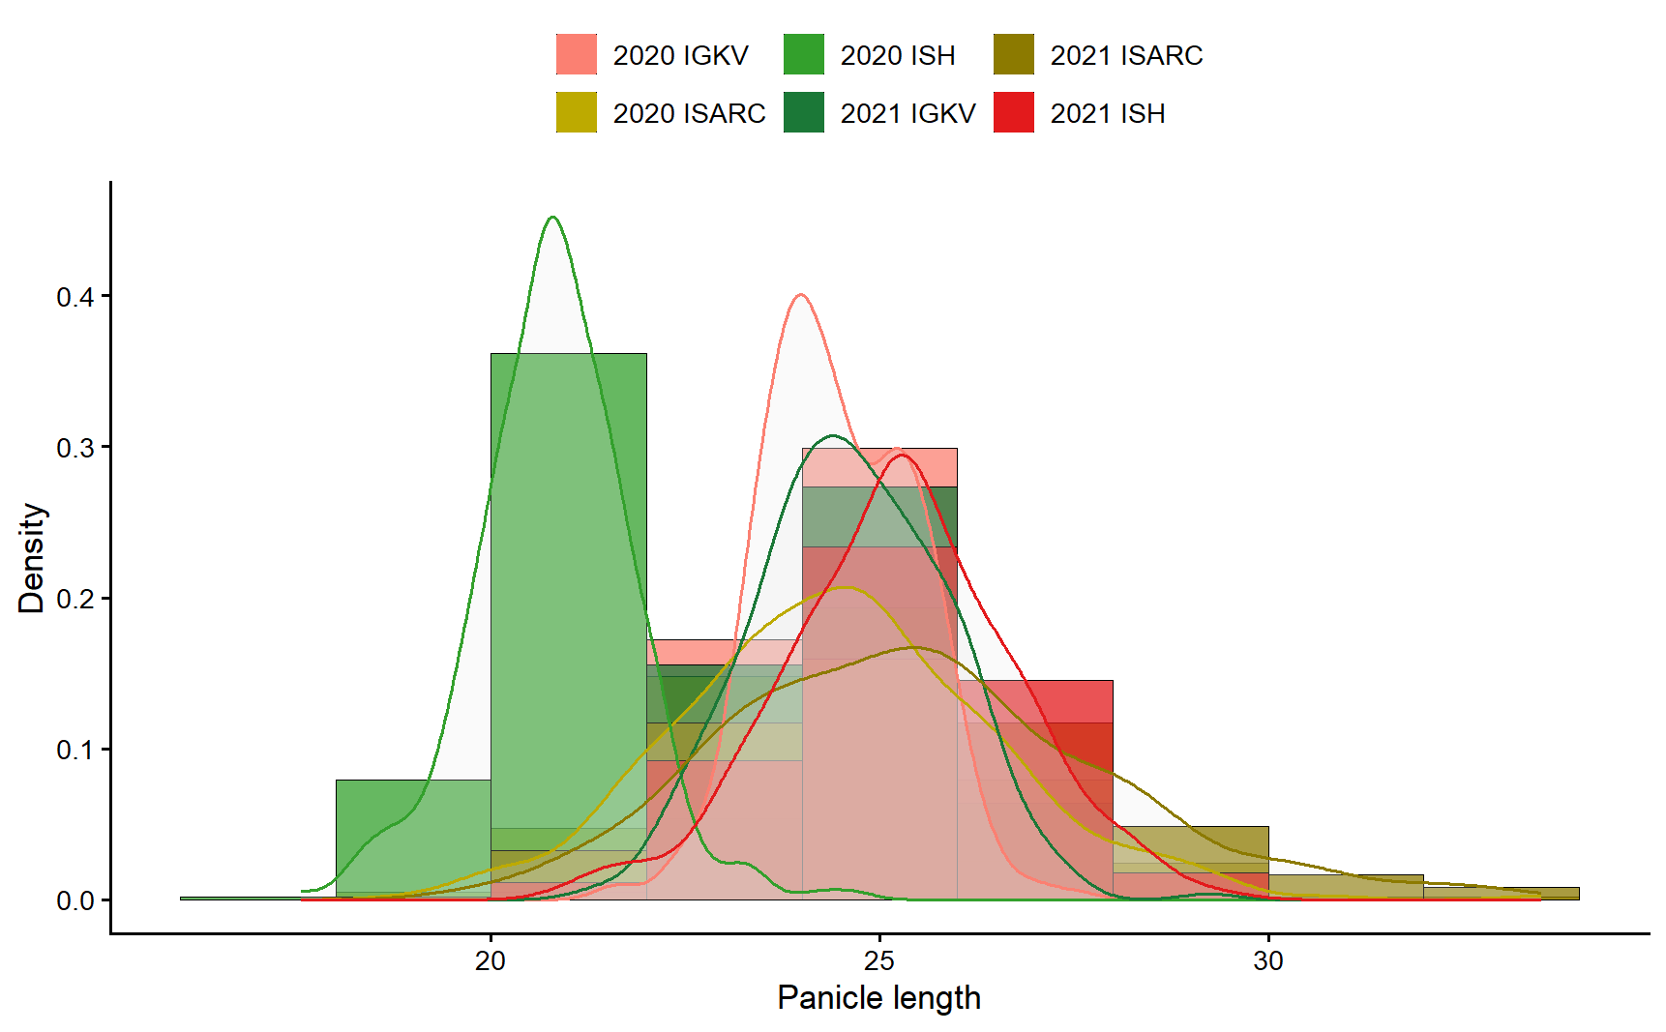 Supplementary Figure S3. Phenotypic frequency distributions (histograms) with kernel density curves of grain yield A) GY B) DTF C)NPT D)PH and E)PL
E
D
A
Supplementary Figure S4. Haplotype diversity of candidate genes. The distribution of haplotypes observed in the candidate genes associated with all five traits studied shows almost a similar distribution.

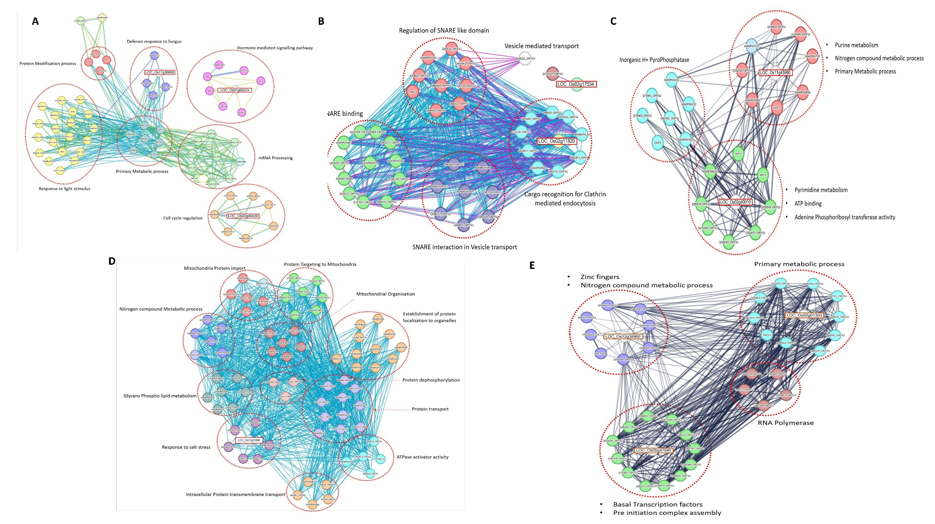Supplementary Figure S5. Protein-Protein network analysis for final candidate genes associated with (A) PH, (B) DTF, (C) NPT, (D) PL, and (E) GY are shown. The clusters formed with in each network is showed with red circles and the candidate genes (query genes) are shown in red square boxes.

Supplementary Figure S6. ZOS12-07 protein structure and phylogenetic relationship. A) The SNPs observed in the identified superior haplotype are compared here with the original sequence of the ZOS12-07 protein. The amino acid changes are given in the second row. The zinc finger (zf) motif structure was predicted using AlphaFold. The key amino acids of zf are two cystines (highlighted with red arrow) and two histidines (highlighted with turquoise arrow). The sequence "QALGGH", highlighted with a red bar, is the conserved amino acid sequence of zf specific to plants. B) BLAST results of the protein sequence show clear conserved regions among the orthologs from closely related crops. C) the phylogeny tree is built based on the BLAST sequence comparison

Supplementary Figure S7. Functional enrichment results of candidate genes identified for DTF (left) and PH (right) traits. The counts are segregated for biological process (BP), molecular function (MF), and cellular compartmentalization (CC). The filtered candidate genes after the haplo-pheno analysis are used here

Supplementary Figure S8. Functional enrichment results of candidate genes identified for NPT (left) and PL (right) traits. The counts are segregated for biological process (BP), molecular function (MF), and cellular compartmentalization (CC). The filtered candidate genes after the haplo-pheno analysis are used here.

Supplementary Figure S9. Functional enrichment results of candidate genes identified for GY trait. The counts are segregated for biological process (BP), molecular function (MF), and cellular compartmentalization (CC). The filtered candidate genes after the haplo-pheno analysis are used here.
A) (i) GYKGPHA_LOC_Os02g01350

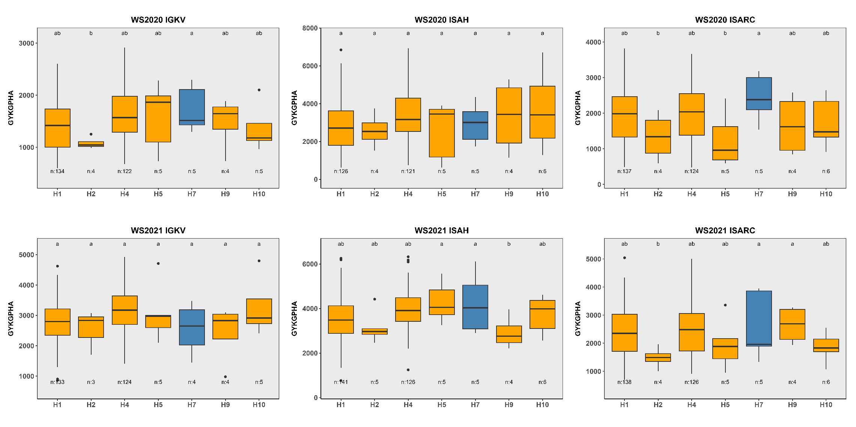

(ii) GYKGPHA_LOC_Os05g47940

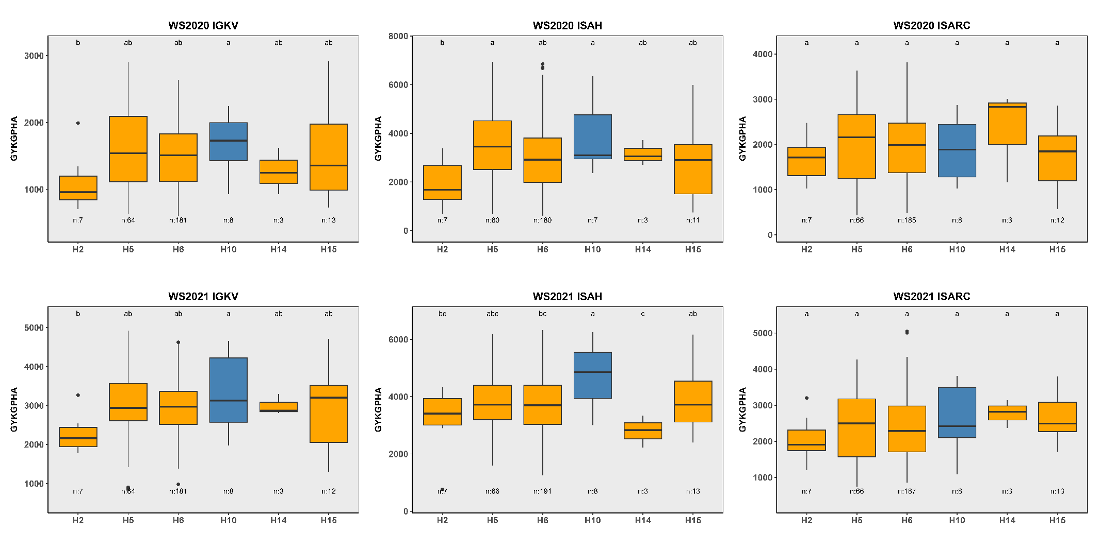

(iii) GYKGPHA_LOC_Os12g38960 -Zos12-07

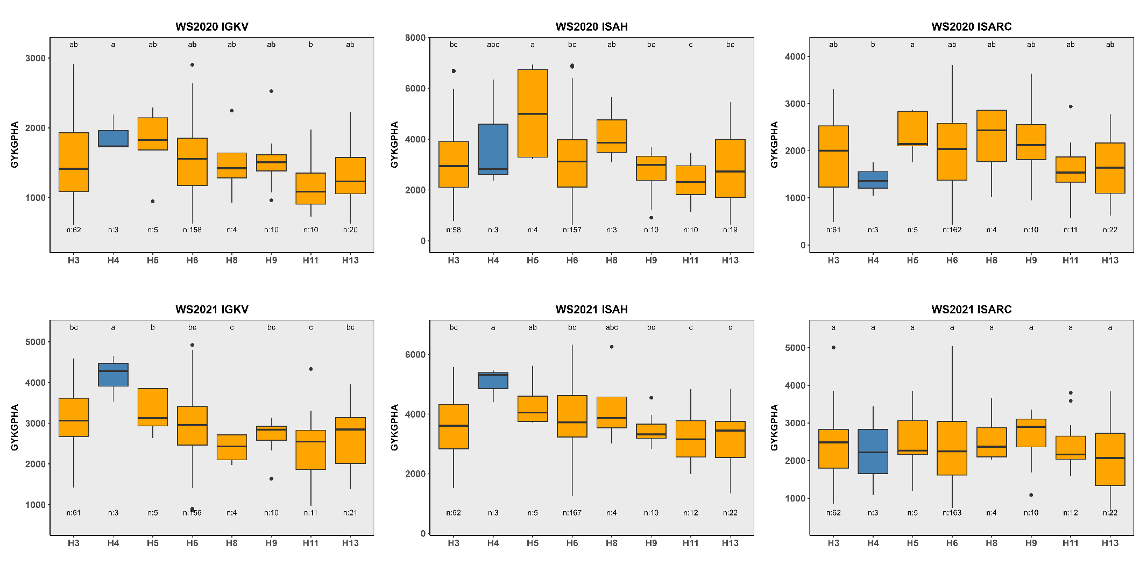

B) (i) DTF_LOC_Os02g11820

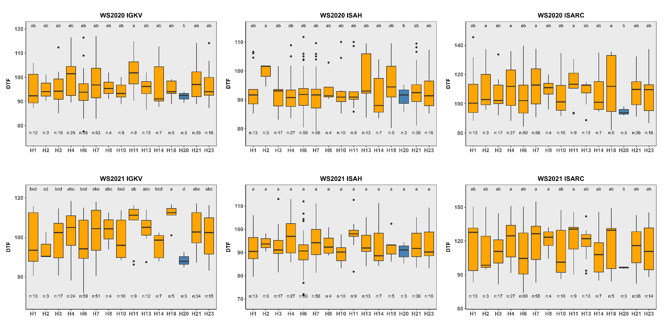

(ii) DTF_LOC_Os02g17534
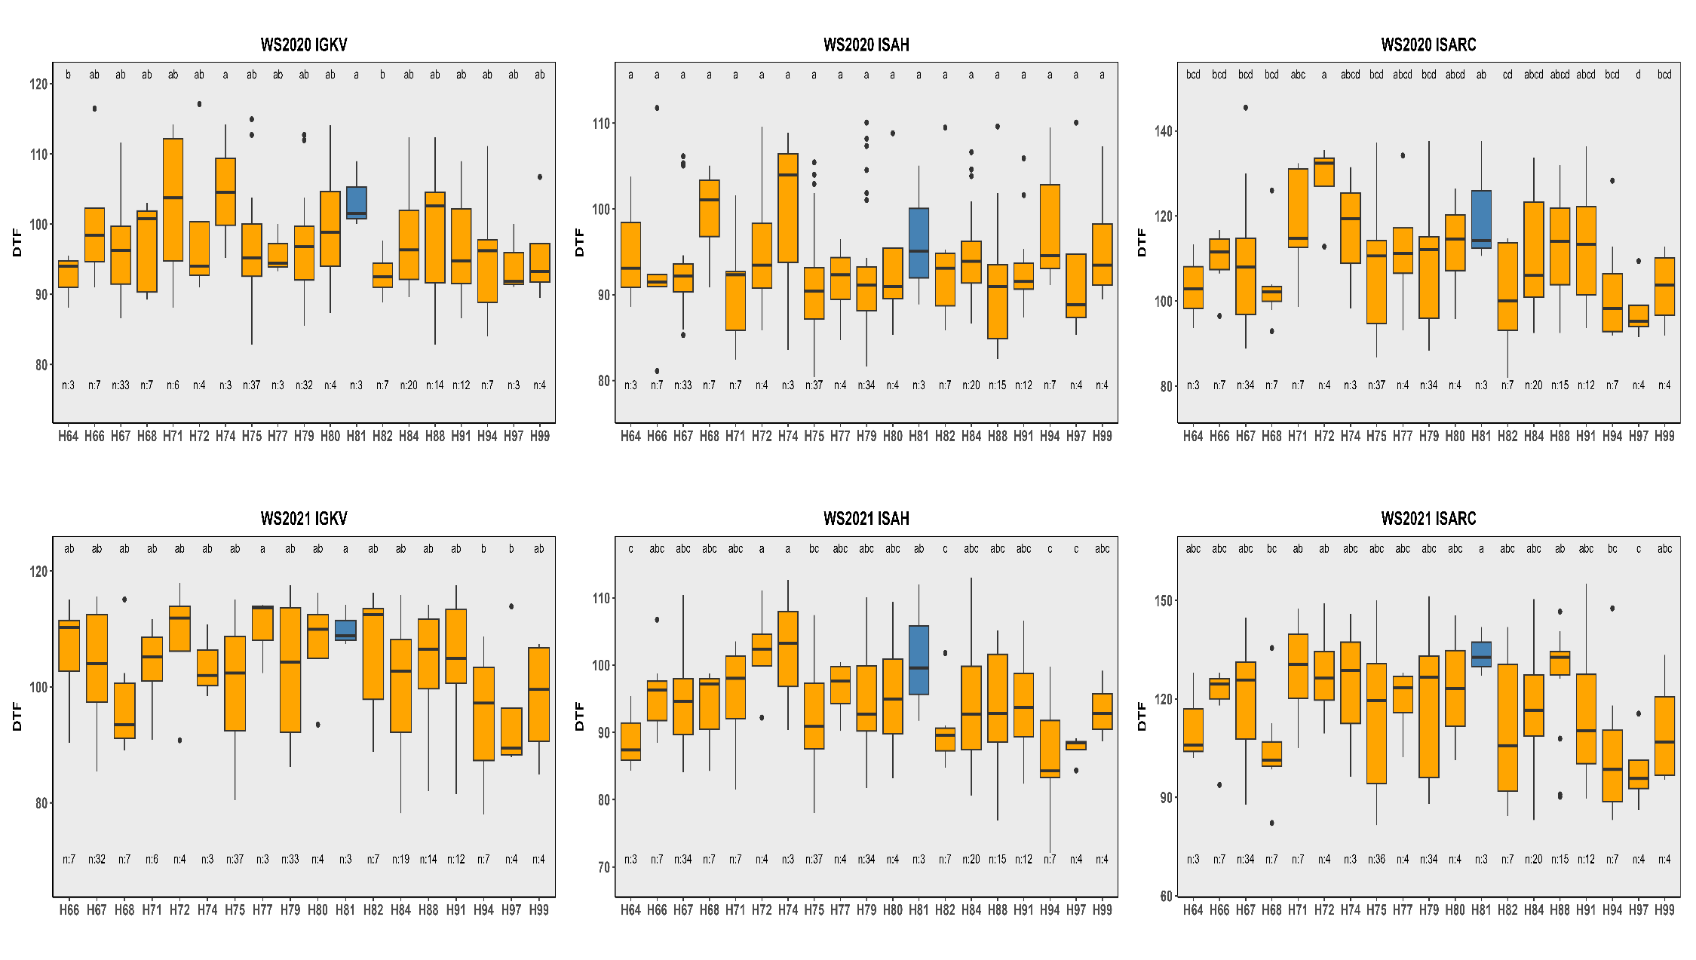

(iii) DTF_LOC_Os09g11760

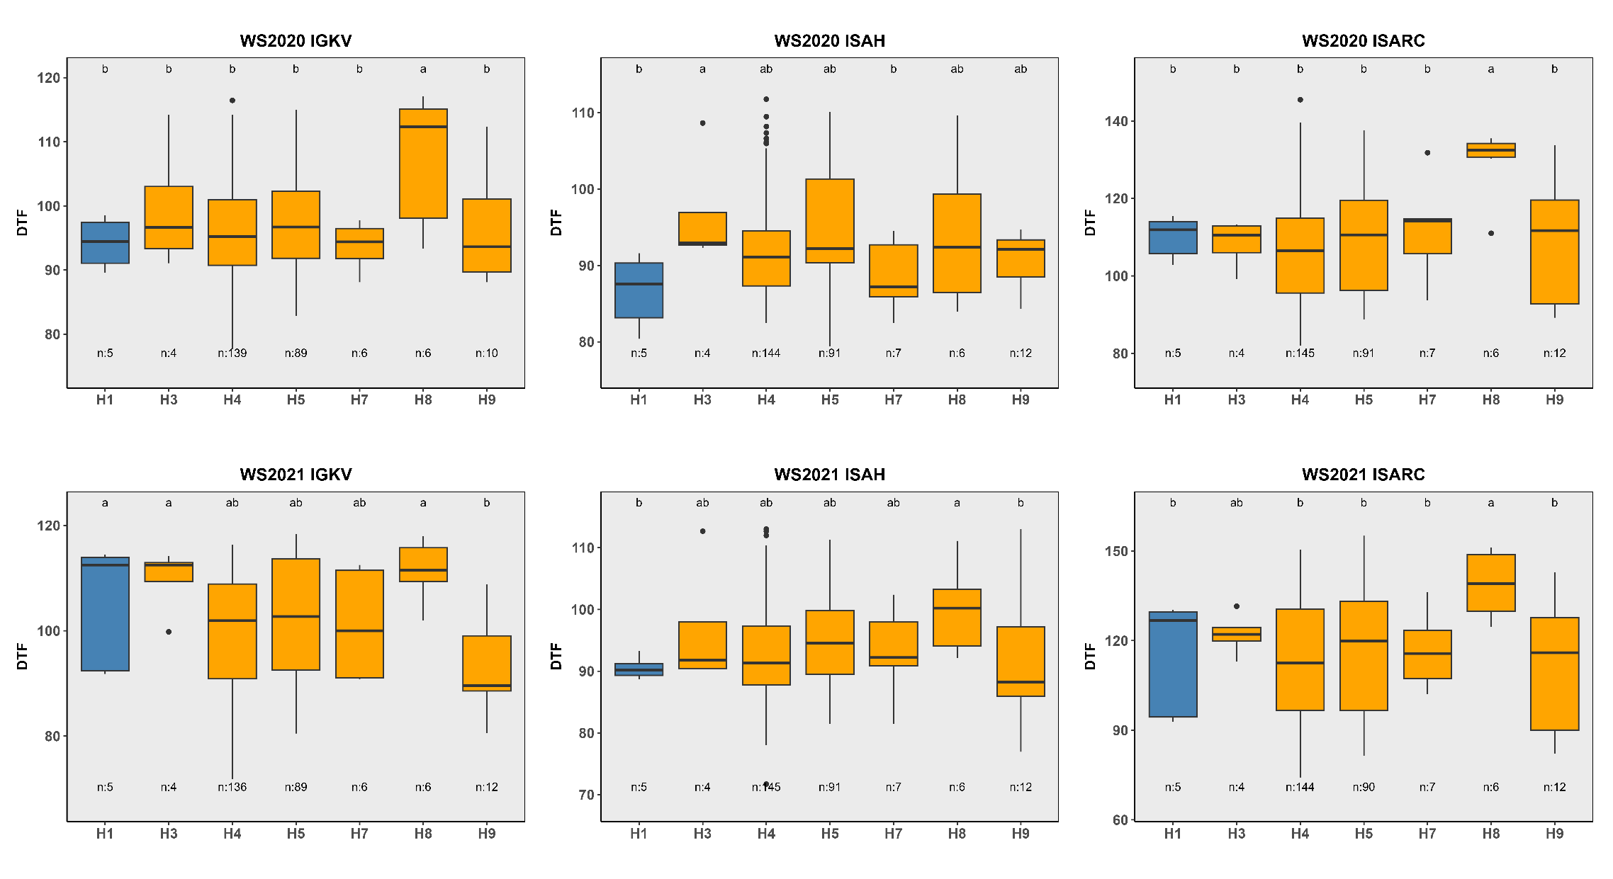

C) (i) NPT_LOC_Os01g51710
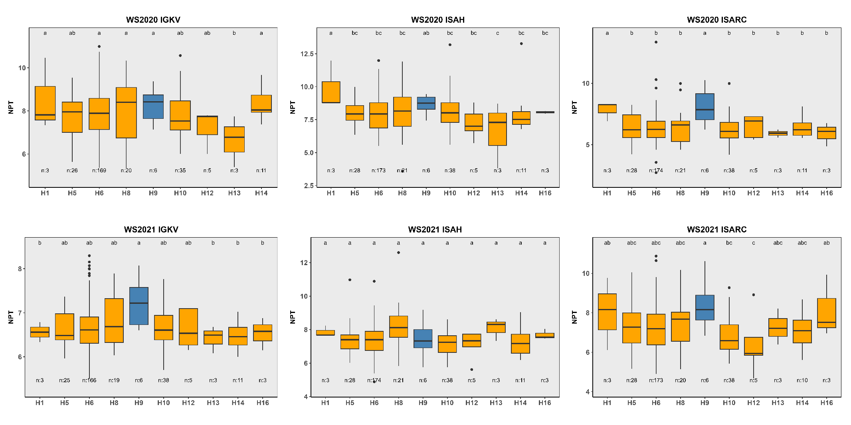

(ii) NPT_LOC_Os02g40010

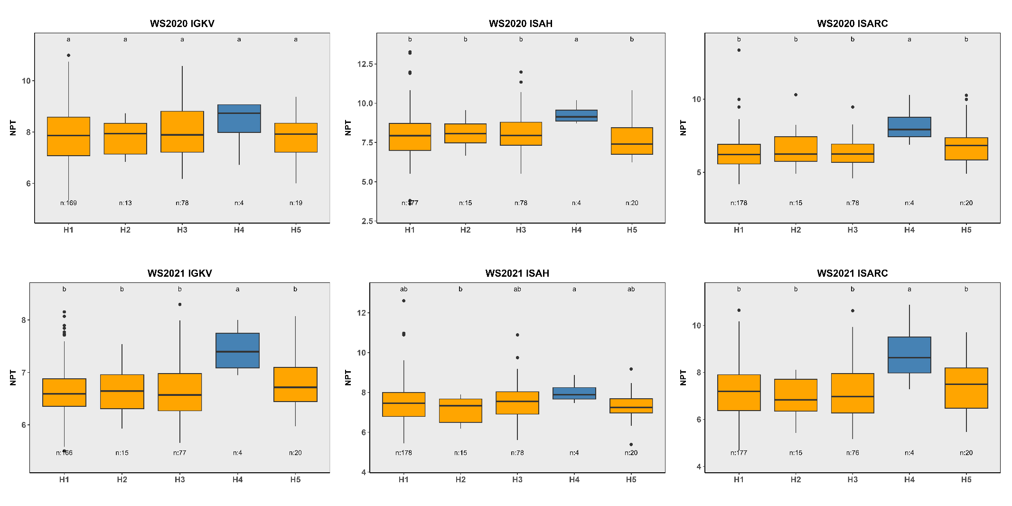

(iii) NPT_LOC_Os11g45990
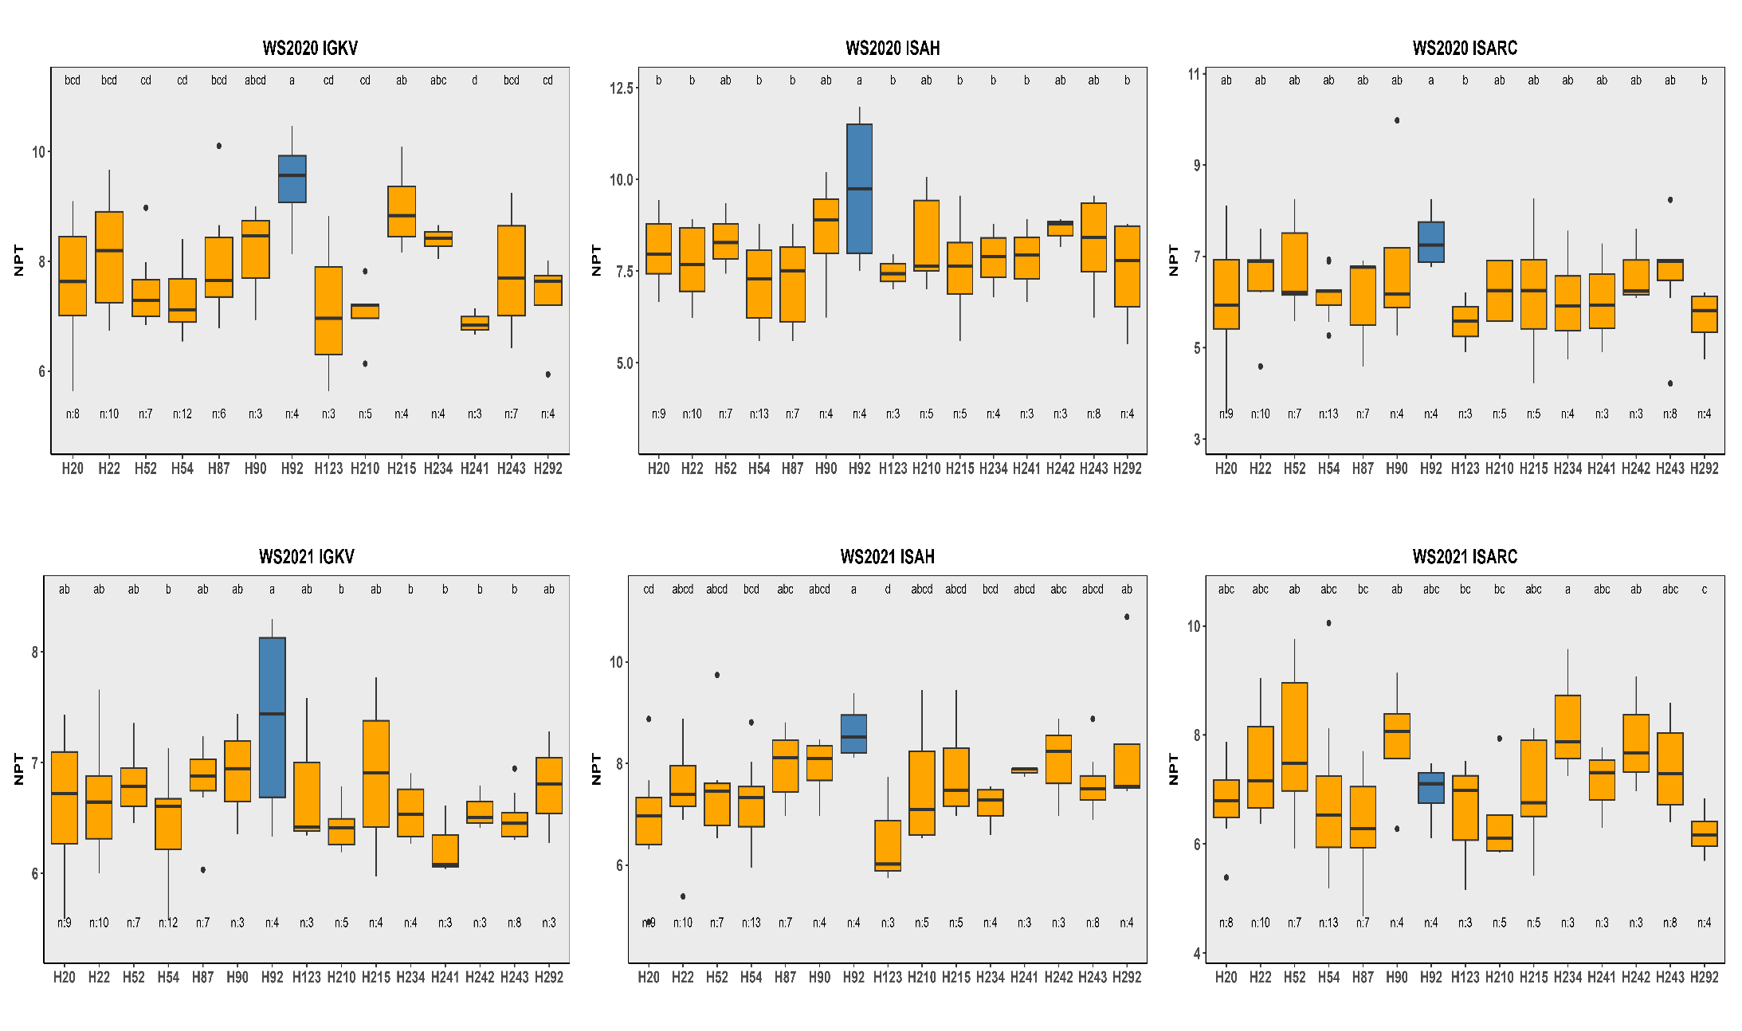

D) (i) PH_LOC_Os01g68370
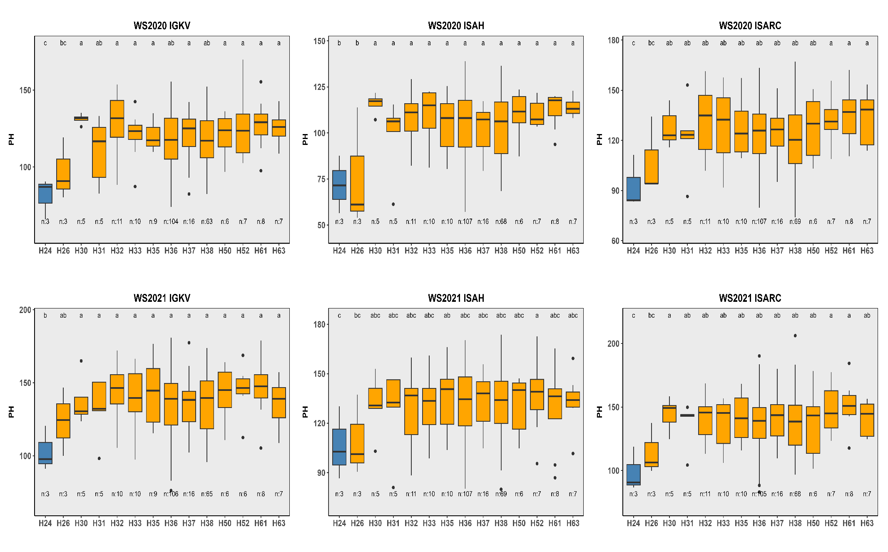
(ii) PH_LOC_Os02g40430
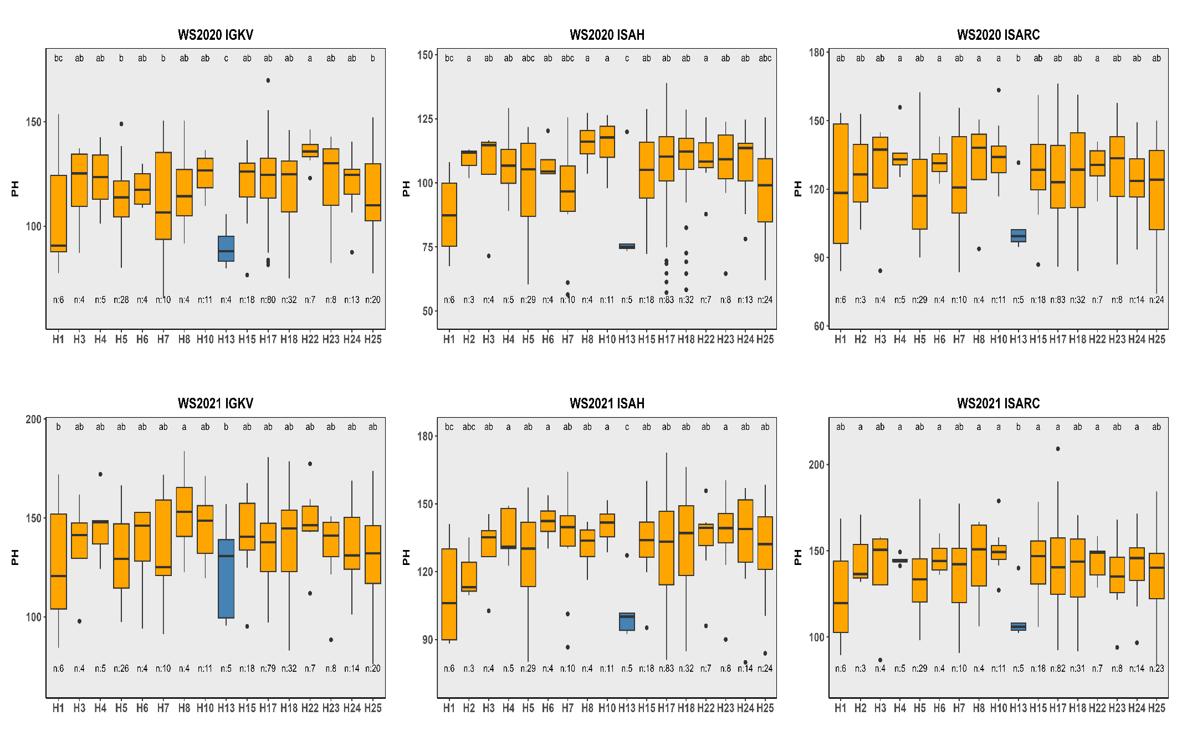

(iii) PH_LOC_Os11g35980

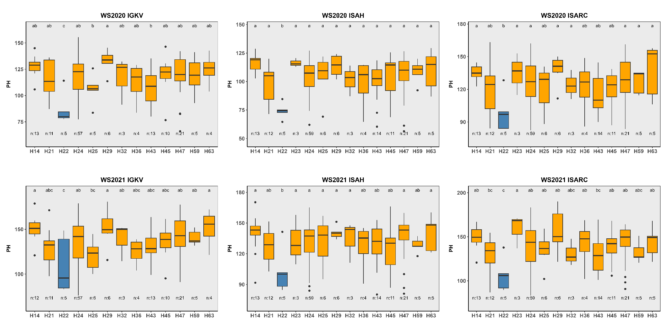

(iv) PH_LOC_Os11g36000

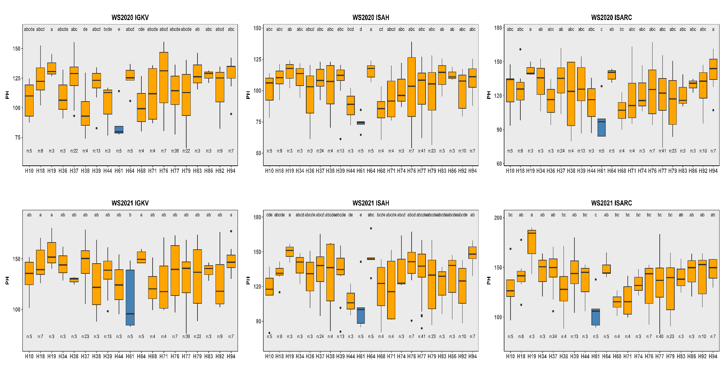

E) PL_LOC_Os11g31890
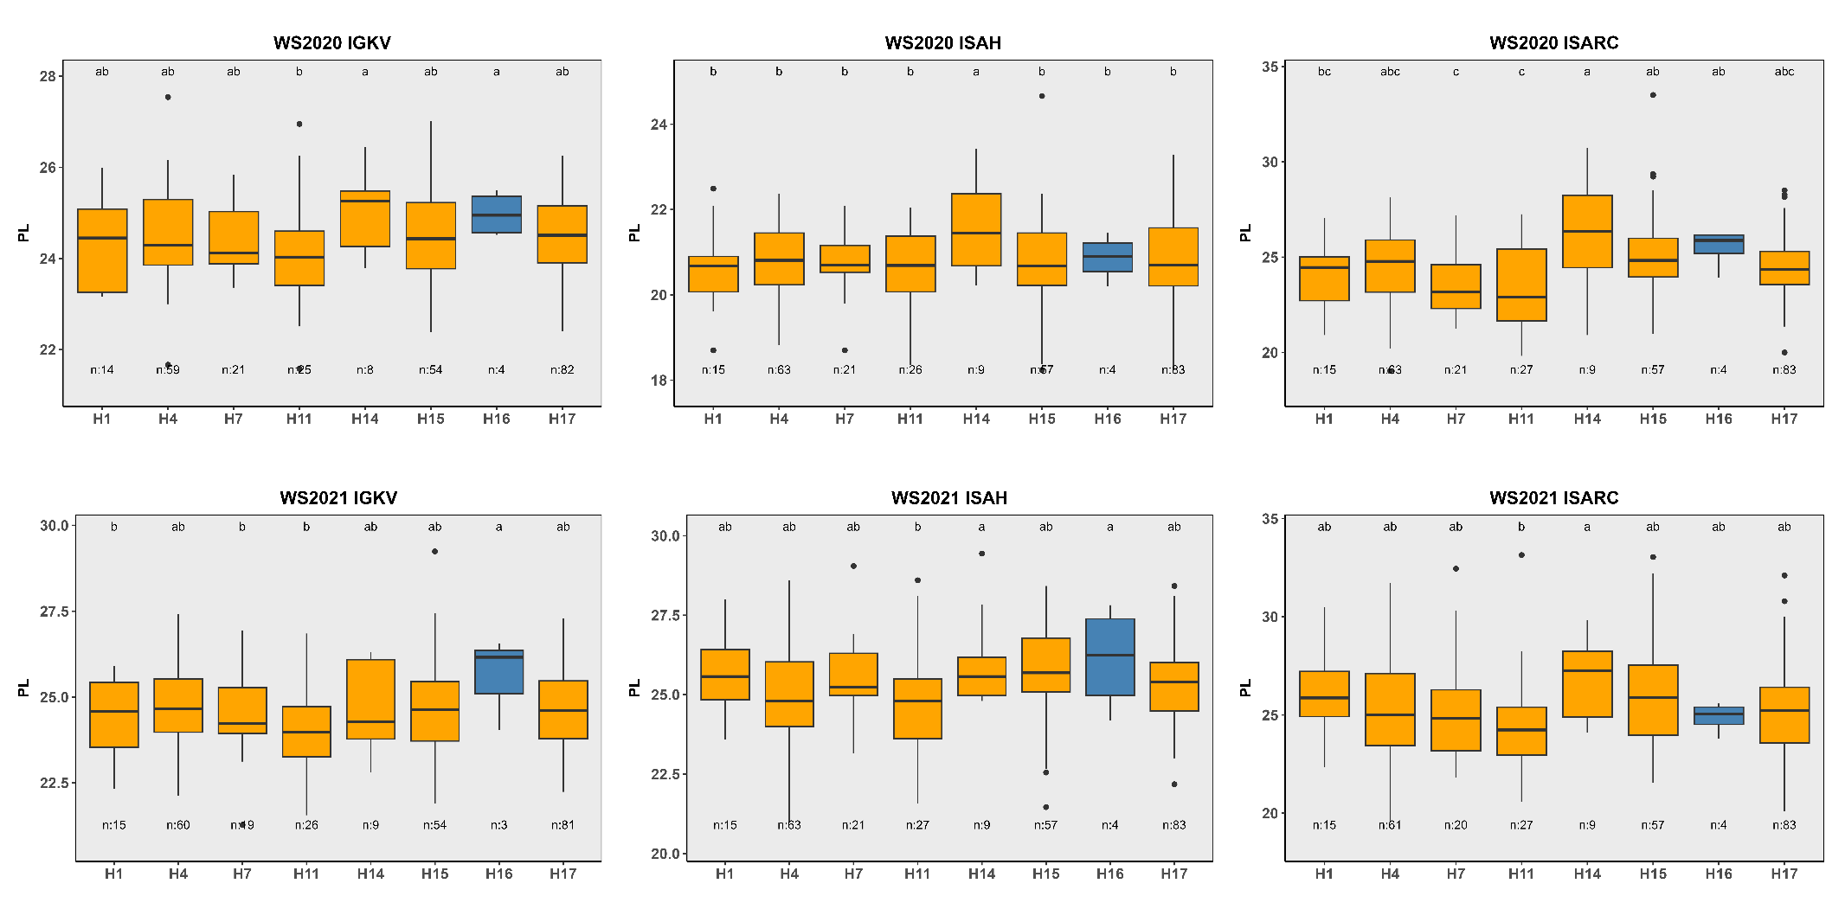
Supplementary Figure S10: Haplotype-pheno results. Boxplot showing the variation of phenotypic values among 300 rice accessions across six environments. The plots are presented for the traits for the traits A) (i-iii) GY B) (i-iii) DTF, C) (i-iii) NPT, D) (i-iv) PH, E) PL with accessions grouped by haplotypes of eachfinal candidate gene. The superior haplotype is highlighted in blue. Lower and upper boxes represent the 25th and 75th percentile, respectively. The median is indicated by a horizontal line in the box. Number of genotypes carrying each haplotype (n) is shown at the bottom of each box (n), and significant groups determined by Duncan’t multiple range test are displayed above the boxes.

.

