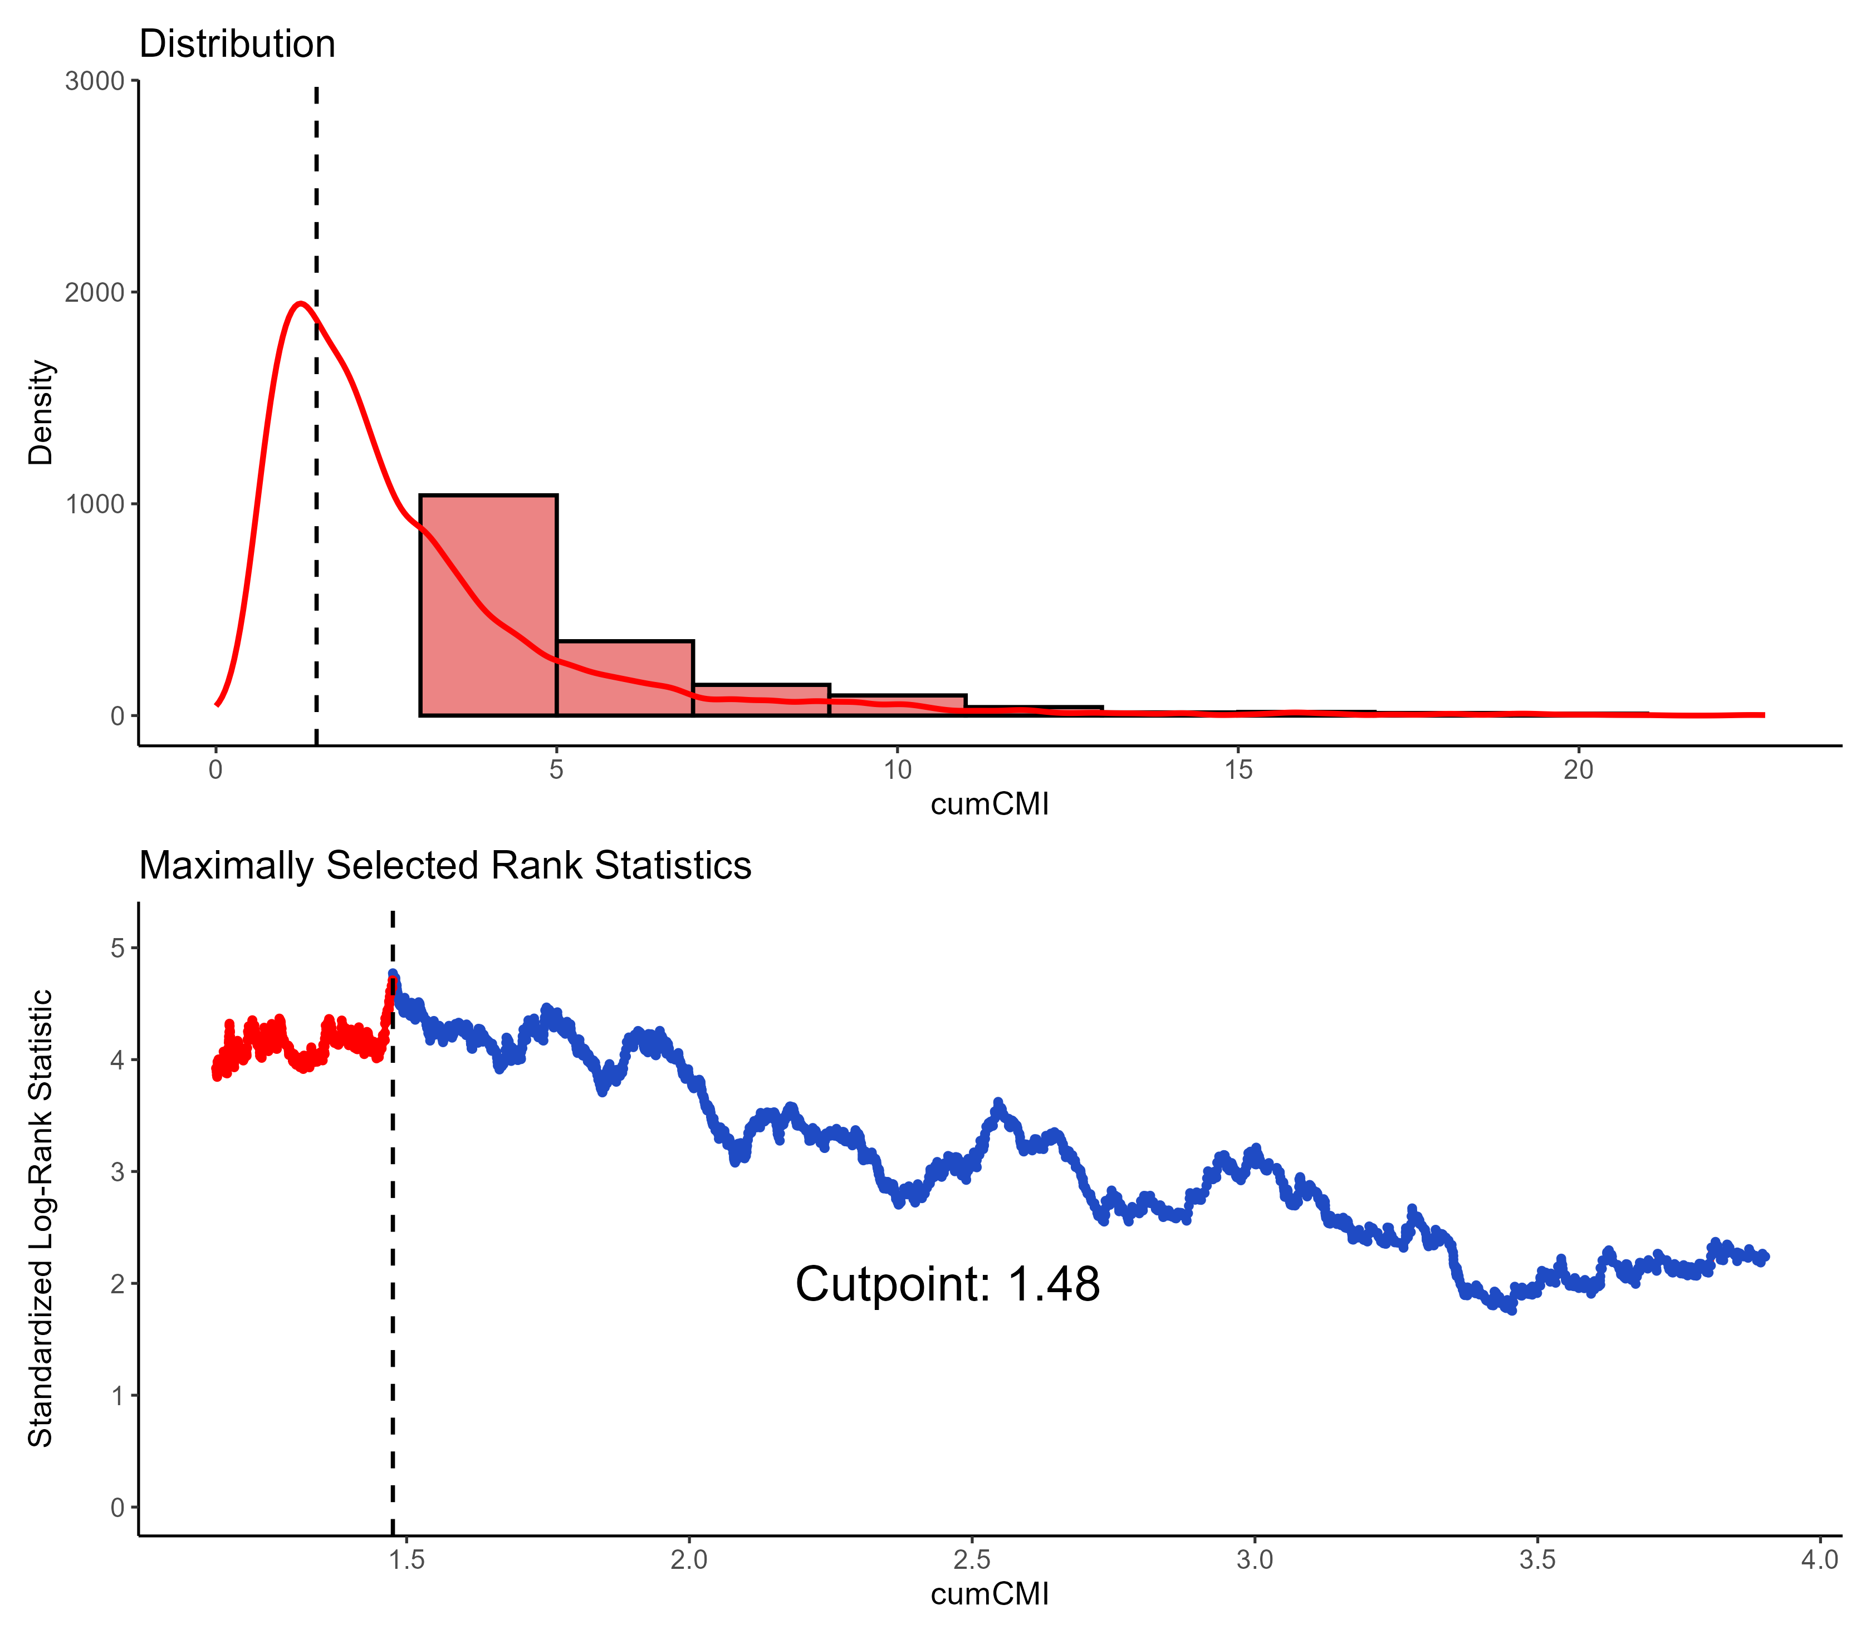
Figure S1. The optimal cut-off value of CumCMI.

