Supplemental Tables and Figures:

Supplementary Table 1. Summary GWAS statistics for the mvAge polygenic risk scores

rsID | Location (chr, pos) | Odds Ratio (OR) | Weight
rs11066320 | 12, 112906415 | 0.993683 | 0.656049
rs1126809 | 11, 89017961 | 1.006641 | 0.502494
rs114298671 | 4, 3281869 | 1.008907 | 0.349714
rs12203592 | 6, 396321 | 1.010903 | 0.341028
rs1230666 | 1, 114173410 | 0.989890 | 0.373095
rs12705966 | 7, 114248851 | 0.993978 | 0.609754
rs1275922 | 2, 26932887 | 0.993025 | 0.520961
rs12769128 | 10, 21883430 | 1.006005 | 0.566657
rs13141210 | 4, 67891641 | 0.994183 | 0.705691
rs142158911 | 19, 11190534 | 0.989943 | 0.335112
rs157581 | 19, 45395714 | 1.016115 | 0.455851
rs159428 | 20, 31099311 | 1.006271 | 0.696491
rs16843603 | 4, 2928577 | 0.992974 | 0.552449
rs16843836 | 4, 3113337 | 0.992028 | 0.555968
rs1689406 | 12, 89754726 | 1.006968 | 0.448107
rs17499404 | 4, 38385479 | 0.994367 | 0.674759
rs2186800 | 11, 113242860 | 0.993881 | 0.679117
rs2271961 | 3, 49878113 | 1.006084 | 0.686440
rs2613508 | 1, 72833582 | 1.007699 | 0.422966
rs2643826 | 3, 27562988 | 1.006344 | 0.672533
rs268 | 8, 19813529 | 1.024702 | 0.117983
rs28455998 | 15, 41430969 | 1.005692 | 0.704273
rs28637671 | 4, 67780392 | 1.006349 | 0.536936
rs2972566 | 19, 45354238 | 1.007926 | 0.390000
rs34891485 | 17, 40263458 | 1.014566 | 0.229521
rs35198068 | 10, 114754784 | 1.008551 | 0.563116
rs36072649 | 4, 140939110 | 0.994064 | 0.604814
rs3768321 | 1, 40035928 | 1.007930 | 0.433474
rs405509 | 19, 45408836 | 0.993358 | 0.695773
rs449647 | 19, 45408564 | 0.992246 | 0.406202
rs472103 | 3, 173122492 | 1.005909 | 0.682056
rs4766578 | 12, 111904371 | 0.992465 | 0.690724
rs55686423 | 12, 49963534 | 0.990023 | 0.297439
rs55730499 | 6, 161005610 | 1.021801 | 0.274864
rs6062322 | 20, 62441599 | 0.992945 | 0.440227
rs61905747 | 11, 113639842 | 1.009143 | 0.388716
rs66906321 | 2, 630070 | 1.007506 | 0.424146
rs6859 | 19, 45382034 | 0.991944 | 0.663626
rs6907508 | 6, 34592090 | 1.010244 | 0.318434
rs7174250 | 15, 81018587 | 1.005625 | 0.674759
rs7412 | 19, 45412079 | 0.979426 | 0.250240
rs7742789 | 6, 43345803 | 1.006054 | 0.589830
rs78438918 | 2, 100630115 | 0.992192 | 0.407431
rs7859727 | 9, 22102165 | 1.009182 | 0.698642
rs79570361 | 6, 161170855 | 1.010686 | 0.287228
rs8042849 | 15, 78817929 | 0.991840 | 0.625060
rs9277988 | 6, 33306235 | 1.007102 | 0.442493
rs9295128 | 6, 160751531 | 1.038381 | 0.113666
rs9355297 | 6, 161023165 | 0.992802 | 0.514198
rs9364552 | 6, 160782934 | 1.005751 | 0.706399
rs940088 | 17, 47145848 | 0.993680 | 0.535070
rs980183 | 2, 59311536 | 0.993676 | 0.620242
List of single nucleotide polymorphisms (SNPs) used in constructing the mvAge polygenic risk score, including rsID, chromosomal location (chromosome and position), odds ratio (OR), and corresponding weight derived from GWAS summary statistics (Beta and SE).

Fig S1. Univariate discrimination (AUC) for all-cause mortality by age group and follow-up horizon in TwinGene and UK Biobank. Heatmaps display area under the receiver operating characteristic curve (AUC) values from univariate models for mortality prediction stratified by baseline age group (<50, 50–60, >60 years) and follow-up duration (5, 10, and 15 years). Columns show predictors (FI, HD, KDM, PhenoAge, PRS, TL) and rows are cohorts (TwinGene and UK Biobank). Each tile reports the AUC value; tile color intensity reflects AUC magnitude using cohort-specific color scales (TwinGene: orange; UK Biobank: blue). PRS: Polygenic Risk Scores, PhenoAge: Phenotypic Age, KDM: Klemera-Doubal Method, HD: Homeostatic Dysregulation, FI: Frailty Index, TL: adjusted Telomere Length.

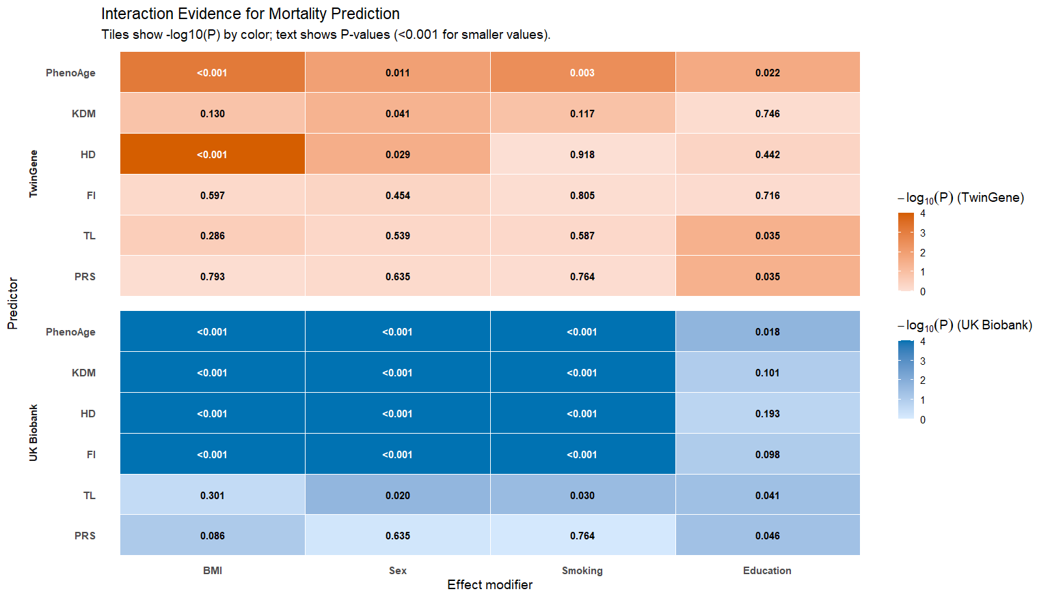

Fig S2. Evidence for effect modification of biological aging measures by lifestyle and demographic factors. Heatmaps summarize statistical evidence for interaction terms between each predictor (PhenoAge, KDM, HD, FI, TL, PRS) and effect modifiers (BMI, sex, smoking, education) in models of all-cause mortality, shown separately for TwinGene and UK Biobank. Tile color represents −log10(P) for the interaction term (stronger color indicates stronger evidence), and each tile reports the corresponding P-value (values <0.001 shown as “<0.001”). Cohort-specific color scales are used to match the main figures (TwinGene: orange; UK Biobank: blue). PRS: Polygenic Risk Scores, PhenoAge: Phenotypic Age, KDM: Klemera-Doubal Method, HD: Homeostatic Dysregulation, FI: Frailty Index, TL: adjusted Telomere Length.

Fig S3. Density plots of biomarkers in the TwinGene cohort. This figure shows the distributions of 8-clinical biomarkers used to construct the blood-based biological age estimates in TwinGene. Panels display serum glucose (mmol/L), glycohemoglobin (HbA1c, %), creatinine (µmol/L), cystatin C (mg/L), triglycerides (mg/dL), total cholesterol (mg/dL), LDL and HDL cholesterol (mg/dL). Densities are shown for the analytic sample with complete biomarker data used in downstream modeling.

