Supplementary figures
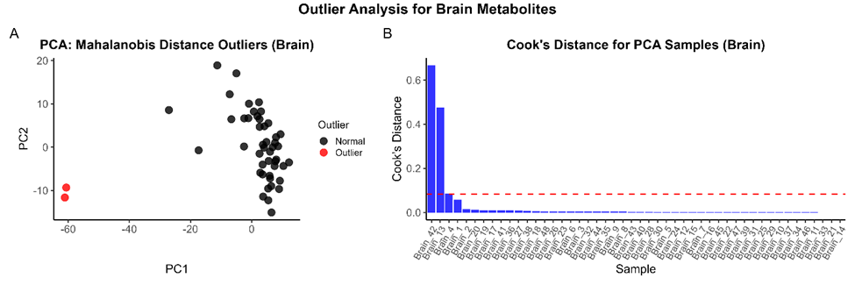Supplementary Figure 1: Outlier detection for brain metabolite profiles. (A) Principal component analysis (PCA) of brain metabolites with Mahalanobis distance-based outlier detection. Samples identified as multivariate outliers are shown in red. (B) Cook's distance plot for the PCA model of brain samples highlights highly influential samples. The red dashed line indicates the commonly used threshold for influential observations (Cook's D > 4/n).

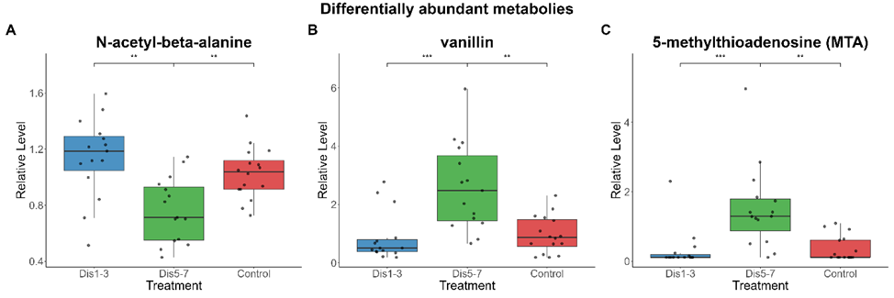
Supplementary Figure 2: Boxplots of tissue-specific metabolites significantly affected by early-life stress. (A) N-acetyl-beta-alanine (brain); (B) vanillin (ileum); (C) 5-methylthioadenosine (MTA, ileum). Significance was determined by linear modelling with treatment and room as fixed effects, followed by FDR correction (q < 0.1) and Tukey-adjusted pairwise contrasts. Asterisks denote significance of pairwise comparisons: p < 0.05 (*), p < 0.01 (**), p < 0.001 (***). Boxes represent interquartile ranges; points represent individual animals.

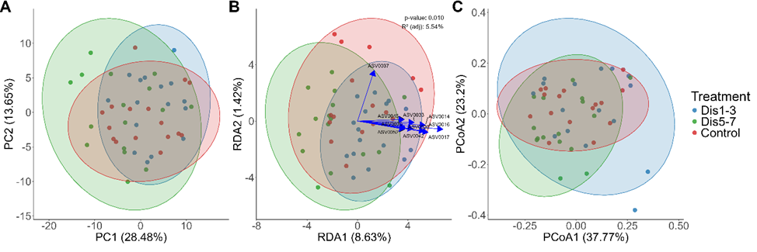Supplementary Figure 3: multivariate analysis of leal microbiota profiles at the ASV level. PCA (panel A), pRDA (panel B), and PCoA (panel C) were conducted on centred log-ratio transformed amplicon sequence variant (ASV) data. As observed at the genus level, PCA and PCoA revealed overlapping microbial communities across treatment groups. A significant but subtle effect of treatment was detected by pRDA (adjusted R² = 5.54%, p = 0.010), indicating treatment-related shifts in microbiota structure. PERMANOVA and ANOSIM on ASV-level Bray–Curtis distances yielded p-values of 0.077 and 0.084, respectively.

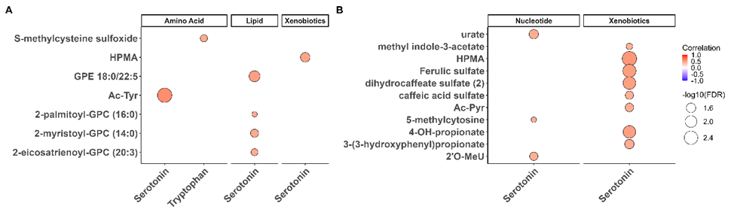Supplementary Figure 4: Correlation analysis of brain (A) and plasma (B) metabolites with blood serotonin concentrations. Only significant correlations are shown (FDR < 0.05, |ρ| > 0.3). Circle size reflects the –log₁₀(FDR) and color indicates the Spearman correlation coefficient (blue = negative, red = positive). Metabolites are grouped by super-pathway. No significant correlations were found for tryptophan.

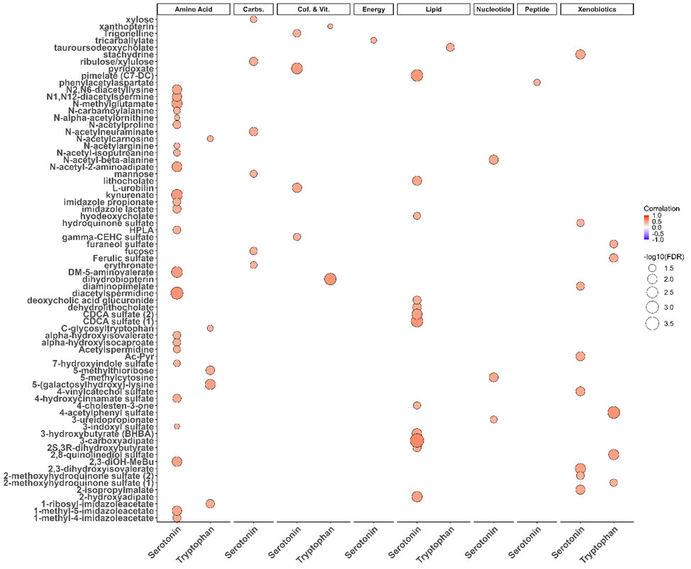Supplementary Figure 5: Spearman correlation between serotonin and ileum metabolites. Significant correlations (FDR < 0.05, |ρ| > 0.3) are visualized with dot size proportional to -log10(FDR) and color indicating correlation strength. Only annotated metabolites are included. Metabolites are grouped by super-pathway.

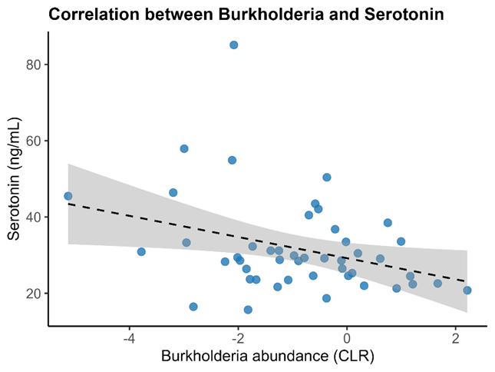
Supplementary Figure 6: Scatterplot showing the significant negative correlation between Burkholderia–Caballeronia–Paraburkholderia genus abundance (CLR-transformed) and serotonin levels in blood (ρ = -0.30, FDR = 0.034). Shaded area indicates 95% confidence interval of the linear fit. Burkholderia group refers to the genus Burkholderia–Caballeronia–Paraburkholderia collapsed for interpretability.

Supplemetary tables

Supplementary Table 1: Significant super-pathway enrichments (FDR < 0.05). Each row reports an enriched super-pathway identified through MSEA, along with the corresponding tissue, treatment contrast, FDR-adjusted p-value, average log2 fold change, and representative metabolites driving the enrichment. Only contrasts and pathways with FDR < 0.05 are included.

Tissue | Contrast | Pathway | FDR_P_Value | Average_Log2FC | Most_Important_Metabolites
Ileum | Dis1-3 vs Control | Lipid | 2.71E-20 | 1.592 | 1-linoleoyl-GPG (18:2), 1-linolenoylglycerol (18:3)
Plasma | Dis1-3 vs Control | Peptide | 0.036 | 0.975 | glycylproline, leucylhydroxyproline
Ileum | Dis1-3 vs Dis5-7 | Energy | 0.046 | -0.188 | isocitrate, aconitate [cis or trans]
Ileum | Dis1-3 vs Dis5-7 | Lipid | 5.35E-10 | 0.812 | 1-linolenoyl-galactosylglycerol (18:3), N-(2-hydroxypalmitoyl)-sphingosine (d18:1/16:0(2OH))
Plasma | Dis1-3 vs Dis5-7 | Amino Acid | 3.43E-04 | 0.614 | histamine, indoleacetoylcarnitine
Plasma | Dis1-3 vs Dis5-7 | Peptide | 0.003 | 0.638 | glycylproline, leucylhydroxyproline
Plasma | Dis1-3 vs Dis5-7 | Xenobiotics | 0.001 | -0.102 | catechol sulfate, p-cresol sulfate
Brain | Dis5-7 vs Control | Lipid | 0.012 | 0.277 | nisinate (24:6n3), 2-docosahexaenoyl-GPE (22:6), 4-hydroxynonenal
Ileum | Dis5-7 vs Control | Lipid | 0.003 | 0.675 | 1-linoleoyl-GPG (18:2), butyrate/isobutyrate (4:0)
Ileum | Dis5-7 vs Control | Xenobiotics | 0.041 | 0.692 | vanillin, 3-butenylglucosinolate

Supplementary Table 2: Significant sub-pathway enrichments (FDR < 0.05). Each row reports an enriched sub-pathway identified through MSEA. Includes tissue origin, treatment contrast, enrichment statistics, average log2 fold change, and top-ranking metabolites. Only contrasts and pathways with FDR < 0.05 are included.

Tissue | Contrast | Pathway | FDR_P_Value | Average_Log2FC | Most_Important_Metabolites
Brain | Dis1-3 vs Control | Monoacylglycerols | 0.001 | 0.424 | 2-oleoylglycerol (18:1), 1-dihomo-linolenylglycerol (20:3)
Ileum | Dis1-3 vs Control | Long Chain Monounsaturated Fatty Acid | 0.007 | 1.114 | nervonate (24:1n9), 10-nonadecenoate (19:1n9)
Ileum | Dis1-3 vs Control | Long Chain Polyunsaturated Fatty Acid (n3 and n6) | 3.75E-05 | 1.881 | dihomolinolenate (20:3n3 or 3n6), dihomolinoleate (20:2n6), docosapentaenoate (n6 DPA; 22:5n6)
Ileum | Dis1-3 vs Control | Lysophospholipid | 5.25E-10 | 2.552 | 1-linoleoyl-GPG (18:2), 1-palmitoyl-GPG (16:0)
Ileum | Dis1-3 vs Control | Monoacylglycerols | 0.012 | 2.279 | 1-linolenoylglycerol (18:3), 2-linoleoylglycerol (18:2)
Plasma | Dis1-3 vs Control | Dipeptide | 0.033 | 1.013 | glycylproline, glycylleucine
Plasma | Dis1-3 vs Control | Fatty Acid Metabolism (Acyl Choline) | 0.007 | 0.343 | stearoylcholine, linoleoylcholine
Plasma | Dis1-3 vs Control | Phospholipid Metabolism | 0.007 | 0.594 | phosphocholine, glycerophosphorylcholine (GPC)
Brain | Dis1-3 vs Dis5-7 | Glutathione Metabolism | 0.021 | -0.231 | S-(1,2-dicarboxyethyl)glutathione, 3'-dephospho-CoA-glutathione
Brain | Dis1-3 vs Dis5-7 | Lysophospholipid | 7.65E-08 | -0.246 | 1-eicosadienoyl-GPC (20:2), 2-docosahexaenoyl-GPE (22:6), 2-docosahexaenoyl-GPC (22:6)
Ileum | Dis1-3 vs Dis5-7 | Fatty Acid, Monohydroxy | 0.024 | 0.352 | 2-hydroxyarachidate, 2-hydroxybehenate
Ileum | Dis1-3 vs Dis5-7 | Long Chain Polyunsaturated Fatty Acid (n3 and n6) | 0.047 | 1.381 | docosapentaenoate (n6 DPA; 22:5n6), dihomolinolenate (20:3n3 or 3n6)
Ileum | Dis1-3 vs Dis5-7 | Lysophospholipid | 0.001 | 1.407 | 1-linoleoyl-GPG (18:2), 2-oleoyl-GPC (18:1)
Ileum | Dis1-3 vs Dis5-7 | Medium Chain Fatty Acid | 0.028 | -0.736 | caproate (6:0), caprylate (8:0)
Plasma | Dis1-3 vs Dis5-7 | Dipeptide | 0.006 | 0.698 | glycylproline, glycylleucine
Brain | Dis5-7 vs Control | Lysophospholipid | 4.16E-07 | 0.354 | 2-docosahexaenoyl-GPE (22:6), 2-docosahexaenoyl-GPC (22:6)
Ileum | Dis5-7 vs Control | Food Component/Plant | 0.022 | 0.689 | vanillin, 3-butenylglucosinolate
Ileum | Dis5-7 vs Control | Long Chain Monounsaturated Fatty Acid | 0.022 | 0.575 | nervonate (24:1n9), erucate (22:1n9)
Plasma | Dis5-7 vs Control | Fatty Acid Metabolism (Acyl Choline) | 3.14E-04 | 0.243 | stearoylcholine, oleoylcholine

Supplementary Table 3: Top pathways enriched in metabolite set enrichment analysis (MSEA) based on correlation between serotonin and tryptophan blood levels and tissue-specific metabolite profiles. Results include the top enriched super-pathways for each tissue, ranked by significance. FDR-adjusted P-values < 0.2 are shown. Only the amino acid pathway in ileum remained significant after multiple testing correction (FDR < 0.05).

Tissue | Pathway | FDR_P_Value | P-value | Top correlated metabolites
Ileum | Amino Acid | 1.0 × 10⁻⁵ | 1.0 × 10⁻⁶ | diacetylspermidine, kynurenate
Plasma | Nucleotide | 0.100 | 0.014 | urate, 2'-O-methyluridine
Brain | Lipid | 0.076 | 0.009 | GPE 18:0/22:5, 2-myristoyl-GPC (14:0)

