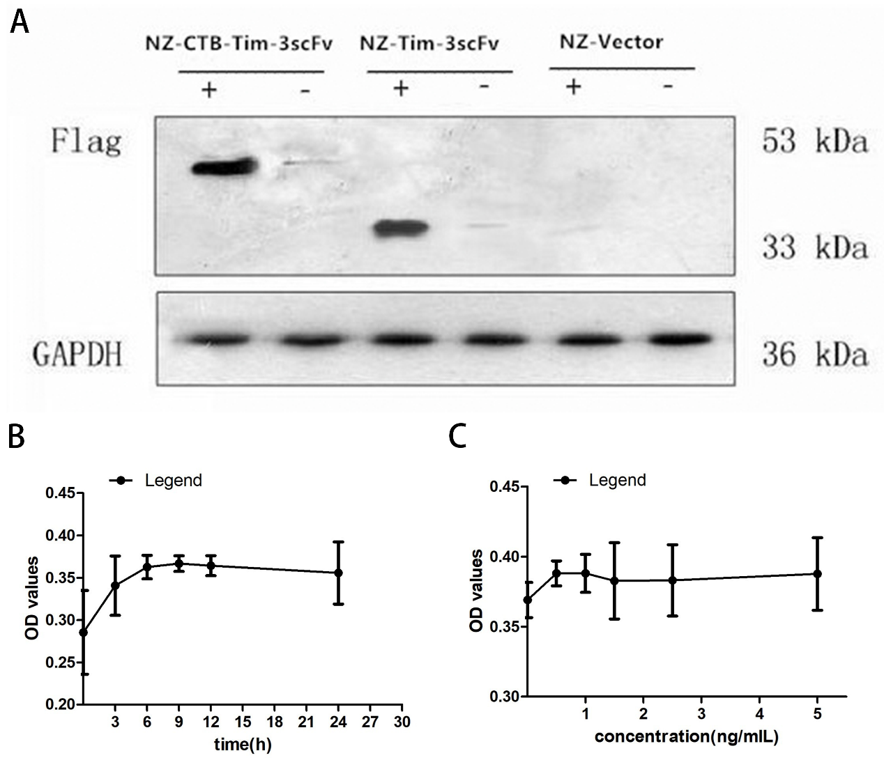
Fig.2 Identification of NZ-CTB-Tim-3scFv, NZ-Tim3scFv, and NZ-Vector by using western blotting. Gene expression was induced in the transformed bacteria NZ-CTB-Tim-3scFv, NZ-Tim3scFv, and NZ-Vector with (+) or without (−) nisin (a). Changes to CTB-Tim3scFv cell expression after different induction times under the same inducer concentration (b). Changes to CTB-Tim3scFv cell expression after different induction concentrations under the same induction times (c).

The following is a description of Fig. 2a
We can't find the uncropped blots. But we have the gray analysis of the WB bands. The software image J is used to analyze the gray level of WB bands in Fig. 2a, and the gray value of each band is obtained
Gray scale analysis of WB bands in Fig. 2a

antibody | Sample |  | 1 |  | 2 | 3 | mean±s.d
Flag | NZ-CTB-Tim-3scFv(+) |  | 2637.85 | 2653.99 |  | 2580.58 | 2624.14±38.57
 | NZ-CTB-Tim-3scFv(-) | 150.57 |  | 138.94 |  | 145.10 | 144.87±5.82
 | NZ- Tim3scFv(+) | 2091.01 |  | 1917.87 |  | 1969.38 | 1992.75±88.91
 | NZ- Tim3scFv(-) | 187.37 |  | 146.15 |  | 169.89 | 167.8±20.69
 | NZ-Vector(+) | 45.06 |  | 50.81 |  | 34.67 | 43.51±8.18
 | NZ-Vector(-) | 34.69 |  | 58.47 |  | 89.58 | 60.91±27.53
GAPDH | NZ-CTB-Tim-3scFv(+) | 2495.92 |  | 2480.96 |  | 2398.65 | 2458.51±52.38
 | NZ-CTB-Tim-3scFv(-) | 2478.55 |  | 2471.86 |  | 2321,60 | 2424±88.75
 | NZ- Tim3scFv(+) | 2482.52 |  | 2484.54 |  | 2469.16 | 2478.74±8.36
 | NZ- Tim3scFv(-) | 2345.04 |  | 2444.04 |  | 2472.14 | 2420.41±66.76
 | NZ-Vector(+) | 2476.55 |  | 2431.76 |  | 2465.44 | 2457.92±23.32
 | NZ-Vector(-) | 2571.04 |  | 2572.15 |  | 2511.73 | 2551.64±34.57

Divide the gray value of the target protein by the gray value of the internal reference strip of the corresponding lane to obtain the data as shown in the table below.
Sample |  | 1 |  | 2 | 3 | mean±s.d
NZ-CTB-Tim-3scFv(+) | 1.057 |  | 1.070 |  | 1.076 | 1.07±0.01
NZ-CTB-Tim-3scFv(-) | 0.061 |  | 0.056 |  | 0.063 | 0.06±0.00
NZ- Tim3scFv(+) | 0.842 |  | 0.772 |  | 0.798 | 0.80±0.04
NZ- Tim3scFv(-) | 0.080 |  | 0.060 |  | 0.069 | 0.07±0.01
NZ-Vector(+) | 0.018 |  | 0.021 |  | 0.014 | 0.02±0.00
NZ-Vector(-) | 0.014 |  | 0.023 |  | 0.036 | 0.02±0.01

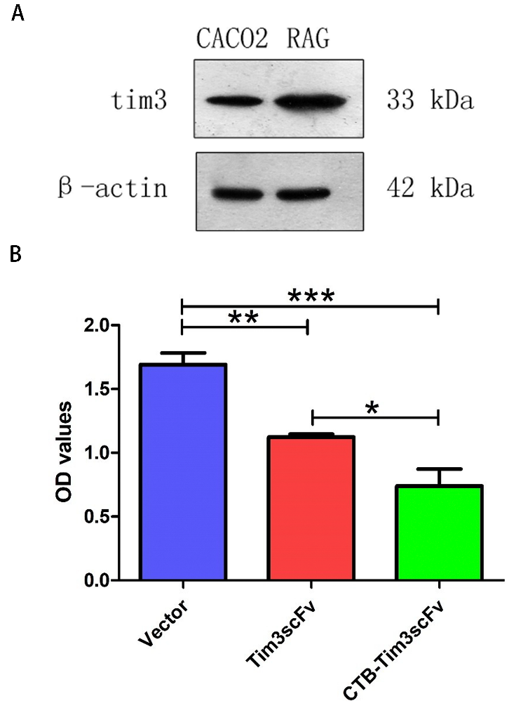
Fig.3 Identification of RAG and CACO₂ using western blotting (a). Proteins expressed by transformants inhibit the proliferation of RAG cells (b).

The following is a description of Fig. 3a
The software image J is used to analyze the gray level of WB bands in Fig. 3a, and the gray value of each band is obtained.

Gray scale analysis of WB bands in Fig. 3a
 | Sample |  | 1 |  | 2 | 3 | mean±s.d
Tim3 | CACO₂ |  | 1932.93 | 2022.85 |  | 2086.39 | 2014.06±77.11
 | RAG | 2669.59 |  | 2578.52 |  | 2666.32 | 2638.14±51.66
β-actin | CACO₂ | 2415.24 |  | 2438.98 |  | 2442.57 | 2432.26±14.85
 | RAG | 2311.35 |  | 2328.49 |  | 2427.37 | 2355.74±62.63

Divide the gray value of the target protein by the gray value of the internal reference strip of the corresponding lane to obtain the data as shown in the table below.
Sample |  | 1 |  | 2 | 3 | mean±s.d
CACO₂ | 0.800 |  | 0.829 |  | 0.854 | 0.828±0.03
RAG | 1.155 |  | 1.107 |  | 1.092 | 1.12±0.03

