Supplementary Fig. 1. Color parameters of bread crust (upper panels) and crumb (lower panels) for all formulations: (a) L* (lightness), (b) a* (redness), (c) b* (yellowness). Data represent mean ± SD (n=3)
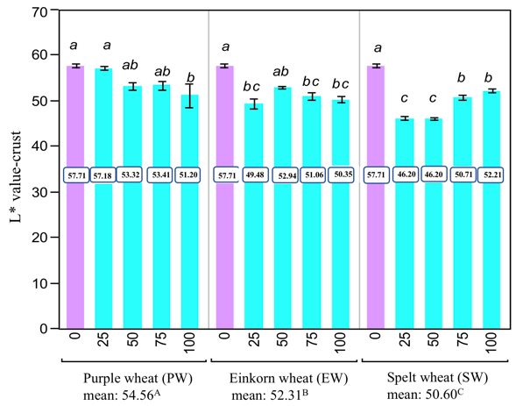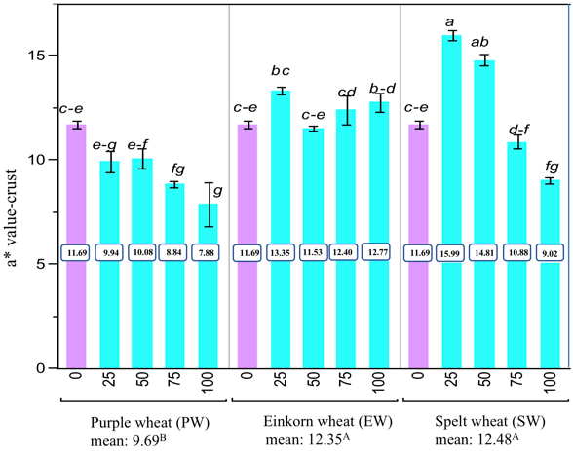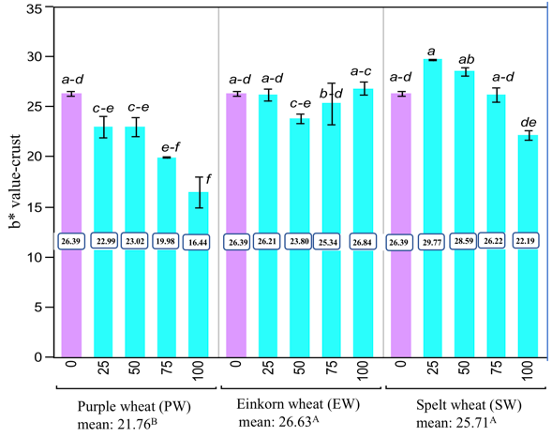
a) b) c)
