Figure S1. Daily watering levels of all 264 plants during the water deficit treatment. Seven days after germination (DAG), watering was withheld to reach 30% of the water holding capacity (WHC) by 21 DAG (orange dotted line), and the well watered control (blue dotted line) was maintained at 80% of the WHC. The solid blue and orange lines indicate the pot estimated WHC measured by weighing every pot before daily watering. The black dotted vertical line indicates the DAG when drought treatment was reached, the red dotted vertical line indicates when water deficit treatment was set at 20% WHC, and the blue vertical dotted line indicates when stress was set back to 30% WHC.
Figure S2. (a) FishEyeMask images showing the side views of the Kokkosenkyla and Käarra genotypes under both well watered (WHC-80%) and drought conditions (WHC-30%). (b) Background excluded images showing the top view canopy areas of the Sairalame0503 and Romfartuna genotypes under well watered (WHC-80%) and water deficit conditions (WHC-30%).
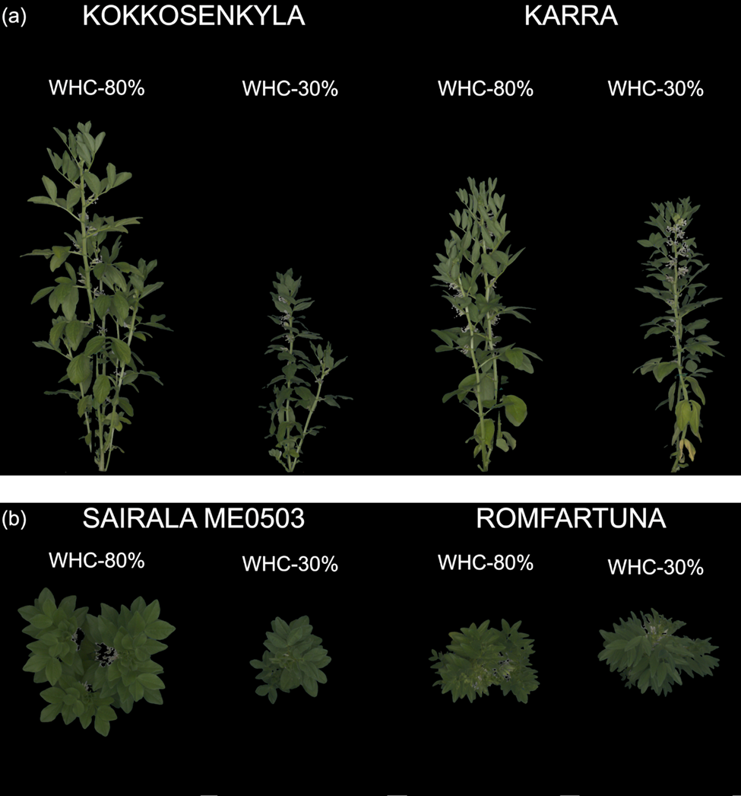

Figure S3. Smooth curves from generalized additive model (GAM) analysis showing the dynamics of plant height trajectory for 44 faba bean genotypes. Each curve represents the modelled growth of a genotype across days after germination (DAG). Observed means and standard deviations are overlaid to illustrate variation around the modelled trends. Plant height is shown in centimetres for the two water WHC treatments: blue lines represent 80% WHC and orange lines represent 30% WHC, allowing visualization of differences among genotypes and treatments throughout the time course.
Figure S4. Pointwise difference between plant height under well watered and water-deficit conditions across days after germination (DAG) for each faba bean genotype. Differences were considered significant when the 95% confidence interval of the water-deficit treatment did not overlap zero. The first day of significant divergence was recorded as the drought impact day for each genotype. Red lines at the bottom of the plot indicate periods with significant differences at the 95% confidence level.

Figure S5. Smooth curves from generalized additive model (GAM) analysis showing the dynamics of digital biomass trajectory for 44 faba bean genotypes. Each curve represents the modelled growth of a genotype across days after germination (DAG). Observed means and standard deviations are overlaid to illustrate variation around the modelled trends. Digital Biomass is shown in arbitrary volume for the two Water Holding Capacity (WHC) treatments: blue lines represent 80% WHC and red lines represent 30% WHC, allowing visualization of differences among genotypes and treatments throughout the time course.

