Supplementary Figure 1: Characterization of ARID1B deficient iPSC lines. (a) Sequencing results of exon 9. (b) Relative ARID1B mRNA level in the derived cell lines measured by qPCR. (c) Western blot quantifying ARID1B protein level in the ARID1B WT and HET iPSCs. (d) Microscopic image of WT and KO ARID1B NPCs. (e) Growth rates of ARID1B WT, HET and KO NPCs. (f) MA plot showing gene expression changes between ARID1B HET and KO datasets. Genes with |log2 (Fold Change)|>0.5 and adjusted p-value < 0.05 are colored in red. (g) PANTHER Pathways enrichment analysis for upregulated (top) and downregulated (bottom) genes in ARID1B KO NPCs relatively to the WT at Day 40 after start of hESCs differentiation to NPCs. Genes for Wnt and TGF-beta signaling pathways are labeled.

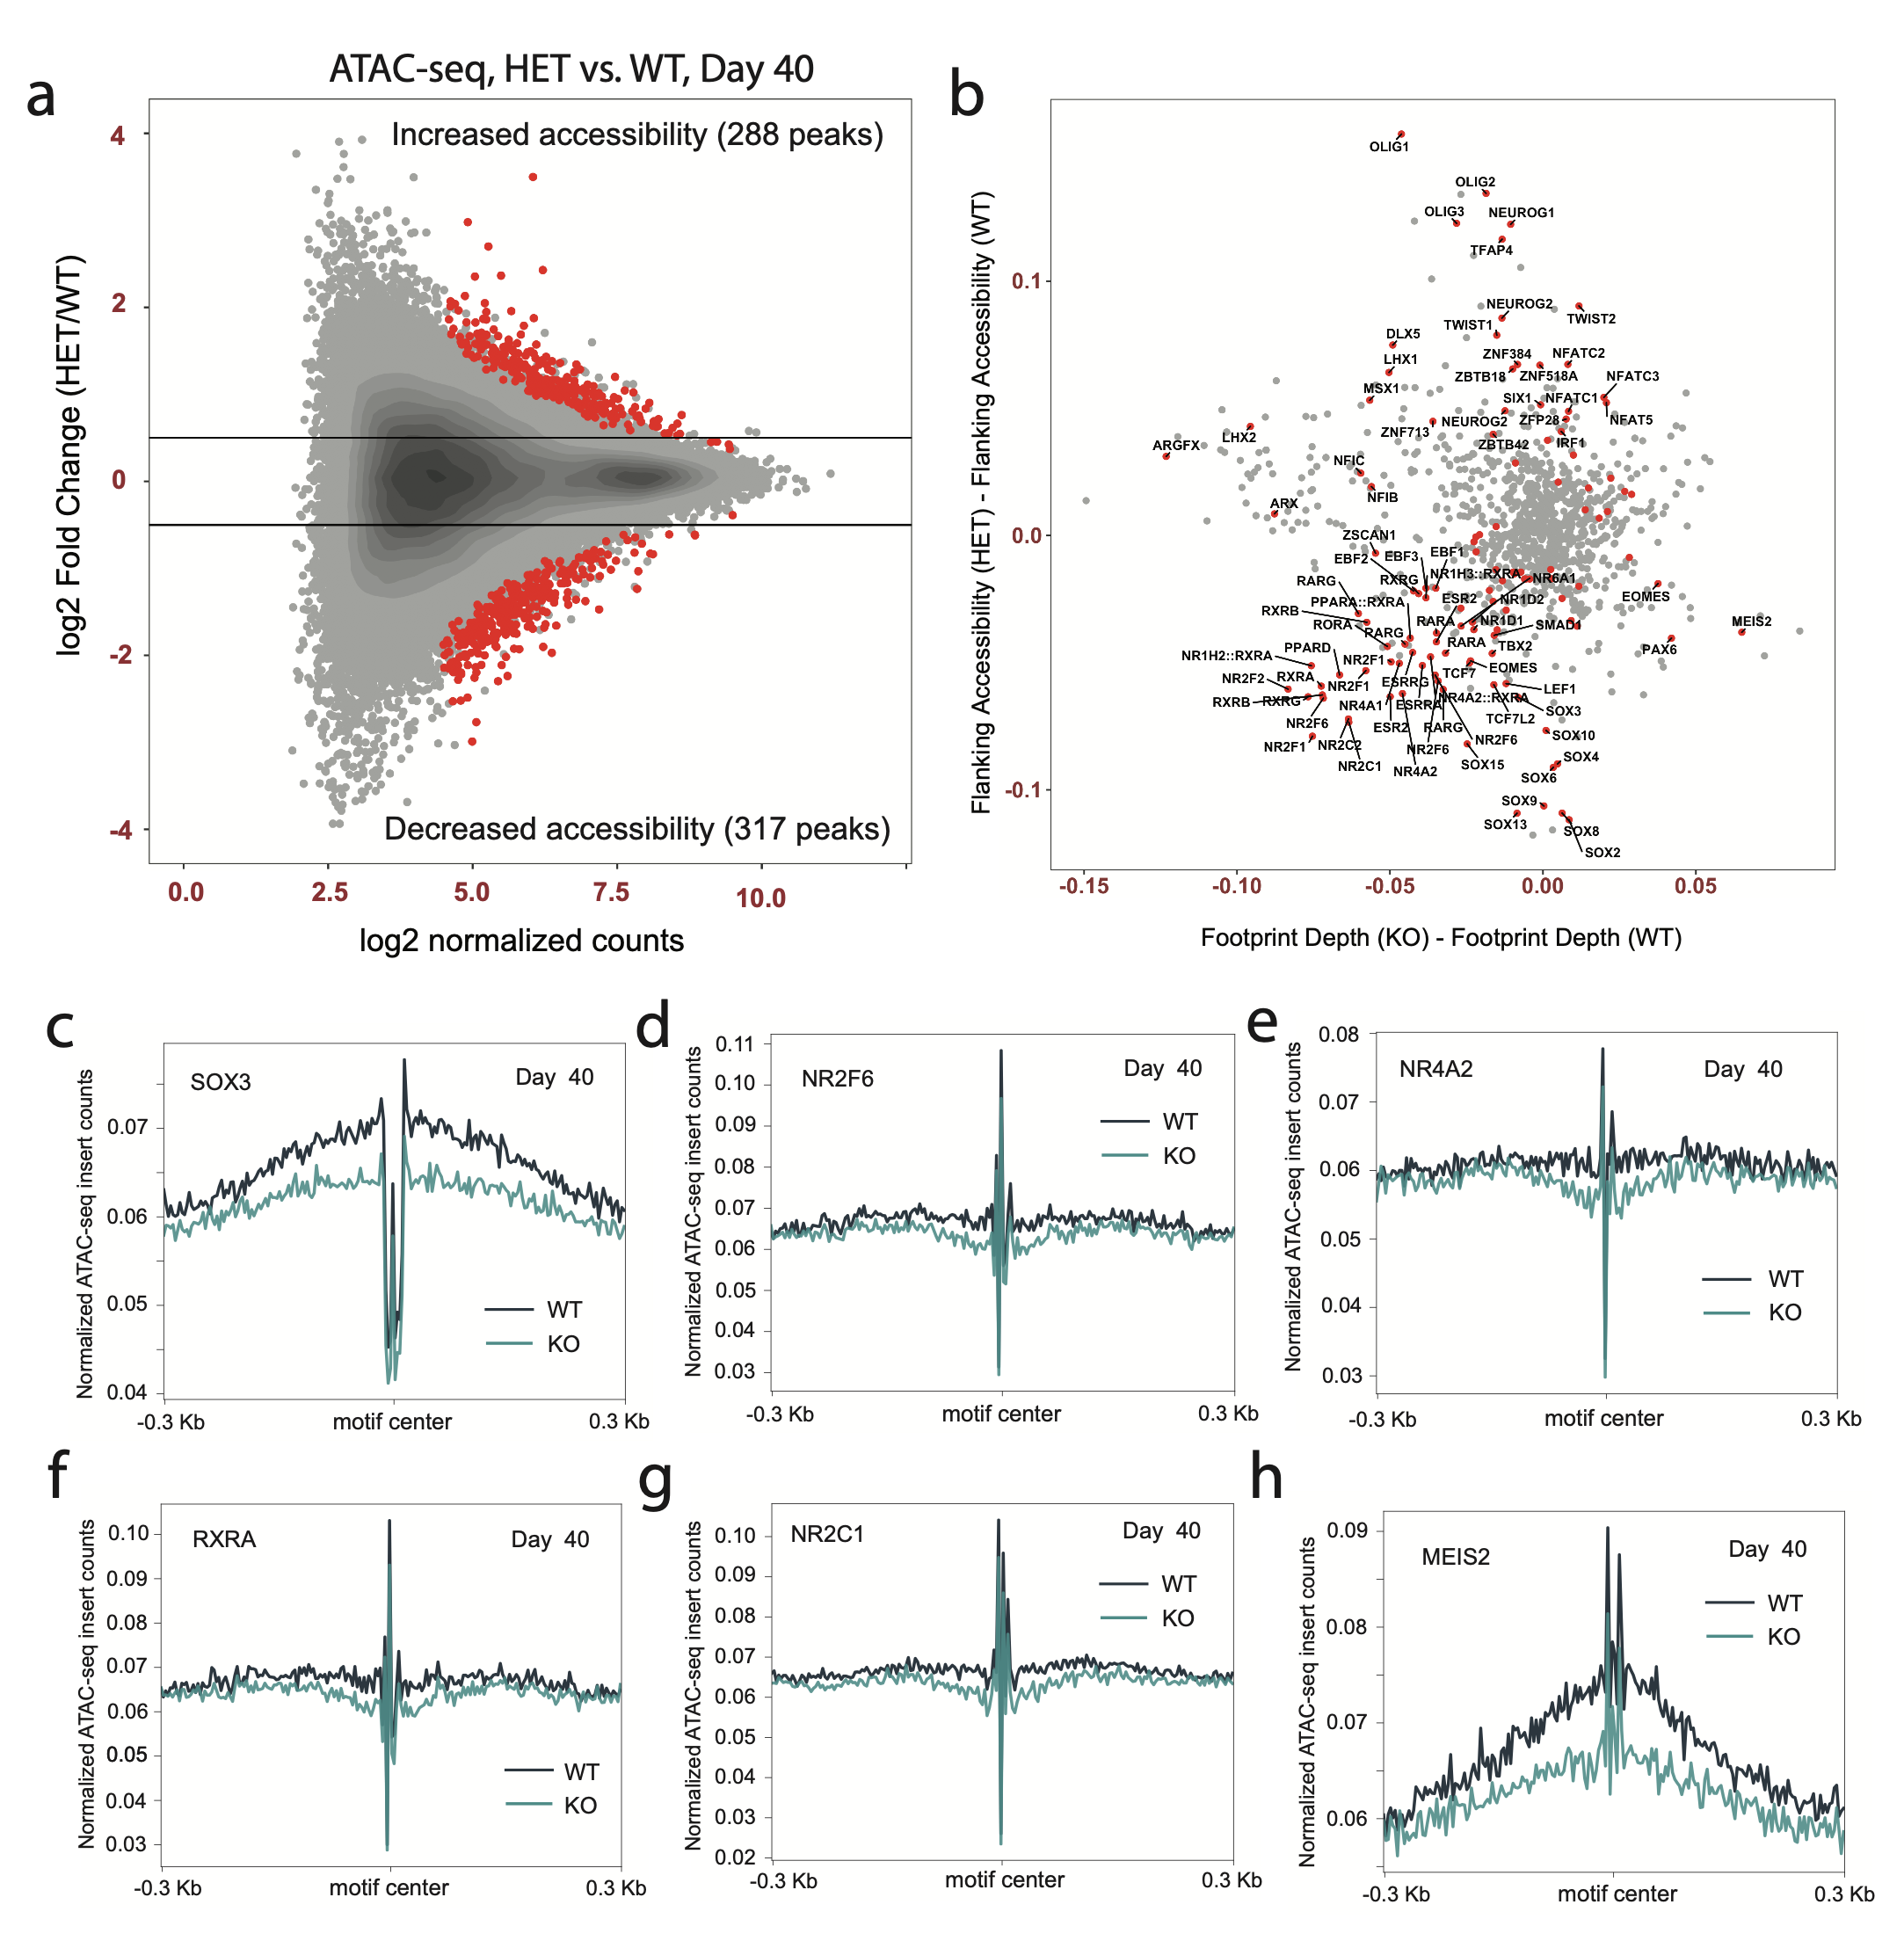
Supplementary Figure 2: ATAC-seq data. (a) MA plot showing changes of accessibility between ARID1B WT and HET datasets at Day 40 after start of hESCs differentiation to NPCs. Peaks with |log2 (Fold Change)|>0.5 and adjusted p-value < 0.05 are colored in red. (b) Changes of Flanking Accessibility and Footprint Depth between ARID1B WT and HET NPCs at Day 40. Motifs with adjusted p-value < 0.05 corresponding to genes with at least minimal expression at NPCs are colored in red. The minimal expression is defined from RNA-seq data as expression exceeding a random threshold in 50 normalized counts calculated by DESeq2 (Love et al., 2014). (c) Accessibility profile of SOX3, (d) NR2F6, (e) NR4A2, (f) RXRA, (g) NR2C1, and (h) MEIS2.

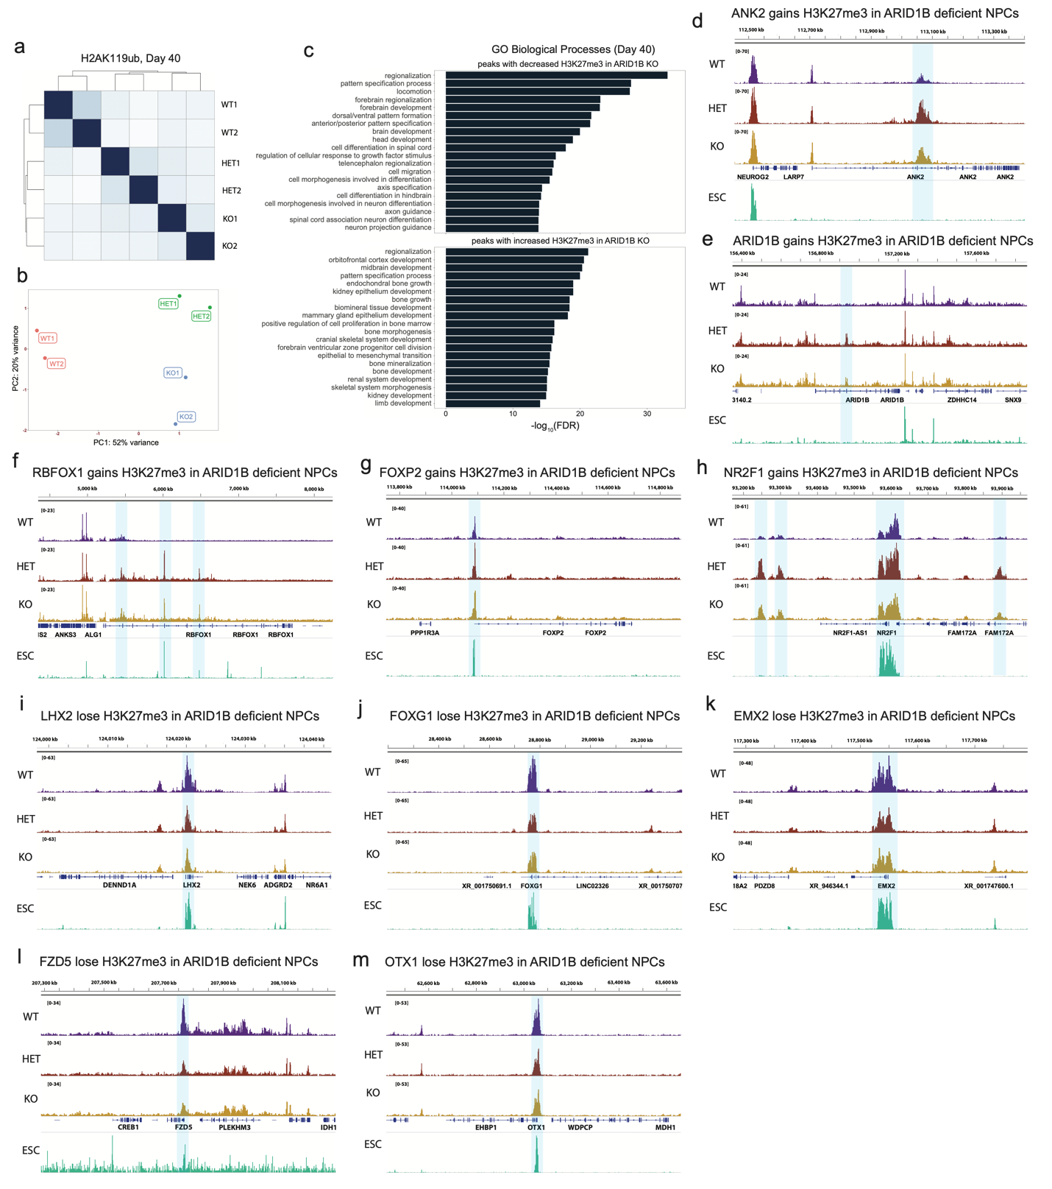
Supplementary Figure 3: H3K27me3 and H2AK119ub data. (a) Correlation between H2AK119ub Cut&Run datasets at Day 40 (b) Principal component analysis of H2AK119ub Cut&Run datasets at Day 40. (c) Gene Ontology Biological Processes associated with H3K27me3 peaks altered upon ARID1B knock out. (d) Genomic tracks of H3K27me3 in ANK2, (e) ARID1B, (f) RBFOX1, (g) FOXP2, and (h) NR2F1 genes exhibiting gain of H3K27me3 level. (i) Genomic tracks of H3K27me3 in LHX2, (j) FOXG1, (k) EMX2, (l) FZD5, and (m) OTX1 genes exhibiting loss of H3K27me3 level. Blue bands highlight regions with altered H3K27me3 peaks.
Supplementary Figure 4: Examples of genes with high expression change but minor change in H3K27me3 level in the gene promoter: (a) EN1, (b) EN2, (c) CDX2, (d) WNT1, (e) LMX1A, (f) LMX1B, (g) RSPO2, (h) GDF7, (j) DMRT3.

Supplementary Figure 5: H3K27me3 coverage tracks for (a) HOXB, (b) HOXC, (c) HOXD loci at Day 40 and Day 60 after start of neural induction. The results of WT and KO H3K27me3 coverage tracks subtraction are shown at the bottom of the coverage tracks. SMARCA4 coverage track for the WT NPCs are also shown.

