Supporting information
A Novel 1D Helical Coordination Polymer Based on Cu²⁺/L-Arginine-Schiff Base: Structure and Supramolecular Insights

Dr. Syed meheboob Elahi*ª
Department of Applied Science and Humanities
Bengal Institute of Technology and Management, Santiniketan
Dwaranda, BYPASS P.O, Sriniketan, West Bengal 731236
meheboob.elahi@gmail.com
Orcid ID: 0000-0002-7418-2770

Figure S1. FT-IR spectra for ligand SalArgH₂
Figure S1. FT-IR spectra of 1D coordination polymer (CuAr)

Figure S3. PXRD pattern match showing sample purity in the bulk phase.

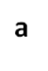  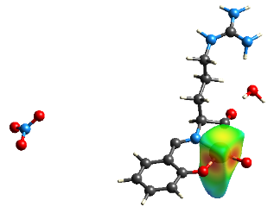 | 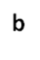  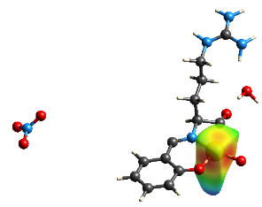
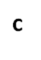  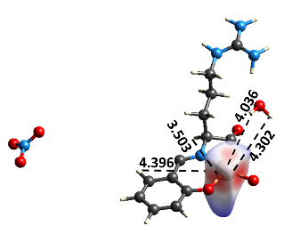 | 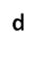  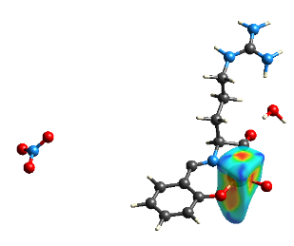
Figure S4. Hirshfeld surface representations around Cu²⁺ ion (a) d_{e} (0.5909 to 2.7753) (b) d_{i} (0.5924 to 2.7753) (c) d_{norm} (-1.1930 to 1.4638) (d) shape index (-1.0000 to 1.0000)

