Supplementary File

Contents:
- Page 2= Supplementary Table 1: Demographics and sleep study parameters of cohort included within this study as compared to those who were lost to follow-up.
- Page 3= Supplementary Table 2: Demographics of study cohort
- Page 4= Supplementary Table 3: Additional imaging data parameters at baseline and follow-up for the (compliant)_NPPV dataset.
- Page 5= Supplementary Table 4: Number of patients above various threshold values for magnitude in percentage changes in facial convexity angle, categorised by craniofacial status and OSA severity at baseline.
- Page 6= Supplementary Figure 1: Correlation graphs for the percent change in facial angle of convexity with duration between images, and the age at follow-up.

Supplementary Table 1: Demographics and sleep study parameters of cohort included within this study as compared to those who were lost to follow-up or did not have a follow-up 3D image from our 1st study*.
 | Included cohort (n-18) | Cohort excluded* (n=95)
 | Mean ± SD |  | Mean ± SD |  | P-value
Age at time of photo (years) | 3.5 ± 3.9 |  | 4.5 ± 4.8 |  | 0.39
Weight (kg) | 15.6 ± 12.0 |  | 21.9 ± 22.3 |  | 0.24
Height (cm) | 86.5 ± 32.5 |  | 96.1 ± 38.1 |  | 0.32
AHI | 23.5 ± 24.8 |  | 22.4 ± 23.8 |  | 0.86
OAHI | 13.6 ± 18.4 |  | 17.1 ± 18.9 |  | 0.47
Baseline SpO₂(%) | 96.3 ± 2.0 |  | 95.9 ± 2.9 |  | 0.47
Min SpO₂(%) | 84.1 ± 8.6 |  | 84.7 ± 11.3 |  | 0.80
Baseline TcCO₂(%) | 47.5 ± 6.2 |  | 45.4 ± 5.0 |  | 0.13
Max TcCO₂(%) | 54.1 ± 8.0 |  | 52.5 ± 9.5 |  | 0.49
Mean facial convexity angle (°) | 167.9 ± 6.4 |  | 165.1 ± 7.3 |  | 0.13

 | Included cohort herein |  | Cohort excluded*
Category | Frequency (n) | Percentage (%) | Frequency (n) | Percentage (%) | P value#
Sex
Male | 10 | 56 | 55 | 58 | 0.85
Female | 8 | 44 | 40 | 42
Age at 3D imaging at baseline
0-<6 months | 7 | 39 | 28 | 29 | 0.77
6-<12 months | 2 | 11 | 9 | 9
1-<6 years | 4 | 22 | 25 | 26
6-<12 years | 5 | 28 | 25 | 26
>12-18 years | 0 | 0 | 8 | 8
OSA Severity at baseline
OAHI negative | 2 | 11 | 10 | 11 | 0.88
Mild | 3 | 17 | 19 | 20
Moderate | 4 | 22 | 14 | 15
Severe | 9 | 50 | 52 | 55
Craniofacial Status
No craniofacial Abnormality | 11 | 61 | 78 | 82 | 0.30
Craniofacial Abnormality | 7 | 39 | 17 | 18
* Cohort of children who were in our first study (J Clin Sleep Med. 2023;19(2):275-282 https://link.springer.com/article/10.5664/jcsm.10312 ) but did not have a follow-up 3D imaging and as such, were excluded from this study.
# Pearson Chi-Square
AHI = apnoea hypopnea index, OAHI = obstructive apnoea hypopnea index, SpO₂ = oxyhaemoglobin saturation, TcCO₂= transcutaneous carbon dioxide, SD= standard deviation.
Supplementary Table 2: Demographics of study cohort
Category | Frequency (n) | Percentage (%)
Sex
Male | 10 | 56
Female | 8 | 44
Age at 3D imaging at baseline
0-<6 months | 7 | 39
6-<12 months | 2 | 11
1-<6 years | 4 | 22
6-<12 years | 5 | 28
OSA Severity at baseline
OAHI negative | 2 | 11
Mild | 3 | 17
Moderate | 4 | 22
Severe | 9 | 50
Ethnicity
Caucasian | 10 | 56
Asian | 5 | 28
Middle Eastern or African | 3 | 17
Craniofacial Status
No craniofacial Abnormality | 11 | 61
Craniofacial Abnormality | 7 | 39
NPPV use
CPAP | 12 | 67
BIPAP | 3 | 17
Not used | 3 | 17
Compliance status of NPPV use
Compliant | 13 | 72
Non-Compliant (including those who did not use NPPV) | 5 | 28

Supplementary Table 3: Additional imaging data parameters at baseline and follow-up for the (compliant)_NPPV dataset.

 | Baseline |  | Follow-up |  | Difference |  | 95% Confidence Interval
 | Mean ± SD | Median | Mean ± SD | Median | Mean | Median | Lower bound | Upper bound | P value
Nasion to Menton (mm)
All cohort (n=10) | 83.3 ± 17.3 | 84.7 | 94.2 ± 13.0 | 89.4 | 9.0 ± 8.3 | 8.7 | 1.6 | 16.4 | 0.01
Non-craniofacial subset (n=6) | 82.1 ±19.6 | 78.2 | 96.3 ± 15.0 | 89.4 | 11.0 ± 8.5 | 10.5 | 1.6 | 22.4 | 0.06
Craniofacial subset (n=4) | 85.1 ± 15.8 | 86.5 | 91.6 ± 11.7 | 91.2 | 6.4 ± 8.4 | 4.7
Nasion to Subnasale (mm)
All cohort (n=10) | 38.9 ± 7.9 | 38.8 | 44.2 ± 6.5 | 42.3 | 4.6 ± 7.1 | 5.7 | -1.2 | 11.0 | 0.16
Non-craniofacial subset (n=6) | 37.8 ± 9.3 | 35.4 | 44.6 ± 6.3 | 42.3 | 5.8 ± 7.3 | 6.4 | -1.5 | 16.2 | 0.31
Craniofacial subset (n=4) | 40.6 ± 6.1 | 41.0 | 43.8 ± 7.7 | 40.7 | 3.2 ± 7.5 | 2.7
Subnasale to Menton (mm)
All cohort (n=9) | 45.9 ± 11.2 | 45.9 | 53.1 ± 9.3 | 53.1 | 6.1 ± 5.8 | 6.1 | 1.7 | 11.3 | 0.02
Non-craniofacial subset (n=5) | 47.0 ± 13.1 | 44.3 | 53.7 ± 11.3 | 53.6 | 4.5 ± 3.8 | 4.6 | -1.3 | 8.2 | 0.13
Craniofacial subset (n=4) | 44.2 ± 9.4 | 45.9 | 52.4 ± 7.8 | 51.2 | 8.2 ± 7.7 | 7.7
Nose Base Width (mm)
All cohort (n=9) | 17.2 ± 3.1 | 16.5 | 20.6 ± 3.8 | 19.6 | 3.0 ± 3.5 | 2.9 | 0.6 | 6.1 | 0.02
Non-craniofacial subset (n=5) | 16.8 ± 3.5 | 15.7 | 21.1 ± 4.7 | 20.4 | 3.7 ± 4.5 | 1.3 | -0.1 | 10.9 | 0.13
Craniofacial subset (n=4) | 17.8 ± 2.8 | 17.5 | 20.0 ± 3.0 | 19.0 | 2.2 ± 2.0 | 3.0

Supplementary Table 4: Number of patients above various threshold values for magnitude in percentage changes in facial convexity angle, categorised by craniofacial status and OSA severity at baseline.
 | Patient exceeding threshold (%)
Threshold* | >1% | >3.5% | >5%
Craniofacial Status
Entire Cohort
NPPV (n=13) | 85 | 46 | 31
NC control (n=5) | 60 | 0 | 0
No Craniofacial Abnormality
NPPV (n=9) | 89 | 67 | 44
NC control (n=2) | 100 | 0 | 0
Craniofacial Abnormality
NPPV (n=4) | 75 | 25 | 0
NC control (n=3) | 67 | 0
OSA Severity at Baseline
Entire Cohort (n=18)
Mild (n=4) | 100 | 25 | 25
Moderate (n=5) | 80 | 20 | 20
Severe (n=9) | 67 | 56 | 22
NPPV (n=13)
Mild (n=2) | 100 | 50 | 50
Moderate (n=4) | 75 | 25 | 25
Severe (n=7) | 86 | 71 | 29
NC Control (n=5)
Mild (n=2) | 100 | 0 | 0
Moderate (n=1) | 100 | 0 | 0
Severe (n=2) | 0 | 0 | 0
*Includes negative percentage change

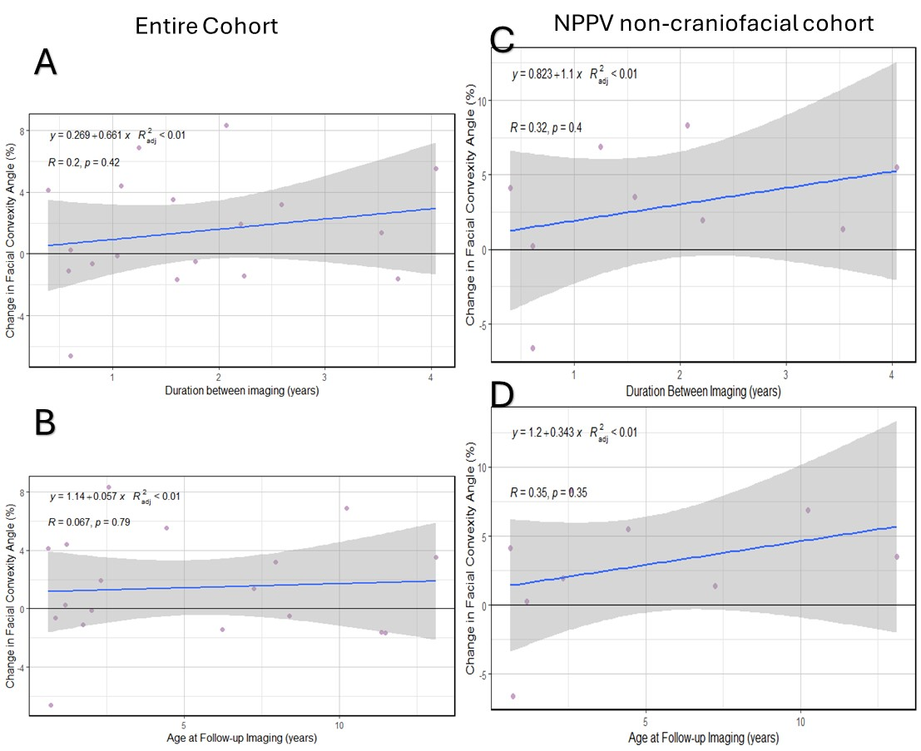

Supplementary Figure 1: Correlation graphs for the percent change in facial angle of convexity with (A & C) duration between imaging (photos 2 and 1), and (B & D) the age at follow-up, for (A&B) entire cohort regardless of NPPV use and craniofacial status (n=18), and (C&D) NPPV non-craniofacial cohort (n=9).

