Figure S1. Kaplan-Meier survival curves for IBR854-treated subjects
Kaplan–Meier curves depicting (a) progression-free survival (PFS) and (b) overall survival (OS) in the FAS cohort (n=16), stratified by IBR854 dose level (3.0×10⁹, 5.0×10⁹, 7.0×10⁹, 9.0×10⁹, 12.0×10⁹ viable cells per infusion). The horizontal axis represents time post-first infusion (days); the vertical axis denotes survival probability. Censored data points (subjects without event at data cutoff) are marked with “+”. For each cohort, the number of events (PFS: disease progression; OS: all-cause death), median survival time (with 95% confidence interval, CI) and log-rank test p-value (p=0.3504 for PFS; p=0.2534 for OS) are annotated. The number of subjects at risk at key time points is listed at the bottom of each panel, quantifying cohort-specific follow-up attrition.

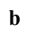
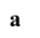
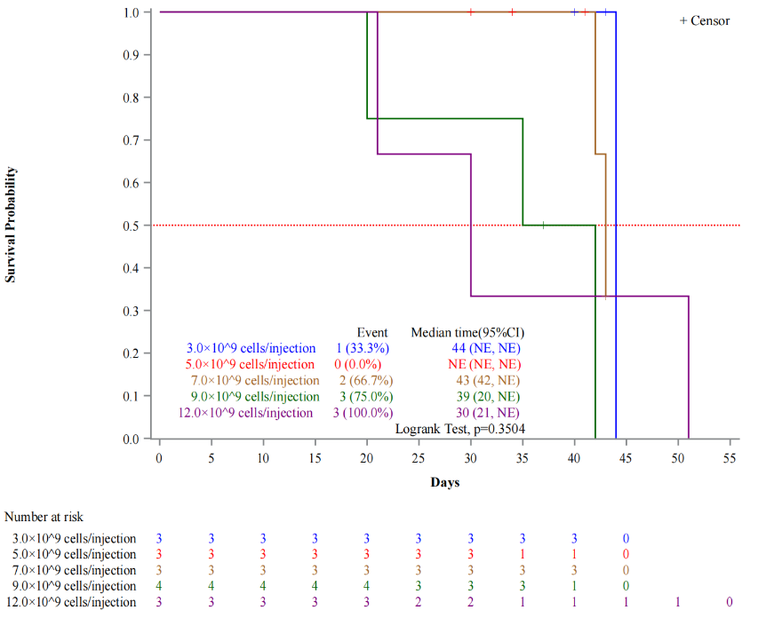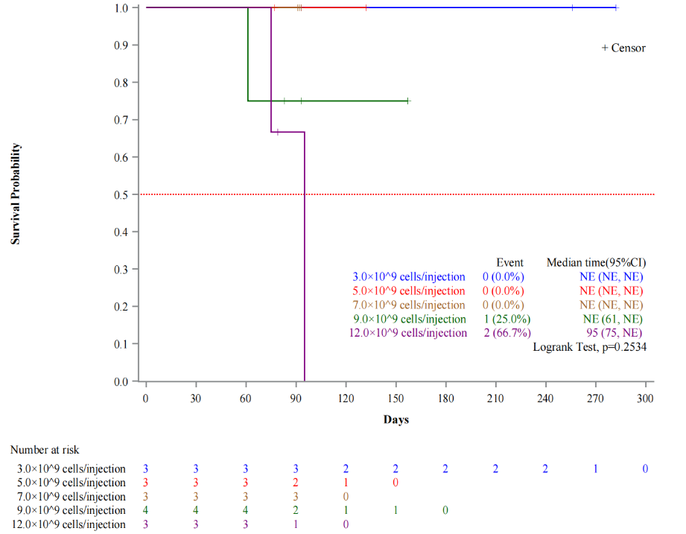

Figure S2. Dose-dependent pharmacokinetic parameter distributions of IBR854
Box-and-whisker plots illustrating the relationship between IBR854 dose and key PK parameters (log-transformed scale, by cell copy number) for (a-b) first infusion and (c-d) multiple infusions (C1D1 and C1D8). Panels (a, c) show peak concentration (C_{max}); panels (b, d) show area under the concentration-time curve from 0 to 7 days (AUC_{0-7d}). Boxes represent interquartile range (IQR, 25th-75th percentile), horizontal lines denote median values, whiskers extend to 1.5×IQR, and individual data points represent outliers. The plots compare parameter distributions across the five dose cohorts (3.0×10⁹ to 12.0×10⁹ viable cells per infusion), with the analysis limited to subjects with complete PK parameter data.
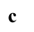
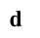
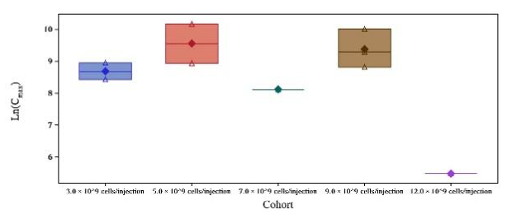

Figure S3. Temporal changes in circulating IL-6 and IFN-γ concentrations following treatment
Circulating levels of IL-6 and IFN-γ were measured at predefined study timepoints, including baseline, Cycle 1 Day 8 (C1D8), Cycle 2 Day 1 (C2D1), and Cycle 2 Day 8 (C2D8). Data are presented as mean ± standard deviation (SD) for IL-6 and mean values for IFN-γ. Sample sizes at each timepoint were as follows: IL-6 (n=3, 3, 1, and 1) and IFN-γ (n=1 at all timepoints).
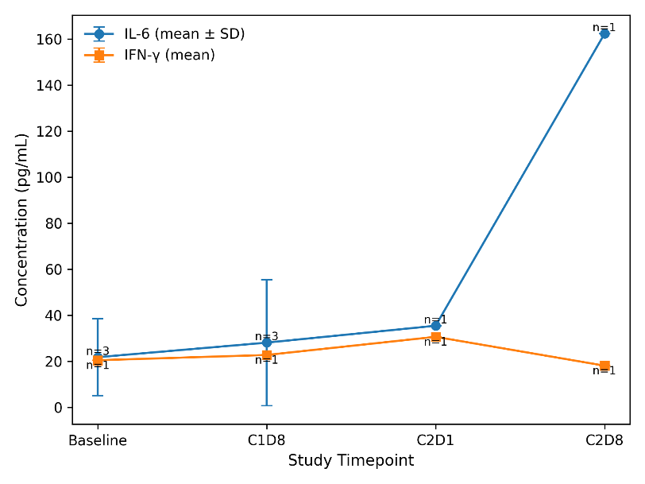

Supplementary Table 1. Inclusion and exclusion criteria
Category | Specific Criteria
Inclusion criteria | 1. Aged 18–75 years (inclusive) at the time of informed consent form (ICF) signing, with full capacity to understand and comply with the study protocol.
Inclusion criteria | 2. Histologically or cytologically confirmed unresectable locally advanced or metastatic solid tumors, with no standard effective treatment options available or progressive disease after standard treatment.
Inclusion criteria | 3. At least one measurable target lesion per Response Evaluation Criteria in Solid Tumors (RECIST) v1.1 (lesion longest diameter ≥10 mm for computed tomography/magnetic resonance imaging, or ≥15 mm for ultrasound).
Inclusion criteria | 4. Eastern Cooperative Oncology Group (ECOG) performance status of 0 or 1 (able to perform daily activities without restriction or with mild restriction, respectively).
Inclusion criteria | 5. Expected survival ≥3 months from the first dose of study drug, as assessed by the principal investigator (PI).
Inclusion criteria | 6. Adequate organ function (laboratory tests within 14 days before enrollment):  6.1 Absolute neutrophil count (ANC) ≥1.5×10⁹/L (without granulocyte colony-stimulating factor support within 7 days prior)  6.2 Platelet count (PLT) ≥75×10⁹/L (without platelet transfusion within 7 days prior)  6.3 Hemoglobin (HGB) ≥80 g/L (without red blood cell transfusion within 7 days prior)  6.4 Total bilirubin ≤1.5×upper limit of normal (ULN); aspartate aminotransferase (AST)/alanine aminotransferase (ALT) ≤2.5×ULN (≤5×ULN for patients with liver metastases)  6.5 Serum creatinine ≤1.5×ULN or estimated glomerular filtration rate ≥50 mL/min/1.73 m² (by Modification of Diet in Renal Disease formula)  6.6 International normalized ratio (INR) ≤1.5×ULN and activated partial thromboplastin time (APTT) ≤1.5×ULN (without anticoagulant use within 7 days prior, unless on stable-dose low-molecular-weight heparin).
Inclusion criteria | 7. For patients of childbearing potential (female: premenopausal or postmenopausal with menopause duration <12 months; male: with fertile partners): Agreement to use effective contraception (e.g., barrier method + oral contraceptive, intrauterine device) from screening to 6 months after the last dose of IBR854.
Inclusion criteria | 8. Voluntary signing of the ICF after full disclosure of study details, risks, and benefits.
Exclusion criteria | 1. History of other malignant tumors within 5 years prior to enrollment (except cured non-melanoma skin cancer, carcinoma in situ of the cervix, or localized prostate cancer with stable disease after treatment).
Exclusion criteria | 2. Active central nervous system (CNS) metastases or leptomeningeal disease (symptomatic, or requiring corticosteroid/anticonvulsant treatment within 2 weeks prior; asymptomatic, untreated CNS metastases with longest diameter <10 mm may be considered by the PI).
Exclusion criteria | 3. History of severe autoimmune disease (e.g., systemic lupus erythematosus, rheumatoid arthritis requiring high-dose glucocorticoids ≥10 mg/day prednisone equivalent) or active autoimmune disease within 6 months prior.
Exclusion criteria | 4. Active infection (e.g., bacterial/fungal infection requiring systemic antibiotics/antifungals, or viral infection such as hepatitis B virus [HBV, HBsAg positive with HBV DNA ≥2000 IU/mL], hepatitis C virus [HCV, HCV RNA positive], human immunodeficiency virus [HIV, HIV-1/HIV-2 antibody positive]) within 2 weeks prior to enrollment.
Exclusion criteria | 5. History of severe hypersensitivity reactions (e.g., anaphylaxis) to monoclonal antibodies, NK cells, or any component of the IBR854 formulation.
Exclusion criteria | 6. Pregnancy, lactation, or refusal to use effective contraception (for patients of childbearing potential, as defined in Inclusion Criterion 7).
Exclusion criteria | 7. Major surgical procedure (e.g., abdominal/thoracic surgery) within 4 weeks prior to the first dose, or unresolved wound healing complications from prior surgery.
Exclusion criteria | 8. Prior receipt of cell-based immunotherapies (e.g., chimeric antigen receptor T cells [CAR-T], other NK cell therapies) within 3 months prior to enrollment, or prior receipt of immune checkpoint inhibitors (e.g., anti-PD-1/PD-L1) within 2 weeks prior.
Exclusion criteria | 9. Presence of uncontrolled comorbidities: severe cardiovascular disease (e.g., myocardial infarction within 6 months prior, New York Heart Association [NYHA] class III/IV heart failure), severe pulmonary disease (e.g., chronic obstructive pulmonary disease [COPD] with forced expiratory volume in 1 second [FEV1] <50% predicted), or uncontrolled hypertension (systolic blood pressure >160 mmHg or diastolic blood pressure >100 mmHg despite medication).
Exclusion criteria | 10. Any condition judged by the PI to render the patient unsuitable for study participation (e.g., poor compliance potential, severe psychiatric disease).

Supplementary Table 2. Definition of Dose Limit Toxicity
DLT Category | Specific Criteria | Grading/Judgment Basis
Hematological Toxicity | 4-grade neutropenia (ANC) lasting > 5 days | NCI CTCAE V5.0
Hematological Toxicity | ≥ 3-grade febrile neutropenia | NCI CTCAE V5.0
Hematological Toxicity | 4-grade thrombocytopenia | NCI CTCAE V5.0
Hematological Toxicity | 3-grade thrombocytopenia accompanied by bleeding | NCI CTCAE V5.0
Hematological Toxicity | 4-grade anemia | NCI CTCAE V5.0
Non-hematological Toxicity | ≥ 3-grade non-hematological toxicity (exceptions: a. Asymptomatic laboratory abnormalities without clinical intervention; b. Asymptomatic laboratory abnormalities resolving to ≤ 2 grade within 7 days; c. 3-grade non-hematological toxicity resolving to ≤ 2 grade within 14 days after treatment) | NCI CTCAE V5.0
Non-hematological Toxicity | ≥ 3-grade Cytokine Release Syndrome (CRS) | 2018 American Society for Transplantation and Cellular Therapy (ASTCT) consensus criteria
Other Toxicity | Toxicity leading to permanent discontinuation of the study drug | Clinical judgment by investigators
Other Toxicity | Toxicity resulting in delay of the second study drug infusion by > 7 days during the DLT observation period | Clinical judgment by investigators

Supplementary Table 3. Overview of safety and treatment-emergent adverse events
Category | Patients, n (%)
Any treatment-emergent adverse event (TEAE) | 19 (100.0)
Treatment-related adverse event (TRAEs) | 16 (84.2)
Grade ≥3 TEAEs | 5 (26.3)
Grade ≥3 TRAEs | 1 (5.3)
Serious adverse events (SAEs) | 3 (15.8)
Drug-related SAEs (SARs) | 1 (5.3)
Cytokine release syndrome (CRS) | 2 (10.5)
Grade ≥3 CRS | 0

TEAEs were defined as adverse events occurring after treatment initiation. TRAEs were defined as treatment-related adverse events. SAEs were defined according to standard criteria. CRS was graded per ASTCT criteria, and all adverse events were graded according to CTCAE version 5.0

Supplementary Table 4. Mean KIR/HLA mismatch score
Center | Subject ID | Dose Group | Mean KIR/HLA Mismatch Score of Subjects
Cancer Hospital, Chinese Academy of Medical Sciences | 1002 | 3.0×10^9 viable cells/dose | 2
Cancer Hospital, Chinese Academy of Medical Sciences | 1004 | 3.0×10^9 viable cells/dose | 1
Sir Run Run Shaw Hospital, School of Medicine, Zhejiang University | 2001 | 3.0×10^9 viable cells/dose | 2
Cancer Hospital, Chinese Academy of Medical Sciences | 1006 | 5.0×10^9 viable cells/dose | 2
Sir Run Run Shaw Hospital, School of Medicine, Zhejiang University | 2002 | 5.0×10^9 viable cells/dose | 1.67
Linyi Cancer Hospital | 3004 | 5.0×10^9 viable cells/dose | 1.83
Cancer Hospital, Chinese Academy of Medical Sciences | 1009 | 7.0×10^9 viable cells/dose | 2
Sir Run Run Shaw Hospital, School of Medicine, Zhejiang University | 2003 | 7.0×10^9 viable cells/dose | 0.5
Linyi Cancer Hospital | 3005 | 7.0×10^9 viable cells/dose | 1.5
Cancer Hospital, Chinese Academy of Medical Sciences | 1012 | 9.0×10^9 viable cells/dose | 2.33
Cancer Hospital, Chinese Academy of Medical Sciences | 1014 | 9.0×10^9 viable cells/dose | 2
Sir Run Run Shaw Hospital, School of Medicine, Zhejiang University | 2006 | 9.0×10^9 viable cells/dose | 3
Sir Run Run Shaw Hospital, School of Medicine, Zhejiang University | 2007 | 9.0×10^9 viable cells/dose | 3
Cancer Hospital, Chinese Academy of Medical Sciences | 1013 | 12.0×10^9 viable cells/dose | 2
Sir Run Run Shaw Hospital, School of Medicine, Zhejiang University | 2008 | 12.0×10^9 viable cells/dose | 3
Fuyang Cancer Hospital | 5001 | 12.0×10^9 viable cells/dose | 1.67

Supplementary Table 5. Detection of 5T4 expression in tumor tissues
Subject Number | Dose Group (viable cells per administration) | Date of preparation of tumor tissue paraffin block | Date of preparation of tumor tissue section | Evaluation of target lesions | 0 (No staining) (%) | 1+ (Weak Positive) (%) | 2+ (Medium Positive) (%) | 3+ (Strong Positive) (%) | Total TPS (%) | 5T4 expression | Reasons for Detection Failure
1004 | 3.0×10^9 | 2020/4/27 | 2023/10/25 | PD | 100 | 0 | 0 | 0 | 0 | Negative
2001 | 3.0×10^9 | 2022/5/13 | 2023/10/23 | SD |  |  |  |  |  |  | IHC slide detachment
2001 | 3.0×10^9 | 2022/5/13 | 2023/10/23 | SD |  |  |  |  |  |  | Re-test sample detachment
2002 | 5.0×10^9 | 2023/5/19 | 2023/11/28 | SD | >99 | <1 | 0 | 0 | <1 | Negative
3004 | 5.0×10^9 | 2019/11/26 | 2023/12/13 | SD | 90 | 10 | 0 | 0 | 10 | Positive
3004 | 5.0×10^9 | 2019/11/26 | 2023/12/13 | SD |  |  |  |  |  |  | Sample shipment error
1009 | 7.0×10^9 | 2023/4/13 | 2024/2/22 | SD | 100 | 0 | 0 | 0 | 0 | Negative
2003 | 7.0×10^9 | 2023/3/30 | 2024/1/10 | PD | 10 | 60 | 30 | 0 | 90 | Positive
3005 | 7.0×10^9 | 2021/6/18 | 2024/1/26 | PD | 95 | 5 | 0 | 0 | 5 | Positive
2006 | 9.0×10^9 | 2022/9/30 | 2024/5/15 | PD | 90 | 10 | 0 | 0 | 10 | Positive
2007 | 9.0×10^9 | 2023/8/31 | 2024/6/5 | SD |  |  |  |  |  |  | Sample detachment

