Direct deep-to-surface turbulent silicic acid pathway at the terminus of Pacific deep overturning circulation – Supplementary information

Ichiro Yasuda^{1,2}, Yusuke Sasaki^{3,2}, Katsuro Katsumata⁴, Shinya Kouketsu¹, Hiroshi Uchida¹, Sachihiko Itoh², Takahiro Tanaka⁵, Youhei Yamashita⁶, Jun Nishioka⁷

¹Research Institute of Global Change (RIGC), Global Ocean Observation Research Center (GOORC), Japan Agency for Marine-Earth Science and Technology (JAMSTEC), Yokosuka, Kanagawa, Japan
²Atmosphere and Ocean Research Institute, The University of Tokyo, Kashiwa, Chiba Japan
³Advanced Institute for Marine Ecosystem Change (WPI-AIMEC), Tohoku University, Sendai, Miyagi, Japan
⁴Graduate School of Science, The University of Tokyo, Bunkyo-ku, Tokyo, Japan
⁵Graduate School of Integrated Science and Technology, Nagasaki University, Nagasaki, Japan
⁶Faculty of Environmental Earth Science, Hokkaido University, Sapporo, Japan
⁷ Pan-Okhotsk Research Center, Low Temperature Research Institute, Hokkaido University, Sapporo, Japan

Corresponding author: Ichiro Yasuda (ichiro@aori.u-tokyo.ac.jp)
Affiliation: Research Institute of Global Change (RIGC), Global Ocean Observation Research Center (GOORC), Japan Agency for Marine-Earth Science and Technology (JAMSTEC), Yokosuka, Kanagawa, Japan
Address: Natsushima-machi 2-15, Yokosuka-shi, Kanagawa, 237-0061, Japan

Supplementary Table S1. Cruise information for GOSHIP P14N, P01, and Hakuho Maru KH-09-4 used in this study. Details of the datasets are provided at the sites denoted by *1 and *2 below the table.

 | Location
Cruise | Latitude | Longitude | Date | Chief Scientist | Ship
GOSHIP-P14N *1 | 27-60ºN | ~180º | Oct.-Nov. 2023 | Katsurou Katsumata | R/V Mirai
GOSHIP-P01 *2 | ~47ºN | 144ºE-150ºW | Jul.-Aug. 2021 | Shinya Kouketsu | R/V Mirai
KH-09-4 | Aleutian & Green Belt |  | Aug.-Sept.2009 | Ichiro Yasuda | R/V Hakuho Maru

*1: expocodes 49N20231006 https://cchdo.ucsd.edu/cruise/49NZ20231006
*2: expocodes 49NZ20210713 https://cchdo.ucsd.edu/cruise/49NZ20210713

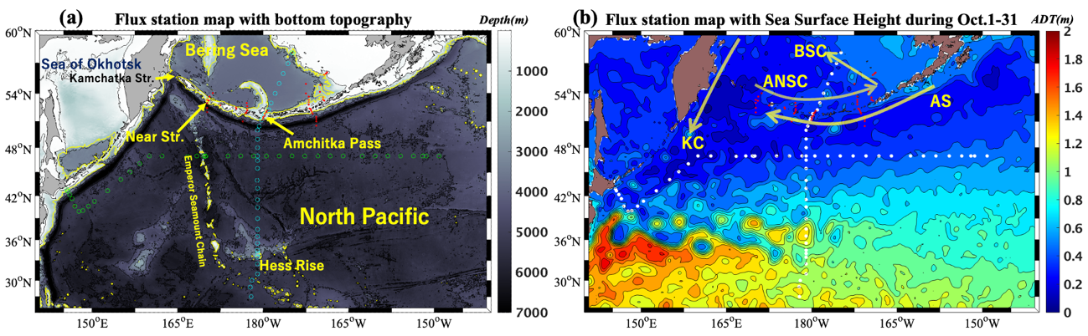
Supplementary Fig. S1. Station location map overlaid on (a) bottom topography (grey shading) and (b) sea-surface height (SSH; meters, colour shading) for 1–31 October 2023 (provided by the Copernicus Climate Change Service, Taburet et al., 2019), representing the stream-function of the surface geostrophic current. In (a), cyan circles denote P14N stations, green circles denote P01 stations, and red dots denote KH-09-4 stations around the Aleutian Passes. Yellow contours indicate the 2000 m isobath. In (b), arrows schematically represent the current system: AS, Aleutian Stream; ANSC, Aleutian North Slope Current; BSC, Bering Slope Current; and KC, Kamchatka Current.

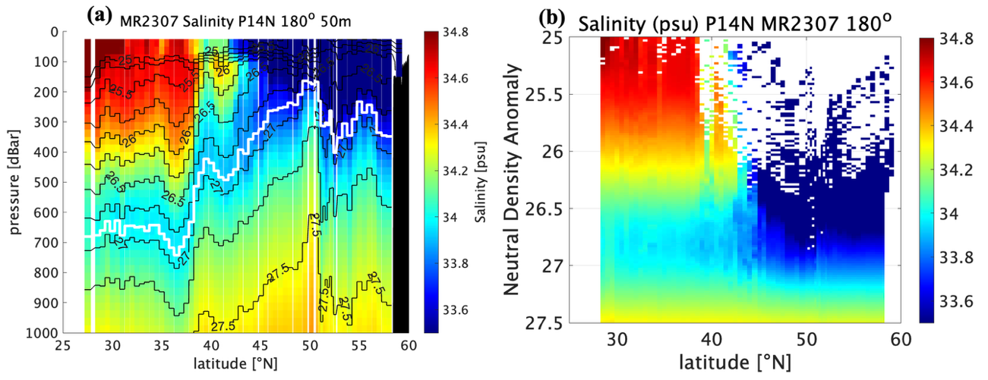
Supplementary Fig. S2. Meridional salinity (psu) cross-sections from MR2307 P14N: (a) vertical (0–1000 m) and (b) neutral density-referenced sections. In (a), black contours represent neutral density anomaly (contour interval: 0.25, starting from 25.0$γ_{N}$). The thick white contour denotes 26.9$γ_{N}$, along which the salinity minimum is distributed between 27° N and 43$°$ N.

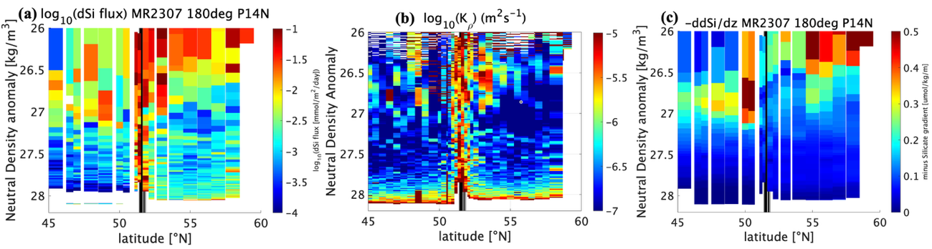

Supplementary Fig. S3. Neutral density-referenced vertical cross-sections of (a) log₁₀ (upward turbulent dSi flux), where dSi flux ${-K_{ρ}×∂(dSi)}/{∂z}$; (b) log₁₀ (turbulent vertical diffusivity, $K_{ρ}$); and (c) vertical gradient of silicate${-∂(dSi)}/{∂z}$in 45-60$°$N, along 45–60°N on the dateline. Sections span the Transition Domain (45–47°N), the subarctic North Pacific (48–51°N; with subsurface temperature minima), the Amchitka Pass (51–52°N), and the Bering Sea (P14N in Fig. 1c and Fig. S1).See Yasuda (2003) for domain characteristics. The Amchitka Pass extends from 51$°$10’N (bottom depth 2400 m) to 51$°$50’N (2021 m).

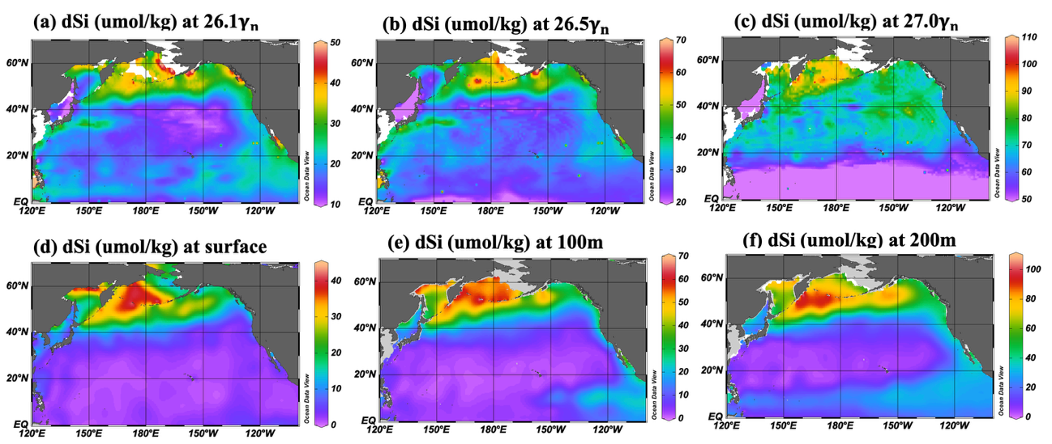
Supplementary Fig. S4. Horizontal distribution of dissolved silicate (SiO_{2,} $μmol kg$⁻¹) in North Pacific from WOA23 at isopycnal surfaces of (a) 26.1$γ_{N}$, (b) 26.5$γ_{N}$, (c) 27.$0γ_{N}$, and at depths of (d) the surface, (e) 100 m, and (f) 200 m.

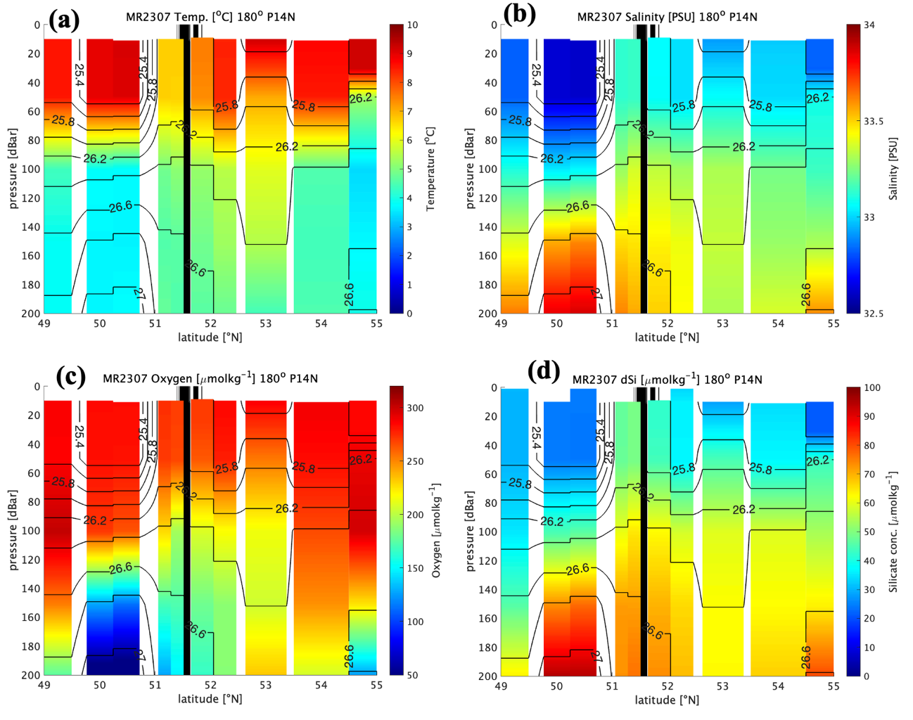

Supplementary Fig. S5. Vertical (0-200 m) cross-sections along 49–55° N of (a) temperature (in °C), (b) salinity (psu), (c) dissolved oxygen ($μmol kg$⁻¹) and (d) dSi ($μmol kg$⁻¹). Contours indicate neutral density anomaly (interval: 0.2, starting from 25.4$γ_{N}$). The Amchitka Pass extends from 51$°$10’N (2400 m) to 51$°$50’N (2021 m).

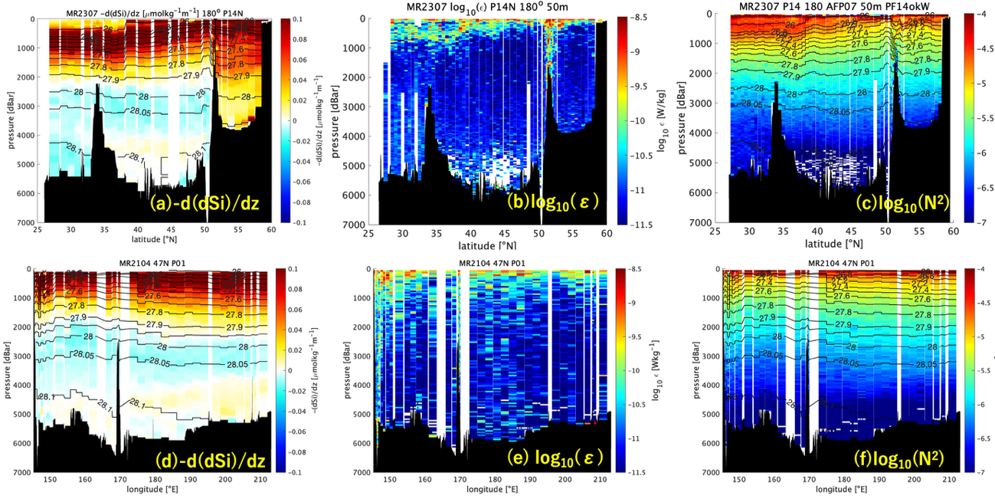
Supplementary Fig. S6. Vertical cross-sections of (a) vertical gradient of silicate ${-∂(dSi)}/{∂z}$, (b) turbulent energy dissipation rate $ε$ (Wkg⁻¹) and (c) squared buoyancy frequency $N^{2}$(s⁻²) along the dateline (P14N in Fig. 1b). Panel (d)–(f) show the same variables along the $\sim$47$°$N (P01 in Fig. 1b). Turbulent dSi flux (Fig. 2b, e) is computed as ${-K_{ρ}×∂(dSi)}/{∂z}$, where turbulent diffusivity $K_{ρ}$ (Fig. 2c, f) is computed as $0.2ε/N^{2}$(see Methods).

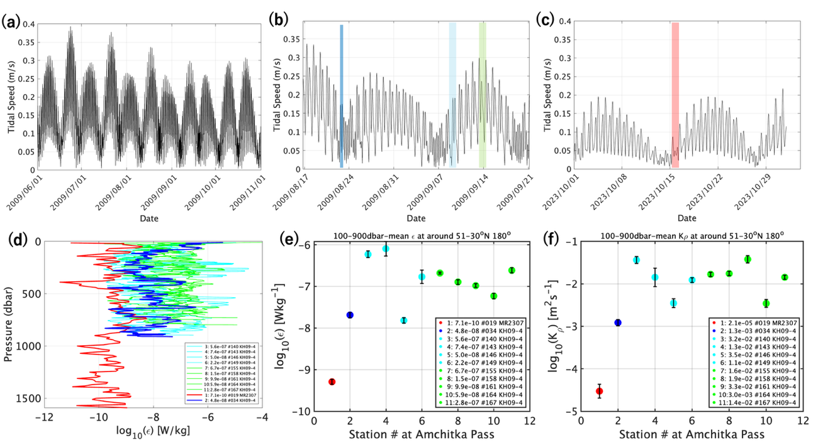

Supplementary Fig. S7. Tidal current speed (ms⁻¹): (a) 1 June–1 November 2009, (b) from 17 August–21 September 2009, and (c) 1–31 October 2023, from the TPXO9 barotropic tide model (Egbert & Erofeeva, 2002). (d) Vertical profiles of turbulent kinetic energy dissipation rate, $ε$ (Wkg⁻¹): (red) measured at 51$°$24.05’N, 179$°$54.37’E (bottom depth 1611 m) on 15–16 October 2023 (neap tide; red shading in (c)) using the micro-temperature method (MR2307); (blue) measured at 51$°$30.95’N, 179$°$56.1’W (1142 m) on 23 August 2009 (neap tide; blue shade in (b)) using the micro-current shear method; (cyan) one-day four profiles (9–10 September 2009; medium tidal amplitude); and (green) one-day six profiles (13–14 September 2009; spring tide). The distance between casts is $\sim$12 km. (e) Mean ε (100–900 m) for each cast, with mean values indicated. (f) Same as (e) but for turbulent vertical diffusivity $K_{ρ}$ (m²s⁻¹).

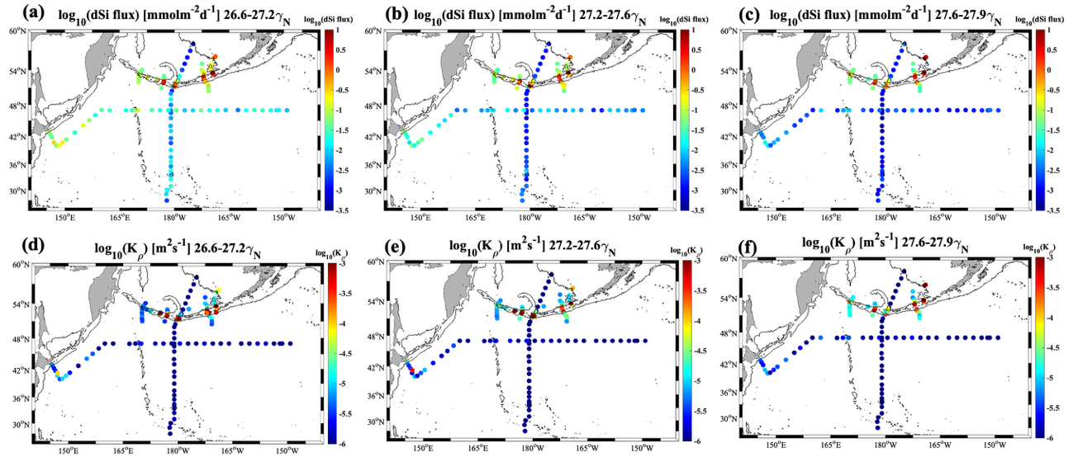
Supplementary Fig. S8. Horizontal distribution of turbulent dSi flux averaged over neutral density ranges of (a) 26.6–27.2$γ_{N}$, (b) 27.2–27.6$γ_{N}$, and (c) 27.6–27.9$γ_{N}$ based on KH-09-4, MR2104, and MR2307 cruise data. Colored dots represent log₁₀(dSi flux), and thin contours denote the 2000 m isobath. Panel (d)–(f) are as in (a)–(c) but for the horizontal distribution of turbulent vertical diffusivity (log₁₀($K_{ρ}$)).

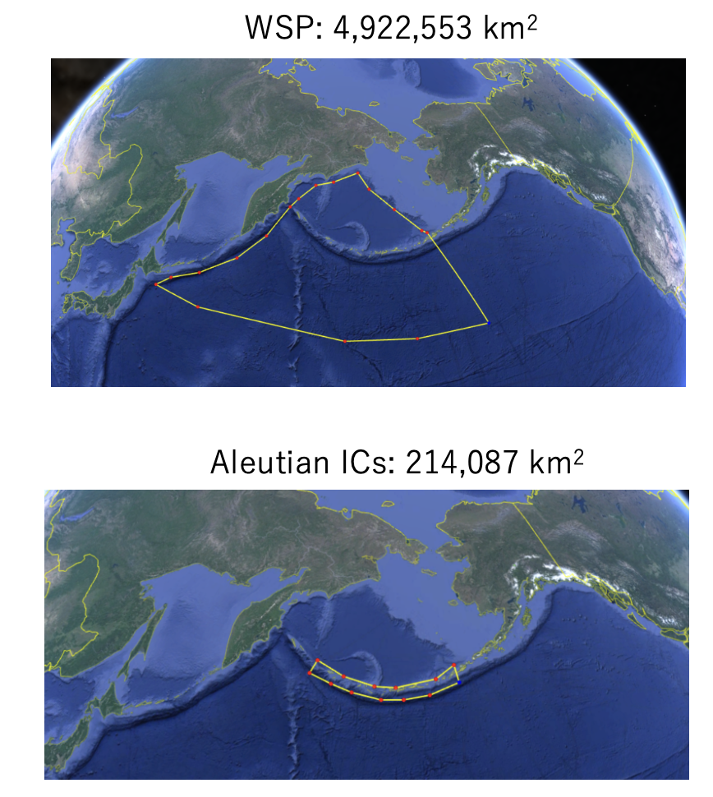
Supplementary Fig. S9. Regions used for computing values in the western Subarctic Pacific (WSP) and the Aleutian Passes. Adapted from the Supplementary Information of Nishioka et al. (2020).

Supplementary Table S2. Mean turbulent nutrient flux and total transport: (a) in the Aleutian Passes (N stations; bottom depth < 2000 m; KH-09-4; current-shear method) and (b) in the open western Subarctic Pacific (WSP) north of 40$°$N and west of 160$°$W; bottom depth > 2000 m; MR2104; micro-temperature method). Mean flux and transport are computed at depths of 100-250m. Total transport in the Aleutian Passes is derived as mean flux × area (< 2000 m; 214,087 km²), with 95% confidence intervals obtained via bootstrap resampling all available N profiles. Total transport in the WSP is derived as mean flux × area (>2000 m; 4,922,553 km²). “Geomean” denotes the geometric mean for comparison the data with the turbulent flux estimates in the previous study (Nishioka et al. 2020).

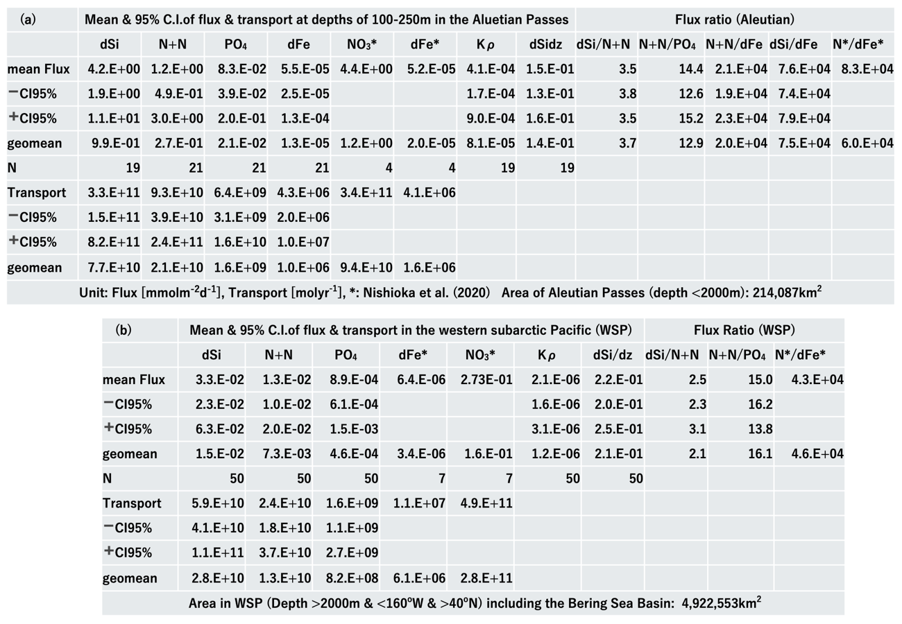

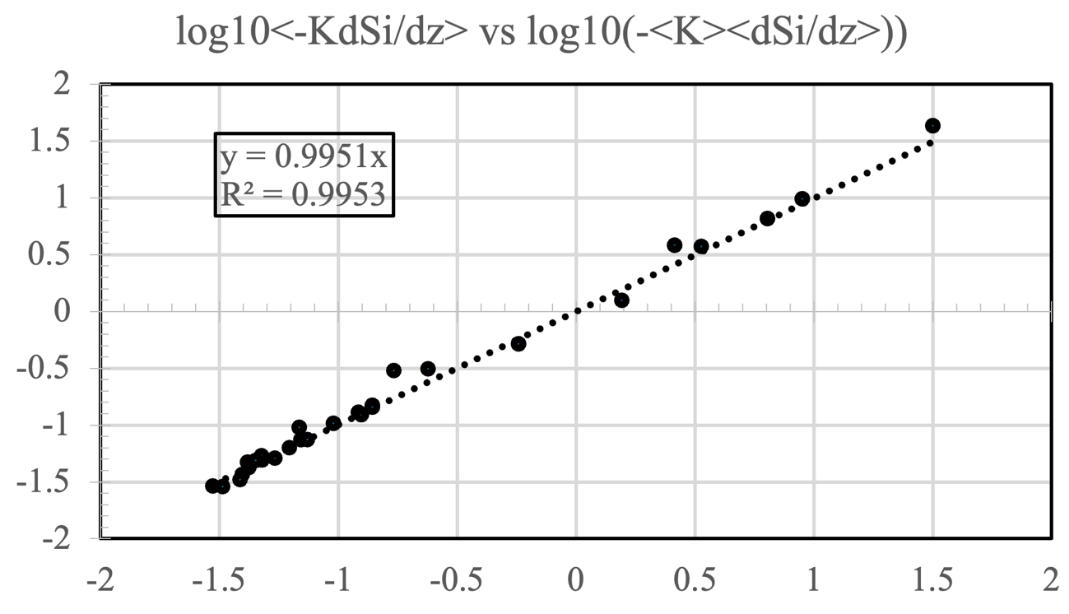

Supplementary Fig. S10. Scatter plot of log₁₀($〈K_{ρ}〉×〈∂(dSi)/∂z〉$) versus log₁₀($〈{K_{ρ}×∂(dSi)}/{∂z}〉$) showing their linear relationship.

