Distinct recovery trajectories of spatiotemporal and trunk kinematic parameters following simultaneous bilateral total hip arthroplasty: a 12-month longitudinal study

2.Methods
2.2. Assessments and Procedures
Supplementary Table S1
Preoperative comparison of hip joint range of motion, muscle strength, radiographic parameters, and clinical outcome scores between the left and right limbs in patients undergoing simultaneous bilateral total hip arthroplasty. Values are presented as mean ± standard deviation. Comparisons between the left and right limbs were performed using paired t-tests. A p-value < 0.05 was considered statistically significant. SMD, Sharp’s angle; MJS, minimum joint space; JOA, Japanese Orthopaedic Association score.

 | Left | Right | p-value
Hip flexion (degree) | 76.0±19.1 | 74.2±22.6 | 0.483
Hip extension (degree) | 3.7±5.6 | 4.4±5.7 | 0.381
Hip abduction (degree) | 15.8±5.8 | 14.6±7.2 | 0.395
Hip adduction (degree) | 9.8±5.4 | 9.4±5.5 | 0.753
Hip external rotation (degree) | 23.3±10.1 | 20.4±10.4 | 0.105
Hip internal rotation (degree) | 13.7±12.4 | 14.6±10.8 | 0.641
Hip abductor strength (kgf/kg) | 0.14±0.04 | 0.13±0.05 | 0.463
Knee extension muscle strength (kgf/kg) | 0.39±0.51 | 0.31±0.13 | 0.453
SMD(mm) | 76.8±3.1 | 76.8±3.1 | 1.000
MJS (mm) | 0.07±0.18 | 0.03±0.16 | 0.375
JOA hip score (total 100points) | 60.6±11.1 | 57.3±11.4 | 0.161

2.3 Equipment and Gait Measurement
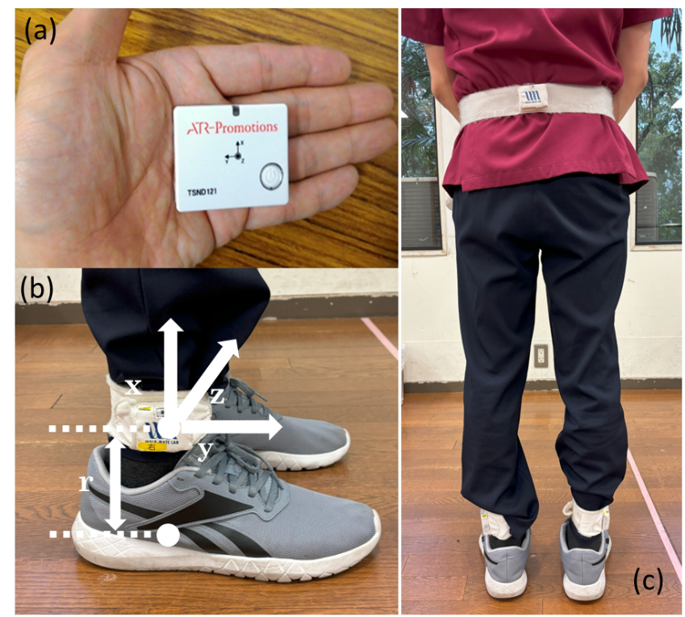
Supplementary Figure 1
Configuration of the IMUs. (a) The IMU with the accelerometer and gyroscope. (b) The special band for wearing the IMU on the shank. (b) The position and coordination of the IMU. Two IMUs are attached to the shank just above the malleolus at a distance of r. IMUs are attached to the shank in the position 0.03 m above the malleolus. The axes x, y, and z are the coordinate system of the IMU, where the z-axis is perpendicular to the sagittal plane formed by the y and z-axes. (c) third IMU sensor was attached above the L3 lumbar vertebra using a band.

3.results
3.3 Between-group comparisons at 12 months and associations with preoperative factors
Supplementary Table S2.
Results of mixed ANOVA between the bilateral THA and healthy control groups at 12 months postoperatively. Group (bilateral THA vs healthy controls) was included as a between-subject factor, and limb (left vs right) as a within-subject factor.
Gait parameters | Condition | df | F-value | p-value | η²G
Stride length | group  Left and right  group × left and right | 1, 50  1, 50  1, 50 | 4.30  0.03  0.05 | 0.043  0.855  0.824 | 0.079  0.000  0.000
Maximum foot clearance | group  Left and right  group × left and right | 1, 50  1, 50  1, 50 | 0.42  30.71  0.17 | 0.520  <0.001  0.678 | 0.007  0.084  0.001
Stride speed | group  Left and right  group × left and right | 1, 50  1, 50  1, 50 | 7.77  0.30  0.04 | 0.008  0.588  0.849 | 0.134  0.000  0.000
Stride duration | group  Left and right  group × left and right | 1, 50  1, 50  1, 50 | 4.16  1.22  1.53 | 0.047  0.274  0.222 | 0.076  0.000  0.001
Stance duration | group  Left and right  group × left and right | 1, 50  1, 50  1, 50 | 1.52  2.86  0.22 | 0.224  0.097  0.638 | 0.028  0.004  0.000
Swing duration | group  Left and right  group × left and right | 1, 50  1, 50  1, 50 | 4.57  1.24  0.05 | 0.038  0.271  0.823 | 0.067  0.005  0.000
The vertical trunk displacement | group  Left and right  group × left and right | 1, 50  1, 50  1, 50 | 0.72  20.97  0.06 | 0.402  <0.001  0.808 | 0.013  0.040  0.000

Supplementary Table S3.
Correlation analysis between preoperative factors and gait parameters, including left stride speed (a), right stride speed (b), and lateral trunk sway (c). Correlation coefficients were calculated using Pearson and Spearman’s rank correlation analysis. Values represent correlation coefficients (ρ). *p < 0.05 was considered statistically significant.
(a)
Variable | Pearson r | Spearman ρ | p-value
Age (years) | -0.567* | - | 0.003
BMI (kg/m²) | - | -0.261 | 0.197
Height (cm) | 0.434* | - | 0.027
Weight (kg) | -0.022 | - | 0.913
Hip flexion left  (degree) right | 0.057  -0.040 | -  - | 0.780  0.844
Hip extension left  (degree) right | -  0.106 | 0.230  - | 0.258  0.604
Hip abduction left  (degree) right | -  0.127 | 0.269  - | 0.184  0.534
Hip abduction left  (degree) right | -0.118  0.122 | -  - | 0.566  0.552
Hip external rotation left  (degree) right | 0.188  0.188 | -  - | 0.356  0.356
Hip internal rotation left  (degree) right | 0.247  0.197 | -  - | 0.223  0.333
Hip abductor strength left  (kgf/kg) right | 0.239  0.188 | -  - | 0.239  0.356
Knee extension muscle strength left  (kgf/kg) right | -  - | 0.016  0.097 | 0.938  0.636

(b)
Variable | Pearson r | Spearman ρ | p-value
Age (years) | -0.626* | - | <0.001
BMI (kg/m²) | - | -0.280 | 0.166
Height (cm) | 0.409* | - | 0.038
Weight (kg) | -0.037 | - | 0.859
Hip flexion left  (degree) right | 0.046  -0.010 | -  - | 0.822  0.960
Hip extension left  (degree) right | -  0.114 | 0.212  - | 0.298  0.584
Hip abduction left  (degree) right | -  0.164 | 0.306  - | 0.128  0.427
Hip abduction left  (degree) right | -0.080  0.128 | -  - | 0.698  0.534
Hip external rotation left  (degree) right | 0.232  0.202 | -  - | 0.255  0.324
Hip internal rotation left  (degree) right | 0.214  0.109 | -  - | 0.295  0.596
Hip abductor strength left  (kgf/kg) right | 0.239  0.209 | -  - | 0.239  0.305
Knee extension muscle strength left  (kgf/kg) right | -  - | 0.067  0.160 | 0.744  0.436

(c)
Variable | Pearson r | Spearman ρ | p-value
Age (years) | -0.057 |  | 0.784
BMI (kg/m²) |  | 0.563* | 0.003
Height (cm) | 0.128 |  | 0.533
Weight (kg) |  | 0.557* | 0.003
Hip flexion left  (degree) right |  | -0.111  0.080 | 0.589  0.697
Hip extension left  (degree) right |  | -0.300  -0.163 | 0.137  0.425
Hip abduction left  (degree) right |  | 0.300  0.018 | 0.137  0.932
Hip abduction left  (degree) right |  | 0.062  0.164 | 0.764  0.422
Hip external rotation left  (degree) right |  | 0.077  -0.099 | 0.709  0.630
Hip internal rotation left  (degree) right |  | 0.052  0.107 | 0.800  0.604
Hip abductor strength left  (kgf/kg) right |  | -0.195  0.007 | 0.341  0.975
Knee extension muscle strength left  (kgf/kg) right |  | -0.274  -0.106 | 0.176  0.605

