Supporting Information

Universal free-energy scaling of quantum efficiency controlled by acceptor end group strength in organic solar cells.
Safakath Karuthedath^{1,2*}, Wenlan Liu³, Neha Chaturvedi¹, Sri H. K. Paleti¹, Catherine S. P. De Castro¹, Abdul Azeez Hamsa², Jianhua Han,¹ Jafar I. Khan¹, Panagiota Kafourou¹, Joel Luke¹, Han Xu,¹ Yuliar Firdaus¹, Anirudh Sharma¹, Wejdan Althobaiti¹, Diego Rosas Villalva¹, Nicolas Ramos⁴, Jaime Martin^{4,5}, Martin Heeney¹, Derya Baran¹, Thomas D. Anthopoulos⁶, Denis Andrienko³, Frédéric Laquai^{7,1*}, Julien Gorenflot^{1*}
¹King Abdullah University of Science and Technology (KAUST), Physical Sciences and Engineering Division (PSE), Thuwal 23955-6900, Kingdom of Saudi Arabia
²Institute of Materials Research, Tsinghua Shenzhen International Graduate School, Tsinghua University, Shenzhen, 518055 China.
³Max Planck Institute for Polymer Research, Ackermannweg 10, 55128 Mainz, Germany.
⁴POLYMAT, University of the Basque Country UPV/EHU Av. de Tolosa 72, 20018, San Sebastián, Spain.
⁵Ikerbasque Basque Foundation for Science Bilbao 481013, Spain.
⁶Henry Royce Institute, Photon Science Institute, Department of Electrical and Electronic Engineering, The University of Manchester, Manchester, M13 9PL, UK
⁷Chair of Physical Chemistry and Spectroscopy of Energy Materials (SPECTRE), Ludwig-Maximilians-Universität München, Department of Chemistry, Faculty of Chemistry and Pharmacy, Butenandtstr. 5-13, Haus E, 81377 Munich, Germany
Neha Chaturvedi
Present address: Department of Electrical and Computer Engineering, North Carolina State University, Raleigh, NC-27606, USA
Sri H. K. Paleti
Present address: The Organic Photonics and Electronics Group, Department of Physics, Umeå University, SE-90187 Umeå, Sweden
Wallenberg Initiative Materials Science for Sustainability, Department of Physics, Umeå University, SE-90187 Umeå, Sweden
Jafar I. Khan
Present Address: Department of Physics, School of Digital and Physical Science, University of Hull, Hull, HU6 7RX United Kingdom
Y. Firdaus
Present address: Research Center for Electronics, National Research and Innovation Agency, Jalan Sangkuriang Komplek BRIN Building BASICS Level 3, Bandung, 40135 Indonesia
F. Laquai
Present address: Chair of Physical Chemistry and Spectroscopy of Energy Materials (SPECTRE), Ludwig-Maximilians-Universität München, Department of Chemistry, Faculty of Chemistry and Pharmacy, Butenandtstr. 5-13, Haus E, 81377 München, Deutschland
W. Liu
Present address: Institute of Computational Physics, Stuttgart University, Allmandring 3, 70569 Stuttgart, Germany.
D. Rosas Villalva
Present address: Department für Chemie Biologie und Physik, Universität Bern, Freiestrasse 3, 3012, Bern, Switzerland
Jianhua Han
Present address: State Key Laboratory of Fine Chemicals, School of Chemical Engineering, Dalian University of Technology, Dalian, 116024, China
Wejdan Althobaiti
King Abdullah City for Atomic and Renewable Energy (K.A.CARE), Riyadh 12244, Saudi Arabia.

Emails: safakath@sz.tsinghua.edu.cn & frederic.laquai@lmu.de & julien.gorenflot @kaust.edu.sa

Contents
1. Device Fabrication and Current Density-Voltage (J-V) Characterization: 3
2. FQ monomer and PFQT polymer synthesis. 7
3. NMR Spectra 10
4. Energetics 13
5. Time-Resolved Photoluminescence (TRPL) Measurement 16
6. Transient absorption (TA) spectroscopy measurements 18
7. Recrystalization 20

Device Fabrication and Current Density-Voltage (J-V) Characterization:
Figure S 1: AM 1.5G solar spectra and corresponding integrated spectra over the wavelength range of 300 nm to 1000 nm.
Figure S 2: Typical normalized EQE spectra of (a) ZY-4Cl and (b) Y6-based organic solar cells with different polymer donors, respectively.

(d)
(c)
Figure S 3: Typical J-V characteristics and EQE spectra of (a-b) ZY-4Cl and (c-d) Y6-based organic solar cells under simulated AM1.5G (100 mW cm⁻²) illumination conditions with different polymer donors, respectively.

Table S 1: The device fabrication conditions and photovoltaic parameters of the optimized organic solar cells under simulated AM 1.5G illumination (100 mW/cm²). Device structure: ITO/PEDOT:PSS/Active layer/PFN-Br/Al (or Ag).
A | D | Solvent | BHJ  ratio  (D:A) | Con.  (mg/ml) | Spin  (RPM) | TA  (ºC)  *10 min | PCE_{max}  (%) | FF  (%) | V_{OC}  (V) | J_{SC}  (mA cm⁻²) | IQE_{avg} (%)
Y6 | PTB7-Th | CF  (0.5% CN) | 1:1 | 14 | 2500 | 110 | 8.20 | 54.0 | 0.66 | 23.29 | 79
Y6 | PBDB-T | CF  (0.5% CN) | 1:1.2 | 16 | 2500 | 100 | 11.0 | 61.0 | 0.71 | 25.40 | 88
Y6 | PBDB-T-SF | CF  (0.5% CN) | 1:1 | 20 | 2500 | 110 | 12.05 | 60.0 | 0.8 | 24.04 | 81
Y6 | PBDB-T-2F | CF  (0.5% CN) | 1:1.2 | 16 | 2500 | 100 | 14.50 | 66.00 | 0.84 | 26.50 | 90
Y6 | PBDB-T-2Cl | CF  (1% DIO) | 1:1 | 20 | 2500 | 110 | 14.48 | 69.59 | 0.82 | 25.34 | 89
Y6 | PTO2 | CF  (0.5% CN) | 1:1.2 | 16 | 2500 | 100 | 9.91 | 60.32 | 0.89 | 18.50 | 63
Y6 | PTQ10 | CF  (0.25%DIO) | 1:1.2 | 16 | 2500 | 100 | 13.25 | 64.90 | 0.80 | 25.50 | 93
Y6 | PFQT-C6-C4 | CF | 1:1.2 | 16 | 2500 | 120 | 6.74 | 49.5 | 0.84 | 16.3
Y6 | PFQT-C8-C6 | CF | 1:1.2 | 16 | 2500 | 120 | 2.6 | 42.1 | 0.86 | 7.3
ZY-4Cl | PTB7-Th | CF | 1:1 | 14 | 2500 | 130 | 2.81 | 33 | 0.89 | 9.34
ZY-4Cl | PBDB-T | CF | 1:1 | 14 | 2500 | 130 | 11.21 | 68 | 1.04 | 15.73 | 89
ZY-4Cl | PBDB-T-SF | CF | 1:1 | 14 | 2500 | 130 | 0.64 | 40 | 1.13 | 1.42
ZY-4Cl | PBDB-T-2F | CF | 1:1 | 14 | 2500 | 130 | 3.6 | 47 | 1..15 | 6.7 | 32
ZY-4Cl | PTO2 | CF | 1:1 | 14 | 2000 | 130 | 0.16 | 28.6 | 1.1 | 0.46 | 3

Figure S 4: UV-Vis-NIR absorption spectra of all neat films (PTO2, PTQ10, PM7/PBDB-T-2Cl, PCE13/PBDB-T-SF, PM6/PBDB-T-2F, PBDB-T/PCE12, PTB7-Th/PCE10, ZY-4Cl and Y6) investigated in this study.

Figure S 5: Absorption spectra of a) ZY-4Cl blends with PTO2, PBDB-T-2F/PM6 and PBDB-T/PCE12 and b) Y6 blends with PTO2, PTQ10, PBDB-T-2Cl/PM7, PBDB-T-2F/PM6, PBDB-T-SF/PCE13, PBDB-T/PCE12 and PTB7-Th/PCE10.

FQ monomer and PFTQ-C6-C4, PFTQ-C8-C6 polymer synthesis.

Scheme S 1. (Top) Synthesis of monomers 4-FQ and 6-FQ and (Bottom) polymers PFTQ-C6-C4, and PFTQ-C8-C6 as a mix of isomers. Experimental procedures for compounds FO4 and FO6, was adopted from the literature.¹
Synthesis of 4,7-dibromo-5-((alkyl)oxy)-6- fluorobenzo-diamine. In a 2-neck 250 mL RBF (round-bottomed flask) containing compound FO4 (or FO6) (3.14 g, 6.32 mmol) was added dry ethanol (120 mL) and let to stir for 15 min and then added NaBH₄ (2.15 g, 63.2 mmol). The reaction was stirred at room temperature for 16 hours and then poured into iced water (100 mL). The organic layer was extracted with diethyl ether (3 × 100 mL), washed with brine (100 mL) and dried over Na₂SO₄. The solvent was removed under reduced pressure to afford the product as red/brown oil (2.5 g, 5.3 mmol, 85%) which was used for the next step immediately and without further purification.
Synthesis of 3,3,3-trifluoro-2-oxopropanal. In a 2-neck RBF was added sodium acetate (14.6 g, 178 mmol) and water (50 mL). The mixture was stirred until sodium acetate was dissolved. 1,1-Dibromo-3,3,3-trifluoroacetone (12 g, 44.5 mmol) was added dropwise and the solution was left to stir for 16 hours at 100 °C. The reaction mixture was left to cool at r.t and the organic phase was extracted with EtOAc (100 mL × 3) and dry over Na₂SO₄. The solvent evaporated to yield a transparent oil (2.5 g, 19.8 mmol, 45%). The product was used directly to the next step without further purification.
Synthesis of 4,7-dibromo-5-((alkyl)oxy)-6- fluoro-trifluoromethyl-quinoxaline
6-FQ (mix) and 4-FQ (mix). In a 2-neck RBF was added 3,3,3-trifluoro-2-oxopropanal (0.787 mg, 1.5 eq) and water (35 mL) and left to stir for 5 min. A solution of the respective diamine (2.73 g, 1 eq) in methanol (40 mL) was added to the mixture and the reaction was stirred at 70 ◦C for 16 hours. The mixture was poured into water (100 mL) and the organic phase was extracted with dichloromethane (3 × 100 mL) and dried over Na₂CO₃. After evaporation of the solvent the crude product was purified by column chromatography with eluent petroleum ether:ethyl acetate (5:1) to produce the product as yellow oil (2.0 g, 8.7 mmol, 60 %). The oily product contained both isomers.
[6-FQ]: ¹H NMR (400 MHz, CDCl₃) δ 9.22 (s, 1H, minor isomer), 9.19 (s, 1H, major isomer), 4.35 (d, J = 5.4 Hz, 2H, minor isomer), 4.22 (d, J = 5.4 Hz, major isomer), 1.66 – 1.61 (m, 7H), 1.52 – 1.27 (m, 79H), 0.91 – 0.86 (m, 24H). ¹⁹F NMR (377 MHz, CDCl3) δ -66.71, -66.78, -104.62, -106.09
[4-FQ]:: ¹H NMR (400 MHz, CDCl₃) δ 9.21 (s, 1H, major isomer), 9.18 (s, 1H, minor isomer), 4.26 (d, J = 5.4 Hz, 2H, major isomer), 4.22 (d, J = 5.4 Hz, minor isomer), 1.90 – 1.85 (m, 3H), 1.64 – 1.62 (m, 79H), 0.91 – 0.86 (m, 24H). ¹⁹F NMR (377 MHz, CDCl3) δ -66.71, -66.78, -104.62, -106.09
General method for polymers PFTQ-C6-C4, and PFTQ-C8-C6. A 2 mL microwave vial was dried and purged with nitrogen. 2,5-bis(trimethylstannyl)thiophene (0.2 mmol, 1 eq), FQ monomer (0.2 mmol, 1 eq), tris(dibenzylideneacetone) dipalladium(0) (0.004 mmol, 0.02 eq), tris(o-tolyl) phosphine (0.016 mmol, 0.08 eq) and the vial was sealed and purged with nitrogen for 10 minutes. Degassed toluene (1 mL) was added and the mixture was further degassed for 3 minutes. The vial was placed in a microwave reactor and heated to 120 °C for 2 min, 140 °C for 2 min, 160 °C for 2 min and 180 °C for 40 min. After cooling to r.t, the product was precipitated in MeOH and filtered into a thimble. Soxhlet extraction was carried out with MeOH, acetone, hexane and chloroform. Both polymers were collected from the chlorobenzene fraction.
6-PFQT. ¹H NMR (600 MHz, TCE, 120 °C) 9.30 (s, 1 H), 8.16 (br, 2H), 4.26 (s, 2H), 2.06-1.97 (br), 1.61-1.31 (br), 0.90. Mn (kDa) 32.1, Mw (kDa) 47.9, Đ 1.5
4-PFQT. ¹H NMR (600 MHz, TCE, 120 °C) 9.32 (s, 1 H), 8.30-8.05 (br, 2H), 4.27 (s, 4.26, 2H), 1.13 (s, 1 H), 1.61-1.32 (br), 0.91 (br). Mn (kDa) 44.0, Mw (kDa) 66.8, Đ 1.5

NMR Spectra
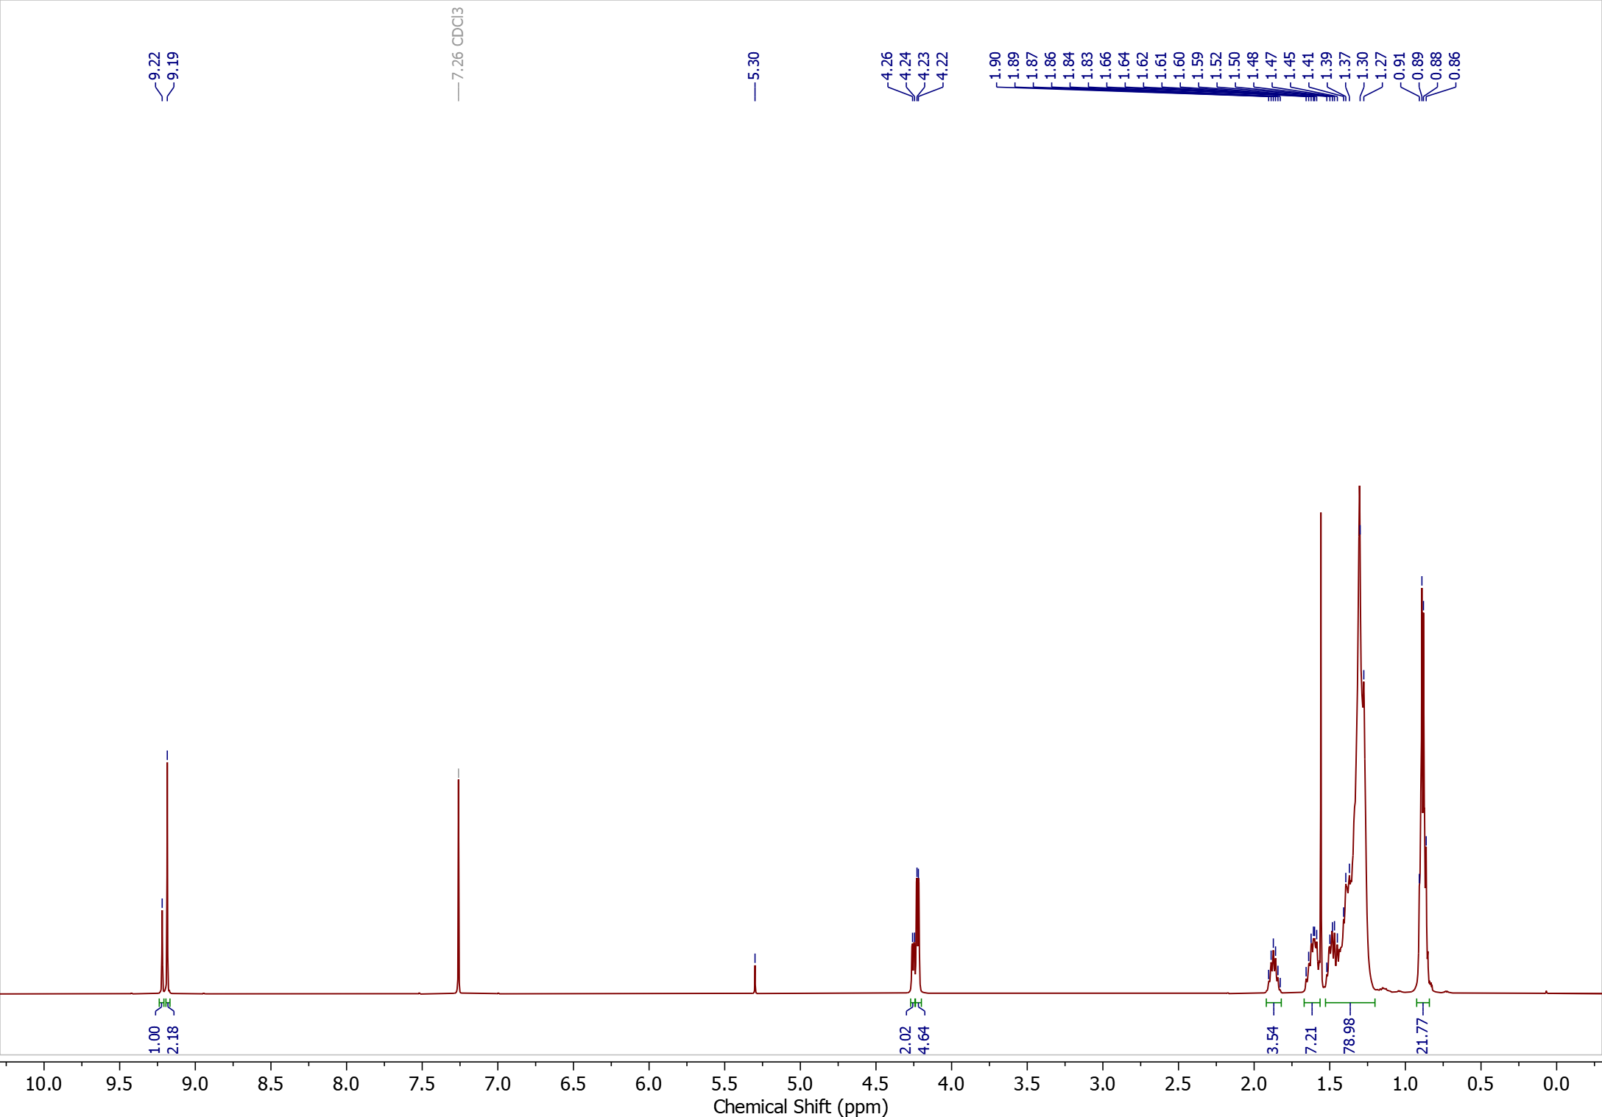
Figure S 6. ¹H NMR (400 MHz) spectrum of 6-FQ(mix) recorded in CDCl_{3.}

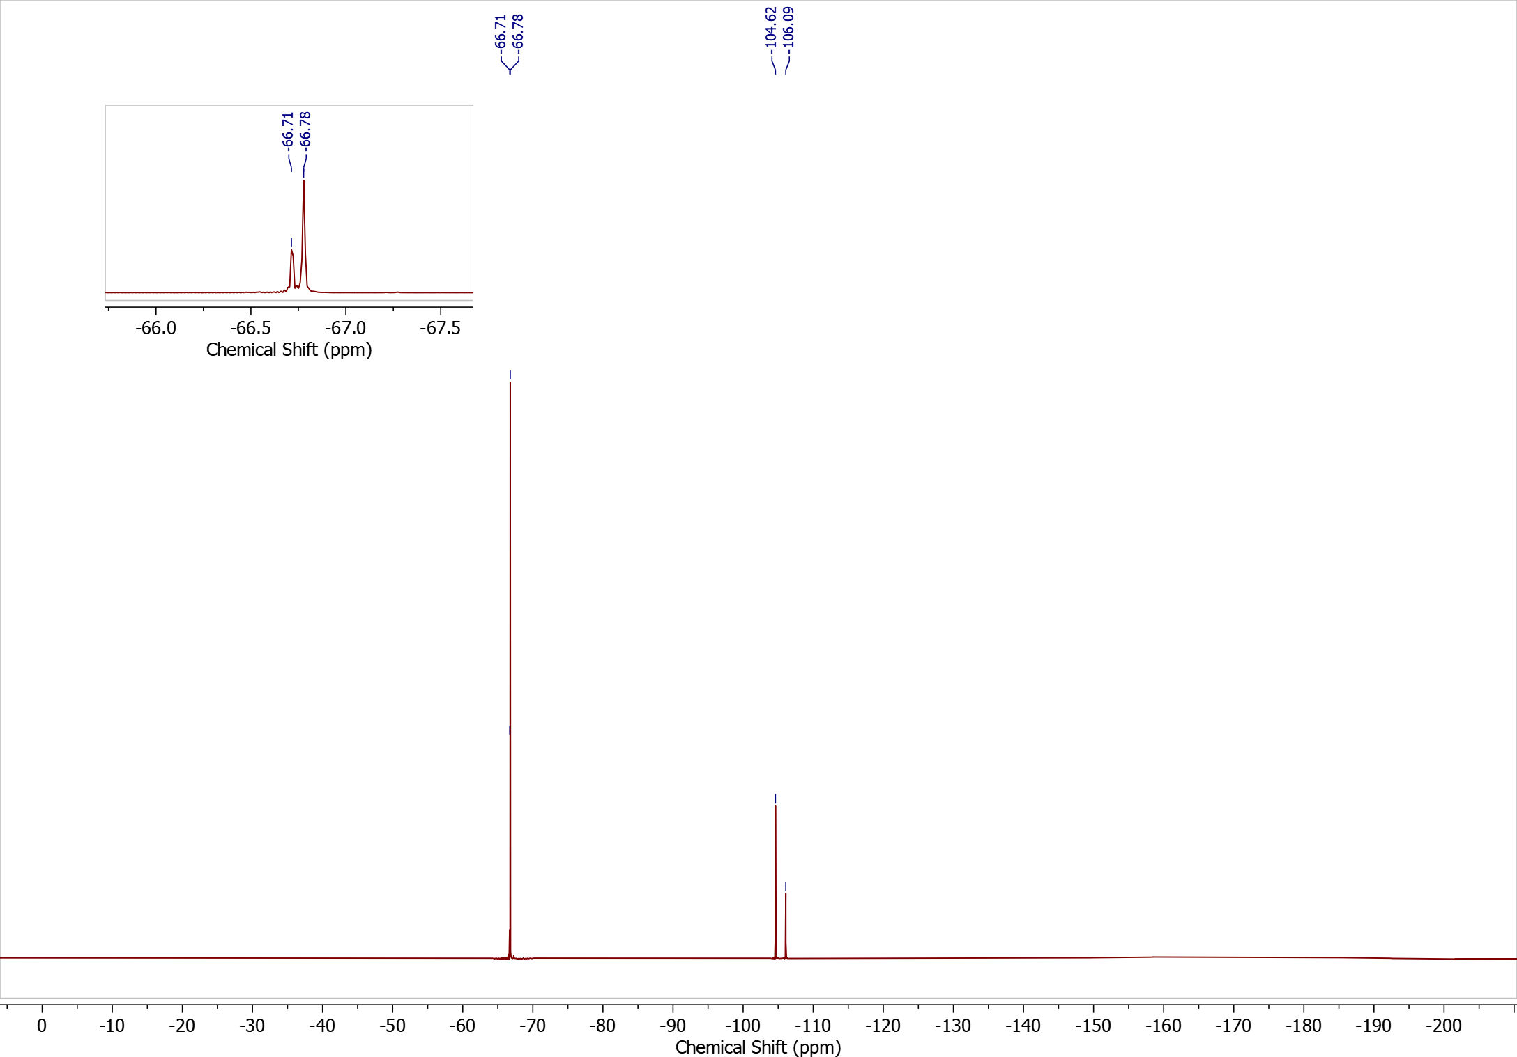
Figure S 7. ¹⁹F NMR (376 MHz) spectrum of 6-FQ(mix) recorded in CDCl_{3.}

Figure S 8. ¹H NMR (400 MHz) spectrum of 4-FQ(mix) recorded in CDCl_{3.}
Figure S 9. ¹⁹F NMR (376 MHz) spectrum of 4-FQ(mix) recorded in CDCl_{3.}
Figure S 10. ¹H NMR (600 MHz) spectrum of polymer PFTQ-C6-C4 (mix) recorded in TCE at 120 °C.
Figure S 11. ¹H NMR (600 MHz) spectrum of polymer PFTQ-C8-C6 (mix) recorded in TCE at 120 °C.

Energetics

Figure S 12: Schematic depiction of the electronic energy level structure (ionization energy and electron affinity) of organic semiconductors characterized by ultraviolet photoelectron spectroscopy (UPS) and photoelectron spectroscopy in air (PESA).
Figure S 13: Ultraviolet photoelectron spectroscopy in air (PESA) data for the neat donor and acceptor thin films. The ionization energy (IE) values, as determined directly from the PESA spectra, are annotated on the respective plots.

UPS/IPES of ZY4CL
Figure S 14: Energetic Landscape of ZY-4Cl: UPS and LE-IPES spectra demonstrating the secondary electron cut-off, as well as the spectral onsets of the occupied and unoccupied molecular orbitals used for determining the IE and EA.

Time-Resolved Photoluminescence (TRPL) Measurement
Figure S 15: TRPL spectra of neat Y6 and D:Y6 blends. Upon 725 nm excitation, at selected time ranges. The pump fluence used was ~1nJ/cm². The greyed areas represent the spectral ranges whose kinetics are plotted on Figure 3 (main text).
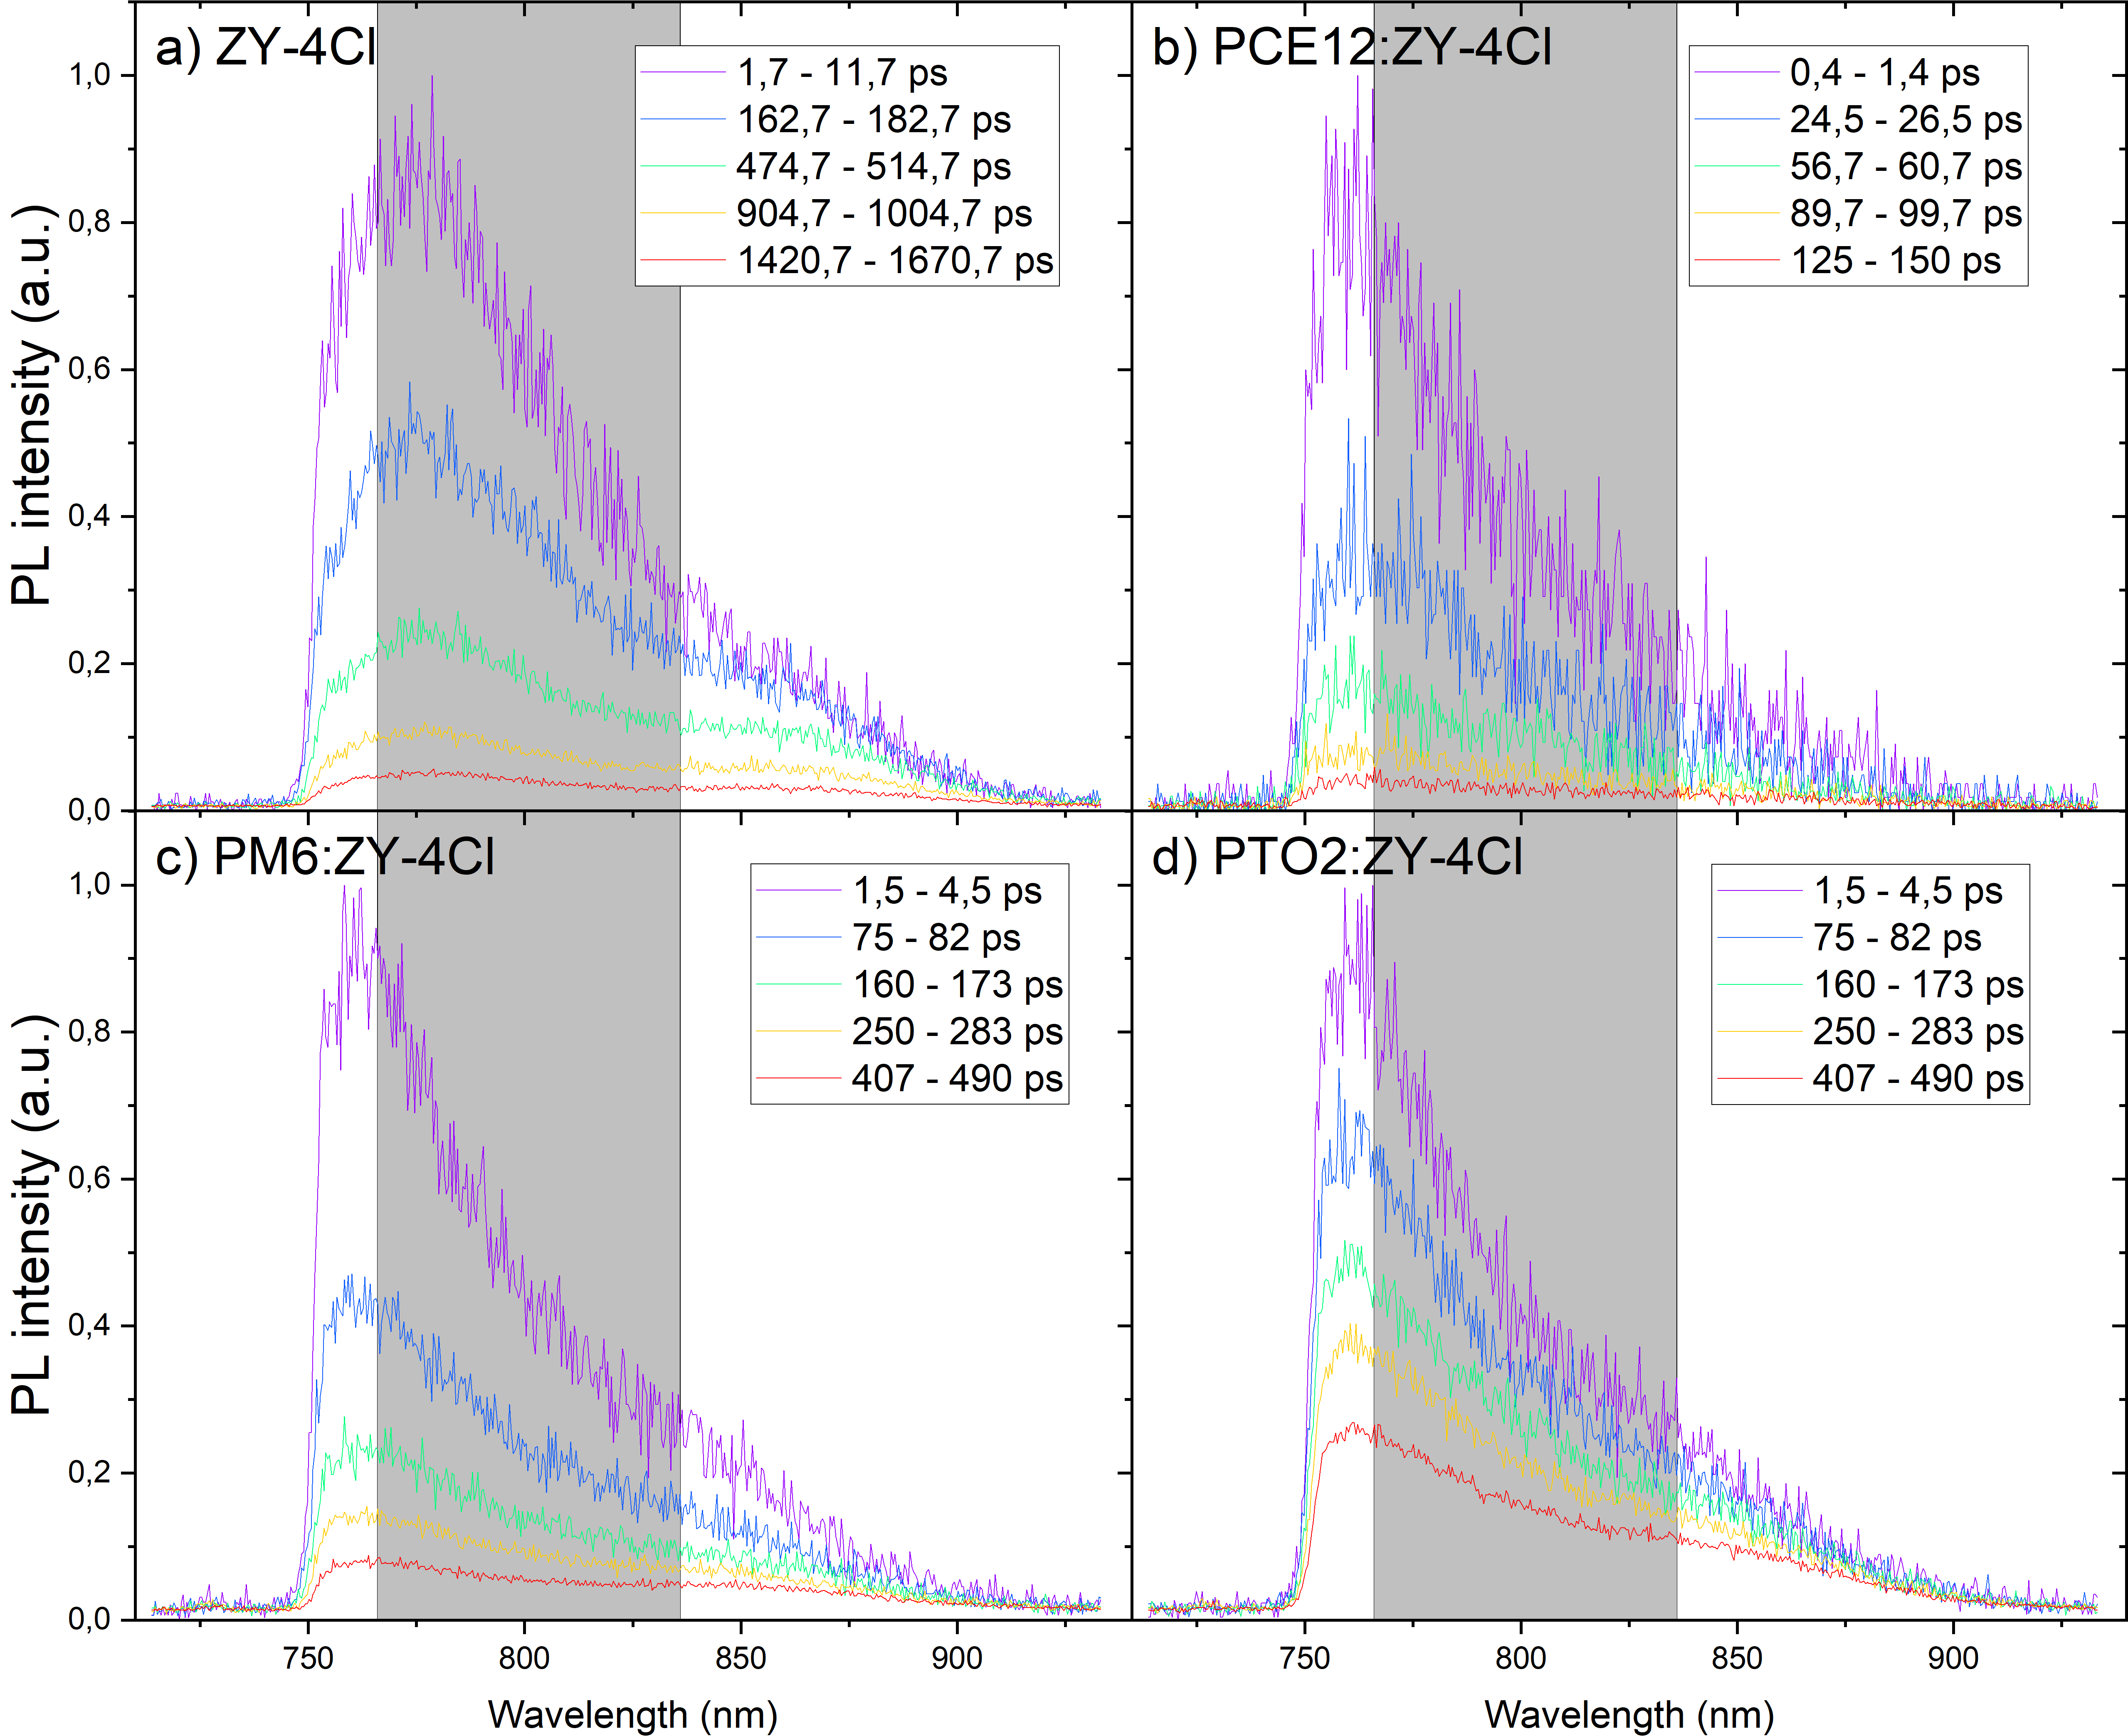
Figure S 16: a) Time-resolved PL spectra of D:ZY-4Cl based systems at selected time delay ranges following 725 nm excitation and observed through a 750 nm long pass filter. The pump fluence used was ~1nJ/cm^{2.} The greyed areas represent the spectral ranges whose kinetics are plotted on Figure 3 (main text).

Table S 2: Normalized amplitude factors (A_{i}) and lifetimes (τ) together with amplitude and intensity weighted average lifetimes τ (avg,wt) and photoluminescence quenching efficiency (PLQE) for Y6 and ZY-4Cl blends (λ_{exc}=725 nm, LP750, λ_{em}= 801 ± 35 nm) and neat films.
 | A₁ | τ₁ (ps) | A₂ | τ₂ (ps) | τ (avg ampl., wt) (ps) | τ (avg int., wt) (ps) | PLQE (%)
PTB7-Th:Y6 | 0.626 | 10.1 | 0.464 | 57.4 | 27.8 ± 1.0 | 46.6 | 96.7
PBDB-T:Y6 | 0.604 | 7.2 | 0.396 | 45.4 | 22.3 ± 0.5 | 38 | 97.3
PBDB-T-SF:Y6 | 0.532 | 48.9 | 0.468 | 147.8 | 95.1 ± 4.8 | 121 | 91.5
PBDB-T-2F:Y6 | 0.447 | 27.3 | 0.553 | 124.5 | 81.0 ± 2.4 | 110 | 92.3
PBDB-T-2F:Y6 |  |  |  |  |  |  | 92.3
PBDB-T-2Cl:Y6 | 0.344 | 21.6 | 0.656 | 99.8 | 72.9 ± 2.1 | 92 | 93.6
PTO₂:Y6 | 0.432 | 35.9 | 0.568 | 169.0 | 111.5 ± 3.4 | 150 | 89.5
Y6 | 1 | 1428 ± 14 |  |  |  | 1428 | 0
P3HT:ZY-4Cl | 0.545 | 12.2 | 0.455 | 50.7 | 29.7 ± 2.6 | 42 | 89.6
PBDB-T;ZY-4Cl | 0.208 | 11.0 | 0.792 | 48.8 | 38.6 ± 1.2 | 47 | 88.8
PBDB-T-2F:ZY-4Cl | 0.655 | 75.2 | 0.345 | 274.2 | 143.9 ± 3.9 | 206 | 48.9
PTO₂:ZY-4Cl | 0.43 | 146 ± 10 | 0.57 | 714 ± 56 | 470 | 638 | 0
ZY-4Cl | 0.123 | 61 ± 7 | 0.877 | 413 ± 4 | 369.7 ± 6.4 | 406 | 0

Transient absorption (TA) spectroscopy measurements

Thin film fabrication for transient absorption spectroscopy
PBDB-T-2F (PM6), ZY-4Cl, and Y6 were purchased from Solarmer Materials Inc., anhydrous chloroform from VWR, and 1-chloronaphtalene (CN) from Fluka. All materials were used as received. For the deposition of the active layer, quartz glass substrates were cleaned by sequential ultrasonication in dilute Extran 300 detergent solution, deionized water, acetone, and isopropanol for 20 min each. The substrates were then treated with UV–ozone for 30 min. Active layers were obtained by dissolving donor and acceptor in organic solvents inside the glovebox. A solution of PM6 and ZY-4Cl (1:1 weight ratio, 14 mg/mL) was prepared by dissolving 0.7 mg of PM6 and 0.7 mg of ZY-4Cl in 100 μL of chloroform (CF). The solution was stirred at 40 °C and subsequently spin-coated (cold solution) at 2500 rpm for 30 s. The resulting film was then annealed at 130 °C. For the PM6:Y6 blend, 0.70 mg of PM6 and 0.84 mg of Y6 were dissolved in 100 μL of chloroform containing 0.5 vol% CN, corresponding to a total concentration of 15.4 mg/mL. The solution was stirred at 40–50 °C and then spin-coated at 2500 rpm for 30 s.

Figure S 17: ps-ns TA spectra of blend films of ZY-4Cl with PBDB-T-2F, PTO2, and PBDB-T (left panels) and kinetics respective spectral range shown in the figure (right panels) after exciting at ~720 nm at ~0.16 µJ/cm².
Figure S 18: ps-ns TA spectra of neat films of PBDB-T-2F, ZY4Cl, PTO2, and PBDB-T (left panels) and kinetics respective spectral range shown in the figure (right panels) after exciting at ~600 nm at ~3 µJ/cm².

Recrystallization

Y6
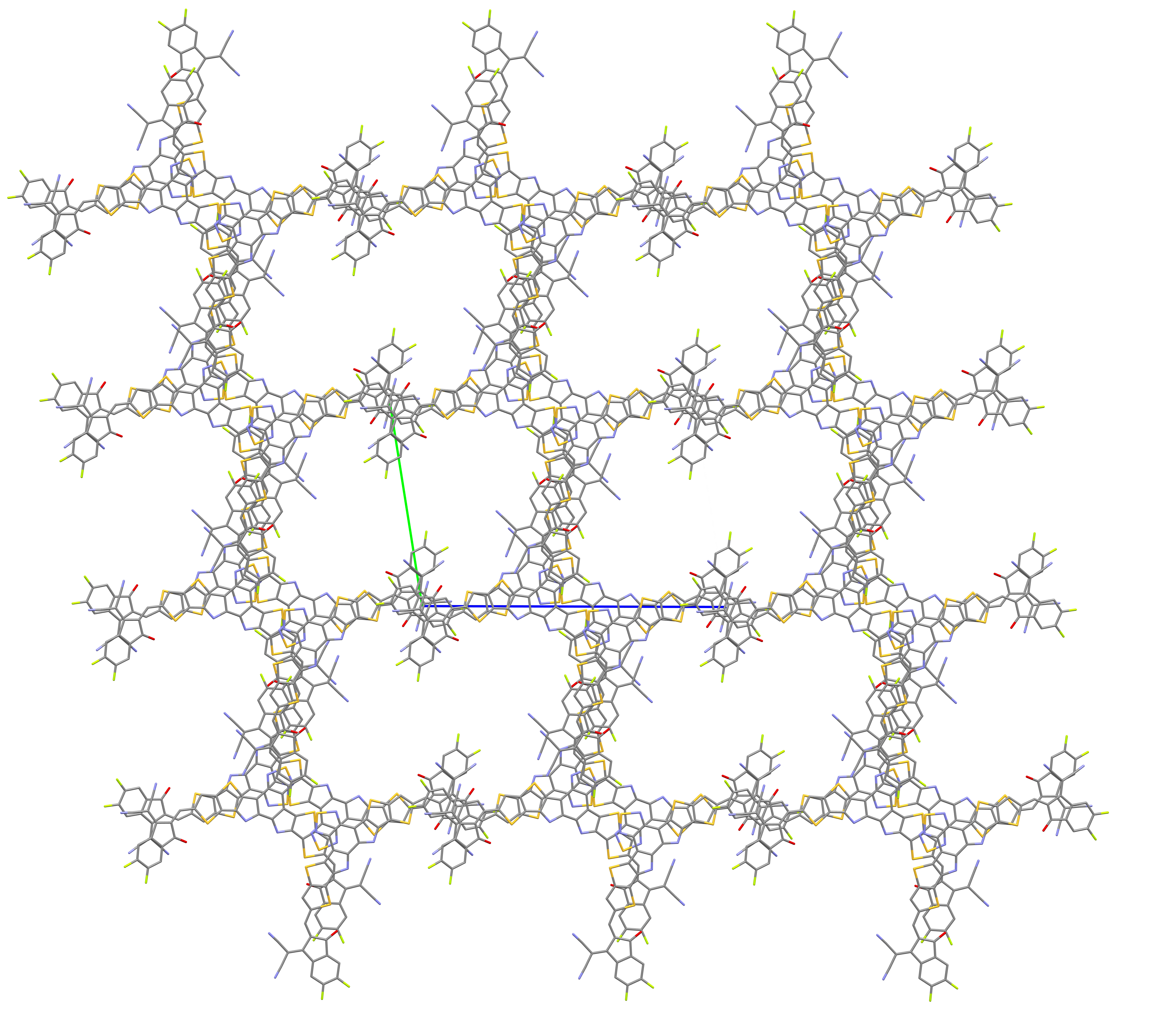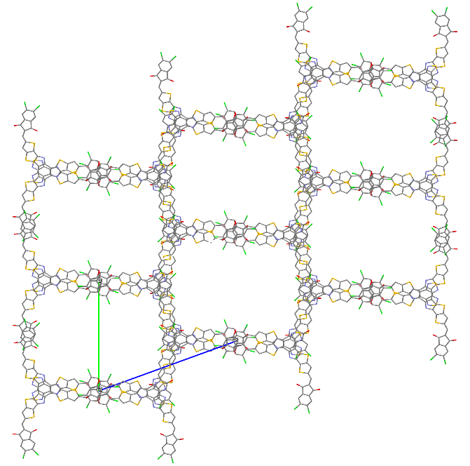
ZY-4Cl
a
b
c
c
b
a
b
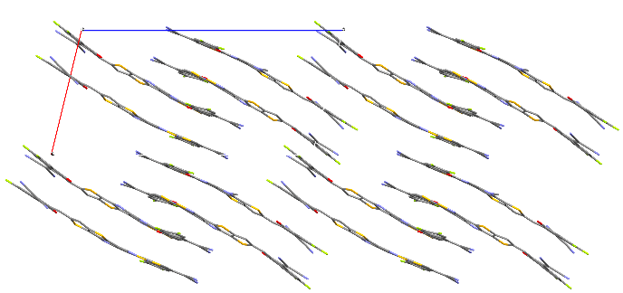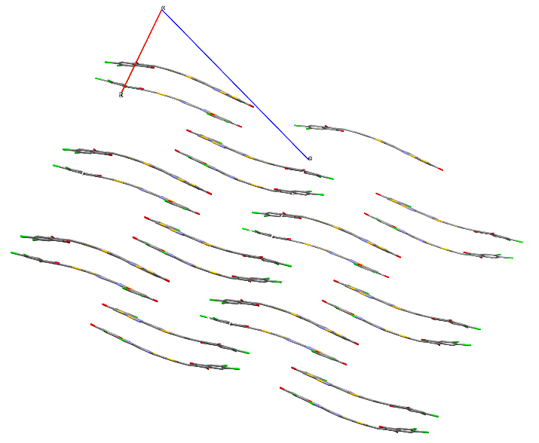
c
b
a
a
c

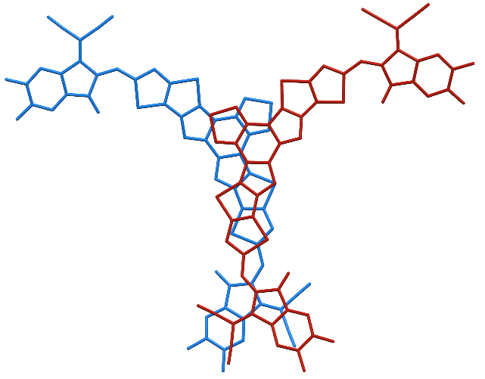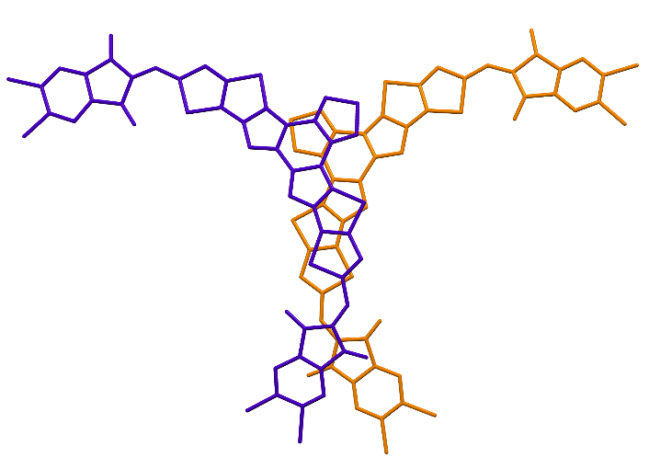
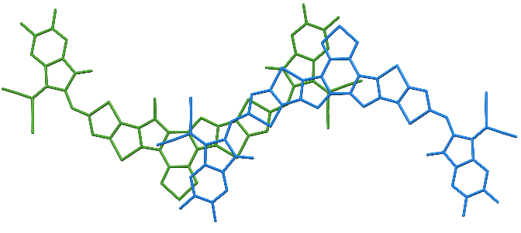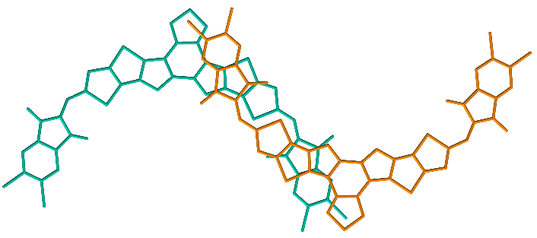
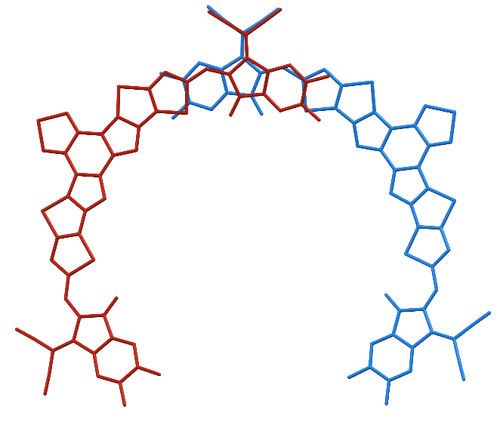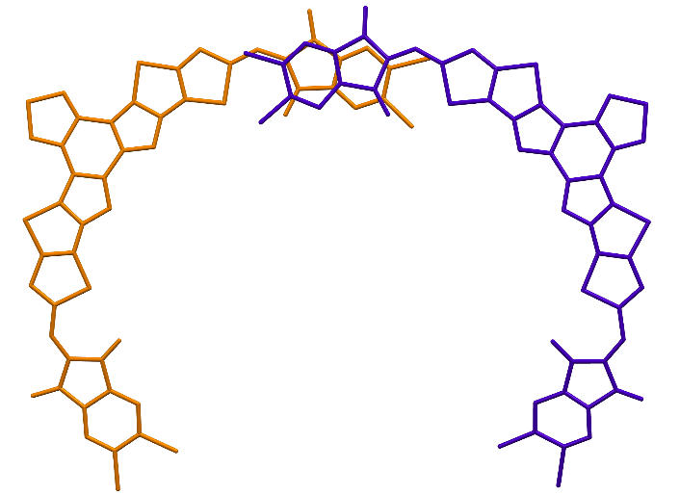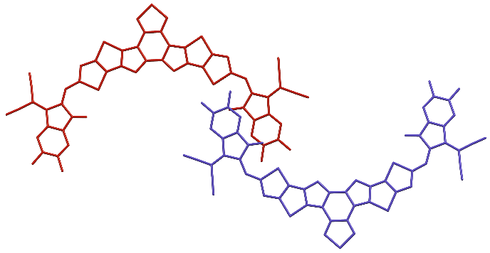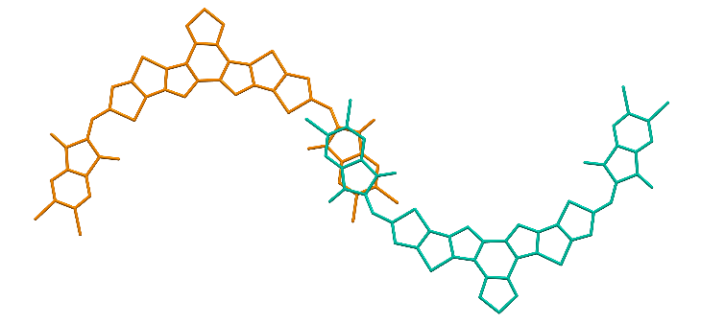
Figure S 19: Y6 (left) and ZY-4Cl (right) crystal structures, as obtained from recrystallization experiments. Upper two rows: overall crystal structures. Next 4 rows: dimers contained in these structures. Y6 data comes from Zhu, L. et al. (Small Exciton Binding Energies Enabling Direct Charge Photogeneration Towards Low-Driving-Force Organic Solar Cells. Angewandte Chemie International Edition 60, 15348-15353 (2021)).

