Additional file 1 for

Tipping points of subtropical forest carbon sinks in southern China: Spatiotemporal dynamics and management insights

Contents of this file

Table S1 to S2 and Figure S1 to S2

Introduction
This supporting information provides the same figures as seen in the main article

Table S1 | Species Life history attribute data.

Species | Common name | LO  NG | SM | ED | MD | VP
 |  |  |  |  |  | probability |  | Min Max
Species | Common name | [year] |  | [m] |  | [year]
Altingia gracilipes | Slender-stalked Altingia | 400 | 25 | 80 | 250 | 0.2 | 10 |  | 90
Eucalyptus spp. | Eucalyptus | 300 | 15 | 60 | 160 | 0.4 | 10 |  | 80
Cupressus funebris | Chinese Weeping Cypress | 500 | 35 | 70 | 200 | 0.4 | 4 |  | 100
Pinus densiflora | Japanese  Red Pine | 250 | 20 | 60 | 200 | 0.6 | 8 |  | 75
Ilex spp. | Holly | 150 | 12 | 60 | 180 | 0.6 | 5 |  | 50
Baeckea frutescens | Shrubby baeckea | 200 | 15 | 30 | 100 | 0.2 | 3 |  | 40
Taxus | Chinese Yew | 350 | 25 | 80 | 250 | 0.7 | 10 |  | 90
Engelhardia roxburghiana | Fenzel's Engelhardia | 100 | 10 | 30 | 100 | 0.8 | 2 |  | 50
Eucalyptus grandis × urophylla | Eucalyptus Grandi | 200 | 18 | 70 | 200 | 0.7 | 8 |  | 90
Castanopsis fargesii Franch | Evergreen-chinkapin | 150 | 30 | 60 | 250 | 0.6 | 6 |  | 50
Lithocarpus glaber | Japanese  Stone Oak | 120 | 15 | 20 | 200 | 0.6 | 5 |  | 100
Dimocarpus longan | Longan | 350 | 30 | 70 | 300 | 0.5 | 15 |  | 120
Diospyros morrisiana | Morris'  Persimmon | 250 | 20 | 40 | 200 | 0.5 | 15 |  | 75
Species | Common name | LO  NG | SM | ED | MD | VP
 |  |  |  |  |  | probability | Min |  | Max
 |  | [year] |  | [m] |  | [year]
Pinus massoniana | Masson pine | 200 | 10 | 200 | 500 | 0 | 0 |  | 0
Schima superba | Chinese  Guger Tree | 300 | 20 | 20 | 200 | 0.6 | 5 |  | 100
Machilus velutina | Nanmu Machilus | 1000 | 50 | 40 | 120 | 0.5 | 6 |  | 200
Cyclobalanopsis  glauca | Blue  Japanese Oak | 200 | 7 | 20 | 50 | 0.4 | 6 |  | 50
Cunninghamia lanceolata | Chinese fir | 200 | 10 | 200 | 500 | 0.6 | 1 |  | 80
Pinus elliottii | Slash pine | 200 | 10 | 200 | 500 | 0 | 0 |  | 0
Metasequoia glyptostroboides | Dawn  Redwood | 150 | 10 | 40 | 150 | 0.4 | 5 |  | 60
Rhodomyrtus tomentosa | Downy Rosemyrtle | 300 | 15 | 50 | 150 | 0.4 | 10 |  | 60
Castanopsis eyrei | Eyre's Evergreen-chinkapin | 300 | 20 | 50 | 200 | 0.5 | 10 |  | 80
Pinus  kwangtungensis | Guangdong White Pine | 150 | 12 | 50 | 180 | 0.3 | 6 |  | 70
Schefflera heptaphylla | Ivy Tree | 200 | 20 | 50 | 150 | 0.3 | 5 |  | 100
Keteleeria fortunei​​ | Fortune's Keteleeria | 250 | 20 | 60 | 150 | 0.4 | 8 |  | 80
Cinnamomum porrectum | Safrole Laurel | 1000 | 15 | 50 | 120 | 0.5 | 6 |  | 200
Castanopsis carlesii | Carles' Evergreen-chinkapin | 200 | 20 | 50 | 120 | 0.6 | 6 |  | 100
Taxus cuspidata | Japanese Yew | 300 | 20 | 70 | 300 | 0.5 | 15 |  | 100
Note. LONG, longevity; SM, the age of sexual maturity; ED, effective seeding distance; MD, maximum seeding distance; VP, vegetative reproduction probability; MINVP, minimum age of vegetative reproduction; MAXVP, maximum age of vegetative reproduction.

Table S2 | Statistical analysis of forest AGB slope distribution among classification areas under various climate scenarios.
Classification | Climate  Scenario | Number of Pixels | Percentage of Study Area | Area
Classification | Climate  Scenario | Number of Pixels | [%] | [ha]
Stable enhancement area | CC | 22,221 | 97 | 2,222,100
Stable enhancement area | SSP1-2.6 | 22,652 | 98.88 | 2,265,200
Stable enhancement area | SSP2-4.5 | 22,675 | 98.99 | 2,267,500
Stable enhancement area | SSP3-7.0 | 22,688 | 99.04 | 2,268,800
Stable enhancement area | SSP5-8.5 | 22,074 | 96.36 | 2,207,400
Tipping point area | CC | 82 | 0.36 | 8,200
Tipping point area | SSP1-2.6 | 50 | 0.22 | 5,000
Classification | Climate  Scenario | Number of Pixels | Percentage of Study Area | Area
Classification | Climate  Scenario | Number of Pixels | [%] | [ha]
Tipping point area | SSP2-4.5 | 17 | 0.07 | 1,700
Tipping point area | SSP3-7.0 | 33 | 0.14 | 3,300
Tipping point area | SSP5-8.5 | 64 | 0.28 | 6,400
Ecologically degraded area | CC | 605 | 2.64 | 60,500
Ecologically degraded area | SSP1-2.6 | 206 | 0.9 | 20,600
Ecologically degraded area | SSP2-4.5 | 216 | 0.94 | 21,600
Ecologically degraded area | SSP3-7.0 | 187 | 0.82 | 18,700
Ecologically degraded area | SSP5-8.5 | 770 | 3.36 | 77,000

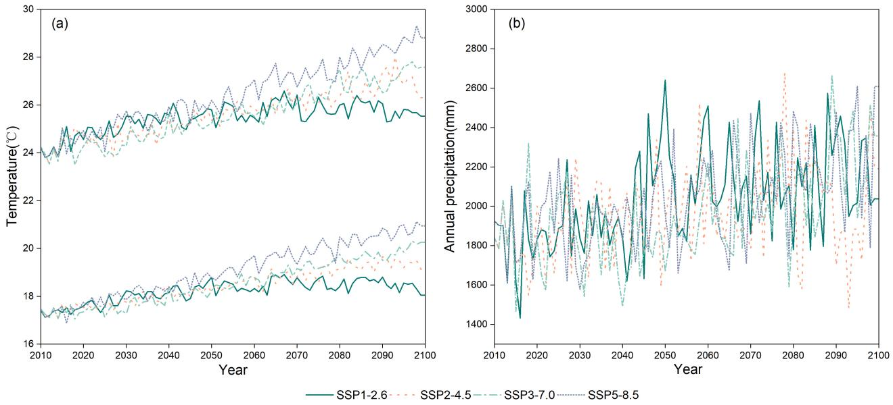

Figure S1. Meteorological data of GBA under different climate scenarios from 2010 to 2100. (a) Trends of maximum and minimum temperatures. (b) Trends of annual average precipitation.

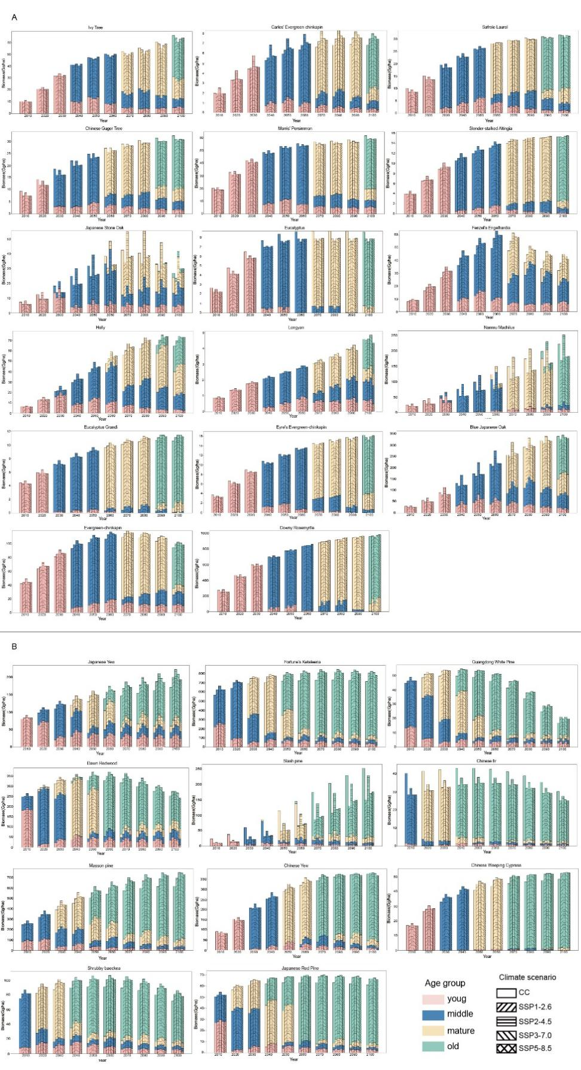

Figure S2. Age classes of single species under different climate scenarios from 2010 to 2100. (A) and (B) represent EBF and ENF, respectively.

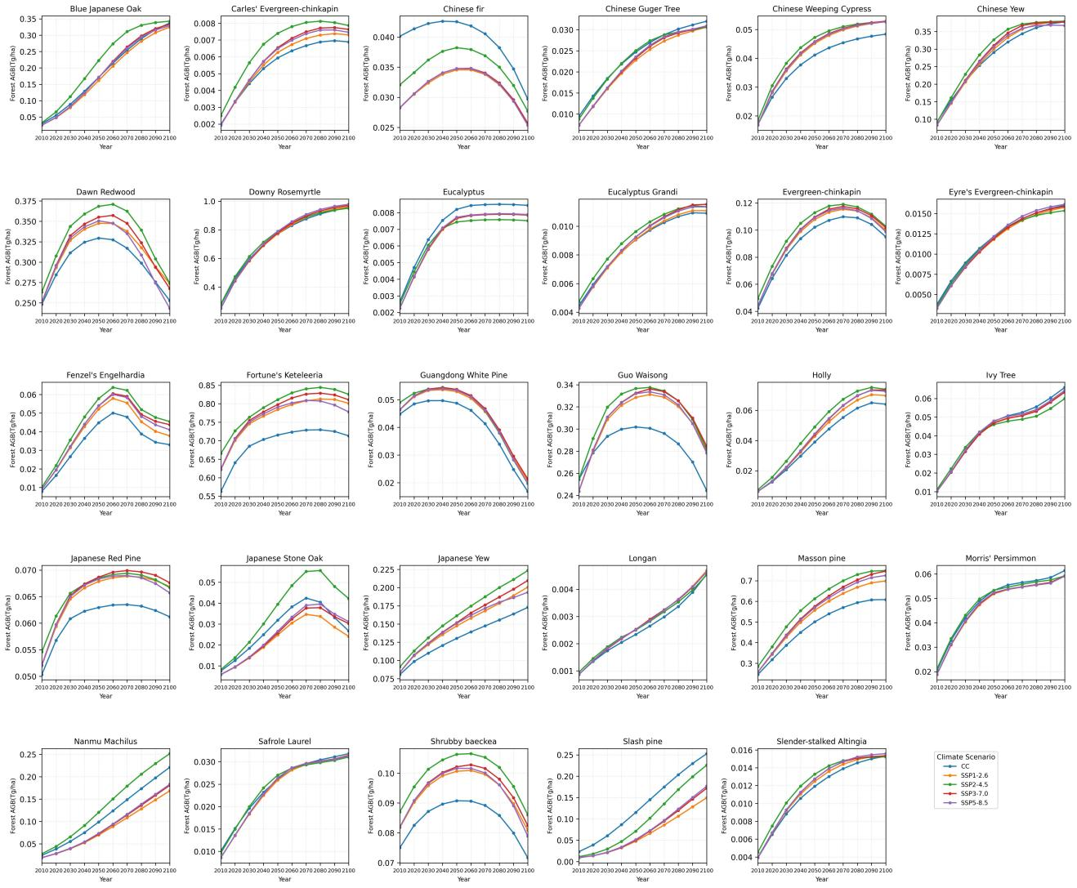

Figure S3. Forest aboveground biomass for single tree species under different climate scenarios during 2010 to 2100.

