SUPPLEMENTARY MATERIALS

Chiral transformers: reconfigurable nanoassemblies for single-step enrichment of low-abundance biomarkers
Michal Sawczyk^{1,2,3,4}, Petr Král^{4,5}, and Nicholas A. Kotov^{1,2,3}

¹Department of Chemical Engineering, University of Michigan, Ann Arbor, MI, 48198, USA
²Biointerfaces Institute, University of Michigan, Ann Arbor, MI, 48198, USA
³Center for Complex Particle Systems (COMPASS), University of Michigan, Ann Arbor, MI, 48198, USA
⁴Department of Chemistry, University of Illinois at Chicago, Chicago, IL 60607, USA
⁵Department of Physics, Pharmaceutical Sciences and Chemical Engineering, University of Illinois at Chicago, Chicago, IL 60607, USA

Table of contents:
- General methods 2
- Synthesis and characterization of SPs 6
- Synthesis of SPs with alternative thiols 18
- Influence of the self–assembly conditions on the SPs structure 20
- Tuning the SPs superstructure by pH 31
- Reversible SPs → NSs disassembly 35
- SPs reconfiguration and structure modifications 43
- Molecular dynamics and DFT simulations 53
- Protein separation with SPs 65
- Protein labeling and confocal microscopy 70
- Quantification of enzyme activity after trapping and release 72
- High–throughput proteomics data 74
- Supplementary references 79

- General methods
Chemicals
D-Penicillamine (98%) and L-penicillamine (99-101%) were purchased from Sigma-Aldrich and further purified by recrystallization. Copper (II) chloride dihydrate (≥99.99% metal basis), cesium chloride (≥99.999% trace metals basis), potassium cyanide (BioUltra, >98%), potassium iodide (99%), calcium chloride dihydrate (≥99%), cetyltrimethylammonium chloride (CTAC, 25 wt. % solution in water), cetyltrimethylammonium bromide (CTAB, ≥98%), hydrochloric acid (37%), potassium hydroxide (~86%, pellets), sodium hydroxide (reagent grade, ≥98%, pellets, anhydrous), sodium hydrogen carbonate (99.7+%), sulfuric acid (95.0–98.0%), poly(sodium 4-styrenesulfonate) (PSS, M_{w} ~70,000, 30 wt. % solution in water), sodium dodecyl sulfate (SDS, >99.0%), 1-butyl-3-methylimidazolium hydrogen sulfate ([BMIM][HSO₄], >95%), choline chloride (>98%), poly(diallyldimethylammonium chloride) (PDADMAC, M_{w} <100,000; 100,000–250,000, and 200,000–350,000), (3-chloro-2-hydroxypropyl)trimethylammonium chloride (3-CHTMAC, 60 wt. % in water), thioglycolic acid (TGA, ≥99%), 3-mercaptopropionic acid (3-MPA, ≥99%), 11-mercaptoundecanoic acid (MUA, 95%), 6-mercapto-1-hexanol (97%), 1-thioglycerol (≥99%), DL-dithiothreitol (DTT, ≥98%), D-cysteine (Cys, 98%), L-cysteine (97%), L-glutathione reduced (L-GSH, ≥98%), mercaptosuccinic acid (MSA, 97%), meso-2,3-dimercaptosuccinic acid (DMSA, 98%), phosphate buffered saline (PBS) tablets, bovine serum albumin (BSA) fluorescein isothiocyanate conjugate, Atto 655 NHS ester, Atto 647N NHS ester, Atto 488 NHS ester (BioReagent, ≥90% HPLC), ApoB (human, ALP30), ApoE (human, ALP70), Human serum (from human male AB plasma, USA origin, sterile-filtered, H4522), human serum albumin, trypsin from bovine pancreas (TPCK treated, ≥10,000 BAEE units/mg), tris(2-carboxyethyl)phosphine hydrochloride (TCEP), Amicon® Ultra Centrifugal Filters, 3 kDa and 10 kDa MWCO, glycerol, ethylene glycol, methanol, ethanol 99.5+%, isopropanol, dimethyl sulfoxide (DMSO), and acetonitrile were purchased from Sigma-Aldrich and used without further purification. Ethylenediaminetetraacetic acid disodium salt dihydrate (EDTA, 99.9%), Gibco™ Fetal Bovine Serum certified (FBS), Gibco™ human ApoE4 recombinant protein (PeproTech®), recombinant human alpha-synuclein (Novus Biologicals; active, pre-formed fibrils type 1, A53T mutant protein), and AnaSpec Beta-amyloid (1-42, HiLyteᵀᴹ Fluor 488-labeled, human) were purchased from Fisher Scientific. Deionized water (18.2 mΩ·cm^{–1}) was used in all experiments, deoxygenated and decarbonized by saturation with nitrogen prior to use.
Electron microscopy
Scanning electron microscopy (SEM) samples were prepared by drop-casting 10 µL of aqueous SPs/NSs/LC dispersions on 5 × 5 mm silicon wafers (TedPella), followed by removing the excess of a solvent with a kimwipe, and drying at room temperature. The samples were then sputter coated a ~5 nm film of gold on the wafer to minimize the local charging under focused electron beam. SEM imaging was performed on FEI Helios Nanolab at 5.0 kV accelerating voltage and 0.4 nA beam current under secondary electrons detection mode. In case of excessive sample charging (which typically occurred when rigid SPs spikes had minimal contact surface area with conductive silicon wafer) the voltage was decreased to 3.0 kV at 0.2 nA beam current, with multiple fast scan accumulation, without significantly affecting final image resolution.
Transmission electron microscopy (TEM) samples were prepared by immersing the carbon-coated copper grids (TedPella, 150 mesh) in aqueous dispersions/solutions, placed on a kimwipe to remove the excess of the solvent, and drying at room temperature. Bright-field TEM images and diffraction experiments were acquired using Thermo Fisher Talos F200X operating at 200 kV equipped with a Gatan OneView camera. A HAADF detector was used to acquire Z-contrast STEM images in which the intensity is proportional to the atomic number of the column over which the electron probe is placed.

X-ray diffraction
Powder XRD measurements of purified, vacuum-dried SPs samples were performed using Rigaku SmartLab diffractometer equipped with a copper K_{α} source (wavelength of 1.5406 Å) in a Bragg-Bentano, θ-2θ configuration. The acquisition of scattered beams was carried out using a D/Tex detector with 2θ angle varying from 2° o to 60° in a step of 0.01° and 2°/min accumulation time. Background subtraction was performed using PDXL software.

Chiroptical spectroscopy
CD measurements in ultraviolet (UV), visible (Vis), and near-infrared (NIR) range were performed using JASCO J-1700 and J-815 spectrometers equipped with one photomultiplier tube detector in a 200–800 nm range and two InGaAs NIR detectors in an 800–1,600 nm range. Typical scanning parameters for SPs were as follows: scanning speed, 500 nm·min⁻¹; data pitch, 0.1 nm; bandwidth, 5 nm (NIR bandwidth, 10 nm), digital integration time, 0.25 s. Due to the low signal-to-noise ratio of tightly packed SPs dispersions, ~20 accumulations were collected with a careful check of the background between the runs. Higher-anisotropy g-factors of NCs and NSs allowed to obtain quality spectra at 200 nm·min⁻¹; with just 2-3 accumulations. Since the general definition of g-factor can be described as the difference between the absorption of right- and left-circularly polarized light, the g-factors were calculated according to the equation,
$$g=\frac{CD}{32,980∙Abs} ,$$
where CD is the signal obtained from CD/DC channel and Abs is the absorbance calculated from ABS and DC channels of the spectrophotometer. CD spectra were stopped at wavelengths in which the high-tension voltage was greater than 800 V to avoid artefacts during acquisition.

VCD spectroscopy
VCD measurements were performed on purified and vacuum-dried samples dispersed in heavy water (D₂O) at 35 mg·mL⁻¹ concentration, using JACSO FVS-6000 VCD spectrometer. 100 µL of such suspensions were sandwiched between two barium fluoride (BaF₂) crystals separated by a 50 µm Teflon spacer. An MCT-V detector was used to acquire infrared and VCD data in the range of 2,000 to 850 cm⁻¹ with a resolution of 4 cm⁻¹ and a total of 100 and 2000 accumulations, respectively. The sandwiched dispersions between BaF₂ crystals were rotated along a axis coinciding with the direction of the beam at a constant speed to avoid settling of particles. Corresponding infrared and VCD were plotted as A and △𝐴/A, respectively, with exclusion of the 1,300 to 1,100 cm⁻¹ range which corresponds to strong absorption from D₂O.
VCD of recrystallized Pen samples were measured after fine grinding of ~50 mg penicillamine crystals with 50 µL D₂O. Such obtained paste was sandwiched between the BaF₂ crystals and measured as described previously.

Circularly polarized luminescence
CPL samples were prepared by dispersing freshly synthesized SPs in water, or, preferably, another achiral solvent of high viscosity, such as ethylene glycol, due to rapid precipitation of particles in water during data collection. The CPL handedness, intensities, and emission maxima were nearly identical regardless of employed solvent, as the luminescence originated from the rigid microparticle, and was not affected by the surface solvation effects. CPL, PL, and excitation spectra were collected using JASCO J-300 spectrometer under constant HT voltage at 600 V, 4,000 µm excitation and emission pinhole, scanning speed, 500 nm·min⁻¹; data pitch, 1.0 nm; bandwidth, 5 nm (NIR bandwidth, 10 nm), digital integration time, 1.0 s, 4 accumulations. Samples of low-CPLE maximum intensity, i.e., <20 mdeg, were measured at 200 nm·min⁻¹ scanning speed to improve the signal-to-noise ratio. Circularly polarized luminescence anisotropy factors were calculated as,
$$g_{lum}=\frac{CPL}{32,980}×\frac{ln⁡(10)}{DC} .$$

Optical microscopy
All samples were prepared by depositing ~10 µL of SPs/NSs suspensions between two standard microscopy glass slides (25 x 75 x 1.0 mm and 22 x 22 mm, Fisherbrand). SPs could be dispersed both in water or high-viscosity organic solvents, such as ethylene glycol or glycerol, while the latter typically improved the image quality and limited the particles movement. However, the images of samples titrated with a base or acid (Fig. S36, S40) were all taken in water, to avoid the chemical interactions or differences in solvation between disassembled NSs and glycol or glycerol.
Confocal microscopy images were acquired using Nikon A1R and Leica 8 microscope with 405 nm (Nikon) and 365 nm (Leica) excitation lasers. Three-dimensional z-stack images were obtained after superimposing multiple frames captured at different z-heights (thus varying focal points), with an interval of Δz = 0.5 µm.
Inverted fluorescence microscopy (IFM) images were acquired with Olympus IX 71 microscope, equipped with cross-polarizer, at maximal emission intensity, using Texas Red emission channel.
Polarized light microscopy (PLM) images were captured with a Nikon Eclipse 80i microscope, equipped with cross-polarizer, maximal light intensity, and 5x, 10x, 20x, 40x, and 100x objectives.
Protein trapping imaging. 100 µL of different SPs dispersions in 150 mM KCl (3.0 mg/mL, D– or rac–SPs) were incubated for 15 min with 5% (mass equivalent) of Atto 655–labeled ApoB, ApoE, or fluorescein isothiocyanate–labeled bovine serum albumin. The SPs were gently centrifuged for 30 s, washed with 150 mM KCl, and redispersed in 100 µL water. 25 µL of SPs–protein conjugates were sandwiched between microscopy glass slides and imaged using Nikon Yokogawa CSU-W1 SoRa confocal microscope (spinning disc mode), equipped with 60x and 100x oil immersion objectives, and collecting the z–stack images throughout the entire particle height (10–25 micron). Images were not deconvoluted except those shown in Fig. 5c,d due to the size of the particle spikes.
- Synthesis and characterization of SPs
Penicillamine recrystallization
Although commercially available penicillamine (Pen) enantiomers are relatively pure, entirely water–soluble, and display relatively symmetric circular dichroism peaks, they need to be recrystallized before SPs syntheses. SPs prepared with unpurified Pen exhibit similar macroscopic morphology under SEM, however, the traces of possible post–production contaminants, such as metals salts or disulfides, affect the nanocrystalline order within SPs. This results in a limited reproducibility of CPLE intensities and introduces the contamination peaks in Vis/NIR-CD and VCD regions. Furthermore, when commercial Pen is stored in the fridge for prolonged periods of time, it absorbs water vapor (due to repeated open-seal cycles), catalyzing its decomposition.
D– or L–penicillamine powder (1.28 g) was mixed with 40 mL of 45:40:15 (v/v/v) ethanol–methanol–water mixture in a sealed 45 mL glass vial and flushed with nitrogen. The solution was heated to 80°C, and the white suspension fully dissolved to form colorless, clear solution. To avoid the oxidation of thiol in air, the solution was not filtered nor transferred to any other container. The solution was left undisturbed at room temperature, and after cooling down, in a fridge until branched needle crystals of Pen formed. The crystals were separated on a Büchner funnel, washed with small amount of ice–cold 100% ethanol, and dried in vacuo; yield: 82%. The use of 80:20 ethanol–water system gives the crystals of similar quality, but the yield decreases to ~75%.
Wherever racemic Pen was employed in the experiments, it was obtained by mixing equal volumes of freshly prepared aqueous solutions of recrystallized D–Pen and L–Pen. Commercially available racemic penicillamine does not fully dissolve in pure water, contains disulfide contamination, and displays weak circular dichroism, which all eliminate it from reproducible syntheses.

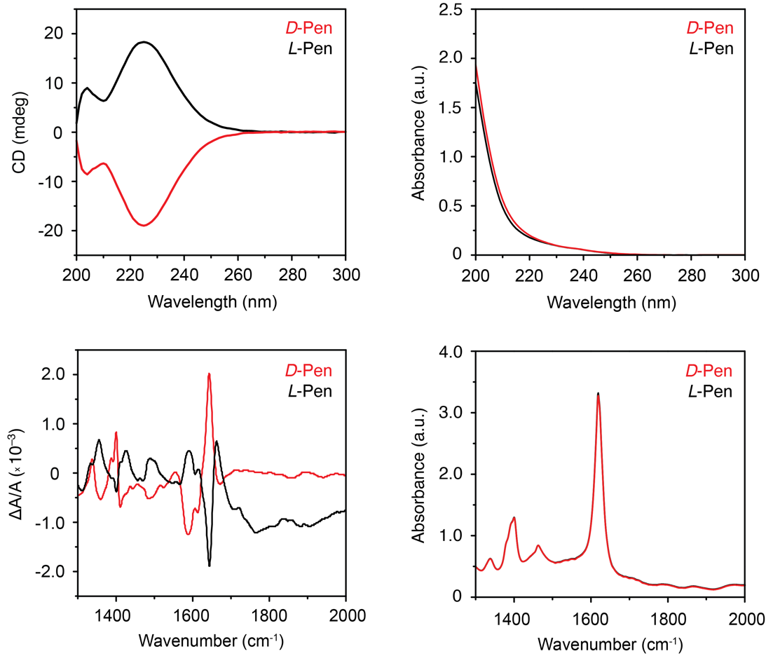
Figure S1. Circular dichroism (CD) and vibrational circular dichroism (VCD) spectra of recrystallized D- and L-Pen used for the synthesis of SPs.
Synthesis of SPs
D-Penicillamine (98%) and L-penicillamine (99-101%) were purchased from Sigma-Aldrich and further purified by recrystallization as described before. 2 mL of solution prepared by mixing 10 mL of water, 10 mL of 25% aqueous CTAC solution, and 2 mL of 100 mM CuCl₂ solution was poured into a 4 mL glass vial and incubated in a 50°C water bath for 10 min. Then, 386 µL of Pen solution (85 mg · mL^{–1}, 6.5 equiv. regarding the molarity of Cu²⁺) was added using an automatic pipette. The vial was gently shaken for 2-3 s and placed back in the water bath for the self-assembly. No stirring was applied. The reaction was complete when the yellowish precipitate settled, and the supernatant became transparent (10-15 min). The supernatant was discharged, the SPs were resuspended in 2 mL of water, centrifuged (2 min, 1,800 rpm), washed with water, and finally with 2 mL of 99% ethanol.
Standard spiky SPs at pH 2.3 (δ = +0.3) form spontaneously upon reacting 16.7 mM CuCl₂ solution in 400 mM aqueous CTAC with a 6.5–fold molar excess of Pen (186 µL of 0.55 M Pen per each mL of Cu²⁺ solution). Theoretically, one equivalent of Pen acts as a reducing agent, one serves as a covalent building block incorporated into the molecular structure of (CuSPen)_{n}, and the remaining four equivalents stabilize the product against oxidation while lowering the pH to sufficiently acidic values. No stirring is applied, as it would disrupt the spontaneous self–assembly of hierarchical SPs domains. The reaction is complete when the pale yellowish precipitate settles and the supernatant becomes transparent, typically within 2–120 min, depending on the protonation degree of Pen and the temperature. Generally, stronger repulsive forces (i.e., at pH below 2.0 or pH above 5.0) slow down the assembly, whereas higher temperatures accelerate it.
In the reaction depicted in Fig. S2, within the first two seconds, Cu²⁺ cations are first reduced to Cu⁺, which is immediately complexed by thiol to produce yellowish Cu(I) complex,
$${2 Cu}^{2+}+4 PenSH →2 Cu^{I}(SPen)+(PenS)_{2}+4 H^{+}$$
This process is followed by continuous supramolecular polymerization of the complex, during which the covalent Cu–S bonds are formed and propagate along the two-dimensional plane to form the Cu₃S₃ ‘honeycomb’ graphene–like NSs stabilized by Pen ligands. Simultaneously, hydrogen bonds between the NSs result in three-dimensional (3D) self-assembly into SPs. Note that the initial reaction produces 2 molar equivalents of hydrochloric acid per each Cu²⁺. Therefore, without modifying the pH by addition of an acid or a base, pure CuCl₂/Pen system has δ = +0.3 and measured pH 2.3 (see Fig. S20).
The SPs growth process is self-limited by electrostatic interactions. At pH 2.3, particles of ~20 micron in diameter emerge. Elevated reaction temperature provides moderate repulsion between building blocks which favors the formation of spheroidal SPs morphologies, in contrast to stochastic aggregates obtained at room temperature (Fig. S11).
The presence of CTAC during the reaction is necessary for the continuous growth of NSs domains large enough to produce SPs with high CPLE dissymmetry factors (g_{lum}). The reaction carried out without the surfactant (Fig. S18) results in disordered SPs of similar photoluminescence intensity but with at least order of magnitude lower g_{lum} values (~10^{–3}).

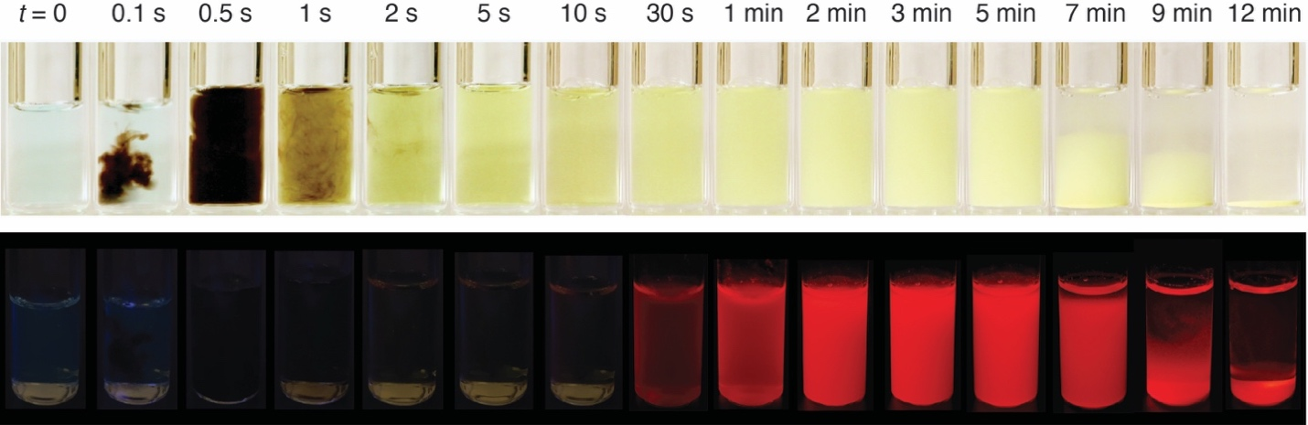
Figure S2. Visual changes accompanying the reaction of 16.7 mM CuCl₂ with 6.5 equiv. D-Pen in 400 mM CTAC, at 50°C and pH 2.3. Initial addition of Pen results in ephemeral formation of dark brown Cu^{II} mixed sulfide and thiolate complexes, which are rapidly reduced to Cu^{I}-Pen yellowish, transparent dispersion of ~2 nm NSs, followed by their progressive self-assembly into SPs. The appearance of red photoluminescence indicates the growth of sub-micron assemblies). Top, reaction mixture under daylight; bottom, under 365 nm ultraviolet light.

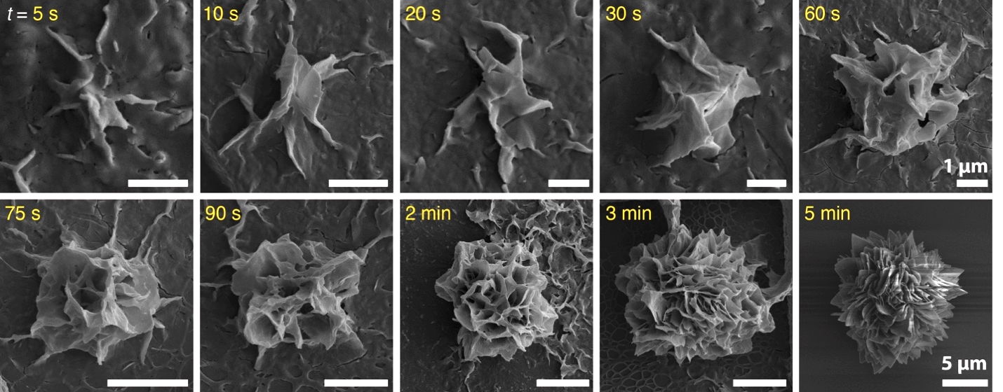
Figure S3. Scanning electron microscopy (SEM) micrographs captured during D–SPs growth, illustrating the coexistence of classical and nonclassical nucleation pathways. Although the initial ‘seeds’ partially resemble the final spiky morphology of SPs and nanoplatelets (which later form the spikes) are already visible, abundant Cu^{I}SPen small NSs and nanoclusters observed between 5 and 120 s of growth appear capable of reconfiguring into electrostatically frustrated assemblies.

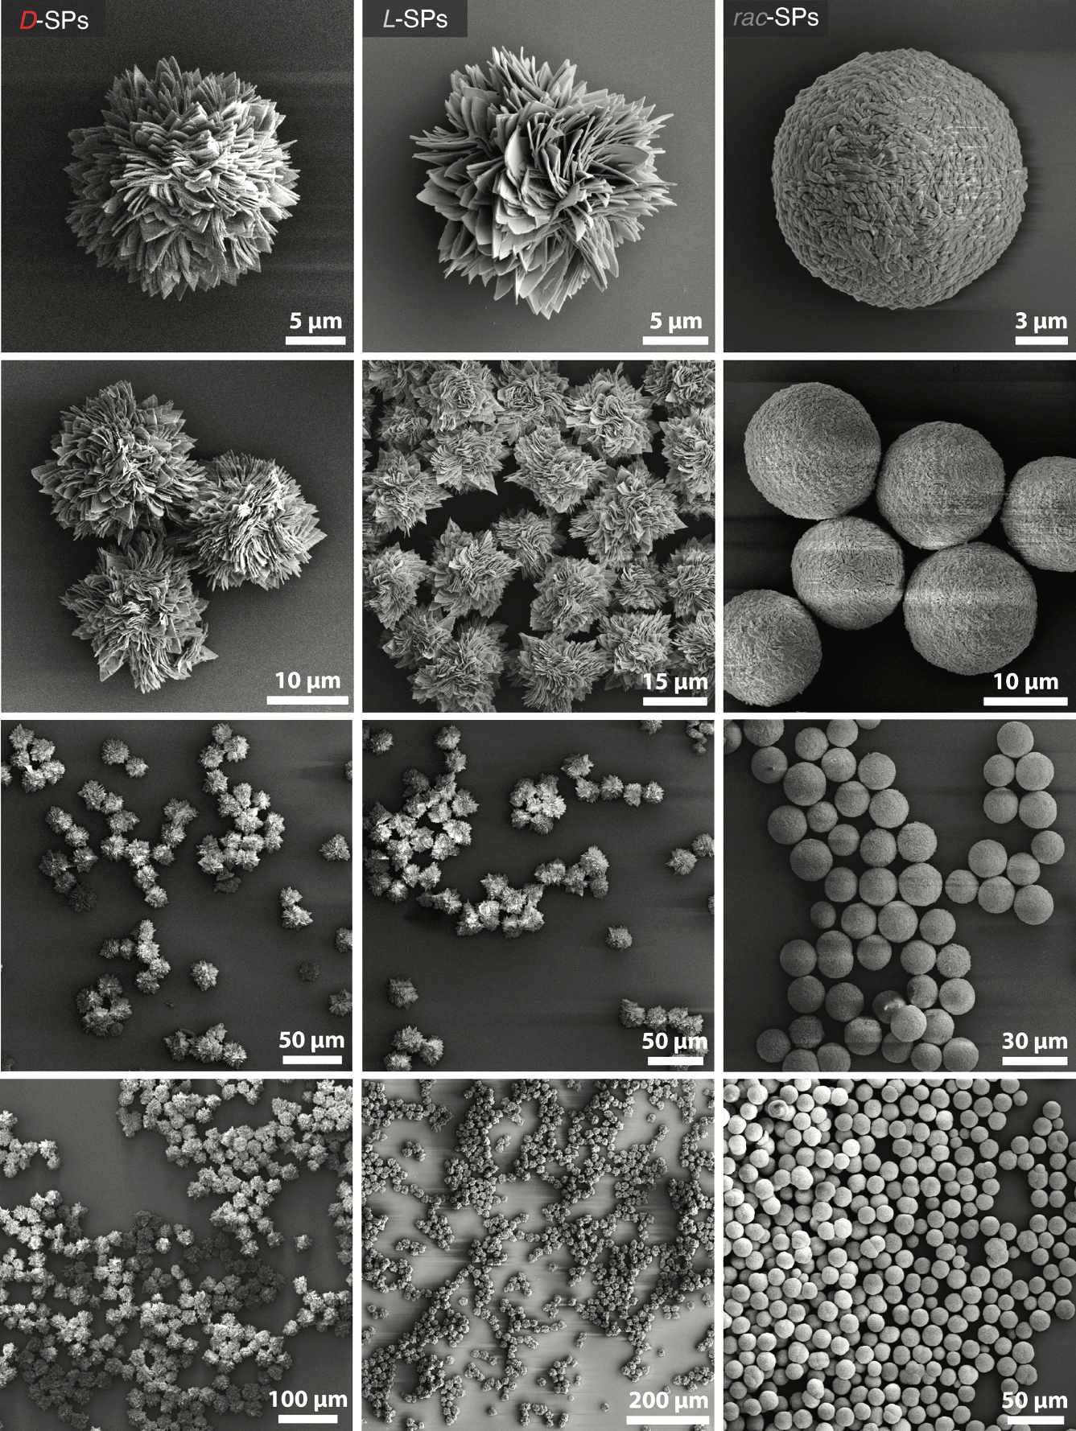
Figure S4. SEM images of D-, L-, and rac-SPs synthesized with 16.7 mM CuCl₂ and 6.5 equiv. Pen in 400 mM CTAC, at 50°C and pH 2.3, at different magnifications.
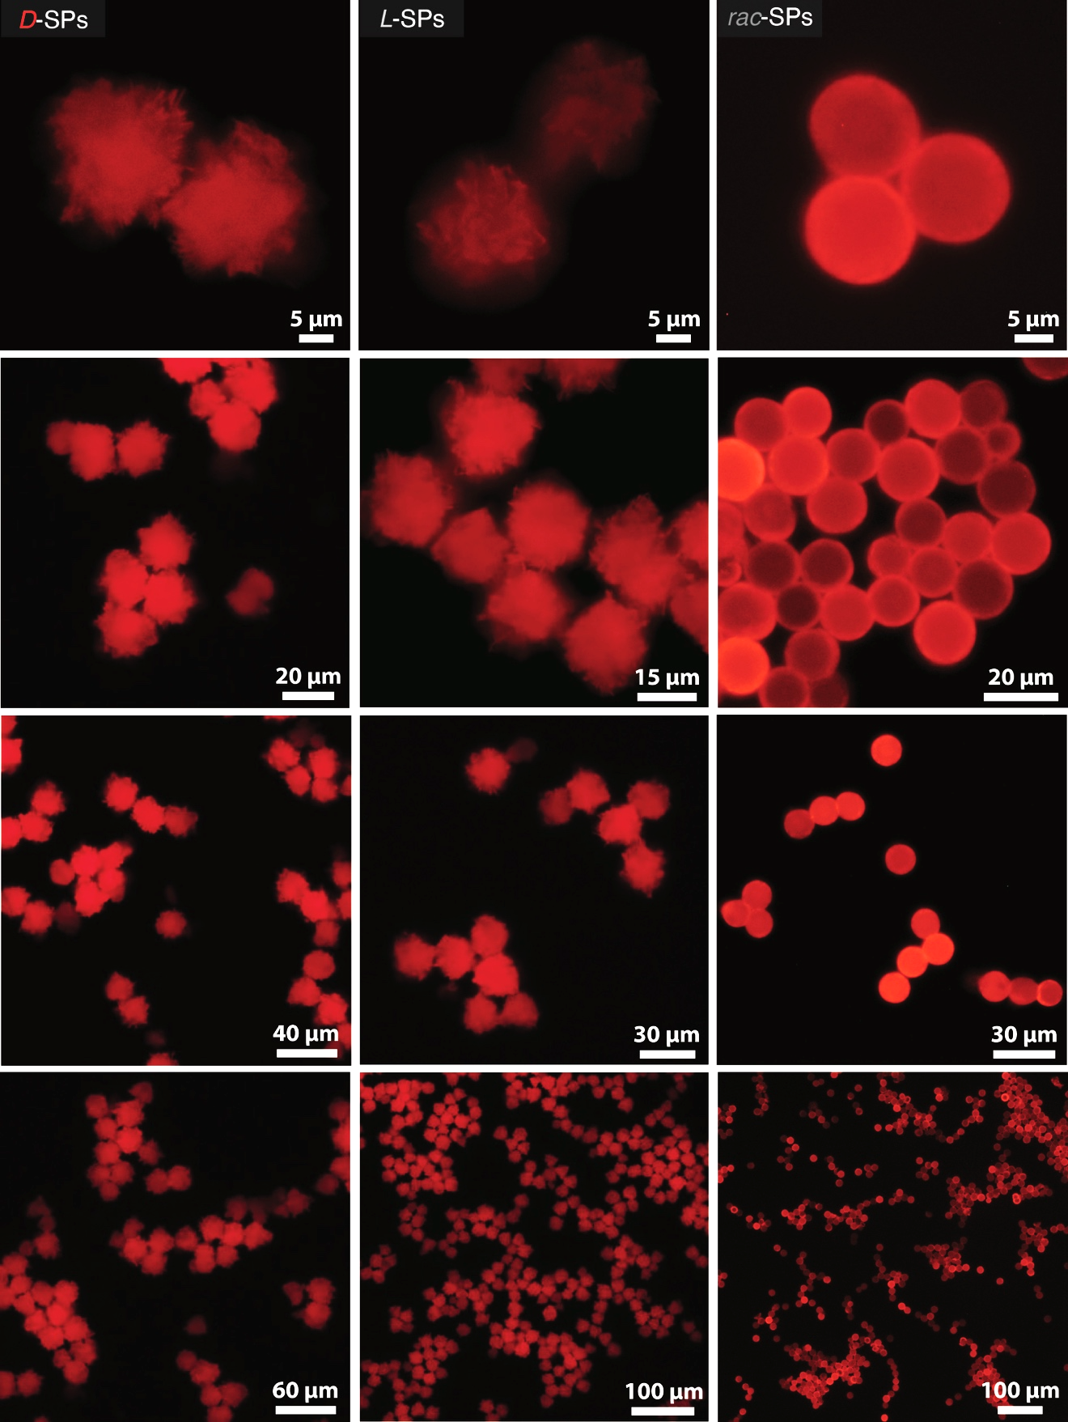
Figure S5. Inverted fluorescence microscopy (IFM) images of D-, L- and rac-SPs prepared with 16.7 mM CuCl₂ and 6.5 equiv. Pen in 400 mM CTAC, at 50°C and pH 2.3, at different magnifications; λ_{exc}= 405 nm, λ_{em} = 615 nm.
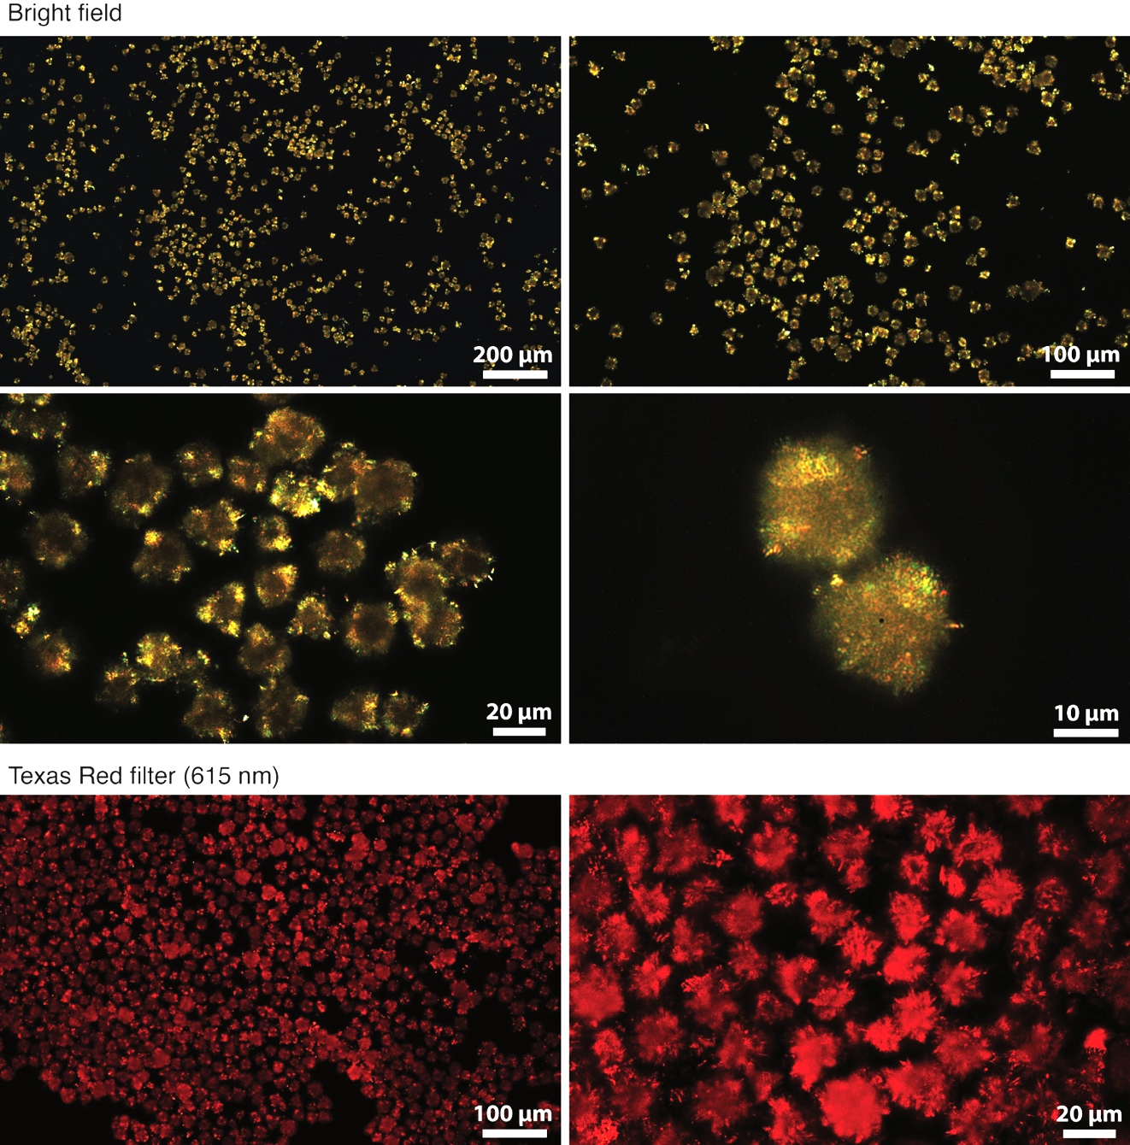
Figure S6. Polarized light microscopy (PLM) images of L-SPs prepared with 16.7 mM CuCl₂ and 6.5 equiv. mM Pen in 400 mM CTAC, at 50°C and pH 2.3, at different magnifications. The top images were acquired in bright-field mode, while the bottom ones were obtained using the Texas Red filter. Variations in the orientation of nanocrystalline domains within the SP spikes cause anisotropic birefringence, which modulates the transmitted light intensity observed under crossed polarizers.

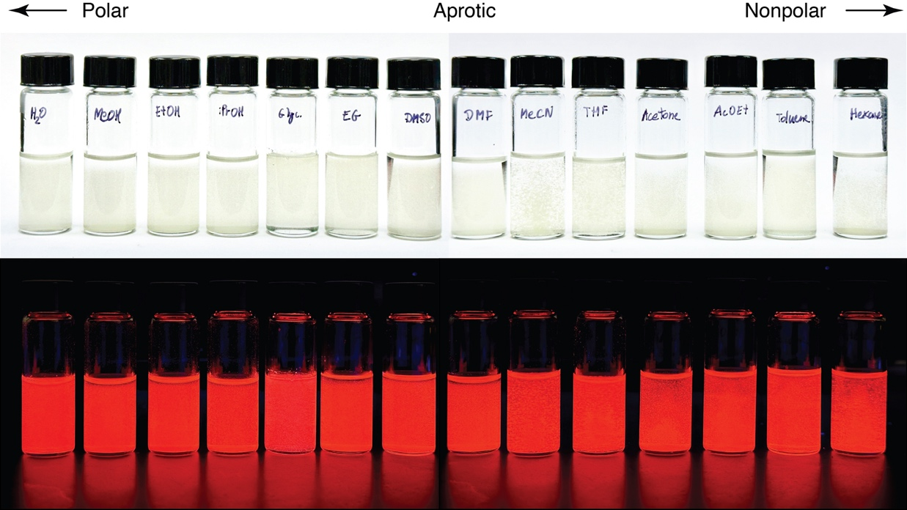

Figure S7. Dispersions of standard spiky D-SPs (2 mg/mL; prepared with 16.7 mM CuCl₂ and 108 mM Pen in 400 mM CTAC, at 50°C and pH 2.3) in different solvents under visible and ultraviolet light. From left to right, water, methanol, ethanol, isopropanol, glycerol, ethylene glycol, dimethylsulfoxide (DMSO), N,N-dimethylformamide (DMF), acetonitrile, tetrahydrofuran (THF), acetone, ethyl acetate, toluene, and hexane. Stable photoluminescence of SPs in all types of solvents indicate the chemical stability of covalent CuSPen network regardless of the surface ligand solvation effects.

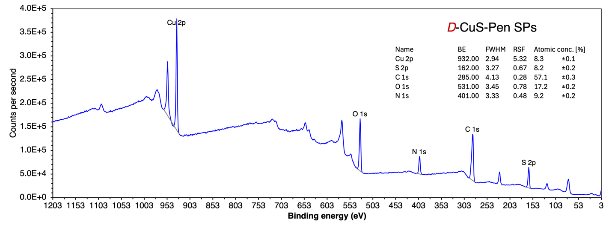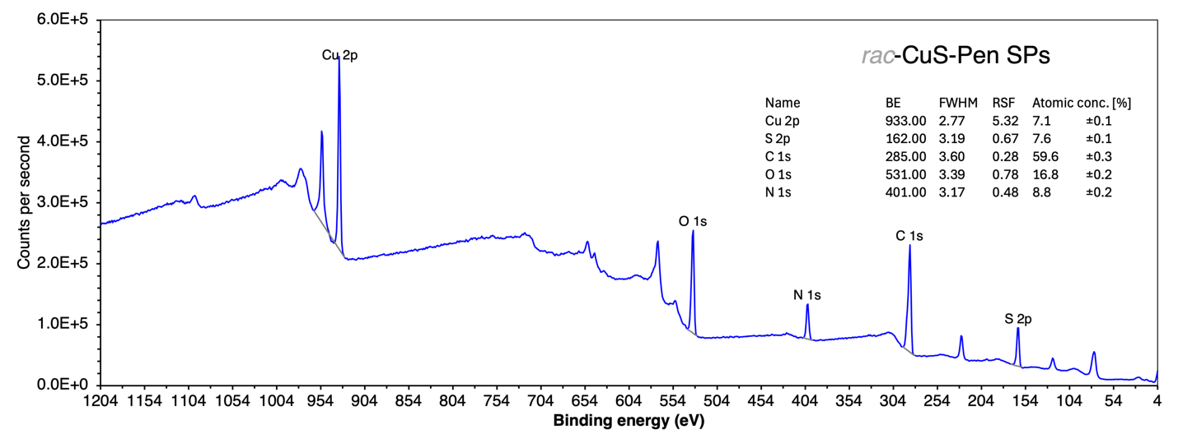

Figure S8. X-ray photoelectron spectroscopy (XPS) spectra of D-SPs (top) and rac-SPs (bottom), synthesized with 16.7 mM CuCl₂ and 6.5 equiv. Pen in 400 mM CTAC, at 50°C and pH 2.3. Both homochiral and racemic SPs display nearly identical composition corresponding to 1:1 molar ratio between Cu and Pen. Slight excess of C and N count comes from the presence of small amounts of CTA⁺ counterions balancing the partial surface charge of deprotonated Pen. No chlorine from CTAC was detected. Therefore, the composition of SPs corresponds to the empirical formula of CuC₅NO₂S and approximately 10.3% to 14.6% molar of co–stabilizing CTA⁺, in homochiral and racemic SPs, respectively.

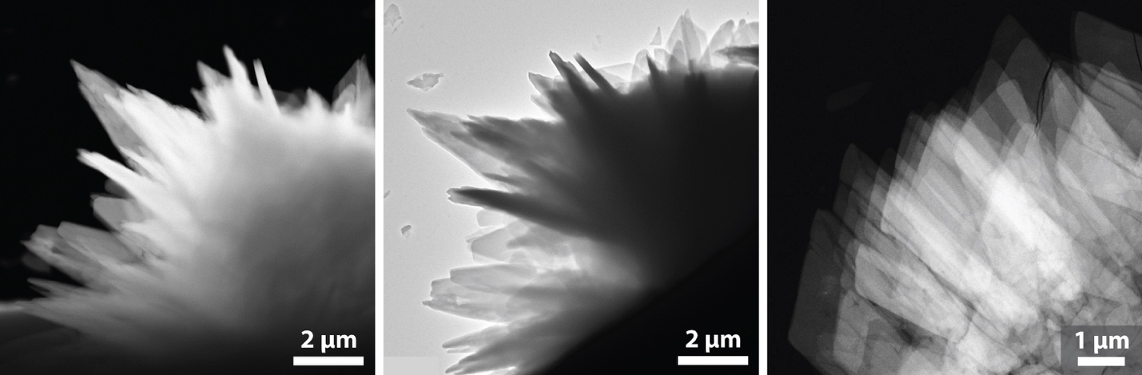

Figure S9. Transmission electron microscopy (TEM) and high-angle annular dark–field scanning transmission electron microscopy (HAADF–STEM) images of D–SPs. The image on the right shows the hierarchical nanoscale organization of nanocrystalline SPs fragments exhibiting covellite–like hexagonal symmetry characteristic of the CuS lattice.

- Synthesis of SPs with alternative thiols
Using a procedure identical to the standard SPs synthesis (50 °C, 6.5 equiv. thiol, 400 mM CTAC), Pen was replaced with various alternative thiols at the same concentration to test whether comparable self-assembly could occur. The set included thioglycolic acid (TGA), 3-mercaptopropionic acid (MPA), 11-mercaptoundecanoic acid (MUA), 6-mercapto-1-hexanol, 1-thioglycerol, DL-dithiothreitol (DTT), L-cysteine (L-Cys), L-glutathione (L-GSH), mercaptosuccinic acid (MSA), and meso–dimercaptosuccinic acid (DMSA). All tested thiols (except MSA and DMSA which did not give out any solid products) produced white, amorphous precipitates (Fig. S10) instead of microcrystalline SPs of well–defined geometries. These solids were subsequently imaged by SEM and evaluated for photoluminescence, which was either absent or extremely weak. In contrast, Pen uniquely yields ordered, chiral SPs composed of CuS–Pen NSs. Its tertiary thiol adjacent to two methyl groups provide steric protection and hydrophobic stabilization to the fragile (Cu₃S₃)_{n} honeycomb lattice (Fig. S41). The methyl substituents introduce steric hindrance between neighboring ligands, maintaining planar NS layers and preventing collapse of the nanosheet stacks. Molecular dynamics (MD) simulations (Fig. S40) confirm that water molecules cannot easily penetrate between the NSs, consistent with a compact, solvent-excluded lamellar structure stabilized by the Pen ligand shells.
Solid samples lacking the continuous CuS framework remain non-luminescent, indicating that aggregation-induced emission (AIE) effects are not sufficient to produce luminescent due to the absence of long–range electronic conjugation within the material. Short-chain aliphatic thiols (TGA, MPA) and flexible aliphatic ligands (MUA, 6-mercapto-1-hexanol, 1-thioglycerol) lack the steric bulk and directional geometry necessary for planar CuS growth, yielding disordered cross-linked aggregates with negligible PL and no detectable CPLE. DTT introduces crosslinking between layers that terminates 2D propagation; L-Cys forms ~80 nm nanoparticles with weak fluorescence and no measurable CPLE; and L-GSH, although bulkier than Pen, produces fused, non-emissive networks due to its flexibility and multiple binding sites. Only Pen combines the steric hindrance, hydrophobic effects, and complementary hydrogen-bonding geometry required to stabilize the (Cu₃S₃)_{n} framework and direct its hierarchical organization into spiky SPs with strong PL and CPLE (Fig. S13, S21).
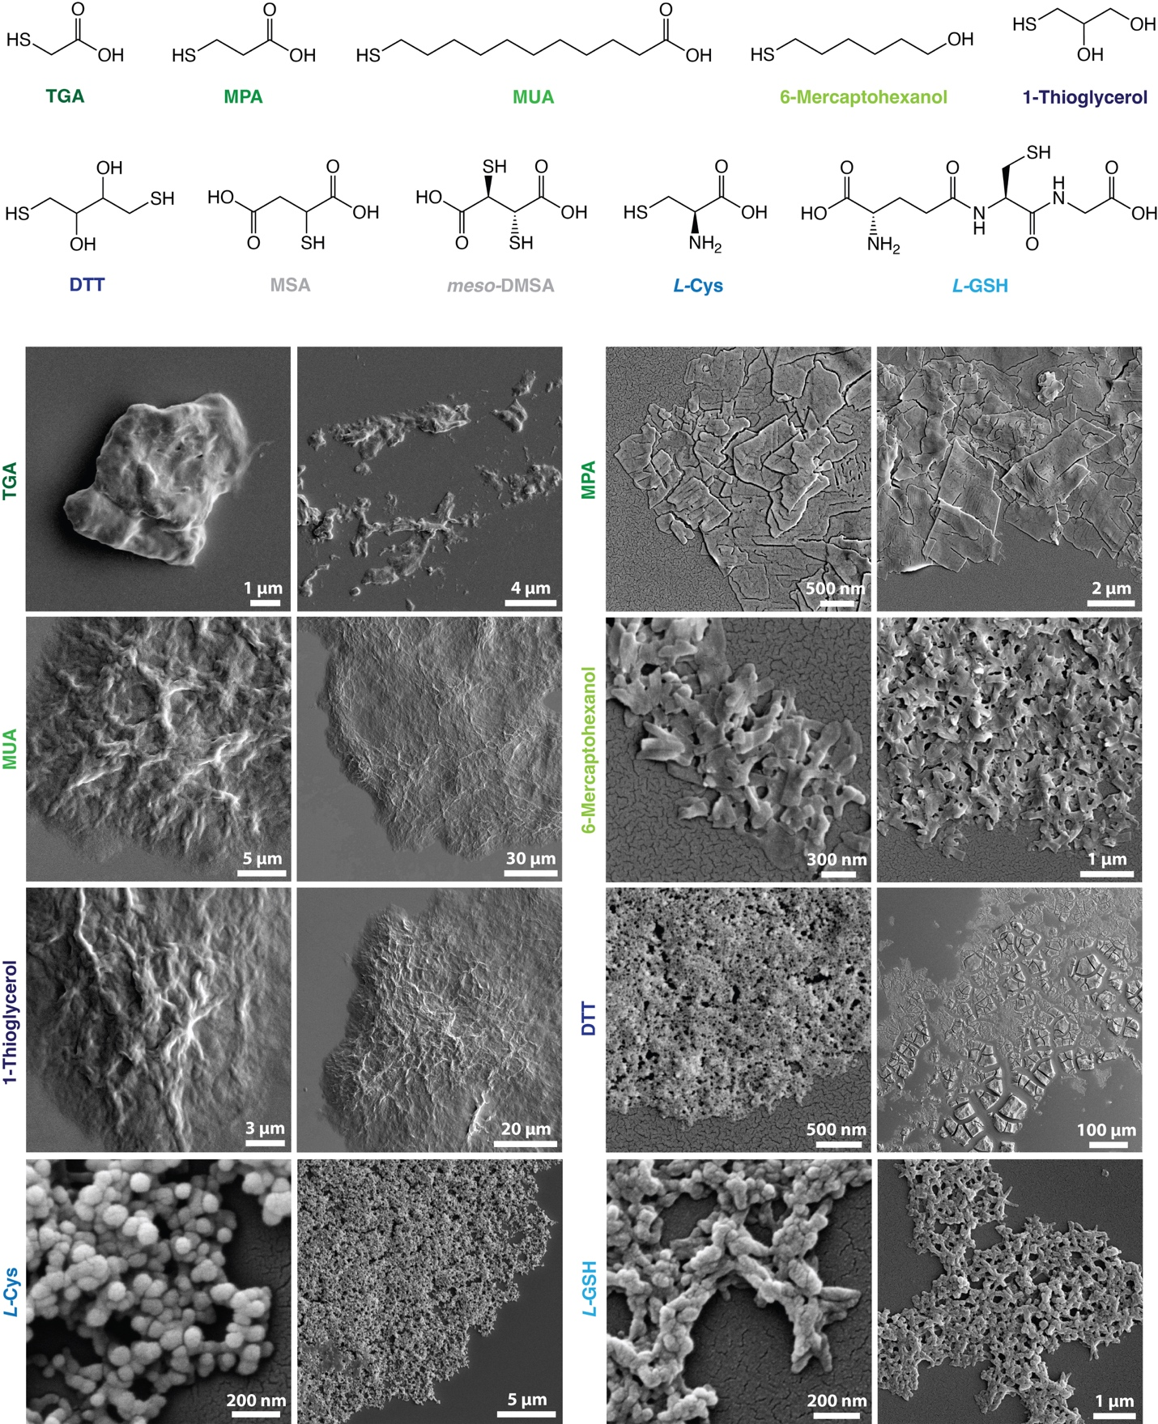
Figure S10. SEM images of SPs prepared with different aliphatic thiols instead of Pen: TGA, MPA, MUA, 6-mercapto-1-hexanol, 1-thioglycerol, DTT, L-Cys, and L-GSH.

- Influence of the self–assembly conditions on the SPs structure
Influence of temperature
The influence of synthesis temperature on the morphology and chiroptical properties of SPs is reflected in both electron microscopy and spectroscopic measurements. SEM images reveal that higher self–assembly temperatures favor the formation of well–defined, spiky architectures, while lower temperatures lead to disordered aggregates with poorly developed surface features (Fig. S11). These morphological changes are accompanied by pronounced differences in chiroptical activity. Formation of SPs correlates directly with the emergence of vibrational circular dichroism (VCD) activity and circularly polarized light emission (CPLE) with both types of spectra presented in Fig. 2g,i. VCD peaks between 1,500 and 1,700 cm^{–1} indicate long–range ordering of hydrogen bonds between carbonyl and amine groups interconnecting chiral nanosheets within SPs, supporting structural prerequisite for CPLE activity. DFT frequency calculations associate the enhanced VCD activity with asymmetric and symmetric N–H and C–H bending and C=O stretch in chiral Cu₃(SPen)₃ ring components of NSs (Fig. S44).
Monitoring the dissymmetry factors (g_{CPLE}) across differently assembled SPs reveals a clear dependence of emission dissymmetry on particle nanocrystallinity, allowing the morphology and chiroptical response to be tuned through thermodynamic and kinetic control of self-assembly. For instance, D-/L-SPs prepared at elevated temperatures (50–60°C) exhibit markedly higher g_{CPLE} values (1.5 × 10^{–2} at λ_{em} = 670 nm) than those assembled at room temperature (1.6 × 10^{–3}). Synthesis at 50°C provides the optimal balance between hydrogen-bonding strength and supramolecular polymerization rate, promoting the formation of spiky particles (at δ = +0.3) with the highest g_{CPLE}. Further deviation from this temperature reduces CPLE intensity (Fig. 2i). Notably, the overall photoluminescence intensity remains nearly unchanged (Fig. S13), as it arises from the electronic conjugation within semiconductive CuS domains irrespective of the degree of chiral twisting responsible for the polarized emission. Consistently, SPs exhibiting strong CPLE also display pronounced VCD signals, whereas disordered low-temperature assemblies lack both.

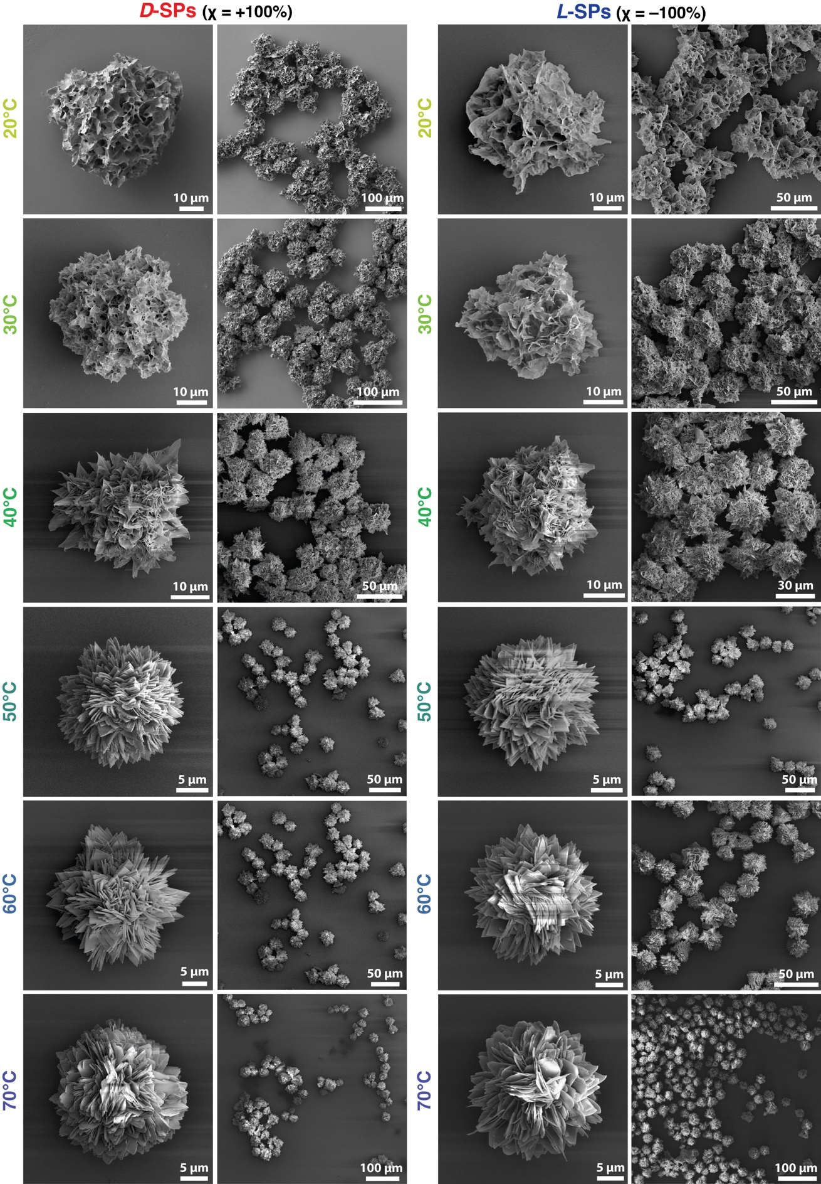
Figure S11. SEM images of D- and L-SPs synthesized at different temperatures and pH 2.3.
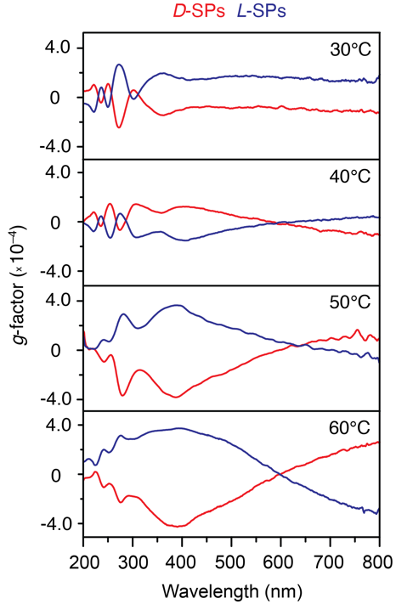
Figure S12. Measured g–factors of D– and L–CuS–Pen SPs synthesized at different temperatures.

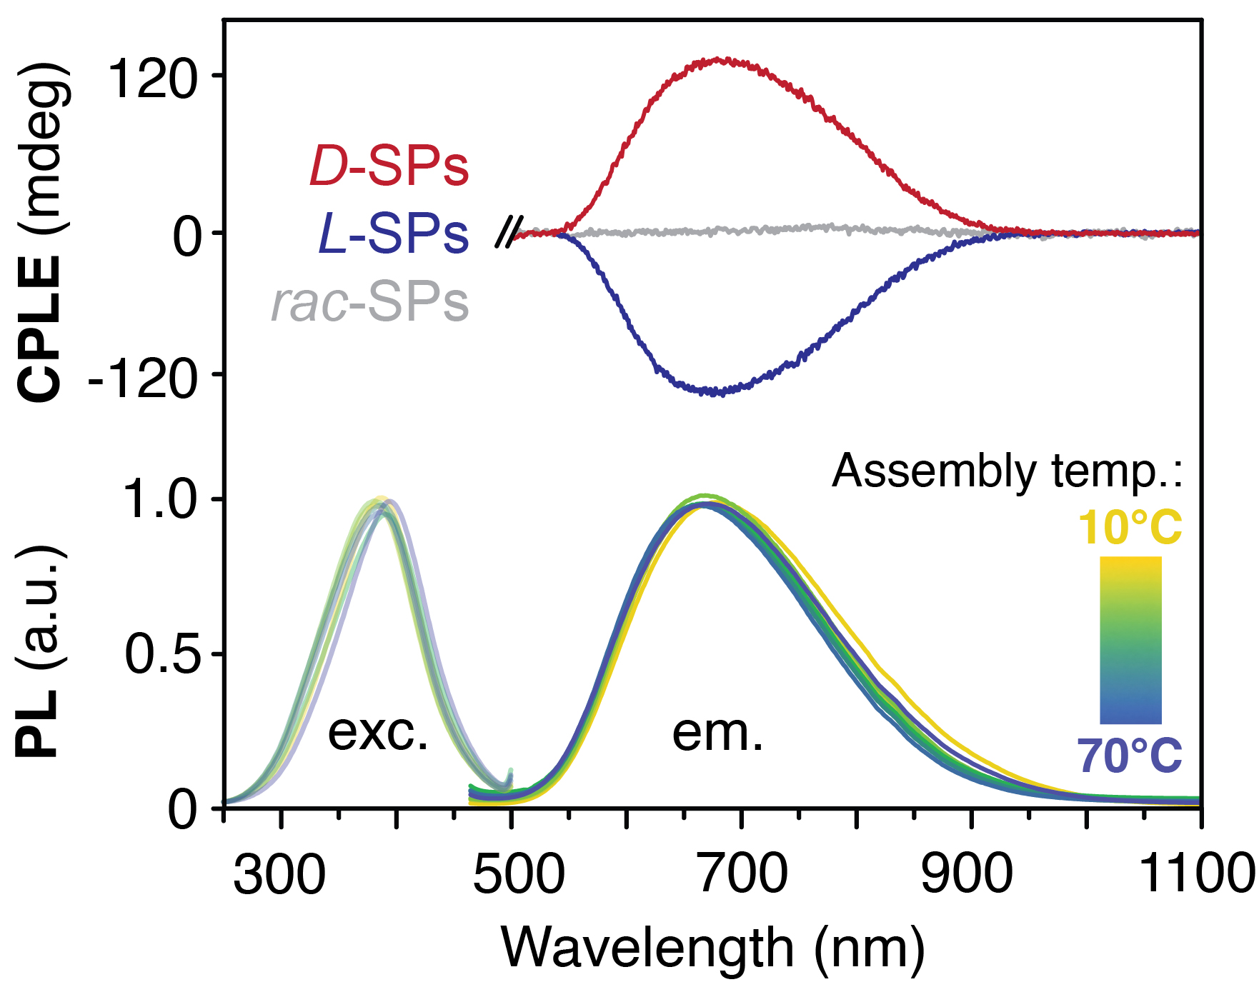
Figure S13. Top, typical CPLE spectra of D–, L–, and rac–SPs synthesized at 50°C in 400 mM CTAC. Bottom, excitation and emission spectra of D–SPs synthesized at different temperatures.
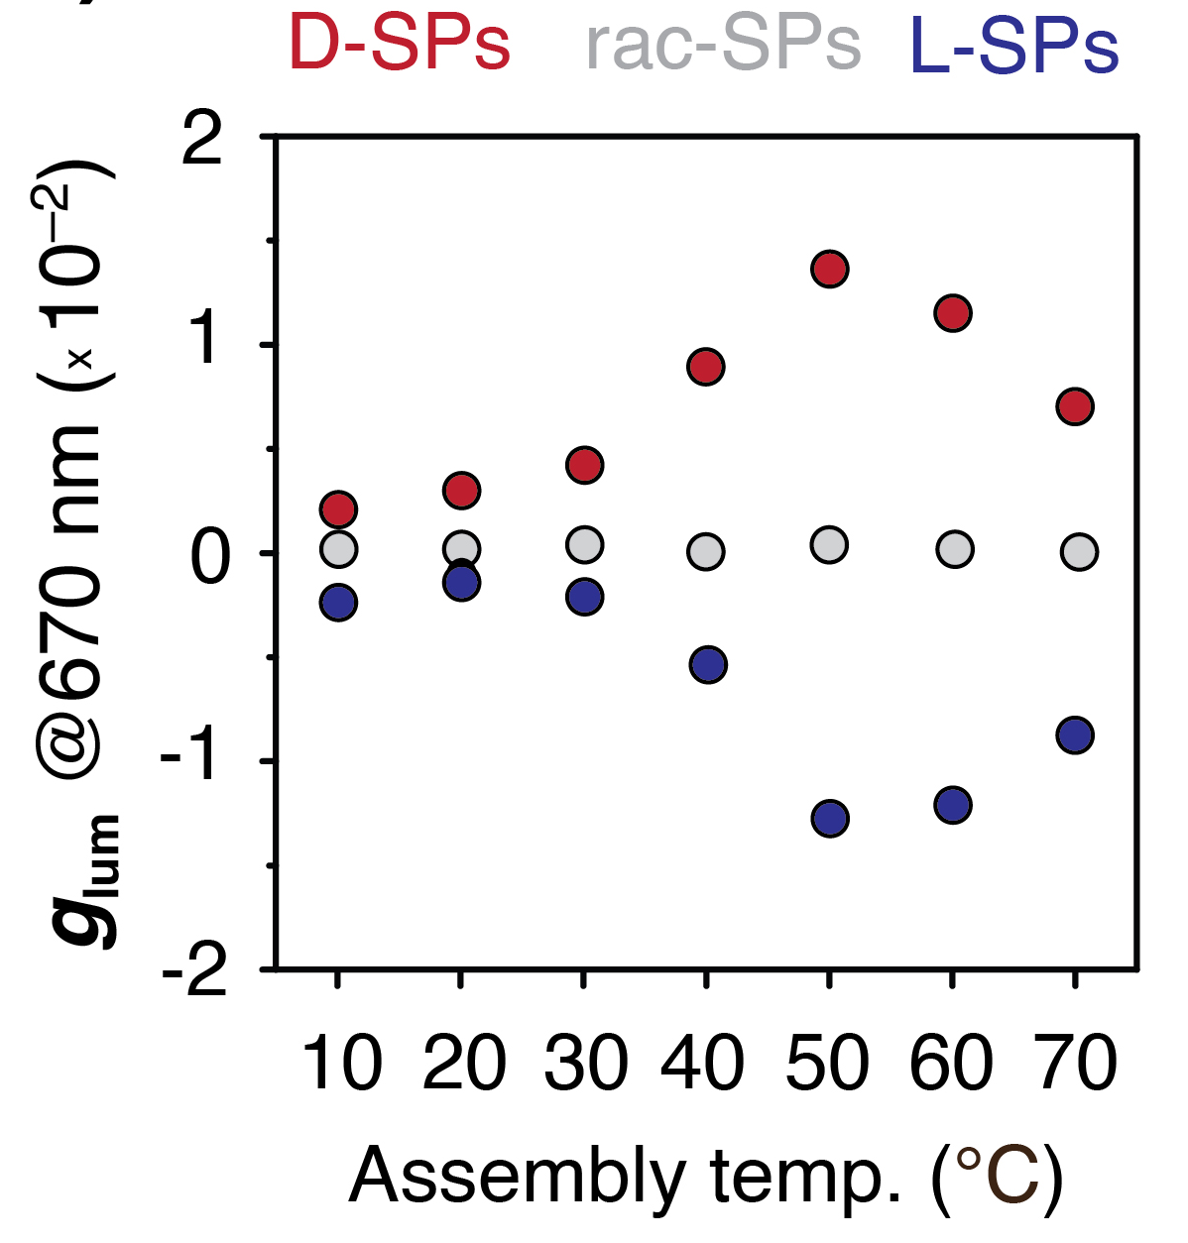
Figure S14. Measured CPLE dissymmetry factors (g_{lum}) of D–, L–, and rac–SPs synthesized at different temperatures in 400 mM CTAC.

Influence of penicillamine concentration
To further optimize the reaction conditions, we examined the synthesis of SPs using different Cu/Pen molar ratios. When less than 3 equiv. of Pen were used, no SP self-assembly occurred due to the release of 2 equiv. of HCl during the initial reduction of Cu²⁺, which protonates most of the free Pen species. The resulting charge generates an electrostatic barrier that prevents nucleation and growth. At higher Pen concentrations, SPs form with similar morphologies (Fig. S15). Monitoring the CPLE intensity revealed that the highest degree of emission polarization is achieved when ~6.5 equiv. of Pen are used.
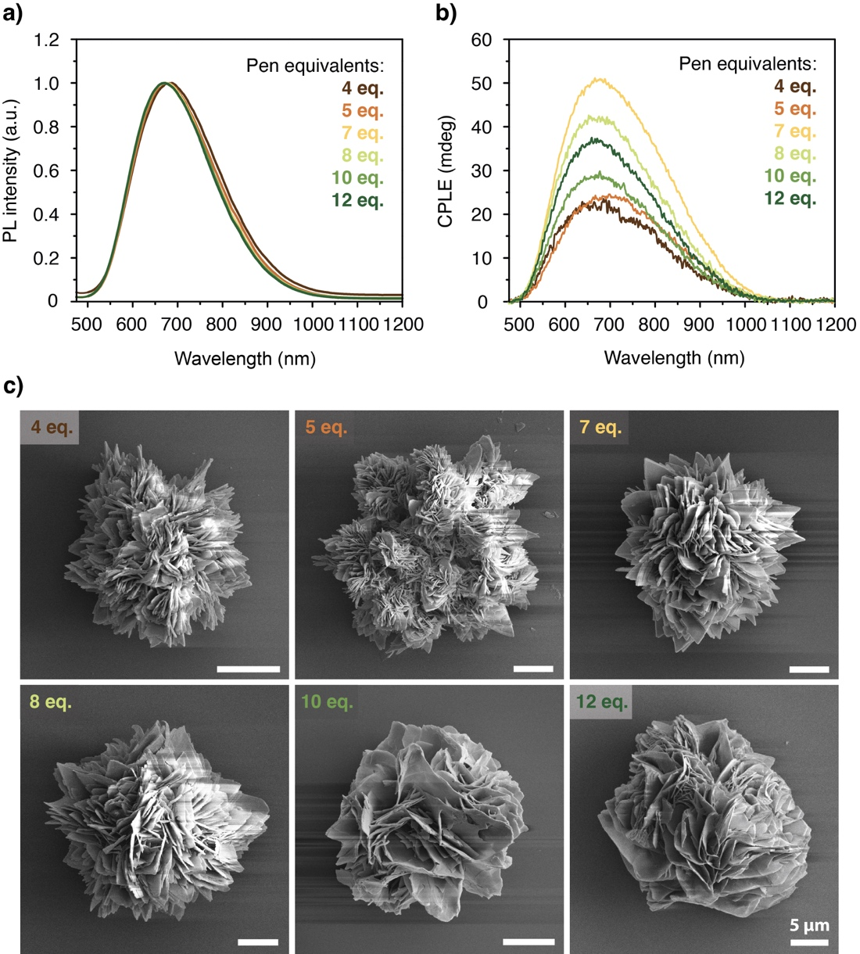
Figure S15. (a) Photoluminescence (PL), (b) circularly polarized luminescence emission (CPLE) spectra, and (c) corresponding SEM images of D–SPs prepared under identical conditions (50°C and 400 mM CTAC) except the different amounts of Pen used in the synthesis.

Influence of enantiomeric excess
Homochirality and high purity of Pen were crucial for the synthesis of spiky SPs with high CPLE polarization intensity. We then tested the morphologies of SPs formed under different enantiomeric excesses at 30 °C, 50 °C, and 70 °C (Fig. S16). This was done to examine how modulation of self–assembly kinetics and repulsive forces (by temperature), together with hydrogen bonding strength complementary to the molecular asymmetry of the ligands (from homochiral → racemic), would affect the SP morphology.
At 30 °C, due to strong hydrogen bonding between Pen ligands, the directionality of self–assembly was limited, and the as-obtained SPs lacked regular geometries: no spiky or spherical particles with long–range order were formed. At 70 °C, on the other hand, the homochirality of Pen led to well–defined spiky SPs, whereas decreasing the enantiomeric excess below χ = ±80% (corresponding to the presence of 10% of the opposite enantiomer) resulted in spherical microparticles lacking characteristic microscale features. These particles, analogous to racemic SPs, were composed of thin CuSPen needles uniformly aggregated into microspheres to minimize surface energy and electrostatic repulsion.
At 50 °C, however, a gradual decrease in enantiomeric excess led to complex super-supraparticles with progressively tuned mesoscale morphologies, ranging from homochiral spiky “hedgehog” SPs (χ = ±100%) to beaded-ball superstructures (±40% < χ < ±60%), and eventually to symmetric spherical SPs (χ < ±20%). This suggests that 50 °C allows partial kinetic trapping, enabling the growth of super-supraparticles composed of separate submicron domains of opposite mesoscale twisting that ultimately assemble into larger, more complex SPs (Fig. S17). Such unique self–separation of oppositely chiral fragments and their assembly into uniform SPs is accompanied by the emergence of CPLE of both left- and right-handed polarization rotations, which are not superimposable throughout the entire spectrum and remain cancelled out only near the PL emission maximum (670 nm). As a result, these beaded-ball SPs (±40% < χ < ±60%) emit both LCP and RCP components that can be differentiated (Fig. S17). In contrast, we did not observe a similar effect in either the disordered SPs (30 °C) or the spherical ones (70 °C).

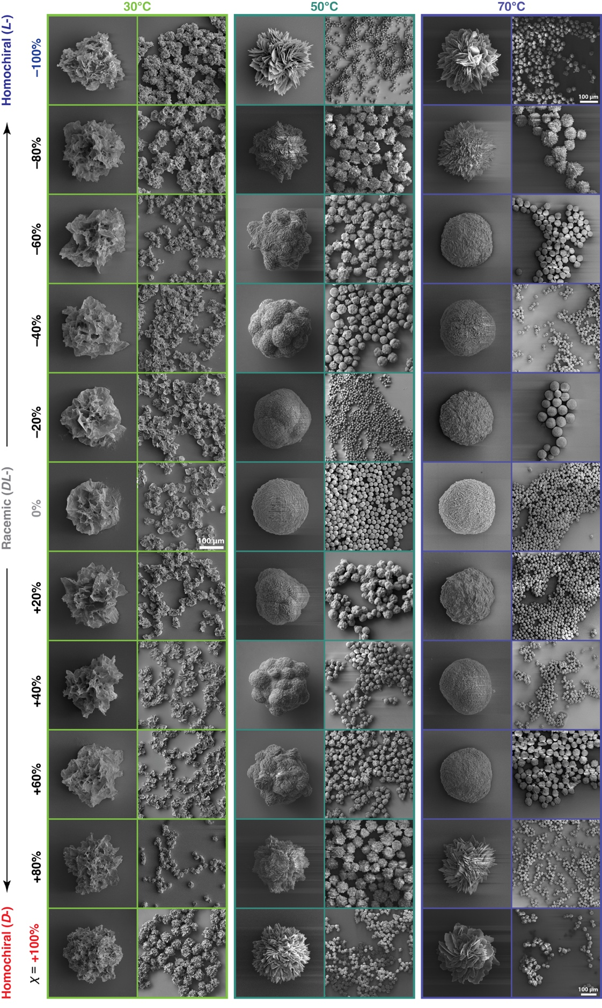
Figure S16. SEM images of SPs synthesized at different enantiomeric excess and temperature.
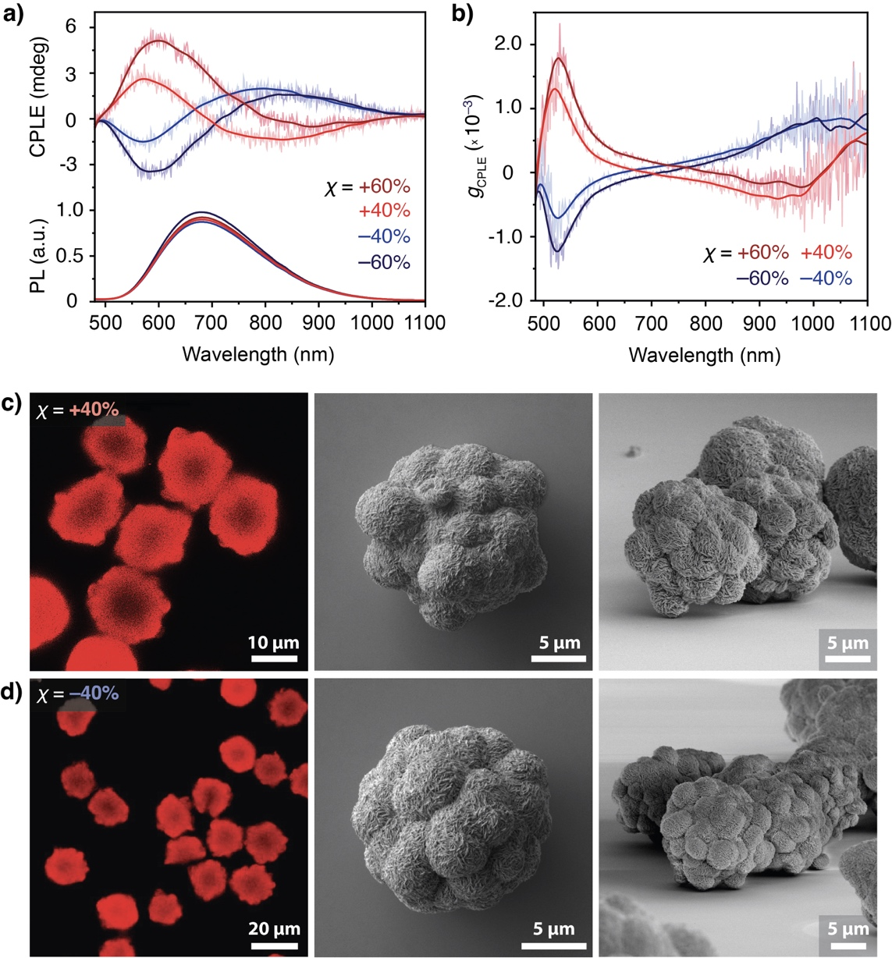
Figure S17. (a) CPLE and PL spectra and (b) corresponding g_{lum} of beaded–ball SPs; (c,d) confocal microscopy and SEM images of the SPs prepared using enantiomeric excess, (c) χ = +40% and (d) χ = –40%.

Influence of surfactants and other ionic additives
To evaluate the influence of structure directing additives on the self-assembly of SPs, we replaced 400 mM CTAC with a series of ionic additives, including classical surfactants (CTAB, SDS), polyelectrolytes (PSS, PDADMAC), small ionic species (choline chloride, 3-CHTMAC), and an ionic liquid ([BMIM][HSO₄]), while using the identical synthesis procedure (Fig. S18, S19). The morphology and optical activity of the resulting SPs were strongly dependent on the chemical nature and molecular structure of the additive. Ionic surfactants self-organize into micelles in aqueous environments, such pre-existing ordered phases can dynamically interact with the charged CuSPen building blocks and either facilitate or restrict their polymerization and directional growth. Among all tested systems, CTAC proved the most effective, producing well-defined spiky SPs with the highest CPLE intensity. The long aliphatic chain of CTAC forms micellar-like bilayers bearing positively charged surfaces that compensate the partially deprotonated carboxylate groups in Pen, which promotes hierarchical self-assembly of CuSPen units into ordered, covalently polymerized nanosheets. In contrast, the structurally similar CTAB inhibited spiky growth, presumably because its more stable micelles reduce dynamic exchange with the assembling nanocrystals. The resulting products lacked the nanoscale order otherwise enabled by cooperative CTAC stabilization and consequently exhibited much weaker CPLE signals (Fig. S18).
Interestingly, a comparable enhancement of CPLE was also observed when poly(diallyl–dimethylammonium chloride) (PDADMAC) of high molecular weight (~275 kDa) was used, suggesting that extended cationic polymers can partially mimic the templating and charge–balancing roles of CTAC. The varying SP morphologies obtained with PDADMAC of different molecular weights reflect the subtle balance between reversible electrostatic interactions and the rigidity of the polymer chain. Other cationic species (Fig. S19), including choline chloride and (3-chloro-2-hydroxypropyl)trimethylammonium chloride (3-CHTMAC), yielded spheroidal SPs lacking any spikes, consistent with their weaker hydrophobic and structural organization compared to CTAC. The use of 1-butyl-3-methylimidazolium hydrogen sulfate ([BMIM][HSO₄]), however, entirely suppressed the formation of three–dimensional morphology, producing well-dispersed ~4 µm platelets instead. This effect can be attributed to π-stacked imidazolium layers forming stiff lamellar assemblies that restrict radial growth of the nanosheet domains. Conversely, anionic additives such as sodium dodecyl sulfate (SDS) and poly(sodium 4-styrenesulfonate) (PSS) did not improve the emission polarization. The weak interaction between sulfonate groups and the partially protonated amine moieties in Pen failed to promote hierarchical organization, yielding SPs similar to those synthesized in pure water.

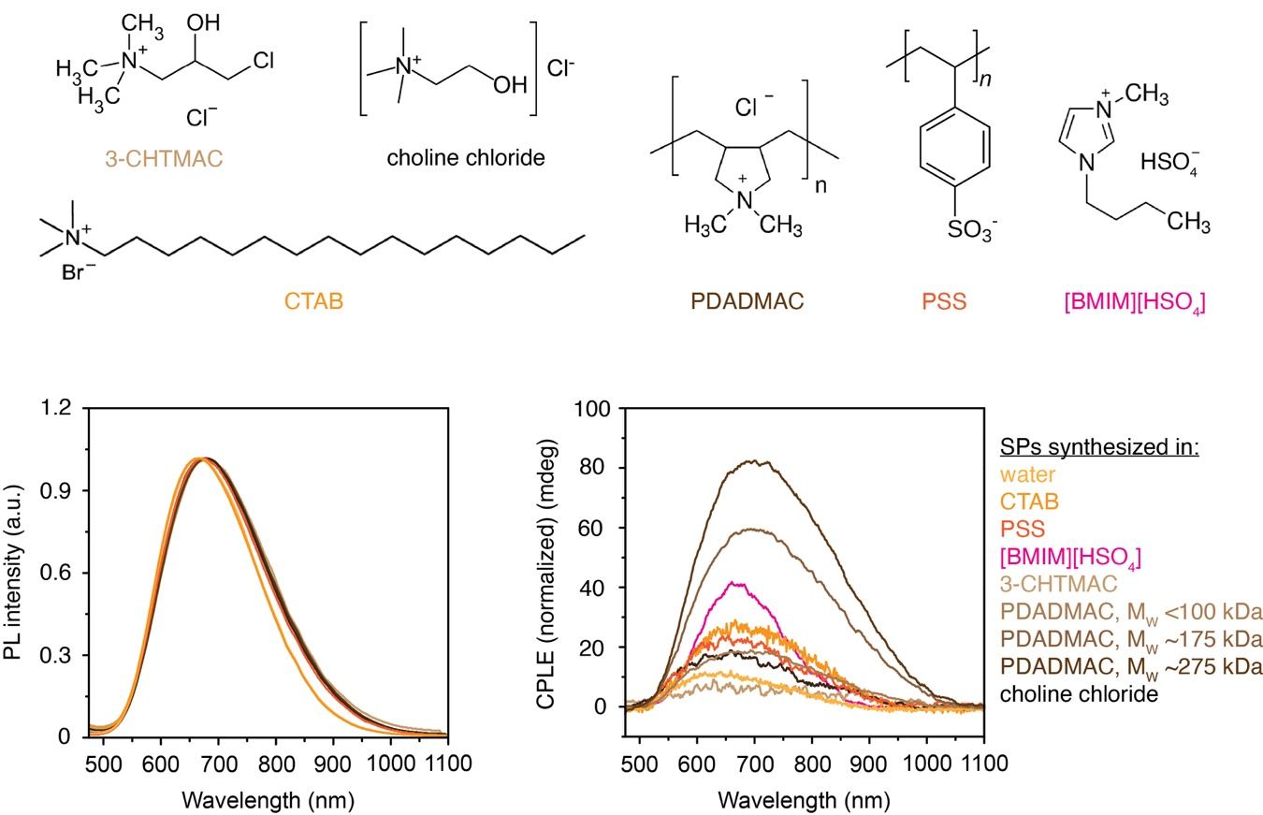

Figure S18. Chemical structures of the tested additives, as well as the photoluminescence and CPLE spectra of SPs prepared in water, CTAB, PSS, PDADMAC of different molecular weights, 3-CHTMAC, choline chloride, and PSS. cetyltrimethylammonium bromide (CTAB); poly(diallyldimethylammonium chloride) (PDADMAC), Mw <100,000, 100,000-250,000, and 200,000-350,000; choline chloride; (3-chloro-2-hydroxypropyl)trimethylammonium chloride (3-CHTMAC); sodium dodecyl sulfate (SDS); poly(sodium 4-styrenesulfonate) (PSS), and 1-butyl-3-methylimidazolium hydrogen sulfate ([BMIM][HSO₄]).

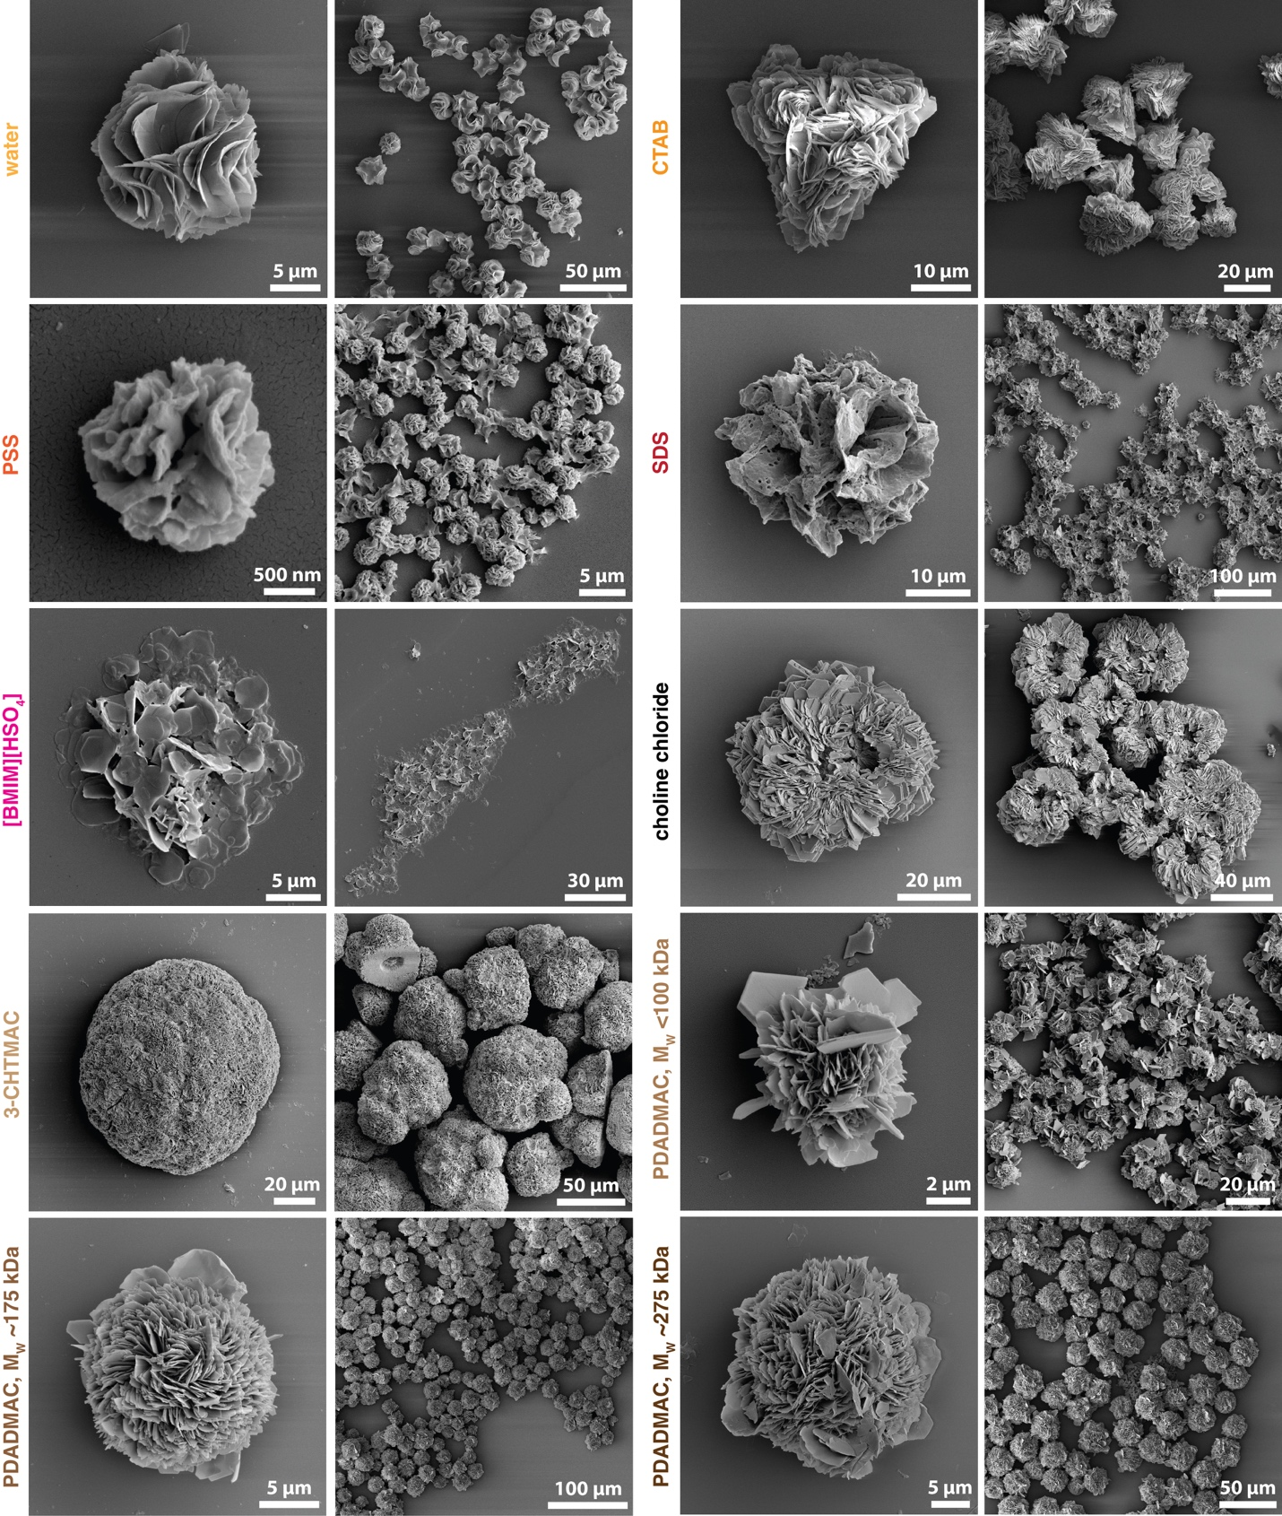
Figure S19. SEM images of D-SPs prepared with different cationic and anionic additives used instead of CTAC; in pure water; CTAB; PDADMAC of varying molecular weights; choline chloride; 3-CHTMAC; SDS; PSS, and [BMIM][HSO₄].

- Tuning the SPs superstructure by pH
Synthesis of SPs of progressively tunable, varying morphologies shown in Fig. 1b, self–assembled at different pH values, were conducted using an identical procedure as described in the Supplementary Section 2. To adjust the pH of the system (thus the net protonation or deprotonation degree of Pen (δ) in the system) to the desired values, Pen solution was mixed with 0.05–1.0 equiv. of either 2M HCl or 1.75M KOH solution prior to the reaction. Fig. S20 shows the dependence of the final pH values on the added acid/base equivalents. Above δ > +0.8 (pH < 1.7) or δ < –0.2 (pH > 6.2) no SPs were formed, as seen by the lack of precipitation of any solid products even after 72 hours, clear transparent reaction mixtures, and the absence of any detectable particles under SEM. Between these pH values, the NSs or SPs of varying chiroptical properties (Fig. S21) and chiral morphologies (Fig. S22) emerge.

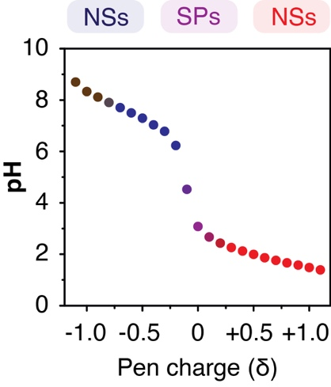
Figure S20. Measured dependence of the net protonation/deprotonation state of Pen (δ) on the pH of the system during the SPs synthesis in 400 mM CTAC solution.

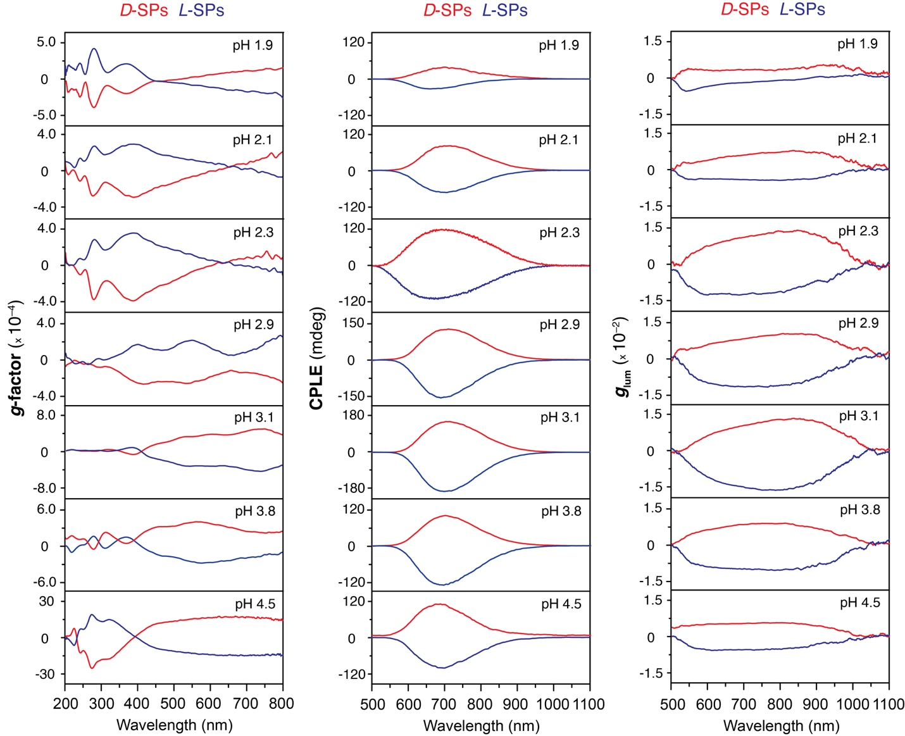

Figure S21. Measured g–factors, CPLE, and g_{lum} spectra of D– and L–SPs prepared using 16.7 mM CuCl₂, 6.5 equiv. Pen in 400 mM CTAC at 50°C, at different pH values adjusted with KOH or HCl.

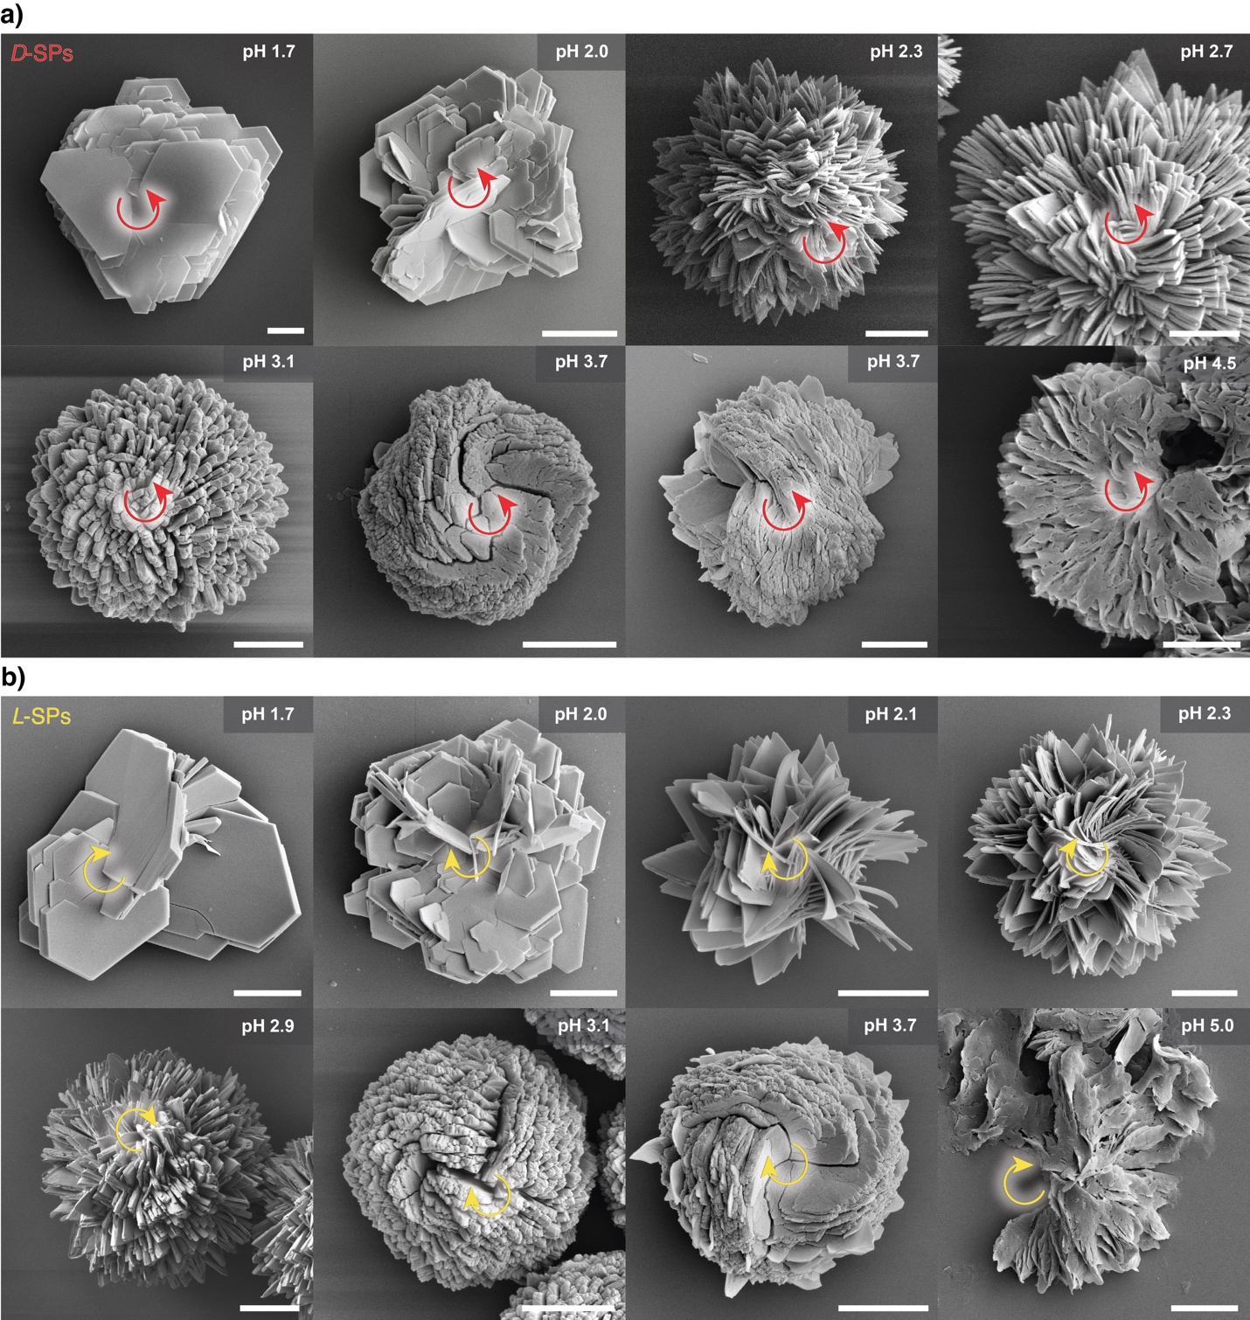
Figure S22. Magnified SEM images of D– and L–SPs synthesized with 16.7 mM CuCl₂, 6.5 equiv. Pen in 400 mM CTAC at different pH values. Coherent unidirectional twists (LH and RH, respectively), regardless of negative or positive charge between NSs, indicates purely electrostatic interactions between 2D NSs forming SPs. The repulsion is mild enough to enable chirality transfer from nano– to microscale. Scale bar, 5 μm.

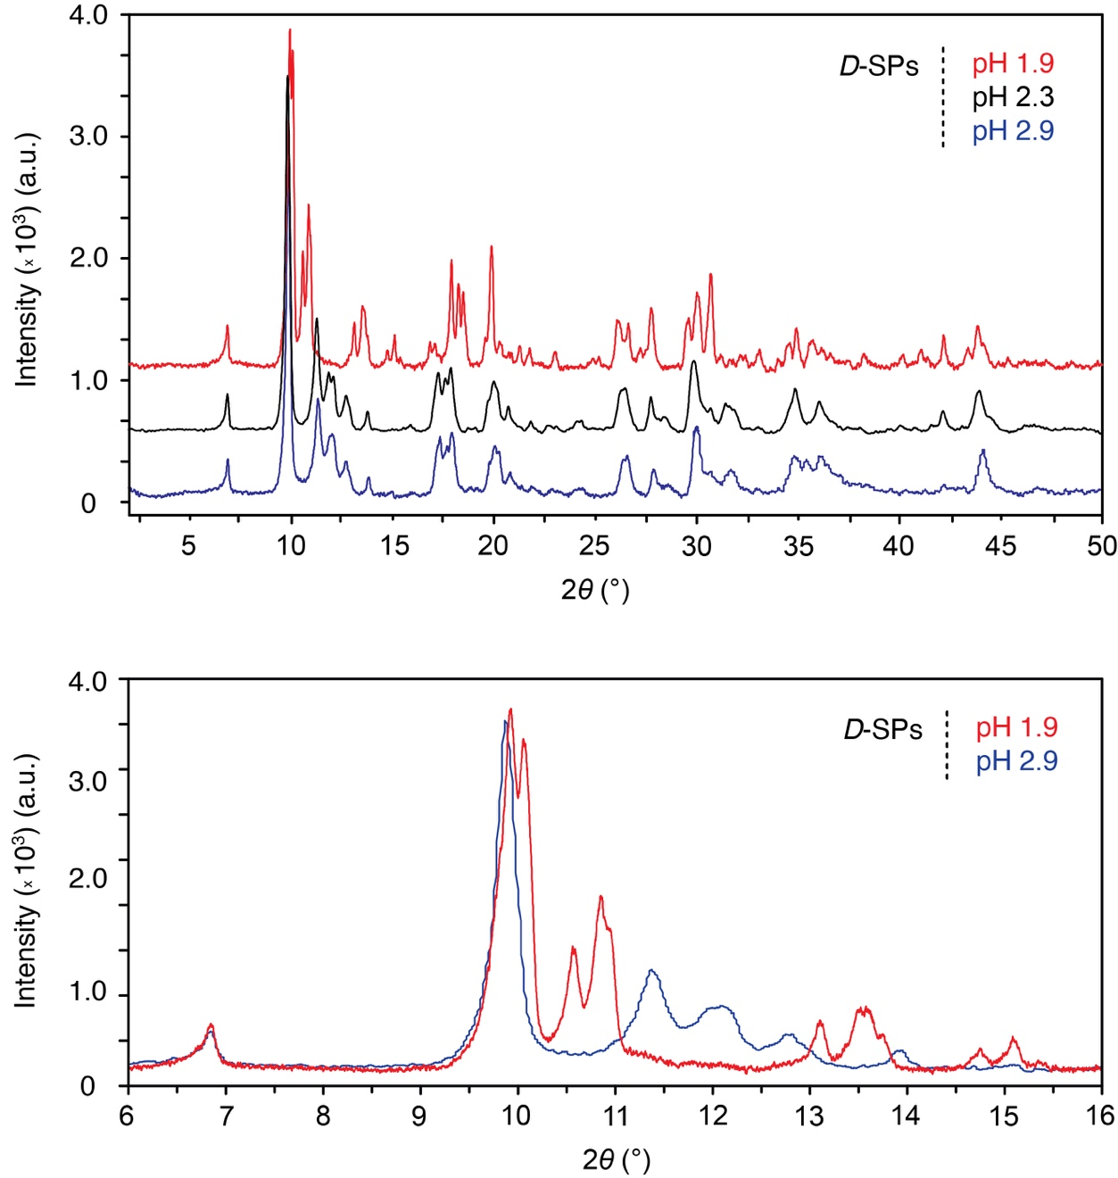

Figure S23. Comparison of powder XRD patterns of D–SPs synthesized at different pH values. The interlayer d spacing between the hierarchically organized nanosheets remains constant at 1.28 nm (2θ = 6.89°), which shows that the lamellar stacking distance is pH–independent. Variations in protonation mainly shift the higher-angle reflections, which originate from changes in the geometry of Pen residues within the nanosheet lattice.

- Reversible SPs → NSs disassembly
pH–driven disassembly:
2 mL of synthesized SPs dispersion (~6 mg SPs) was purified as described previously and resuspended in 2 mL 10% CTAC solution. 162 µL of fresh Pen solution (85 mg · mL^{–1}) was added and the SPs were disassembled by an addition of 1.75 M KOH or 2M HCl solutions, followed by gentle shaking. Typically, 0.7 equiv. of the base, or 0.9-1.1 equiv. of the acid, were sufficient to fully disassemble the SPs into transparent, nearly colorless solutions of 2 nm NSs. Note that the base-driven disassembly results in a formation of air-unstable NSs, which easily oxidize on air to produce dark brown Cu_{x}S_{y} NPs. To prevent the oxidation, the solutions should be bubbled with nitrogen prior to disassembly. The disassembly can be performed with any other base, such as alkali carbonate or bicarbonate, once the pH reaches >6.5.
Analogously, SPs can be disassembled upon addition of other strong inorganic acids, such as HCl, H₂SO₄, or HBr, so that the pH drops to ~1.5. The SPs were reassembled by incubating as-formed NCs solutions in a 50°C water bath and an addition of identical amount (with respect to the molarity of the base or acid) of 2M HCl or 1.75 M KOH solutions. The pH value of reaction mixtures was then shifted to 2.3, and within 10-20 min, reassembled SPs precipitated as during standard synthesis from CuCl₂ precursor as seen in Fig. S2.
Progressive disintegration of electronically conjugated CuS framework of SPs into ~2 nm NSs fragments results in the gradual decay of CPLE and PL as shown in Fig. S24, while the reassembly into SPs recovers the original CPLE intensity nearly quantitively throughout multiple pH cycling (Fig. 3e).
After each cycle, settled particles were purified and analyzed as described previously. The disassembly–reassembly cycles were repeated multiple times to produce luminescent SPs of similar morphologies (Fig. S29).

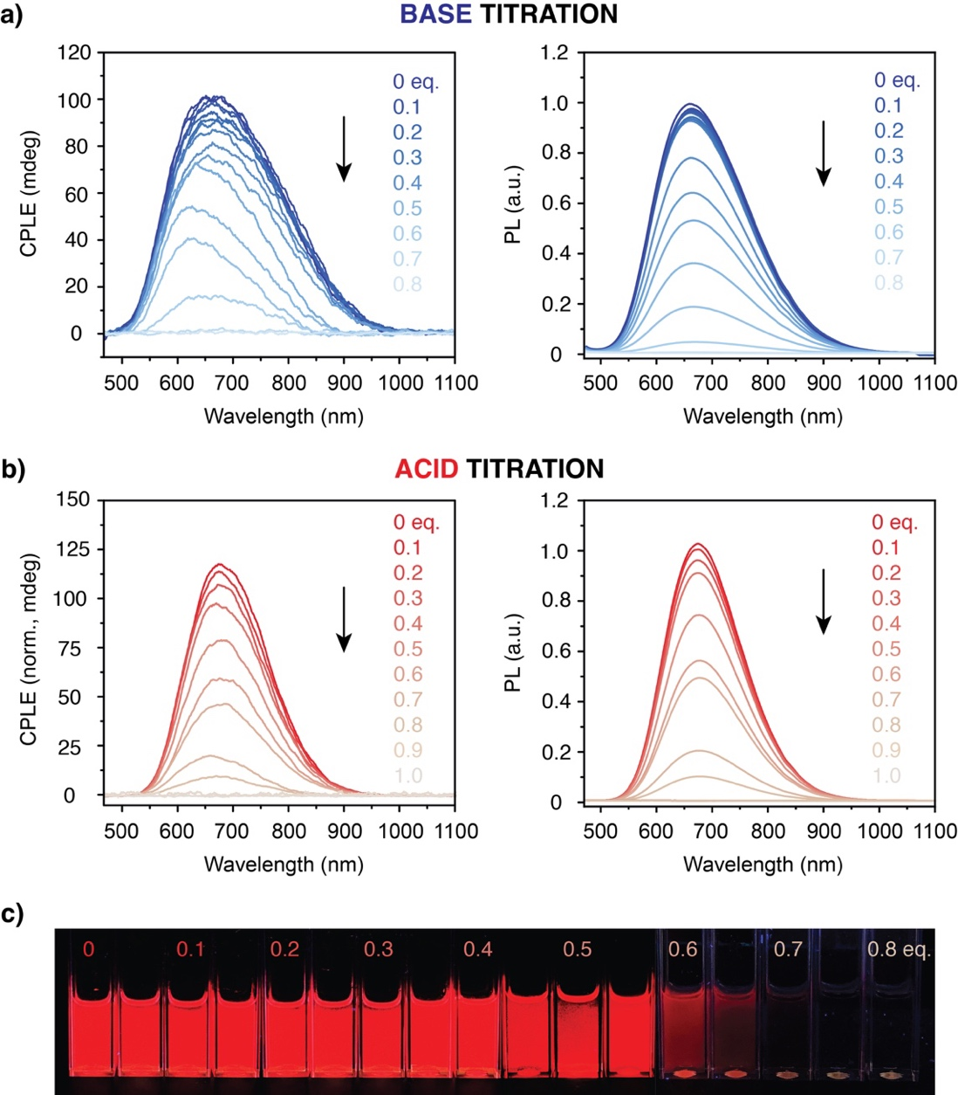
Figure S24. CPLE and photoluminescence spectra changes accompanying the D-SPs titration with diluted (a) KOH and (b) HCl solutions. (c) Photographs of aqueous dispersions of D-SPs (seen under UV light) titrated with KOH solution.
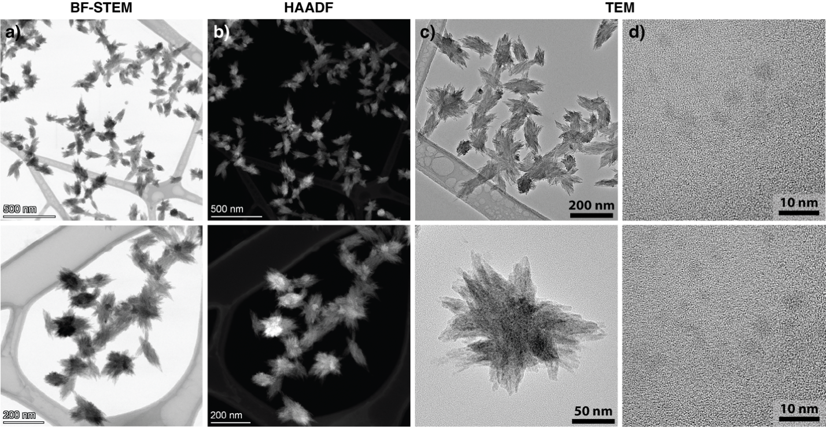
Figure S25. Transmission electron microscopy (TEM), bright-field (BF-STEM) and high-angle annular dark-field scanning transmission electron microscopy (HAADF-STEM) images of small hedgehog particles and NCs obtained by partially disassembly of L-SPs with 0.6 equiv. KOH in the absence of CTAC. Digestion process of SPs produces certain amount of small spiky particles (a-c), which retain the morphology and hierarchical organization of original SPs, and are surrounded by <5 nm NSs (d) from fully digested CuS-Pen NSs.

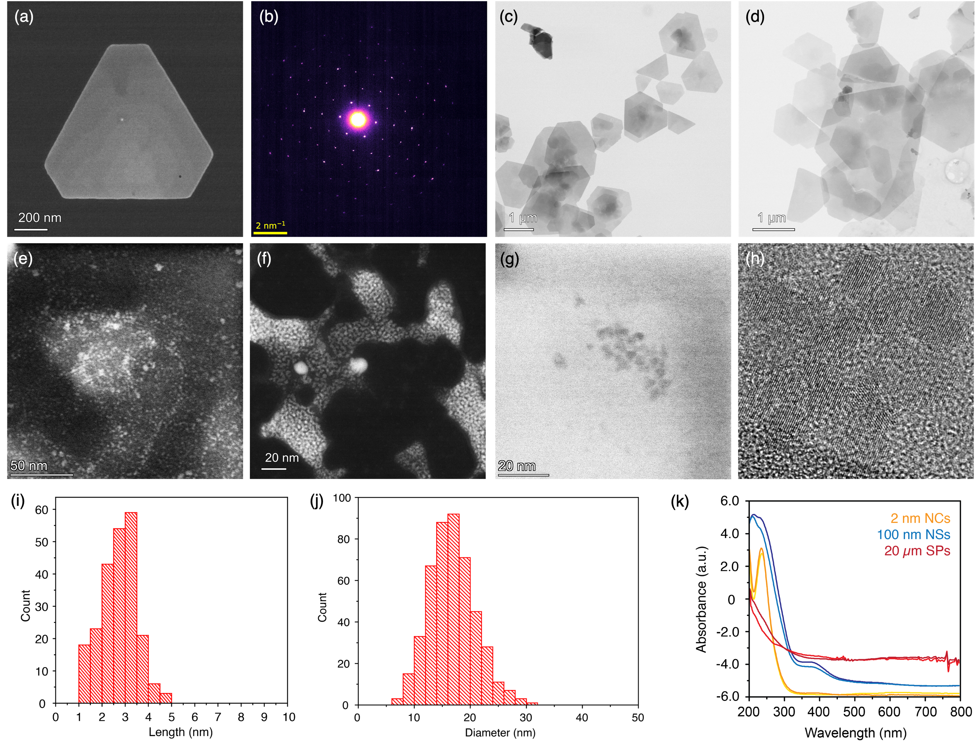

Figure S26. (a,c,d) TEM and HAADF–STEM images of CuS–Pen NSs. (b) Selected-area electron diffraction (SAED) pattern of NSs showing the hexagonal lattice arising from the atomically thin, covellite CuS network. (e–h) TEM and HAADF–STEM images of NSs and nanoclusters formed during acid-driven disassembly. (i,j) Size distributions of NSs following disassembly with (i) 1.2 equiv. and (j) 1.0 equiv. HCl. (k) UV/Vis absorption spectra of NSs and SPs, illustrating the emergence of Rayleigh and Mie scattering across the visible region as the hydrodynamic size of NSs and SPs increase.

Deconvoluted spectra:
Figure S27. ESI– Q–TOF mass spectra of D–SPs disassembled into NSs at pH 6.9.

Deconvoluted spectra:
Figure S28. ESI+ Q–TOF mass spectra of D–SPs disassembled into NSs at pH 1.5.

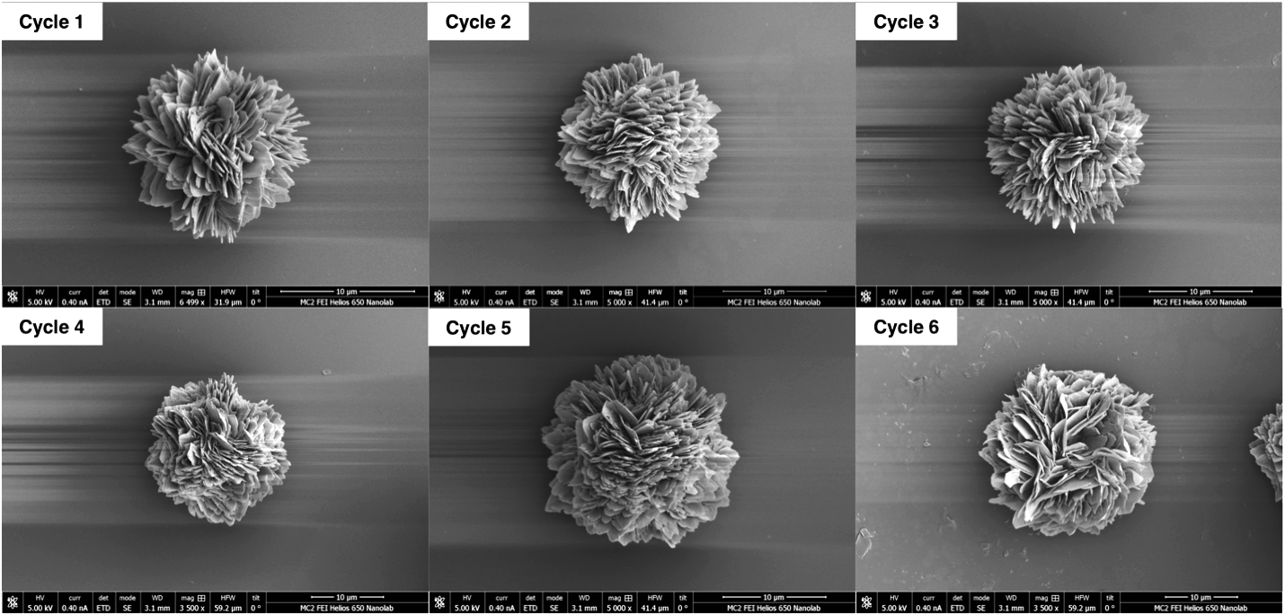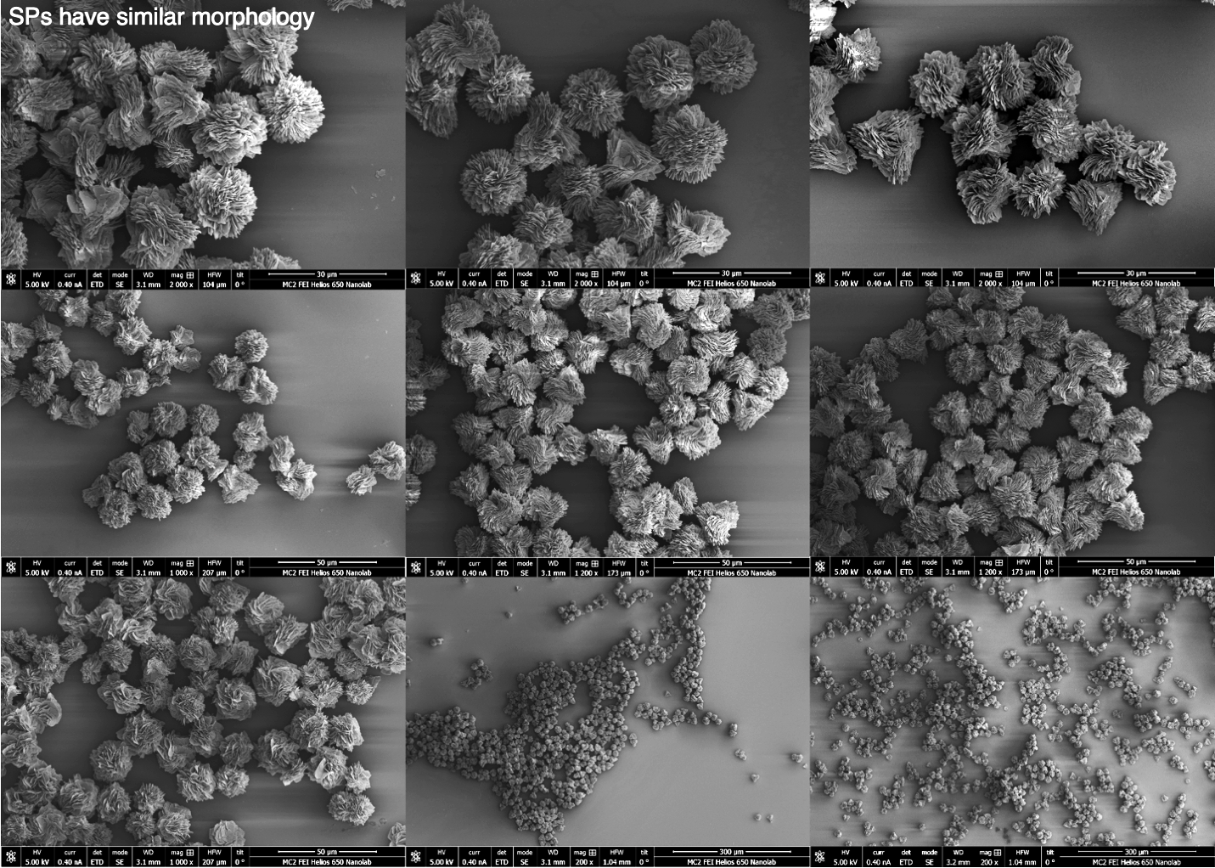
Figure S29. SEM images of D–SPs reassembled throughout 10 consecutive pH cycling between pH 6.9 (disassembly) and pH 2.3 (reassembly).

Thermal reassembly of CuS–Pen SPs:
The dispersion of D–CuS–Pen SPs (2 mL, 3.0 mg/mL, 28 μmol of SPs) synthesized at pH 2.3 and 50°C was purified as described previously, and the SPs were dispersed in 1:1 water/ethanol mixture containing 400 mM CTAC and 90 mM Pen. The mixture was bubbled with nitrogen, followed by addition of 1.2 equiv. of concentrated H₂SO₄, and the mixture was placed in a ~90°C water bath. The suspension was gently shaken or stirred until the milky solution became transparent (5–10 min), indicating the complete SPs disassembly. Upon cooling the solution to room temperature, SPs spontaneously reassembled (Fig. 3, Fig. S30a–d).
Similar disassembly/reassembly cycling could be achieved in aqueous 4.0 M KCl solution; however the process requires prolonged heating for >1h and the reasembled SPs display more compact morphology (Fig. S30e).

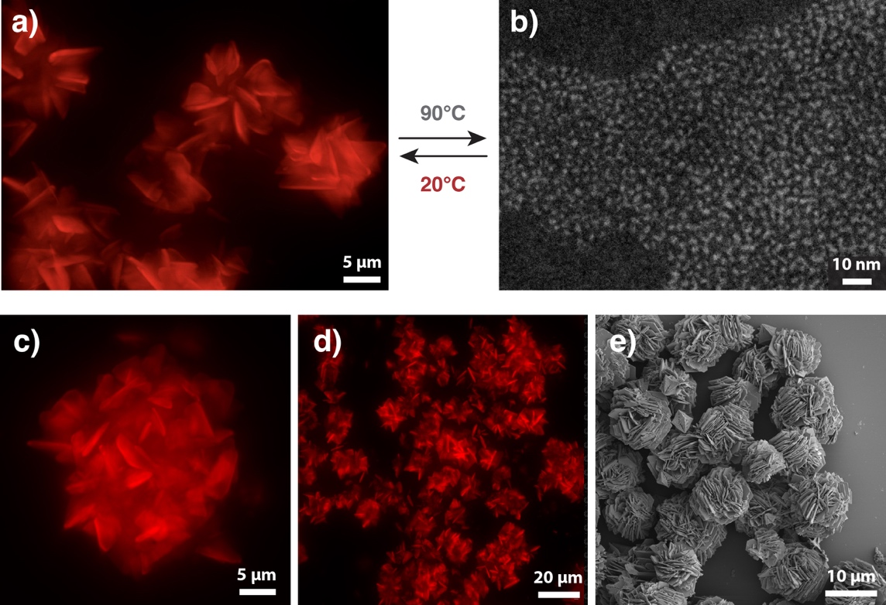
Figure S30. Temperature–controlled self–assembly of CuS–Pen SPs. (a,c,d) Confocal microscopy images of D–SPs reassembled through thermal cycling in acidified 1:1 ethanol/water mixture containing 1.2 equiv. H₂SO₄. (b) HAADF–STEM image of ~2 nm NSs thermally disassembled SPs (a). (e) SEM image of SPs reassembled in 4.0 M aqueous KCl solution after cooling to room temperature.

- SPs reconfiguration and structure modifications
Reassembly of CuS–Pen SPs under different conditions
D–CuS–Pen SPs (synthesized at pH 2.3 and 50°C), in media of choice (2 mL, 3.0 mg/mL of SPs), containing 90 mM Pen were disassembled by adjusting the pH to 6.9 as described in the Supplementary chapter 6. The system was acidified with 132 µL 2 M HCl solution to initiate the reassembly. Settled particles were purified and analyzed as described previously. Depending on the conditions, particles of varying morphologies were produced (Fig. 3g, S31). The particles were imaged using confocal microscopy and SEM.
Hexagonal microcrystals were prepared in 5 M cesium chloride solution at 55°C.
Corrugated microspheres (5 µm) were prepared in 50/50 (v/v) mixture of 0.4 M CTAC and isopropanol at 50°C.
Porous sponges were reassembled in 0.4 M CTAC solution at room temperature (20°C).
Iodide-doped nanowires (Fig. S32) were reassembled in water at 50°C, after adding 5.2 mg (31 µmol) of potassium iodide.
Microtriangles (80–100 µm) were obtained by slow vapor diffusion of acid-disassembled SPs. Briefly, 12 mL of D-SPs dispersion was purified by centrifugation, washing with water, and resuspended in 700 µL of water containing 50 mg of D-Pen. SPs were disassembled by adding 90 µL of sulfuric acid and the clear solution was filtered through 0.2 µm PTFE syringe filter into a 5 mL glass vial. The vial was then placed in a 45 mL vial containing 8 mL of 99.8% ethanol, flushed with nitrogen, sealed, and left at room temperature for several days to crystallize.

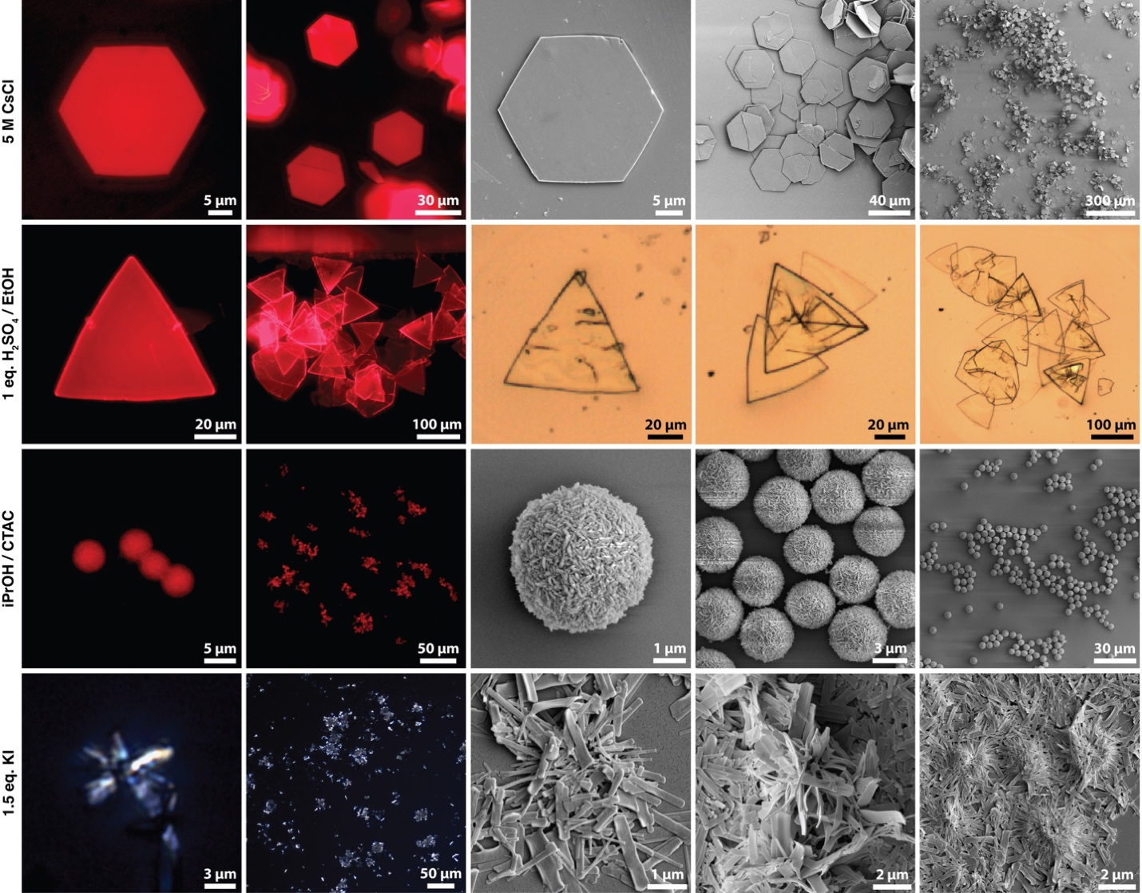
Figure S31. Inverted fluorescence microscopy (IFM), scanning electron microscopy (SEM) and polarized light microscopy (PLM) images of D-SPs reassembled under different conditions. From top to bottom, (1) in superionic 5 M cesium chloride solution, (2) in diluted sulfuric acid followed by slow ethanol vapor diffusion, (3) in isopropanol / CTAC mixture; (4) in aqueous potassium iodide solution. Note that the incorporation of iodide anion yields non-luminescent needles due to the disruption of electronic conjugation within CuS NS upon covalent halide incorporation.

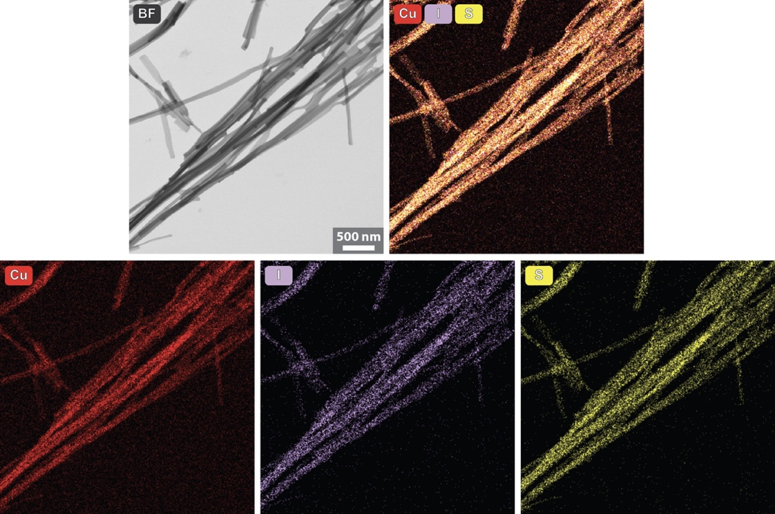
Figure S32. Bright–field STEM image and EDS elemental maps of nanoribbons forming iodide–doped Cu–Pen SPs.

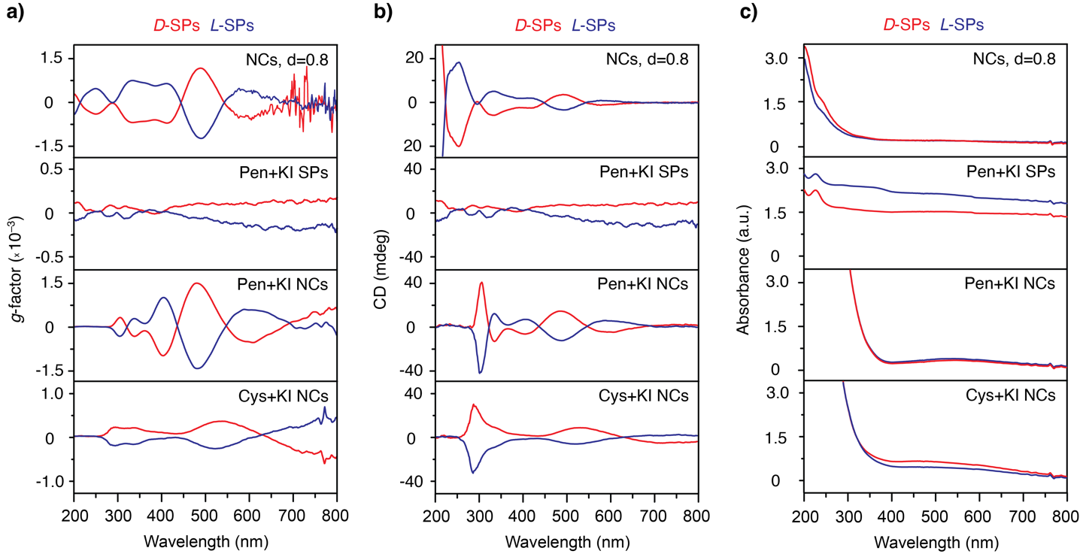
Figure S33. (a) The values g-factors, (b) CD spectra, and (c) UV/Vis absorption spectra of (1) deprotonated CuS–Pen NSs; (2) reassembled CuI–Pen needles shown in Fig. S32 and Fig. 3; (3) CuI–Pen needles disassembled at pH 6.9; (4) CuI–Cys SPs disassembled at pH 6.9.

Hierarchical composites of NSs and ionic surfactants
Aqueous dispersion of standard spiky SPs prepared at 50°C (700 µL, 6.0 mg/mL, 19.8 µmol of SPs), containing 90 mM Pen and 400 mM CTAC, were mixed with 41 µL of 1.75 M KOH solution (0.6 equiv. OH–) to induce the disassembly to NSs. The mixture was sonicated for 10 s and gently shaken in 1.5 mL Eppendorf tube under nitrogen for 15 min. The appearance of NSs organized into liquid crystalline (LC)–like superstructures (Fig. S34, S35) was indicated by characteristic ambient light scattering of the solution as shown in Supplementary Video 1. Microscopy samples were prepared by depositing ~20 µL of dispersions between two standard microscopy glass slides (25 x 75 x 1.0 mm and 22 x 45 mm, Fisherbrand) and imaged using PLM and IFM microscopes.
Similarly, SDS- and SDBS-stabilized LC dispersions (Fig. S36) were prepared by treating 300 µL of 3.0 mg/mL SPs dispersion in water with 17.7 µL 0.55 M Pen, 150 µL 0.2 M SDS or SDBS solution, and 24 µL 2M HCl. After stirring for 15 min, 20 µL of dispersion was sandwiched between microscopy glass slides and imaged as described previously.

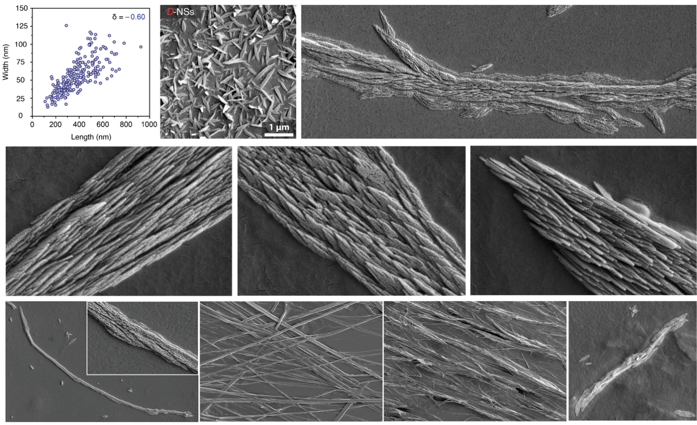
Figure S34. SEM images of NSs and their lamellar assemblies formed at pH 6.0 in a presence of CTAC. Right top, the typical length and width distribution of NSs under these conditions.
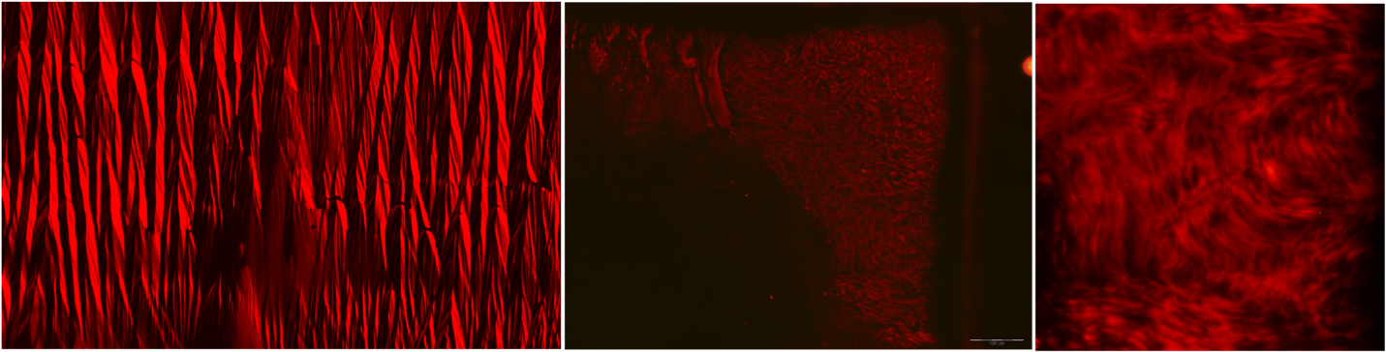
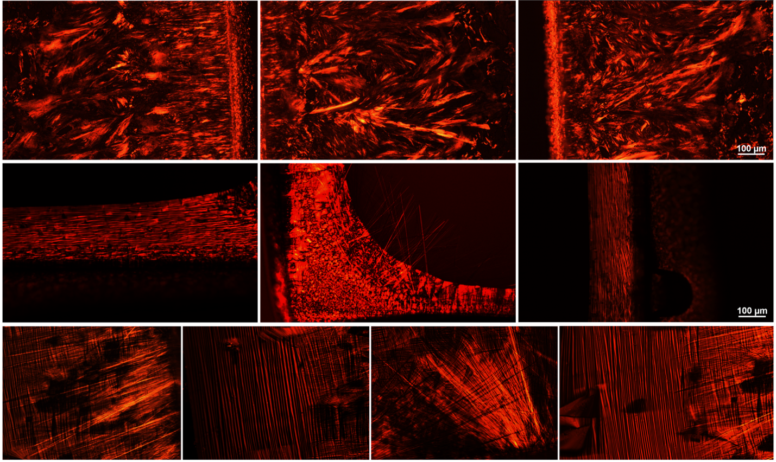
Figure S35. Polarized light microscopy and inverted fluorescence microscopy images of lamellar NSs assemblies forming at pH 6.0 in the presence of CTAC as ionic surfactant counterbalancing the negative charge of deprotonated NSs.

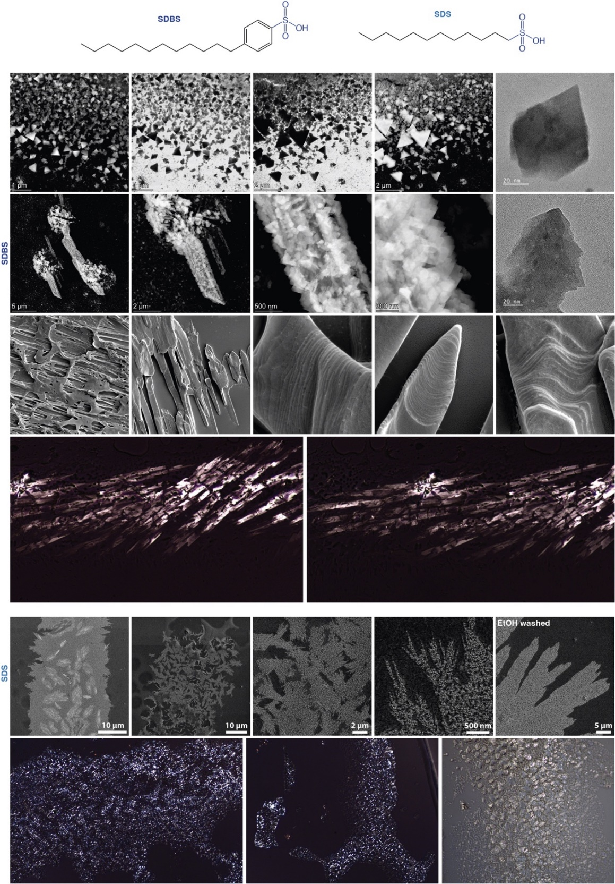
Figure S36. SEM and polarized light microscopy images of lamellar superstructures formed during D-CuS–Pen SPs disassembly with hydrochloric acid (HCl) in a presence of anionic surfactants, SDBS and SDS.
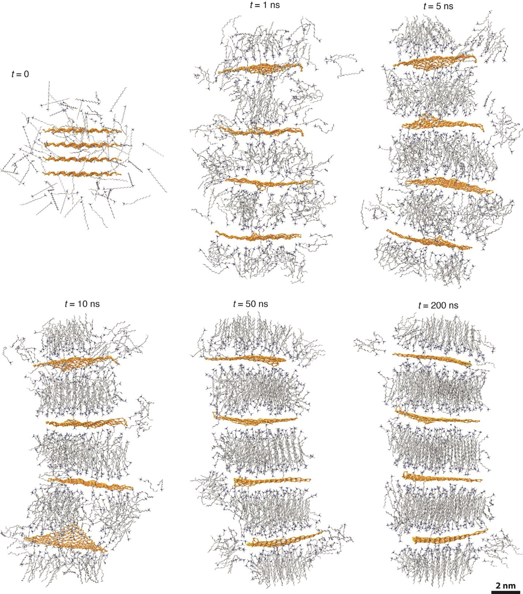
Figure S37. MD simulation snapshots of deprotonated 5 nm D-NSs in a presence of CTAC. Initially, electrostatic repulsion results in a rapid disassembly of NSs (<1 ns). The NSs charge is then compensated by CTA⁺ counterions, which gradually self-organize into bilayers between the NSs. For clarity, CTAC molecules present farther away than 1.5 nm from NSs, and Pen ligands, are not displayed.
Synthesis of anion-doped non-luminescent SPs
Iodide-doped SPs. 3 mL of 16.7 mM aqueous CuCl₂ solution were placed in a water bath preheated to 40°C. After 5 min, freshly prepared mixture of 578 µL of 0.55 M D-, L-, or rac-Pen and 105 µL of 0.5 M potassium iodide solutions was added at once using an automated pipette. The reaction mixture was gently shaken for 2 s and left in the water bath for the self-assembly. The solution immediately turned dark brown due and became colorless in 5 s, indicating the complete reduction of Cu^{II} to Cu^{I}. Within 2-5 min, the mixture became cloudy and self-assembled spiky SPs started to slowly settle as a white, non-luminescent precipitate. The vial was shaken several times. After 10-20 min the solution became fully transparent, and the reaction was complete. The raw SPs dispersion can be stored for several months in a fridge without purification. In all the further experiments, SPs were purified before use by low-g centrifugation (1,000 rpm, 3 min), removal of supernatant, and dispersing the precipitate in either pure water or the buffer of choice.
Cyanide-doped SPs. Procedure analogous to the iodide-doping was performed, using 110 µL of 0.50 M potassium cyanide solution instead of KI, and the bath temperature was adjusted to 50°C. 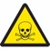 [NOTE: Due to the high cyanide toxicity and a small amount of lethal HCN gas forming under acidic conditions, the reaction and further SPs purification must be carried out under the fume hood!] After the injection of Pen/KCN solution, the solution turned dark and brownish cloudy precipitate of mixed-valence Cu transient species was formed. The bath temperature was risen to 70°C and the suspension was gently shaken every 5 minutes. The reduction process and the growth of SPs was typically slower than iodide-doped SPs and took between 15 to 60 minutes for homochiral and racemic SPs. The reaction was complete after cloudy suspension turned into white, denser precipitate and settled at the bottom of the vial. The SPs were non-luminescent and could be stored in a fridge for several months. SPs were freshly purified by centrifugation and water washing immediately before further experiments to avoid decomposition.

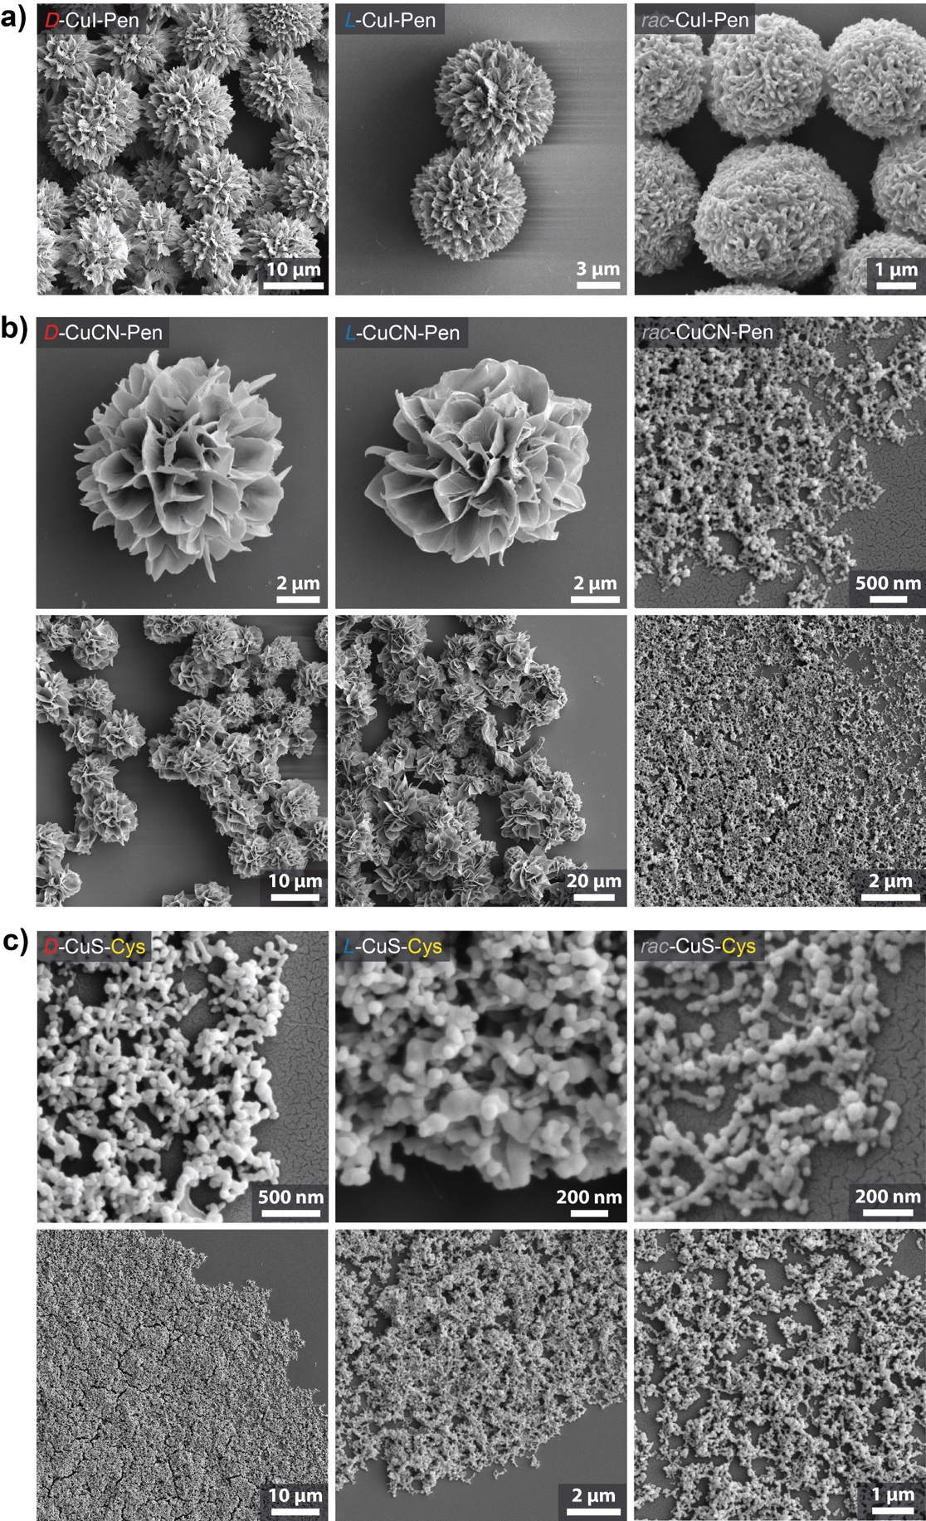
7 in Fig. 5
8 in Fig. 5
5 in Fig 5
6 in Fig 5
3 in Fig. 5
4 in Fig. 5
Figure S38. SEM images of SPs used in protein separation: (a) CuI-Pen, (b) CuCN-Pen SPs, and (c) CuS–Cys SPs. The isomorphs described in Fig. 5 are examples of NS assemblies that make possible selective protein concentration of low-abundance disease markers. The isomorphs are labeled as 1,2,3… in Fig. 5 and Fig S38.

- Molecular dynamics and DFT simulations
MD simulations
The molecular structures of the ligands, surfactants and final nanosheets were prepared in GaussView, and the atom types and charges were obtained from the CHARMM force field. The pristine backbone MD model of a CuS graphene-like (honeycomb) nanosheet was constructed based on the crystal structure reported by Low et al.¹ The equimolar Cu/Pen ratio (1:1) was assumed based on the structural data of widely studied two-dimensional copper thiolate coordination polymers, both aromatic and aliphatic including Cu-SPen itself studied by Y.Jin et al.² (XPS data (Fig. S8) indicated that the chemical composition of SPs included exclusively Cu, S, C, N, and O atoms (no chloride counterions) with Cu/Pen ratio ~1:1. Except the system comprising homochiral D- and L-Pen ligands, the approximate model of racemic system was built by using the alternating homochiral D- and L-NSs. This simplification was employed due to multiple other theoretical possibilities of combining both ligand enantiomers within a single 2D nanosheet, while in all cases, the MD-equilibrated NSs assemblies functionalized with Pen of net enantiomeric excess, χ = 0, should provide isotropic assemblies as an outcome.
The CHARMM36 general force field³ was implemented for the bond, angle, and dihedral parameters of the ligands and solvent molecules. The parameters for copper and sulfur within the nanosheets were implemented from the ab initio calculations of copper-thiolate complexes reported previously.⁴ Non-bonding interactions between the molecules, such as vdW attraction and steric repulsion were described by the Lennard-Jones (LJ) potential,
$$U_{LJ}\left(r\right)=ε\left[{\left(\frac{r_{min}}{r}\right)}^{12}-2{\left(\frac{r_{min}}{r}\right)}^{6}\right] ,$$
where 𝜀 is the minimum (negative) energy of this coupling, and 𝑟 is a distance where $U_{LJ}\left(r\right)$ has a local minimum, which are provided by the CHARMM force field. Here, the 𝑟⁻¹² term describes an atomic repulsion, due to overlapping electron orbitals, and the 𝑟⁻⁶ term represents the vdW attractive coupling. The LJ potential implemented in NAMD has a cutoff distance of 4.0, to assure that long-range interactions between chiral ligands are taken into account. The electrostatic coupling between ions and partially charged atoms also contributes to the non-bonding interactions, has the same cutoff distance as the LJ potential, but its long-range part is calculated by the PME method in the presence of periodic boundary conditions. The MD simulations of the prepared systems were performed with NAMD3 in an NPT ensemble at T = 298 K and P = 1 atm, using the Langevin dynamics with a damping constant of 𝛾_{Lang} = 0.1 ps⁻¹ and a time step of 1.0 fs, extended to 2.0 fs after the energy minimization and thermalization steps. Simulation times varied between 200–500 ns, depending on the progress of system equilibration. TIP3P water model was used in all the MD simulations.
MM/GBSA energy calculations.
Molecular mechanics with generalized Born and surface area solvation (MM/GBSA) method was employed to calculate the free energy of the interaction between Cu-Pen nanosheets. The zwitterionic systems of D- and L-NSs, as well as the racemic system of alternating D- and L-NSs were run in 500 ns MD simulations. One hundred frames of the last 10 ns simulation were extracted (100 ps interval) and MM/GBSA energies of central nanosheets were obtained for each frame.
The Coulombic and van der Waals contributions to the coupling energies of interacting residues in different NSs were calculated by the NAMD energy plugin. The electrostatic contributions were obtained from,
$$U_{elec}=\sum_{i=1}^{n}{\sum_{j>i}^{n}{\frac{1}{4πε_{0}ε_{r}}\frac{q_{i}q_{j}}{\left|{\vec{r}}_{i}-{\vec{r}}_{j}\right|}}} ,$$
where $q_{i}$ and $q_{j}$ are the atomic charges in the separate NSs, ${\vec{r}}_{i}$ and ${\vec{r}}_{j}$ their respective positions, and $ε_{0}$ is the permittivity of vacuum and $ε_{r}$ is the dielectric constant of water.
The van der Waals and close-distance atomic repulsion contributions were calculated from the LJ 6–12 potential energy,
$$U_{LJ}=\sum_{i=1}^{n}{\sum_{j>i}^{n}{ε_{ij}\left[{\left(\frac{σ_{ij}}{r_{ij}}\right)}^{12}-2{\left(\frac{σ_{ij}}{r_{ij}}\right)}^{6}\right]}} ,$$
Here, $ε_{ij}$ is the maximum stabilization energy between $i^{th}$ and $j^{th}$ atoms, where $σ_{ij}$ is the distance between the atoms at the minimum potential energy, and $r_{ij}$ is the actual distance between the two atoms. Lorentz–Berthelot rules were used to calculate the LJ parameters between different atom types. MM/GBSA calculations have been performed to find the free energies of binding between the self-assembling NSs residues. Separate MM/GBSA calculations were done for three components: a single central nanosheet, the self-assembled three NSs with the central NS subtracted, and the whole system. The approximate free energies of binding between the NSs were calculated as,
$$∆G_{MM/GBSA}=G_{total}-G_{NS\left(1,3\right)}-G_{NS\left(2\right)} ,$$
by subtracting the energy of the external NSs ($G_{NS\left(1,3\right)}$), and energy of central NS ($G_{NS\left(2\right)}$) from the energy of the entire system ($G_{total}$). The obtained free energy values were divided by the number of penicillamine ligands in the NS to obtain the average energies (per ligand) of –10.0 ± 0.21 kcal/mol for D- and L-NSs, and –12.2 ± 0.18 kcal/mol for rac-SPs. This stands in accordance with typical binding energies between amino-acid residues in typical peptides’ α-helices and β-sheets. Note the absence of water molecules inside of the densely packed NSs ensembles (Fig. S40).
In the simulations, we tested different effects discussed below, to assure the realistic character of noncovalent forces reflected in the experimentally observed stability and chirality of the nanosheets.
Ligand charge. Since in the aqueous solutions, amino acids primarily exist in a zwitterionic form, we commenced the MD simulations from verifying how the amino acid charge distribution affected the stability of ~2.5 nm NSs ensembles. Hence, we first simulated the systems composed of D-NSs stabilized with neutral (uncharged), zwitterionic, and deprotonated Pen ligands for 200 ns in a 7x7x7 nm periodic water box (Fig. S39). Among those three, only zwitterionic ligands provided undisrupted ensemble stability, observed by lamellar stack between NSs with stable unidirectional left-handed twist perpendicular to the NSs plane. Neutral Pen ligands did not assure a sufficiently strong electrostatic attraction between weakly charged NH₂ and COOH groups, thus the NSs assembly disintegrated within ~10 ns simulation time. When negatively charged Pen was used, NSs rapidly disassembled due to the electrostatic repulsion, which could not be compensated by the presence relatively small Na⁺ counterions.
Counterions. We initially employed potassium carbonate and hydroxide for the pH control in the experiments, as such irreversible cation binding should be limited due to larger K⁺ ionic radius. Further experiments showed no pronounced differences in the disassembly–reassembly cycling with NaOH, NaHCO₃, Na₂CO₃, KOH, K₂CO₃, and other mildly basic reagents. Since we did not observe such binding in the MD–simulated, deprotonated NSs system, this clearly supports the instability of SPs at pH values significantly higher than the isoelectric point of Pen, e.g., at pH exceeding 6.5, and explains the SPs disassembly shown in Fig. 3 in the main text.
Chirality effects. In the next step, we ran the MD simulations of analogous system of 2.5 nm L-NSs to verify the influence of ligand chirality on the assembly distortion (Fig. S41). Indeed, the equilibrated system retained the twist between NSs opposite to the D-NSs. While the angle 2γ between bottom and top NSs in ‘counterclockwise’ D- system equaled –22°, in L- system, it was the opposite (clockwise, +22°), giving the average distortion between two consecutive NSs equal to γ = ±11°.
Nanosheet size effects. To verify the effects of NS size on the ensemble chirality, we further simulated three systems composed of three ~5 nm D- and L-NSs, as well as a racemic system built of four alternating D- and L-NSs (two each) (Fig. S41). The result of the equilibration of such systems for 500 ns was analogous to smaller, 2.5 nm NSs; while D-NSs displayed left-handed twist, and L-NSs, right-handed, the orientation of racemic NSs ensemble was not twisted at all. Interestingly, the twisting angles γ were found smaller than in 2.5 nm NSs, i.e., γ = –4° for D-NSs, γ = +4° for L-NSs, and γ = ~0° for rac-NSs, respectively. Furthermore, the 5 nm NSs ensemble’s edges were significantly less distorted than the smaller ~2.5 nm ones, possibly due to a stronger multivalent binding between extended CuS–Pen planar networks, compared to the limited contact surface area in the latter. Simultaneously, the edges and corners of the 2.5 nm NSs were solvated more efficiently by water molecules, leading to a larger overall structure distortion (Fig. S40).
The MD results explain three experimentally observed characteristics of chiral SPs, NSs and other isomorphs:
- The SPs of different morphologies display unidirectional twists between consecutive layers of NSs, observable by SEM in all homochiral samples, regardless of the protonation degree of Pen (Fig. S23). Both positively charged (δ > 0) and negatively charged D- and L-SPs (δ < 0) are left- and right-handed, respectively. This also suggests that the interactions between NSs layers are purely electrostatic and exclude chemical complexation effects or existence of coordination bonds in between NSs, which otherwise would disrupt the handedness of SPs due to dramatically different coordination chemistry of deprotonated and protonated amino acid ligands.
- The anisotropy (g) factors of disassembled NSs (Fig. S22) are approximately an order of magnitude higher than self-assembled, rigid SPs. Facilitated solvation of small NSs results in a greater CuS plane distortion observed by higher γ angle values in 2.5 nm NSs ensembles and overall higher anisotropy (Fig. S41).
- In the absence of ligand homochirality, all the mesoscale SPs subcomponents lack anisotropy and self-assemble into achiral microspheres or hexagonal microcrystals.
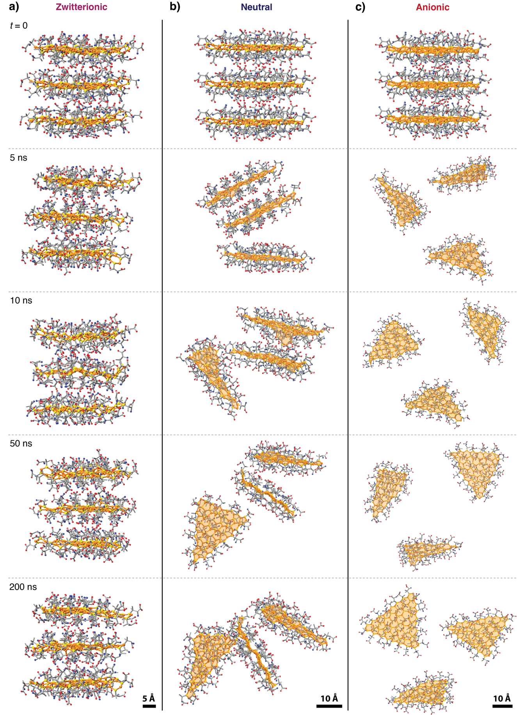
Figure S39. Molecular dynamics (MD) simulation snapshots of 2.5 nm D-NSs assemblies in water. (a) zwitterionic, (b) neutral, (c) anionic after deprotonation, δ = –1.0.
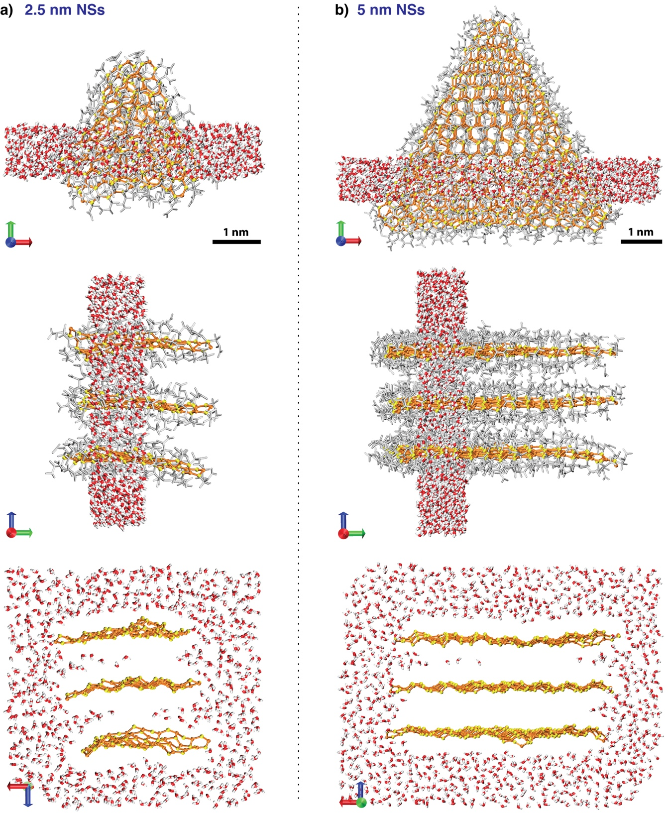
Figure S40. 1 nm cross-sections of MD simulation boxes showing the spatial distribution of water around lamellar stacks of 2.5 nm and 5 nm L-NSs. Water molecules solvate only the outer surfaces and edges of the stacks, while the interlamellar regions remain devoid of water due to the tightly packed, complementary NSs interfaces. In the bottom panels, Pen ligands are hidden for clarity.
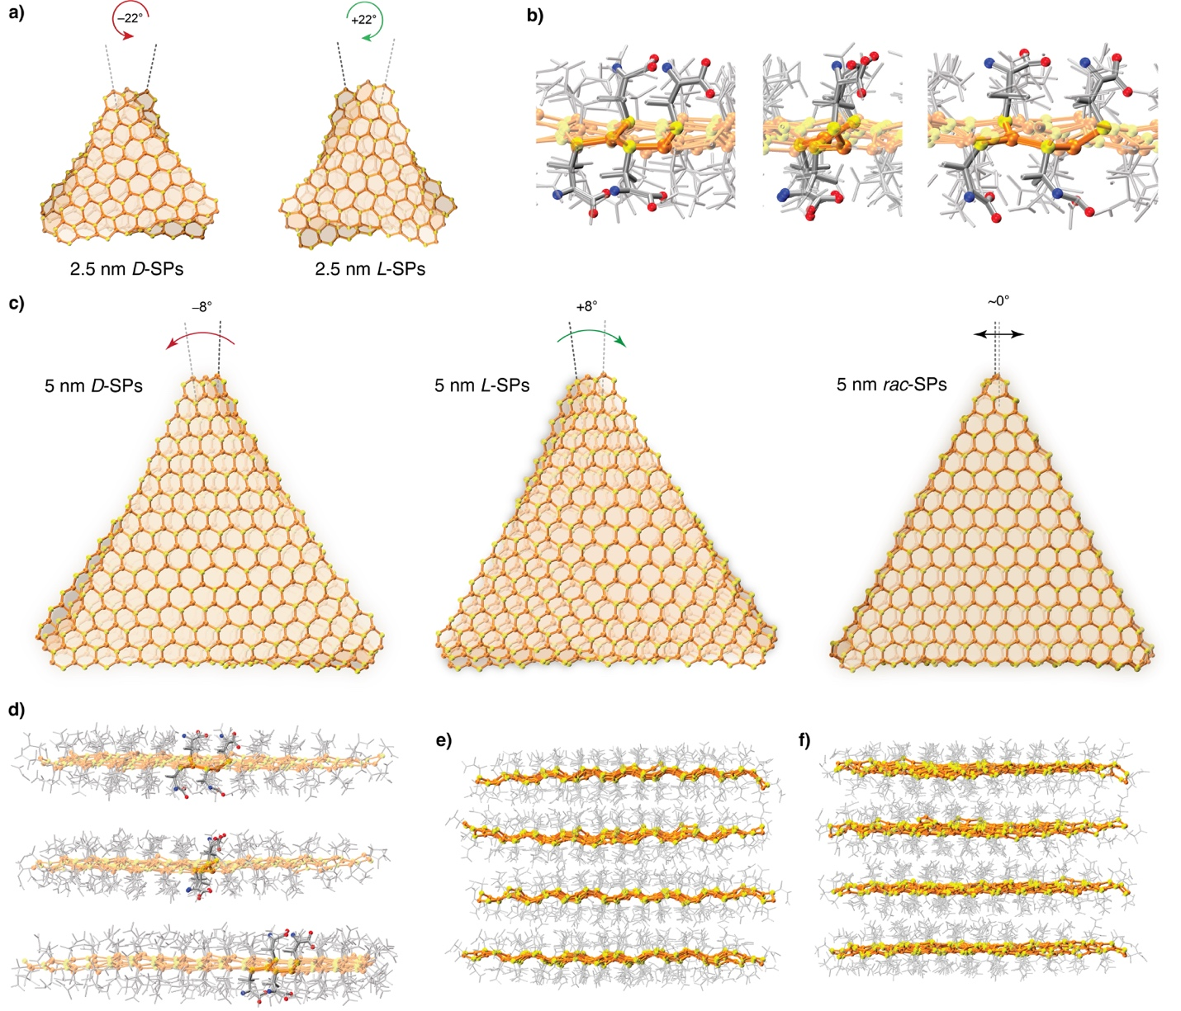

Figure S41. MD simulation snapshots of (a) 2.5 nm and (c) 5 nm NSs of different chirality. Racemic NSs in (c) are restricted from unidirectional twisting observed in simulated homochiral NSs ensembles, a s well as experimental SPs. For clarity, Pen ligands are not displayed. (b,d) Ligand organization motifs in L-SPs seen from different perspectives. (e,f) Side-view of MD–simulated racemic system. Racemic assemblies are modelled as an alternating sequence of D- and L-NSs.

DFT and TD–DFT calculations
Density functional theory (DFT) and time-dependent (TD) DFT calculations were carried out using ORCA 5.0.4 and 6.0 packages.⁵ The geometry of small building blocks, such as cyclic Cu₃(SPen)₃ (Fig. S42) were first optimized using B3LYP functional and def2-TZVP basis set. Pen ligands employed in the simulations were neutral, instead of zwitterionic ones used in the MD, to avoid undesired complexation of copper atoms by charged carboxylate units. In the next step, optimized structures were used for TD-DFT excited states calculation, using def2-TZVP basis set, with the number of roots, N_{roots} = 25–125, and energy change convergence tolerance, dE = 10^{–6} Eh. TD-DFT calculations of larger NSs fragments (Cu₁₂S₁₂(Pen)₁₂) were performed without DFT geometry optimization, without using Tamm-Dancoff approximation, with ORCA 5.0.4 package. The atomic coordinates of these NSs fragments were extracted from MD-equilibrated systems of D- and L-NSs after 500 ns simulation time. The implicit solvent effects were implemented using the polarization continuum model (CPCM). VCD spectra calculations were performed using ORCA 6.0 package with Coulomb-attenuating method (CAM) extension of B3LYP functional and def2-TZVP basis set.
IR, CD, and UV/Vis spectra were plotted using the outputs from DFT frequency calculations and TD-DFT excited states. CD and UV/Vis absorption peaks were obtained by using the Gaussian broadening function in ChimeraX equipped with SECROW plugin and Avogadro packages, with velocity representation for CD transitions. IR absorption spectra were plotted using analogous Gaussian broadening of calculated frequencies with the aid of ChimeraX software as well.
Molecular orbitals were visualized after running the single point energy calculations using optimized geometries and the same parameters as described.
VCD spectra simulation. Previously DFT-optimized structures were employed in vibrational frequency calculations using analytical (AnFreq) instead of numerical methods, using ORCA 6.0 package. Such approach provides higher accuracy as the vibrational frequencies are calculated by directly computing the second derivative of the energy with respect to nuclear coordinates using analytical mathematical expressions, unlike the numerical method. To further improve calculation accuracy, Coulomb-attenuating method extension of B3LYP functional was used (CAM-B3LYP) with valence triple-zeta with two sets of polarization functions basis set (TZVPP) instead of TZVP. Final VCD and IR spectra were plotted using USCF ChimeraX software, after implementing the frequency scaling appropriate for used functional and basis set,
$$∆_{anh}=c_{1}ν_{e}+c_{1}ν_{e}^{2} ,$$
where c₁ = 3.5 × 10^{–2} and c₁ = 0, and applying Gaussian broadening function at full width at half maximum ranging between 1.00 cm^{–2} (VCD) to 10.0 cm^{–2} (IR).

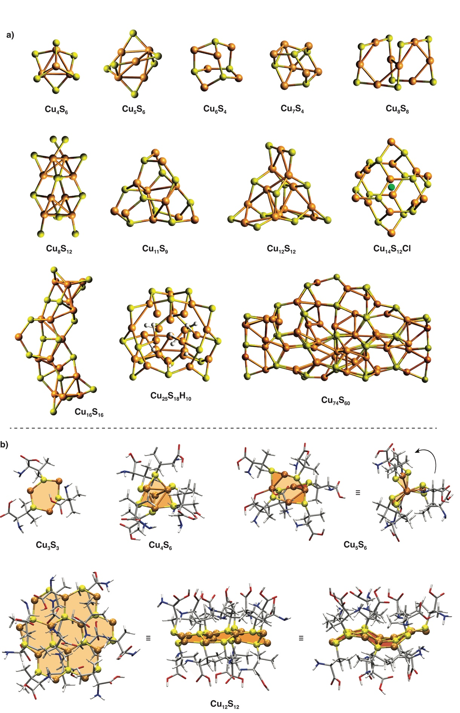
Figure S42. (a) Examples of Cu_{x}S_{y} motifs in experimentally obtained copper thiolate nanoclusters. (b) Different CuS-Pen computational models used in the simulations of chiroptical properties.
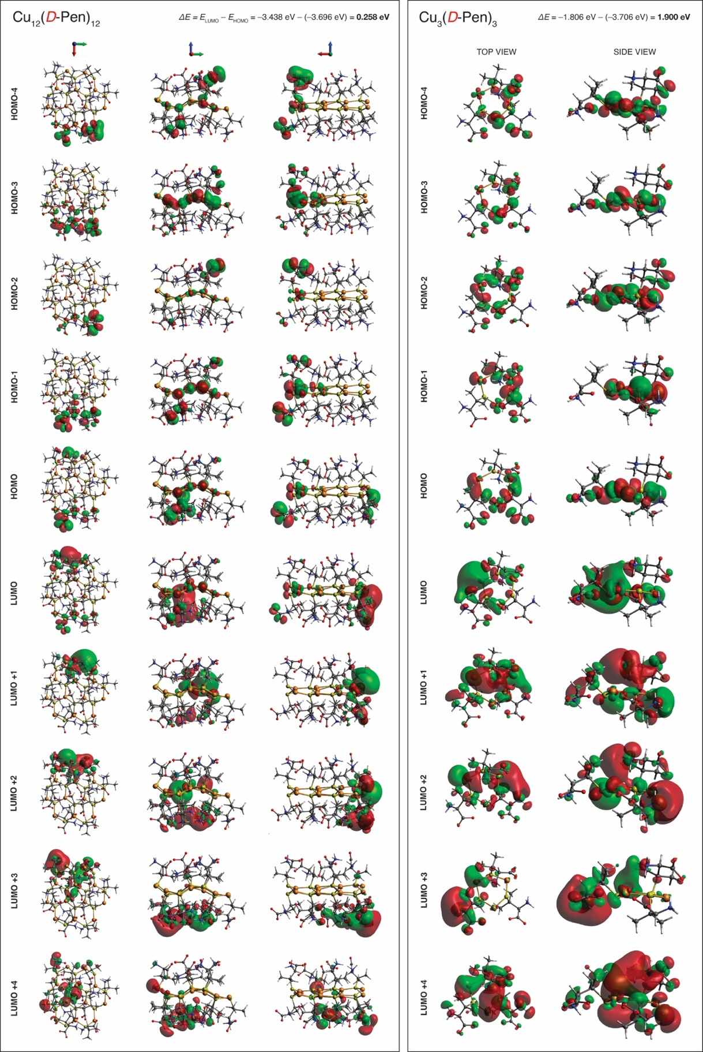
Figure S43. Visualization of HOMO/LUMO orbitals calculated for D–Cu₁₂S₁₂(Pen)₁₂ nanosheet fragment and cyclic D–Cu₃S₃(Pen)₃ ring.
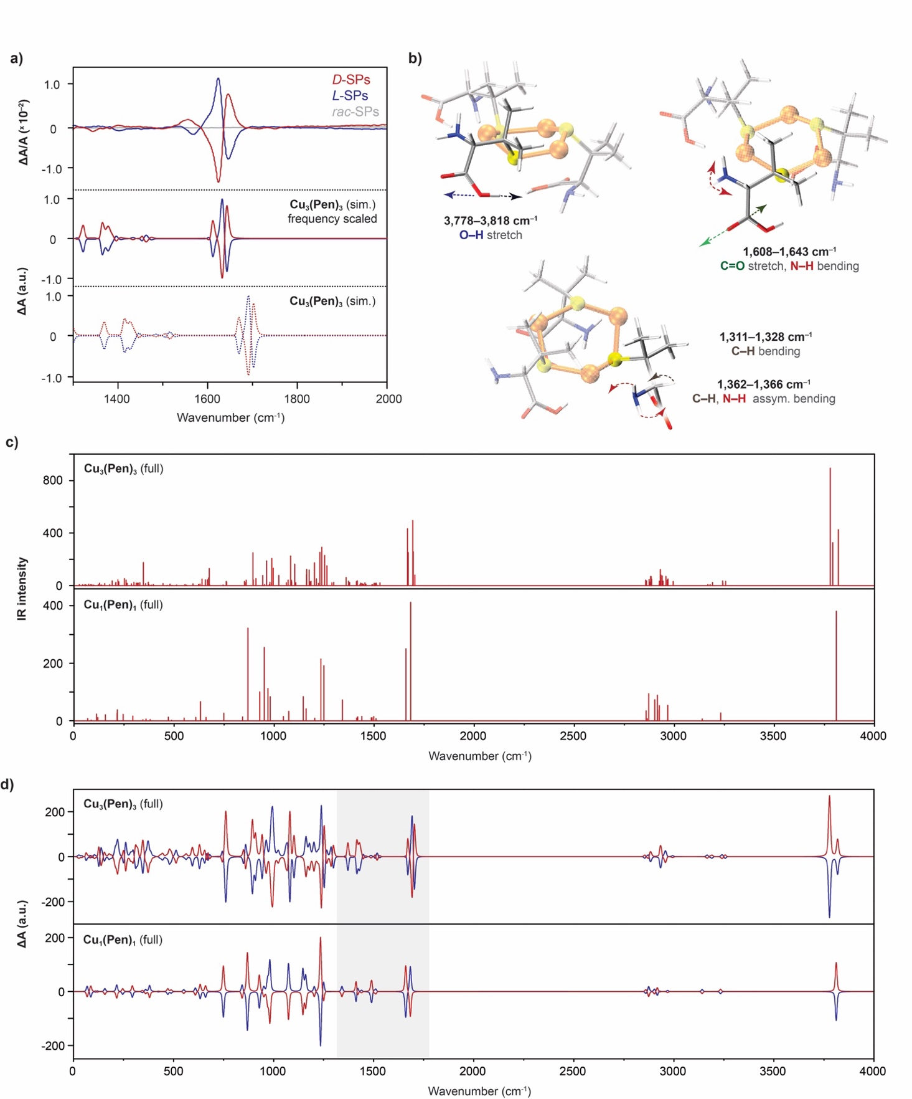
Figure S44. (a) Comparison of experimentally acquired VCD spectra of D-, L-, and rac-SPs, and the simulated VCD of Cu₃(SPen)₃ ring structure extracted from MD-simulated NSs. (b) Normal modes responsible for the strongest IR absorption and VCD signals. (c,d) Simulated IR absorption spectra and full VCD spectra of CuS-Pen monomer and Cu₃(SPen)₃ rings.
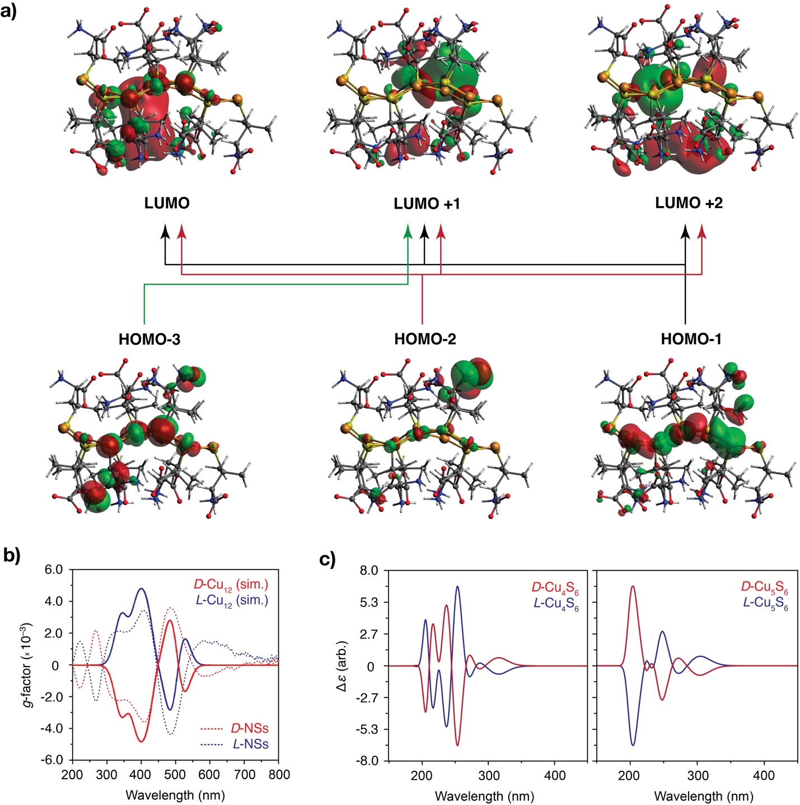

Figure S45. (a) Simulated molecular orbital transitions responsible for absorption and CD spectra in the Cu₁₂(SPen)₁₂ NS. (b) TD–DFT calculated CD spectra of the same Cu₁₂(SPen)₁₂ nanosheet extracted from MD-equilibrated 5 nm NSs model. (c) TD-DFT-calculated CD spectra of [Cu₄(SPen)₆]^{2–} and [Cu₅(SPen)₆]– nanoclusters shown in Fig. S42b show that high–energy transitions in small nanoclusters are not responsible for the experimentally measured CD spectra of ~2 nm NSs in the visible range, as shown in (b).
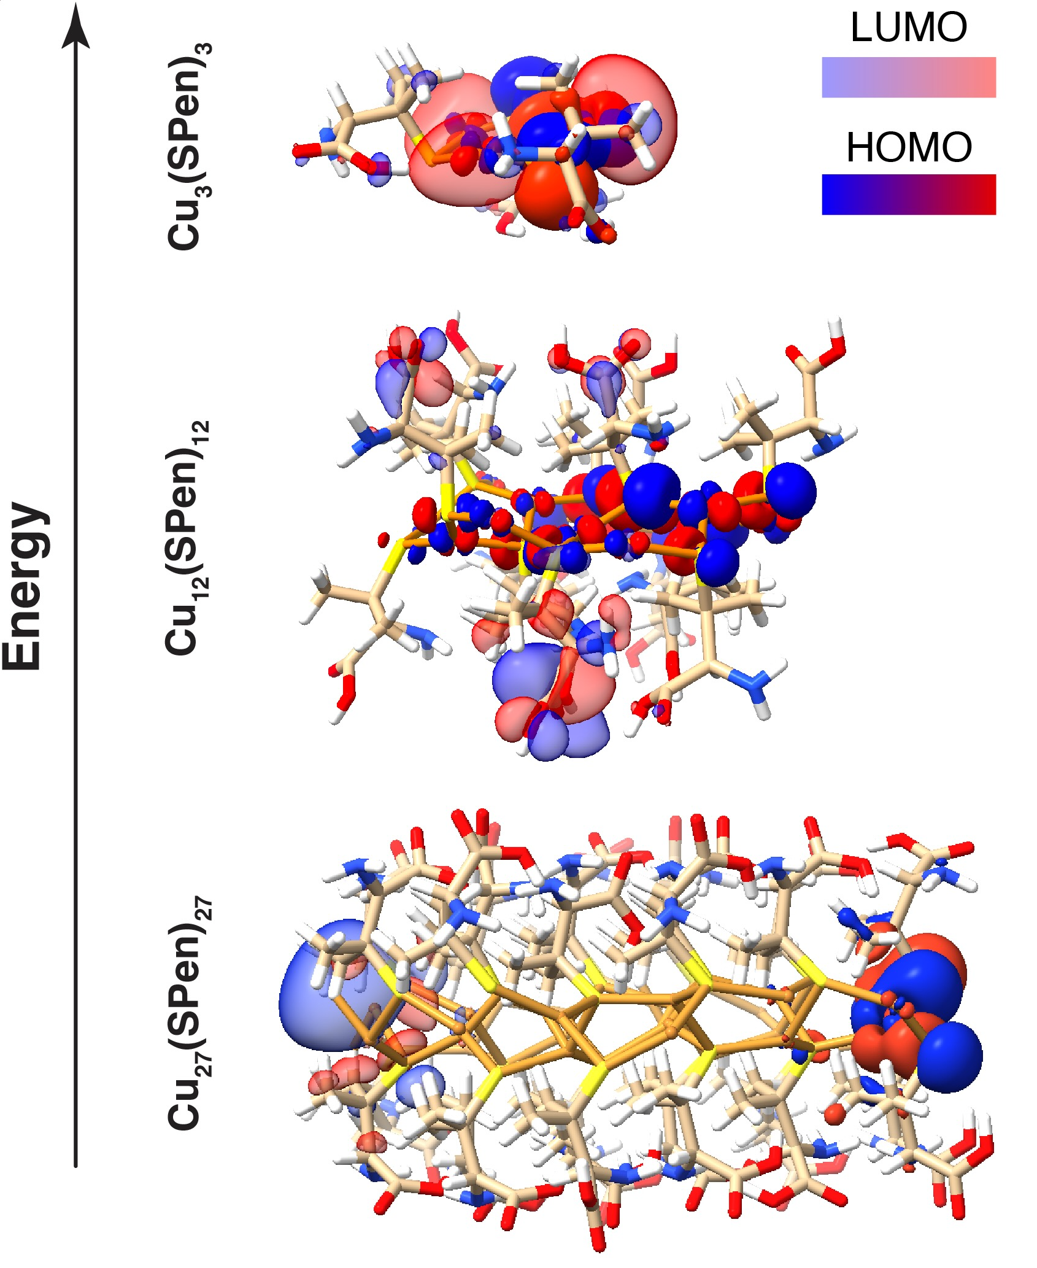
Figure S46. DFT–simulated molecular orbitals distribution in larger Cu₂₇(SPen)₂₇, compared to smaller Cu₃(SPen)₃ and Cu₁₂(SPen)₁₂. The location of HOMO and LUMO on the opposite edges of the Cu₂₇ nanosheet suggests strong electronic conjugation with an increased NS size, thus the semiconducting properties of larger NSs observed experimentally.

- Protein separation with SPs
General protein separation procedure was performed as follows: 2 mL of SPs dispersions of D-, L-, and rac- CuS–Pen, CuI–Pen, CuCN–Pen, CuS–Cys SPs (Fig. 5a and Fig. S38) were purified, supernatants were discharged, and the remaining SPs (6.0 mg, 28 µmol) were mixed with 2 mL of fetal bovine serum (FBS) solution, followed by gentle shaking for 5 minutes. SPs were centrifuged at low g (1,800 rpm, 2 min) and washed three times with either water or 400 mM KCl (see detailed procedures below). For the pH-controlled protein separation, concentrated 1.00 M acetate buffers of pH 4.2 and 5.2 were prepared by dissolving sodium acetate in deionized water, adding appropriate amount of glacial acetic acid for the adjusted pH, and adjusting the molarity by diluting the solution with water. The buffers were mixed with FBS aliquots to reach the salt concentration 100 mM, and immediately used for protein trapping with SPs of choice as described.
Washed SPs-protein conjugates were then disassembled by dissolution in 800 µL of phosphate buffered saline (PBS) solution, containing 75 mM EDTA and 25 mM DTT, adjusted to pH 7.4 with 1 M NaHCO₃. The vials were gently mixed until the red photoluminescence vanished (~1–2 min) and the solutions became transparent, which indicated the complete SPs disassembly. Protein concentrates were then immediately frozen at –80°C.
High-throughput proteomics
The samples were submitted to Proteomics Resource Facility at University of Michigan for analysis using their optimized protocols. Briefly, cysteine thiol residues were reduced with 10 mM DTT (45°C for 30 min) and alkylated with 65 mM 2-chloroacetamide, under darkness, for 30 min at room temperature. Overnight digestion with 1 ug sequencing grade, modified trypsin was carried out at 37°C with constant mixing (ThermoMixer). Digestion was stopped by acidification and peptides were desalted using SepPak C18 cartridges using manufacturer’s protocol (Waters Corp.). Samples were completely dried using vacufuge.
MS: Resulting peptides were dissolved in 9 µL of 0.1% formic acid/2% acetonitrile solution. Two µL of the resulting peptide solution were resolved on a nano-capillary reverse phase column (EasySpray PepMap C18, 2-micron, 50 cm, #ES903, Thermo Scientific) using a 0.1% formic acid/acetonitrile gradient at 300 nL/min over a period of 90 min. Eluent was directly introduced into Q Exactive HF mass spectrometer (Thermo Scientific, San Jose CA) using an EasySpray source. MS1 scans were acquired at 60K resolution (AGC target=3x106; max IT = 50 ms). Data-dependent collision induced dissociation MS/MS spectra were acquired on 20 most abundant ions following each MS1 scan (NCE ~28%; AGC target 1x105; max IT 45 ms).
Database Search. Proteins were identified by searching the data against XX protein database using Proteome Discoverer (v3.0, Thermo Scientific). Search parameters included MS1 mass tolerance of 10 ppm and fragment tolerance of 0.05 Da; two missed cleavages were allowed; carbamidimethylation of cysteine was considered fixed modification and oxidation of methionine, deamidation of asparagine and glutamine, phosphorylation of serine, threonine and tyrosine were considered as potential modifications. False discovery rate (FDR) was determined using Percolator and proteins/peptides with an FDR of ≤1% were retained for further analysis. Spectra assigned to phosphopeptides were manually verified, when possible.
To compare the obtained proteomes with the separation conditions, we tested different washing procedures and the presence of salts.
Procedure I used washing with water. Procedure II used washing with water, then 400 mM KCl solution, and water again. Analogously to procedure I, procedure III was also performed using 3.00 mL of SPs and 1.00 mL of FBS and water washing. Smaller protein-to-SPs ratio and larger available chiral surface allowed to observe the differences in binding of weak-affinity proteins (compared to procedure I, were V_{SPs}/V_{FBS} = 1:1). Procedure I was carried out to separate both high-affinity proteins and weakly bound proteins due to the presence of ‘hard’ and ‘soft’ corona on SPs surface (23), while procedure II was performed to remove the most external ‘soft corona’ protein components at high ionic strength.
Procedure IV involved pH-controlled protein occlusion. First, concentrated 1.00 M acetate buffers of pH 4.2 and 5.2 were prepared by dissolving sodium acetate in deionized water, adding appropriate amount of glacial acetic acid for the adjusted pH, and adjusting the molarity by diluting the solution with water. The buffers were mixed with FBS aliquots to reach the salt concentration 100 mM, and immediately used for protein trapping with SPs of choice as described in procedure II, using 400 mM KCl (2 mL) and 200 mM KCl (2 mL) for washing out the unbound serum proteins.
Protein affinity chromatography. 3 mm-thin polycarbonate micro-column (length 25 cm, total volume 1.7 mL) was filled with standard spiky D-SPs (synthesized at pH 2.3). 33 mg of purified SPs were dispersed in 8.1 mL of water and split into 3 portions, 2.7 mL each, followed by pouring each portion into the column and adding a ~4 mm layer of acid-treated sand in between the portions. Such setup was then flushed with 5 mL water using compressed air, to form three separate sorption regions containing 30 mm3 of packed SPs, 11 mg each. Then, 5.3 mL of FBS, with pH adjusted to 5.2 using acetic acid/potassium acetate buffer (final salt concentration 100 mM), was passed through the column over the course of 75 minutes. The column was washed with 0.5 mL water and 1.0 mL of 350 mM KCl. Then, the 3 SPs fractions were separated by cutting the column, followed by washing each fraction of the SPs with 2 mL 200 mM KCl, centrifuging the particles, and subsequent SPs disassembly with protein release.
Total protein estimation
The approximate protein content in the samples extracted from serum was estimated by commonly used Bradford protein assay. The other standardized colorimetric methods, such as Lowry or bicinchoninic acid (BCA) protein assays were incompatible in the presence of reducing agents (Cys, DTT), and copper cations, which both were present in the samples. In contrast, we found that Bradford and similar Pierce 660nmTM assays were insensitive to the presence of significant levels of Pen, DTT, copper(I) and copper(II) species. In the Bradford assay, brownish Coomassie brilliant blue G-250 dye forms a vibrant blue, anionic dye-protein complex with basic amino acids, which allows to spectroscopically estimate the average protein content in the solution. The test is not affected by presence of small peptides, free amino acids, and numerous inorganic or organic chemicals.
Briefly, the reference curve was made by measuring the absorbance of pure Bradford reagent (3.000 mL + 100 µL of water) at λ = 595 nm, and 3.100 mL of the reagent containing 4.5, 9.0, 18, 22.5, 45, and 90 µg of bovine serum albumin (BSA). Then, the identical tests were carried out using 100 µL of the protein concentrate and 3 mL of the reagent.
The approximate protein layer thickness $d$ (Fig. S48) adsorbed on each SPs type (A–H) was calculated as follows: after obtaining the mass % content of protein in SPs–protein conjugates from Bradford assay, we estimated the available surface area (SA) of the building blocks constituting the SPs (nanosheet, nanowire, or nanosphere). A typical protein density, regardless of its molecular weight, is ~1.35 g/cm³, hence $d={m_{protein}}/{SA}$.

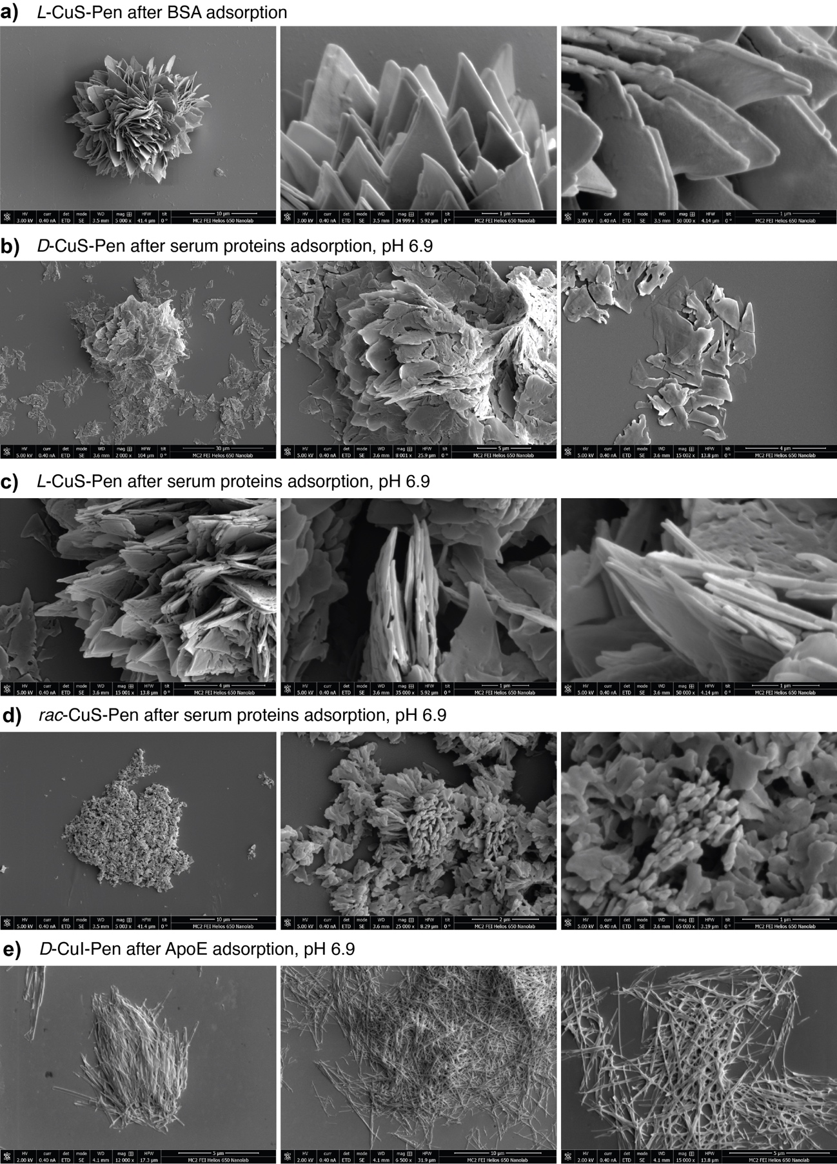
Figure S47. SEM images of different SPs after protein trapping. Note that high affinity of certain serum proteins leads to the partial SPs disassembly into submicron nanosheets and nanowires.
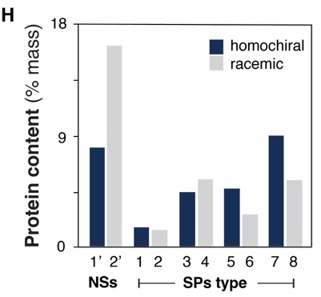
Figure S48. Protein content for fetal bovine serum proteins adsorbed on different isomorphs in Fig. 5 in the main text and Fig S38 in SI.

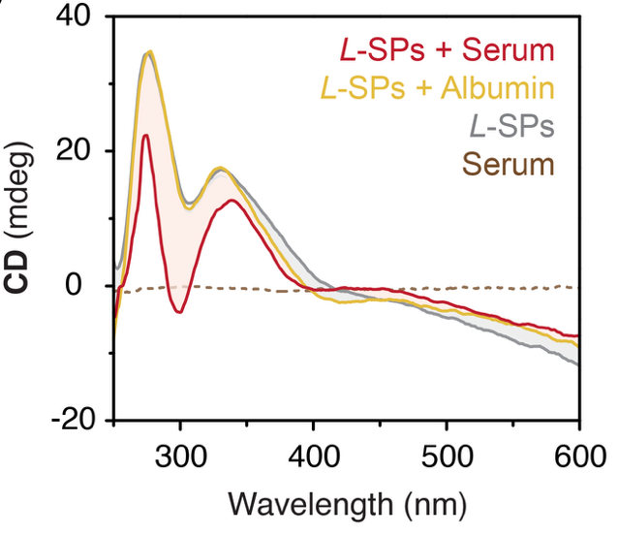
Figure S49. Changes in the CD spectra accompanying the adsorption of serum proteins (red) and albumin (yellow) on L–CuS–Pen SPs at pH 2.3. Note that albumin does not influence the CD spectra. Absorption of the high–affinity lipoproteins present in serum leads to significant changes in CD spectrum related to molecular distortion of NSs in SPs.

- Protein labeling and confocal microscopy
Apolipoprotein B (human, Chemicon®, ALP30, UniProt accession #P04114) and apolipoprotein E (human, Chemicon®, ALP70, UniProt accession #P02649) were labeled with Atto 655 and Atto 647N NHS ester. Briefly, 250 µg ApoB and 50 µg ApoE 0.5 mg/mL solutions in 150 mM KCl with pH adjusted to 8.3 with sodium hydrogen carbonate, were treated with 2-fold excess of Atto 655 or Atto 647N NHS ester dissolved in amine-free, anhydrous DMSO at room temperature. After 1 hour, the labeled proteins were purified by removing the excess of the dye with Amicon Ultra 3 kDa/10 kDa centrifugal filters, washed until the filtrate did not display fluorescence. Labeled proteins were dissolved in 150 mM NaCl solution and used for microscopy imaging. The unused aliquots were frozen at –80°C.
Analogous procedure was carried out for labeling of ApoE and alpha–synuclein (Novus Biologicals; active, pre-formed fibrils type 1, A53T mutant protein) with Atto 488 NHS ester. AnaSpec beta-amyloid–42 (Aβ42) was purchased labeled (1-42, HiLyteᵀᴹ Fluor 488-labeled, human) and used as received.
Imaging. 100 µL of different SPs dispersions in 150 mM KCl (3.0 mg/mL, D– or rac–SPs) were incubated for 15 min with 5% (mass equivalent) of Atto 655–labeled ApoB, ApoE, or fluorescein isothiocyanate–labeled bovine serum albumin. The SPs were gently centrifuged for 30 s, washed with 150 mM KCl, and redispersed in 100 µL water. 25 µL of SPs–protein conjugates were sandwiched between microscopy glass slides and imaged using Leica SP8 confocal microscope using z–stack throughout the entire particle height (~20 micron). Additional images were taken using Olympus IX 71 microscope, using the emission channels for FTIC and Cy5.
Quantification of biomarker trapping from serum.
100 µL of purified D–CuI–Pen and D–CuCN–Pen SPs were centrifuged and separately incubated with 400 µL human serum or FBS at pH 5.2 adjusted with 100 mM acetate buffer, containing 2.7 µL of labeled Aβ42 (300 µg/mL in PBS containing 0.3% NH₃). The dispersions were gently vortexed for 3 min, centrifuged, and the supernatants were analyzed using fluorimetry at λ_{em} = 520 nm. Remaining SPs were washed and disassembled in PBS buffer. Comparing the emission intensities of supernatants and disassembled SPs with the calibration curve for pure Aβ42, we calculated the enrichment factors for CuCN and CuI SPs, in FBS and human serum systems. Based on the initial Aβ42–to–serum proteins ratio, measured total protein content after trapping using Bradford assay, we calculated the Aβ42–to–serum proteins ratio after trapping.
In FBS, K = 221× and 250× for CuCN and CuI, respectively; for human serum, K = 420× and 487× for CuCN and CuI, respectively.

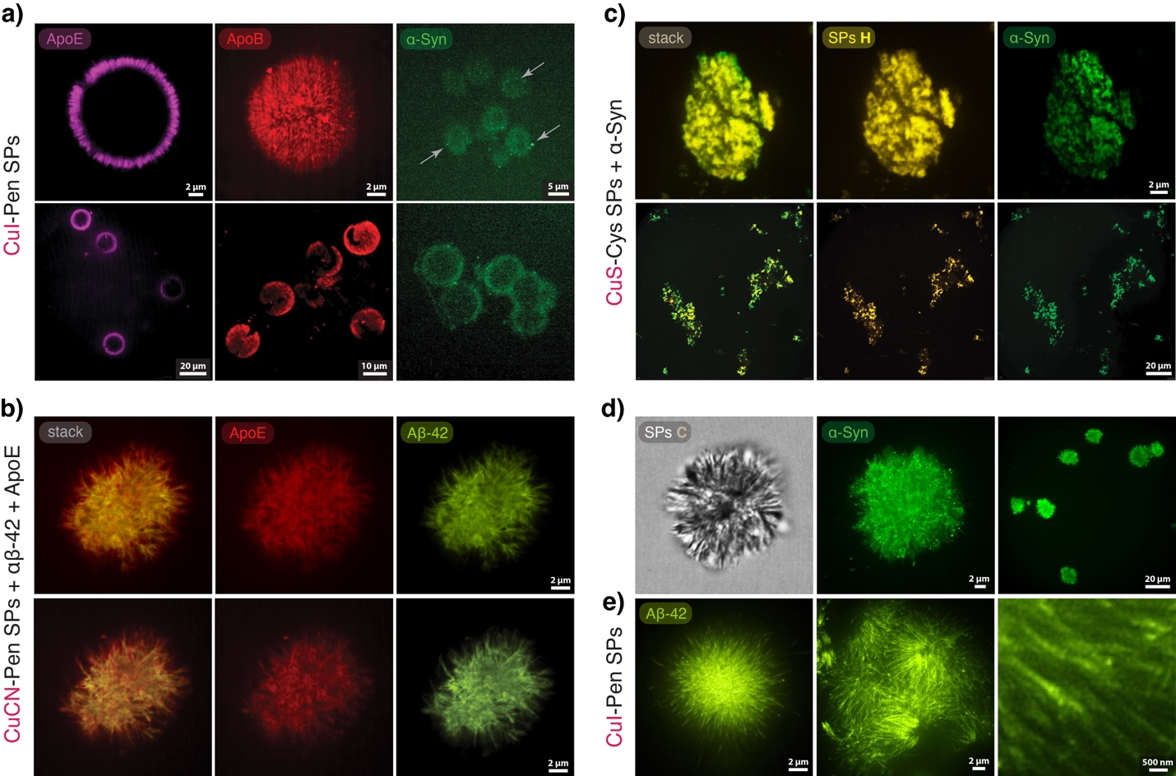
Figure S50. Confocal microscopy images of fluorescent dye–labeled targets after trapping with different SPs. (a) D–CuI–Pen SPs after trapping ApoE (one slice instead of z–stack), ApoB, and α–Syn. (b) D–CuCN–Pen SPs after simultaneous trapping both Atto 647N–labeled ApoE and Fluor 488–labeled Aβ42. (c) D–CuS–Cys SPs after trapping α–Syn; yellow emission channel corresponds to the intrinsic emission of the SPs. (d) D–CuCN–Pen SPs trapping α–Syn. (e) Deconvoluted images of D–CuI–Pen SPs trapping Aβ42.

- Quantification of enzyme activity after trapping and release
To demonstrate that our SPs–based separation operates under biologically compatible, non-denaturing conditions, we analyzed the proteins after separation and confirmed that neither the SPs, the disassembled NSs, nor the molecular Cu complex formed upon complete SPs disassembly damaged the protein structure or caused denaturation, unlike many conventional protein separation techniques. As a convenient model for this study, we tested the separation of trypsin from its aqueous solution by D- and L-SPs, followed by assessment of its enzymatic activity toward the cleavage of peptide bonds at the Arg carboxylate side, using aminomethyl coumarin (AMC)–labeled peptide as shown in the reaction in Fig. S51a. The acylated AMC is essentially non-emissive, whereas hydrolysis of the amide bond releases free 7-amino-4-methylcoumarin, which has a much higher fluorescence quantum yield; this turn-on of AMC fluorescence is routinely used to monitor reaction progress by fluorescence spectroscopy.
Enzyme extraction. Procedures were carried out as follows: 1.8 mL of freshly synthesized D- and L-SPs were purified as described in the Methods section. The SPs were redispersed in 1 mL of 150 mM NaCl, 2 mM CaCl₂, 1 mM HCl solution in an Eppendorf tube, after which 350 μL of 1 mg · mL^{–1} trypsin (from bovine pancreas) solution in 1 mM HCl was added. The mixture was incubated for 3 min with gentle vortexing, then centrifuged. The supernatant was removed, and the SPs were washed three times with water, each followed by 2 min centrifugation at 8,000 rpm. The SPs were then completely disassembled in 1.8 mL of Tris/HCl buffer (pH 7.5) containing 150 mM NaCl, 2 mM CaCl₂ and 5 mM tris(2-carboxyethyl)phosphine hydrochloride (TCEP) to prevent formation of reactive Cu²⁺ species.
Enzymatic activity quantification. Assays were performed as follows: 190 μL of Tris/HCl buffer (pH 7.5) containing 150 mM NaCl, 2 mM CaCl₂ and 2 mM TCEP was mixed with 10 μL of 200 μM substrate peptide Pyr-Arg-Thr-Lys-Arg-AMC. Then, 5 μL of enzyme solution of varying concentrations was added, and the evolution of fluorescence was monitored in a 1.5 × 1.5 mm quartz microcuvette at 20°C, every 4 s for 1 hour (integration time 2 s; excitation 380 nm, emission 440 nm, excitation/emission slit width 2 nm). For the reference kinetics, 20, 40, and 100 ng of trypsin (>10,000 BAEE units/mg) were used. For the samples, 5 μL of enzyme solutions extracted with D- and L-SPs were tested under identical conditions. The initial linear regime $v_{0}$ of the reaction (zero-order in substrate and directly proportional to the concentration of active enzyme; Fig. S51b) was used to compare activities. The half-conversion times (τ_{1/2}) obtained for pure trypsin were compared with those determined for the enzyme extracted using SPs.
Control experiments confirmed that, within the timescales used, the substrate remained stable in the absence of trypsin (Fig. S51b,c). Within τ_{1/2} ranges (<240 s) no detectable hydrolysis was observed in buffer alone or in the presence of D- or L-SPs that had been fully disassembled under the same conditions used to release the trapped enzyme. Quantification of enzymatic activity was based on the initial fluorescence kinetics under identical substrate and buffer conditions. For a Michaelis–Menten enzyme, the initial rate is,
$$v_{0}=\frac{k_{cat}{[E]}_{active}{[S]}_{0}}{K_{M}+{[S]}_{0}} ,$$
where ${[E]}_{active}$ is the concentration of catalytically active enzyme, ${[S]}_{0}$ is the initial substrate concentration, $K_{M}$ is the Michaelis–Menten constant, and $k_{cat}$ is the catalytic turnover number. Because all experiments were performed with the same ${[S]}_{0}$, buffer composition, temperature, and optical settings, the denominator of this expression remained constant, and therefore,
$v_{0}∝{\left[E\right]}_{active }$.
Equivalently, for reactions monitored to the half-conversion point under these fixed conditions, the half-conversion time satisfies,
$$τ_{1/2}∝\frac{1}{{\left[E\right]}_{active}} ,$$
providing a direct means to compare the activity of extracted trypsin with reference samples.
The half-conversion times (τ_{1/2}) obtained for trypsin recovered from the supraparticles were 105.8 s (D-SPs) and 161.2 s (L-SPs). Thus, separation by SPs was enantiomer–dependent with enzyme content corresponding to 2.14 μg · mg^{–1} and 1.41 μg · mg^{–1} of active trypsin extracted by D- and L-SPs, respectively.

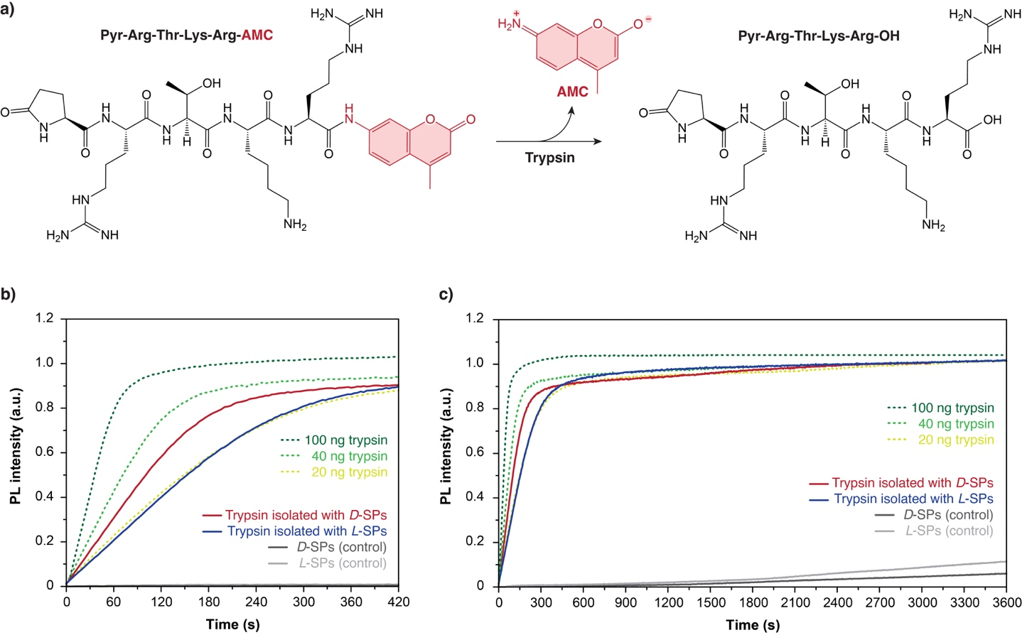
Figure S51. Enzymatic hydrolysis of AMC-labeled peptide catalyzed by commercially available trypsin and by trypsin recovered using D- and L-SPs. (a) Reaction scheme; (b) Kinetics around the τ_{1/2} region; (c) Full time course (0–3600 s). Green dotted lines: reference kinetics for 20, 40, and 100 ng of active trypsin; red and blue lines: kinetics for trypsin isolated using D- and L-SPs, respectively; black and grey lines: buffer-disassembled D- and L-SPs without loaded enzyme (controls). The isolation of trypsin was enantiomer–dependent with enzyme content corresponding to 2.14 μg · mg–1 and 1.41 μg · mg–1 of active trypsin extracted by D- and L-SPs, respectively.
- High–throughput proteomics data
In Fig. S52 and Tables S1–S3 we summarized the relative protein content in different samples using different types of SPs under varying conditions. Isomorphs 1-6 are labeled according to the Fig. 5a. Isomorphs 7,8 are CuS–Cys SPs shown in Fig. S38c. L–CuS–GSH isomorph shown in Fig. S10 is labeled as 9. Except for the three first columns containing the water–washed samples, all other samples were prepared under identical conditions, using the same molar amounts of isomorphs dispersed in 2 mL FBS and washed with KCl solution as described previously. The pH values were equal to 6.9 or adjusted to 5.2 or 4.2 as indicated. The black, grey, and white circle signs above each column indicate the chirality of the isomorphs: D–, L–, and rac–SPs, respectively. Note that the largest differences in the proteomes were observed between homochiral vs. racemic SPs due to much more significant nanoscale morphology differences.
All the raw high throughput proteomics data are also attached as separate Excel files to this Supplementary material.

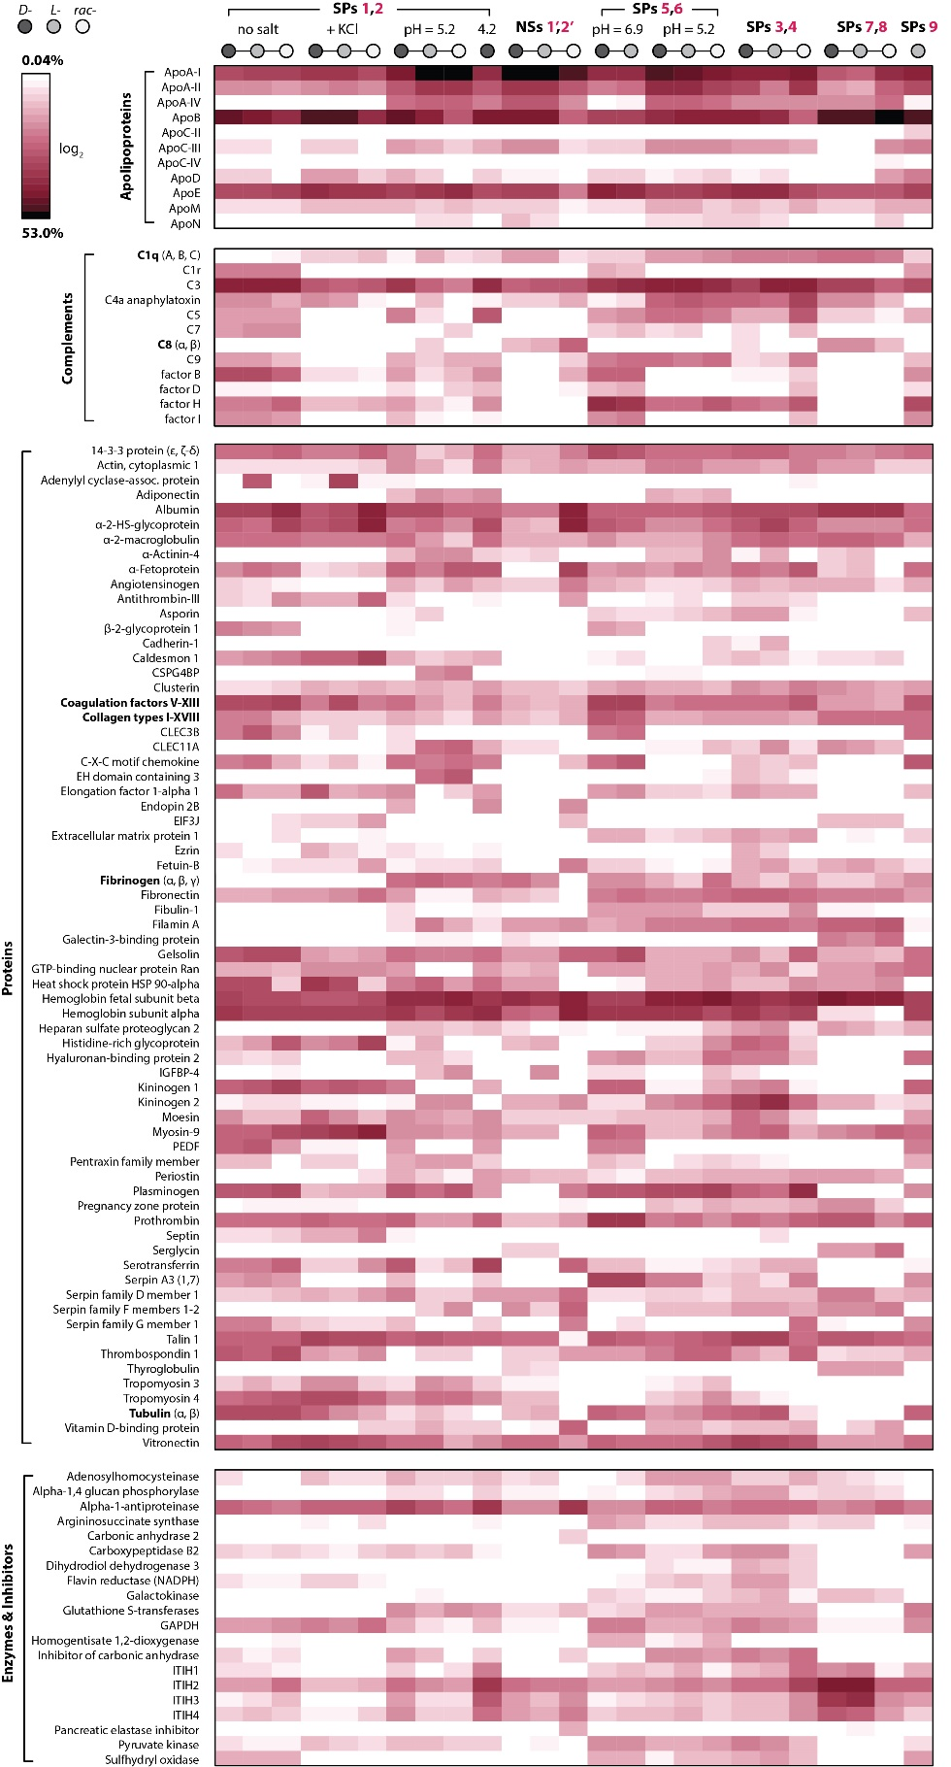
Figure S52. Relative content of the most abundant proteins extracted using different types of SPs.

Protein | D-SPs | L-SPs | rac-SPs
Apolipoprotein B | 27.61% | 29.36% | 8.03%
Apolipoprotein E | 6.34% | 5.16% | 4.50%
Heat shock protein HSP 90-alpha | 4.35% | 2.84% | 0.10%
Apolipoprotein A-I preproprotein | 4.29% | 4.87% | 2.48%
Hemoglobin fetal subunit beta | 4.16% | 3.72% | 3.84%
Myosin heavy chain 9 | 3.75% | 4.78% | 9.59%
Talin 1 | 3.24% | 2.45% | 2.87%
Vitronectin | 3.19% | 2.19% | 1.73%
Uncharacterized protein | 2.95% | 2.60% | 0.70%
Tropomyosin 4 | 2.70% | 2.92% | 1.09%
Hemoglobin subunit alpha | 1.97% | 1.64% | 2.38%
Elongation factor 1-alpha 1 | 1.62% | 0.24% | 0.25%
Albumin | 1.55% | 2.14% | 10.31%
Alpha-2-HS-glycoprotein | 1.52% | 2.09% | 12.13%
Complement C3 | 1.51% | 1.38% | 1.84%
Kininogen 1 | 1.38% | 1.50% | 1.11%
Alpha-1-antiproteinase | 1.31% | 1.37% | 1.29%
Prothrombin | 1.17% | 0.92% | 0.95%
Moesin | 1.16% | 0.46% | 0.14%
Caldesmon 1 | 1.05% | 1.41% | 3.37%
Glyceraldehyde-3-phosphate dehydrogenase | 0.61% | 0.49% | 0.91%
Uncharacterized protein | 0.54% | 0.63% | 0.17%
Alpha-2-macroglobulin | 0.53% | 0.58% | 0.57%
Coagulation factor V | 0.51% | 1.97% | 0.35%
Apolipoprotein A-II | 0.50% | 0.56% | 0.36%
Histidine rich glycoprotein | 0.49% | 0.55% | 3.79%
Complement C1q subcomponent subunit B | 0.44% | 0.17% | 0.06%
Plasma serine protease inhibitor | 0.44% | 0.30% | 0.34%
C1QC protein | 0.42% | 0.16% | 0.07%
Complement component 4A | 0.41% | 0.35% | 0.05%
Vasodilator-stimulated phosphoprotein | 0.40% | 0.31% | 0.11%
GTP-binding nuclear protein Ran | 0.37% | 0.41% | 0.48%
Tropomyosin 3 | 0.37% | 0.42% | 0.10%
Myosin light chain 6 | 0.36% | 0.47% | 1.15%
Heat shock 70kD protein binding protein | 0.35% | 0.39% | 0.25%
Heat shock protein HSP 90-beta | 0.33% | 0.24% | 0.05%
phosphopyruvate hydratase | 0.33% | 0.12% | 0.06%
Fibrinogen alpha chain | 0.30% | 0.33% | 0.79%
Endoplasmin | 0.30% | 0.17% | 0.01%
High mobility group protein B2 | 0.29% | 0.12% | 0.04%
Apolipoprotein D | 0.29% | 0.30% | 0.11%
Fibronectin | 0.29% | 0.36% | 0.83%
Thrombospondin 1 | 0.28% | 0.23% | 0.49%
Tropomyosin 1 | 0.28% | 0.31% | 0.11%
Histone H2B | 0.27% | 0.32% | 0.09%
Gelsolin | 0.25% | 0.24% | 0.29%
Stathmin | 0.24% | 0.15% | 0.19%
Antithrombin-III | 0.24% | 0.23% | 1.19%
Septin | 0.23% | 0.22% | 0.57%
Ezrin | 0.22% | 0.09% | 0.05%
Radixin | 0.21% | 0.10% | 0.01%
Septin-7 | 0.20% | 0.22% | 0.50%
Table S1. Relative protein content obtained after chirality-dependent separation of proteins from FBS at pH 6.9, KCl washed, using D-, L-, and rac-CuS-Pen SPs isomorphs.
Protein | pH 6.0 | pH 5.1 | pH 4.2
Apolipoprotein A-I | 19.00% | 39.41% | 32.60%
Apolipoprotein B-100 | 18.55% | 14.10% | 11.28%
Complement C3 | 16.59% | 8.38% | 12.39%
Histidine-rich glycoprotein | 4.90% | 3.34% | 0.97%
Apolipoprotein E | 3.73% | 2.07% | 2.23%
Complement C1q subcomponent subunit B | 3.03% | 0.07% | 0.01%
Serum amyloid P-component | 2.91% | 0.14% | 0.06%
Plasminogen | 2.10% | 2.70% | 0.25%
Gelsolin | 1.94% | 0.86% | 1.16%
Prothrombin | 1.89% | 0.28% | 0.29%
Complement C1q subcomponent subunit C | 1.84% | 0.05% | 0.01%
Apolipoprotein A-II | 1.06% | 1.76% | 2.54%
Coagulation factor XII | 0.98% | 0.16% | 0.05%
C4b-binding protein alpha chain | 0.95% | 0.18% | 0.02%
Complement factor B | 0.94% | 1.24% | 0.70%
Complement C4-B | 0.93% | 1.13% | 0.77%
Complement factor H | 0.87% | 0.24% | 0.11%
Complement component C9 | 0.86% | 0.58% | 0.44%
Vitronectin | 0.82% | 0.26% | 0.24%
Albumin | 0.77% | 0.69% | 3.20%
Tetranectin | 0.65% | 0.01% | 0.01%
Immunoglobulin heavy constant mu | 0.62% | 0.23% | 0.33%
Cytochrome P450 27C1 | 0.62% | 0.95% | 0.90%
Complement factor H-related protein 1 | 0.59% | 0.02% | 0.00%
Complement component C8 beta chain | 0.57% | 0.16% | 0.13%
Apolipoprotein C-I | 0.54% | 1.02% | 1.45%
Immunoglobulin heavy constant gamma 3 | 0.54% | 0.47% | 0.09%
Kininogen-1 | 0.53% | 0.80% | 0.53%
Platelet factor 4 | 0.51% | 0.03% | 0.01%
Apolipoprotein A-IV | 0.48% | 3.92% | 4.51%
Complement component C8 alpha chain | 0.47% | 0.06% | 0.02%
Talin-1 | 0.40% | 0.05% | 0.07%
Complement component C8 gamma chain | 0.39% | 0.05% | 0.01%
Hyaluronan-binding protein 2 | 0.39% | 0.17% | 0.05%
Complement C1s subcomponent | 0.38% | 0.09% | 0.15%
Complement C1q subcomponent subunit A | 0.36% | 0.00% | 0.00%
Complement C5 | 0.29% | 0.29% | 0.26%
Keratin, type II cytoskeletal 1 | 0.29% | 0.14% | 0.05%
Vitamin K-dependent protein S | 0.27% | 0.07% | 0.02%
Complement C1r subcomponent | 0.24% | 0.06% | 0.02%
Synaptotagmin-like protein 4 | 0.24% | 0.22% | 0.36%
Insulin-like growth factor-binding protein complex acid labile subunit | 0.24% | 0.07% | 0.06%
Complement factor H-related protein 5 | 0.23% | 0.01% | 0.00%
Serum amyloid A-4 protein | 0.22% | 0.39% | 0.33%
Immunoglobulin gamma-1 heavy chain | 0.22% | 0.41% | 0.08%
Inter-alpha-trypsin inhibitor heavy chain H2 | 0.21% | 1.35% | 5.18%
Haptoglobin | 0.20% | 1.07% | 2.45%
Clusterin | 0.19% | 0.36% | 0.33%
Selenoprotein P | 0.15% | 0.03% | 0.01%
Inter-alpha-trypsin inhibitor heavy chain H1 | 0.07% | 0.77% | 2.64%

Table 2. Relative protein content obtained after pH-dependent separation of proteins from human serum using D-CuS-Pen SP isomorph at pH 4.2, 5.1, and 6.0.
Protein | D-Cu₂I₂-Pen | L- Cu₂I₂-Pen | L-CuS-GSH
Apolipoprotein E | 9.13% | 6.09% | 3.15%
Apolipoprotein A-I preproprotein | 6.44% | 7.57% | 10.63%
Thrombospondin 1 | 6.11% | 4.96% | 4.03%
Complement factor H | 6.08% | 5.93% | 2.63%
Complement C3 | 5.75% | 6.62% | 2.35%
Prothrombin | 4.99% | 5.28% | 1.11%
Hemoglobin subunit alpha | 4.30% | 4.98% | 3.87%
Apolipoprotein B | 4.19% | 3.96% | 28.12%
Hemoglobin fetal subunit beta | 3.71% | 4.08% | 3.42%
Complement C8 beta chain | 2.41% | 1.96% | 0.21%
Coagulation factor V | 2.24% | 2.64% | 1.14%
Complement C8 alpha chain | 1.69% | 1.21% | 0.22%
Plasminogen | 1.62% | 1.56% | 0.44%
Talin 1 | 1.54% | 1.22% | 0.75%
Fibrinogen alpha chain | 1.50% | 0.91% | 0.36%
Alpha-2-HS-glycoprotein | 1.47% | 1.33% | 0.77%
Kininogen 1 | 1.33% | 1.09% | 1.08%
Gelsolin | 1.31% | 2.32% | 0.99%
Complement factor B | 1.10% | 1.24% | 0.44%
Myosin heavy chain 9 | 1.09% | 0.79% | 0.99%
Albumin | 1.07% | 1.15% | 0.83%
Vitronectin | 1.04% | 0.99% | 0.99%
Uncharacterized protein | 0.90% | 1.05% | 0.83%
C-X-C motif chemokine | 0.85% | 1.73% | 1.66%
Fibrinogen beta chain | 0.73% | 0.52% | 0.23%
Apolipoprotein A-II | 0.71% | 0.91% | 2.25%
Glyceraldehyde-3-phosphate dehydrogenase | 0.67% | 0.62% | 0.44%
Fibronectin | 0.66% | 0.82% | 0.27%
C-type lectin domain family 3 member B | 0.56% | 0.76% | 0.78%
Complement component C9 | 0.53% | 0.85% | 0.14%
Pigment epithelium-derived factor | 0.51% | 0.63% | 0.67%
Fibrinogen gamma chain | 0.47% | 0.33% | 0.17%
Complement C1q subcomponent subunit B | 0.47% | 0.34% | 0.40%
Pyruvate kinase | 0.42% | 0.36% | 0.08%
Histidine-rich glycoprotein | 0.40% | 0.29% | 0.17%
14-3-3 protein zeta/delta | 0.40% | 0.45% | 0.43%
Alpha-1-antiproteinase | 0.40% | 0.50% | 0.59%
Alpha-2-macroglobulin | 0.39% | 0.24% | 0.21%
Complement factor I | 0.39% | 0.59% | 0.45%
Carboxypeptidase B2 | 0.37% | 0.31% | 0.34%
Complement C8 gamma chain | 0.37% | 0.21% | 0.08%
C1QC protein | 0.36% | 0.24% | 0.45%
Collagen type XII alpha 1 chain | 0.36% | 0.23% | 0.37%
Fibulin-1 | 0.34% | 0.29% | 0.03%
Thrombospondin-1 | 0.33% | 0.26% | 0.23%
Alpha-fetoprotein | 0.32% | 0.42% | 0.79%
Collagen type VI alpha 2 chain | 0.31% | 0.36% | 0.07%
Complement C5 | 0.31% | 0.49% | 0.21%
Collagen type VI alpha 1 chain | 0.30% | 0.28% | 0.05%
Coagulation factor XIII B chain | 0.30% | 0.30% | 0.21%
Argininosuccinate synthase | 0.29% | 0.20% | 0.05%
ITIH2 protein | 0.27% | 0.35% | 1.26%
Table 3. Relative protein content obtained after the separation of proteins from FBS at pH 6.0 using D- and L-Cu₂I₂-Pen SP isomorph at pH 6.0, as well as L-glutathione-functionalized CuS SPs.
- Supplementary references
1. Low, K.-H., Roy, V. A. L., Chui, S. S.-Y., Chan, S. L.-F. & Che, C.-M. Highly conducting two-dimensional copper(i) 4-hydroxythiophenolate network. Chem. Commun. 46, 7328–7330 (2010).
2. Jin, Y. et al. Self-Assembled Chiral Copper Superstructures with Enhanced Circularly Polarized Light Emission. Adv. Opt. Mater. 11, 2203068 (2023).
3. Yu, W., He, X., Vanommeslaeghe, K. & MacKerell, A. D. Extension of the CHARMM general force field to sulfonyl-containing compounds and its utility in biomolecular simulations. J. Comput. Chem. 33, 2451–2468 (2012).
4. Fuchs, J.-F. et al. New model potentials for sulfur–copper(I) and sulfur–mercury(II) interactions in proteins: From ab initio to molecular dynamics. J. Comput. Chem. 27, 837–856 (2006).
5. Neese, F. Software update: The ORCA program system—Version 5.0. WIREs Comput. Mol. Sci. 12, e1606 (2022).

