Supplementary Material to:
Prognostic value of EMMPRIN in patients with metastatic soft tissue sarcoma treated with pazopanib
Antoine Lefèvre^{1,2}, Alicja Puszkiel^{3,4}, Yoann Martin⁵, Pascaline Boudou-Rouquette¹, Anne Jouinot⁵, Manuela Tiako Meyo¹, Michel Vidal^{2,3}, Xavier Declèves^{3,4}, Jérôme Alexandre¹, Benoit Blanchet^{2,3}

 |  | Progression-free survival |  | Overall survival
Variable | Median value (range) | Hazard ratio (95%CI) | p-value | Hazard ratio (95%CI) |  | p-value
Angiopoietin (pg/mL) | 586 (467–905)
≥ median vs < median |  | 0.62 (0.35–1.10) | 0.10 | 1.06 (0.60–1.89) | 0.80
BMP9 (pg/mL) | 21.6 (13.0–42.0)
≥ median vs < median |  | 1.54 (0.88–2.70) | 0.10 | 1.59 (0.89–2.78) | 0.12
CD31 (pg/mL) | 33283 (20964–46707)
≥ median vs < median |  | 1.45 (0.83–2.56) | 0.20 | 1.41 (0.79–2.50) | 0.20
EGF (pg/mL) | 41.4 (34.5–60.6)
≥ median vs < median |  | 1.23 (0.70–2.16) | 0.50 | 1.10 (0.62–1.95) | 0.70
EMMPRIN (pg/mL) | 668 (296–956)
≥ median vs < median |  | 2.25 (1.25–4.07) | 0.007 | 2.03 (1.12–3.67) | 0.02
FGF2 (pg/mL) | 5.4 (2.2–13.0)
≥ median vs < median |  | 1.23 (0.70–2.13) | 0.50 | 1.03 (0.58–1.82) | 0.9
Follistatin (pg/mL) | 461 (365–648)
≥ median vs < median |  | 1.04 (0.59–1.82) | 0.90 | 1.35 (0.76–2.38) | 0.30
G-CSF (pg/mL) | 79.6 (66.2–92.6)
≥ median vs < median |  | 0.87 (0.51–1.51) | 0.63 | 0.59 (0.34–1.06) | 0.08
HBEGF (pg/mL) | 36.7 (31.3–46.4)
≥ median vs < median |  | 1.49 (0.85–2.63) | 0.20 | 1.56 (0.88–2.78) | 0.13
IL8 (pg/mL) | 4.3 (1.6–9.4)
≥ median vs < median |  | 1.06 (0.61–1.85) | 0.80 | 1.39 (0.79–2.44) | 0.30
Leptin (pg/mL) | 6098 (2905–12410)
≥ median vs < median |  | 0.83 (0.47–1.45) | 0.50 | 0.65 (0.36–1.16) | 0.14
LYVE1 (pg/mL) | 1307 (674–1762)
≥ median vs < median |  | 1.41 (0.81–2.44) | 0.20 | 1.30 (0.74–2.33) | 0.40
PDGF bêta (pg/mL) | 23.0 (13.8–50.6)
≥ median vs < median |  | 1.06 (0.61–1.85) | 0.80 | 1.14 (0.64–2.00) | 0.70
Syndecan (pg/mL) | 392 (189–643)
≥ median vs < median |  | 1.25 (0.71–2.17) | 0.40 | 1.56 (0.88–2.78) | 0.12
Tie2 (pg/mL) | 8821 (6027–1281)
≥ median vs < median |  | 1.61 (0.93–2.86) | 0.09 | 1.54 (0.87–2.70) | 0.14
VEGF A (pg/mL) | 220 (199–277)
≥ median vs < median |  | 1.72 (0.97–3.12) | 0.06 | 1.72 (0.96–3.03) | 0.07
VEGF D (pg/mL) | 24.1 (17.9–33.4)
≥ median vs < median |  | 1.39 (0.78–2.50) | 0.30 | 1.75 (0.99–3.12) | 0.06
Supplemental Table 1: Selection of biomarkers using a Cox proportional hazard analysis of risk factors for progression and death in the training cohort (PAZOSARC 1).
95% CI, 95% confidence interval; BMP9, bone morphogenetic protein 9; CD31, cluster of differentiation 31; EGF, Epidermal growth factor; EMMPRIN, extracellular matrix metalloproteinase inducer; FGF2, fibroblast growth factor 2; G-CSF, granulocyte colony-stimulating factor; HBEGF, heparin-binding EGF-like growth factor; IL8, interleukin 8; LYVE1, lymphatic vessel endothelial hyaluronan receptor 1; PDGF, platelet derived growth factor; Tie2, tyrosine kinase with immunoglobulin-like loops and epidermal growth factor homology 2; VEGF, vascular endothelial growth factor.

Supplemental Figure 1: Distribution of 17 baseline biomarker levels in the training cohort (PAZOSARC 1).

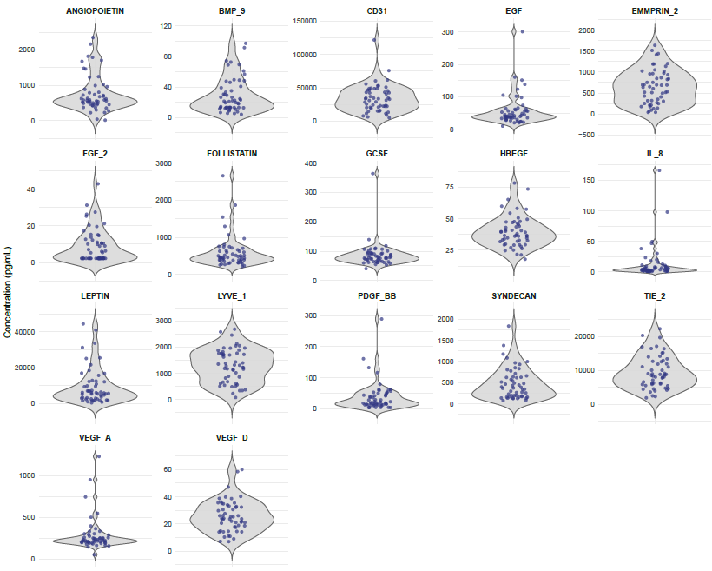

BMP9, bone morphogenetic protein 9; CD31, cluster of differentiation 31; EGF, Epidermal growth factor; EMMPRIN, extracellular matrix metalloproteinase inducer; FGF2, fibroblast growth factor 2; GCSF, granulocyte colony-stimulating factor; HBEGF, heparin-binding EGF-like growth factor; IL8, interleukin 8; LYVE1, lymphatic vessel endothelial hyaluronan receptor 1; PDGF, platelet derived growth factor; Tie2, tyrosine kinase with immunoglobulin-like loops and epidermal growth factor homology 2; VEGF, vascular endothelial growth factor

Supplemental Figure 2: Distribution of baseline EMMPRIN levels in the training (PAZOSARC 1) and validation (PAZOSARC 2) cohorts. The median baseline values of EMMPRIN were 668 [interquartile range, 287-958] pg/mL and 2,184 [1,690-3,014] pg/mL in PAZOSARC 1 and PAZOSARC 2, respectively.

