Supplementary Materials

Streamlined stable CHO cell line development using droplet microfluidics with monoclonality assurance

Kumar Vishven Naveen¹, Akanksha Tyagi¹, Omnia Mohammed Hamid Ibrahium², Rainer EAW Fischer¹, and Raluca Ostafe^{1,2*}

¹Purdue Institute of Inflammation, Immunology and Infectious Disease, Purdue University, West Lafayette, 47907, United States
²Department of Biological Sciences, Purdue University, West Lafayette, IN 47907, United States

* Corresponding author- rostafe@purdue.edu

Table S1. List of donor/acceptor probe pairs evaluated for FRET-based total IgG detection, including full-length antibodies (anti-Fc and anti-F(ab')₂), F(ab')₂ fragments, and Protein G- or Protein L-based binding reagents.
Ref. |  | Species | Antigen | Fluorophore | Ab Type | Degree of Labeling (DOL) | Supplier | Product #
Figure 3a | Donor | Goat | Mouse IgG, F(ab')₂ | Alexa Fluor® 488 | IgG, Polyclonal | 1.648 | Jackson Immuno Research | 115-545-006  lot 174859
Figure 3a | Acceptor | Goat | Mouse IgG, Fcγ | Alexa Fluor® 594 | IgG, Polyclonal | 1.228 | Jackson Immuno Research | 115-585-008  lot 174840
Figure 3b | Donor | Goat | Mouse IgG, F(ab')₂ | DyLight® 488 | F(ab')₂, Polyclonal | 1.305 | Abcam | ab98757
Figure 3b | Acceptor | Goat | Mouse IgG, Fc | DyLight® 594 | IgG, Polyclonal | 3.055 | Abcam | ab97017
Figure 3c | Donor | E. coli | IgG, Fc | iFluor® 488 succinimidyl ester (staining in house) | Protein G | 2.42 | GenScript | Z02007
Figure 3c | Acceptor | E. coli | IgG, κ (kappa) light chains | iFluor® 594 succinimidyl ester (staining in house) | Protein L | 0.987 | Pierce | 21189
Figure 3d | Donor | Goat | Mouse IgG, Fcγ | Alexa Fluor® 488 | F(ab')₂, Polyclonal | 1.676 | Jackson Immuno Research | 115-546-008  lot 169468
Figure 3d | Acceptor | Goat | Mouse IgG, F(ab')₂ | Alexa Fluor® 594 | F(ab')₂, Polyclonal | 0.642 | Jackson Immuno Research | 115-586-006  lot 169591

Figure S1. Flow cytometry analysis of CHO-S cell populations before and after picodroplet sorting. (a) CellTrace™ Far Red (CTFR)-stained CHO-S cells transiently expressing gevokizumab, used to define the producer population. (b) Unstained non-expressing CHO-S cells, used to define the non-producer population. (c) Artificial mixed library generated at a defined 5%:95% ratio of CTFR-positive to unstained cells prior to sorting. (d) Post-sorting analysis showing enrichment of CTFR-positive antibody-secreting cells from the mixed population.

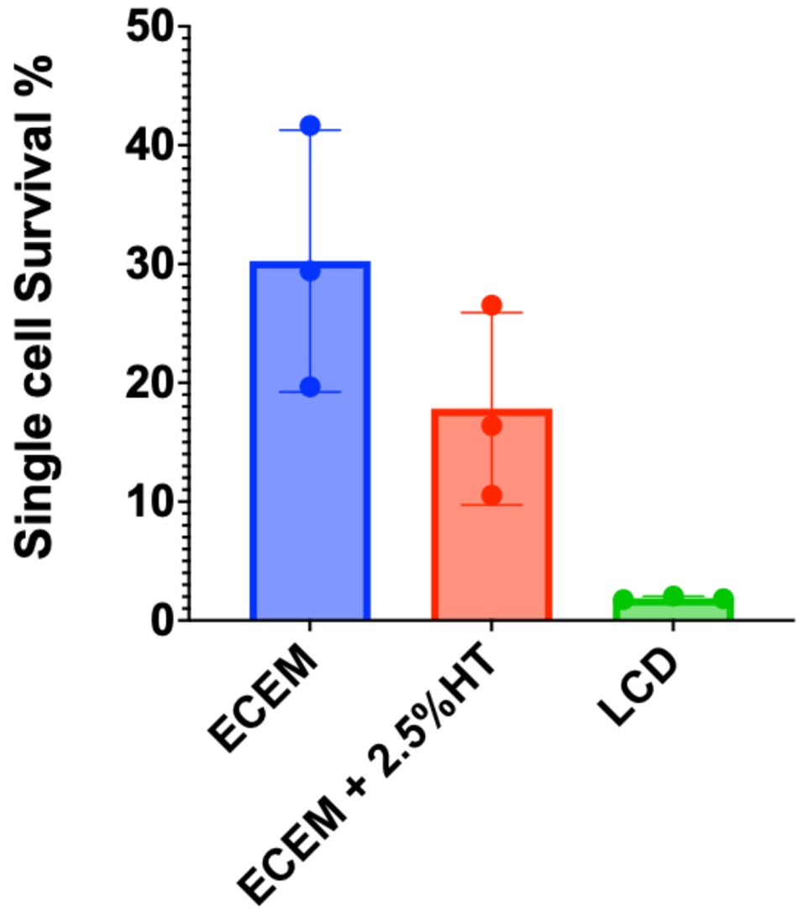
Figure S2. Single-cell outgrowth of ExpiCHO-S cells in 96-well plates (deposited using a FACSAria™ Fusion sorter) containing 200 µL of different media, assessed on Day 14. Error bars represent the standard deviation (n=3). ECEM; ExpiCHO Expression Medium, HT; HT supplement, LCD; Low Cell Density media

Figure S3. Kill-curve analysis of ExpiCHO-S cells treated with Zeocin (0–500 µg/mL), with cell viability measured at specified time points. Viability was determined using Trypan blue. C; control

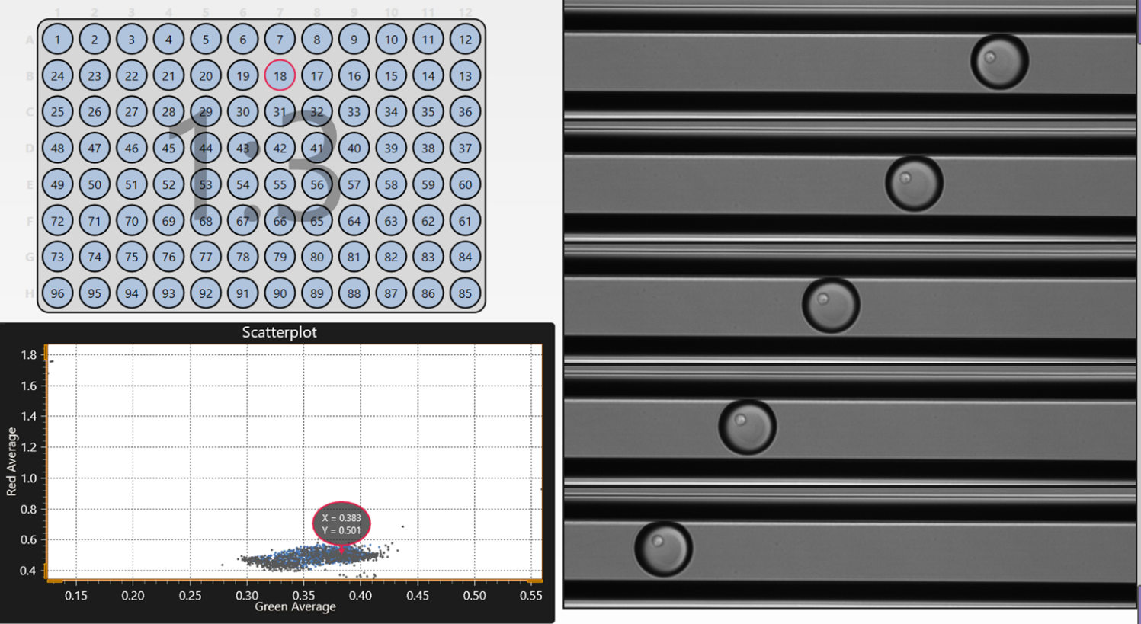
Figure S4. Representative images of picodroplets prior to dispensing. Five sequential images of each picodroplet were recorded immediately before dispensing into a well of a microtiter plate. Shown here is picodroplet from sorting event 1, sample 18 on plate 3 (well 3B7), containing a single cell. The accompanying scatterplot indicates the location of this picodroplet.

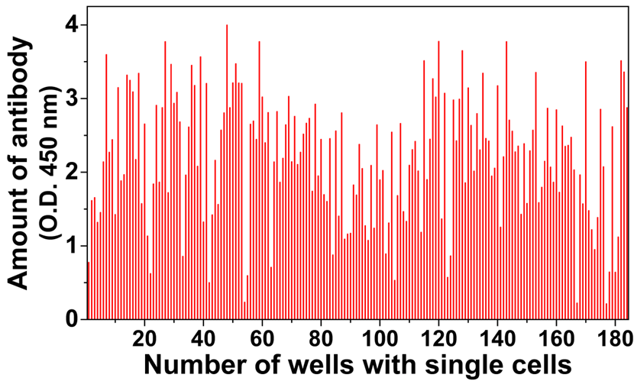
Figure S5. ELISA-based analysis of antibody productivity in individual clones verified following single-cell sorting.

Figure S6. Map of Gevokizumab in pTRIOZ-mIgG1e2 vector.

