Fig. 1 The 5-point pictorial response format
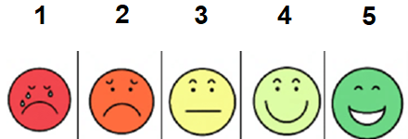

Fig. 2 The 7-point pictorial response format
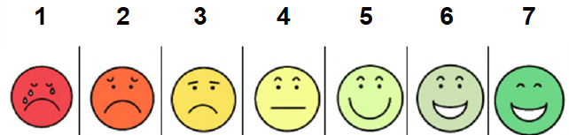

Open questions
- How would you describe your overall experience?
- What did you like the most about doing this task?
- What did you like the least?
- What, if anything, surprised you about the experience?
- What, if anything, caused you frustration?

