Memory navigation task

1. Pilot of the VR task
A pilot study with 10 participants (age: M = 27.80, SD = 5.39) was conducted in order to test different iterations. The first iteration of the task involved the same VR tasks that were used in the final version but here people were seating. We opted for this choice, as we were going to include older people in the study and wanted to increase comfort. The purpose of the pilot was to capture glitches and to gather feedback from participants for the two different passive condition, i.e., the video or the more interactive version where people follow instructions (arrows). The first participant completed the active condition, and there was no negative feedback except that they felt low levels of cybersickness and that was very unusual for them. They reported some experience with immersive VR but not regular use, and that in their previous experiences they did not feel any cybersickness symptoms. In addition, they mentioned that they would prefer standing than seating, and that while seating they felt restricted and a somewhat claustrophobic.
Thus, the next two participants tested a standing and seating version, and they both reported that standing felt more natural and was more preferrable. One participant felt low levels of cybersickness in both standing and seating conditions but reported the effects to be more intense in the seated condition. This participant had casual and irregular exposure to immersive VR prior to this experiment. The second participant, who was a seasoned immersive VR user did not report cybersickness in the standing position, but low levels on the seated condition. Both participants mentioned that had no history of motion sickness. Considering the above we decided to change the configuration of the immersive condition as participants with both low and high exposure to VR reported a preference to the standing position and reported lower levels of cybersickness.
The fourth participant was also exposed to both seating and standing conditions, but this time they did the task in the passive mode. They experienced intense cybersickness in both seating and standing conditions when used the video, and in both cases, we had to stop the experiment completely and continue another day. They reported better tolerance in the standing position for the more interactive version (following arrows). Another comment was that they would prefer the arrows on the street to appear gradually. In the initial version, the arrows on the street were all visible, so one could see them on the horizon. The participant mentioned that this was distracting and that they would prefer if they could see only the direction they need to take at their current location. To accommodate that, we activated only the three arrows in front of the participant and deactivated all the rest (Figure 1). There is also a gradient effect so the further the arrow is the more transparent it is.
The next participant tested the same conditions as the fourth participant (passive video vs more interactive, seated vs standing), but while showing only the three arrows. This participant reported intense cybersickness in the video condition and none in the more interactive version. Considering the feedback from participant four and five, we decided to use the less immersive version with the arrows instead of the video version. Participants also mentioned that they found the task to be more naturalistic, resembling following navigation instructions on their phones. This participant also reported a preference to the standing position, and some general discomfort in the seated position, thus we decided to change this configuration too.
Figure 1 Arrows in the more interactive version of the passive condition
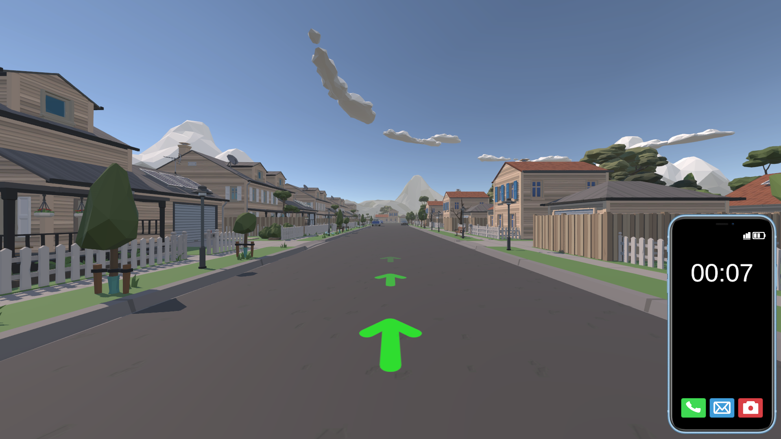
Participants six to 10 tested the standing version only. Two of them tested the passive condition (the more interactive version only), while the remaining three tested the active condition. Feedback was positive and no one reported cybersickness. At this stage we were able to capture and fix small issues with the VR task. These were: reduction of the sentence length in some texts in the instructions to make the user interface less cluttered, light up the ending points in both practice and main experiment to make it more explicit, and various bug fixes (e.g., people falling through the floor, or getting stuck on the pavement). During this phase we also piloted the administration of the all the questionnaires with all five participants. Two participants reported some confusion with some of the terms in the questionnaire, so we added a definition in parentheses next to the terms e.g., in cybersickness the item “fullness of head”.

Natural landscape attention task

1. Design and pilot of the VR tasks
We conducted a pilot study involving 10 participants (mean age: 28.80, standard deviation: 6.20) to explore various design options aimed at enhancing usability and adjusting difficulty levels. Our objective was to devise tasks that require moderate effort by most participants. Factors such as interstimulus interval (ISI), stimulus interval (SI), and the presence of distraction elements were determined based on existing attention tests and feedback gathered from the pilot study participants. Additionally, environmental elements like field of view and participant positioning within the setting were adjusted based on participant input. For instance, early on, it became apparent that our system lacked sufficient feedback mechanisms following user actions, such as taking a picture. Consequently, we incorporated a camera positioned in front of the participant to provide visual and auditory cues upon action execution (e.g., pressing the picture-taking button would trigger a brief flash of light atop the camera accompanied by a clicking sound).
Each attention task featured a flock of 50 distractor birds navigating the environment in a randomised manner. The selection of this specific number was informed by established attention paradigms, such as the symbol cancellation test (Mesulam, 1985), which typically involves 45 distractor symbols. Participant feedback further influenced this decision (see pilot information in the supplemental material). When participants tested versions with 30 and 40 distractors, they reported that it was “easy”. This feedback influenced our decision to round the number up to 50.
Moreover, the flock of distractor birds was organised into five distinct groups, with each group comprising 10 birds and characterised by a unique colour. Careful consideration was given to ensure that these colours were easily differentiable from both each other and the colour of the target stimulus. Prior to implementation, the selected colours underwent piloting to confirm participants' ease in distinguishing them.
Previous studies have utilised fixed or jittered ISIs such as 1350 ms (Rizzo et al., 2000) or a range of 1000 – 2000 ms (Ryan et al., 2010). However, during our pilot phase, we found these durations to be insufficient for tracking transitions between target birds. This may be attributed to our task's inclusion of multiple dynamic distractors, unlike the single static targets in prior studies (Rizzo et al., 2000; Ryan et al., 2010). To address this, we piloted a range of intervals (1000 to 10000 ms) for both ISIs and SIs. When fixed intervals were used, participants could predict the target bird's behaviour, such as its duration of activity or the timing of the next appearance. Predictability of the target stimulus falls outside the scope of our study, as indicated by previous research (Hsu et al., 2014). Hence, we opted for jittered intervals instead. Jittered intervals have been demonstrated to negate attention discrepancies between healthy and clinical populations, unlike fixed intervals (Ryan et al., 2010). Considering our focus on investigating VR factors' impact on attention among healthy individuals, and our inclusion of participants without formal clinical assessment for attention deficits screening, neutralising potential performance differences between healthy and clinical groups was important. Following exploration of various intervals for ISI and SI, we determined that ISIs ranging from 2000 to 7000 ms and SIs ranging from 4000 to 8000 ms effectively balanced predictability removal with moderate task difficulty.
During piloting, participants reported being able to predict bird behaviour when both target birds appeared simultaneously, which allowed them time to “rest” and not pay attention to the task. To address this, we introduced variation in the ISI of the second target bird. Experimentation with different latency intervals revealed that varying the ISI between 0 ms (simultaneous appearance) and half the SI of the first target bird effectively eliminated predictability. For instance, if the SI of the first target bird is 5000 ms, the second bird would appear with a latency between 0 and 2500 ms. The selection process was random, allowing for any decimal within the specified range. Consequently, the probability of selecting the same exact number twice was exceedingly low (1/107; see Unity documentation https://docs.unity3d.com/ScriptReference/Random.Range.html). Given this low likelihood, we determined that additional mechanisms to prevent the selection of the same number more than once were unnecessary. This ensures that each latency contained a different number for all participants.

2. VR environment and attention tasks
We opted for visual-only stimuli in our VR attention tasks for two primary reasons. First, we aimed to adhere to the established and rigorously validated paradigm of assessing attention in VR, as demonstrated in studies such as the virtual classroom by Rizzo et al. (2000); Schultheis and Rizzo (2001), which has been effective in evaluating attention deficits in children with ADHD (Neguț et al., 2017; Parsons et al., 2019). Second, research indicates that CPT tasks utilising visual stimuli present greater challenges compared to those using auditory modalities, particularly in clinical populations with attention difficulties such as individuals with depression and anxiety. Therefore, training in the visual modality may offer more significant benefits in such contexts (Voinescu, et al., 2023).
In our virtual tasks, participants were asked to complete a series of bird-watching scenarios, where they had to photograph or record a video of a target bird. The environment consisted of a hut (where participants were seated) located in a naturalistic setting. Numerous birds were flying around the environment, with some acting as target stimuli and others as distractors (Figure 1).
There were four scenarios in the VR environment, each designed to assess a different type of attention: one task aimed to assess selective attention, another sustained attention, a third divided attention, and the fourth alternating attention. In all the attention tasks, distinctively coloured distractor birds moved throughout the environment. Participants had to respond by pressing once (for taking the photograph) or pressing continuously down (for recording the video) when the target stimulus appeared. The target bird was considered “active” only when it was within the field of view of the participant, so for example, if a participant was looking down and not towards the field, this was not registered as active target and therefore participant’s scores were not penalised. This was done to avoid confound effects for the cases participants moved their head more in the high immersion (HMD) condition than in the low immersion (monitor) condition. Participants in the low immersion condition could look around the environment using an Xbox controller, while participants in the high immersion condition used head movements for looking around, much like in real life. There were on-screen instructions to guide participants in terms of the objectives of the task. The VR attention tasks were piloted with 10 participants (Age: M = 28.80, SD = 6.20).

3. Practice session
Prior to the main tasks, participants completed a practice session designed to familiarise them with the virtual environment, task procedures, and control mechanisms. This session comprised two simplified tasks, serving as a precursor to the primary attention tasks. In the first practice task, participants practiced the buttons for photographing a target bird. In the second task they practiced pressing the button continuously for recording a target bird. Each training task lasted for two minutes, and participants were encouraged to repeat the practice session as many times as necessary to become comfortable with the controls before proceeding to the main tasks. However, none of the participants repeated the practice more than once.

4. Attention tasks

Selective attention
The selective attention task implemented in this study draws upon the clinical model proposed by Sohlberg and Mateer (2001), which describes it as the capacity to identify a target stimulus amidst competing distractors. Mirroring established selective attention paradigms like the Automated Cancellation Test (Santos dos Santos et al., 2020) and Map Search (Robertson et al., 1996), participants were tasked with locating a target stimulus amid distractors in our task. Specifically, participants were presented with a green bird (the target stimulus) at regular intervals (ISI) within a field populated by birds of various colours distinct from the target, including blue, brown, red, purple, and black, with 10 birds per colour. The objective was to capture an image of the target bird by pressing a button when it appeared within participant’s field of view. Following its disappearance (SI), a new target would subsequently emerge, with this process continuing throughout the task duration. The ISI and SI ranged between 2000 – 7000 ms and 4000 – 8000 ms, respectively, with the number of birds consistent across all intervals but presented in random order for each participant. Table 2 provides a breakdown of the bird counts corresponding to each ISI and SI.
The task duration was set at two minutes, aligning with established selective attention protocols such as the Automated Cancellation Test (Santos dos Santos et al., 2020) and Map Search (Robertson et al., 1996). Within this timeframe, a total of eight target birds appeared.

Table 2 The number of target birds for each interval in the selective attention task
ISI (ms) | N |  | SI (ms) | N
2000 | 1 |  | 4000 | 1
3000 | 1 |  | 5000 | 2
4000 | 2 |  | 6000 | 2
5000 | 2 |  | 7000 | 2
6000 | 1 |  | 8000 | 1
7000 | 1
Note: ISI interstimulus interval, SI stimulus interval, N number of birds. The number of target birds for each interval is fixed and the same for all participants.

Sustained attention
Sohlberg and Mateer (2001) define sustained attention as the ability to maintain focus on a stimulus over an extended duration. Traditional assessments of sustained attention typically involve prolonged tasks during which participants must remain attentive to respond to specific stimuli. Examples include the CPT, where stimuli appear sequentially, and participants must detect a predefined sequence (Neguț et al., 2017), and the lottery task, where participants listen to lists of lottery tickets and identify those containing specific numbers (Robertson et al., 1996). Our task shared similarities with these assessments, as participants were required to sustain attention for extended periods. Specifically, participants were tasked with recording a video of a target stimulus (yellow bird) by continuously pressing a button while the bird remained in their field of view, stopping when the bird disappeared. Distractor birds of various colours (blue, brown, red, purple, and black, with 10 birds per colour) were present alongside the target bird.
The task duration was set at 10 minutes, consistent with other sustained attention tests such as CPT and virtual classroom tasks. A total of 41 target birds appeared within this timeframe. Each target bird remained visible for a set duration (SI), followed by the appearance of a new target bird after a brief interval (ISI). The SI and ISI durations ranged from 4000 to 8000 ms and 2000 to 7000 ms, respectively. The number of target birds for each interval was consistent across participants and is detailed in Table 3, with the order of presentation randomised for each participant.

Table 3 The number of target birds for each interval in the sustained attention task
ISI (ms) | N |  | SI | N
2000 | 7 |  | 4000 | 8
3000 | 7 |  | 5000 | 8
4000 | 7 |  | 6000 | 9
5000 | 6 |  | 7000 | 8
6000 | 7 |  | 8000 | 8
7000 | 7
Note: ISI interstimulus interval, N number of birds, SI stimulus interval

Divided attention
Divided attention refers to the ability to focus on two or more stimuli simultaneously or respond to a stimulus with multiple competing actions (Sohlberg & Mateer, 2001). One example of a divided attention task is the telephone search while counting task (Robertson et al., 1996), where participants search through a list of items while simultaneously listening for and counting tones. In our task, we adapted this concept by presenting participants with two visual stimuli simultaneously. Participants were instructed to take a photograph every time both target birds (red and blue) were in their field of view, but not when only one bird was present. Similar to the other attention tasks, distractor birds with distinct colours (green, yellow, brown, white, and black, with 10 birds per colour) were present alongside the target birds. Unlike the telephone search while counting task, which ends upon task completion, we opted for a fixed duration of 4 minutes to mitigate potential adverse effects of prolonged VR exposure. In addition, our intention was to keep the number of the target stimulus the same as the selective attention task in accordance with the TEA. The number of birds per interval was consistent across participants but presented in random order (see Table 4).

Table 4 The number of target birds for each interval in the divided attention task
ISI (ms) | N |  | SI (ms) | N
2000 | 2 |  | 4000 | 3
3000 | 3 |  | 5000 | 3
4000 | 3 |  | 6000 | 4
5000 | 3 |  | 7000 | 3
6000 | 3 |  | 8000 | 3
7000 | 2
Note: ISI interstimulus interval, N number of birds, SI stimulus interval

Alternating attention
Sohlberg and Mateer (2001) define alternating attention as the capacity to shift focus between various cognitive tasks. As standardised tests for this construct are scarce, we developed our task based on the theoretical framework outlined by Sohlberg and Mateer (2001) and the visual elevator task from the Test of Everyday Attention (TEA) test (Robertson et al., 1996). In the visual elevator task, participants count floors presented as tiles, ascending, or descending based on visual cues. Similarly, our task requires participants to perform two distinct actions depending on the colour of the active target bird: pressing a button to capture a picture when the bird is pink and holding the button to record a video while the bird is blue. Unlike the divided attention task, the two target birds in this task appear separately and never simultaneously. Distractor birds, with colours distinct from the targets (green, yellow, brown, white, and black, with 10 birds per colour), were present alongside the target birds.
To minimise VR exposure, the task duration was set at four minutes, informed by feedback from pilot participants who preferred shorter durations of the task, the average completion time of the visual elevator task (approximately 5 minutes), and to be consistent with the rest of the attention tasks (except the sustained). Within the four-minute duration, participants encountered eight target birds of each colour (pink and blue), totalling 16 target birds. At the start of the task, the chance of encountering a pink or blue target bird is always equal, but in the subsequent rounds, the likelihood of selecting the less frequently encountered colour increases due to a decrease in the pool size for the initially selected colour. Each target bird has fixed ISI and SI durations, detailed in Table 5. The number of birds per ISI and SI is consistent for both colours and all participants, although the presentation order is randomised.

Table 5 The number of target birds for each interval in the alternating attention task
ISI (ms) | N |  | SI (ms) | N
2000 | 2 |  | 4000 | 3
3000 | 3 |  | 5000 | 3
4000 | 3 |  | 6000 | 4
5000 | 3 |  | 7000 | 3
6000 | 3 |  | 8000 | 3
7000 | 2
Note: ISI interstimulus interval, N number of birds, SI stimulus interval

