Supplementary Figures

Fig. S1. 2D and 3D confocal fluorescence microscopy images of single PDDA/ATP coacervate droplets after incubation with E.coli-eGFP (a,b) or P. aeruginosa-mCherry (c,d). Expression of eGFP (green fluorescence) or mCherry (red fluorescence) is used to locate the bacteria as dense clusters within the droplet interior (E. coli, a) or as a thin outer shell on the surface of the droplet (P. aeruginosa, c). Live and dead bacterial cells are stained with DNA dyes SYTO-9 (green, membrane permeable) and PI (red, membrane impermeable), respectively. Note the prevalence of living cells associated with both the interior and surface of the coacervate droplets. All scale bars, 5 μm.

Fig. S2. Schematic representation showing disassembly and release of E. coli and/or P. aeruginosa cell membrane and cytoplasmic components via a stepwise lysis procedure using lysozyme and melittin. E. coli and P. aeruginosa are gram-negative bacteria. The procedure is also applicable to gram-positive bacteria such as S. aureus.

Fig. S3. Percentage number of lysed E. coli (a) or P. aeruginosa (b) cells present in coacervate droplets after capture and plotted against melittin concentration in the presence of lysozyme (5 mg/mL). Approximately 40 or 50% of the E. coli or PAO1 cells, respectively, are completely disassembled in situ. In general, melittin concentrations of 2 mg/mL were used to prepare the bacteriogenic protocells.

Fig. S4. Cell death (D) and cell lysis (L) ratios (%) for E.coli cells (initial OD = 5) after treatment with melittin (2 mg/mL) alone for 1 h. (D = A_{510nm} (after) / A_{510nm} (before); L = OD_{600 nm} (after) / OD_{600 nm} (before). Melittin alone killed ca. 80% of the bacteria in the coacervate droplets within 10 min but without inducing high levels of cell lysis (9 %), indicating that both lysozyme and melittin were required for effective release and redistribution of the bacterial components.

Fig. S5. Confocal fluorescence microscopy images of PDDA/ATP coacervate droplets containing binary populations of E.coli-eGFP and P. aeruginosa-mCherry cells before lysis (a), after lysis of only P. aeruginosa-mCherry (b), and after lysis of both bacteria (c). Before lysis, populations of E.coli and P. aeruginosa cells are spatially separated between the interior and surface regions of the coacervate droplets, respectively (a; left image, eGFP(green)/mCherry (red) overlay; centre, eGFP; right, mCherry). Lysis of the surface-adsorbed P. aeruginosa population results in coacervate droplets comprising a smooth and continuous shell of phospholipid bilayer membrane fragments derived from the dead P. aeruginosa cells (red fluorescence ring, DilC18 cytoplasmic membrane staining) along with an interior containing high numbers of live E. coli cells (b). Lysis of both bacterial populations all the cells (DilC18 staining throughout) and releases eGFP into the coacervate matrix to produce bacteriogenic protocells (c). All scale bars, 5 μm.

Fig. Fig. S6. a, Confocal fluorescence microscopy images of a single PDDA/ATP coacervate droplet recorded after capture of E.coli cells and treatment with lysozyme and melittin. Lysis of the E. coli cells releases membrane components (left, DilC18 lipid staining, red fluorescent aggregates), expressed proteins (upper right, eGFP, green fluorescence) and DNA (lower right, SYTO-9/PI staining, red fluorescence) into the coacervate interior. All scale bars, 5 μm. b, As for (a) but for captured and lysed PAO1 cells. Membrane fragments are redistributed around the droplet surface to produce a continuous outer shell (left, DilC18 lipid staining, red fluorescence), and release of low levels of expressed proteins (upper right, m-Cherry, red fluorescence) and DNA (lower right, SYTO-9/PI staining, red fluorescence) into the coacervate matrix. All scale bars, 5 μm. c, Concentrations of eGFP (green column), mCherry (red column) and DNA (blue column) in a population of coacervate droplets after complete lysis of captured E.coli-eGFP or PAO1-mCherry cells. Numbers of samples for tests: n = 3.

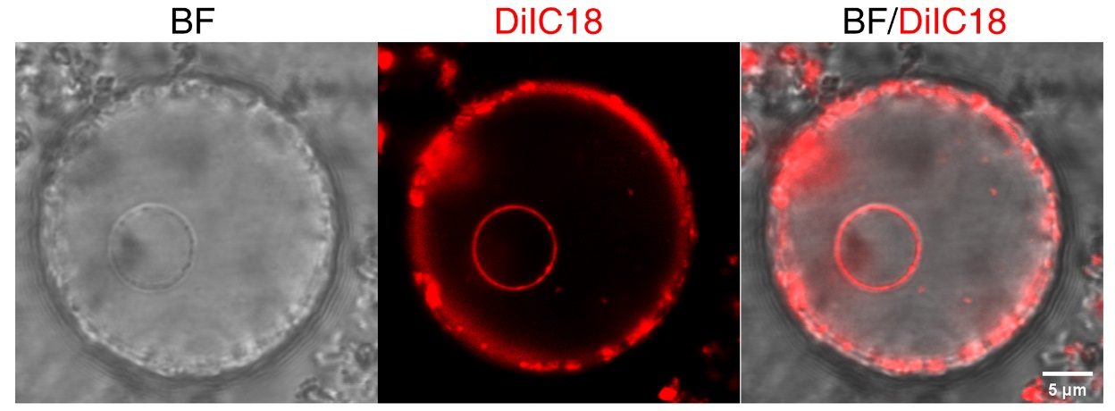

Fig. S7. Bright field (BF, left) and confocal fluorescence microscopy image (middle) and overlay image (right) of an individual bacteriogenic protocell prepared from lysed PA01 cells in the absence of co-captured E. coli cells and exposed to hypotonic conditions. The protocell contains a water-filled vacuole (non-fluorescent region) trapped inside the protocell. Phospholipid membrane fragments derived from the lysed PAO1 shell (red fluorescence, DilC18 lipid stain) are partitioned specifically at both the coacervate/water and coacervate/vacuole interfaces.

Fig. S8. Confocal ﬂuorescence microscopy images showing membrane permeability tests for bacteriogenic protocells constructed from PDDA/ATP coacervate droplets loaded and coated respectively with E. coli or P. aeruginosa cells, followed by in situ lysis of the captured bacteria. DiIC18 staining revealed a continuous and smooth outer shell of phospholipid membrane fragments (red fluorescence). Protocells were incubated with small molecule fluorescence dyes (HPTS (green) or calcein (green) (a,b), or macromolecular solutes (FITC-dextran 4 kDa and 70 kDa (green) (c,d). Both small and large molecules readily partition into the coacervate matrix in the interior of the bacteriogenic protocells, revealing the high permeability of the cytomembrane shell. Scale bar, 5 μm.

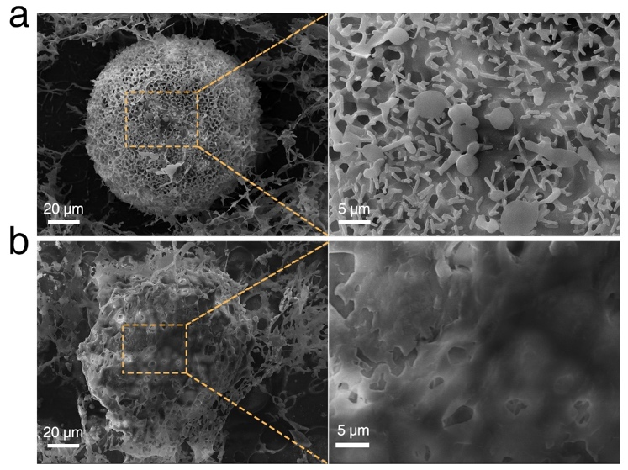

Fig. S9. Low (left) and high (right) magnification scanning electron micrographs of freeze dried single PDDA/ATP coacervate droplets before (a) and after (b) lysis of captured E. coli and PA01 cells; the bacteriogenic protocell produced after disassembly of the surface attached PA01 cells is enclosed by a shell of disordered cytomembrane fragments.

Fig. S10. FACS 2D gated data of non-fluorescent PDDA/ATP coacervate micro-droplets (grey dots), and a population of bacteriogenic protocells (blue dots). Pink dots correspond to a control sample containing a lysate of a E. coli-eGFP/PAO1 mixture pre-labelled by DilC18-staining of the PAO1 cells; superimposition of the pink and blue dots confirm the presence of both PAO1 membrane and bacteria lysate components in the protocells. Only bacteriogenic protocells (blue dots, 31 %) were distributed in area Q2; free non-lysed E. coli-eGFP (Q1, 28 %), free non-lysed PAO1 (Q3, 22%) and free coacervate droplets (Q4, 18 %) are also detected. Data were recorded after 5 min with a total population size of 1x 10⁶.

Fig. S11. 3D (right) and 2D (left) confocal fluorescence microscopy images of a single bacteriogenic protocell (a) and single coacervate droplet with co-captured non-lysed bacteria (b) 10 min after addition of RBG. β-gal activity is observed only after lysis and construction of the protocells. Typically, the final red fluorescence intensity of the bacteriogenic protocells was about 10 times higher than that of the non-lysed bacteria-loaded droplets (see Fig. S12). β-gal activity arises from the lysis of E. coli Rosetta (strain DE3) cells, which along with PA01 cells were used for protocell construction in place of the non-β-gal-active E. coli strain BL21. Scale bars, 5 μm.

Fig. S12. Time-dependent fluorescence microscopy images of a single coacervate droplet with co-captured E. coli Rosetta (strain DE3) and PA01 cells after addition of RBG showing no apparent β-galactosidase-mediated production and sequestration of resorufin (red fluorescence). The absence of enzyme activity arises from the cell membrane impermeability of RBG. Scale bars, 5 μm.

Fig. S13. Time-dependent fluorescence profiles of RBG reactions with E.coli Rosetta cells (black line) or lysed E.coli Rosetta cells (red line). Ex: 560 nm, Em: 594 nm. The absence of enzyme activity arises from the cell membrane impermeability of RBG (Wittrup, K. D. & Bailey, J. E. A single-cell assay of β-galactosidase activity in Saccharomyces cerevisiae. Cytometry 9, 394-404, (1988).

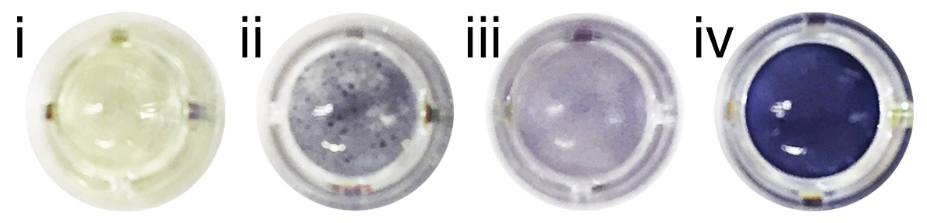

Fig. S14. Photographs of the sample well holder containing various samples after 30 min exposure to Luria-Bertani (LB) broth and assayed for glycolysis via conversion of pyruvate to L-lactate and formation of the reduced purple dye formazan; native coacervate droplets (i), bacteriogenic protocells (ii), bacterial lysate (iii), E. coli cells and PA01 (2 : 1; OD = 1, iv). Lysate and protocells were generated from the same bacterial concentrations as used in the cell sample.

Fig. S15. a, Time-dependent series of confocal microscopy images showing liquid-liquid phase separation and formation of a single DNA-enriched droplet in a PDDA/ATP/histone/DNA coacervate micro-droplet after addition of FITC-CM-dextran (70 kDa). DNA and CM-dextran are labelled with DAPI (blue fluorescence) and FITC (green fluorescence), respectively. CM-dextran is excluded from the DNA-enriched sub-compartment. b, 3D confocal fluorescence microscopy images of a single PDDA/ATP/histone/DNA (wt ratio; 3.2 : 5 : 2 : 1) coacervate droplet after addition of FITC-CM-dextran (70 kDa, green fluorescence). Filtered and overlay images are shown. c, Confocal microscopy images of multiphase coacervate droplets showing co-location of DNA (blue fluorescence) and histone (red fluorescence) in the phase-separated sub-compartment. Samples were prepared using mixtures of PDDA/ATP/RITC-histone/DAPI-DNA. Images were recorded 10 min after addition of FITC-CM-dextran (70 kDa). All scale bars, 5 μm.

Fig. S16. a, Illustration showing cleavage of circular (plasmid) DNA by DNase 1 to produce linear dsDNA fragments with blunt ends. b, DNA electrophoresis profiles for commercial purified E.coli DNA before (-) and after (+) incubation with DNase 1 for 30 min in the presence of aqueous MnCl₂. Oligonucleotides with molecular weights less than 200bp are produced.

Fig. S17. Confocal bright field (BF) and fluorescence microscopy images of PDDA/ATP/histone/E. coli plasmid DNA coacervate droplets after addition of FITC-CM-dextran (70 kDa, green fluorescence) without (a) or with (b) subsequent treatment with DNase1 to produce linear fragments. Phase separation of the circular or linear DNA produces, respectively, sub-micrometre-sized discontinuous aggregates (a) or a single demixed sub-compartment (b) (blue fluorescence, DAPI-stained DNA). One possibility is that differences in histone-DNA binding for the circular and linear variants influences the surface tension of the phase-separated nuclei and their ability to undergo coalescence. All scale bars, 5 μm.

Fig. S18. a, Time-dependent series of confocal fluorescence microscopy images of a single bacteriogenic protocell before and after addition of CM-dextran showing nucleation of a population of plasmid DNA/histone condensates (red fluorescence) throughout the molecularly crowded interior. The protocells were prepared from histone-containing PDDA/ATP coacervate droplets followed by in situ lysis of co-captured E. coli and PAO1 cells to release the bacterial DNA in situ. DNA is stained with PI. Scale bar, 5 μm. b, Plot showing time-dependent increase in the number of DNA/histone particles nucleated within individual bacteriogenic protocells after addition of CM-dextran at t = 0. Data normalized to protocell cross-sectional area (number/100μm²) to account for different protocell sizes. Typically, single protocells would contain around 200 particles of the DNA/histone condensates, which remain dispersed in the protocell interior with minimal aggregation. Number of protocells measured, n = 4; errors bars, standard deviations.

Fig. S19. 3D confocal fluorescence microscopy images showing in situ assembly of short RhB-labelled actin filaments (red fluorescence) in PDDA/ATP coacervate-based bacteriogenic protocells comprising a bacterial DNA-derived phase-separated histone-containing sub-compartment (proto-nucleus, blue fluorescence, (DAPI stained) embedded in a coacervate matrix (proto-cytoplasm, green fluorescence (FITC-CM-dextran)). Low (left side) and high (right side) magnification images of multiple or single protocells are shown. Uptake of RhB-G-actin from the external solution via diffusion through the protocell membrane (not stained) results in ATP-mediated polymerization to produce fibre-like aggregates specifically in the proto-cytoplasm, but not in the proto-nucleus. Fibre growth was inhibited due to the high concentration of ATP (ca. 200 mM) present in the coacervate phase.

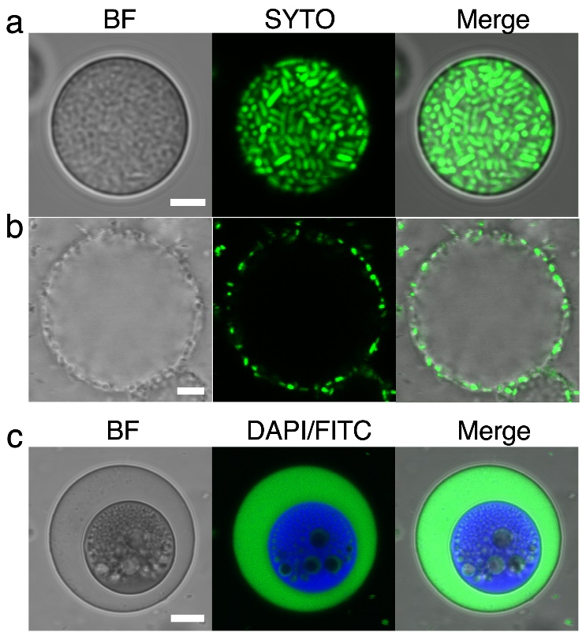

Fig. S20. Confocal bright field (BF) and fluorescence microscopy images of single PDDA/UTP coacervate droplets after capture of (a) E.coli or (b) P. aeruginosa cells in the droplet interior or at the surface, respectively. In both cases, the prevalence of live bacteria is shown by SYTO-9 staining of DNA (green fluorescence). (c) Single PDDA/UTP/histone/DNA coacervate droplet after addition of FITC-CM-dextran (green fluorescence) showing formation of a phase separated DNA/histone-enriched sub-compartment (DAPI stained, blue fluorescence). All scale bars, 5 μm.

Fig. S21. 2D (left) and 3D (right) confocal fluorescence microscopy images showing the distribution of actin (red fluorescence, RhB-labelled) in a single PDDA/UTP coacervate-based bacteriogenic protocell containing a phase-separated DNA/histone sub-compartment (blue fluorescence, (DAPI stained) dispersed in a FITC-CM-dextran-enriched coacervate matrix (green fluorescence). No ATP-generating system is present. As a consequence, actin-rich aggregates, 0.1-1 μm in size (red spots) in place of F- actin filaments are observed. All scale bars, 5 μm.

Fig. S22. Confocal fluorescence microscopy images showing live/dead stain for E.coli BL21 (DE3) cells in a single PDDA/UTP coacervate-based bacteriogenic protocell with a single proto-nucleus (blue/red fluorescence, DAPI/PI stained). To inactivate the lysozyme and melittin inside the protocell and in the solution, the protocells were pre-incubated with lysozyme inhibitor NAG3 and melittin inhibitor OBAA for 0.5 h before adding of E.coli. The live E.coli cells were stained by SYTO-9 (green fluorescence), which can penetrate live bacteria, and dead cells were stained by PI (red fluorescence), which can only penetrate dead bacteria and can also stained the DNA in the proto-nucleus. Images showed that almost all of the E.coli cells remained alive in the protocells after 3 h.

Fig. S23 FACS 2D gated data (a) and time-dependent plot profiles (b) of live/dead E.coli cell population/numbers in bacteriogenic protocells after incubation with Luria-Bertani (LB) broth. Green dots correspond to live bacteria (stained by SYTO-9); red dots correspond to dead bacteria (stained by PI). (c), Plot showing time-dependent decrease in percentage of live E.coli cells within bacteriogenic protocells after incubation with Luria-Bertani (LB) broth.

Fig. S24. Time-dependent plots of concentration of extracellular ATP secreted by E.coli BL21(DE3). Number of samples, n = 3.

Fig. S25. Time-dependent plots of ATP concentrations produced in bacteriogenic protocells via endogenous bio-generation (entrapped live E. coli cells) over a period of 72 h. The bacterial ATP profiles were dependent on the nutrient levels in the experimental system. Number of samples, n = 3; error bars are standard deviations.

Fig. S26. a, b, Schematic diagram of the Z’-LYTE™ biochemical assay for kinase activity detection in protocells. The Z’-LYTE™ biochemical assay employs a FRET-based, coupled-enzyme format and is based on the differential sensitivity of phosphorylated and non-phosphorylated peptides to proteolytic cleavage. The pentapeptide substrate is labelled with two fluorophores, coumarin (C) and fluorescein (F) —one at each end—that make up a FRET pair. In the primary reaction (a, the kinase Reaction), the kinase transfers the γ-phosphate of ATP to a single serine or threonine residue in the synthetic peptide substrate. In the secondary reaction (b, the Development reaction), a site-specific protease (the Development reagent) recognizes and cleaves non-phosphorylated peptides. Phosphorylated peptides exhibit suppressed cleavage by the Development reagent. Cleavage disrupts FRET between the donor (coumarin) and acceptor (fluorescein) fluorophores on the peptide, whereas uncleaved, phosphorylated peptides maintain FRET. A ratiometric method, which calculates the ratio (the Emission Ratio = Coumarin Emission (445 nm)/Fluorescein Emission (520 nm) of donor emission to acceptor emission after excitation of the donor fluorophore at 400 nm, quantitates reaction progress. c, The emission ratio (445/520) of protocells with endogenous ATP bio-generation (entrapped live E. coli cells (+), green column, 1.7), with endogenous ATP chemical (enzyme) generation (PK/PEP/ADP pathway, purple column, 2.3) or ATP present in the released bacterial lysate (no live E. coli, grey column, 3.9) after incubation with Z’-LYTE™ biochemical substrate reagents and developing reagent for 1 h under room temperature. Number of samples, n = 3; error bars are standard deviations.

Fig. S27. a-c, In vitro translation and transcription in live E. coli-containing bacteriogenic protocells (PDDA/UTP); Confocal fluorescence (a) and bright field (b) microscopy image, 3D fluorescence surface plot (c) and weight percent (%) and of deGFP partitioning (d) in the cytoplasm- and nucleus-like regions in a single hybrid protocell. Gel electrophoresis profiles (e) and western blotting images (f) of extracted proteins obtained after salt-induced disassembly of protocells with (+) or without (-) plasmid pEXP5-NT/deGFP. Arrow in (e, f) shows additional band at 35 kDa that was absent without the plasmid and which stains on exposure to an anti-GFP antibody.

Fig S28. Glycolysis in ATP-generating E. coli-containing bacteriogenic protocells (PDDA/UTP); time-dependent plot of changes in absorption at 565 nm, final concentration of L-lactate produced (insert, left) and photograph of sample after 30 min (insert, right) associated with endogenous ATP biogeneration. Number of samples, n = 3; error bars are standard deviations. For comparison with protocells containing only released bacterial lysate; see Figure 3h-j in the main manuscript.

Fig S29. 3D confocal fluorescence microscopy images of an individual living/synthetic cell construct showing extensive network of F-actin micro-filaments (red fluorescence, RhB-labelled actin) within the cytoplasmic-like space of a bacteriogenic host protocell. The DNA/histone sub-compartment (blue fluorescence, DAPI, DNA stain) and guest eGFP-E.coli cells (green fluorescence, expressed GFP) are immobilized within the cytoskeletal-like matrix. Continuous on-site bio-production of ATP from a glucose source and uptake of G-actin give rise to extensive hydrogelation of the protocell interior. Images are recorded 0.5 h after addition of G-actin.

Fig. S30. a,b, Confocal fluorescence microscopy images recorded at low (a) and high (b) magnification of a single bacteriogenic protocell with entrapped live E. coli cells showing extensive cytoskeletal-like network (red fluorescence, RhB-F-actin filaments) within the cytoplasmic-like space of the bacteriogenic host protocell. The DNA/histone proto-nucleus (blue fluorescence, DAPI DNA stain) and guest eGFP-E.coli cells (green fluorescence, expressed GFP) are immobilized within the cytoskeletal-like matrix. Images recorded 2 days after completion of internal hydrogelation. The enlarged image shown in b is taken from the dashed box shown in a.

Fig. S31 Confocal fluorescence microscopy of bacteriogenic hybrid protocell with (a) and without (b) F-actin after exposure to 200 mM NaCl (added at t = 6 s (white arrows)). Outer membrane (red fluorescence, Dil stain; PAO1-derived lipids), molecularly crowded proto-cytoplasm (non-fluorescent), proto-cytoskeleton (red fluorescence), membrane-free DNA/histone proto-nucleus (blue fluorescence). The protocells with F-actin (a) showing minimal shrinking under hypertonic conditions, while without F-actin, the protocells were disassembled. Scale bars, 5μm.

Fig. S32. (a) Confocal fluorescence microscopy image of an individual bacteriogenic protocell with F-actin and endogenous ATP chemical (enzyme) generation (PK/PEP/ADP pathway) after incubation with substrates (PEP/ADP) for 1 day showing no morphological change associated with F-actin or ATP production. (b) Confocal fluorescence microscopy image of an individual amoeba-like bacteriogenic protocell with entrapped E. coli-eGFP cells after incubation with Luria-Bertani (LB) broth for 1 day. (c) Confocal fluorescence microscopy image of an individual bacteriogenic protocell with high levels of entrapped E. coli-eGFP cells after incubation with Luria-Bertani (LB) broth for 1 h. The E. coli-eGFP cells were washed with PBS buffer to remove bacterial secretions before addition to the protocells. Scale bars, 5μm.

Fig. S33 Optical images (a) and contact angle plot (b) showing time-dependent increase in wettability and decrease in contact angle for single droplets of a concentrated suspension of living/synthetic constructs mounted on a pegylated glass slide.

Fig. S34. 2D Confocal fluorescence microscopy images and 3D Imaris reconstruction images of bacteriogenic protocells with entrapped E. coli-eGFP cells showing progressive formation of amoeba-like living/synthetic microscale constructs with retention of internal organization and outer membrane after incubation on a non-modified glass cover slide or plastic cover slide. Data recorded at 1 h and 48 h. Staining: DNA/histone condensate (DAPI, blue); guest live E.coli cells (eGFP, green dots); outer membrane (DilC18, red). Scale bars, 10 μm.

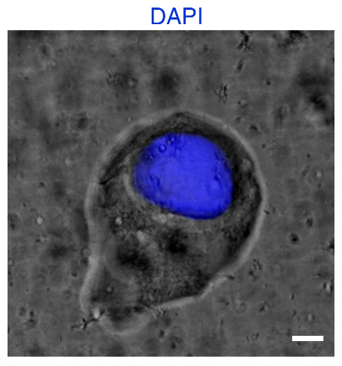

Fig. S35 Confocal microscopy image of an individual bacteriogenic protocell containing entrapped E. coli cells and F-actin after incubation with Luria-Bertani (LB) broth for 48 h. The image was recorded in aqueous suspension. DNA staining by DAPI, blue fluorescence. Scale bar, 10 μm.

Fig. S36 (a) Confocal ﬂuorescence microscopy images of single living/synthetic constructs incubated for 1h and 48 h followed by addition of various green-fluorescent solutes (FITC-BSA, Mw = 66 kDa), eGFP (32 kDa) and ssDNA-FAM (8 Da) to the external phase. (b) Corresponding uptake ratios (grey-value ratios, (FL_{interior}/FL_{exterior}) after 1 and 48 h of biological activity showing in each inhibition of uptake at 48 h. All scale bars, 10 μm.

Fig. S37 Confocal fluorescence microscopy images of single PLL/ATP (a) and DEAE-dextran/CM-dextran (b) coacervate droplets after incubation with E. coli-eGFP (green fluorescence) and PAO1-mCherry (red fluorescence). Although no positional changes were observed when the PDDA/ATP monomer molar ratio was adjusted between 4:1 to 1:1, replacing the PDDA/ATP matrix with a 1:1 mixture of polylysine (PLL)/ATP induced the preferential localization of E. coli cells (and PAO1 cells) at the droplet interface (a). Alternatively, PAO1 (and E. coli) cells were captured within the interior of coacervate droplets prepared from mixtures of diethylaminoethyl-dextran (DEAE-dex) and carboxymethyldextran (CM-dex) (b). All scale bars, 5 μm.

Supplementary Movies

Supplementary Movie 1
Confocal microscopy video (optical and fluorescence overlay) showing a single PDDA/ATP coacervate droplet in the presence of flowing stream of SYTO-9 stained E. coli cells. The bacterial cells readily penetrate the droplet surface and become trapped within the molecularly crowded coacervate matrix. Video runs for 5 min 50 s; real time is shown on the top left.

Supplementary Movie 2
Confocal microscopy video (optical and fluorescence overlay) showing a single PDDA/ATP coacervate droplet in the presence of flowing stream of SYTO-9 stained PA01 cells. The bacterial cells do not penetrate the droplet but remain attached to the droplet surface to produce an outer shell. Video runs for 1 min 26 s; real time is shown on the top left.

Supplementary Movie 3
Confocal microscopy video (optical and fluorescence overlay) showing PDDA/ATP coacervate droplets in the presence of flowing stream of E.coli-eGFP (green fluorescence) and PA01-mCherry (red fluorescence). The E. coli cells are trapped and aggregated inside the droplets while the PA01 cells attach to the droplet surface to produce a continuous outer shell. Video runs for 1 min 26 s; real time is shown on the top left.

Supplementary Movie 4
Fluorescence microscopy video showing a single PDDA/ATP coacervate droplet loaded with living E. coli Rosetta™(DE3) and PA01 cells before lysis (left panel) and a single bacteriogenic protocells prepared after bacterial lysis (right panel); in both cases, resorufin-β-D-galactopyranoside (RBG) is added to the external environment at t = 0. Production of resorufin by β-galactosidase (β-gal) only occurs in the protocell (onset of red fluorescence) due to accessibility of the released enzyme to the added RBG. Real time is shown on the top left of the two panels.

