Supplementary figures1.
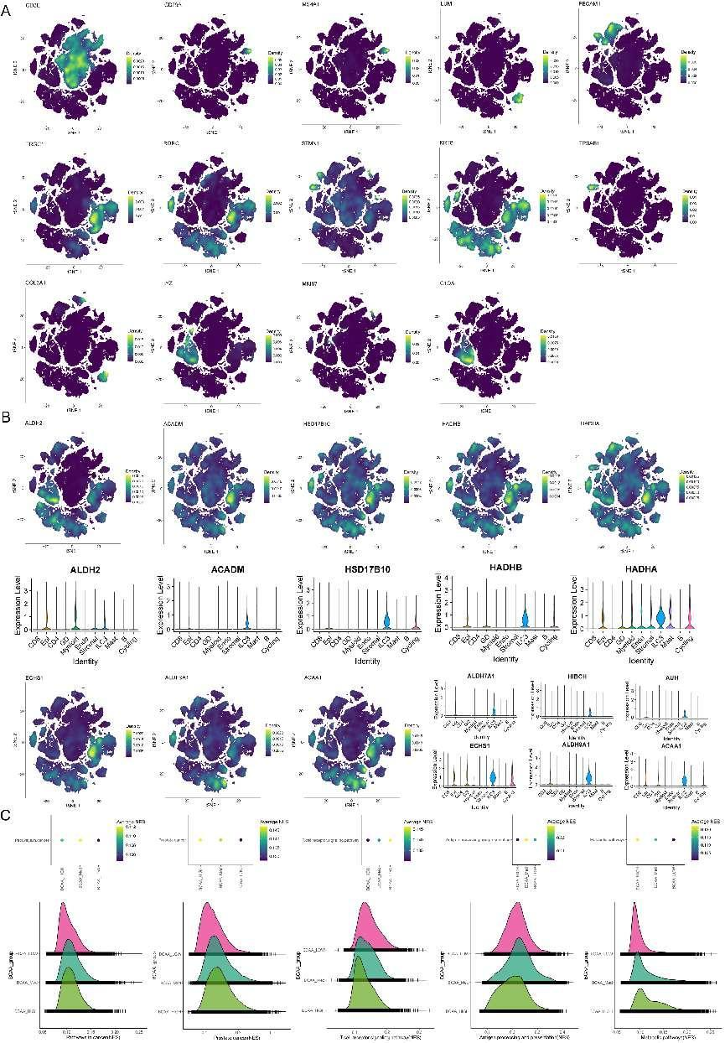
Figure S1. Single-cell stratification study of branched-chain amino acids.
A:Cell marker gene expression in single-cell stratification study of branched-chain amino acids. B:Metabolic-related gene expression in single-cell stratification studies of branched-chain amino acids. C:Cellular function GSVA analysis of single-cell stratification study of branched-chain amino acids.

Supplementary figures2.
Figure S2. Highly stratified branched-chain amino acids mediate T cell dysfunction in mice.
A-B:Expression characteristics of genes related to T cell function. C:GSVA functional analysis of branched-chain amino acid metabolism in different layers.

Supplementary figures3.
Figure S3. Overexpression of DHHC5 in PC cells attenuates the antitumor function of T cells.
A-C:Flow scatter plot of the regulation of the activation rate of H2Kb/I-Ab/I-A/E macrophages by branched-chain amino acid (BCAA) supplementation. D-F:Flow scatter plot of the regulation of the activation rate of H2Kb/I-Ab/I-A/E neutrophils by branched-chain amino acid (BCAA) supplementation.

