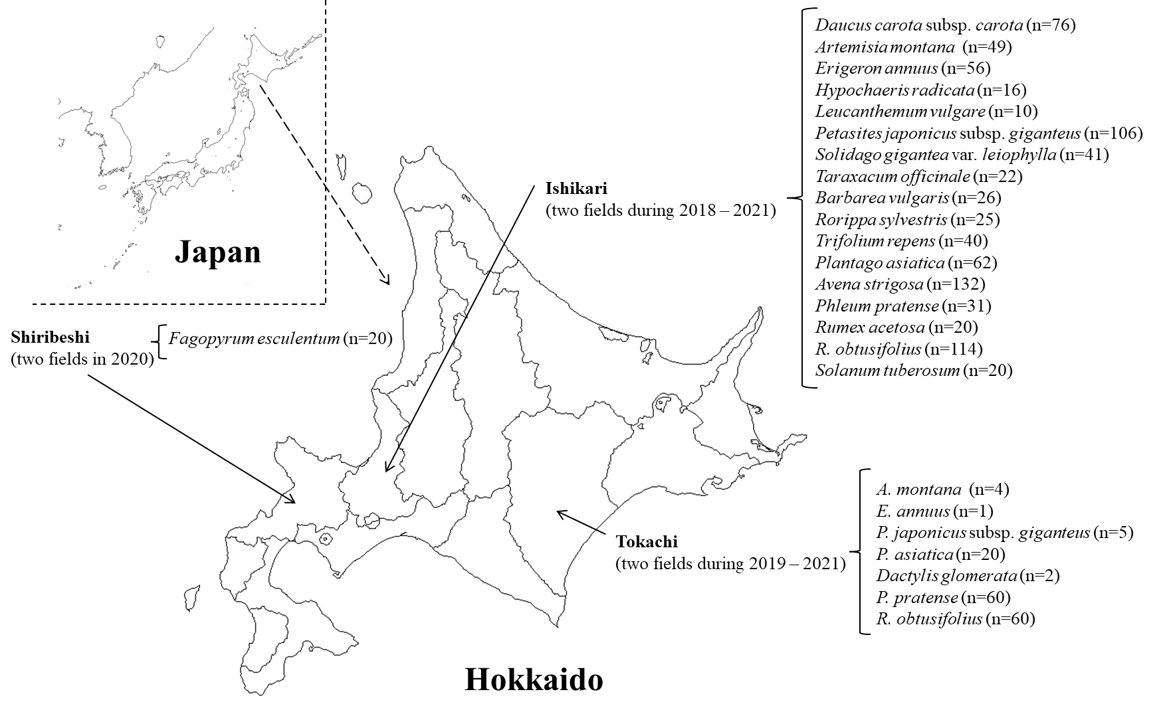
Fig. S1 Collection sites of tested plant
n, number of plants tested.

