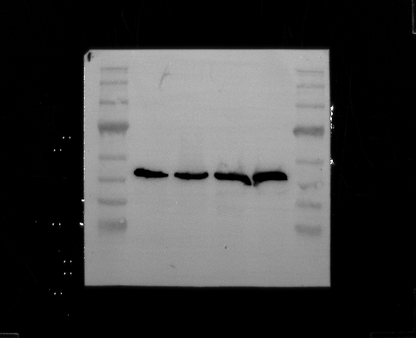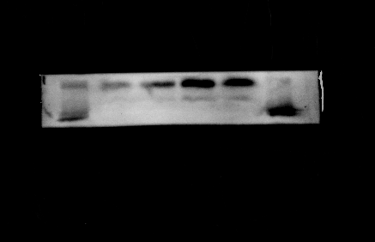
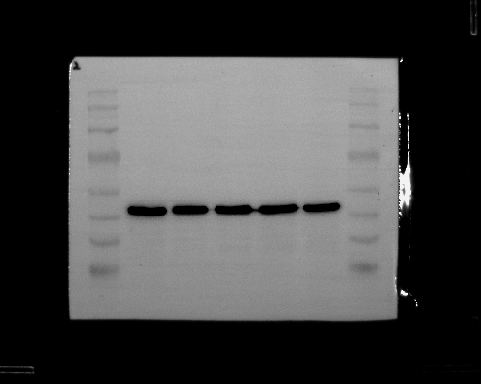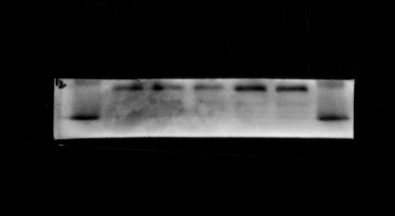
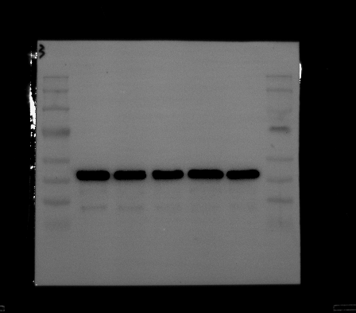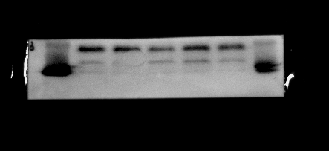
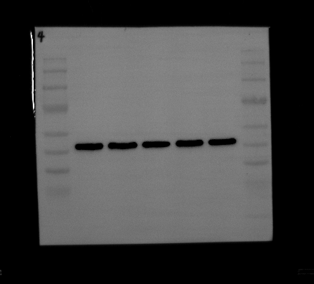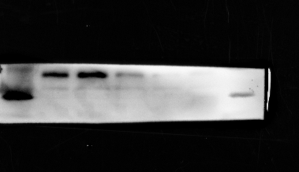
Figure 5. Expression profiles of small interfering NME1 sequences (si-NME1-17/123/392) in CAKI cells.

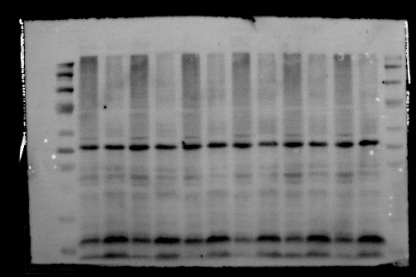
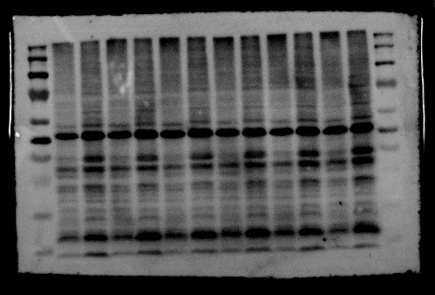
P12
P9
P1
P2
P3
P6
P4
P5
P11
P10
P8
β-Actin:43kd
NME1:17KD
P7
NME1:17KD
β-Actin:43kd

Figure 13. Western blot analysis of NME1 expression in human renal tissues and KIRC.

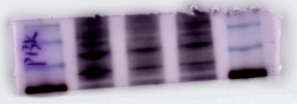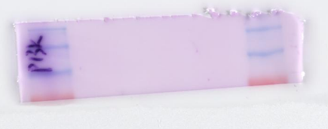
PI3K/P-PI3K:80kd
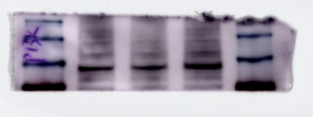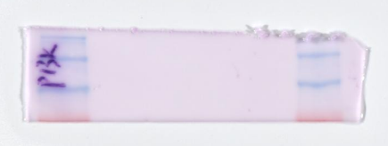

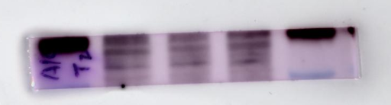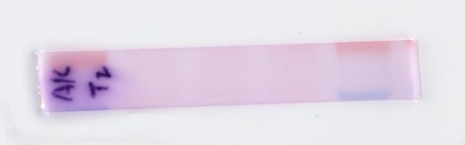
AKT/P-AKT:60kd

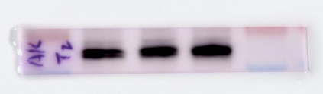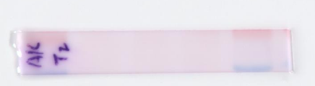

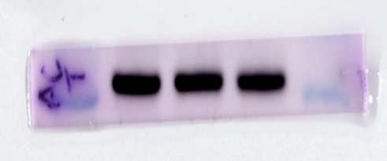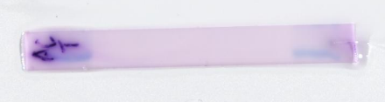
β-Actin:43kd

Figure 10. NME1 is involved in regulating the PI3K/Akt signaling pathway

