Supplementary Information
The online version contains supplementary material available at

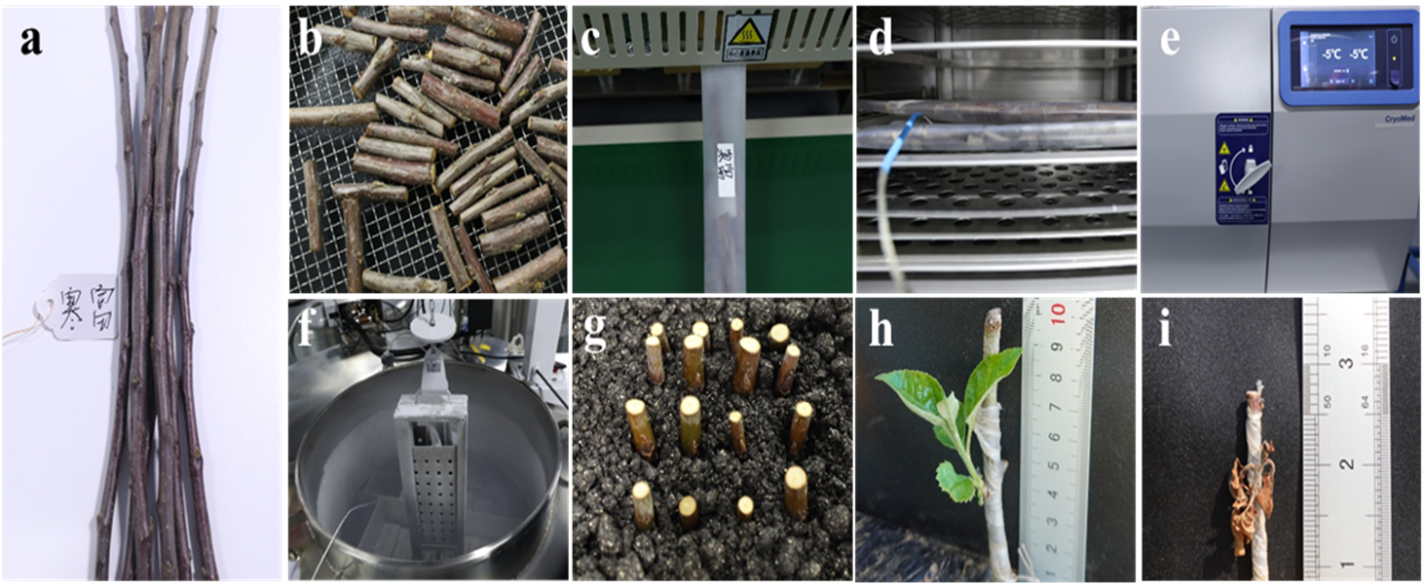
Figure S1 Cryopreservation and regrowth of apple dormant buds. a, Dormant branches. b, Drying treatment. c, Sealing in plastic tubes with labels. d, Precooling treatment. e, Controlled-cooling treatment. f, Exposure in liquid nitrogen and preservation in a cryo-tank for long-term storage. g, Rehydrating treatment. h, Regrowth of cryopreserved dormant buds. I, Dead cryopreserved after grafting.

Figure S2 TTC staining pattern in different parts of dormant buds. A-B, CT images of dormant buds in multiple planes. C–D, TTC staining indicates viable dormant buds. E-F, TTC staining showing dead dormant buds. Red staining indicates viability, and green indicates death. arrow 1 indicates the meristem. arrow 2 indicates the cambium. arrow 3 indicates the phloem. Scale bar represents 1 cm.

Figure S3 Heatmap of relative contents of FFA, SM and Cer in dormant bud during cryopreservation procedures.

Figure S4 Heatmap of relative contents of FFA, SM and Cer in dormant bud during cryopreservation procedures. TEM observation of apple dormant bud with different moisture content after rehydration. A-C, show lipid droplets in buds with 40%, 30%, and 20% MC. D-F, show meristematic tissues in buds with 40%, 30%, and 20%. Red arrows point to nucleus. blue arrows point to endoplasmic reticulum. yellow arrows point to starch granule. white arrows point to lipid droplets.

Table S1. Primers used in Real-time RT-PCR experiment.
Gene name | Primer | Sequence (5'-3')
MdActin | Forward | GGATTTGCTGGTGATGATGCT
MdActin | Reverse | AGTTGCTCACTATGCCGTGC
LPCAT1 | Forward | GTGGCTCCGTCACTATGTGT
LPCAT1 | Reverse | GCCATTTTCGGACTGATCGC
LPCAT2 | Forward | GCTGTCTGGCATGGACTGTA
LPCAT2 | Reverse | AATGACACGCACATGGGACT
PDAT | Forward | ACAATGAAACGGGGCTCGAT
PDAT | Reverse | GCTTGGTCCCGAATCTCTGT
PDCT | Forward | GAGCAGACTTTCCGAGAATG
PDCT | Reverse | CACCTCCTTCAGCCATAGCC
MdDGK2 | Forward | AGAACAGAGCGAGGAAAGGC
MdDGK2 | Reverse | GGCCACAAAAGACCAGGTGA
MdDGK4 | Forward | GAAGTTTCGGATGGGGAGGTT
MdDGK4 | Reverse | GGAACCAACCCTGAGAGCAA
MdPLA1 | Forward | ATGTCCAGTCTCGTGCCAAG
MdPLA1 | Reverse | TGCCAAAGAATCTGATCCCTGA
MdPLA2 | Forward | TGCCAAAGAATCTGATCCCTGA
MdPLA2 | Reverse | CCTCAGAAATGGAGGCACTGA
MdPI-PLC2 | Forward | GCACACACACTTTGATGCGT
MdPI-PLC2 | Reverse | TTCAATGCGGAGCACAGCTA
MdPI-PLC4 | Forward | GGTGCTCAAATGGTTGCGTT
MdPI-PLC4 | Reverse | CCTGCTATGCCAACCCTAGT
MdPI-PLC6 | Forward | CCCGACTTCTACACAAAGGTCT
MdPI-PLC6 | Reverse | AAGGGGAAGTGCTGTTGTCC
MdPLD03 | Forward | GAGGAAAGTAAATGAGGTTGCA
MdPLD03 | Reverse | GCATATCAGGAATTTTGTTGGA
MdPLD05 | Forward | ACAACGATCGATTTGGGAATAG
MdPLD05 | Reverse | GGGGATGTATAAAATTCACTTTCA
MdPLD09 | Forward | ACAACTATCGACTTGGGAATTG
MdPLD09 | Reverse | AATGAAATACTTGAGGAGACGC
MdPLD10 | Forward | GTGAACCAGATTGCTGACAAA
MdPLD10 | Reverse | GTAAGGATCGGAGGAAGGTAG
MdPLD17 | Forward | GTGAACCAGATTGCTGACAAA
MdPLD17 | Reverse | GTAAGGATCGGAGGAAGGTAG

