Supplementary Figures
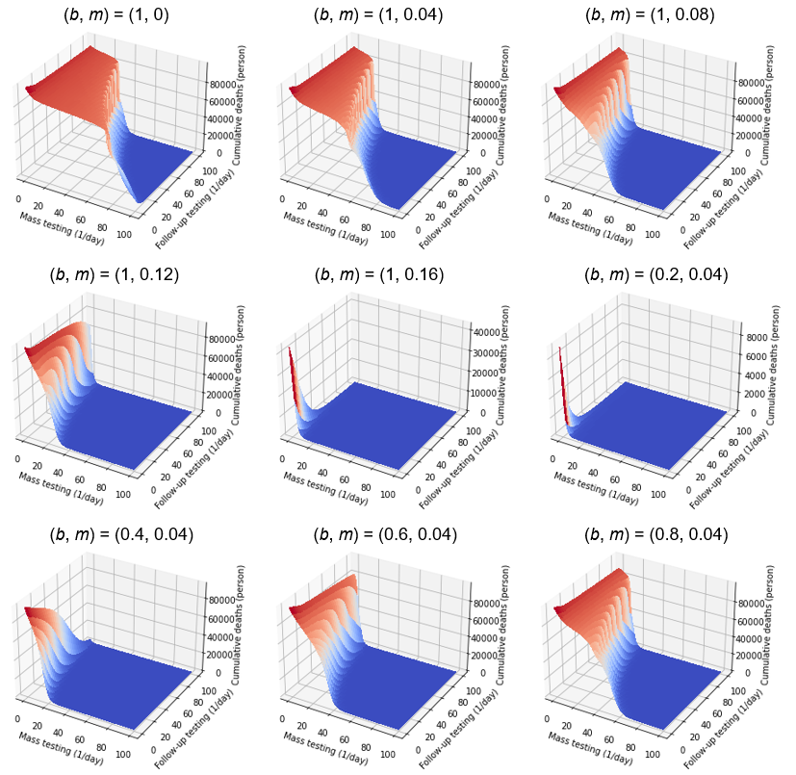
Figure S1: Sensitivity analyses of parameters b and m on the number of cumulative deaths
Simulations were performed with different values of b and m.

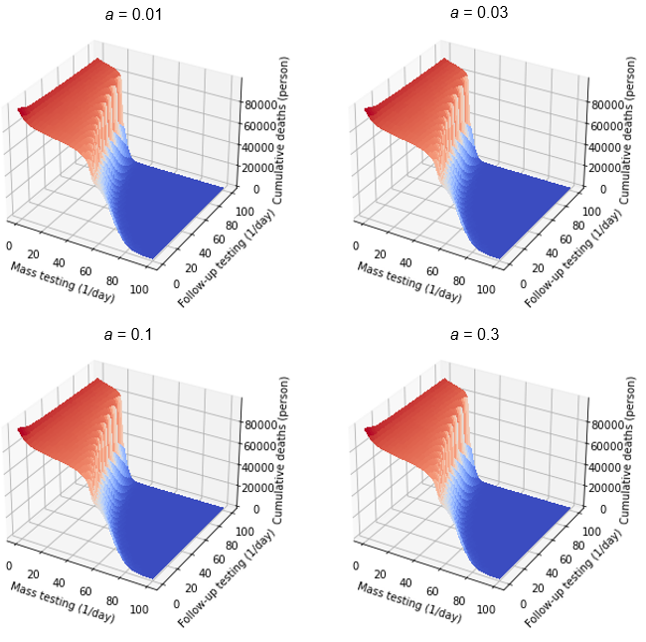
Figure S2: Sensitivity analyses of parameter a on the number of cumulative deaths
Simulations were performed with different values of a.

