Development of a novel immunoassay method for sensitive and fast detection of benzopyrene in foods based on a PDA@Mn-ZIF-8 nanozyme label and a molecularly imprinted biomimetic antibody
Kaiyue Su¹, Xinli Peng¹, Yuze Zheng¹, Xuguang Qiao¹, Geoffrey I.N. Waterhouse², Zhixiang Xu^{1*}
¹College of Food Science and Engineering, Shandong Agricultural University, Tai’an 271018, People’s Republic of China
²School of Chemical Sciences, The University of Auckland, Auckland 1142, New Zealand
*Corresponding author:
E-mail: zhixiangxu@sina.com (Zhixiang Xu)
Tel: +86 538 8242263
Fax: +86 538 8242482
A

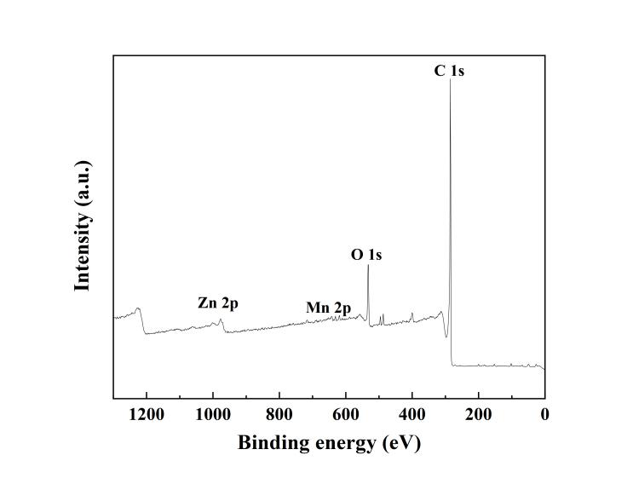
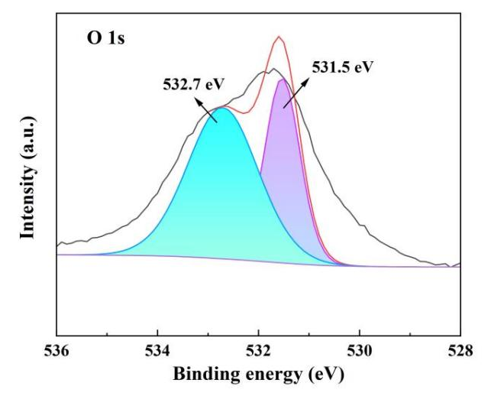
A
B
A

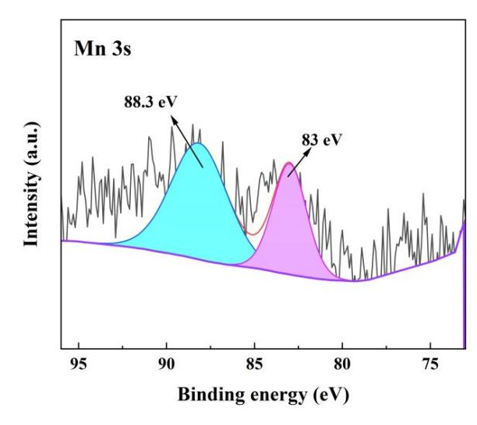
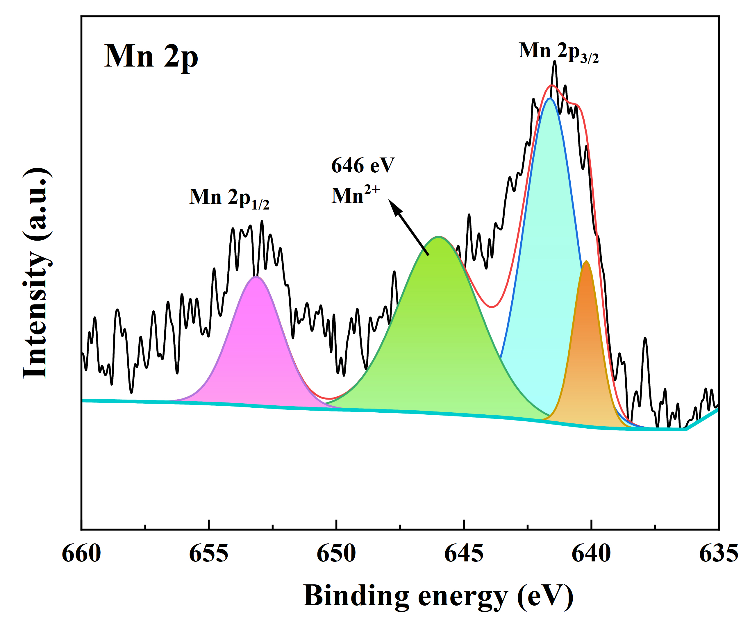
D
C

Figure S1. (A) XPS survey spectrum for PDA@Mn-ZIF-8 NPs; (B) O 1s XPS spectra for PDA@Mn-ZIF-8 NPs; (C) Mn 2p XPS spectrum for PDA@Mn-ZIF-8NPs; and (D) Mn 3s XPS spectrum of PDA@Mn-ZIF-8NPs.

B
A
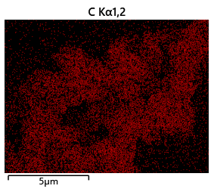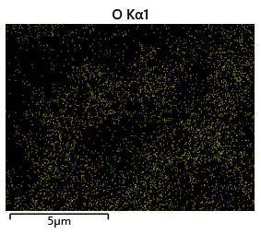
D
C
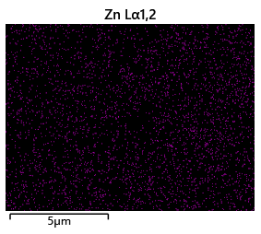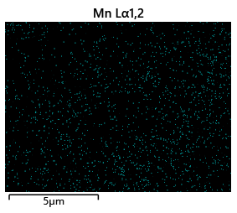
Figure S2. EDS spectrum for multiple PDA@Mn-ZIF-8 nanozyme.

Figure S3. SEM image of PDA@Mn-ZIF-8 NPs.

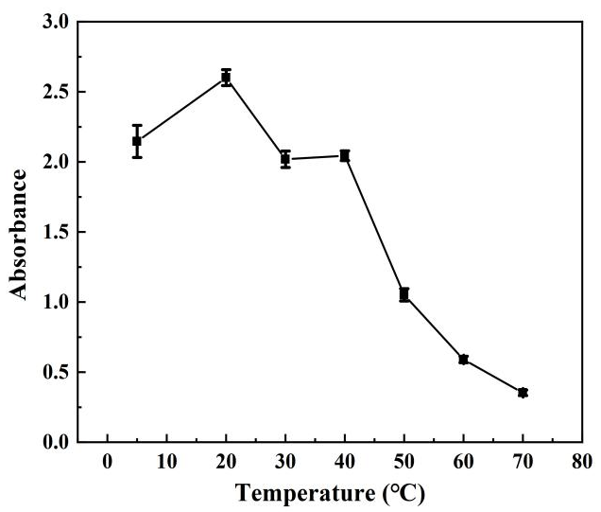
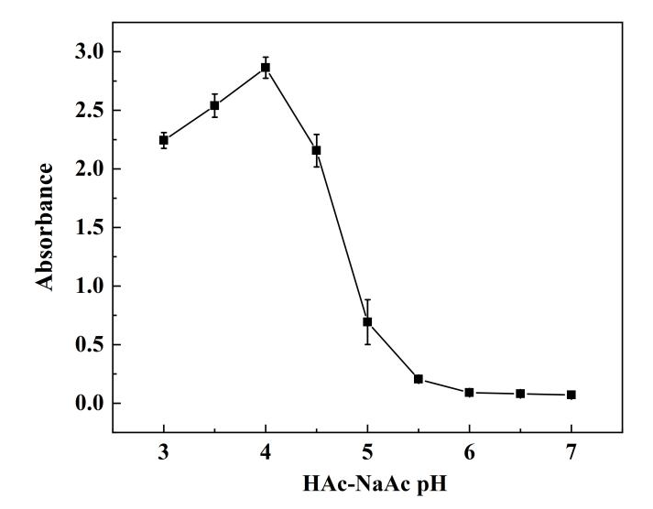
B
A

Figure S4. (A) Effect of pH on the oxidation of TMB by PDA@Mn-ZIF-8 NPs, (B) The influence of temperature on the oxidation of TMB by PDA@Mn-ZIF-8 NPs.
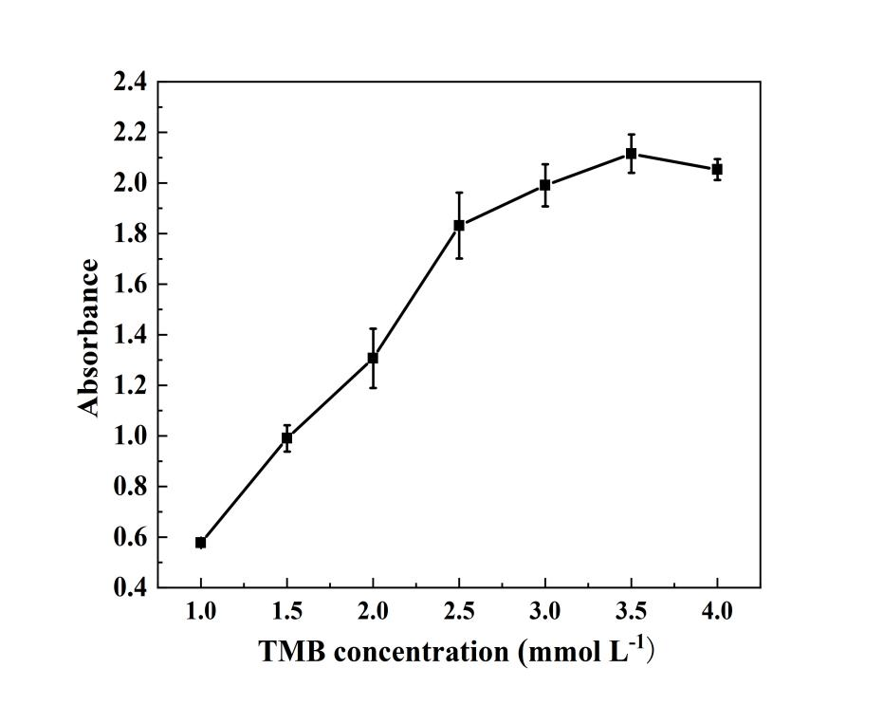
A

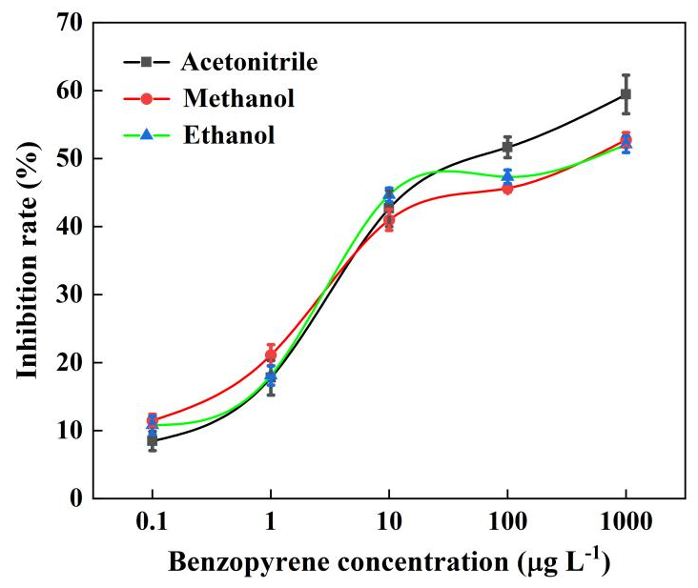

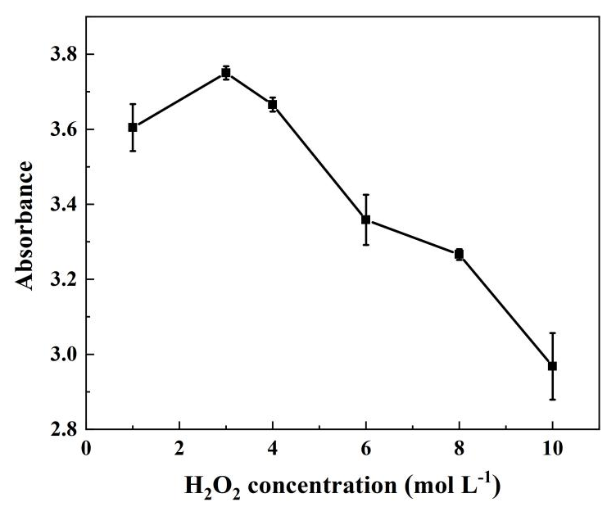
B

C

Figure S5. Effect of substrate concentration and solvent on TMB oxidation by PDA@Mn-ZIF-8 NPs in the presence of H₂O₂. TMB oxidation gave rise to an absorbance maximum at 652 nm: (A) Effect of the TMB concentration, (B) Effect of H₂O₂ concentration, and (C) Effect of the standard solution solvent on the inhibition rate of benzopyrene.

Table S1. Recoveries of Benzopyrene in liquor sample.
Sample | Benzopyrene content in sample  (μg L⁻¹) | Spiked level (μg L⁻¹) | Found level (μg L⁻¹) | Recovery  (± RSD, %)
Chicken | 0 | 1.00 | 0.95 | 94.94±2.52
Chicken | 0 | 50.00 | 44.56 | 89.12±4.58
Chicken | 0 | 100.00 | 105.54 | 105.26±1.05
Pork | 0 | 1.00 | 0.93 | 93.16±2.83
Pork | 0 | 50.00 | 53.11 | 112.31±5.58
Pork | 0 | 100.00 | 92.83 | 92.83±3.19

Table S2. Comparison of the BELISA method and HPLC method for the detection of benzopyrene in different foods.
Sample | Analyte | Found level by HPLC  (µg kg⁻¹, ± SD) | Found level by BELISA  (µg kg⁻¹, ± SD)
Sausages | Benzopyrene | 0.83±0.06a | 0.80±0.02a
Grilled lamb | Benzopyrene | 1.07±0.16a | 0.98±0.05a

Table S3. Comparison of the BELISA method with other methods for benzopyrene detection. detection.
detection
Method | Analyte | LOD (µg L⁻¹) | Reference
SERS | Benzopyrene | 20.00 | Fu et al. 2015
Fluorescence | Benzopyrene | 0.36 | Nahornia et al. 2006
Electrochemical | Benzopyrene | 2.80 | Ni et al. 2014
HPLC | Benzopyrene | 0.005 | Kato et al. 2003
BELISA | Benzopyrene | 0.52 | This work

