Supplementary Figures

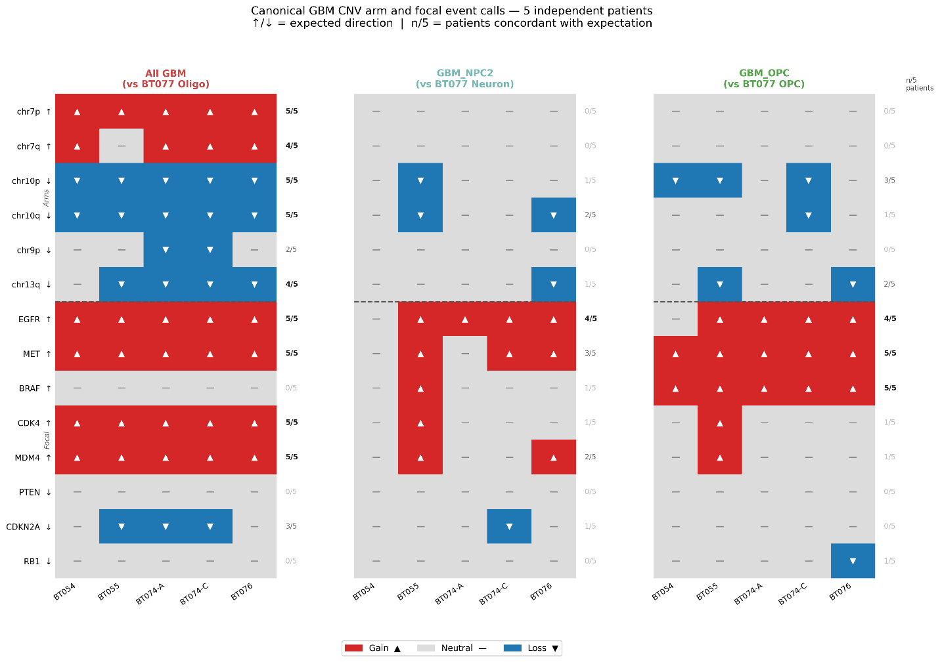
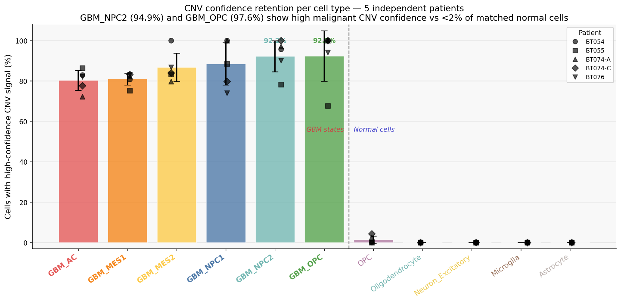
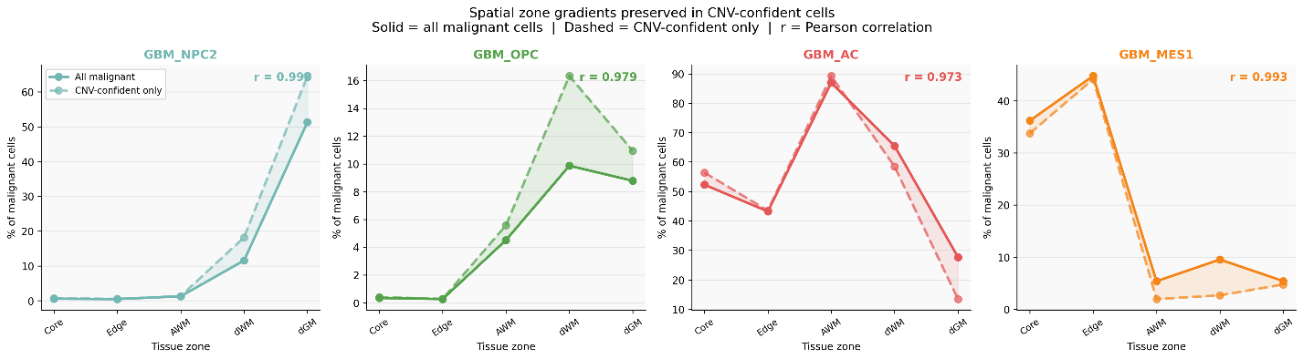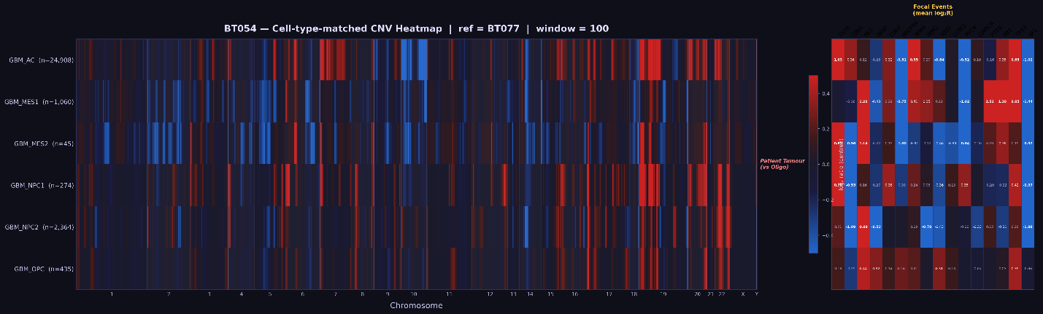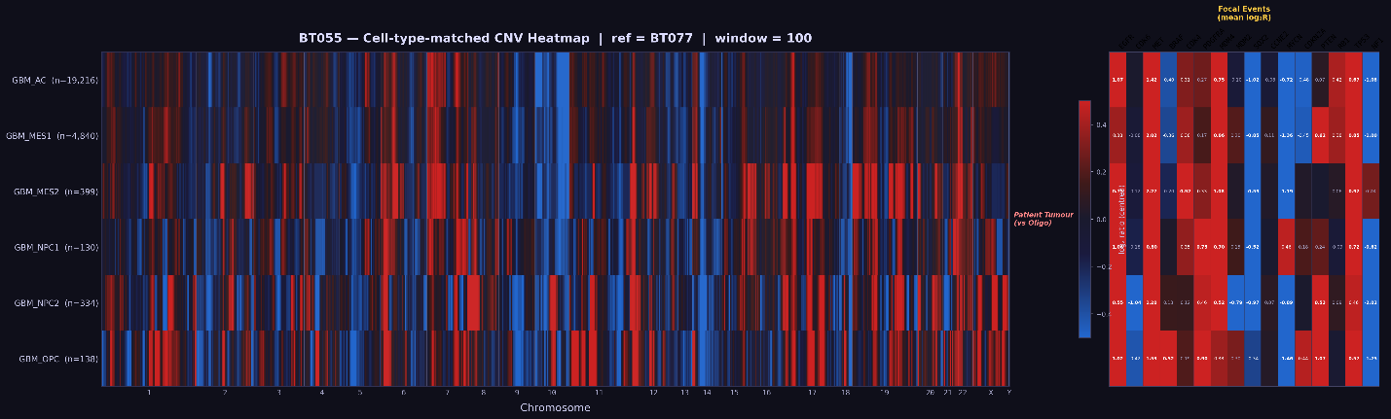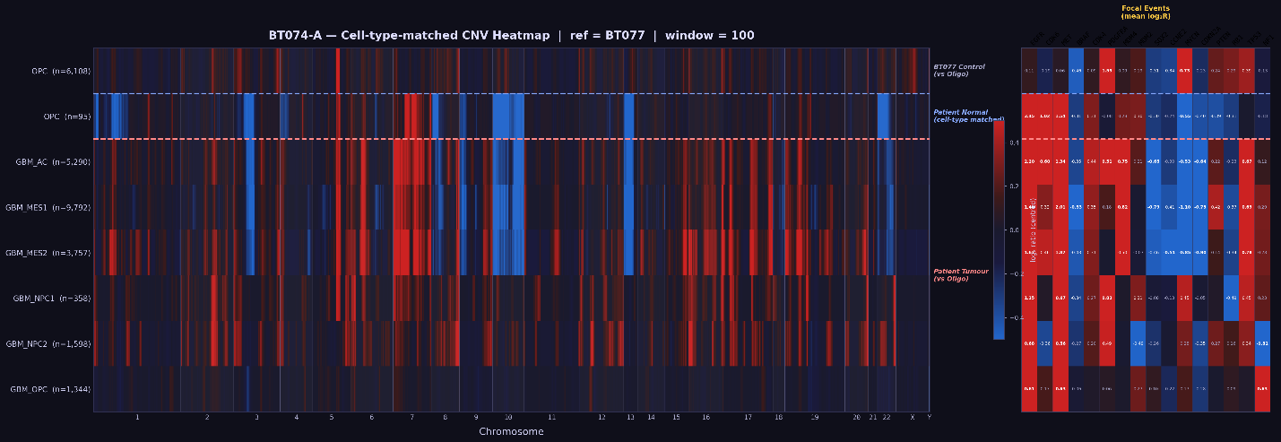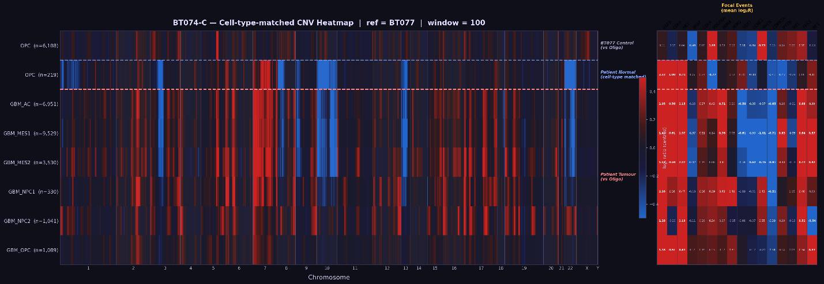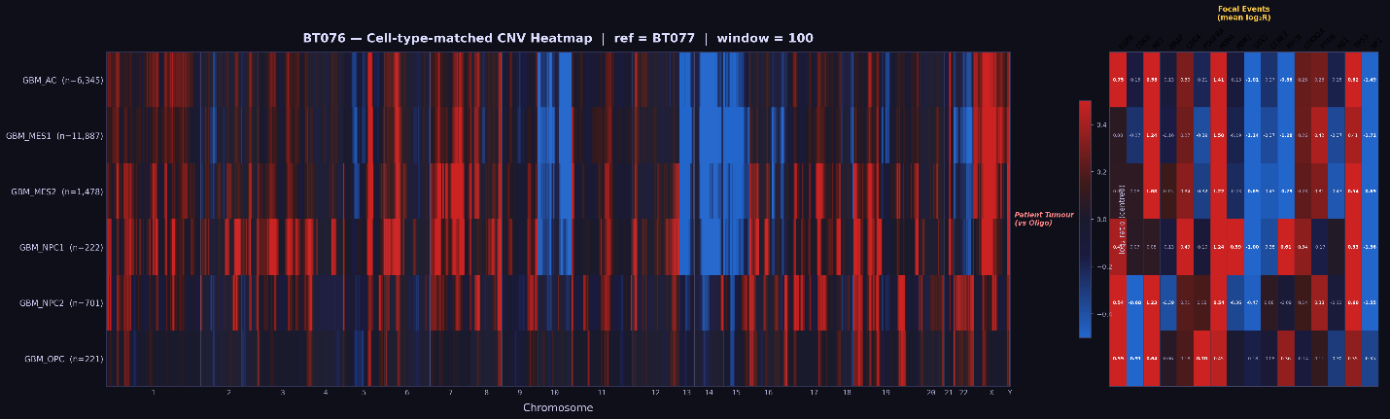
Supplementary Figure 1. CNV malignancy validation.
Three-panel summary of the patient-level pseudo-bulk CNV analysis used to validate malignancy across the five GB patients (BT054, BT055, BT074-A, BT074-C, BT076). For each patient, raw counts were aggregated across malignant cells and across cell-type-matched BT077 reference cells, normalized to counts per million, and the log2(tumour/reference) ratio was computed per gene and smoothed across chromosomal position (rolling median, window = 100 genes; |Z| > 2 vs the BT077 reference distribution called as significant). The analysis confirmed hallmark glioblastoma alterations, chromosome 7 gain and chromosome 10 loss in 4 of 5 patients, with concordant focal EGFR amplification calls, across cell-type-matched reference panels (AC-like vs. oligodendrocyte; MES1/MES2-like vs. oligodendrocyte; NPC-like vs. neuron; OPC-like vs. OPC). The complementary per-cell CNV calls produced by `cnv_group_flex` v3.6 (Supplementary Figure 18; Methods) are concordant with the patient-level signal at the lineage level.

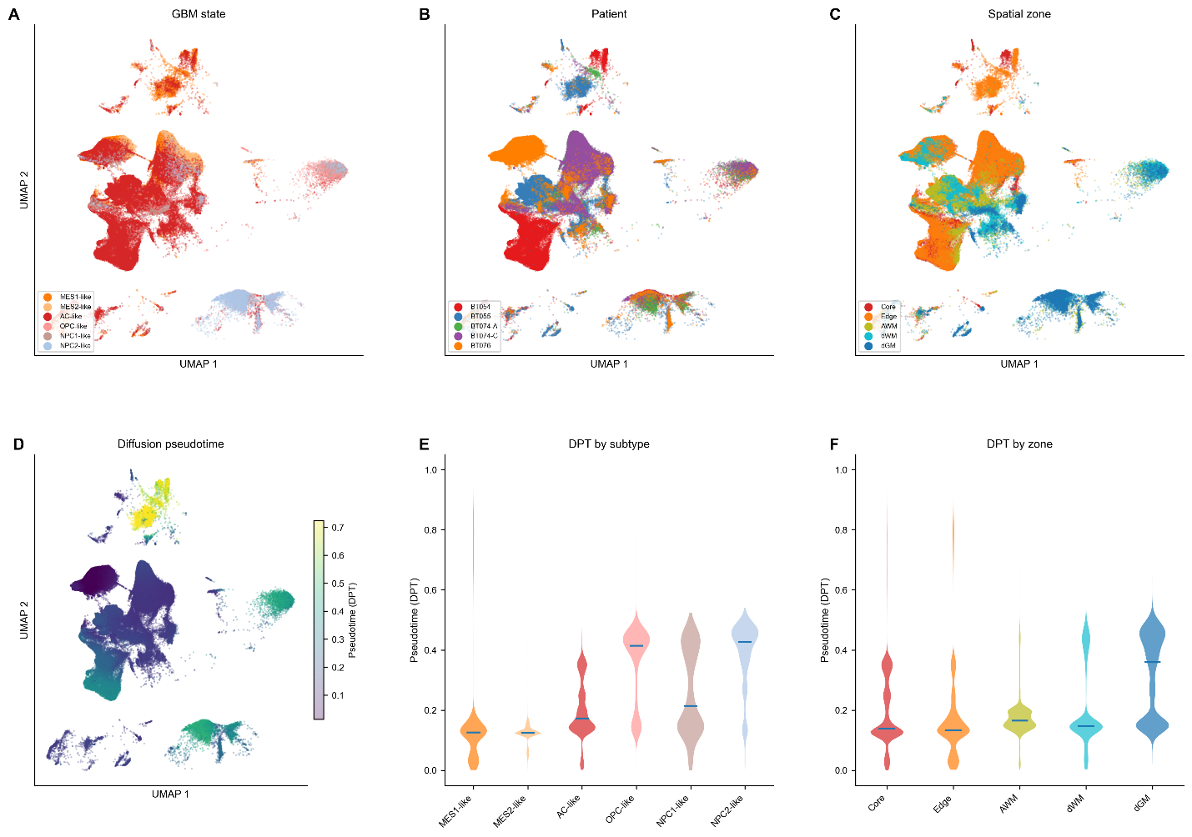
Supplementary Figure 2. GB malignant cell UMAP coloured by state, patient, and spatial zone.
Three-panel UMAP restricted to malignant cells (n = 144,089). Left: Neftel et al. (2019) malignant state annotation (AC-like, MES1-like, MES2-like, NPC1-like, NPC2-like, OPC-like, Unassigned). Centre: patient of origin (BT054, BT055, BT074-A, BT074-C, BT076). Right: spatial zone of origin (Core, Edge, AWM, dWM, dGM).

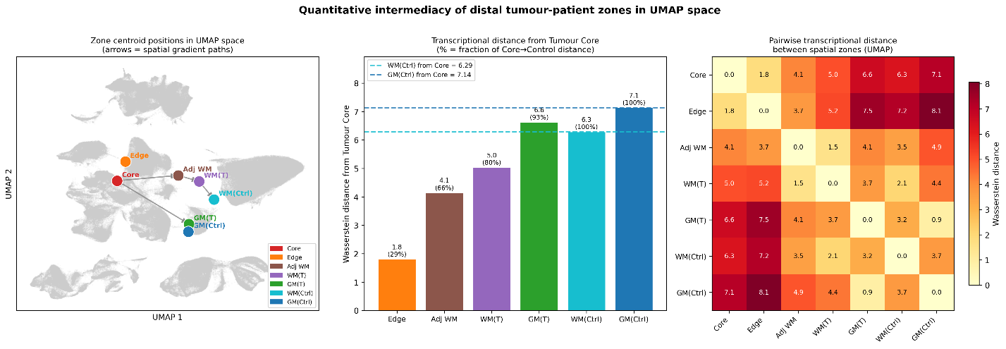
Supplementary Figure 3. Wasserstein distance analysis of transcriptional intermediacy across spatial zones.
A) Wasserstein distance (earth mover's distance) from the tumour core UMAP distribution to each of the remaining 6 spatial zones . B) Distances computed from 2D UMAP coordinates shown as a barplot, with 5,000 cells subsampled per zone per iteration; values averaged across 10 subsampling runs. Dashed reference lines indicate the Core-to-control distance for WM(Ctrl) and GM(Ctrl). Bars annotated with percentage of the Core-to-matched-control distance: dWM 80%, dGM 92.8%. C) A heatmap of pairwise Wasserstein transcriptional distances show both OID compartments retain a measurable residual transcriptional distance from matched non-oncological control tissue (dWM residual 2.07 UMAP distance units; dGM 0.89 units). Together, these distances quantify a progressive but incomplete normalisation of the malignant transcriptome along the OID, with even the most distal compartments (dWM, dGM) retaining a measurable residual divergence from matched non-oncological control tissue.

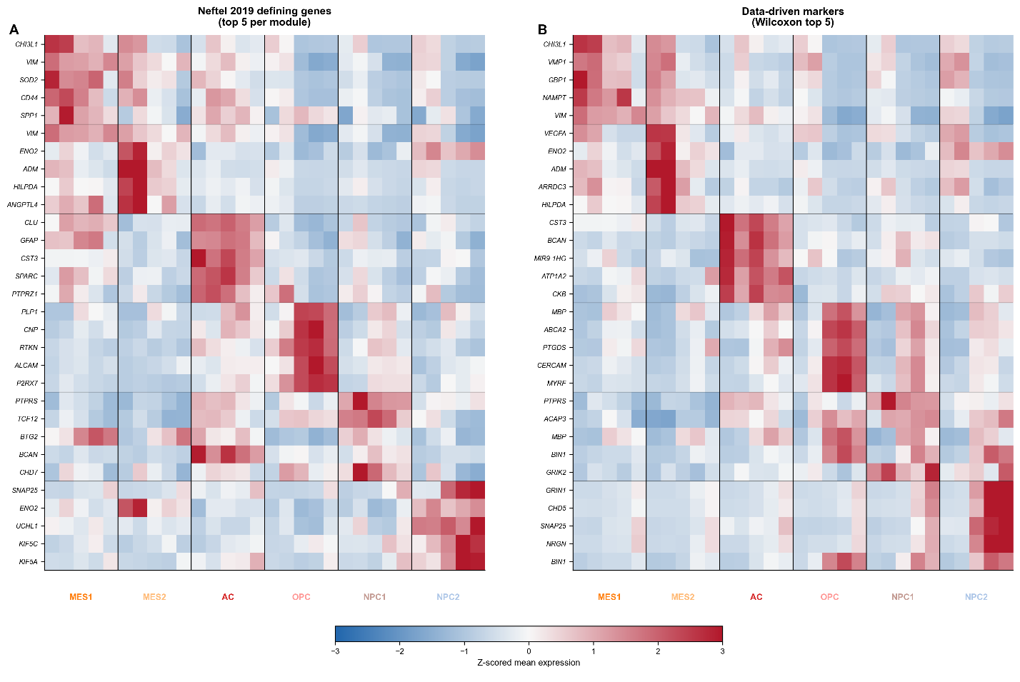
Supplementary Figure 4. Comparison of Neftel 2019 defining genes and data-driven marker genes across spatial zones.
(A) the top 5 Neftel et al. (2019) module genes per subtype (ranked by mean expression within the defining subtype) and (B) the top 5 data-driven marker genes per subtype (Wilcoxon rank-sum, each subtype vs all other malignant cells). Both heatmaps show mean log-normalised expression per subtype per zone, z-scored per gene (row), clipped at +/-3. The block-diagonal pattern (subtype-specific enrichment) and spatial gradients (MES markers declining distally, NPC2/OPC markers increasing distally) are concordant across both gene sets, confirming that spatial transcriptional variation is robust to gene set choice. Gene overlap between Neftel and data-driven top 5: MES2 3/5 shared (ENO2, ADM, HILPDA); MES1 2/5 (CHI3L1, VIM); AC 1/5 (CST3); NPC2 1/5 (SNAP25); OPC 0/5. n = 144,089 malignant cells.

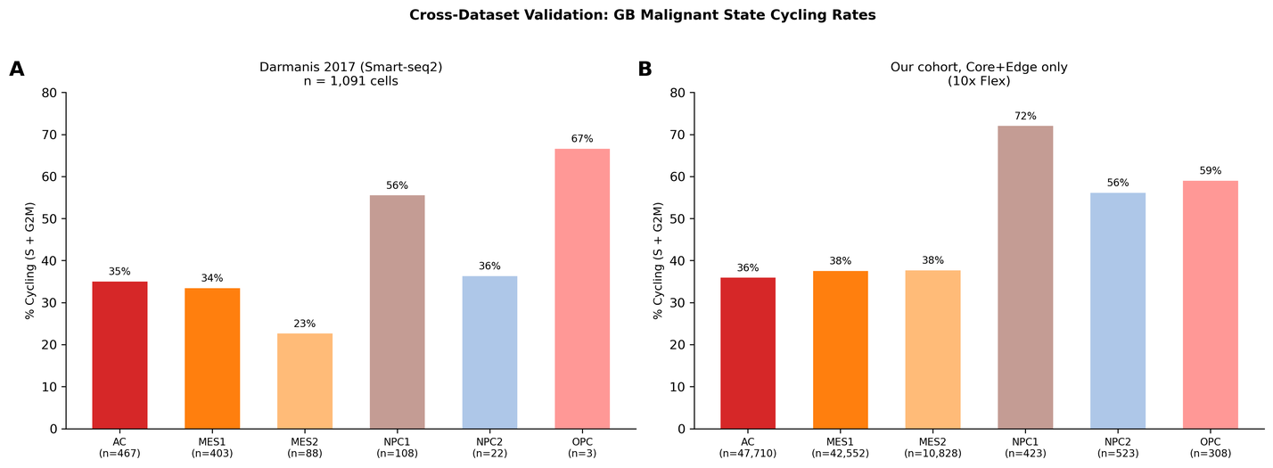
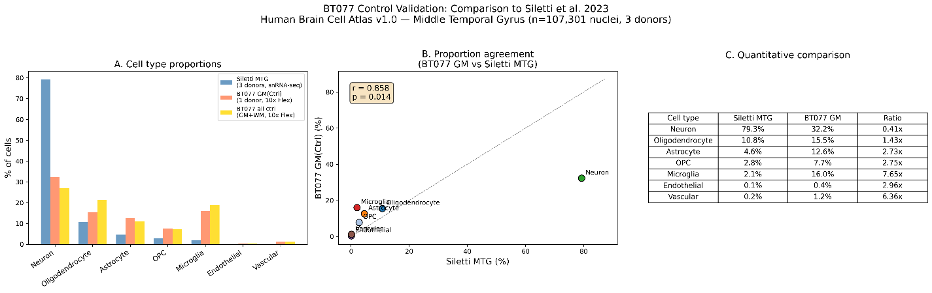
Supplementary Figure 5. External validation.
(A) GB cycling comparison: Darmanis et al. 2017 (Smart-seq2, n = 1,091 cells) vs current cohort (10x Flex, n = 144,089). Cycling fractions compared at Core + Edge only (fair comparison: Darmanis tissue was tumour mass). Close concordance for abundant subtypes: AC-like 36.0% vs 35.1% (n = 47,710 vs 467); MES1-like 37.6% vs 33.5% (n = 42,552 vs 403). Greater divergence for rare subtypes reflects limited Darmanis statistical power (NPC2-like n = 22; OPC-like n = 3). (B) Non-oncological control GM(Ctrl) cell type composition vs Siletti et al. 2023 Human Brain Cell Atlas (MTG region, n = 107,301). Pearson r = 0.858, p = 0.014. Neuronal underrepresentation (32.2% vs 79.3%) reflects expected technology bias (nuclei vs cells). Non-neuronal populations preserve relative ordering. (C) Quantitative comparison table.
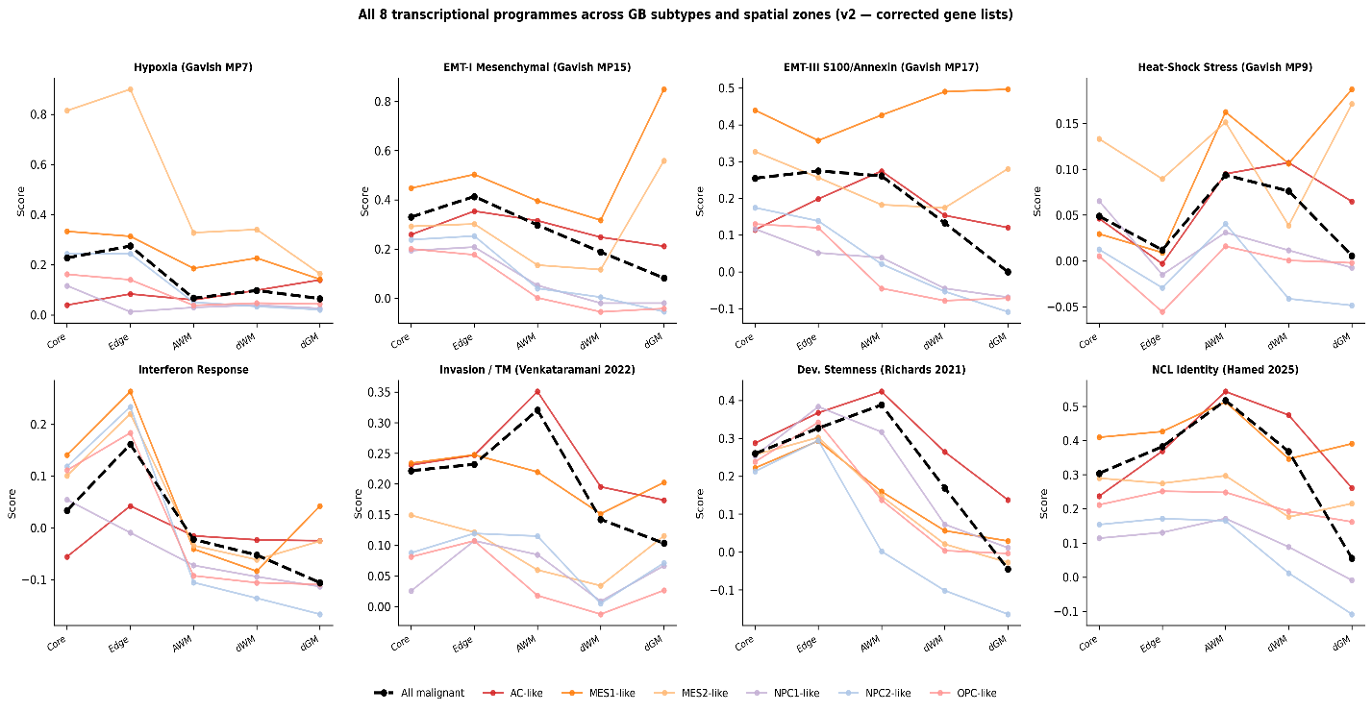
Supplementary Figure 6. Transcriptional program scores across GB malignant subtypes and spatial zones.
Mean program score per subtype per zone for the eight published GB transcriptional programs scored in this study (gene lists in Supplementary Table 14). (A) Hypoxia (MP7; Gavish et al. 2023) - highest in MES2-like cells at the Core (0.829), declining sharply across the OID; in MES2-like cells, score falls from 0.814 at Core to 0.165 in dGM. (B) EMT-I Mesenchymal (MP15) - concentrated in MES1/MES2-like cells at Core and Edge, near baseline distally. (C) EMT-III S100/Annexin (MP17) - co-localises with the EMT-I signature in mesenchymal subtypes at the tumour mass. (D) Heat-Shock Stress (MP9) - broadly distributed across malignant subtypes within tumour-proximal zones, declining distally. (E) Interferon Response - peaks at the tumour edge in MES1-like cells (0.263 at Edge, declining to near-zero across the OID), consistent with an immune-interface signature. (F) Invasion / Tumour Microtube (Venkataramani et al. 2022) - peaks at AWM in AC-like cells (0.351), elevated above Core, identifying the active invasion front. (G) Developmental Stemness (Richards et al. 2021) - peaks at AWM in AC-like cells (0.423), indicating a progenitor-like state at the leading edge. (H) Neural-Crest-Like identity (NCL; Hamed et al. 2025; 12 NCC identity markers, injury-associated genes excluded) - highest in AC-like cells at AWM (0.543), with elevated expression persisting through the OID. The dashed black line in each panel shows the all-malignant mean per zone. Scores computed with sc.tl.score_genes (Scanpy 1.12) using the same expression-stable background; n = 144,089 malignant cells across the five tumour zones. Two additional cell-state-specific programs - neural mimicry (NPC2-like neuronal resemblance) and OPC lineage (OPC-like oligodendroglial resemblance) - are scored on the same cells but shown in the main figures (Fig. 2E, 2F).

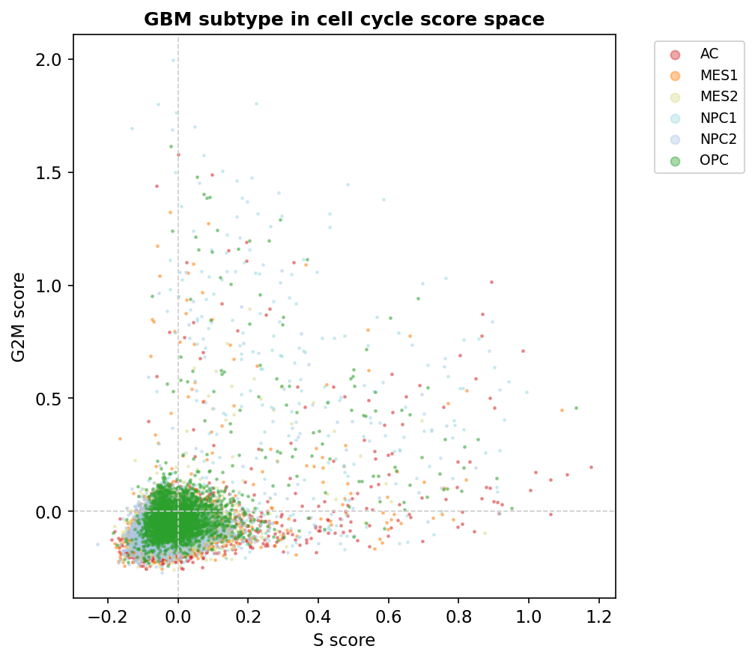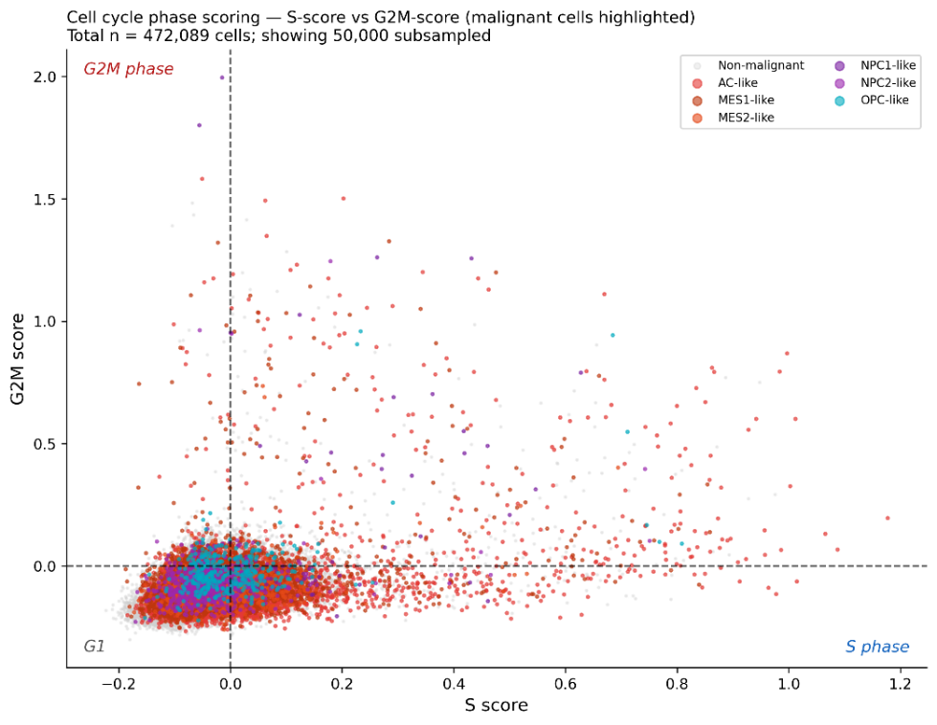
Supplementary Figure 7. Cell cycle phase scoring validation across cell types.
(A) G2M score vs S score scatter for all malignant cells (n = 144,089), with phase assignment based on the Tirosh et al. (2016) S-phase and G2/M gene sets scored via Scanpy sc.tl.score_genes_cell_cycle (cells with G2M > 0 and G2M > S assigned to G2M; cells with S > 0 and S ≥ G2M assigned to S; remaining cells assigned to G1). Threshold cutoffs are shown as dashed lines. (B) S vs G2M score scatter coloured by GB malignant subtype, confirming subtype-specific cycling differences.

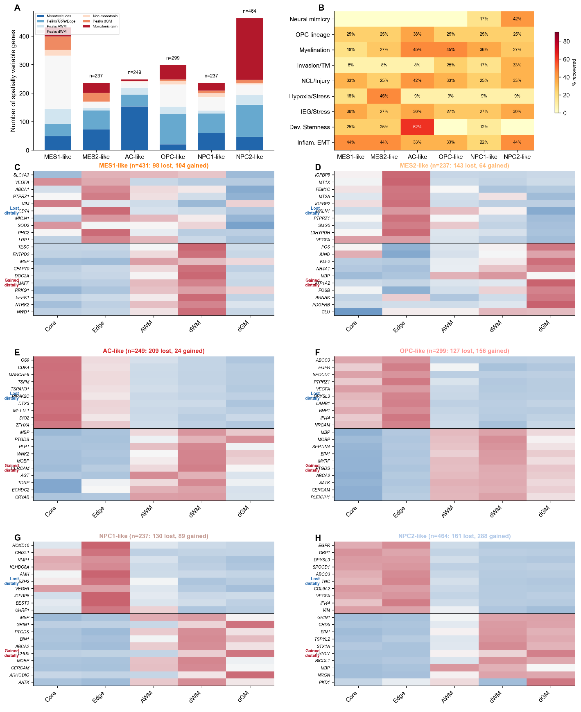
Supplementary Figure 8. Cell type specific transcriptional changes across space for malignant cells.
(A) The number of spatially variable genes per malignant cell (n = 144,089 malignant cells) subtype as a stacked barplot with spatial pattern (Core to distal) as colour (Kruskal-Wallis H test across 5 tumour zones; FDR < 0.05, effect size > 0.7, no contamination filter). The NPC2-like cells have the most gained-distally genes (288) while the AC-like has the most decreased-distally genes (209). (B) A heatmap showing percentage of predefined transcriptional program genes recovered by malignant cell types. We see considerable overlap between NPC2 x Neural Mimicry 42% (5/12); OPC x Myelination 45% (5/11); AC x Dev. Stemness 62% (5/8); MES2 x Hypoxia 45% (5/11). (C–H) Per-subtype heatmaps showing expression z-scores the top 10 genes reduced distally and top 10 genes gained distally for each of the 6 malignant subtypes (AC-like, MES1-like, MES2-like, NPC1-like, NPC2-like, OPC-like). Genes ranked by Kruskal-Wallis H statistic; raw mean expression values annotated where ≥ 0.3. NPC2-like gained genes include neuronal identity markers (GRIN1, CHD5, SNAP25, NRGN), while OPC-like gained genes include oligodendrocyte lineage markers (MBP, MOBP, MYRF, PLP1) and MES1/MES2 lost genes include hypoxia/stress markers (VEGFA, IGFBP2).

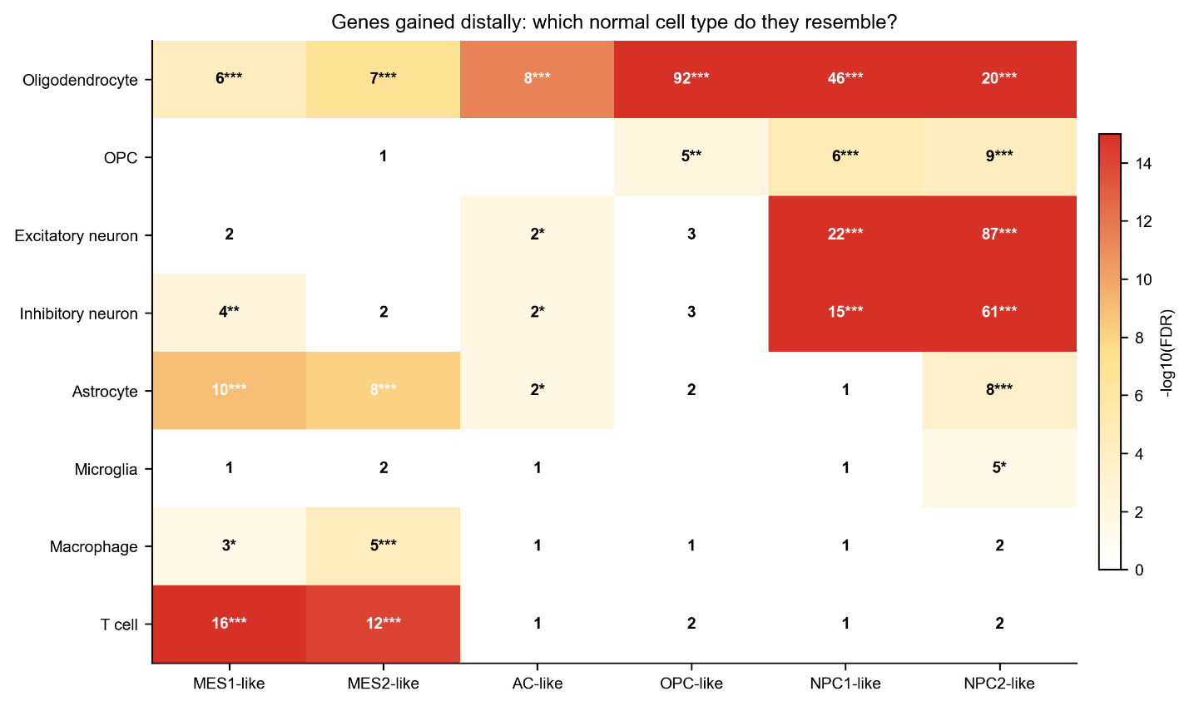
Supplementary Figure 9. Agnostic cell type identity test: spatially gained genes overlap with normal cell type markers.
Heatmap showing -log10(FDR) from Fisher's exact test comparing each malignant subtype's gained-distally genes against independently derived normal cell type markers (top 100 markers per type, Wilcoxon rank-sum on 328,000 non-malignant cells; logFC > 0.5, FDR < 0.01). Numbers indicate gene overlap; asterisks indicate significance (* FDR < 0.05, ** FDR < 0.01, *** FDR < 0.001). Key results: OPC-like gained-distally genes overlap with 92/100 oligodendrocyte markers (FDR = 2.0 x 10^-193); NPC2-like gained-distally genes overlap with 87/100 excitatory neuron markers (FDR = 1.0 x 10^-146) and 61/100 inhibitory neuron markers (FDR = 5.1 x 10^-85). Both gene lists are independently data-derived. No curated gene lists used.

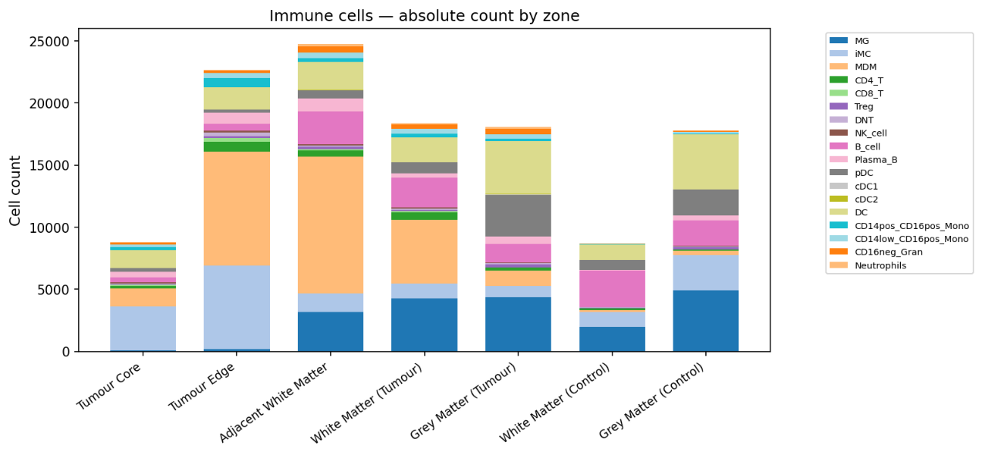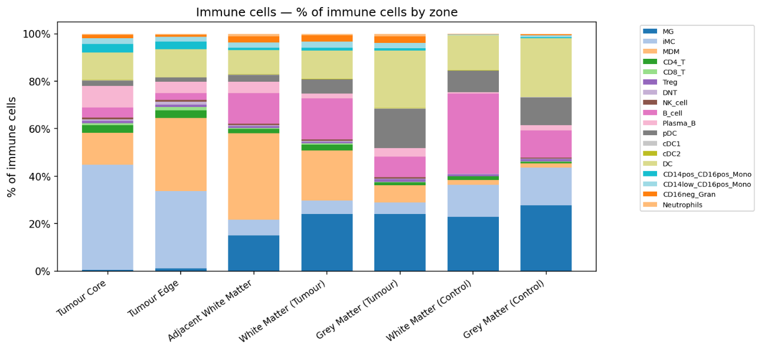
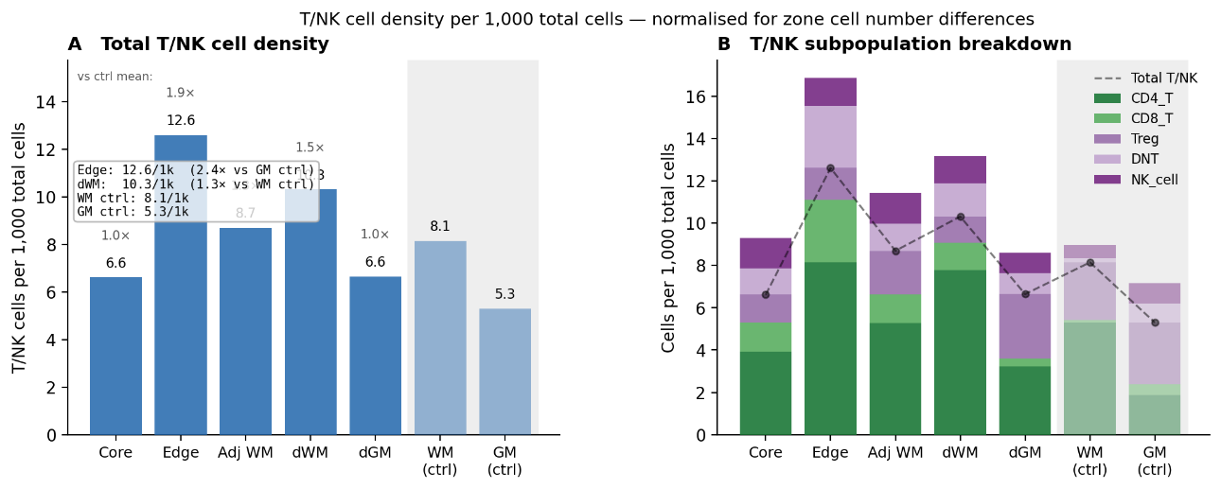
Supplementary Figure 10. Immune deepdive: absolute and relative immune populations by zone.
(A) Absolute immune cell counts per zone for all 18 immune subpopulations (cells per 1,000 total cells). (B) Relative immune composition (% of CD45+ cells) per zone. (C) T cell density heatmap (T cells per 1,000 total cells) per zone and per subpopulation. Cluster-modal assignment. n = 119,164 immune cells.

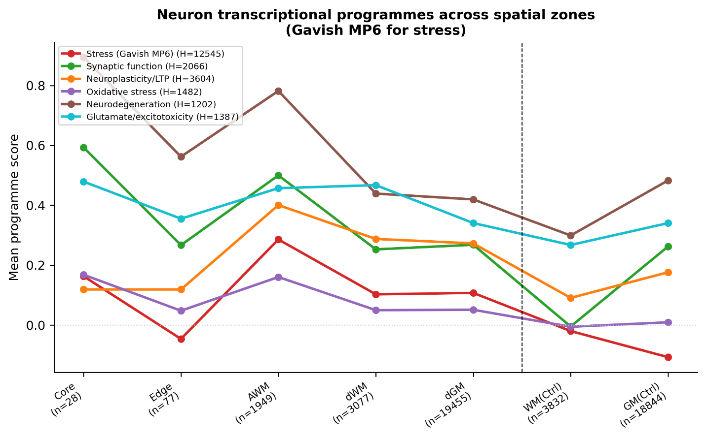
Supplementary Figure 11. Neuron transcriptional program scores across spatial zones.
Line plots showing score distributions for six transcriptional programs across the seven spatial zones. Diamonds indicate zone mean; n per zone shown beneath the x-axis. The dashed vertical line separates GB-patient zones from non-oncological control zones. The MP6 stress/injury program (Gavish et al. 2023 Stress 1 meta-program; 49 genes from the 3CA Supplementary Table; KW H = 12,817) is elevated in all five GB-patient zones relative to pooled non-oncological control (Mann-Whitney U with Benjamini-Hochberg FDR; AWM, dWM and dGM all FDR < 2.2 × 10⁻³⁰⁸), and remains elevated in macroscopically normal-appearing dGM and dWM. The five additional neuron programs - synaptic function, neuroplasticity/LTP, oxidative stress, neurodegeneration, and glutamate/excitotoxicity (gene lists in Methods and Supplementary Table 14) - are shown alongside MP6 to contextualise the stress signature within the broader neuronal transcriptional state. n = 47,262 neurons.

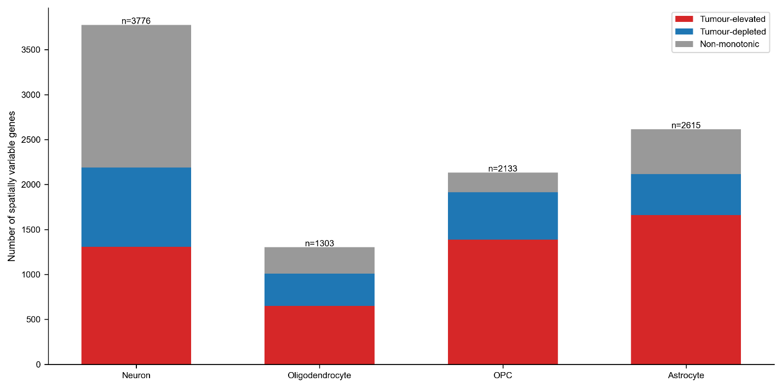
Supplementary Figure 12. Spatially variable genes in non-malignant cell types across the tumour-to-control axis.
Stacked bar chart showing the number of spatially variable genes per non-malignant cell type (Kruskal-Wallis H test across 5 tumour-patient zones; FDR < 0.05, effect size > 0.3, minimum 3% expression, tumour patients only). Genes classified by direction: tumour-elevated (red; higher expression in tumour-proximal zones), tumour-depleted (blue; higher expression in distal/control-adjacent zones), or non-monotonic (grey; no consistent spatial trend). Neurons had the most spatially variable genes (3,776), followed by astrocytes (2,615), OPCs (2,133), and oligodendrocytes (1,303). The majority of astrocyte spatially variable genes were tumour-elevated (1,659/2,615; 63.4%), consistent with pervasive reactive state induction. OPCs showed a similar tumour-elevated bias (1,389/2,133; 65.1%). Neurons had the largest non-monotonic fraction (1,589/3,776; 42.1%), reflecting complex zone-dependent transcriptional programs including concurrent stress induction and synaptic preservation. n = 328,000 non-malignant cells across 5 tumour patients.
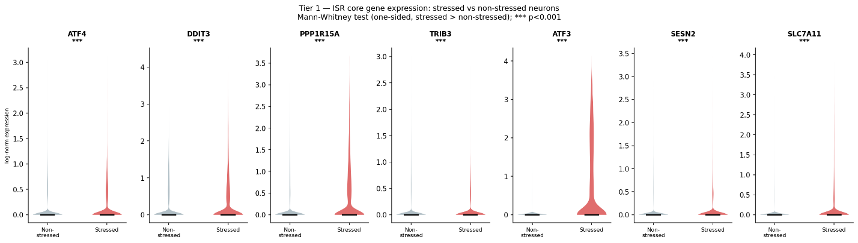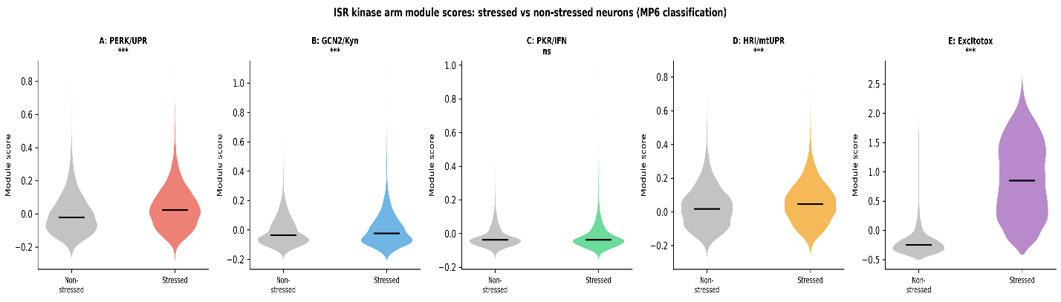
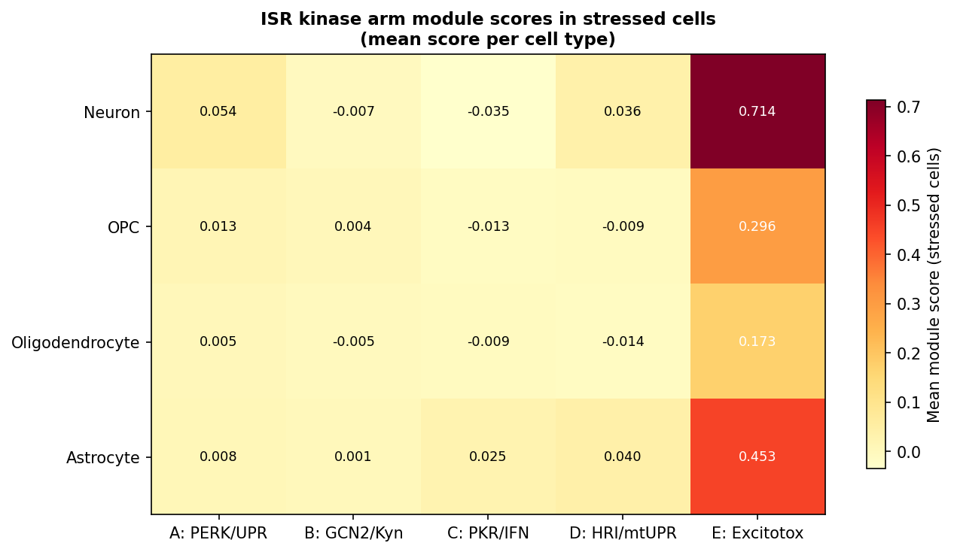
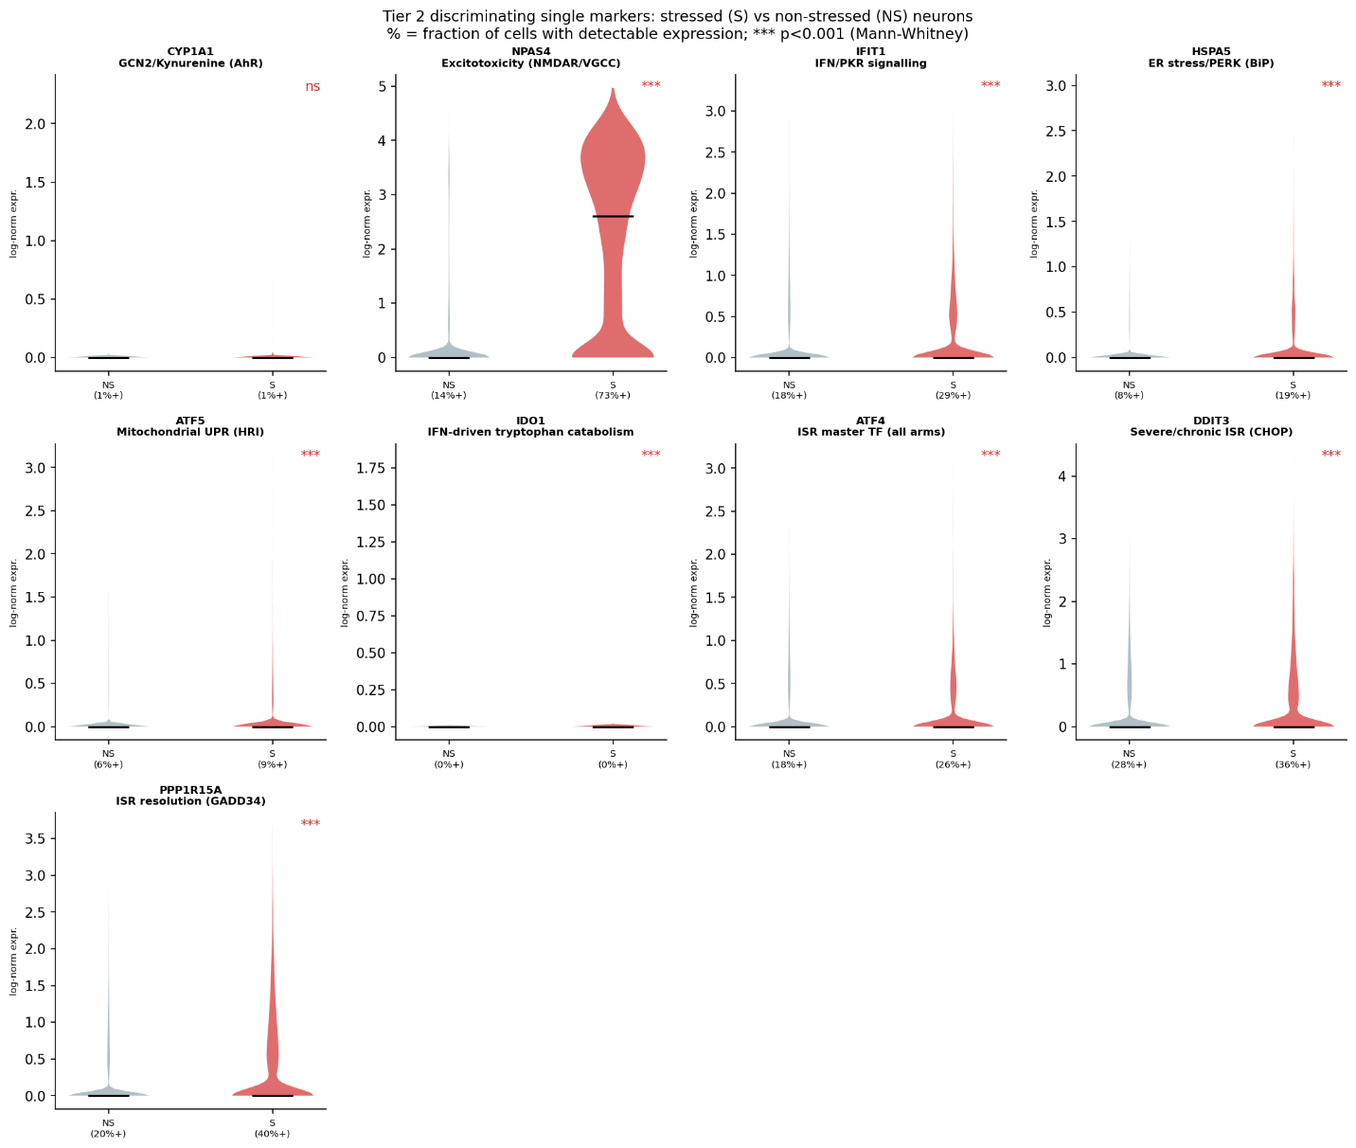
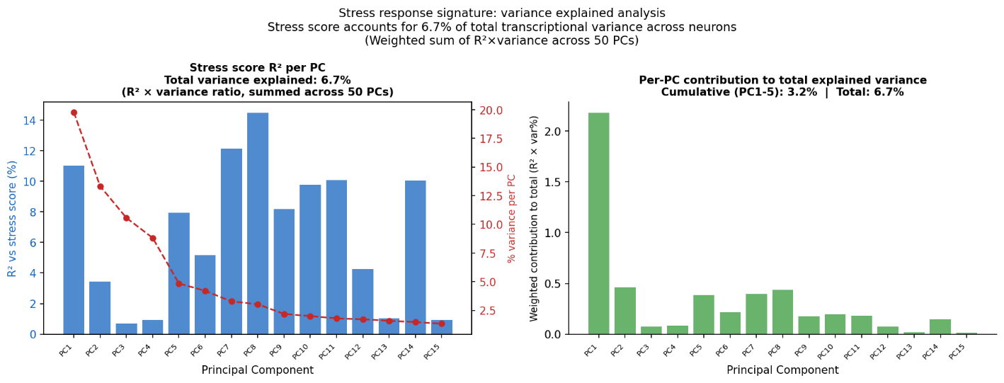
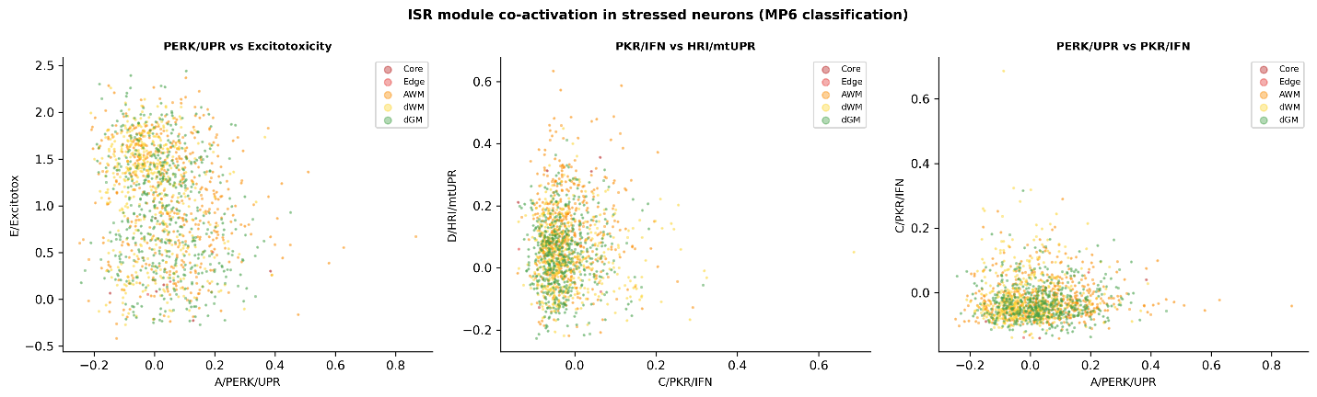
Supplementary Figure 13. ISR kinase arm module dissection in stressed neurons.
Multi-panel dissection of integrated stress response (ISR) module activation in MP6-stressed neurons (n = 8,401). (A) Expression of ISR core genes (ATF4, CHOP/DDIT3, GADD34/PPP1R15A, TRIB3) across stressed vs non-stressed neurons. (B) Kinase arm module scores (PERK/UPR, GCN2/kynurenine, PKR/interferon, HRI/mitochondrial UPR) in stressed vs non-stressed neurons (violin plots). (C) Mean kinase arm module scores in stressed cells across all four profiled cell types (neurons, OPCs, oligodendrocytes, astrocytes) × 5 ISR modules (heatmap). Excitotoxicity/IEG dominates in every cell type but is highest in neurons (0.714); PKR/IFN remains near baseline in all four. (D) Per-arm discriminating single markers. (E) Stress variance-explained decomposition across kinase arms. (F) Module co-activation patterns. The CHOP:GADD34 ratio in stressed neurons indicates an active resolution phase rather than chronic terminal stress. Gene-list compositions for all five ISR modules are given in Methods and Supplementary Table 14.

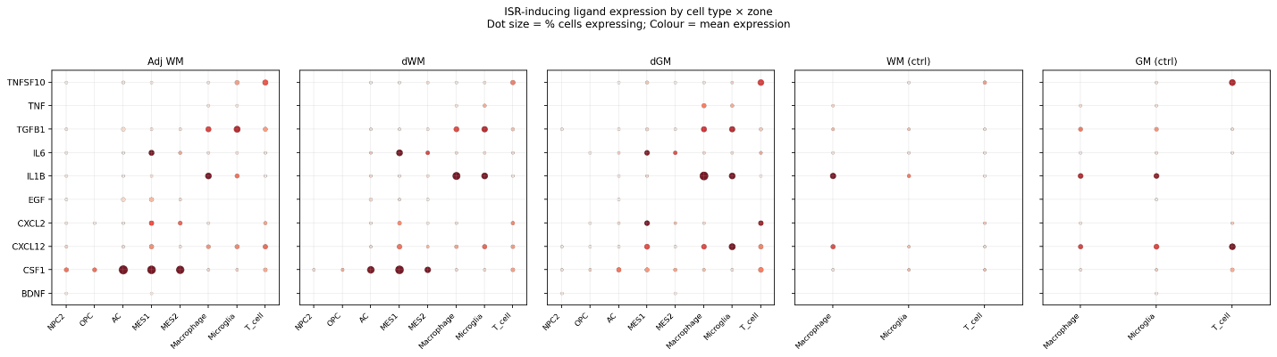
Supplementary Figure 14. Candidate ISR-activating ligands in the GB tumour microenvironment.
Dot plot showing mean log-normalized expression of candidate inflammatory and ISR-activating ligands (TNFSF10, TNF, TGFB1, IL6, IL1B, EGF, CXCL2, CXCL12, CSF1, BDNF) across cell types and spatial zones. Dot size = percentage of cells expressing the gene (detection rate); dot colour = mean log-normalized expression. Tumour-associated macrophages (MDM) and AC-like tumour cells are the principal expressing populations in Core and Edge zones, with expression declining across the spatial axis. These ligands are established activators of ISR kinase arms: TGFB1 activates PKR via type I IFN signalling; CXCL12 contributes to GCN2 pathway activation; the broader inflammatory panel (TNF, IL6, IL1B, CSF1) reflects tumour-associated paracrine signalling concomitant with ISR engagement. MIF and SPP1 (referenced in main text) are addressed in a separate ligand-receptor analysis.

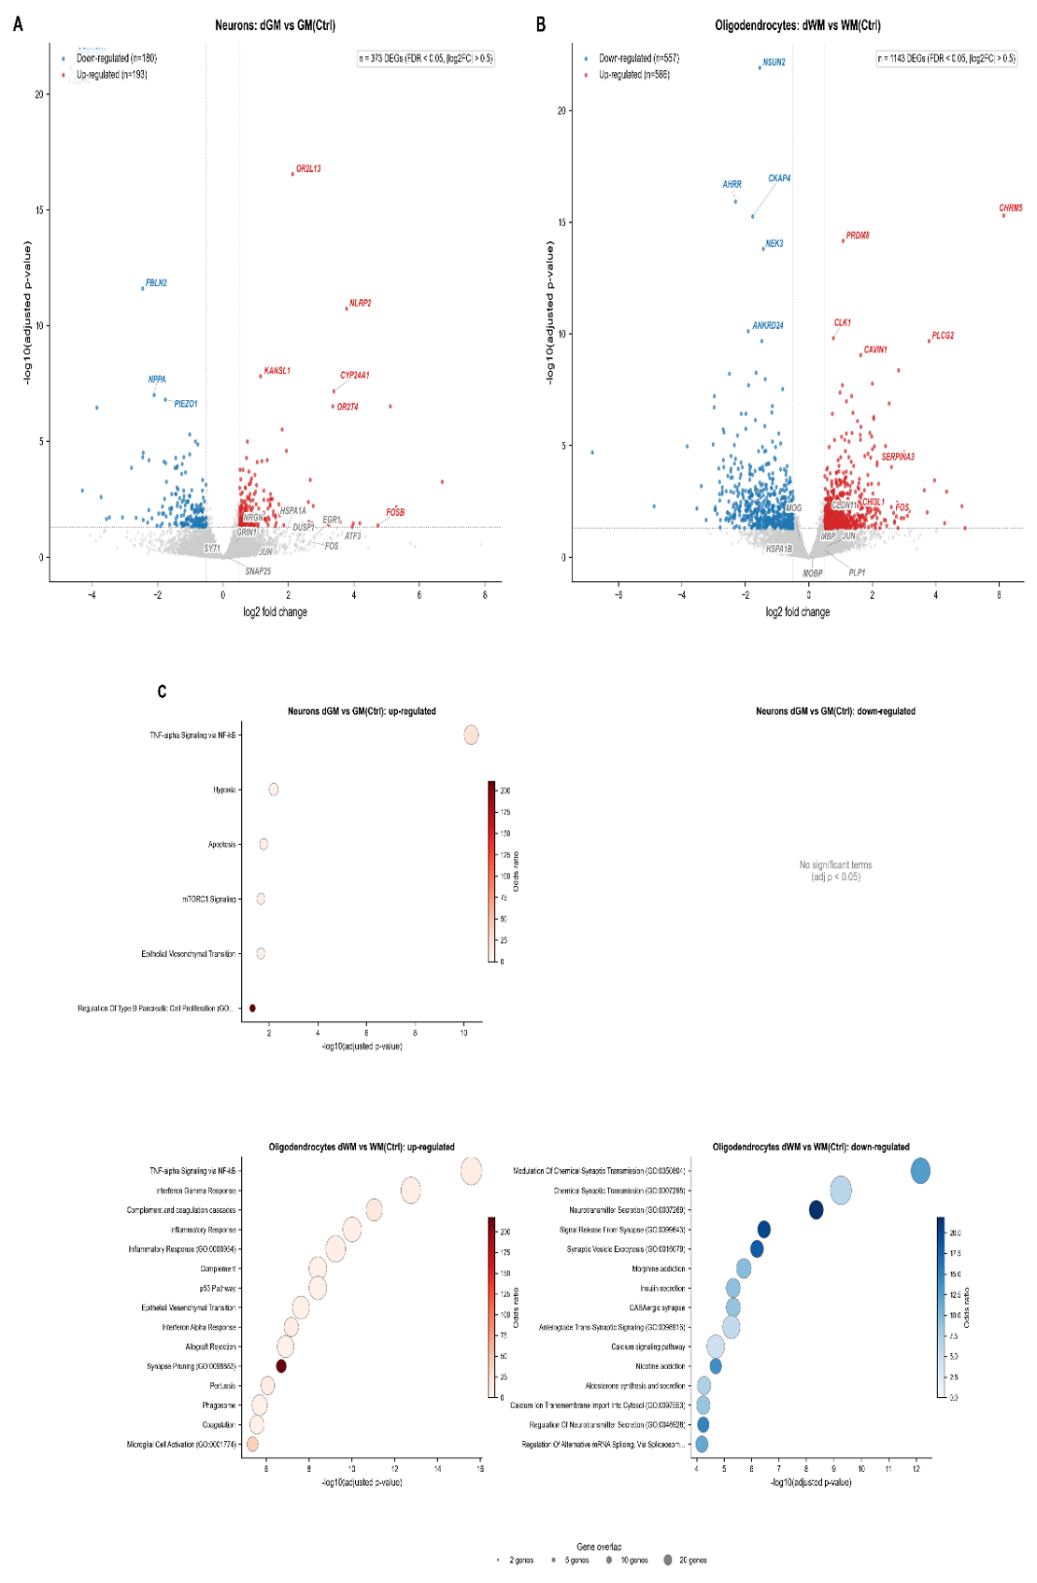
Supplementary Figure 15. Distal zone differential gene expression and pathway enrichment.
(A) Volcano plot: neurons dGM vs GM(Ctrl) (pseudobulk DESeq2), ISR and synaptic markers labelled. (B) Volcano plot: oligodendrocytes dWM vs WM(Ctrl). (C) GSEA pathway enrichment for both DEG sets (MSigDB Hallmark + GO_BP). n = 5 tumour vs 1 control.

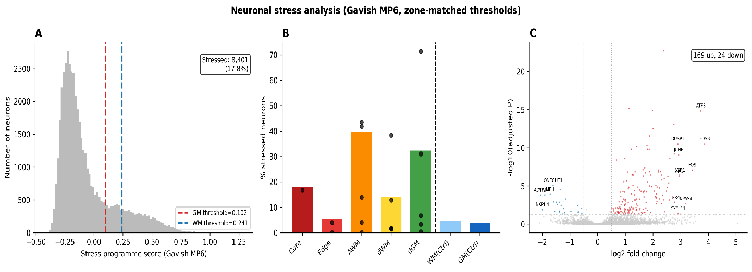
Supplementary Figure 16. Stressed neuron characterisation and DEG analysis.
(A) MP6 stress score distribution across all 47,262 neurons. Neurons were classified as stressed if their MP6 score exceeded a zone-matched threshold defined as the non-oncological control neuron mean + 2 SD, computed separately for white-matter zones (threshold = 0.241) and grey-matter zones (threshold = 0.102) to account for baseline differences in neuronal transcriptional state between tissue compartments. The histogram is coloured by stressed/non-stressed classification under this zone-matched scheme. (B) Percentage of stressed neurons per patient per zone; individual patient lines coloured, cohort mean overlaid in black. (C) Volcano plot of 169 upregulated and 24 downregulated genes (pseudobulk DESeq2; FDR < 0.05, |log2FC| > 0.5) comparing stressed versus non-stressed neurons across the five tumour patients. Top hits labelled. (D) Stressed-neuron counts per patient broken down by zone. n = 8,401 stressed / 38,861 non-stressed (17.8% of all neurons).

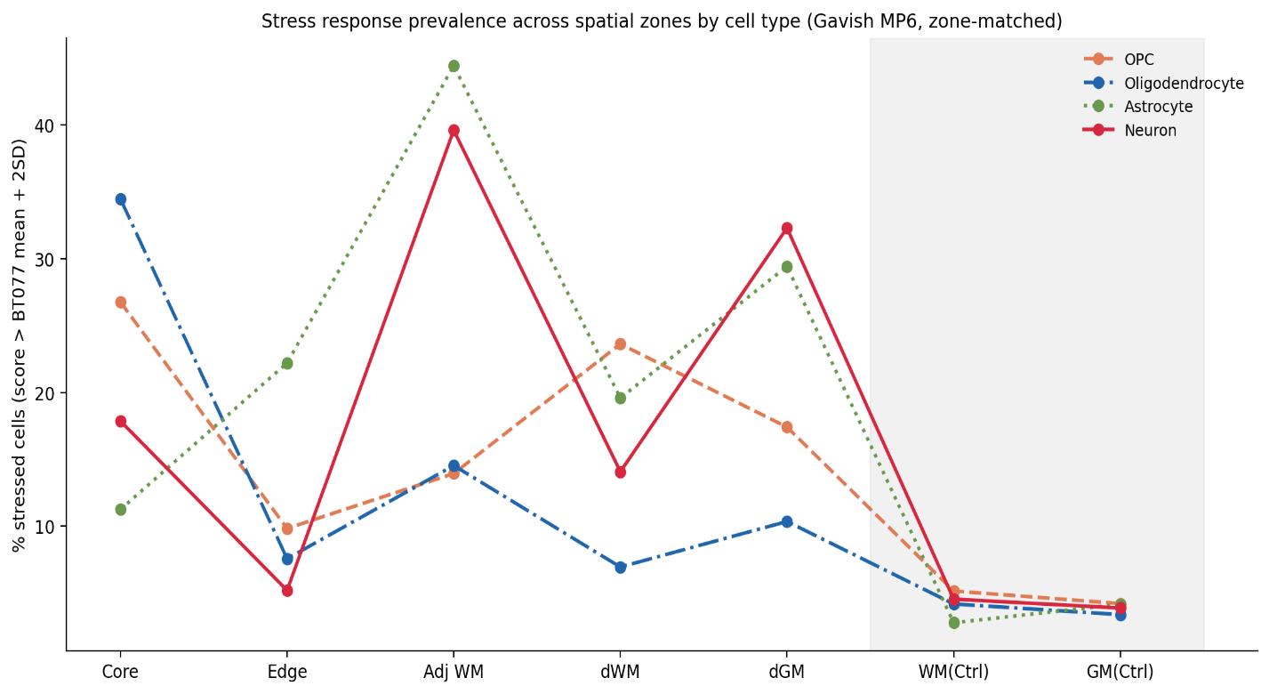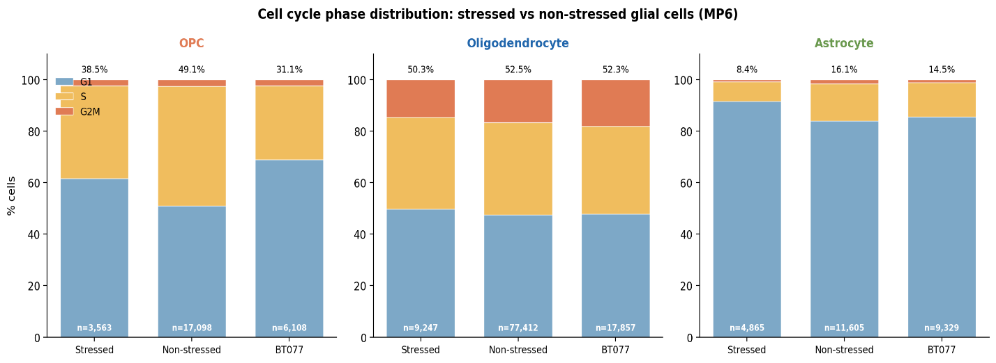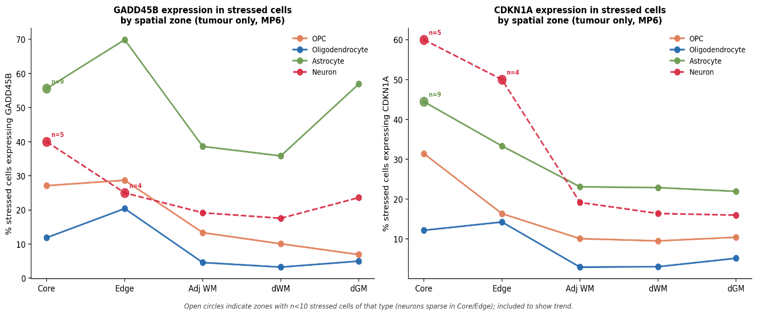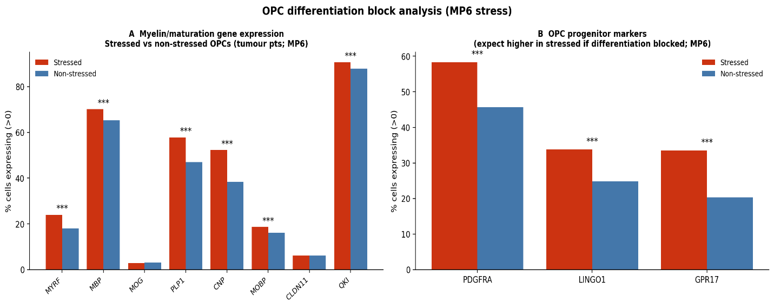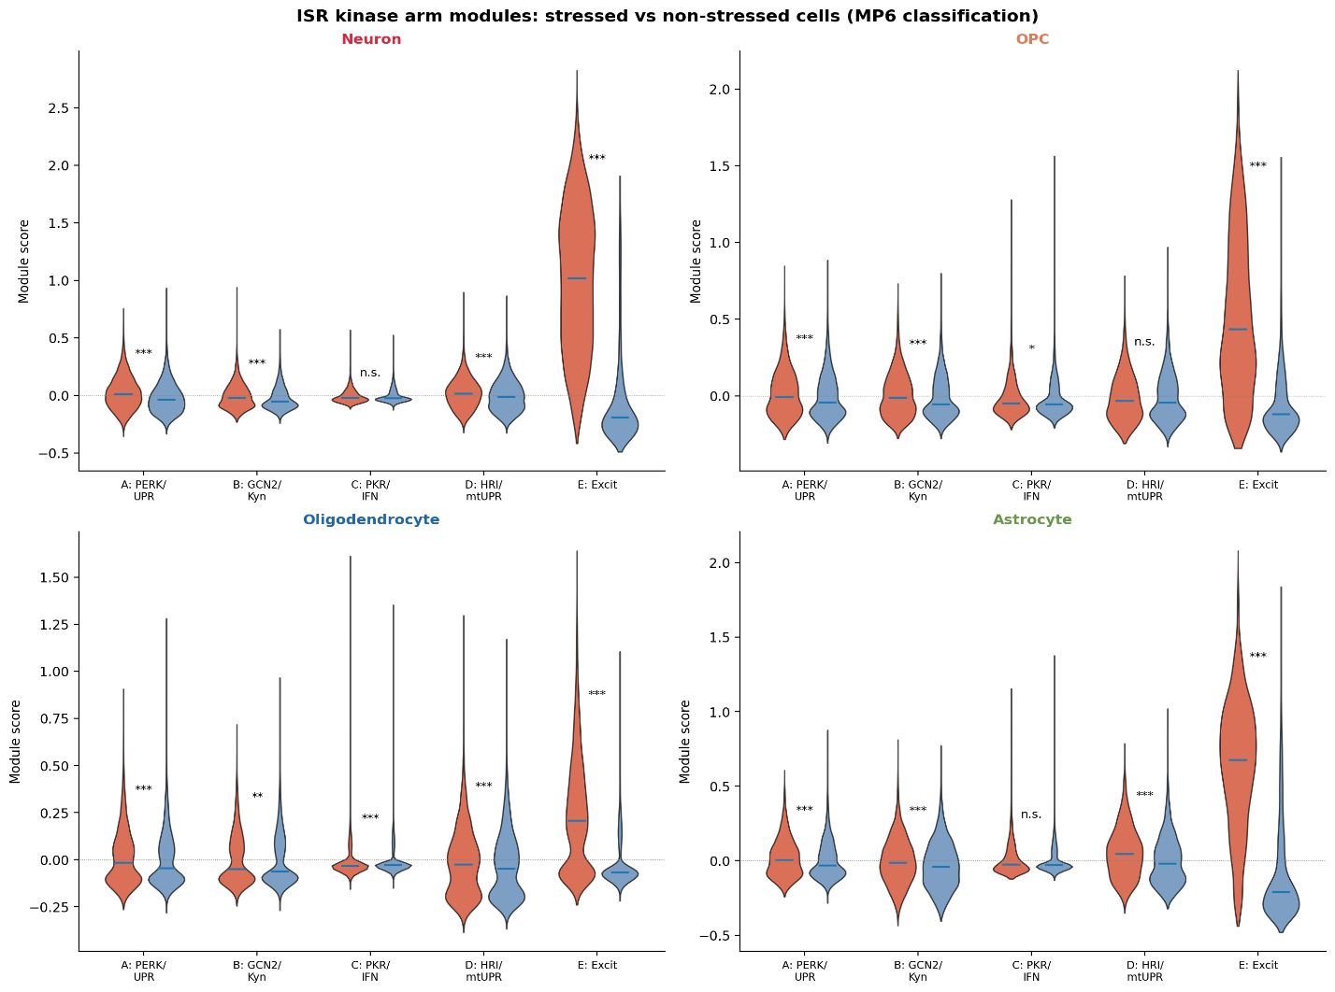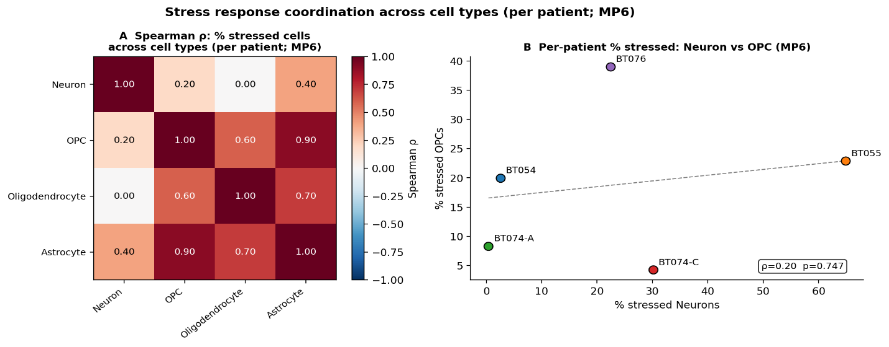
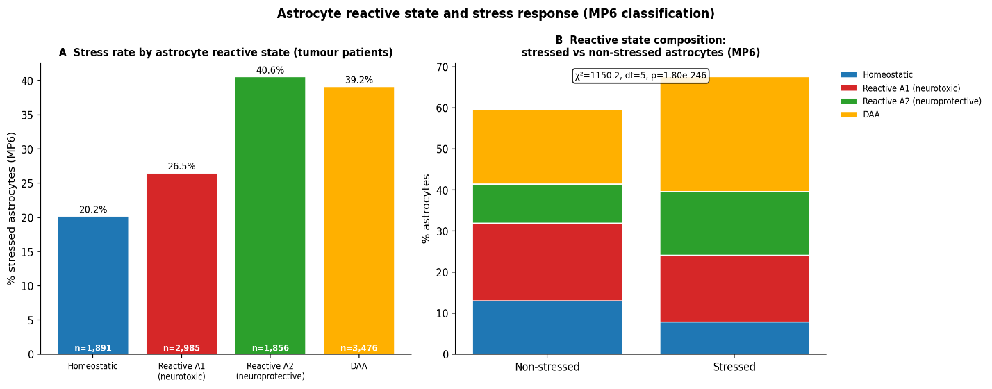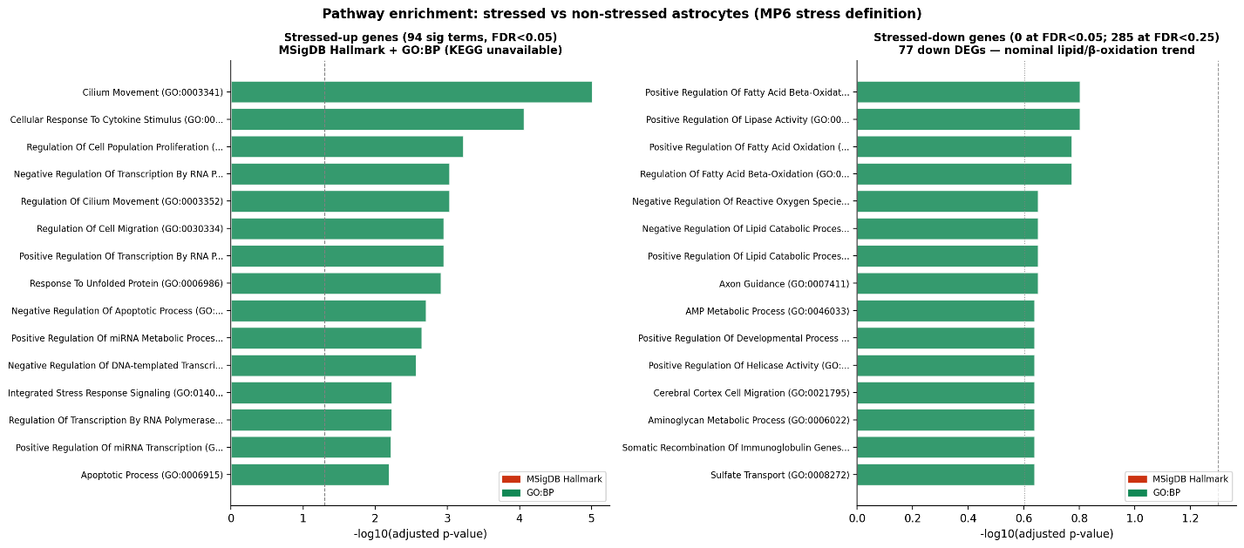

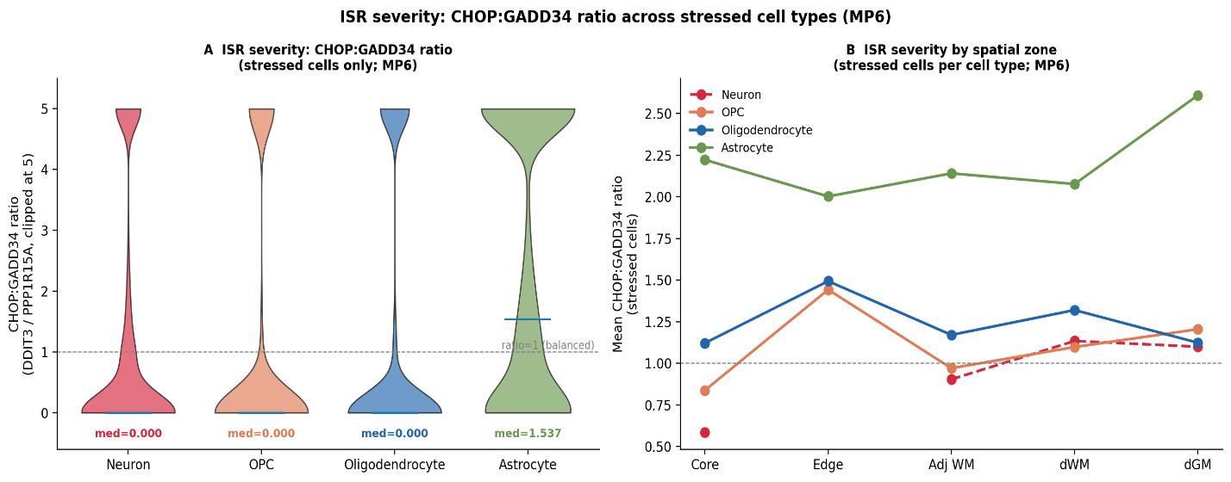
Supplementary Figure 17. Stress response across non-malignant cell types and oligodendrocyte lineage analyses.
(A) Percentage of stressed cells per zone for neurons, OPCs, oligodendrocytes, and astrocytes (MP6 stress score above zone-matched control mean + 2 SD; WM/GM thresholds applied separately). (B) Cell cycle phase composition (G1/S/G2M) in stressed vs non-stressed OPCs, oligodendrocytes, and astrocytes (neurons predominantly post-mitotic and excluded). (C) GADD45B and CDKN1A expression in stressed cells across the five tumour-patient zones for OPCs, oligodendrocytes, astrocytes, and neurons; open circles indicate zones with n<10 stressed cells of the indicated type (neurons sparse in Core/Edge), shown for trend visualisation only. (D) OPC transcriptional program differences (myelin maturity, progenitor markers) in stressed vs non-stressed OPCs. (E) Five ISR kinase-arm modules (PERK/UPR, GCN2/kynurenine, PKR/interferon, HRI/mitochondrial UPR, excitotoxicity/IEG) scored across all four cell types in stressed vs non-stressed cells (4×5 violin grid; Mann-Whitney significance markers). PKR/interferon shows no differential activation in stressed neurons. (F) Per-patient Spearman correlation matrix of percentage of MP6-stressed cells across the four cell types (n = 5 GB tumour patients), plus Neuron-vs-OPC %-stressed scatter annotated by patient (BT054, BT055, BT074-A, BT074-C, BT076). (G) Left: percentage of MP6-stressed astrocytes within each reactive state (Homeostatic, A1 neurotoxic, A2 neuroprotective, DAA) in tumour patients. Right: reactive state composition stratified by stress classification (stressed vs non-stressed astrocytes; χ² = 1150.2, df = 5, p = 1.8×10⁻²⁴⁶). (H) MSigDB Hallmark + GO:BP pathway enrichment for stressed-up vs stressed-down astrocyte DEGs (pseudobulk DESeq2; KEGG unavailable due to API rate-limit). No stressed-down terms reach FDR<0.05 (77 down DEGs); top suggestive terms at FDR<0.25 highlight a nominal lipid/fatty-acid β-oxidation signature, shown for completeness. (I) CHOP (DDIT3) : GADD34 (PPP1R15A) ratio in stressed cells per cell type and by spatial zone, with the ratio clipped at 5 to control for low-PPP1R15A outliers. n = 47,262 neurons; 26,769 OPCs; 104,516 oligodendrocytes; 25,799 astrocytes (stress definition: Gavish et al. 2023 MP6).

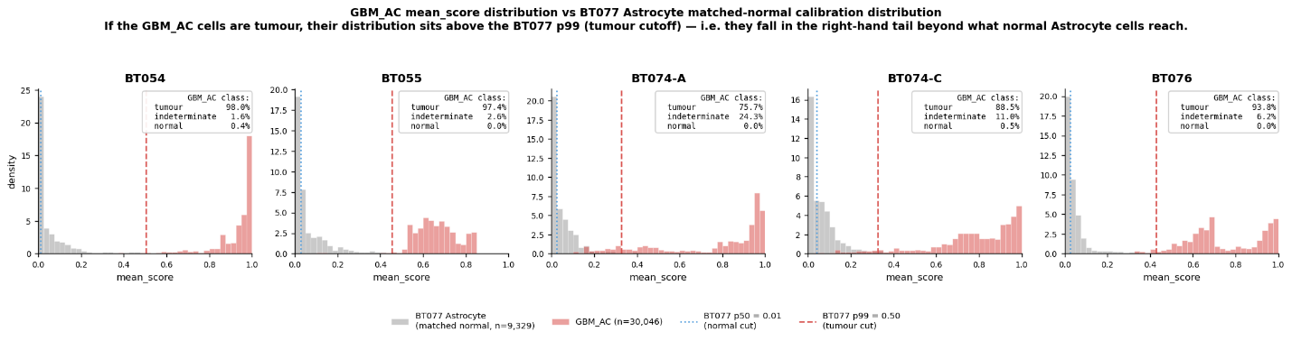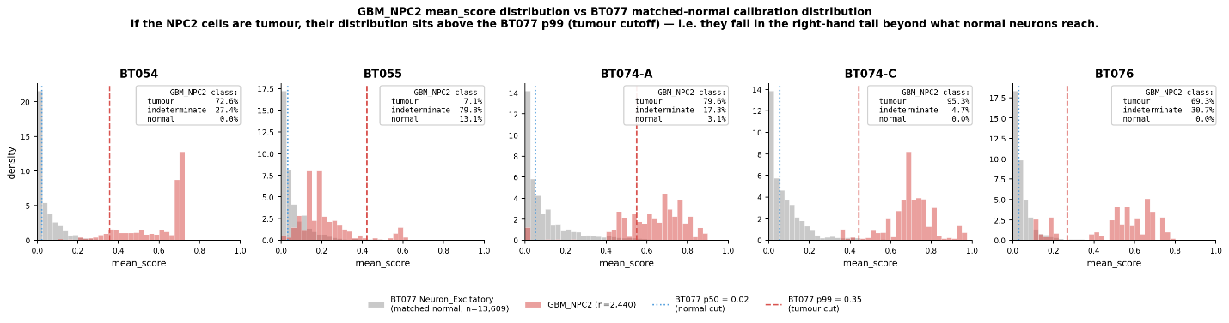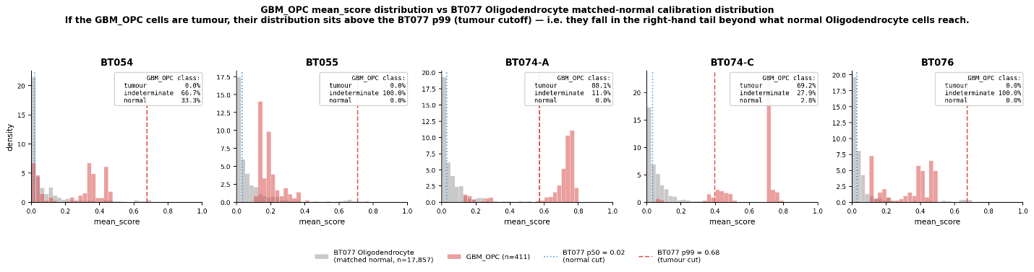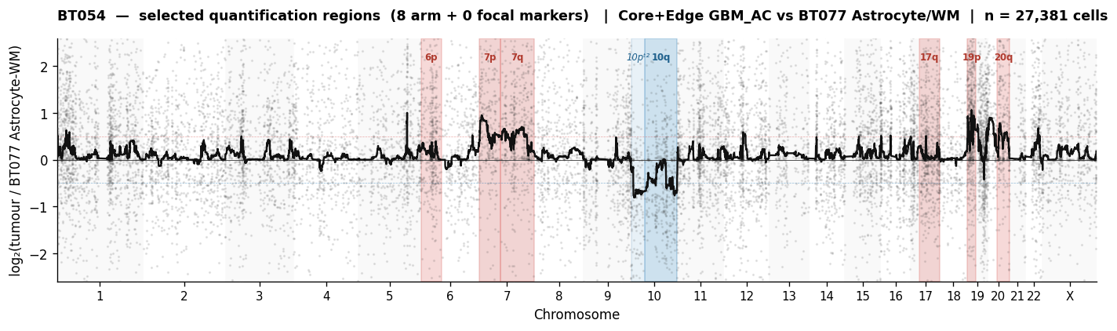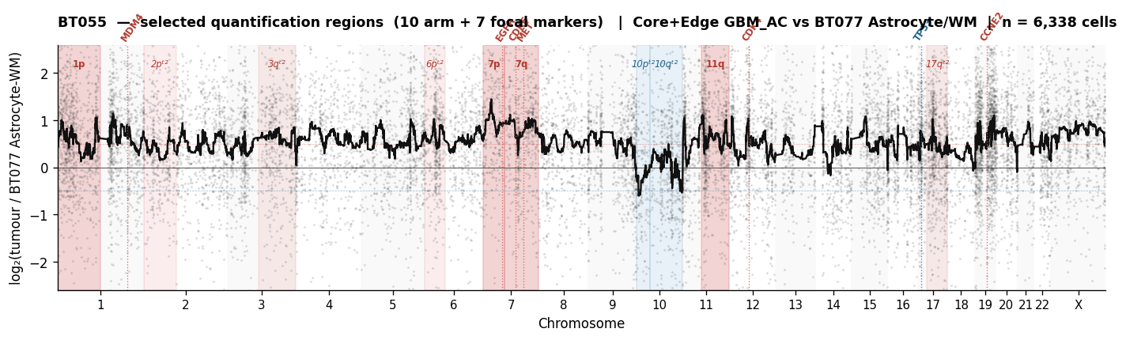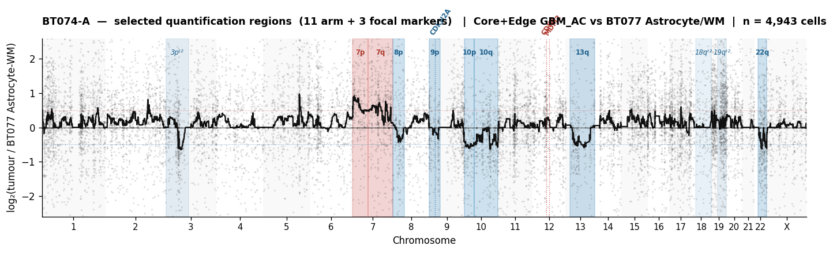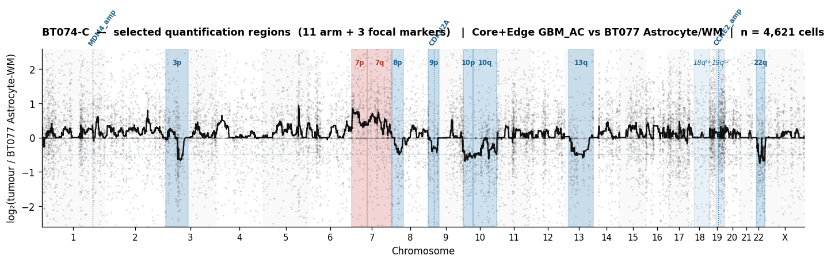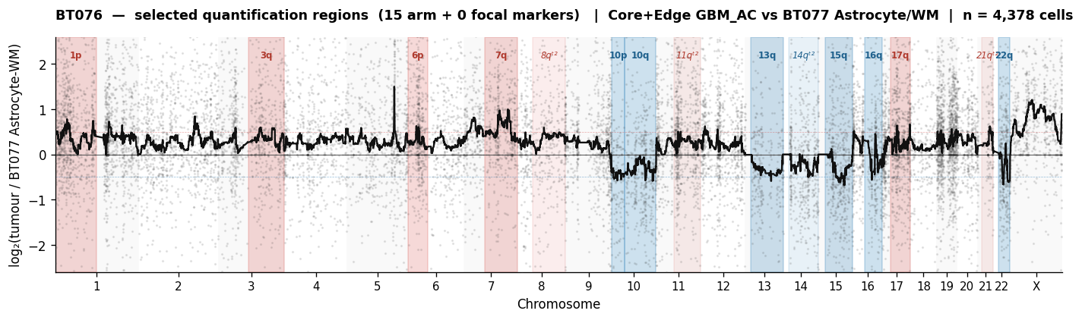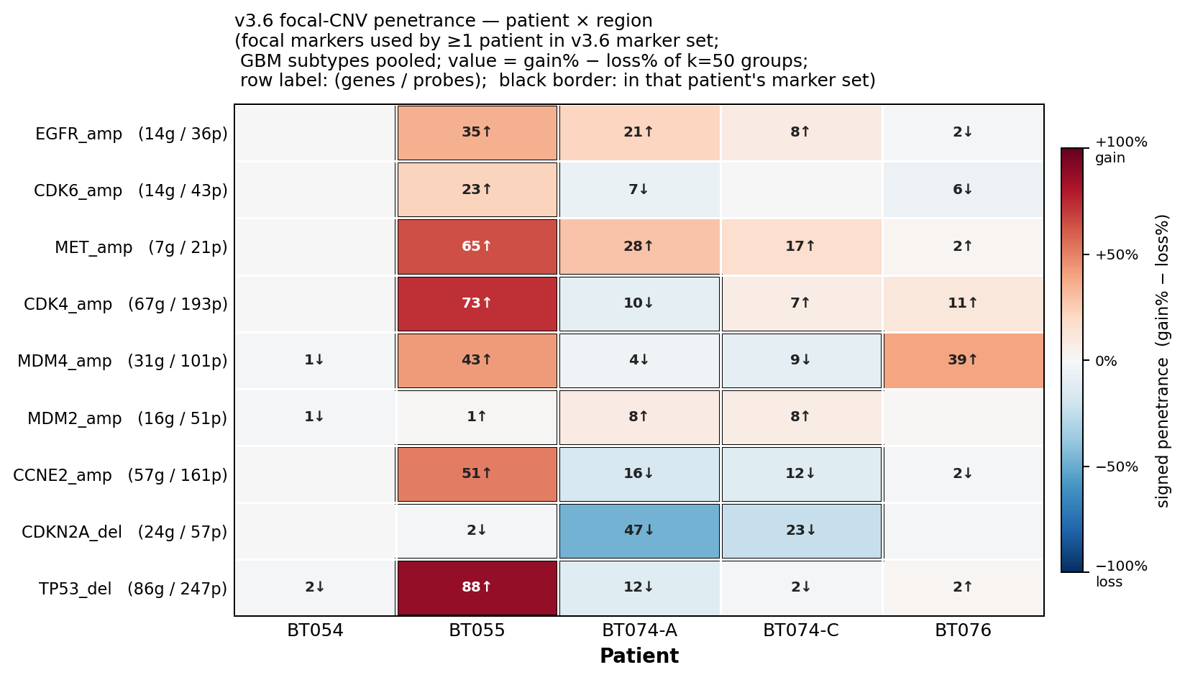
Supplementary Figure 18. Per-cell CNV pipeline (cnv_group_flex v3.6) - calibration, per-patient signature, and focal-CNV penetrance.
Validation outputs from the per-cell CNV classification pipeline. For each tumour patient, every malignant cell received a continuous mean_score ∈ [0, 1] derived from a tiered weighted aggregate of arm-gain, arm-loss, focal-gain and focal-loss markers, calibrated against an empirical null distribution generated from BT077 cells of the matched-normal reference cell type.
(A) GBM_AC mean_score distribution per tumour patient (red) overlaid on the BT077 Astrocyte matched-normal calibration distribution (grey). Vertical lines indicate the BT077-derived 50th percentile (dotted; normal cut) and 99th percentile (dashed; tumour cut) thresholds. Per-patient classification fractions (tumour / indeterminate / normal) are inset; AC-like cells reach the tumour cut in 75.7–98.0% of cells across the five patients. (B) Equivalent histograms for GBM_NPC2-like cells against the BT077 Excitatory Neuron reference. (C) Equivalent histograms for GBM_OPC-like cells against the BT077 Oligodendrocyte reference.
(D–H) Per-patient genome-wide log₂(tumour/reference) Manhattan plots (BT054, BT055, BT074-A, BT074-C, BT076), showing the smoothed per-region log₂ ratio across the 39 autosomal arms used in marker selection. Selected marker regions are highlighted; vertical bands mark the focal regions used in the v3.6 marker set. The number of arm and focal markers per patient is annotated on each panel.
(I) Patient × focal-CNV penetrance heatmap (pre-drift correction) for the nine GB-relevant focal regions (EGFR, CDK6, MET, CDK4, MDM4, MDM2, CCNE2, CDKN2A, TP53). Cell values give signed penetrance (gain% − loss% across k = 50 pseudobulk groups). Black borders highlight focal markers selected for that patient's marker library; "g" / "p" annotations indicate the number of genes / probes per region. The heatmap demonstrates patient-specific focal-CNV signatures (e.g., BT055 carries TP53 deletion and CDK4/EGFR/MDM4 amplifications; BT074-A carries CDKN2A deletion; BT076 carries MDM4 amplification), consistent with hallmark glioblastoma copy-number alterations.

