Additional File 5: Search Strategy
VES #2026002: Canine Otitis Externa
Lascher SM. Audax: A Principled Method for AI-Assisted Evidence Synthesis.
Systematic Reviews (BMC). Submitted April 2026.
Status: FINAL | Prepared: April 14, 2026 (Session 40); record counts confirmed April 26, 2026 (Session 58)

Purpose
This document provides the complete search strategy for the OE_2026002 evidence base, in compliance with BMC Systematic Reviews editorial requirements for evidence synthesis papers. The strategy is reproduced as executed; it has not been modified for reporting.

Database Search: PubMed/MEDLINE
Search date: February 7, 2026
Database: PubMed/MEDLINE (https://pubmed.ncbi.nlm.nih.gov/)

Search query:
"otitis externa"[All Fields] AND "dogs"[MeSH Terms]

Filters applied:
• Language: English
• Species: Animals (humans excluded)
• Publication years: 1975 to 2026

Records retrieved: 124

Supplementary Source Searches
In addition to the PubMed systematic search, targeted supplementary searches were conducted to identify recent publications, clinical practice guidelines, and grey literature not indexed in PubMed.

Sources searched:
• American College of Veterinary Internal Medicine (ACVIM) – consensus statements and guidelines
• American College of Veterinary Dermatology (ACVD) – position statements
• Veterinary Information Network (VIN) – clinical resources
• FDA Center for Veterinary Medicine (FDA CVM) – adverse event and safety reporting documents

Records identified: 13

Deduplication
Records from the PubMed search and supplementary sources were combined and assessed for duplication. Records sharing a PubMed identifier (PMID) or Digital Object Identifier (DOI) were identified as duplicates and removed. Title, first author, and year matching was applied as a tertiary check.

Duplicates removed: 3
Unique records after deduplication: 134

Records Carried Forward to Level I Screening
Following deduplication and an automated pre-screening step that removed records with obvious ineligibility signals (wrong species, wrong condition, non-English without translation), 106 records were carried forward to formal Level I (Title and Abstract) Screening.

Records screened at Level I: 106

The pre-screening step that reduced 134 to 106 records occurred before formal PRISMA-stage tracking began and is documented here for completeness. Record counts have been confirmed against the locked source inventory (FinalSourceInventoryOE_20260207; locked February 7, 2026).

PRISMA Flow Diagram
Figure 1. PRISMA 2020 flow diagram for OE_2026002 (VES #2026002, Canine Otitis Externa). Records identified reflects the 106 records carried forward to formal Level I Title and Abstract Screening after pre-screening removal of 28 records with obvious ineligibility signals.

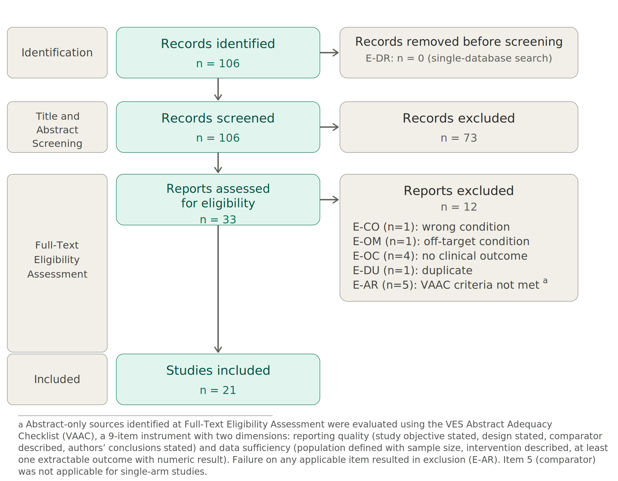

PRISMA Flow Summary
Stage | Count
Records identified (carried to Level I Screening) | 106
Records excluded at Level I (Title and Abstract Screening) | 73
Records assessed at Level II (Full-Text Eligibility Assessment) | 33
Records excluded at Level II | 12
Studies included in synthesis | 21

Notes
1. Search construction: The investigator developed all search terms and strategies; AI was not used to construct search strings, consistent with the Audax method design (see Methods paper §Search and screening). This decision is informed by empirical evidence that AI systems systematically fabricate MeSH and Emtree terms when constructing search strategies. Search execution (PubMed query submission and supplementary source retrieval) was performed by AI using the investigator-designed strategy, consistent with the human-AI role distribution described in Table 3.
2. Single-database systematic search: The systematic component of the OE_2026002 search used a single database (PubMed). Pre-screening deduplication using the E-DR code (Duplicate Record) is applicable from condition 3 onward, where multi-channel searches spanning multiple databases are employed. This is documented as a design exception in the methods paper (§Search and screening) and in project Decisions Register entry DR-013.
3. Search currency: The OE_2026002 source inventory was locked on February 7, 2026 (lock date). No additional records were added after this date.

