Table S1: Sampling dates and associated weather.

Date | Temperature (deg C) | Relative humidity (%) | Wind speed (m/s)
11/04/2024 | 15 | 74.9 | 23
11/05/2024 | 25.7 | 46.9 | 0.7
13/06/2024 | 15.7-16.7 | 62.5-70.9 | 0.6-2.6
12/08/2024 | 29.3-29.8 | 50.4-55.9 | 0.4-1.3
09/09/2024 | 19.5 | 50.8 | 1.1
03/04/2025 | 19.5 | 46.4 | 1.1
29/04/2025 | 26-27 | 32-38 | 0-0.8
02/06/2025 | 20.3 | 44 | 0.6
29/06/2025 | 26.4 | 53.3 | 0.5
12/07/2025 | 30-32.7 | 33.6-40 | 0.5-1.7
28/07/2025 | 23.9 | 47 | 1
25/08/2025 | 28 | 42.3 | 1.5
29/09/2025 | 15.5 | 62.8 | 2.3

Table S2: t-tests comparing FMC of each fuel in ghost and control plots per sample date.

Fuel | group1 | group2 | statistic | df | P value
11/04/2024
Heather canopy | Control | Ghost | -1.14723 | 7.604443 | 0.286
Organic layer | Control | Ghost | 1.261927 | 7.897262 | 0.243
Heather stem | Control | Ghost | 1.488499 | 11.89421 | 0.163
11/05/2024
Heather canopy | Control | Ghost | 0.067728 | 9.930971 | 0.947
Organic layer | Control | Ghost | -1.28647 | 9.780111 | 0.228
Heather stem | Control | Ghost | 0.373441 | 8.875583 | 0.718
13/06/2024
Heather canopy | Control | Ghost | -0.40334 | 10.76236 | 0.695
Organic layer | Control | Ghost | -0.78314 | 11.70102 | 0.449
Heather stem | Control | Ghost | -0.95586 | 11.3454 | 0.359
12/08/2024
Heather canopy | Control | Ghost | 2.113725 | 11.25419 | 0.0576
Organic layer | Control | Ghost | 0.270536 | 11.29267 | 0.792
Heather stem | Control | Ghost | 0.109407 | 9.491847 | 0.915
09/09/2024
Heather canopy | Control | Ghost | 1.610538 | 8.078949 | 0.146
Organic layer | Control | Ghost | -1.07704 | 10.62116 | 0.305
Heather stem | Control | Ghost | 0.201433 | 11.99348 | 0.844
03/04/2025
Heather canopy | Control | Ghost | 1.169605 | 11.0851 | 0.267
Organic layer | Control | Ghost | -0.4002 | 10.93544 | 0.697
Heather stem | Control | Ghost | -0.98445 | 7.139098 | 0.357
29/04/2025
Heather canopy | Control | Ghost | -0.43167 | 7.953768 | 0.677
Organic layer | Control | Ghost | -1.02232 | 8.167492 | 0.336
Heather stem | Control | Ghost | -0.56248 | 10.79787 | 0.585
02/06/2025
Heather canopy | Control | Ghost | 0.173987 | 11.80024 | 0.865
Organic layer | Control | Ghost | 0.510622 | 8.306345 | 0.623
Heather stem | Control | Ghost | 0.080797 | 11.93318 | 0.937
29/06/2025
Heather canopy | Control | Ghost | -0.2375 | 11.75458 | 0.816
Organic layer | Control | Ghost | -0.20983 | 11.54494 | 0.837
Heather stem | Control | Ghost | -0.66836 | 11.43375 | 0.517
12/07/2025
Heather canopy | Control | Ghost | -0.04247 | 11.99657 | 0.967
Organic layer | Control | Ghost | 0.284965 | 10.89267 | 0.781
Heather stem | Control | Ghost | 0.014973 | 11.44493 | 0.988
28/07/2025
Heather canopy | Control | Ghost | 0.692335 | 11.97503 | 0.502
Organic layer | Control | Ghost | -0.44112 | 10.31004 | 0.668
Heather stem | Control | Ghost | 1.526693 | 10.77392 | 0.156
25/08/2025
Heather canopy | Control | Ghost | 0.714979 | 10.24257 | 0.491
Organic layer | Control | Ghost | -0.16733 | 10.54236 | 0.87
Heather stem | Control | Ghost | 0.601847 | 11.26142 | 0.559
29/09/2025
Heather canopy | Control | Ghost | 2.194845 | 11.8563 | 0.0488
Organic layer | Control | Ghost | -0.96723 | 10.50469 | 0.355
Heather stem | Control | Ghost | 1.229955 | 9.706396 | 0.248

Table S3: t-tests comparing the Peak Heat Release Rate (PHRR) of each fuel in ghost and control plots per sample date.

Fuel | group1 | group2 | statistic | df | P value
11/04/2024
Heather canopy | Control | Ghost | 0.382641 | 10.58314 | 0.71
Heather stem | Control | Ghost | -0.7021 | 9.782212 | 0.499
13/06/2024
Heather canopy | Control | Ghost | -0.49254 | 8.147655 | 0.635
Heather stem | Control | Ghost | 0.080144 | 10.71288 | 0.938
12/08/2024
Heather canopy | Control | Ghost | -2.6337 | 10.42537 | 0.0242
Heather stem | Control | Ghost | -2.38847 | 11.83572 | 0.0345
09/09/2024
Heather canopy | Control | Ghost | 0.992086 | 11.55546 | 0.341
Heather stem | Control | Ghost | -0.98971 | 10.0278 | 0.346
29/04/2025
Heather canopy | Control | Ghost | -0.18494 | 10.00052 | 0.857
Heather stem | Control | Ghost | 0.247795 | 8.480383 | 0.81
02/06/2025
Heather canopy | Control | Ghost | -1.2772 | 10.77988 | 0.228
Heather stem | Control | Ghost | -0.62944 | 10.51284 | 0.542
29/06/2025
Heather canopy | Control | Ghost | 0.089529 | 10.39286 | 0.93
Heather stem | Control | Ghost | 0.408615 | 11.14378 | 0.691
12/07/2025
Heather canopy | Control | Ghost | -1.7234 | 8.878649 | 0.119
Heather stem | Control | Ghost | -0.95308 | 10.89539 | 0.361
28/07/2025
Heather canopy | Control | Ghost | -0.83328 | 11.5146 | 0.422
Heather stem | Control | Ghost | -0.93623 | 10.87294 | 0.369
25/08/2025
Heather canopy | Control | Ghost | 0.061106 | 11.3861 | 0.952
Heather stem | Control | Ghost | -0.99966 | 11.64719 | 0.338
29/09/2025
Heather canopy | Control | Ghost | -1.23702 | 9.561668 | 0.246
Heather stem | Control | Ghost | -0.29733 | 10.69874 | 0.772

Table S4: t-tests comparing the Total Heat Release (THR) of each fuel in ghost and control plots per sample date.

Fuel | group1 | group2 | statistic | df | P value
11/04/2024
Heather canopy | Control | Ghost | 0.648275 | 10.0132 | 0.531
Heather stem | Control | Ghost | -0.46325 | 11.93891 | 0.652
13/06/2024
Heather canopy | Control | Ghost | -0.41725 | 11.19528 | 0.684
Heather stem | Control | Ghost | 0.724849 | 11.95924 | 0.482
12/08/2024
Heather canopy | Control | Ghost | -1.22614 | 9.15998 | 0.251
Heather stem | Control | Ghost | -1.93526 | 9.501931 | 0.0832
09/09/2024
Heather canopy | Control | Ghost | 0.652654 | 10.84996 | 0.528
Heather stem | Control | Ghost | -1.20493 | 11.58137 | 0.252
29/04/2025
Heather canopy | Control | Ghost | -0.12198 | 10.23872 | 0.905
Heather stem | Control | Ghost | -0.62266 | 8.271017 | 0.55
02/06/2025
Heather canopy | Control | Ghost | -1.93644 | 11.68929 | 0.0774
Heather stem | Control | Ghost | 0.293972 | 8.849165 | 0.776
29/06/2025
Heather canopy | Control | Ghost | 0.311921 | 10.29199 | 0.761
Heather stem | Control | Ghost | 0.341794 | 10.40714 | 0.739
12/07/2025
Heather canopy | Control | Ghost | -2.16996 | 8.667082 | 0.0593
Heather stem | Control | Ghost | -2.35172 | 10.92074 | 0.0385
28/07/2025
Heather canopy | Control | Ghost | -0.15975 | 9.913404 | 0.876
Heather stem | Control | Ghost | -1.21681 | 6.589702 | 0.265
25/08/2025
Heather canopy | Control | Ghost | 0.581037 | 11.76578 | 0.572
Heather stem | Control | Ghost | -0.37947 | 11.99947 | 0.711
29/09/2025
Heather canopy | Control | Ghost | -1.38583 | 7.486119 | 0.206
Heather stem | Control | Ghost | -0.85983 | 11.03741 | 0.408

Table S5: t-tests comparing the maximum temperature of decomposition (Tmax) of each fuel in ghost and control plots per sample date.

Fuel | group1 | group2 | statistic | df | P value
11/04/2024
Heather canopy | Control | Ghost | 0.965688 | 11.97133 | 0.353
Heather stem | Control | Ghost | -0.10464 | 11.77988 | 0.918
13/06/2024
Heather canopy | Control | Ghost | -1.38709 | 11.50202 | 0.192
Heather stem | Control | Ghost | 0.202312 | 11.98332 | 0.843
12/08/2024
Heather canopy | Control | Ghost | 0.805066 | 11.97496 | 0.436
Heather stem | Control | Ghost | -1.60053 | 9.539543 | 0.142
09/09/2024
Heather canopy | Control | Ghost | 1.125996 | 11.32181 | 0.283
Heather stem | Control | Ghost | 0.500134 | 9.525541 | 0.628
29/04/2025
Heather canopy | Control | Ghost | -0.32252 | 8.053489 | 0.755
Heather stem | Control | Ghost | 0.104523 | 11.37119 | 0.919
02/06/2025
Heather canopy | Control | Ghost | 0.198268 | 8.152418 | 0.848
Heather stem | Control | Ghost | 0.081648 | 8.077423 | 0.937
29/06/2025
Heather canopy | Control | Ghost | -2.44811 | 10.47147 | 0.0334
Heather stem | Control | Ghost | 1.450575 | 11.63399 | 0.173
12/07/2025
Heather canopy | Control | Ghost | 0.034145 | 8.136739 | 0.974
Heather stem | Control | Ghost | -0.80721 | 10.72841 | 0.437
28/07/2025
Heather canopy | Control | Ghost | -0.55408 | 11.88272 | 0.59
Heather stem | Control | Ghost | 1.426157 | 11.26684 | 0.181
25/08/2025
Heather canopy | Control | Ghost | -0.81389 | 8.976222 | 0.437
Heather stem | Control | Ghost | -1.30363 | 9.467827 | 0.223
29/09/2025
Heather canopy | Control | Ghost | 0.441288 | 11.99364 | 0.667
Heather stem | Control | Ghost | -0.07529 | 11.9102 | 0.941

Table S6: t-tests comparing FMC of each fuel in control (ghost + control) and drought plots per sample date. Significant p-values are shown in bold.

Fuel | group1 | group2 | statistic | df | P value
11/04/2024
Heather canopy | Control | Drought | -0.90961 | 18.95708 | 0.374
Organic layer | Control | Drought | 1.324803 | 15.04422 | 0.205
Heather stem | Control | Drought | 0.256866 | 9.613119 | 0.803
11/05/2024
Heather canopy | Control | Drought | 0.568638 | 10.56394 | 0.581
Organic layer | Control | Drought | 1.658253 | 17.88783 | 0.115
Heather stem | Control | Drought | 0.699294 | 8.445343 | 0.503
13/06/2024
Heather canopy | Control | Drought | 0.817068 | 14.85442 | 0.427
Organic layer | Control | Drought | 2.850299 | 18.18198 | 0.0106
Heather stem | Control | Drought | 1.5311 | 16.72109 | 0.144
12/08/2024
Heather canopy | Control | Drought | 1.265163 | 17.05442 | 0.223
Organic layer | Control | Drought | 1.085173 | 15.62874 | 0.294
Heather stem | Control | Drought | 0.999722 | 18.46751 | 0.33
09/09/2024
Heather canopy | Control | Drought | 2.039621 | 13.09079 | 0.0621
Organic layer | Control | Drought | 2.033464 | 9.899168 | 0.0697
Heather stem | Control | Drought | 1.451574 | 13.64701 | 0.169
03/04/2025
Heather canopy | Control | Drought | 1.296272 | 6.840341 | 0.237
Organic layer | Control | Drought | 1.129567 | 14.08049 | 0.278
Heather stem | Control | Drought | -0.68425 | 13.81287 | 0.505
29/04/2025
Heather canopy | Control | Drought | -0.3687 | 8.322 | 0.722
Organic layer | Control | Drought | 2.493275 | 18.87046 | 0.0221
Heather stem | Control | Drought | 1.034813 | 13.5905 | 0.319
02/06 2025
Heather canopy | Control | Drought | 1.859437 | 15.14381 | 0.0825
Organic layer | Control | Drought | 3.254475 | 17.3143 | 0.00458
Heather stem | Control | Drought | 2.60006 | 9.233655 | 0.0282
29/06/2025
Heather canopy | Control | Drought | -0.21223 | 9.684678 | 0.836
Organic layer | Control | Drought | -0.23368 | 11.8758 | 0.819
Heather stem | Control | Drought | 0.486535 | 12.31596 | 0.635
12/07/2025
Heather canopy | Control | Drought | -0.09041 | 18.97528 | 0.929
Organic layer | Control | Drought | 1.177104 | 15.82343 | 0.257
Heather stem | Control | Drought | 1.789422 | 12.64622 | 0.0975
28/07/2025
Heather canopy | Control | Drought | 0.099965 | 13.57632 | 0.922
Organic layer | Control | Drought | 0.532314 | 12.48311 | 0.604
Heather stem | Control | Drought | 0.931404 | 7.783012 | 0.38
25/08/2025
Heather canopy | Control | Drought | -0.37467 | 10.4162 | 0.715
Organic layer | Control | Drought | 0.944134 | 15.19623 | 0.36
Heather stem | Control | Drought | -1.03825 | 18.23878 | 0.313
29/09/2025
Heather canopy | Control | Drought | 0.973605 | 8.036121 | 0.359
Organic layer | Control | Drought | 3.334223 | 17.1731 | 0.00389
Heather stem | Control | Drought | 0.540991 | 18.56084 | 0.595

Table S7: t-tests comparing the Peak Heat Release Rate (PHRR) of each fuel in control (ghost + control) and drought plots per sample date. Significant p-values are shown in bold.

Fuel | group1 | group2 | statistic | df | P value
11/04/2024
Heather canopy | Control | Drought | -1.01724 | 11.54738 | 0.33
Heather stem | Control | Drought | -0.03406 | 11.26456 | 0.973
13/06/2024
Heather canopy | Control | Drought | 0.021548 | 9.931419 | 0.983
Heather stem | Control | Drought | 0.612623 | 8.668628 | 0.556
12/08/2024
Heather canopy | Control | Drought | 0.49214 | 7.328374 | 0.637
Heather stem | Control | Drought | -1.2227 | 11.42931 | 0.246
09/09/2024
Heather canopy | Control | Drought | -2.1819 | 9.057901 | 0.0568
Heather stem | Control | Drought | -0.16297 | 12.59698 | 0.873
29/04/2025
Heather canopy | Control | Drought | -1.03314 | 18.98983 | 0.315
Heather stem | Control | Drought | 0.706069 | 11.833 | 0.494
02/06/2025
Heather canopy | Control | Drought | -1.77341 | 15.26718 | 0.0961
Heather stem | Control | Drought | -1.37481 | 13.97783 | 0.191
29/06/2025
Heather canopy | Control | Drought | -0.63426 | 9.458906 | 0.541
Heather stem | Control | Drought | 0.20345 | 7.663159 | 0.844
12/07/2025
Heather canopy | Control | Drought | 0.778683 | 17.65525 | 0.446
Heather stem | Control | Drought | 1.134824 | 13.52051 | 0.276
28/07/2025
Heather canopy | Control | Drought | -0.1814 | 13.36363 | 0.859
Heather stem | Control | Drought | -0.59477 | 18.30899 | 0.559
25/08/2025
Heather canopy | Control | Drought | -0.76796 | 8.195857 | 0.464
Heather stem | Control | Drought | -1.07194 | 16.5778 | 0.299
29/09/2025
Heather canopy | Control | Drought | -0.31824 | 18.81171 | 0.754
Heather stem | Control | Drought | -1.38978 | 14.62888 | 0.185

Table S8: t-tests comparing the Total Heat Release (THR) of each fuel in control (ghost + control) and drought plots per sample date. Significant p-values are shown in bold.

Fuel | group1 | group2 | statistic | df | P value
11/04/2024
Heather canopy | Control | Drought | -1.16184 | 12,29565 | 0.267
Heather stem | Control | Drought | 0.461602 | 13.24459 | 0.652
13/06/2024
Heather canopy | Control | Drought | -0.26069 | 10.4044 | 0.799
Heather stem | Control | Drought | 0.491633 | 9.359182 | 0.634
12/08/2024
Heather canopy | Control | Drought | -1.03336 | 9.881019 | 0.326
Heather stem | Control | Drought | -2.59933 | 18.77671 | 0.0177
09/09/2024
Heather canopy | Control | Drought | -2.54476 | 8.459317 | 0.033
Heather stem | Control | Drought | -1.12057 | 10.35469 | 0.288
29/04/2025
Heather canopy | Control | Drought | -1.09338 | 14.0273 | 0.293
Heather stem | Control | Drought | 0.216265 | 17.0684 | 0.831
02/06/2025
Heather canopy | Control | Drought | -2.16558 | 16.64626 | 0.0452
Heather stem | Control | Drought | -2.81699 | 17.59139 | 0.0116
29/06/2025
Heather canopy | Control | Drought | -0.88047 | 9.205634 | 0.401
Heather stem | Control | Drought | -1.28156 | 9.624353 | 0.23
12/07/2025
Heather canopy | Control | Drought | 0..371243 | 11.94056 | 0.717
Heather stem | Control | Drought | -0.17273 | 10.40807 | 0.866
28/07/2025
Heather canopy | Control | Drought | -0.44552 | 12.27111 | 0.664
Heather stem | Control | Drought | -1.19152 | 14.17317 | 0.253
25/08/2025
Heather canopy | Control | Drought | -0.52212 | 9.406486 | 0.614
Heather stem | Control | Drought | -0.19995 | 18.14885 | 0.844
29/09/2025
Heather canopy | Control | Drought | -0.6888 | 18.97484 | 0.499
Heather stem | Control | Drought | -0.99682 | 11.318 | 0.34

Table S9: t-tests comparing the maximum temperature of decomposition (Tmax) of each fuel in control (ghost + control) and drought plots per sample date. Significant p-values are shown in bold.

Fuel | group1 | group2 | statistic | df | P value
11/04/2024
Heather canopy | Control | Drought | -1.3698 | 10.92445 | 0.198
Heather stem | Control | Drought | -0.74141 | 18.9986 | 0.468
13/06/2024
Heather canopy | Control | Drought | -0.36519 | 10.29077 | 0.722
Heather stem | Control | Drought | -0.62428 | 10.89132 | 0.545
12/08/2024
Heather canopy | Control | Drought | 0.18436 | 9.290477 | 0.858
Heather stem | Control | Drought | 1.290171 | 7.543477 | 0.235
09/09/2024
Heather canopy | Control | Drought | -0.3366 | 13.54314 | 0.742
Heather stem | Control | Drought | -0.51307 | 16.34346 | 0.615
29/04/2025
Heather canopy | Control | Drought | -0.70787 | 11.58009 | 0.493
Heather stem | Control | Drought | 0.819374 | 8.726728 | 0.434
02/06/2025
Heather canopy | Control | Drought | -1.46414 | 18.95294 | 0.16
Heather stem | Control | Drought | -1.37888 | 7.981493 | 0.205
29/06/2025
Heather canopy | Control | Drought | -2.76462 | 18.37995 | 0.0126
Heather stem | Control | Drought | 0.694379 | 14.04453 | 0.499
12/07/2025
Heather canopy | Control | Drought | -1.25946 | 9.860276 | 0.237
Heather stem | Control | Drought | -0.42035 | 8.765147 | 0.684
28/07/2025
Heather canopy | Control | Drought | -0.05645 | 9.489731 | 0.956
Heather stem | Control | Drought | -0.38912 | 10.9306 | 0.705
25/08/2025
Heather canopy | Control | Drought | -1.13204 | 17.46405 | 0.273
Heather stem | Control | Drought | -1.97035 | 17.41834 | 0.0649
29/09/2025
Heather canopy | Control | Drought | 0.572634 | 9.513613 | 0.58
Heather stem | Control | Drought | 0.958628 | 11.98836 | 0.357

Table S10: t-test results comparing FMC of heather canopy, heather stem and the organic layer during a ‘normal’ baseline July, a heatwave and a drought. Bold p-values are significant.

group1 | group2 | statistic | df | P value
Heather canopy
Heatwave | Drought | 2.557382 | 6.50572 | 0.04
Heatwave | Baseline | -3.64327 | 10.6727 | 0.004
Drought | Baseline | -9.76262 | 7.075809 | <0.001
Heather stem
Heatwave | Drought | 5.784219 | 12.95702 | <0.001
Heatwave | Baseline | -3.91407 | 9.177113 | 0.003
Drought | Baseline | -7.69741 | 7.802191 | <0.001
Organic layer
Heatwave | Drought | 2.085517 | 9.695504 | 0.064
Heatwave | Baseline | -4.11 | 24.6953 | <0.001
Drought | Baseline | -6.29641 | 16.5418 | <0.001

Micrometeorological effects of drought and control shelters

To determine whether the plastic strips of the drought shelters affected the microclimate of the plots via greenhouse-style warming, and whether there were any edge-effects in the micrometeorological conditions of the drought and control shelters, we carried out linear models using a number of measurements from dataloggers in each plot: soil moisture and three temperature measures from TMS-4 dataloggers (−6, +2 and +15 cm relative to soil surface), and air temperature and relative humidity measures from HOBO dataloggers that were placed in the mid-canopy of Calluna plants in each plot. We calculated the mean temperature across the entire experimental timeframe (roughly April to September) for each of these six logger measurements and for each year (2024 and 2025). We ran a linear model for each of the six measurements for each year comparing the mean value with the treatment type (ghost, control or drought) and the position of the logger (edge or middle).

There was an effect of drought shelters on air temperature, where temperatures around the Calluna canopy were on average 0.44 and 0.42 °C warmer in 2024 and 2025, respectively (Table S11). The middle of the control and drought plots were cooler by 0.51-0.54 °C than the edge of the plots in 2025, likely due to the shading effect of Calluna canopy within the middle of the plots. Given the lack of effect of the experimental drought on FMC observed, we are reasonably confident that the slight warming effect of the drought shelters did not affect the experiment.

Table S11: Linear models comparing the temperature , soil moisture and relative humidity of ghost, control and drought plots. For TMS loggers, middle and edge effects of plots were also modelled. T1 sensor = 6 cm below ground, T2 sensor = 2 cm above ground, T3 sensor = 15 cm above ground. HOBO loggers were placed in heather canopy. Significant p values are in bold.

Logger | Term | Estimate | Std.error | Statistic | p-value
TMS logger 2024
T1 | Intercept (ghost, edge) | 13.15 | 0.11 | 118.91 | 0.000
T1 | Control | -0.28 | 0.10 | -2.67 | 0.012
T1 | Drought | -0.13 | 0.10 | -1.26 | 0.216
T1 | Middle | -0.14 | 0.08 | -1.82 | 0.080
T2 | Intercept (ghost, edge) | 13.23 | 0.14 | 92.96 | 0.000
T2 | Control | -0.23 | 0.13 | -1.71 | 0.099
T2 | Drought | 0.02 | 0.13 | 0.12 | 0.908
T2 | Middle | -0.17 | 0.10 | -1.64 | 0.111
T3 | Intercept (ghost, edge) | 6.15 | 9.06 | 0.68 | 0.503
T3 | Control | 3.27 | 8.56 | 0.38 | 0.705
T3 | Drought | -3.14 | 8.36 | -0.38 | 0.710
T3 | Middle | 7.21 | 6.52 | 1.10 | 0.278
Soil moisture | Intercept (ghost, edge) | 1712.19 | 199.12 | 8.60 | 0.000
Soil moisture | Control | 17.82 | 188.06 | 0.09 | 0.925
Soil moisture | Drought | -300.50 | 183.78 | -1.64 | 0.113
Soil moisture | Middle | -19.59 | 143.38 | -0.14 | 0.892
HOBO logger 2025
Temperature | Intercept (ghost) | 13.66 | 0.08 | 179.16 | 0.000
Temperature | Control | -0.32 | 0.12 | -2.67 | 0.017
Temperature | Drought | 0.44 | 0.11 | 4.07 | 0.001
Rel. humidity | Intercept (ghost) | 85.70 | 0.91 | 94.65 | 0.000
Rel. humidity | Control | 0.88 | 1.40 | 0.62 | 0.541
Rel. humidity | Drought | -1.86 | 1.28 | -1.46 | 0.165
TMS logger 2025
T1 | Intercept (ghost, edge) | 13.93 | 0.21 | 66.98 | 0.000
T1 | Control | -0.21 | 0.19 | -1.07 | 0.295
T1 | Drought | -0.09 | 0.19 | -0.46 | 0.649
T1 | Middle | -0.51 | 0.15 | -3.48 | 0.001
T2 | Intercept (ghost, edge) | 15.55 | 0.25 | 61.51 | 0.000
T2 | Control | -0.24 | 0.24 | -1.03 | 0.310
T2 | Drought | 0.00 | 0.24 | 0.01 | 0.992
T2 | Middle | -0.54 | 0.18 | -3.03 | 0.005
T3 | Intercept (ghost, edge) | 7.48 | 10.49 | 0.71 | 0.481
T3 | Control | 3.77 | 9.81 | 0.38 | 0.704
T3 | Drought | -4.23 | 9.81 | -0.43 | 0.669
T3 | Middle | 7.94 | 7.42 | 1.07 | 0.293
Soil moisture | Intercept (ghost, edge) | 1086.01 | 128.42 | 8.46 | 0.000
Soil moisture | Control | 8.64 | 120.13 | 0.07 | 0.943
Soil moisture | Drought | -182.17 | 120.13 | -1.52 | 0.140
Soil moisture | Middle | -9.42 | 90.81 | -0.10 | 0.918
HOBO logger 2025
Temperature | Intercept (ghost) | 16.33 | 0.13 | 123.53 | 0.000
Temperature | Control | 0.00 | 0.18 | -0.02 | 0.984
Temperature | Drought | 0.42 | 0.18 | 2.32 | 0.033
Rel. humidity | Intercept (ghost) | 77.27 | 0.71 | 108.87 | 0.000
Rel. humidity | Control | -1.80 | 0.97 | -1.86 | 0.080
Rel. humidity | Drought | -1.90 | 0.97 | -1.97 | 0.066

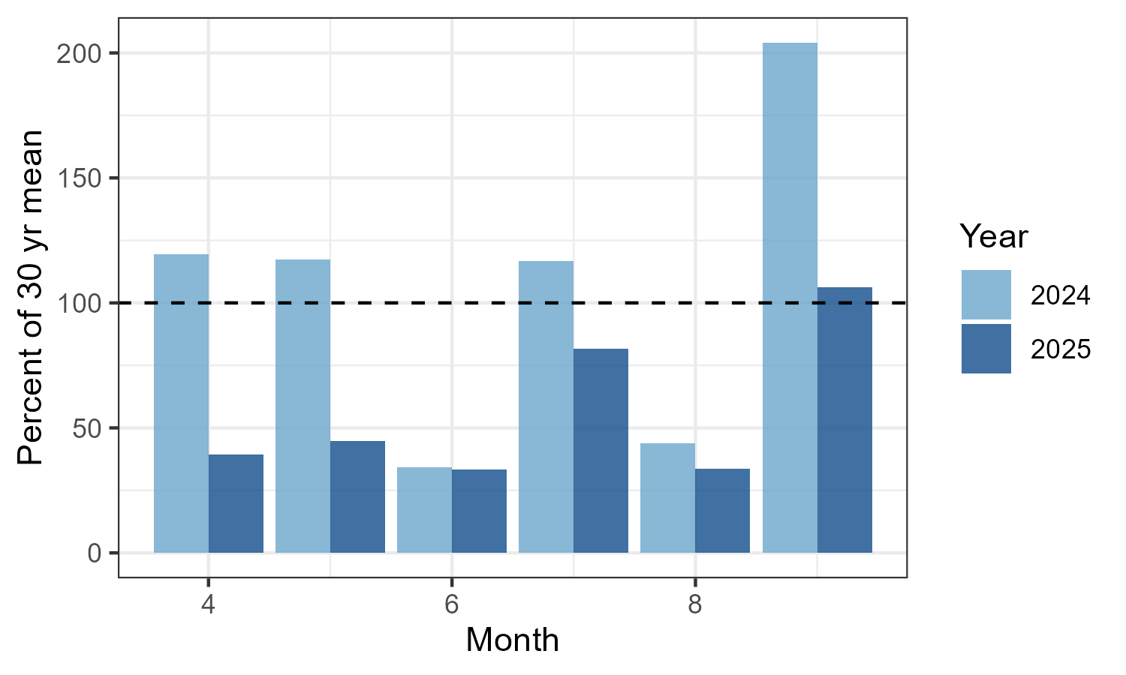
Figure S1: Average total mm of rainfall/month as a percentage of the 30-year average (black dashed line represents the average) in 2024 & 2025. Weather data was collected from Winterbourne weather station.

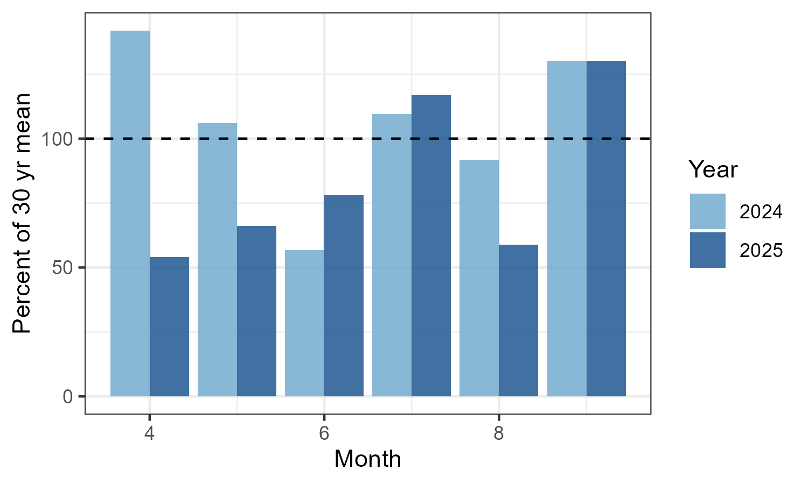
Figure S2: Average number of days/month where rainfall exceeds 0.2 mm as a percentage of the 30-year average (black dashed line represents the average) in 2024 & 2025. Weather data was collected from Winterbourne weather station.

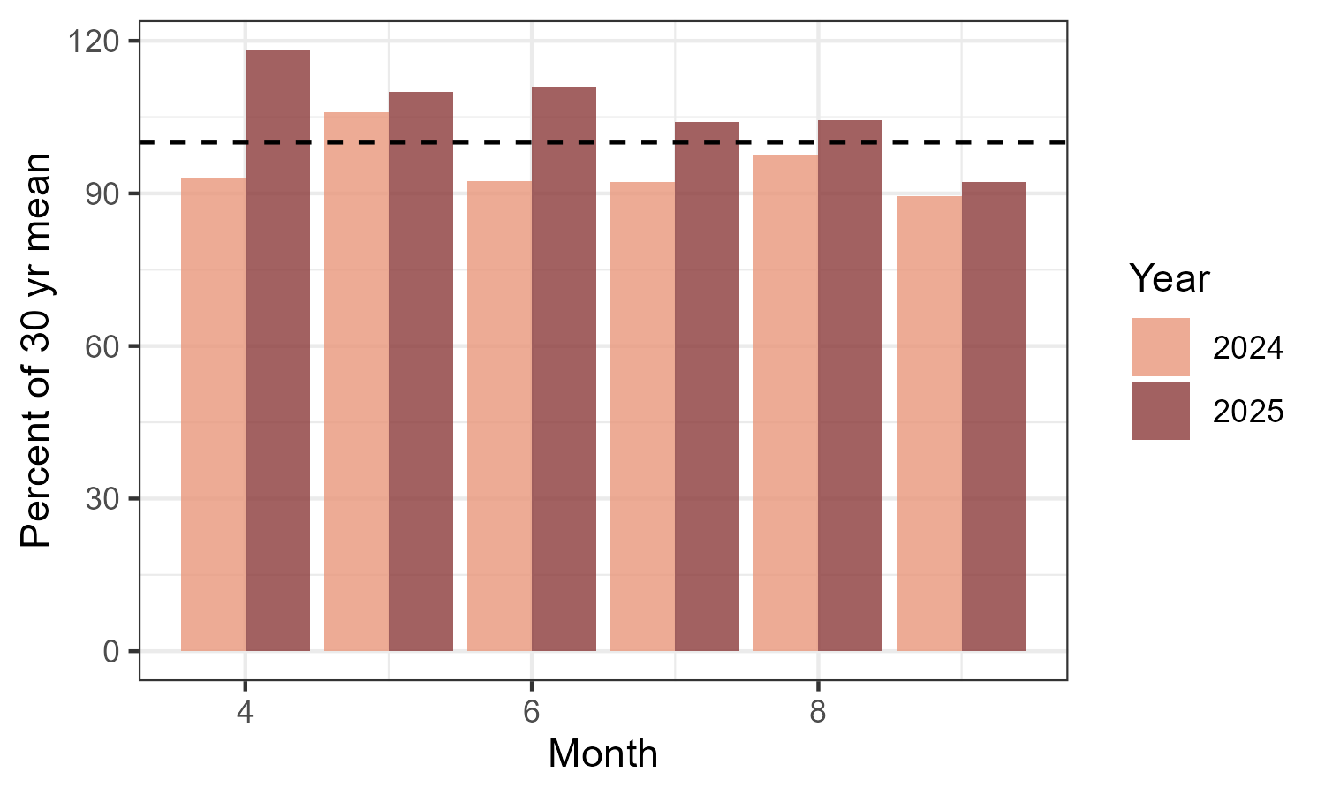Figure S3: Average mean monthly temperature (deg C) as a percentage of 30-year average monthly temperature (black dashed line represents the average) in 2024 & 2025. Weather data was collected from Winterbourne weather station.

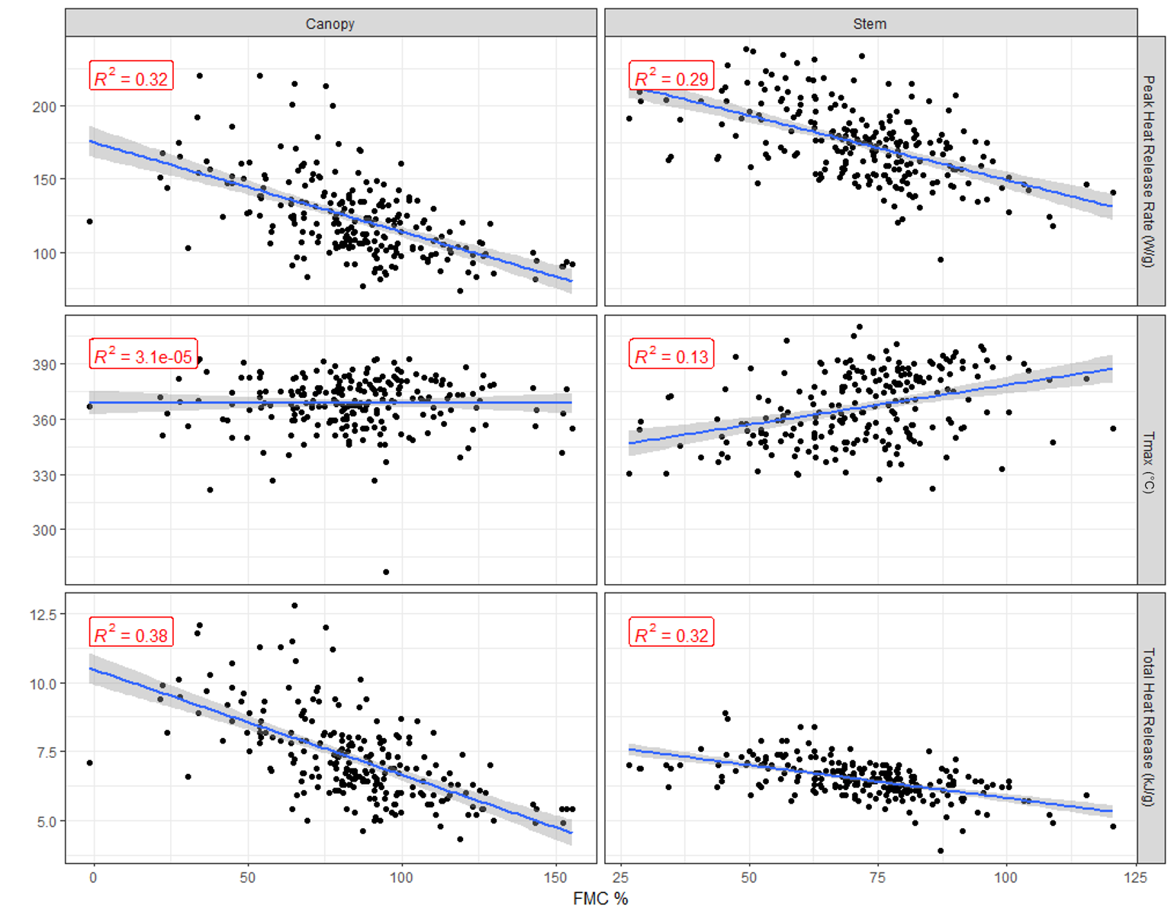
Figure S4: Relationship between fuel moisture content (FMC %) and flammability metrics for Calluna canopy and stem material.

