Supporting Information
TACO1 regulates mitochondrial adaptation in hypertension-induced cardiac remodeling and heart failure.
Berwin Singh Swami Vetha^{1,2†}, Ronald McMillan^{3†}, James Marchant^{4†}, Mohd Mabood Khan⁵, Joyonna Gamble-George^{6,7,8,9}, Jeremiah Afolabi¹⁰, Edgar Garza-Lopez¹¹, Andrea G. Marshall¹², Calixto Pablo Hernandez Perez⁶, Dillon Garbrandt¹, Bret Mobley¹², Jenny Schafer¹³, Max Kushner¹³, Oleg Kovtun¹⁴, Debra D. Murray¹⁵, Tonya Zeczycki¹⁶, Annet Kirabo^{10˒17}, Alexandre Colas⁴, Celestine Wanjalla², Dao-Fu Dai¹⁸, Melanie McReynolds¹⁹, Azeez Aileru^{1*}, Antentor Hinton Jr.^{6*}
†Co-first authors, *Co-corresponding authors and co-senior authors.
¹Department of Foundational Science, East Carolina University, Greenville, NC, USA
²Department of Pharmacology and Toxicology, East Carolina University, Greenville, NC, USA
³Department of Medicine, Division of Infectious Diseases, Vanderbilt University Medical Center, Nashville, TN, USA
⁴Development, Aging and Regeneration Program, Sanford Burnham Prebys Medical Discovery Institute, La Jolla, CA, USA
⁵Department of Medicine, Division of Genetic Medicine & Clinical Pharmacology, Vanderbilt University Medical Center, Nashville, TN, USA
⁶Department of Computer Science, Whiting School of Engineering, Johns Hopkins University, Baltimore, MD 21218, USA
⁷Department of Epidemiology, Harvard T.H. Chan School of Public Health, Boston, MA 02115, USA
⁸Department of Social and Behavioral Sciences, Yale School of Public Health, New Haven, CT, 06520, USA
⁹Environmental Sciences Graduate Program, Oregon State University, Corvalis, OR 97331, USA
¹⁰Department of Molecular Physiology and Biophysics, Vanderbilt University, Nashville, TN, USA
¹¹Department of Internal Medicine, University of Iowa, Iowa City, IA, USA
¹²Department of Pathology, Vanderbilt University Medical Center, Nashville, TN, USA
¹³Department of Cell and Developmental Biology, Vanderbilt University, Nashville, TN, USA
¹⁴Department of Chemistry, Vanderbilt University, Nashville, TN, USA
¹⁵Department of Molecular and Human Genetics, Baylor College of Medicine, Houston, TX, USA
¹⁶Department of Biochemistry and Molecular Biology, East Carolina University, Greenville, NC, USA
¹⁷Vanderbilt Institute for Global Health, Vanderbilt University Medical Center, Nashville, TN, USA
¹⁸Department of Pathology, Johns Hopkins University School of Medicine, Baltimore, MD, USA
¹⁹The Huck Institutes of the Life Sciences; Department of Biochemistry and Molecular Biology, Pennsylvania State University, University Park, PA, USA

Co-corresponding authors and co-senior authors.
Antentor Hinton Jr., PhD
Department of Molecular Physiology & Biophysics
Vanderbilt University, Nashville, TN, USA
Email: antentor.o.hinton.jr@vanderbilt.edu.
Azeez Aileru., PhD
Department of Foundational Science,
East Carolina University, Greenville, NC, USA
Email: ailerua19@ecu.edu

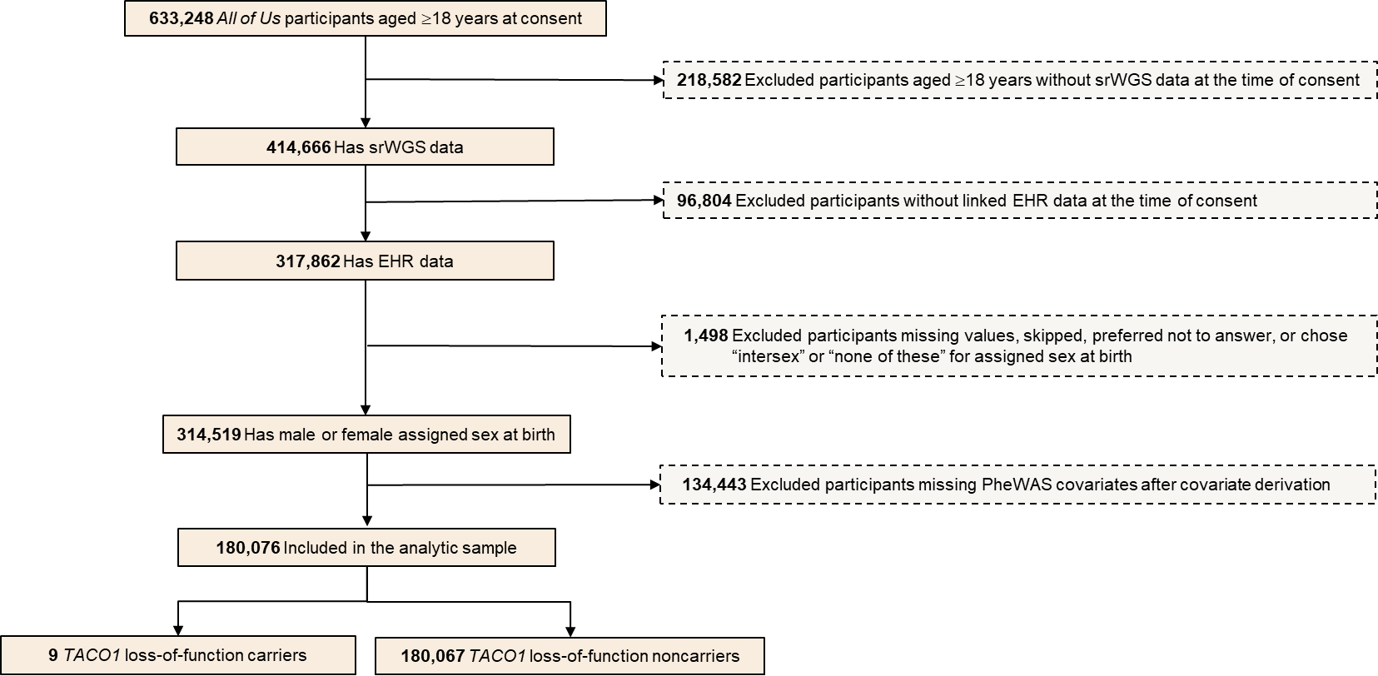
Figure S1. Flowchart of TACO1 loss-of-function carrier cohort selection for covariate-adjusted PheWAS analysis from the All of Us Research Program. Participants were selected from the All of Us Research Program using Controlled Tier Dataset version 8, including participants enrolled and consented through October 1, 2023. Among 633,248 participants aged ≥18 years at consent, participants without srWGS data, without linked EHR data, or with assigned sex at birth other than male or female or missing and declined responses were excluded. TACO1 rare predicted LoF carriers were defined using variants annotated as frameshift, splice-acceptor, splice-donor, or stop-gained, with allele frequency ≤0.01. This yielded an initial eligible case-control cohort of 314,519 participants, including 24 TACO1 LoF carriers and 314,495 noncarriers. After derivation of regression covariates and removal of participants with missing covariate data, the final covariate-complete analytic sample comprised 180,076 participants, including 9 TACO1 LoF carriers and 180,067 noncarriers (controls). srWGS, short-read whole-genome sequencing; EHR, electronic health record; LoF, loss-of-function.
Figure S2: Protein log₂ abundance (A-C) & relative abundance in heart Left Ventricle tissue (D-F).

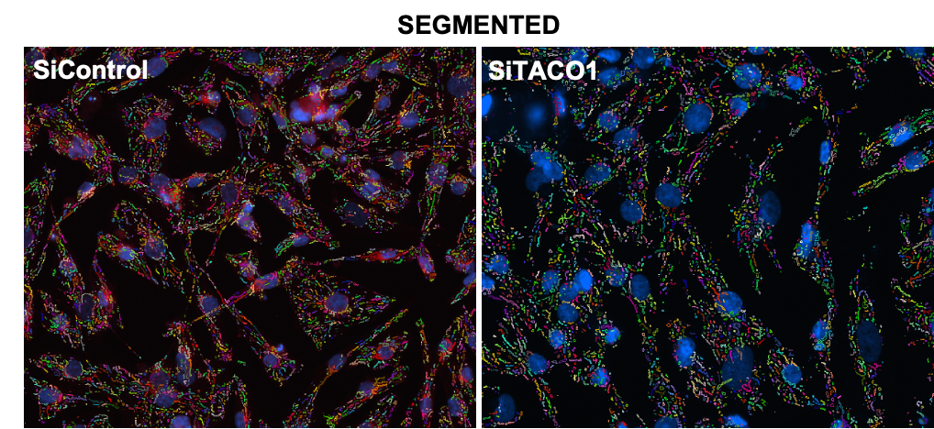
Figure S3: Ventricular-Like hiPSCs Mitochondrial segmentation imaging.

Figure S4: TACO1 loss reduces mitochondrial area and volume while increasing sphericity in HEK and HeLa cells. (A–E) Representative 3D-reconstructed fluorescence images of the mitochondrial network (green) in HEK cells treated with DMSO control (A), Mysl22 (B), Mfi8 (C), MiclXin (D), or Taco-1 (E). Scale bar = 7 μm. (F–H) Quantification of mitochondrial area (F), volume (G), and sphericity (H) in HEK cells across all conditions, displayed as violin plots. All treatment conditions show significant reductions in mitochondrial area and volume, and significant increases in sphericity, relative to DMSO-treated controls. (I–M) Representative 3D-reconstructed fluorescence images of the mitochondrial network in HeLa cells transfected with control (I), MiCOS (J), OPA1 (K), MFN2 (L), or Taco-1 (M) siRNA. Scale bar = 7 μm. (O–Q) Quantification of mitochondrial area (O), volume (P), and sphericity (Q) in HeLa cells across all knockdown conditions, displayed as violin plots. All knockdown conditions produced significant reductions in mitochondrial area and volume, and significant increases in sphericity, compared to control siRNA-transfected cells. Data represent individual mitochondrial measurements pooled across multiple cells and biological replicates. One-way ANOVA determined statistical significance with post-hoc multiple comparisons testing. ****p < 0.0001.
Figure S5. TACO1 knockdown drives peripheral redistribution of mitochondria in HeLA cells.
(A) Representative MitoTracker fluorescence images of HeLA cells transfected with control, MICOS, OPA1, MFN2, or TACO1 siRNA. Concentric circle overlays (yellow) are centered on the nucleus and define five radial zones used to quantify the subcellular distribution of mitochondria: nuclear, perinuclear, central, radial, and distal. (B) Quantification of MitoTracker fluorescence intensity (expressed as a percentage of total cellular signal) within each concentric zone for control (green), MICOS (blue), OPA1 (pink), MFN2 (purple), and TACO1 (orange, hatched) knockdown conditions. TACO1 depletion results in a significant shift the mitochondrial signal toward the radial and distal zones compared with all other conditions, indicating a peripheral redistribution of the mitochondrial network. Data represent mean ± SEM. One-way ANOVA determined statistical significance using one-way ANOVA with post hoc multiple comparisons. **p < 0.01, ***p < 0.001, ****p < 0.0001.
Figure S6: Peripheral redistribution of mitochondria in HeLa cells (MICOS, OPA1, MFN2, TACO1).

Table S1. Bonferroni and nominally significant circulatory and endocrine/metabolic phecodes associated with TACO1 loss-of-function carrier status in the All of Us cohort. Each row represents a phecode-defined circulatory or endocrine/metabolic phenotype nominally associated with TACO1 predicted loss-of-function carrier status in covariate-adjusted logistic regression. Carrier status was modeled as the independent variable of interest and phecode case status as the outcome, adjusting for age at last event, sex at birth, and the first five principal components. Cases and controls indicate the numbers of participants in the analytic cohort with and without the corresponding phecode. OR, odds ratio; CI, confidence interval.

Phecode | Phenotype | Category | Cases | Controls | Beta | OR (95% CI) | p-value
395.2 | Nonrheumatic aortic valve disorders | circulatory system | 5139 | 171762 | 4.321 | 75.262 (14.182, 399.415) | 3.87e-07
430.1 | Subarachnoid hemorrhage | circulatory system | 498 | 179226 | 4.012 | 55.249 (6.673, 457.145) | 1.99e-04
459.1 | Hemorrhage NOS | circulatory system | 625 | 177729 | 3.624 | 37.485 (4.522, 310.754) | 7.83e-04
246 | Other disorders of thyroid | endocrine/metabolic | 4703 | 171988 | 2.38 | 10.808 (2.04, 57.283) | 5.14e-03
430 | Intracranial hemorrhage | circulatory system | 1526 | 177609 | 2.94 | 18.919 (2.282, 156.805) | 6.44e-03
279.11 | Deficiency of humoral immunity | endocrine/metabolic | 1098 | 178482 | 2.899 | 18.161 (2.153, 153.086) | 7.69e-03
395.3 | Nonrheumatic tricuspid valve disorders | circulatory system | 1461 | 175677 | 2.904 | 18.249 (2.145, 155.4) | 7.86e-03
429.3 | Symptoms involving cardiovascular system | circulatory system | 6518 | 164610 | 2.164 | 8.702 (1.697, 44.612) | 9.48e-03
420.2 | Pericarditis | circulatory system | 1864 | 176445 | 2.724 | 15.234 (1.837, 126.343) | 1.16e-02
244 | Hypothyroidism | endocrine/metabolic | 23137 | 152523 | 1.787 | 5.969 (1.354, 26.311) | 1.83e-02
415.2 | Chronic pulmonary heart disease | circulatory system | 2291 | 176069 | 2.416 | 11.205 (1.34, 93.691) | 2.57e-02
420 | Carditis | circulatory system | 3057 | 174419 | 2.273 | 9.705 (1.162, 81.126) | 3.59e-02
429 | Ill-defined descriptions and complications of heart disease | circulatory system | 9915 | 159399 | 1.725 | 5.613 (1.074, 29.371) | 4.10e-02
250.41 | Impaired fasting glucose | endocrine/metabolic | 9523 | 166436 | 1.72 | 5.584 (1.05, 29.666) | 4.36e-02

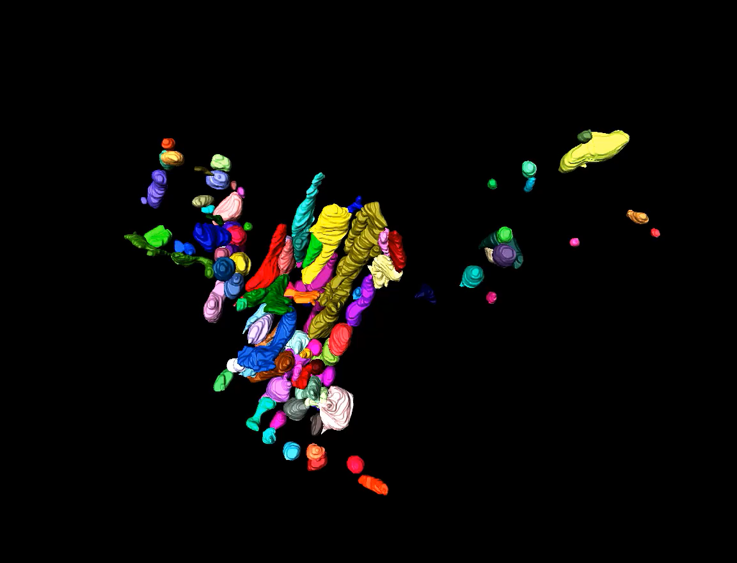
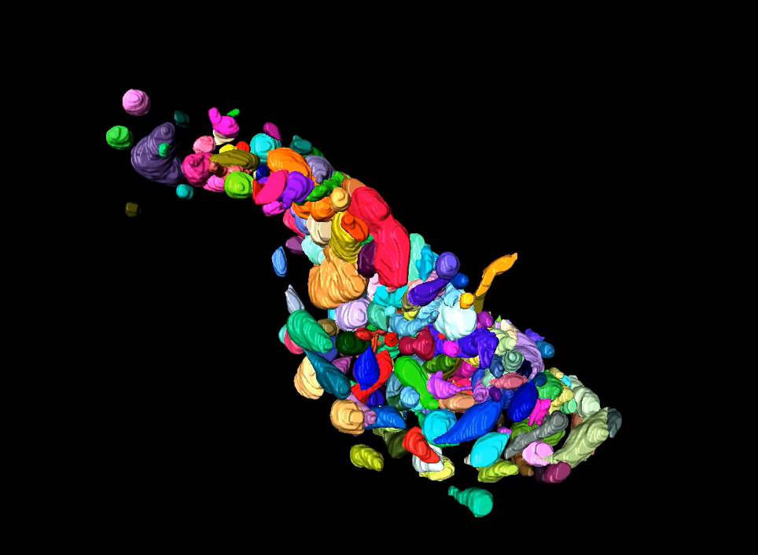
Movie 1: Representative video of three-dimensional mitochondrial reconstructions from Serial Block-Face Scanning Electron Microscopy volumes of heart failure sample. Rotational visualization of mitochondrial reconstruction from Subsarcolemmal in a heart failure subject.
Subsarcolemmal
Intermyofibrillar
Movie 2: Representative video of three-dimensional mitochondrial reconstructions from Serial Block-Face Scanning Electron Microscopy volumes of heart failure sample. Rotational visualization of mitochondrial reconstruction from Intermyofibrillar in a heart failure subject.

Perinuclear

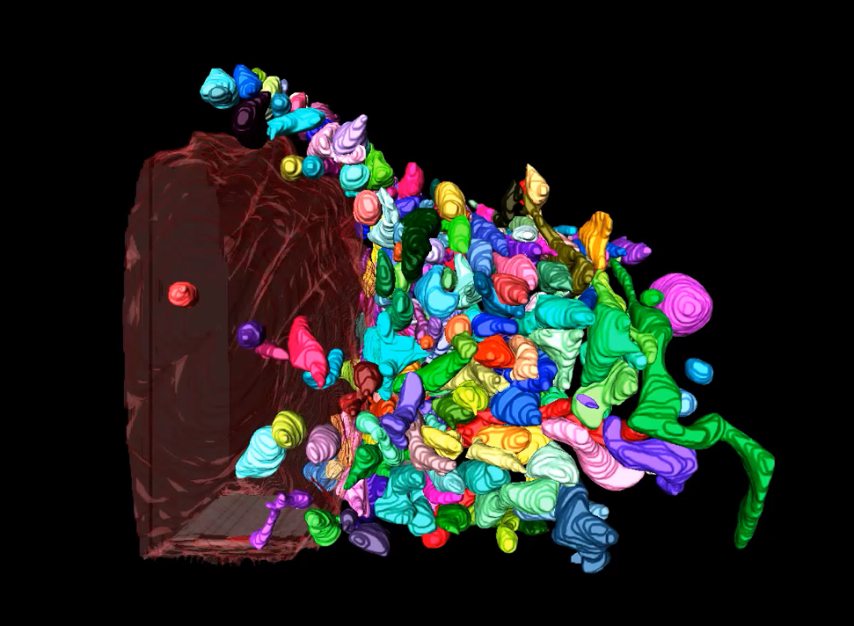
Movie 3: Representative video of three-dimensional mitochondrial reconstructions from Serial Block-Face Scanning Electron Microscopy volumes of heart failure sample. Rotational visualization of mitochondrial reconstruction from Perinuclear in a heart failure subject.

