Supplementary Material
Activation of chaperon-mediated autophagy via modulation of Hsp90 activity inhibits tumor growth under hypoxia
Jun-Kyu Byun, Sun Hee Lee, Ji-Hak Jeong, Eui Jung Moon, Myo-Hyeon Park, Hyeonha Jang, Douglas H. Weitzel, Hyun-Hwi Kim, Nikita Basnet, Chen-Ting Lee, Michael C. Fitzgerald, Robert A. Mook Jr., Bhargav A. Patel, Sung Jean Park, Im-Sook Song, Jen-Tsan Chi, Mark W. Dewhirst, Jiyong Hong, and You Mie Lee

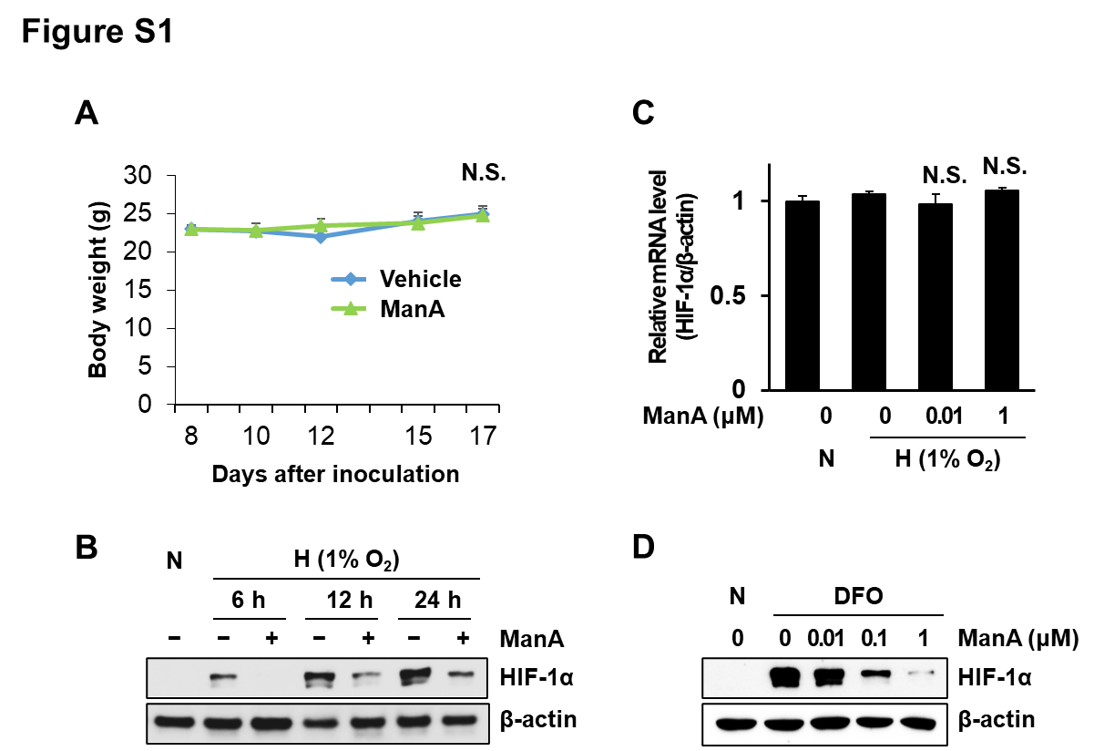

Figure S1
(A) Body weight in mice treated with vehicle or ManA as shown in Figure 1B. N.S., not significant.
(B) Western blot analysis of HIF-1α expression in HEK293T cells treated with ManA at indicated times under hypoxic conditions for 24 h.
(C) qRT-PCR analysis of HIF-1α mRNA expression in HEK293T cells with ManA at indicated concentrations under hypoxic conditions for 24 h. N.S., not significant
(D) Western blot analysis of HIF-1α expression in HEK293T cells treated with ManA at indicated concentrations in the presence of DFO (130 μM).

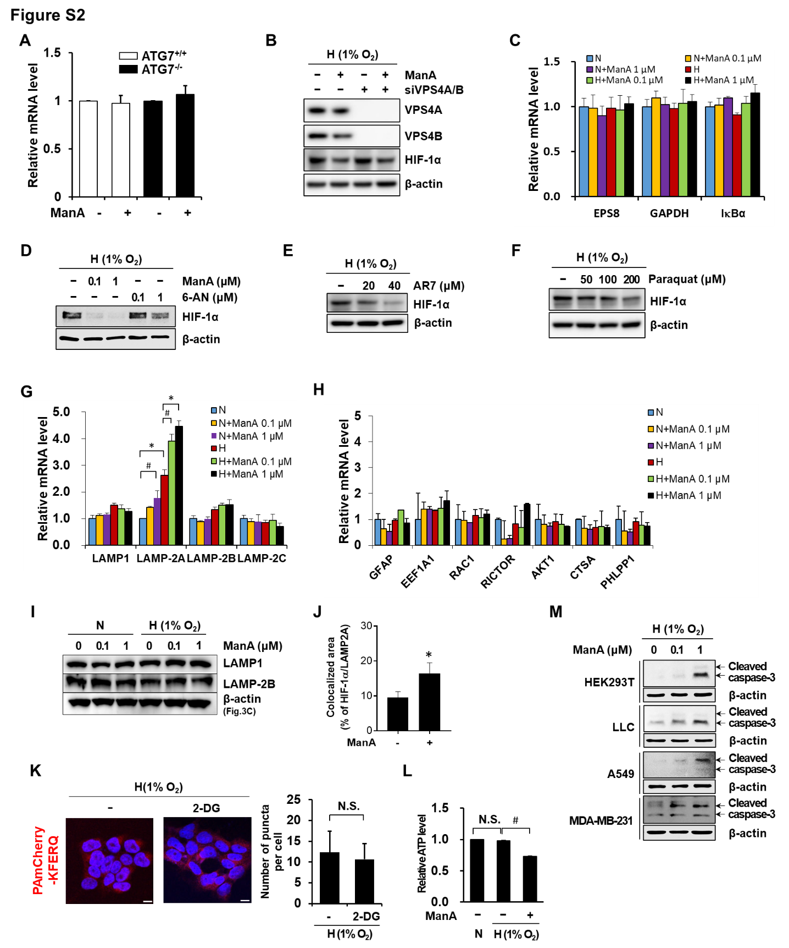

Figure S2
(A) qRT-PCR analysis of HIF-1α mRNA expression in HeLa wild type or ATG7 knockout (KO) cells treated with vehicle or ManA (1 μM) under hypoxic conditions for 24 h.
(B) Western blot analysis of HIF-1α expression in HEK293T cells transfected with scrambled or VPS4A and VPS4B siRNA (siVPS4A/B) for 24 h, followed by treatment with vehicle or ManA (1 μM) under hypoxic conditions for 24 h.
(C) qRT-PCR analysis of EPS8, GAPDH, and IκBα in HEK293T cells treated with indicated concentrations of ManA under normoxia or hypoxic conditions for 24 h
(D-F) Western blot analysis of HIF-1α expression in HEK293T cells treated with ManA, 6-AN, AR7, or Paraquat at indicated concentrations under hypoxic conditions for 24 h.
(G and H) qRT-PCR analysis of indicated genes in HEK293T cells treated with indicated concentrations of ManA under normoxia or hypoxic conditions for 24 h. #p < 0.05, *p < 0.005 between indicated two groups.
(I) Western blot analysis of LAMP1 and LAMP-2B in HEK293T cells treated with indicated concentrations of ManA under normoxia or hypoxic conditions for 24 h.
(J) The colocalized area (HIF-1α/LAMP-2A) was image-analyzed for quantification in Figure 3G.
(K) Immunofluorescence of PA-mCherry-KFERQ in photoactivated HEK293T cells treated with vehicle, ManA (1 μM) and 2-DG (2 mM) under hypoxic conditions for 24 h (Left). Scale bar = 10 µm. CMA activity was analyzed as the number of fluorescent puncta per cell (Right).
(L) ATP assay in HEK293T cells treated with vehicle or ManA (1 μM) under normoxic or hypoxic condition for 24 h. ATP levels were measured and data are normalized versus vehicle group (n=3). N.S., not significant; #p < 0.01 between indicated two groups.
(M) Western blot analysis of cleaved caspase-3 expression in various cells treated with ManA at indicated concentrations under hypoxic conditions for 2 days. Arrow indicates cleaved caspase-3 band (17/19 kDa)

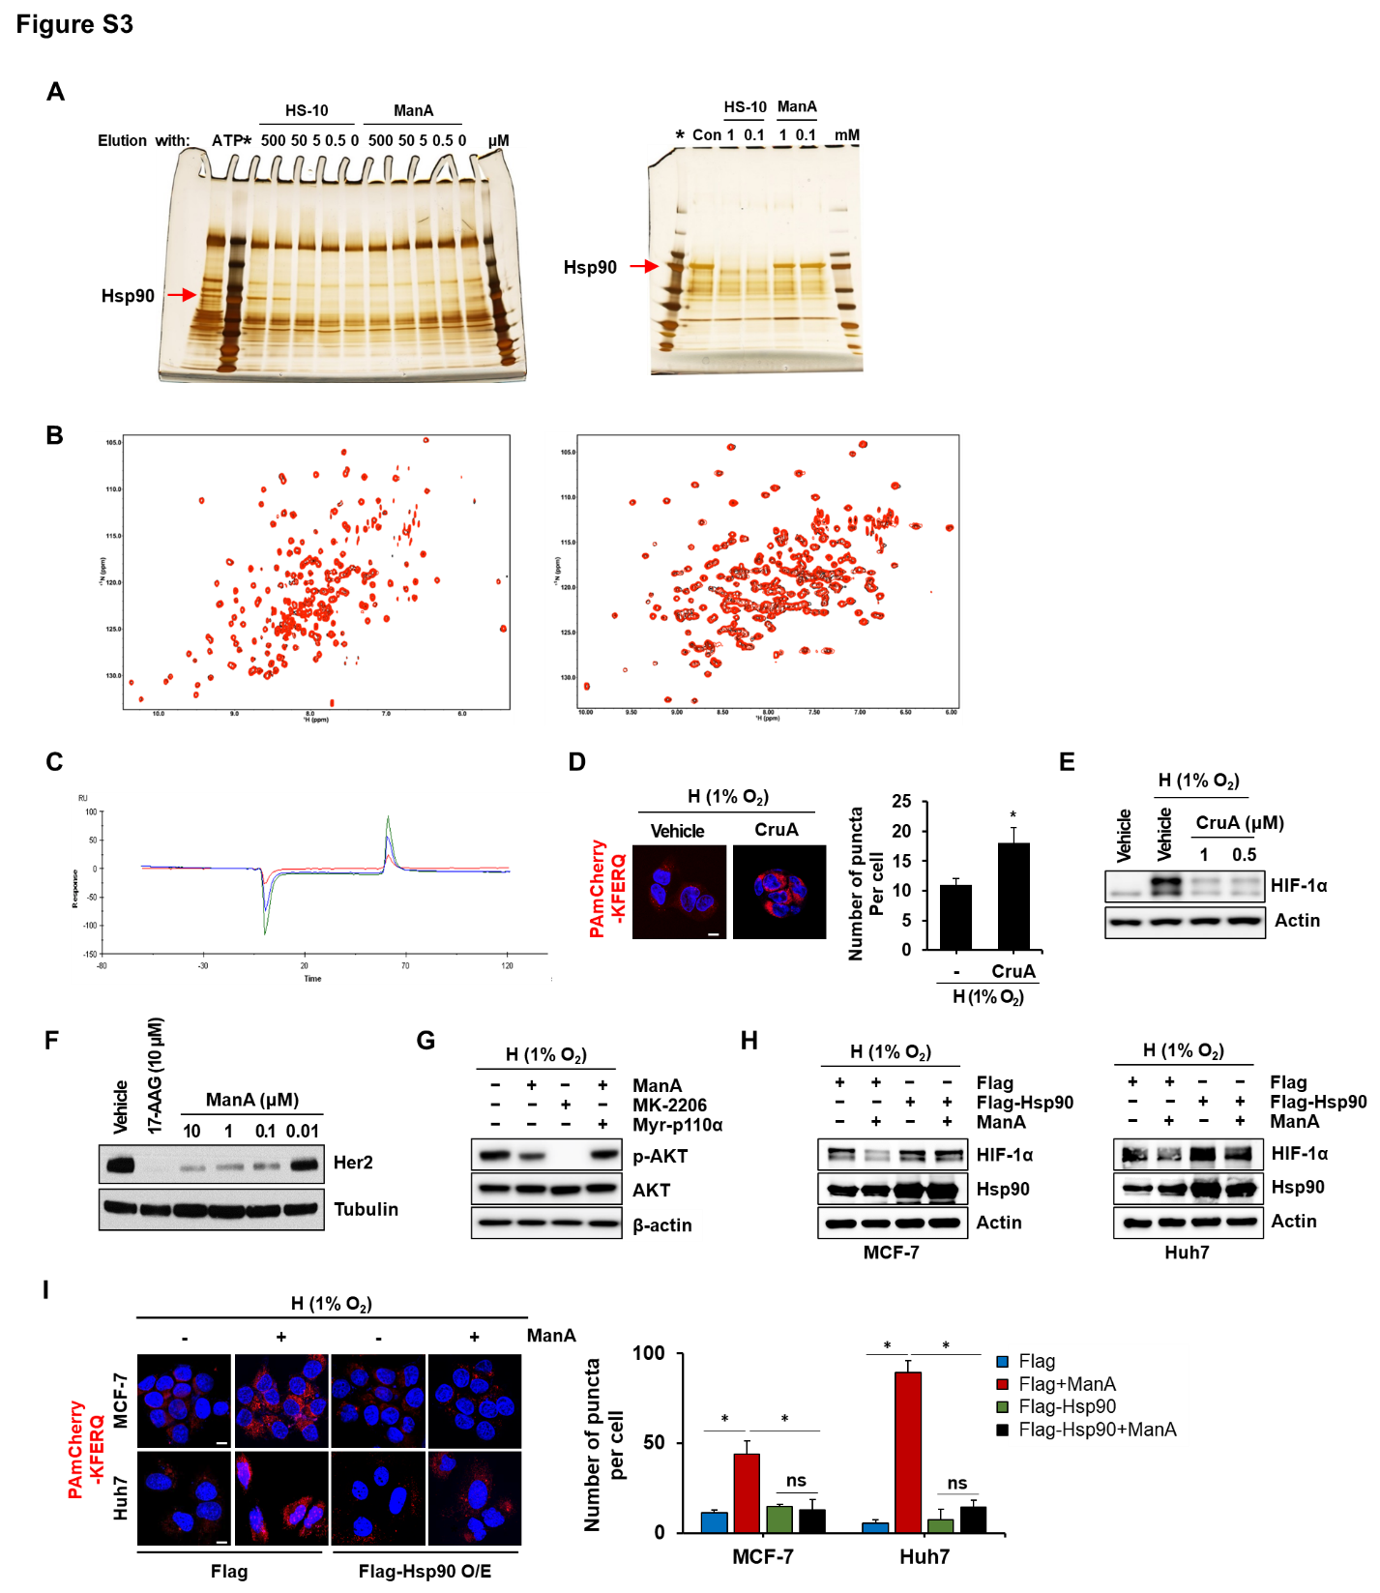Figure S3
(A) After mixed with pig mammary lysate, the gamma-phosphate linked ATP-sepharose slurry was treated with increasing concentrations of HS-10, ManA, or ATP (100 mM). The eluates were analysed by SDS/PAGE and silver staining (Left). Before binding to the HS-10 resin, each sample of lysate was pre-incubated with HS-10 or ManA. Following the pre-treatment, all samples were tumbled with 100 µL of a 50% slurry of resin. After 1 h of tumbling, the resin was washed 3× with a low stringency wash buffer. After the final wash, the buffer was completely aspirated, replaced with SDS sample buffer, and processed as above (Right). Protein ladder is indicated as asterisk.
(B) The TROSY spectra of apo N-terminal domain (black) and the mixture of the N-terminal domain and ManA (red) obtained in 10% DMSO supplemented with sodium phosphate buffer (pH 7.5). The concentration of the N-terminal domain was 100 μM and the concentration of mannassantin A was 200 μM (Left). The TROSY spectra of apo Middle domain (black) and the mixture of the Middle domain and ManA (red) obtained in the same buffer (pH 7.5). The concentration of the Middle domain was 100 μM and the concentration of ManA was 200 μM (Right).
(C) The GST-CTD protein was immobilized and the surface was injected with ManA at different concentrations. Kinetic sensorgrams of CTD-bound mannassantin A at 5 (red), 10 (blue), and 20 (green) μM are depicted.
(D) Immunofluorescence of PA-mCherry-KFERQ in photoactivated HEK293T cells treated with vehicle, cruentaren A (0.5 μM) under hypoxic conditions for 24 h (Left). Scale bar = 10 µm. CMA activity was analyzed as the number of fluorescent puncta per cell (Right). *p<0.05 vs Vehicle group.
(E) Western blot analysis of HIF-1α expression in HEK293T treated with cruentaren A under hypoxic conditions for 24 h.
(F) Western blot analysis of Her2 expression in BT-474 cells treated with ManA at indicated concentrations for 24 h.
(G) Western blot analysis of p-AKT and AKT expression in HEK293T cells expressing TFEB-3 X Flag transfected with control or Myr-p110α expression vector for 24 h, followed by treatment with vehicle, ManA (1 μM) or MK-2206 (1 μM) under hypoxic condition for 24 h.
(H) Western blot analysis of HIF-1α expression in MCF-7 and Huh7 transfected with control or Flag-HSP90α expression vector for 48 h, followed by treatment with vehicle or ManA (1 μM) under hypoxic condition for 24 h.
(I) Immunofluorescence of PA-mCherry-KFERQ in MCF-7 and Huh7 cells expressing Flag or Flag-Hsp90α, followed by treatment with vehicle or ManA (1 μM) under hypoxic conditions for 24 h (Left). Scale bar = 10 µm. CMA activity was analyzed as the number of fluorescent puncta per cell (Right). N.S., not significant; *p < 0.0001 vs. Vehicle group.
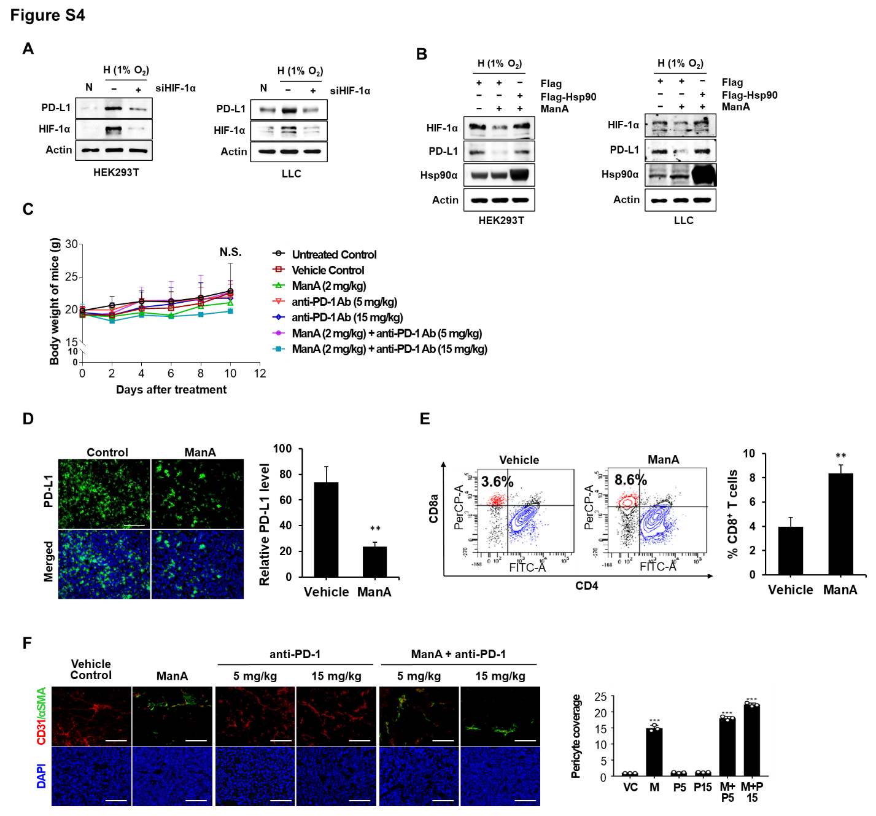

Figure S4
(A) Western blot analysis of PD-L1 and HIF-1α expression in HEK293T and LLC cells transfected with scrambled or HIF-1α siRNA (siHIF-1α) for 24 h, followed by incubation under hypoxic conditions for 24 h.
(B) Western blot analysis of PD-L1 and HIF-1α expression in HEK293T and LLC transfected with control or Flag-HSP90α expression vector for 48 h, followed by treatment with vehicle or ManA (1 μM) under hypoxic condition for 24 h.
(C) Body weight in C57BL/6 mice from Figure 6B. N.S., not significant
(D) IHC analysis against PD-L1 of frozen tumor tissue sections from Figure 6B (Left). Scale bar = 50 µm. The positive staining area was image-analyzed for quantification (Right). **p<0.01 vs. Vehicle control.
(E) FACS analysis depicting the cell number of CD8⁺ T cells in tumor tissues from Figure 6B. **p<0.01 vs. Vehicle control.
(F) IHC analysis against CD31 and αSMA of frozen tumor tissue sections from Figure 6B (Left). DAPI was used for nuclear staining. The positively stained area was image-analyzed for quantification (Right). ***p<0.001 vs. Vehicle control. VC, vehicle control; M, ManA (2 mg/kg); P5, Anti-PD-1 (5 mg/kg); P15, anti-PD-1 (15 mg/kg).

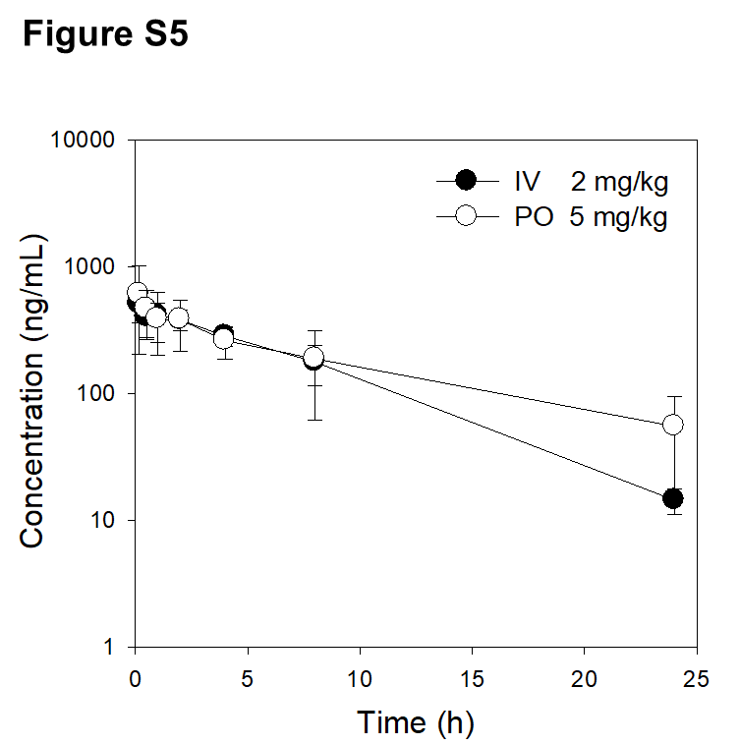
Figure S5
Plasma concentration-time profile of Man A in mice following an intravenous injection (IV, 2 mg/kg) and oral administration (PO, 5 mg/kg) of Man A. Data point represents the mean ± standard deviation (n = 3).

Supplementary Table 1. The top compound hits from the Connectivity Map (CMAP) analysis of ManA-induced transcriptional changes. Top matching compounds from the Connectivity Map based on the P value calculated from the CMAP scores. Score is based on the relative strength of a given signature in an instance from the total set of instances calculated upon execution of a query.

Rank | Compound Name | Mean CMAP Score | Enrichment
1 | geldanamycin | 0.43 | 0.62
2 | 17-AAG | 0.318 | 0.567
3 | trichostatin A | 0.3 | 0.448
4 | valproic acid | 0.23 | 0.353
5 | vorinostat | 0.415 | 0.633
6 | alvespimycin | 0.339 | 0.569
7 | 1,4-chrysenequinone | 0.695 | 0.98
8 | thioridazine | 0.258 | 0.427
9 | MS-275 | 0.8 | 0.974
10 | dipyridamole | 0.457 | 0.708
11 | verteporfin | 0.522 | 0.894
12 | prochlorperazine | 0.295 | 0.434
13 | mitoxantrone | 0.649 | 0.886
14 | irinotecan | 0.627 | 0.883
15 | cephaeline | 0.416 | 0.729
16 | clioquinol | 0.32 | 0.72
17 | colforsin | 0.372 | 0.72
18 | hyoscyamine | -0.316 | -0.717
19 | trifluoperazine | 0.283 | 0.416
20 | niclosamide | 0.406 | 0.706
21 | diflorasone | -0.404 | -0.774
22 | amiprilose | -0.444 | -0.77
23 | zidovudine | -0.415 | -0.762
24 | meclozine | 0.451 | 0.684
25 | cytisine | -0.336 | -0.74
26 | ursolic acid | -0.438 | -0.732

Supplementary Table 2. Pharmacokinetic parameters of Man A in mice.

Parameters | IV (2 mg/kg) | PO (10 mg/kg)
T½ (h) | 4.6 ± 0.2 | 6.9 ± 2.5
C_{o} or C_{max} (ng/mL) | 491.4 ± 211.6 | 627.3 ± 389.3
T_{max} (h) |  | 0.17±0.0
AUC (ng∙h/mL) | 4045.9 ± 657.2 | 5098.6 ± 2546.0
MRT (h) | 6.1 ± 0.9 | 11.3 ± 4.4
CL (mL/min/kg) | 8.6 ± 1.5
V_{dss} (L/kg) | 3.2 ± 0.7
BA (%) |  | 43.5

T½: Elimination half-life; C_{o:} initial concentration after intravenous injection; C_{max:} maximum concentration after oral administration; T_{max:} time to reach C_{max;} AUC: Area under plasma concentration curve; MRT: mean residence time; CL: clearance calculated by dividing dose by AUC; V_{dss:} volume of distribution at steady state, BA: bioavailability. Data expressed as the mean ± standard deviation (n = 3).

Supplementary Table 3. (A) Plasma stability and metabolic stability of Man A and (B) the apparent permeability (Papp) of Man A in Caco-2 monolayer

(A) | Compounds | Stability (% remaining)
(A) | Compounds | mouse | human
Plasma  (t = 2 h) | Man A | 96.8 ± 5.7 | 95.0 ± 3.5
Plasma  (t = 2 h) | Propranolol | - | 98.7 ± 4.4
Plasma  (t = 2 h) | Metformin | - | 98.7 ± 5.6
Liver microsomes  (t = 1 h) | Man A | 103.4 ± 3.8 | 71.7 ± 9.0
Liver microsomes  (t = 1 h) | Propranolol |  | 17.8 ± 2.3
Liver microsomes  (t = 1 h) | Metformin |  | 69.3 ± 3.0

(B) | Compounds | Papp (× 10⁻⁶ cm/s) |  | Efflux ratio
(B) | Compounds | Absorptive | Secretory | Efflux ratio
 | Man A | 9.2 ± 1.0 | 6.5 ± 0.1 | 0.71
Low Papp | atenolol | 0.33 ± 0.1 | 0.32 ± 0.2 | 0.98
Moderate Papp | Ofloxacin | 5.3 ± 1.6 | 4.7 ± 0.3 | 0.89
High Papp | Propranolol | 19.9 ± 4.0 | 19.4 ± 1.5 | 0.97
High Papp | Caffeine | 35.1 ± 1.0 | 31.6 ± 2.2 | 0.90
Involvement of efflux pump | paclitaxel | 0.13 ± 0.02 | 2.9 ± 0.5 | 22
Data expressed as the mean ± standard deviation (n = 3).

