Supplementary Material

Consultation rates in people with type 2 diabetes with and without vascular complications: A retrospective analysis of 141,328 adults in England

Sophia Abner, Statistician/Epidemiologist, Leicester Real World Evidence Unit, Diabetes Research Centre, Leicester General Hospital, University of Leicester, Leicester, LE5 4PW, UK
Clare L Gillies, Lecturer in Medical Statistics, Leicester Real World Evidence Unit, Diabetes Research Centre, Leicester General Hospital, University of Leicester, Leicester, LE5 4PW, UK
Sharmin Shabnam, Data Scientist, Leicester Real World Evidence Unit, Diabetes Research Centre, Leicester General Hospital, University of Leicester, Leicester, LE5 4PW, UK
Francesco Zaccardi, Clinical Epidemiologist, Leicester Real World Evidence Unit, Diabetes Research Centre, Leicester General Hospital, University of Leicester, Leicester, LE5 4PW, UK
Samuel Seidu, Clinical Lecturer in Primary Care, , Leicester Diabetes Centre, Leicester General Hospital, Leicester, LE5 4PW, UK
Melanie J Davies, Professor of Diabetes Medicine, National Institute for Health Research Biomedical Research Centre, Leicester Diabetes Centre, Leicester, LE5 4PW, UK
Tobi Adeyemi, MSD UK Limited, London, EC2M 6UR, UK
Kamlesh Khunti*, Professor of Primary Care Diabetes and Vascular Medicine, National Institute for Health Research (NIHR) Applied Research Collaboration - East Midlands (ARC-EM), Leicester Diabetes Centre, Leicester, LE5 4PW, UK
David Webb*, Senior Lecturer in Diabetes Medicine, Leicester Diabetes Centre, Leicester General Hospital, Leicester, LE5 4PW, UK

Contents
Table S1. Type 2 Diabetes - Medical codes (CPRD) and ICD-10 codes (HES) 3
Table S2. Coronary heart disease/Myocardial infarction - Medical codes (CPRD) and ICD-10 codes (HES) 6
Table S3. Stroke/Cerebrovascular accidents - Medical codes (CPRD) and ICD-10 codes (HES) 8
Table S4. Severe CKD - Medical codes (CPRD) and ICD-10 codes (HES) 12
Table S5. Consultation type codes used to identify consultations in CPRD 14
Table S6. Staff role codes used to identify acceptable staff roles for consultations in CPRD 14
Figure S1: Study population flow diagram. 15
Figure S2. Annual crude consultation rates for primary and secondary care consultation, by exposure status and ethnicity 16
Figure S3. Annual crude consultation rate for primary and secondary care consultation, by exposure status and sex 17
Figure S4. Annual crude consultation rate for primary and secondary care consultation, by exposure status and age 18
Figure S5. Mean consultation duration for primary care consultation, by exposure status and sex 19
Figure S6. Mean consultation duration for primary care consultation, by exposure status and ethnicity 20
Figure S7. Mean consultation duration for primary care consultation, by exposure status and age 21

Table S1. Type 2 Diabetes - Medical codes (CPRD) and ICD-10 codes (HES)
ICD Codes | Description
E11.xx | Non-insulin dependent diabetes
O24.1 | Pre-existing diabetes mellitus, non-insulin-dependent

Medcode | Description
64668 | Insulin treated Type II diabetes mellitus
106061 | Type II diabetes mellitus with ketoacidotic coma
101801 | Type II diabetic dietary review
36633 | Hyperosmolar non-ketotic state in type 2 diabetes mellitus
28769 | Diabetic on insulin and oral treatment
17262 | Non-insulin-dependent diabetes mellitus with retinopathy
62674 | Type 2 diabetes mellitus with mononeuropathy
61071 | Type 2 diabetes mellitus with hypoglycaemic coma
26054 | Type 2 diabetes mellitus with persistent proteinuria
39317 | Diabetes mellitus, adult onset, + neurological manifestation
108005 | Type 2 diabetes mellitus with multiple complications
98616 | Type II diabetes mellitus with neurological complications
35385 | Type 2 diabetes mellitus with neuropathic arthropathy
40401 | Non-insulin dependent diabetes mellitus with gangrene
111798 | Type II diabetes mellitus with exudative maculopathy
49074 | Type 2 diabetes mellitus with ulcer
1407 | Insulin treated Type 2 diabetes mellitus
63357 | Diabetes mellitus, adult, + peripheral circulatory disorder
25041 | Dietary advice for type II diabetes
18278 | Insulin treated Type 2 diabetes mellitus
50527 | Type II diabetes mellitus with polyneuropathy
107701 | Hyperosmolar non-ketotic state in type II diabetes mellitus
37806 | Type 2 diabetes mellitus with peripheral angiopathy
758 | Type 2 diabetes mellitus
36695 | Diabetes mellitus autosomal dominant type 2
24693 | Non-insulin dependent diabetes mellitus with arthropathy
51756 | Type 2 diabetes mellitus with ketoacidotic coma
69278 | Non-insulin depend diabetes mellitus with diabetic cataract
18390 | Type 2 diabetes mellitus with persistent microalbuminuria
58604 | Type II diabetes mellitus with retinopathy
42762 | Type 2 diabetes mellitus with retinopathy
95351 | Type II diabetes mellitus with mononeuropathy
104639 | Type II diabetes mellitus with peripheral angiopathy
56268 | Type II diabetes mellitus with hypoglycaemic coma
34268 | Type 2 diabetes mellitus with neurological complications
34912 | Non-insulin dependent diabetes mellitus with ulcer

25591 | Type 2 diabetes mellitus with exudative maculopathy
47954 | Type 2 diabetes mellitus without complication
107824 | Type II diabetes mellitus in remission
98723 | Type II diabetes mellitus with hypoglycaemic coma
59253 | Type 2 diabetes mellitus with arthropathy
34450 | Hyperosmolar non-ketotic state in type 2 diabetes mellitus
37648 | Insulin treated non-insulin dependent diabetes mellitus
18264 | Insulin treated Type II diabetes mellitus
48192 | Type II diabetes mellitus with diabetic cataract
70316 | Type 2 diabetes mellitus with ophthalmic complications
59725 | Type II diabetes mellitus with ophthalmic complications
57278 | Type II diabetes mellitus with renal complications
64571 | Type II diabetes mellitus with nephropathy
24836 | Type 2 diabetes mellitus with nephropathy
63762 | Diabetes mellitus, adult onset, + unspecified complication
50609 | Pre-existing diabetes mellitus, non-insulin-dependent
55842 | Non-insulin-dependent diabetes mellitus with neuro comps
65267 | Type 2 diabetes mellitus with multiple complications
35105 | Diabetes mellitus, adult onset, with renal manifestation
41389 | Diabetes mellitus, adult onset, + ophthalmic manifestation
62146 | Non-insulin-dependent diabetes mellitus with multiple comps
65704 | Type 2 diabetes mellitus with ulcer
55075 | Type II diabetes mellitus with ulcer
104323 | Type II diabetes mellitus with gangrene
53392 | Type II diabetes mellitus without complication
110611 | Type 2 diabetes mellitus in remission
46917 | Type 2 diabetes mellitus with hypoglycaemic coma
66965 | Type 2 diabetes mellitus with neuropathic arthropathy
43139 | Diabetes mellitus, adult onset, with hyperosmolar coma
12640 | Type 2 diabetes mellitus with nephropathy
44779 | Type 2 diabetes mellitus with diabetic cataract
1684 | Diabetic on oral treatment
103902 | Type II diabetes mellitus with arthropathy
54899 | Type II diabetes mellitus with peripheral angiopathy
60699 | Type 2 diabetes mellitus with peripheral angiopathy
105784 | Type 2 diabetes mellitus without complication
109103 | Type II diabetes mellitus without complication
50429 | Non-insulin-dependent diabetes mellitus with ophthalm comps
18777 | Type 2 diabetes mellitus with renal complications
59365 | Non-insulin dependent diabetes mellitus with nephropathy
12736 | Type 2 diabetes mellitus with gangrene
47816 | Type II diabetes mellitus with neuropathic arthropathy
67905 | Type II diabetes mellitus with neurological complications
45919 | Type 2 diabetes mellitus with neurological complications
43227 | Type II diabetes mellitus with multiple complications
33807 | Diabetes mellitus, adult with gangrene
110344 | Diabetic on non-insulin injectable medication
49655 | Type II diabetes mellitus with retinopathy
106528 | Type II diabetes mellitus with ketoacidosis

44982 | Type 2 diabetes mellitus with diabetic cataract
4513 | Non-insulin dependent diabetes mellitus
47321 | Type 2 diabetes mellitus with ophthalmic complications
24458 | Type II diabetes mellitus - poor control
45913 | Type 2 diabetes mellitus - poor control
50813 | Type II diabetes mellitus with mononeuropathy
102201 | Type II diabetes mellitus with nephropathy
52303 | Non-insulin-dependent diabetes mellitus with renal comps
29979 | Non-insulin-dependent diabetes mellitus without complication
45467 | Non-insulin dependent diabetes mellitus with polyneuropathy
68843 | Diabetes mellitus, adult onset, with ketoacidotic coma
63371 | Diabetes mellitus, adult, + other specified manifestation
14803 | Diabetes mellitus, adult onset, no mention of complication
18496 | Type 2 diabetes mellitus with retinopathy
50225 | Type II diabetes mellitus with renal complications
32627 | Type 2 diabetes mellitus with ketoacidosis
102611 | Type 2 diabetic dietary review
93727 | Type II diabetes mellitus with diabetic cataract
5884 | NIDDM - Non-insulin dependent diabetes mellitus
17859 | Type 2 diabetes mellitus
47315 | Type II diabetes mellitus - poor control
100964 | Type II diabetes mellitus with ophthalmic complications
43785 | Non-insulin dependent diabetes mellitus with hypoglyca coma
60796 | Type II diabetes mellitus with persistent proteinuria
8403 | Non-insulin dependent diabetes mellitus - poor control
72320 | Non-insulin dependent diabetes mellitus with mononeuropathy
109197 | Type II diabetes mellitus with neuropathic arthropathy
103597 | Family history of diabetes mellitus type II
54856 | Diabetes mellitus, adult onset, with ketoacidosis
63690 | Type 2 diabetes mellitus with gastroparesis
18209 | Type 2 diabetes mellitus with renal complications
47409 | Type II diabetes mellitus with polyneuropathy
109865 | Type 2 diabetes mellitus with polyneuropathy
14889 | Maturity onset diabetes
46150 | Type 2 diabetes mellitus with gangrene
62107 | Type II diabetes mellitus with gangrene
91646 | Type II diabetes mellitus with ulcer
25627 | Type 2 diabetes mellitus - poor control
18219 | Type II diabetes mellitus
18143 | Type II diabetes mellitus with arthropathy
506 | Non-insulin dependent diabetes mellitus
22884 | Type II diabetes mellitus
59991 | Maturity onset diabetes in youth type 2
49869 | Type 2 diabetes mellitus with arthropathy

Table S2. Coronary heart disease/Myocardial infarction - Medical codes (CPRD) and ICD-10 codes (HES)
ICD-10 | Description
I21 | Acute myocardial infarction
I22 | Subsequent myocardial infarction
I23 | Certain current complications following acute myocardial infarction
I24 | Other acute ischaemic heart diseases

Medcode | Description
Myocardial Infarction
241 | acute myocardial infarction
1677 | mi - acute myocardial infarction
1678 | inferior myocardial infarction nos
3704 | acute subendocardial infarction
4017 | old myocardial infarction
5387 | other specified anterior myocardial infarction
7783 | ecg: myocardial infarction
8935 | acute inferolateral infarction
9413 | other acute and subacute ischaemic heart disease
9507 | acute non-q wave infarction
10562 | acute non-st segment elevation myocardial infarction
12139 | acute anterolateral infarction
12229 | acute st segment elevation myocardial infarction
12743 | revascularisation of wall of heart
14658 | acute myocardial infarction nos
14897 | anterior myocardial infarction nos
14898 | lateral myocardial infarction nos
16408 | healed myocardial infarction
17464 | personal history of myocardial infarction
17689 | silent myocardial infarction
17872 | acute anteroseptal infarction
18842 | subsequent myocardial infarction
23579 | postmyocardial infarction syndrome
23892 | posterior myocardial infarction nos
27951 | other acute and subacute ischaemic heart disease
28736 | acute atrial infarction
29643 | acute inferoposterior infarction
29758 | acute transmural myocardial infarction of unspecif site
30421 | cardiac rupture following myocardial infarction (mi)
32272 | postoperative myocardial infarction
32854 | acute posterolateral myocardial infarction
34803 | other acute myocardial infarction

35119 | post infarction pericarditis
35674 | h/o: myocardial infarct <60
36423 | certain current complication follow acute myocardial infarct
38609 | subsequent myocardial infarction of inferior wall
39904 | ecg: old myocardial infarction
40399 | h/o: myocardial infarct >60
40429 | acute anteroapical infarction
41221 | acute septal infarction
45809 | subsequent myocardial infarction of anterior wall
46017 | other acute myocardial infarction nos
46112 | postoperative transmural myocardial infarction anterior wall
46166 | subsequent myocardial infarction of unspecified site
46276 | postoperative transmural myocardial infarction inferior wall
50372 | h/o: myocardial infarction in last year
52705 | ecg: lateral infarction
59032 | ecg: myocardial infarct nos
61670 | diab mellit insulin-glucose infus acute myocardial infarct
62626 | acute papillary muscle infarction
63467 | true posterior myocardial infarction
68401 | [x]other forms of acute ischaemic heart disease
68748 | postoperative myocardial infarction, unspecified
72562 | subsequent myocardial infarction of other sites
95550 | admit ischaemic heart disease emergency
96838 | [x]acute transmural myocardial infarction of unspecif site
99991 | [x]subsequent myocardial infarction of unspecified site
100139 | history of myocardial infarction
100437 | exception reporting: myocardial infarction quality indicator
102917 | exc myocar infarction quality indicators: patient unsuitable
106812 | postoperative transmural myocardial infarction unspec site
109035 | [x]subsequent myocardial infarction of other sites

Table S3. Stroke/Cerebrovascular accidents - Medical codes (CPRD) and ICD-10 codes (HES)
ICD-10 |  | Description
 | Intracranial haemorrhages
I60 |  | Subarachnoid haemorrhage
I60.0 |  | Subarachnoid haemorrhage from carotid siphon and bifurcation
I60.1 |  | Subarachnoid haemorrhage from middle cerebral artery
I60.2 |  | Subarachnoid haemorrhage from anterior communicating artery
I60.3 |  | Subarachnoid haemorrhage from posterior communicating artery
I60.4 |  | Subarachnoid haemorrhage from basilar artery
I60.5 |  | Subarachnoid haemorrhage from vertebral artery
I60.6 |  | Subarachnoid haemorrhage from other intracranial arteries
I60.7 |  | Subarachnoid haemorrhage from intracranial artery, unspecified
I60.8 |  | Other subarachnoid haemorrhage
I60.9 |  | Subarachnoid haemorrhage, unspecified
I61 |  | Intracerebral haemorrhage
I61.0 |  | Intracerebral haemorrhage in hemisphere, subcortical
I61.1 |  | Intracerebral haemorrhage in hemisphere, cortical
I61.2 |  | Intracerebral haemorrhage in hemisphere, unspecified
I61.3 |  | Intracerebral haemorrhage in brain stem

I61.4 |  | Intracerebral haemorrhage in cerebellum
I61.5 |  | Intracerebral haemorrhage, intraventricular
I61.6 |  | Intracerebral haemorrhage, multiple localized
I61.8 |  | Other intracerebral haemorrhage
I61.9 |  | Intracerebral haemorrhage, unspecified
I62 |  | Other nontraumatic intracranial haemorrhage
I62.0 |  | Subdural haemorrhage (acute)(nontraumatic)
I62.1 |  | Nontraumatic extradural haemorrhage
I62.9 |  | Intracranial haemorrhage (nontraumatic), unspecified
 | Cerebrovascular diseases
I63 |  | Cerebral infarction
I63.0 |  | Cerebral infarction due to thrombosis of precerebral arteries
I63.1 |  | Cerebral infarction due to embolism of precerebral arteries
I63.2 |  | Cerebral infarction due to unspecified occlusion or stenosis of precerebral arteries
I63.3 |  | Cerebral infarction due to thrombosis of cerebral arteries
I63.4 |  | Cerebral infarction due to embolism of cerebral arteries
I63.5 |  | Cerebral infarction due to unspecified occlusion or stenosis of cerebral arteries
I63.6 |  | Cerebral infarction due to cerebral venous thrombosis, nonpyogenic
I63.8 |  | Other cerebral infarction
I63.9 |  | Cerebral infarction, unspecified
I64 |  | Stroke, not specified as haemorrhage or infarction
I65 |  | Occlusion and stenosis of precerebral arteries, not resulting in cerebral infarction
I65.0 |  | Occlusion and stenosis of vertebral artery
I65.1 |  | Occlusion and stenosis of basilar artery
I65.2 |  | Occlusion and stenosis of carotid artery
I65.3 |  | Occlusion and stenosis of multiple and bilateral precerebral arteries
I65.8 |  | Occlusion and stenosis of other precerebral artery
I65.9 |  | Occlusion and stenosis of unspecified precerebral artery
I66 |  | Occlusion and stenosis of cerebral arteries, not resulting in cerebral infarction
I66.0 |  | Occlusion and stenosis of middle cerebral artery
I66.1 |  | Occlusion and stenosis of anterior cerebral artery
I66.2 |  | Occlusion and stenosis of posterior cerebral artery
I66.3 |  | Occlusion and stenosis of cerebellar arteries
I66.4 |  | Occlusion and stenosis of multiple and bilateral cerebral arteries
I66.8 |  | Occlusion and stenosis of other cerebral artery
I66.9 |  | Occlusion and stenosis of unspecified cerebral artery
I67 |  | Other cerebrovascular diseases
I67.0 |  | Dissection of cerebral arteries, nonruptured
I67.1 |  | Cerebral aneurysm, nonruptured
I67.2 |  | Cerebral atherosclerosis
I67.3 |  | Progressive vascular leukoencephalopathy
I67.4 |  | Hypertensive encephalopathy
I67.5 |  | Moyamoya disease
I67.6 |  | Nonpyogenic thrombosis of intracranial venous system
I67.7 |  | Cerebral arteritis, not elsewhere classified

I67.8 | Other specified cerebrovascular diseases
I67.9 | Cerebrovascular disease, unspecified
I68 | Cerebrovascular disorders in diseases classified elsewhere
I68.0 | Cerebral amyloid angiopathy
I68.1 | Cerebral arteritis in infectious and parasitic diseases classified elsewhere
I68.2 | Cerebral arteritis in other diseases classified elsewhere
I68.8 | Other cerebrovascular disorders in diseases classified elsewhere
I69 | Sequelae of cerebrovascular disease
I69.0 | Sequelae of subarachnoid haemorrhage
I69.1 | Sequelae of intracerebral haemorrhage
I69.2 | Sequelae of other nontraumatic intracranial haemorrhage
I69.3 | Sequelae of cerebral infarction
I69.4 | Sequelae of stroke, not specified as haemorrhage or infarction
I69.8 | Sequelae of other and unspecified cerebrovascular diseases

Medcode | Description
1433 | transient ischaemic attack
1469 | stroke and cerebrovascular accident unspecified
2418 | cerebrovascular disease
2760 | peripheral vascular disease nos
3149 | cerebral infarction nos
3530 | peripheral vascular disease nos
5141 | congestive cardiomyopathy
5602 | cerebellar infarction
5702 | peripheral ischaemic vascular disease
5871 | h/o: stroke
6116 | cva - cerebrovascular accident unspecified
6228 | sequelae of stroke,not specfd as h'morrhage or infarction
6960 | cva - cerebrovascular accid due to intracerebral haemorrhage
7138 | [v]personal history of cerebrovascular accident (cva)
7535 | primary dilated cardiomyopathy
8443 | brain stem stroke syndrome
9402 | secondary dilated cardiomyopathy
9985 | left sided cerebral infarction
10062 | cerebrovascular disease nos
10444 | h/o: cardiovascular disease
10504 | right sided cerebral infarction
10962 | exception reporting: stroke quality indicators
11039 | excepted from stroke quality indicators: patient unsuitable
11074 | excepted from stroke quality indicators: informed dissent
12555 | generalised ischaemic cerebrovascular disease nos
13577 | other cerebrovascular disease
13707 | stroke / transient ischaemic attack referral
15252 | brainstem infarction nos
16148 | peripheral vascular complications of care
17322 | cerebellar stroke syndrome
17645 | angiocardiography of left side of heart nec
18499 | peripheral vascular disease monitoring
18687 | dna - did not attend stroke clinic
18804 | referral to stroke clinic
19348 | [v]personal history of stroke
22672 | cardiovascular disease, unspecified
23361 | late effects of cerebrovascular disease
24035 | subacute confusional state, of cerebrovascular origin
24446 | cerebral infarction due to embolism of precerebral arteries
25114 | acute confusional state, of cerebrovascular origin
25615 | brainstem infarction
27975 | cerebral infarction due to embolism of cerebral arteries
28753 | stroke/transient ischaemic attack monitoring first letter
28914 | haemorrhagic stroke monitoring
31218 | stroke/transient ischaemic attack monitoring administration
32434 | renal infarction
32959 | seen in stroke clinic
34117 | other cerebrovascular disease os
34135 | h/o: cva/stroke
34245 | stroke/transient ischaemic attack monitoring second letter
34375 | stroke/transient ischaemic attack monitoring third letter
35382 | angiocardiography abnormal
36609 | atherosclerotic cardiovascular disease
36717 | cerebral infarction due to thrombosis of cerebral arteries
37391 | revascularisation for impotence
37493 | other cerebrovascular disease nos
38907 | other specified peripheral vascular disease
39403 | sequelae of cerebral infarction
40053 | generalised ischaemic cerebrovascular disease nos
40098 | suspected cerebrovascular disease
40834 | other primary cardiomyopathy nos
41488 | constrictive cardiomyopathy
41577 | h/o: cerebrovascular disease
41835 | postoperative subendocardial myocardial infarction
42248 | discharge from stroke serv
42335 | cerebrovascular disorders in the puerperium
43001 | dna - did not attend peripheral vascular disease clinic
47607 | cva - cerebrovascular accident in the puerperium
51138 | sequelae/other + unspecified cerebrovascular diseases
51195 | h/o: major vascular surgery
51311 | other specified cerebrovascular disease
51465 | stroke/transient ischaemic attack monitoring verbal invitati
52637 | canadian cardiovascular society classification of angina
53745 | [x]other cerebral infarction
54744 | cerebral degeneration due to cerebrovascular disease
55351 | delivery of rehabilitation for stroke
56458 | ref to multidisciplinary stroke function improvement service
57306 | other primary cardiomyopathies
59534 | h/o: peripheral vascular disease procedure

63746 | [x]other transnt cerebral ischaemic attacks+related syndroms
64837 | dystrophic cardiomyopathy
67640 | puerperal cerebrovascular disorder unspecified
68766 | congestive obstructive cardiomyopathy
70536 | acute cerebrovascular insufficiency nos
73901 | [x]cerebrovascular diseases
89913 | stroke/transient ischaemic attack monitoring telephone invte
91272 | puerperal cerebrovascular disorder with antenatal comp
95347 | [x]other vascular syndroms/brain in cerebrovasculr diseases
96801 | advanced cardiopulmonary resuscitation
97470 | puerperal cerebrovascular disorder - delivered
97780 | arrhythmogenic right ventricular cardiomyopathy
98188 | small vessel cerebrovascular disease
99051 | [x]cardiovascular disease, unspecified
99367 | [x]other cerebrovascular disorders in diseases ce
100015 | transient ischaemic attack clinical management plan
100639 | central post-stroke pain
101251 | [v]personal history of transient ischaemic attack
102326 | suspected transient ischaemic attack
102357 | suspected cerebrovascular accident
104638 | ref multidisciplinary stroke function improvement declined
105520 | admission to stroke unit
105651 | amyloid cardiomyopathy
105738 | carotid territory transient ischaemic attack
106260 | peripheral vascular disease monitoring first letter
106660 | peripheral vascular disease monitoring second letter
109679 | old cerebral infarction on imaging
110337 | [x]sequelae of stroke,not specfd as h'morrhage or infarction
111096 | [x]other specified cerebrovascular diseases
112561 | puerperal cerebrovascular disorder nos

Table S4. Severe CKD - Medical codes (CPRD) and ICD-10 codes (HES)
ICD Code | Description
Z99.2 | Dependence on renal dialysis
Z94.0 | Kidney dialysis
Y84.1 | Kidney transplant status
T86.1 | Complications of kidney transplant
T86.12 | Kidney transplant failure
T86.11 | Kidney transplant rejection
T86.19 | Other complication of kidney transplant
T86.13 | Kidney transplant infection
I12.0 | Hypertensive chronic kidney disease with stage 5 chronic kidney disease or end stage renal disease
I13.1 | Hypertensive heart and chronic kidney disease without heart failure, with  stage 5 chronic kidney disease, or end stage renal disease
I13.2 | Hypertensive heart and chronic kidney disease with heart failure and with stage 5 chronic kidney disease, or end stage renal disease
N18.4 | Chronic kidney disease, stage 4
N18.5 | Chronic kidney disease, stage 5
N18.6 | End stage renal disease
Z49 | Care involving dialysis

Med Code | Description
105328 | Cadaveric renal transplant
96133 | Allotransplantation kidney from cadaver, heart non-beating
66705 | Allotransplantation of kidney from live donor
20073 | Renal dialysis
24361 | Transplantation of kidney from cadaver
89924 | Allotransplantation of kidney from cadaver, heart-beating
101756 | Thomas intravascular shunt for dialysis
98364 | Allotransplantation of kidney from cadaver
88597 | Automated peritoneal dialysis
2997 | Transplantation of kidney
64828 | Peritoneal dialysis NEC
71124 | Haemofiltration
11745 | Transplantation of kidney from live donor
30756 | Continuous ambulatory peritoneal dialysis
55151 | Autotransplant of kidney
2996 | Haemodialysis NEC
105787 | Xenograft renal transplant
5911 | [V]Kidney transplanted
109455 | Allotransplantation of kidney from cadaver NEC
70874 | Other specified transplantation of kidney
2994 | Peritoneal dialysis
5504 | Transplantation of kidney NOS
8330 | End-stage renal disease
95508 | Chronic kidney disease stage 5 with proteinuria
11553 | Kidney transplant failure and rejection
6712 | End stage renal failure
53852 | End stage renal failure
26862 | Exploration of renal transplant
95405 | Chronic kidney disease stage 5 without proteinuria
18774 | Renal transplant with complication, without blame
17253 | Renal transplant planned
12585 | Chronic kidney disease stage 5
10081 | Chronic uraemia
512 | Chronic renal failure
54990 | Kidney transplant with complication, without blame

Table S5. Ethnicity medcodes used in CPRD

Medcode | Read term
White Ethnicity Grouping
12351 | British or mixed British - ethnic category 2001 census
12352 | English - ethnic category 2001 census
12355 | Greek - ethnic category 2001 census
12402 | Oth White European/European unsp/Mixed European 2001 census
12412 | Italian - ethnic category 2001 census
12421 | Other White background - ethnic category 2001 census
12433 | Baltic Estonian/Latvian/Lithuanian - ethn categ 2001 census
12436 | Scottish - ethnic category 2001 census
12444 | Other white ethnic group
12446 | White British
12467 | Polish - ethnic category 2001 census
12532 | Irish - ethnic category 2001 census
12591 | Other White or White unspecified ethnic category 2001 census
12633 | Other European (NMO)
12681 | Welsh - ethnic category 2001 census
12746 | Turkish - ethnic category 2001 census
12769 | Greek Cypriot - ethnic category 2001 census
22467 | White
24270 | Irish (NMO)
24837 | White Irish
25422 | Albanian - ethnic category 2001 census
26310 | Other white British ethnic group
26341 | Kosovan - ethnic category 2001 census
26391 | Mixed Irish and other White - ethnic category 2001 census
26467 | White Scottish
28866 | Croatian - ethnic category 2001 census
28887 | Cornish - ethnic category 2001 census
28900 | Other mixed White - ethnic category 2001 census
28936 | Other republics former Yugoslavia - ethnic categ 2001 census
28973 | Commonwealth (Russian) Indep States - ethn categ 2001 census
32066 | Turkish/Turkish Cypriot (NMO)
32069 | Turkish Cypriot (NMO)
32126 | Turkish (NMO)
32413 | Turkish Cypriot - ethnic category 2001 census
32778 | Cypriot (part not stated) - ethnic category 2001 census
40102 | Ulster Scots - ethnic category 2001 census
42290 | Gypsy/Romany - ethnic category 2001 census
42294 | Northern Irish - ethnic category 2001 census
45947 | Greek/Greek Cypriot (NMO)
45955 | Greek (NMO)
45964 | Kurdish - ethnic category 2001 census
47074 | Serbian - ethnic category 2001 census
47601 | Irish traveller
47949 | Greek Cypriot (NMO)
55113 | Traveller - ethnic category 2001 census
55223 | Irish Traveller - ethnic category 2001 census
98111 | White British - ethnic category 2001 census
98213 | White Irish - ethnic category 2001 census
99788 | Bulgarian
100143 | Czech
Black Ethnicity Grouping
12350 | African - ethnic category 2001 census
12432 | Caribbean - ethnic category 2001 census
12437 | White and Black African - ethnic category 2001 census
12443 | Somali - ethnic category 2001 census
12452 | Black British
12632 | Black Caribbean
12742 | White and Black Caribbean - ethnic category 2001 census
12778 | Black African
24339 | Black, other, non-mixed origin
25451 | Moroccan - ethnic category 2001 census
25623 | Other Black - Black/White orig
25676 | Black - other, mixed
26312 | Black Black - other
32100 | Black Guyana
32136 | Other black ethnic group
32165 | Other Black - Black/Asian orig
32389 | Other Black background - ethnic category 2001 census
32425 | Black Caribbean and White
32443 | Black African and White
32886 | Nigerian - ethnic category 2001 census
35350 | Black - other Asian
35412 | Black - other African country
40096 | Mixed Black - ethnic category 2001 census
40097 | Black British - ethnic category 2001 census
40110 | Black and White - ethnic category 2001 census
41329 | Black N African/Arab/Iranian
46047 | Other Black or Black unspecified ethnic category 2001 census
46812 | Black North African
47028 | North African - ethnic category 2001 census
47950 | Black Caribbean
47965 | Black E Afric Asia/Indo-Caribb
47969 | Other African countries (NMO)
47997 | Black West Indian
48005 | Black Indian sub-continent
49940 | Black and Chinese - ethnic category 2001 census
54593 | Caribbean I./W.I./Guyana (NMO)
57094 | Caribbean Island (NMO)
57435 | Black Caribbean/W.I./Guyana
57752 | Black Arab
57753 | Black East African Asian
57763 | Black Indo-Caribbean
93144 | Guyana (NMO)
99316 | Indo-Caribbean (NMO)
South Asian Ethnicity Grouping
12414 | Indian or British Indian - ethnic category 2001 census
12460 | Pakistani or British Pakistani - ethnic category 2001 census
12482 | Indian
12513 | Other Asian background - ethnic category 2001 census
12608 | Sri Lankan - ethnic category 2001 census
12638 | White and Asian - ethnic category 2001 census
12653 | British Asian - ethnic category 2001 census
12668 | Other Asian ethnic group
12760 | Tamil - ethnic category 2001 census
12887 | Sinhalese - ethnic category 2001 census
24690 | Pakistani
24740 | Bangladeshi
26379 | Other Asian (NMO)
26392 | Punjabi - ethnic category 2001 census
28888 | Bangladeshi or British Bangladeshi - ethn categ 2001 census
28935 | Other Asian or Asian unspecified ethnic category 2001 census
32399 | Caribbean Asian - ethnic category 2001 census
32401 | Other ethnic, Asian/White orig
38097 | E Afric Asian/Indo-Carib (NMO)
39696 | Indian sub-continent (NMO)
46056 | Mixed Asian - ethnic category 2001 census
47077 | East African Asian - ethnic category 2001 census
56127 | Hindu - ethnic category 2001 census
57075 | West Indian (NMO)
Other Ethnicity Grouping
12420 | Filipino - ethnic category 2001 census
12434 | Other - ethnic category 2001 census
12468 | Chinese - ethnic category 2001 census
12473 | Japanese - ethnic category 2001 census
12696 | Other ethnic, mixed origin
12706 | Chinese and White - ethnic category 2001 census
12718 | Chinese
12719 | Vietnamese - ethnic category 2001 census
12730 | Malaysian - ethnic category 2001 census
12756 | South and Central American - ethnic category 2001 census
12757 | Other ethnic group
12795 | Black and Asian - ethnic category 2001 census
12873 | Other Mixed background - ethnic category 2001 census
24272 | Chinese
24962 | N African Arab/Iranian (NMO)
25082 | Iranian (NMO)
25411 | Vietnamese
25937 | Iranian - ethnic category 2001 census
26246 | Latin American - ethnic category 2001 census
26455 | Any other group - ethnic category 2001 census
28909 | Mid East (excl Israeli, Iranian & Arab) - eth cat 2001 cens
30280 | Other ethnic non-mixed (NMO)
32110 | Brit. ethnic minor. spec.(NMO)
32382 | Mauritian/Seychellois/Maldivian/St Helena eth cat 2001census
32408 | Other Mixed or Mixed unspecified ethnic category 2001 census
32420 | Other ethnic, other mixed orig
35459 | Other ethnic, mixed white orig
41214 | Other ethnic NEC (NMO)
46059 | Arab - ethnic category 2001 census
46063 | Jewish - ethnic category 2001 census
46818 | East African Asian (NMO)
46956 | Bosnian - ethnic category 2001 census
46964 | Israeli - ethnic category 2001 census
47005 | Asian and Chinese - ethnic category 2001 census
47091 | Muslim - ethnic category 2001 census
47285 | North African Arab (NMO)
47401 | Other ethnic, Black/White orig
49658 | Sikh - ethnic category 2001 census
50286 | Black Iranian
57764 | Brit. ethnic minor. unsp (NMO)
63872 | Buddhist - ethnic category 2001 census
64133 | Kashmiri - ethnic category 2001 census
89910 | Cook Island Maori
Unknown Ethnicity Grouping
10196 | Ethnic groups (census)
12429 | Ethnic group not given - patient refused
12435 | Ethnic category - 2001 census
12459 | Ethnic category not stated - 2001 census
24340 | Ethnic group not recorded
45199 | Ethnic groups (census) NOS
93749 | Patient ethnicity unknown

Table S6. Consultation type codes used to identify consultations in CPRD
Code | Description
1 | Clinic
2 | Night visit, Deputising service
3 | Follow-up/routine visit
4 | Night visit, Local rota
6 | Night visit , practice
7 | Out of hours, Practice
8 | Out of hours, Non Practice
9 | Surgery consultation
11 | Acute visit
18 | Emergency Consultation
27 | Home Visit
28 | Hotel Visit
30 | Nursing Home Visit
31 | Residential Home Visit
32 | Twilight Visit
34 | Walk-in Centre
36 | Co-op Surgery Consultation
37 | Co-op Home Visit
38 | Minor Injury Service
40 | Community Clinic
50 | Night Visit

Table S7. Staff role codes used to identify acceptable staff roles for consultations in CPRD
Code | Description
1 | Senior Partner
2 | Partner
3 | Assistant
4 | Associate
5 | Non-commercial local rota of less than 10 GPs
7 | Locum
8 | GP Registrar
9 | Consultant
10 | Sole Practitioner
11 | Practice Nurse
13 | Community Nurse
14 | Midwife
15 | Community Psychiatric Nurse
33 | Other Health Care Professional
34 | Hospital Nurse
36 | School Nurse
38 | Contact Tracing Nurse
45 | Mental Handicap Nurse
54 | Other Nursing & Midwifery
57 | Other Healthcare Scientists

Figure S1: Study population flow diagram.
Source population: Total patients in the CPRD GOLD database with
  - age >=18
  - ‘up-to-standard’ registration for ≥ 1 year
  - ‘acceptable’ standard for research
  - at least one T2DM diagnostic code
Between the study start (01/01/2000) and end (31/12/2018) date
(n=499,393)
Eligible patients from HES
(n=150,224)
T2DM
n=83,094 (58.8%)
CHD/Stroke
n=57,974(41.0%)
T2DM + CHD/Stroke
n=262 (0.2%)
Total eligible patients with HES/ONS linkage data
(n=141,328)

Patients with a first diagnosis of T2DM or CHD/Stroke in the study period
(n=455,311)

Total patients in the HES database with linkage eligibility (n=234,944)
in admitted patient care (for ethnicity)
(n=218,564)

Eligible patients with a first diagnosis of T2DM or CHD/Stroke within the study period from CPRD
(n=197,063)

Exclusions:
-Cancer at any time before the end of study period
-Previous diagnosis of type 1 diabetes, or gestational diabetes
-Patients diagnosed with severe CKD before/at the index date
(n=46, 839)
(n = 46,839)
Exclusions:
-Cancer at any time before the end of study period
-Previous diagnosis of cardiovascular disease, type 1 diabetes, or gestational diabetes
-Diagnosis of severe CKD before/at the index date
-Registered at a practice for <1 year at the index date
-Registered at a practice with last collection date before the index date or which is not ‘up-to-standard’ at the index date
(n = 8,432)

Figure S2. Annual crude consultation rates for primary and secondary care consultation, by exposure status and race/ethnicity

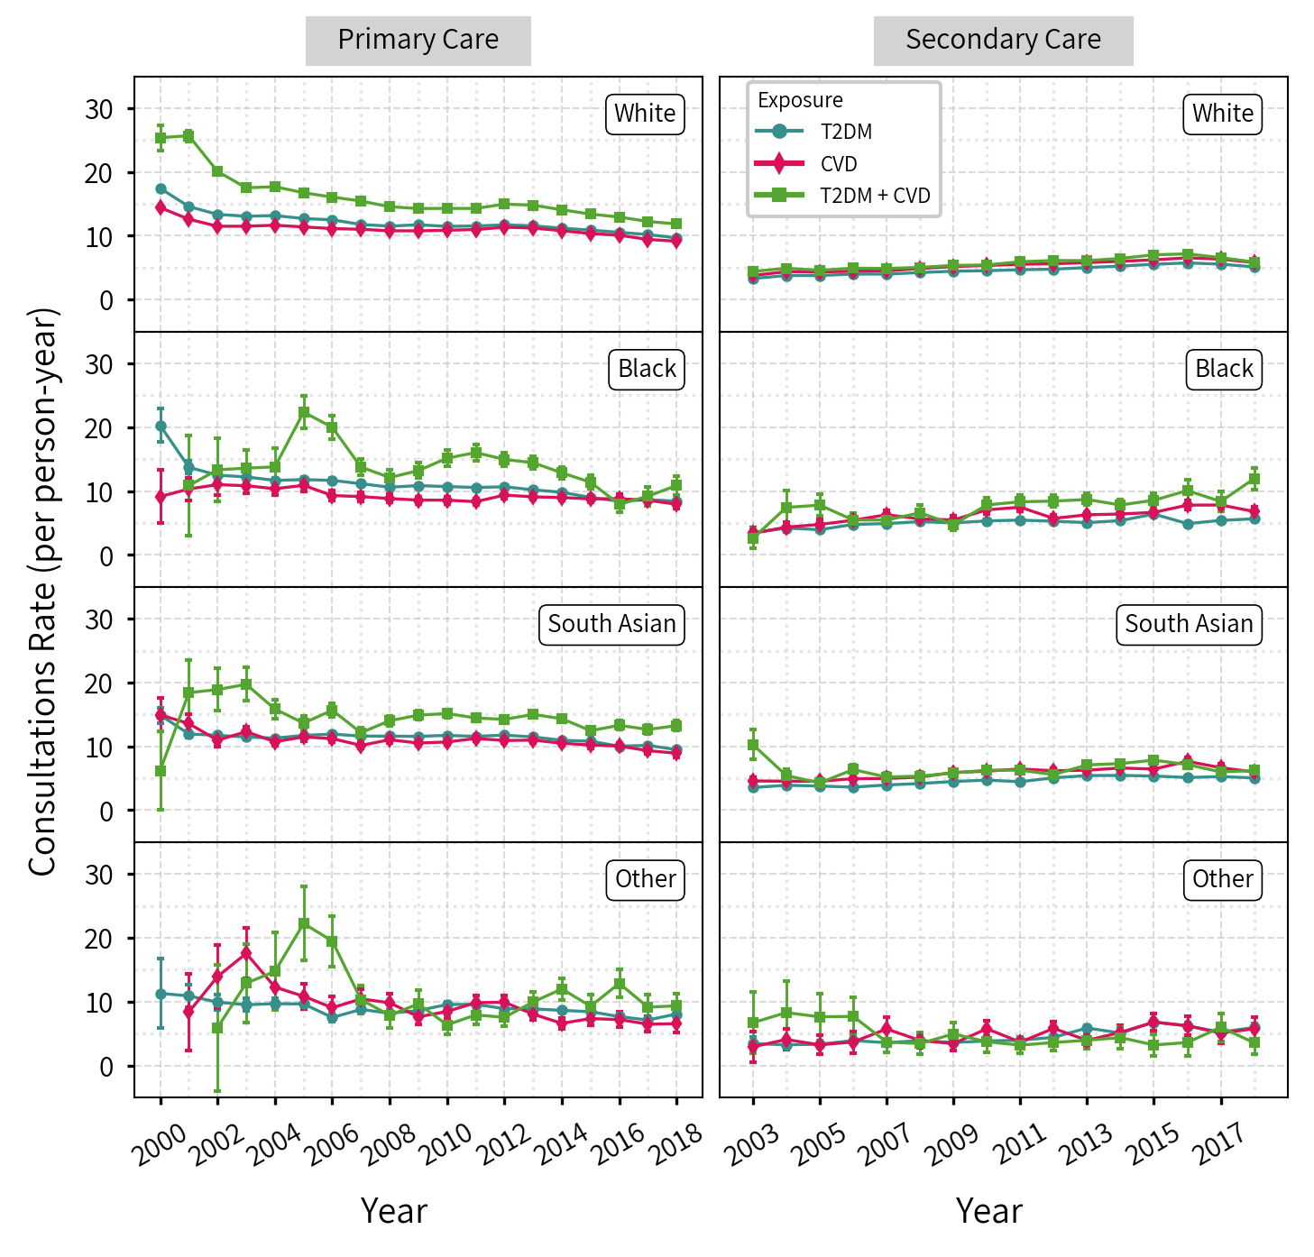

Figure S3. Annual crude consultation rate for primary and secondary care consultation, by exposure status and sex

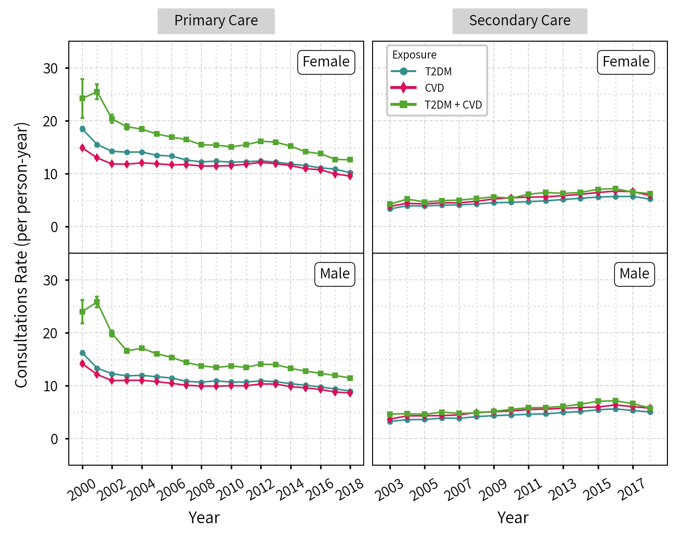

Figure S4. Annual crude consultation rate for primary and secondary care consultation, by exposure status and age

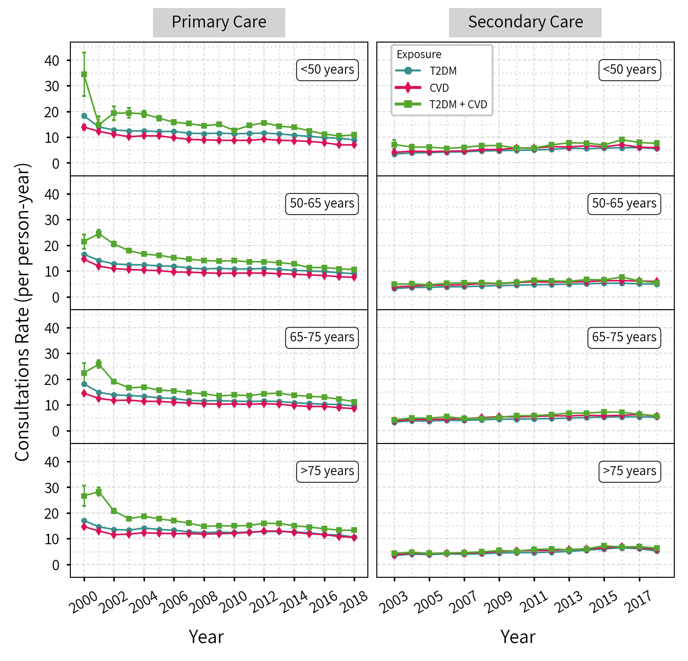

Figure S5. Mean consultation duration for primary care consultation, by exposure status and sex

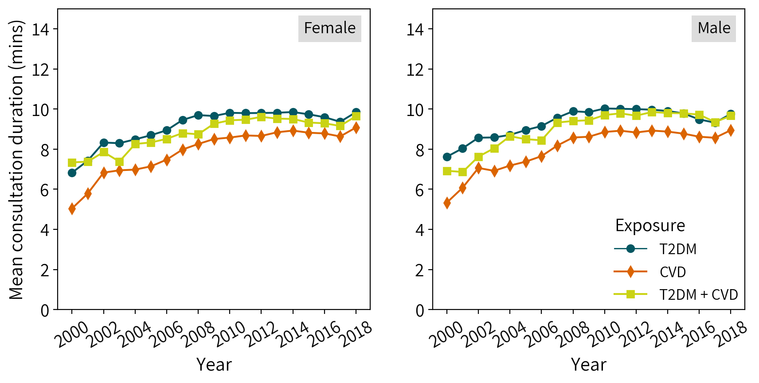

Figure S6. Mean consultation duration for primary care consultation, by exposure status and ethnicity

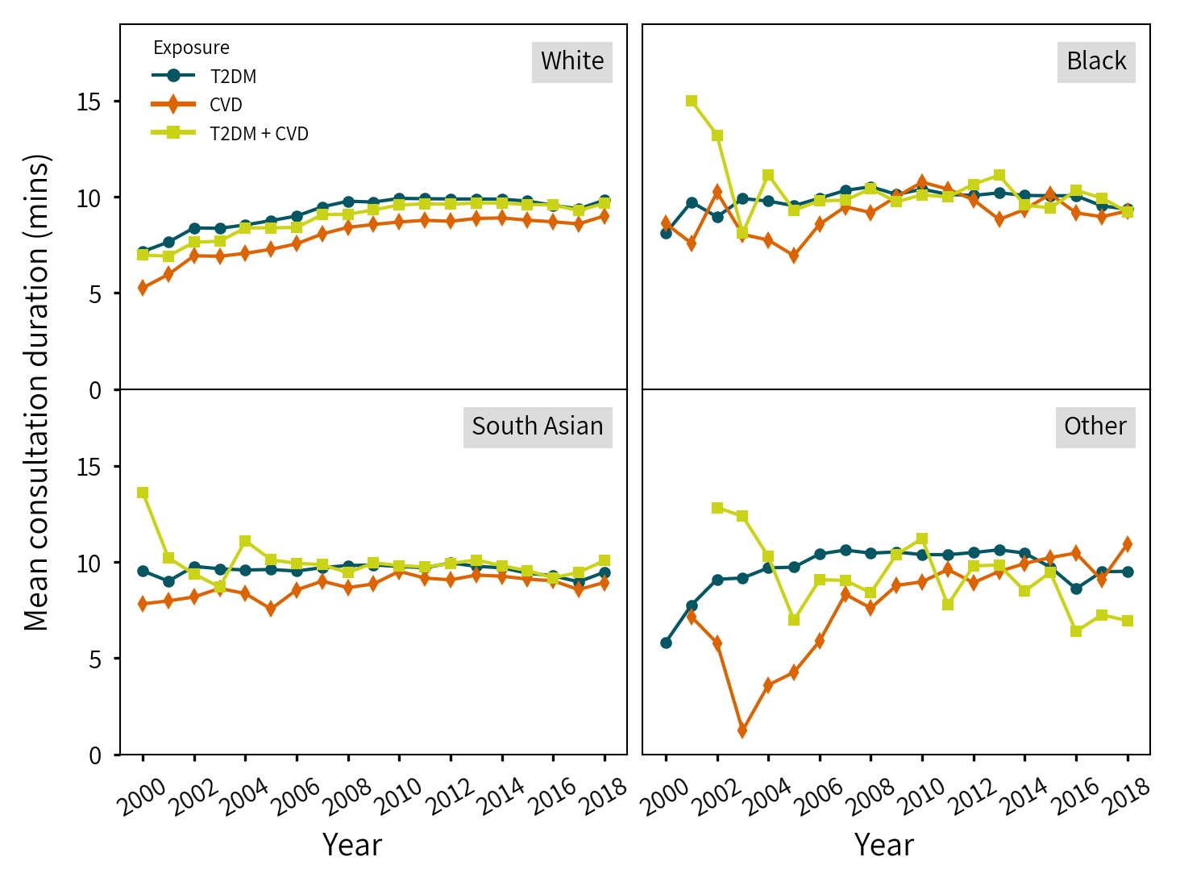

Figure S7. Mean consultation duration for primary care consultation, by exposure status and age

