Supplementary materials for “Improving the spatial measurement of conflict exposure for population health research: Comparing kernel density estimation against conventional approaches in Mali”

Mariame O. Ouédraogo¹, Peter Macharia^{2, 3}, Birama A. Ly^{4, 5}, Hamidou Niangaly⁶, Rokia Sissoko⁷, Léa Dao⁸, Aboubakary Konaté⁹, Erjia Ge¹, Hilary K. Brown^{1,10*}, Diego G. Bassani^{1,11*}

- Dalla Lana School of Public Health, University of Toronto, Toronto, Ontario, Canada
- Department of Public Health, Institute of Tropical Medicine, Antwerp, Belgium
- Population and Health Impact Surveillance Group, Kenya Medical Research Institute-Wellcome Trust Research Programme, Nairobi, Kenya
- Faculté de Médecine et d'Odontostomatologie de l'Université des Sciences, des Techniques et des Technologies de Bamako, Bamako, Mali
- Centre d'Analyse et de Recherche de l'Espace Sahélo-Saharien Modibo GOITA de l'École de Maintien de la Paix Alioune Blondin BEYE, Bamako, Mali
- Département Études et Recherches, Institut National de la Santé Publique, Bamako, Mali
- Independent Public Health and Development Consultant, Dakar, Senegal
- Cluster Santé, Organisation Mondiale de la Santé, Bamako, Mali
- Office National de la Santé de la Reproduction, Bamako, Mali
- Department of Health and Society, University of Toronto Scarborough, Canada
- Department of Paediatrics, University of Toronto, Toronto, Canada

Introduction

These supplementary materials accompany the main paper. Here, we offer further details of the methods section, along with additional figures and tables.

Section 1: Setting
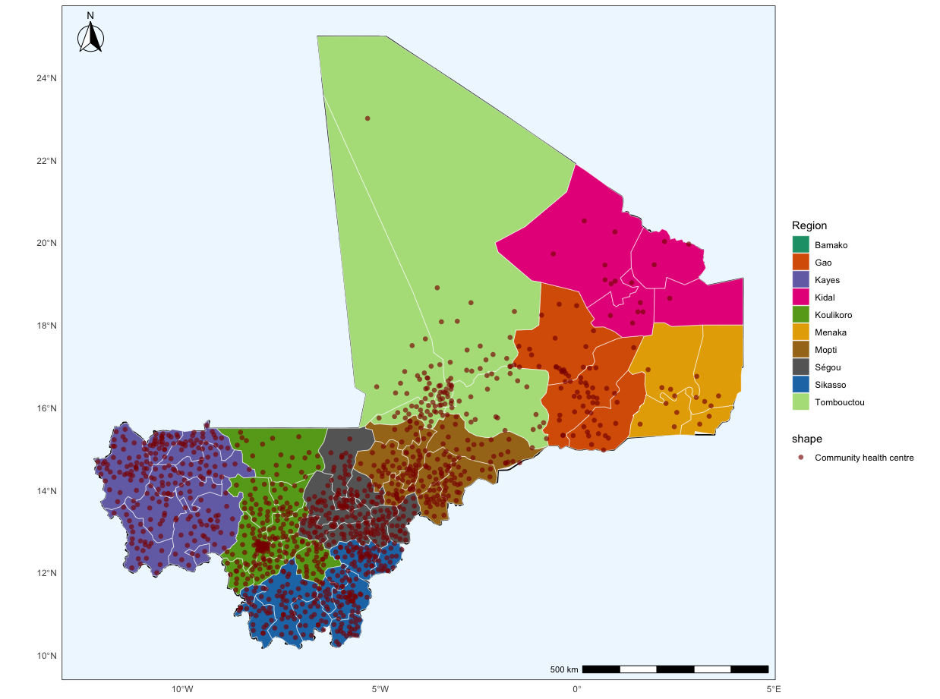

Figure S1. Map of Mali’s community health centres, health districts, and regions

Section 2: Merging of armed conflict datasets

To carry out this work, we relied on publicly available georeferenced data on armed conflict events. The Armed Conflict Location Event Data (ACLED) [1, 2] and the Uppsala Conflict Data Program (UCDP) [3, 4] are global references for conflict data. Both databases record conflict events from a wide range of sources, including traditional and new media, reports from international institutions and non-governmental organizations, as well as research articles and books. Additionally, they rely on their networks of local partners to facilitate the real-time transmission of conflict-related information.

The UCDP adopts a strict definition of armed conflict, requiring 25 deaths annually to be included in the dataset. Recorded events are those that resulted in at least one fatality. In contrast, ACLED has a broader scope, capturing instances of political violence, explosions, riots, and protests. It also includes events that did not lead to fatalities, which is particularly relevant as some armed perpetrators purposefully terrorize populations, without killing them [5]. For this study, we combined both datasets to include conflict events regardless of whether casualties occurred. In line with the UCPD’s definition of an armed conflict, across both data sources, we captured the following categories of events: (1) state-based conflict events (i.e., events between two parties, of which one is the government of the state), (2) non-state conflict events (i.e., events between two organized groups, neither of which is the government of the state), and (3) one-sided violent events (i.e., use of force by the government of the state or a formally organized group against civilians). A formally organized group is defined as a group with an announced name.

To capture the UCDP’s event categories in ACLED, we limited the ACLED data to battle-related events (which closely align with UCDP’s definition of state and non-state conflict), targeted explosions and remote violence, and violence against civilians (closely matching UCDP’s one-sided violence definition). We removed events labeled as riots, protests, and strategic development (more information on these events, including their definitions, can be found on the ACLED website [6]). We also excluded events involving “unidentified armed groups” as actors, to align as closely as possible with the UCDP's definition of a formally organized group. Based on the event notes provided in the ACLED dataset, it was also determined that these actors belonged to criminal networks or were involved in land or mining disputes, which were not relevant to this study.

Figure S2 depicts the spatio-temporal distribution of conflict events from 2000 to 2024, while Figure S3 shows the trends in the number of fatalities by conflict event types over the same time period.

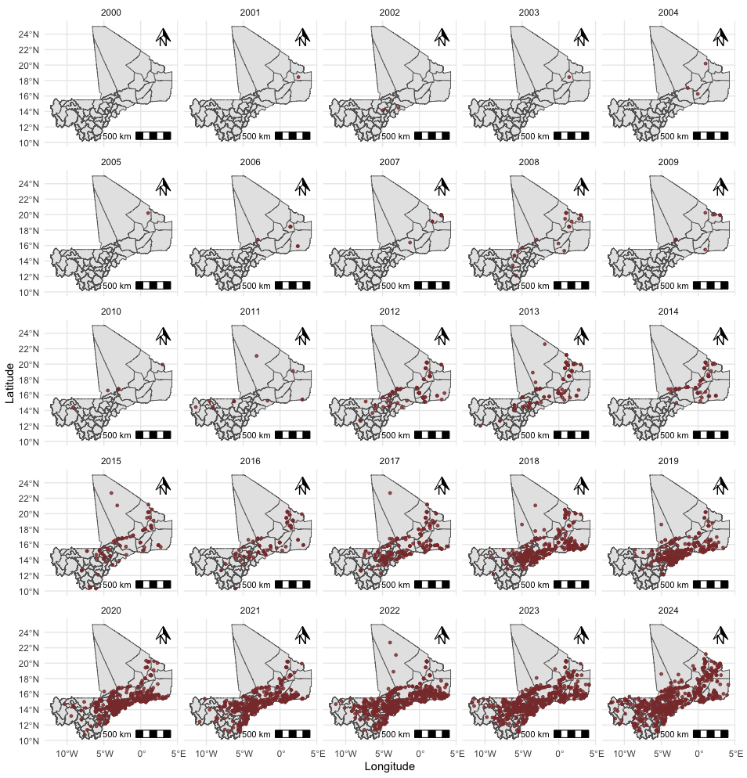Figure S2. Spatial and temporal distribution of conflict-related events in Mali from 2000 to 2024

Figure S3. Temporal distribution of conflict-related fatalities by conflict event type (battles, explosions/remote violence, and violence against civilians) in Mali from 2000 to 2024.

Section 3: Kernel density estimation (KDE)

KDE is a non-parametric method that estimates the underlying probability density function (PDF) 𝑓 from a sample of random realizations of the process of interest [7, 8]. To estimate the PDF that reflects the phenomenon of interest, KDE requires a representative finite sample of events. By specifying a kernel function and a bandwidth, KDE computes the contribution of each event and, by summing these contributions across all observations, assigns a nonzero density to locations where no events were directly observed, based on their proximity to observed events (Figure S3). This approach helps reduce the influence of location bias and partially accounts for missed events.
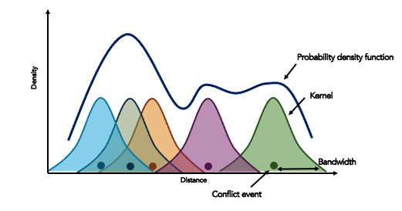
Figure S4. Representation of kernel density estimation (KDE). Legend: The kernel density function can be obtained by summing the contributions of each conflict event, each defined by a kernel (Gaussian) and a spatial and/or temporal bandwidth.

KDE was defined using spatio-temporal bandwidths, considering fatalities, population size, and edge correction. Here, we elaborate on each parameter and offer a detailed rationale for some decisions.

Spatio-temporal bandwidth selection
The most important parameter of the KDE model is the bandwidth, which controls the level of smoothness. Large bandwidth values can lead to over-smoothing, producing surfaces that are too smooth to distinguish local density characteristics [9]. On the other hand, small bandwidth values can lead to under-smoothing, resulting in surfaces that are too noisy (i.e., with multiple peaks). The choice of bandwidth is therefore important for obtaining surfaces that adequately depict the process of interest. The bandwidth can either be fixed (implying that the radius over an event is kept the same across space and over time) or adaptive (adjusting the radius based on the number of events). Research has demonstrated that adaptive bandwidth KDE outperforms fixed bandwidth KDE, particularly for densities with substantial magnitude variations and multi-modalities [7].

We used the bootstrap method to determine an appropriate spatio-temporal bandwidth [10], which involves constructing a ‘reference’ density estimate from the dataset, repeatedly simulating data from that reference density, and calculating the mean integrated squared error (MISE) for each iteration at different bandwidths. The bandwidth that minimises the bootstrap-estimated MISE was selected as the optimal (pilot) bandwidth [10]. The sparr package [10] on R software was used to implement the bootstrap method.

Accounting for fatalities and population size
Considering the number of fatalities in the KDE is important because it can reflect the intensity of conflict events. Additionally, accounting for population size is relevant, as events in densely populated areas may not spread as widely as those in rural, remote areas. In the Malian context, most conflict events have occurred in rural areas, where access to social and health services, as well as economic opportunities, is more limited. Attacks in populated urban centres, such as the capital city Bamako, have been more targeted and sporadic. As a result, it is assumed that the broader population is less exposed to their effects, is less likely to change its behaviour, and tends to resume daily life more quickly. Consequently, risk perception in cities differs significantly from that in remote areas. This understanding draws on the lived experiences of co-authors from the country, as well as nationwide surveys documenting public perceptions of the conflict. The most recent Afrobarometer survey [11], conducted in 2024, found that 63% of rural respondents felt unsafe in their homes and neighborhoods due to insecurity, compared with 46% of urban respondents. Regional differences were also pronounced: in the more remote central regions of Mopti and Segou, perceived insecurity was 92% and 74%, respectively. It averaged 79% across the northern regions of Tombouctou, Gao, and Kidal, which together account for less than 10% of the country's overall population. By contrast, in the more densely populated southern areas (e.g., Bamako, Sikasso, Koulikoro), the perceived insecurity ranged from 44% to 48% [11, 12].

The KDE formula presented in (3) can be adapted to account for the number of fatalities as well as population size as weights [13]:
$\hat{f}\left(\overline{x}\right)= \sum_{i=1}^{n}{φ\left(m_{i}\right) \frac{1}{nλ_{i}H}}K\left(\frac{({\overline{x}}_{i}-\overline{x}}{λ_{i}H}\right)$,
, where 𝜑($m_{i}$) = 1 + $log⁡(1+ m_{i}$) is the weight variable. $m_{i}$ is obtained by dividing the number of fatalities for event i by the population count at the location of event i. The log scale was used, recognizing that many events had zero casualties, while a few had very high casualty numbers. The weights were then rounded to the nearest integer to reduce the effect of fluctuations in the number of casualties [13].

Edge correction
KDE values for areas near country boundaries can be distorted by edge effects [9, 14]. Each event contributes a kernel to the density function; however, for events near the boundaries (or edges of the study window), part of the kernel extends beyond the study area and is therefore truncated. KDE values near the boundary are thus biased downward. Diggle proposed an edge-correction method that addresses this bias by weighting each event by the inverse of the proportion of its kernel that lies within the study boundaries [14]. Events whose kernels fall entirely within the study area receive a weight of 1, whereas events for which only a fraction of the kernel lies within the boundary receive a weight of 1 by that fraction. We implemented the edge correction using Monte Carlo sampling. For each conflict event location, 1,000 random points were generated to represent the kernel's spatial spread under an adaptive bandwidth, and the proportion of points falling within the country's boundaries was used to compute the corresponding weight for each event.

Model specifications
Several model specifications for KDE were implemented, considering changes in spatial and temporal bandwidths and windows and adjustments for population size, mortality, and edge correction. Because our objective was to produce yearly surfaces, a reference date within each year was required; we selected December 31st, and applied a 364-day temporal window so that only events occurring during the year contributed to the annual intensity surfaces. A temporal bandwidth was not always applied in our base models, as it would imply that events closer to the reference date contributed more to the estimated probability density function than those earlier in the year. Since our primary interest was to weight all events within a given year equally, the temporal bandwidth was only considered in separate models. Additionally, as a sensitivity analysis, we also considered a symmetric temporal window of ±182 days centered on the reference date, July 2. We also further restricted the kernel by applying a 500- km cap to the spatial window in addition to the temporal window.

Section 4: Exposure and outcome variables
Table S1. List of exposure and outcome variables
Construct | Variable details
Exposure to armed conflict | 1. Continuous KDE-based conflict intensity values, capturing the expected number of conflict events per unit area  - Aggregated at community health centre catchment area and health district levels
Exposure to armed conflict | 2. Standard binary conflict exposure, captured as exposure to at least 1 event  - Presence of at least 1 event at the health district level  - Proximity to at least 1 conflict event within a 50-km radius of a Community health centre
Exposure to armed conflict | 3. Standard continuous conflict exposure, which is defined as the number of conflict events reported  - Aggregated at the health district level  - Aggregated within a 50-km radius from the community health centre
Reproductive, maternal, and child health outcomes | - Unmet need for family planning: Proportion of women of reproductive age with unmet contraceptive needs  - Aggregated at community health centre catchment area and health district levels
Reproductive, maternal, and child health outcomes | - Ineffective antenatal care: Proportion of pregnant women who attend fewer than four antenatal care visits  - Aggregated at community health centre catchment area and health district levels
Reproductive, maternal, and child health outcomes | - Non-institutional delivery: Proportion of women who gave birth outside a health facility  - Aggregated at community health centre catchment area and health district levels
Reproductive, maternal, and child health outcomes | - Missed DTP3 vaccination: Proportion of children between 12 and 23 months who did not receive their DTP3 dose  - Aggregated at community health centre catchment area and health district levels

Section 4: Additional figures

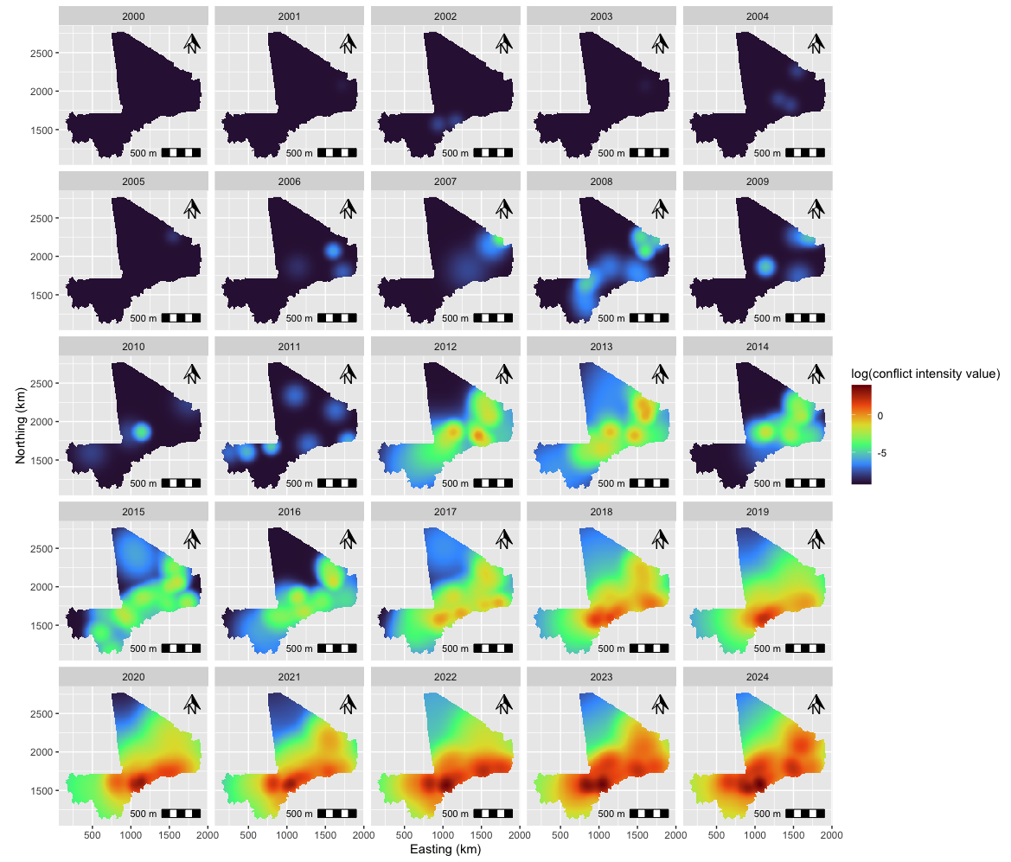
Figure S5. Annual conflict intensity surfaces on the log-scale obtained using Model 2 specifications, Mali 2000 to 2024. Legend: Model 2 included a temporal window of 364 days, an adaptive spatial bandwidth, and edge correction. No spatial window, temporal bandwidth, or population size adjustment was accounted for. It should be noted that the number of events per unit area (10 km²) is displayed on a log scale.

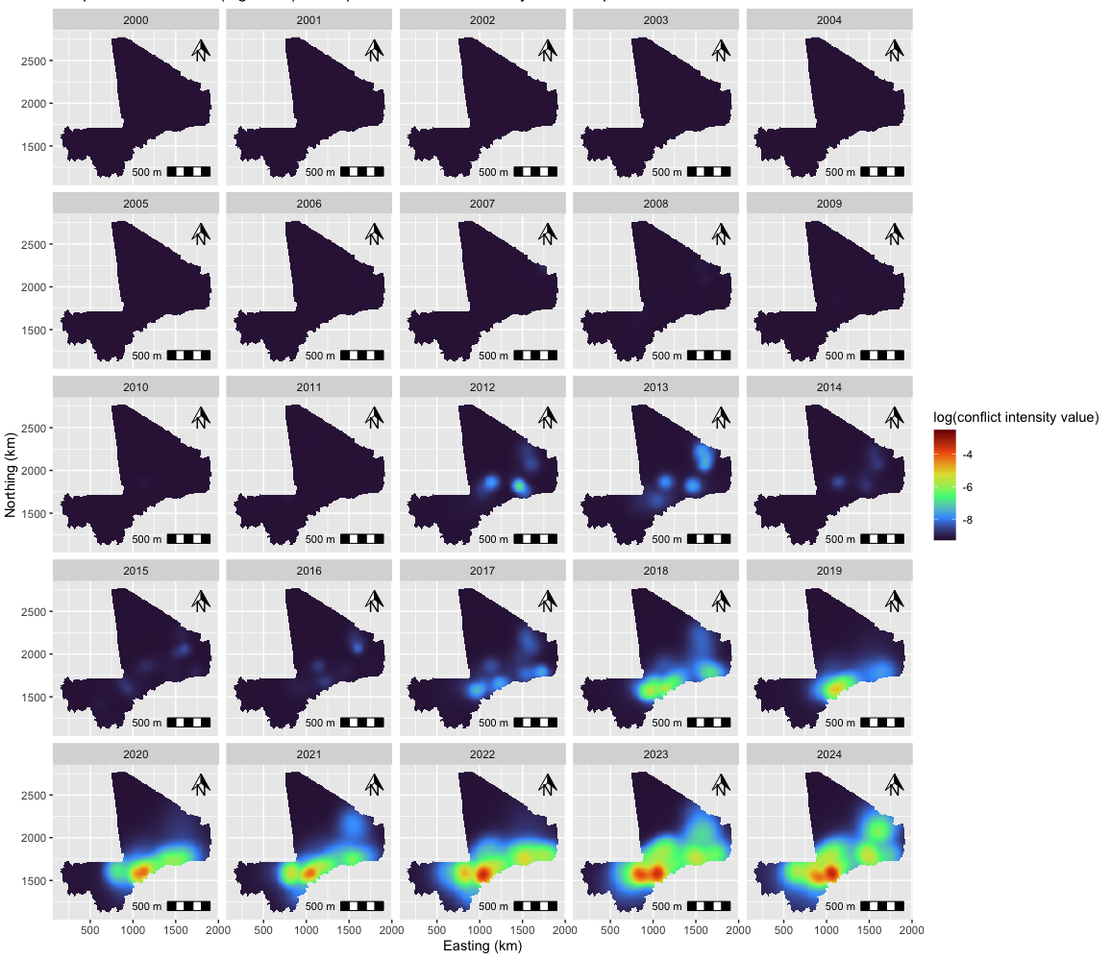
Figure S6. Annual conflict intensity surfaces on the log-scale obtained using Model 3 specifications, Mali 2000 to 2024. Legend: Model 3 included a temporal window of 364 days, an adaptive spatio-temporal bandwidth, population size adjustment, and edge correction. No spatial window was included. It should be noted that the number of events per unit area (10 km²) per time unit (days) is displayed on a log scale.

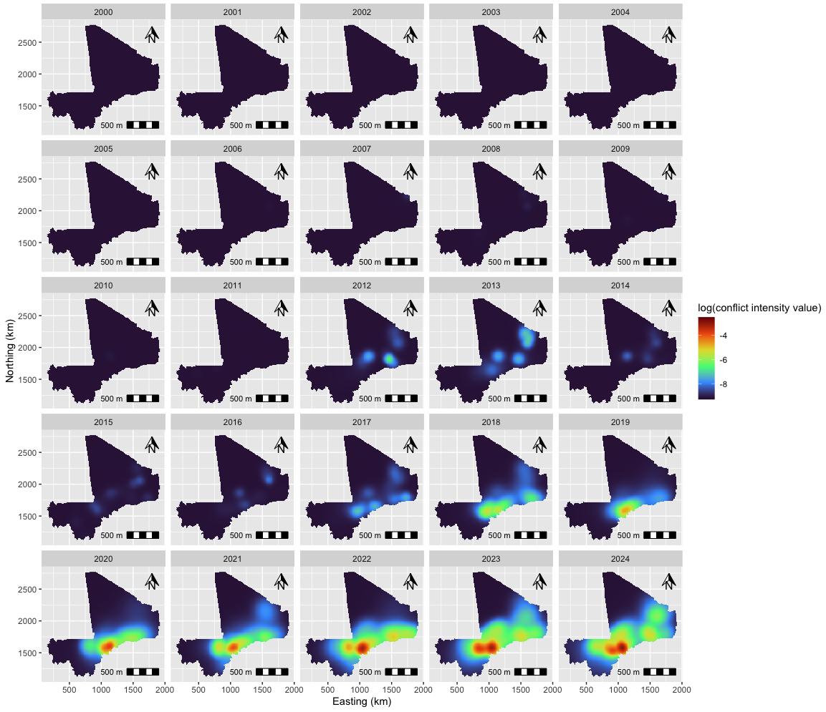
Figure S7. Annual conflict intensity surfaces on the log-scale obtained using Model 4 specifications, Mali 2000 to 2024. Legend: Model 4 included a temporal window of 182 days, an adaptive spatio-temporal bandwidth, population size adjustment, and edge correction. No spatial window was included. It should be noted that the number of events per unit area (10 km²) per time unit (days) is displayed on a log scale.
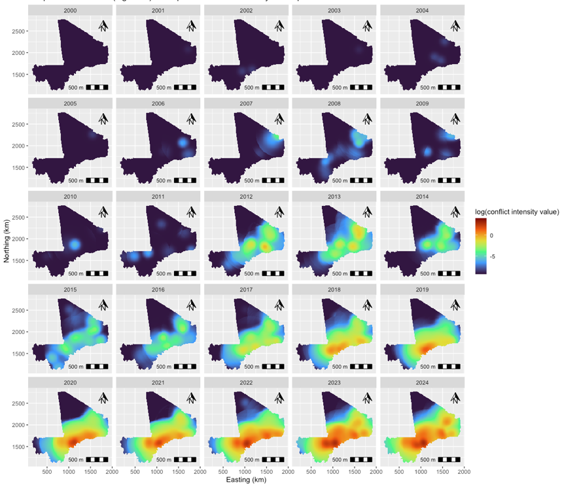

Figure S8. Annual conflict intensity surfaces on the log-scale obtained using Model 5 specifications, Mali 2000 to 2024. Legend: Model 5 included a temporal window of 364 days, a spatial window of 500 km, an adaptive spatial bandwidth, population size adjustment, and edge correction. No temporal bandwidth was included. It should be noted that the number of events per unit area (10 km²) is displayed on a log scale.

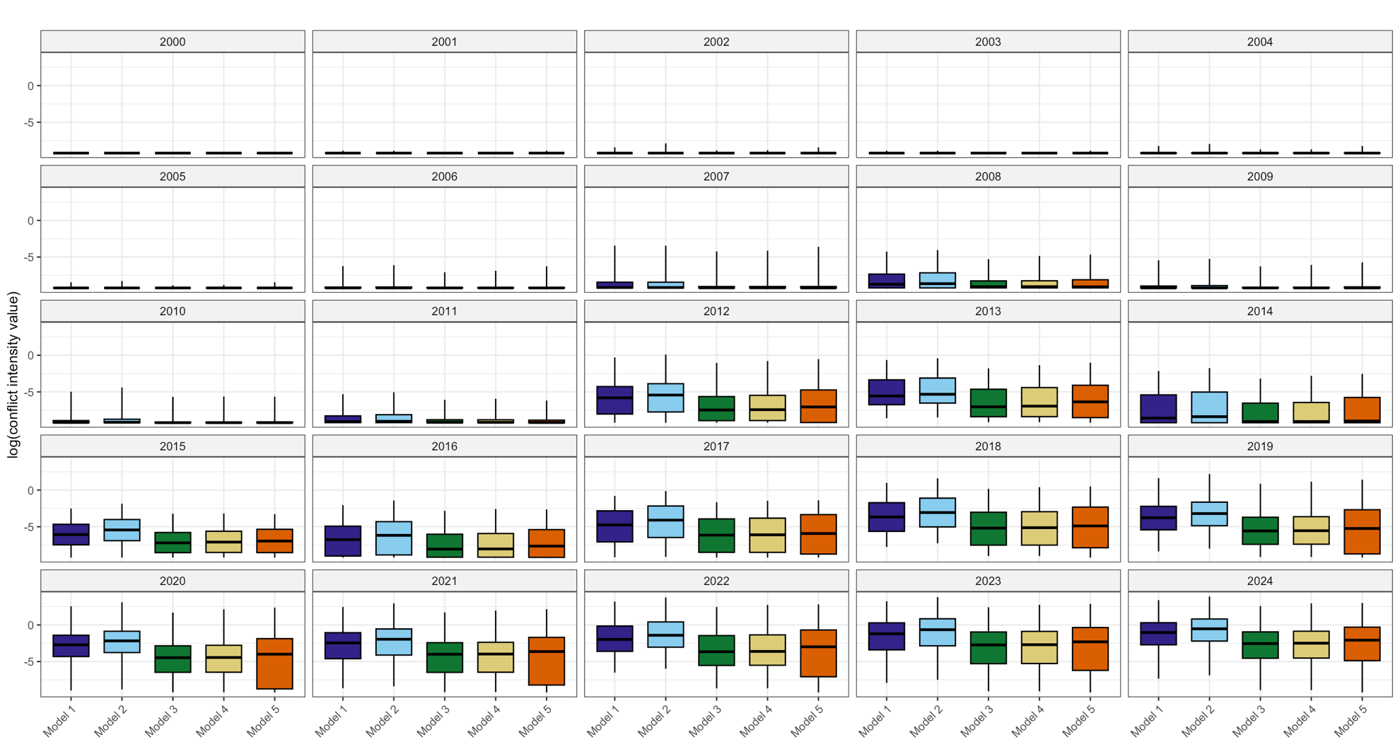

Figure S9. Annual distribution of conflict intensity value on the log scale across KDE model specifications. The five model specifications are depicted. Legend: To facilitate comparison between the spatial KDE (models 1, 2, and 5) and the spatio-temporal KDE (models 3 and 4), we converted the spatio-temporal KDE models to spatial models by aggregating the estimated intensity values over the temporal window [15].

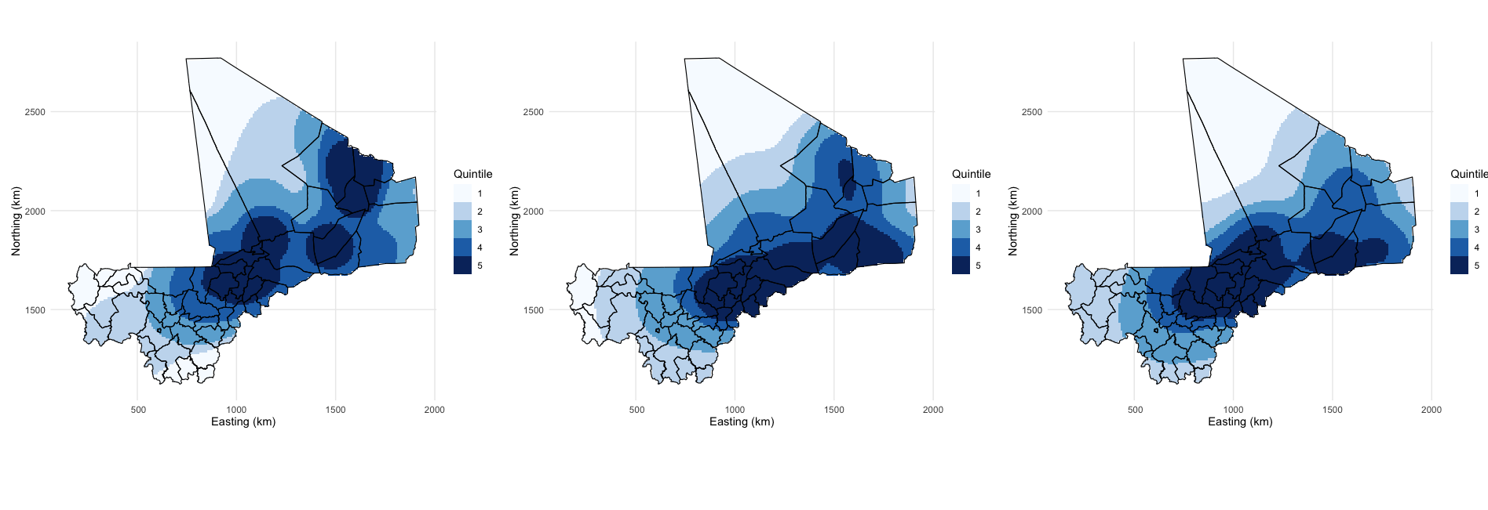
Figure S10. Quintiles of KDE values for years 2013, 2018, and 2023. Legend: We considered Q4 and Q5 as population groups that were moderately and severely exposed to armed conflict, respectively.

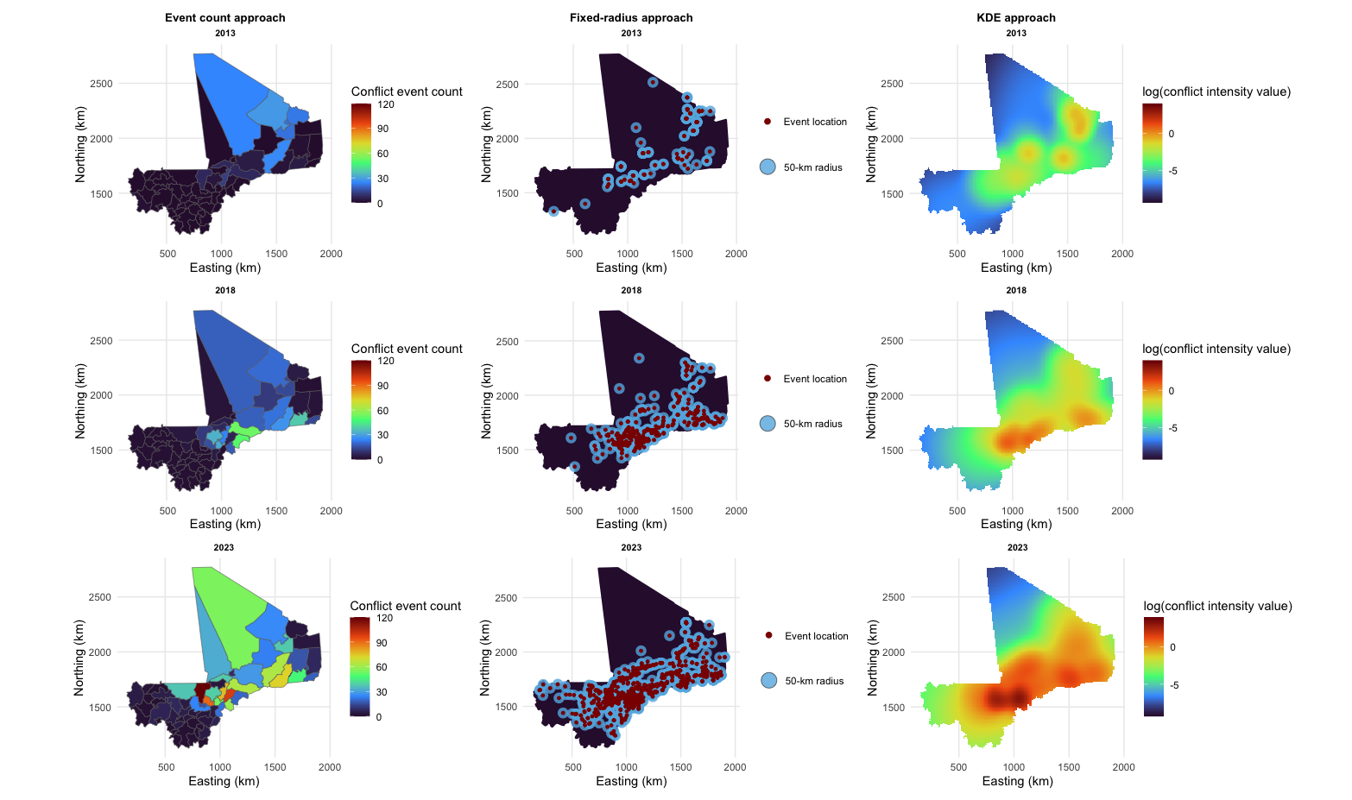

Figure S11. Conflict exposure surfaces generated using the standard approaches and kernel density estimation (KDE) for the years 2013, 2018, and 2023.

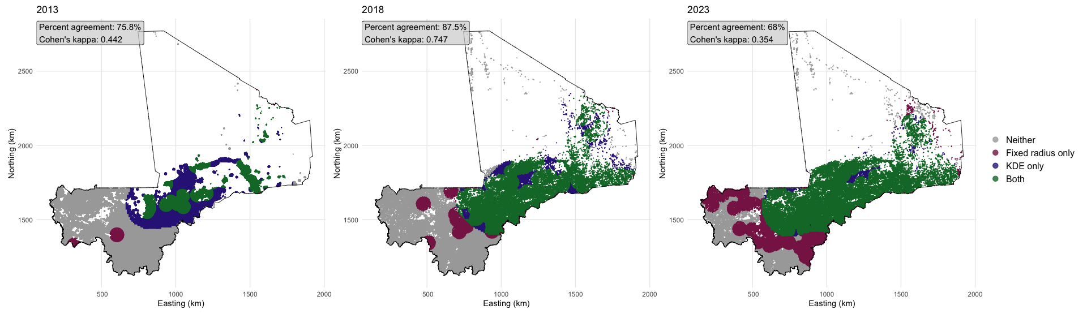
Figure S12. Comparison of kernel density estimation (KDE) and the fixed-radius approach in the population of women of reproductive age (15 to 49 years) estimated to be exposed to armed conflict. Legend: Panels 1, 2, and 3 display the agreement for years 2013, 2018, and 2023, respectively. The years’ respective percent agreement and Cohen’s kappa values are also provided.

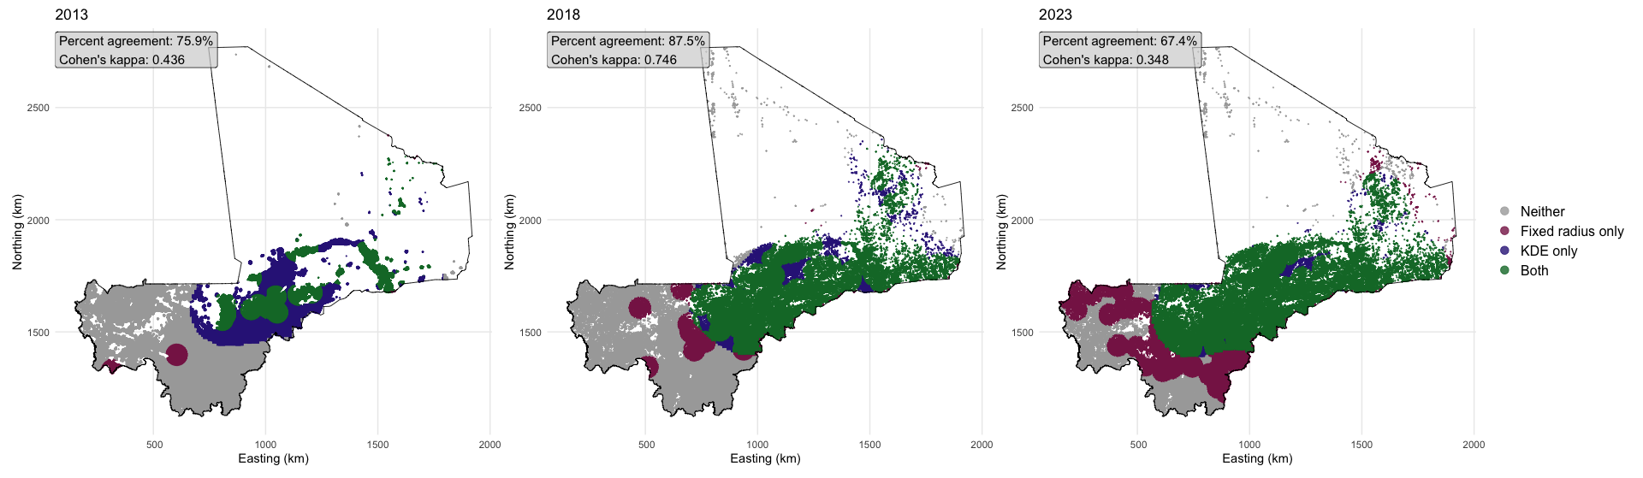
Figure S13. Comparison of kernel density estimation (KDE) and the fixed-radius approach in the under-five population estimated to be exposed to armed conflict. Legend: Panels 1, 2, and 3 display the agreement for years 2013, 2018, and 2023, respectively. The years’ respective percent agreement and Cohen’s kappa values are also provided.

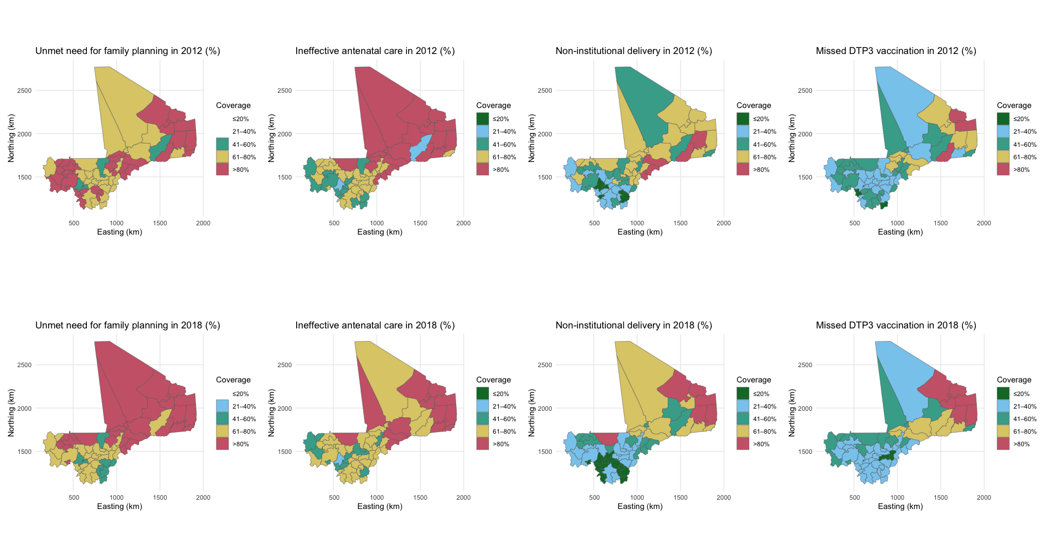
Figure S14. Coverage of reproductive, maternal, and child health indicators at the health district level for the years 2012 and 2018

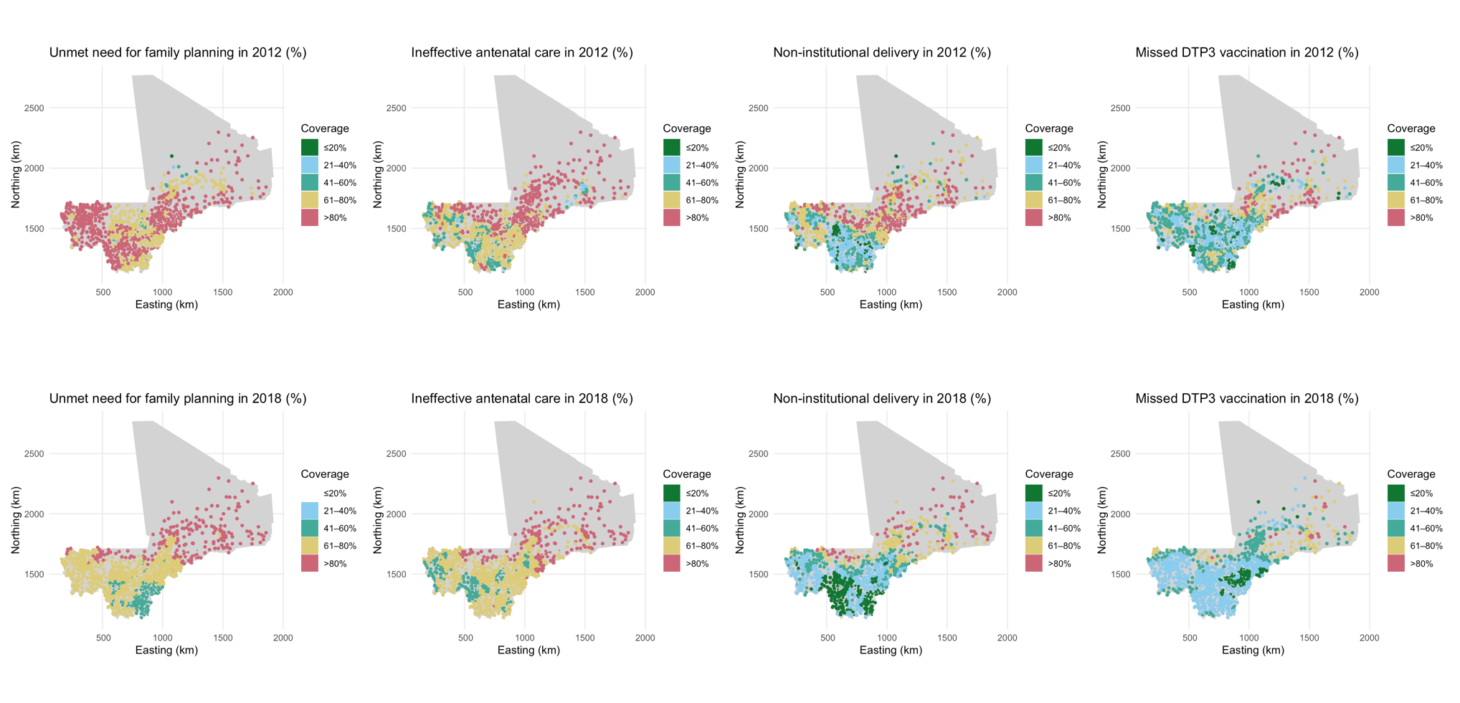
Figure S15. Coverage of reproductive, maternal, and child health indicators in the community health centre catchment areas for the years 2012 and 2018

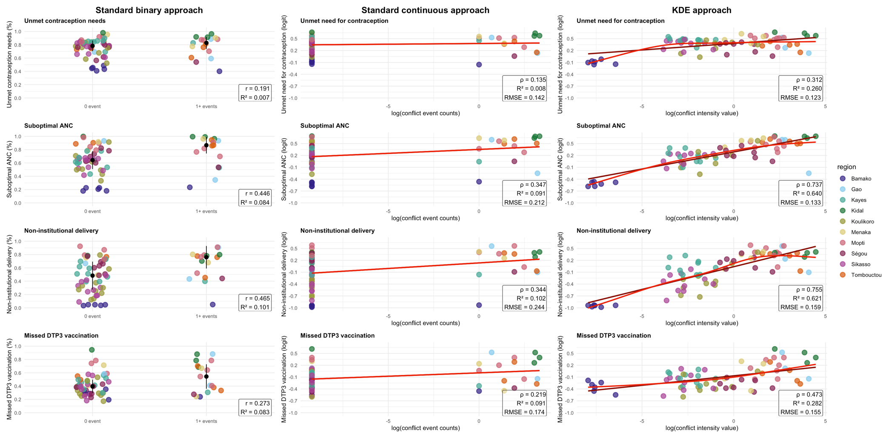
Figure S16. Association between conflict exposure measures and reproductive, maternal, and child health outcomes at the health district level, 2012. Legend: The left column displays RMCH indicator (%) distributions by the binary conflict exposure, obtained using the standard approach. The middle column shows distributions of the RMCH indicator (logit) by conflict counts on the log scale, obtained using the standard approach. The right column presents distributions of the RMCH indicator (logit) by continuous conflict intensity on the log scale, estimated using kernel density estimation (KDE). The correlation coefficients (r for the bi-serial correlation coefficient and ρ for the Spearman correlation coefficient), coefficients of determination (R²), and root mean square error (RMSE) are also provided. The linear regression lines are shown in light red, and the non-linear lines from generalized additive models are shown in dark red.

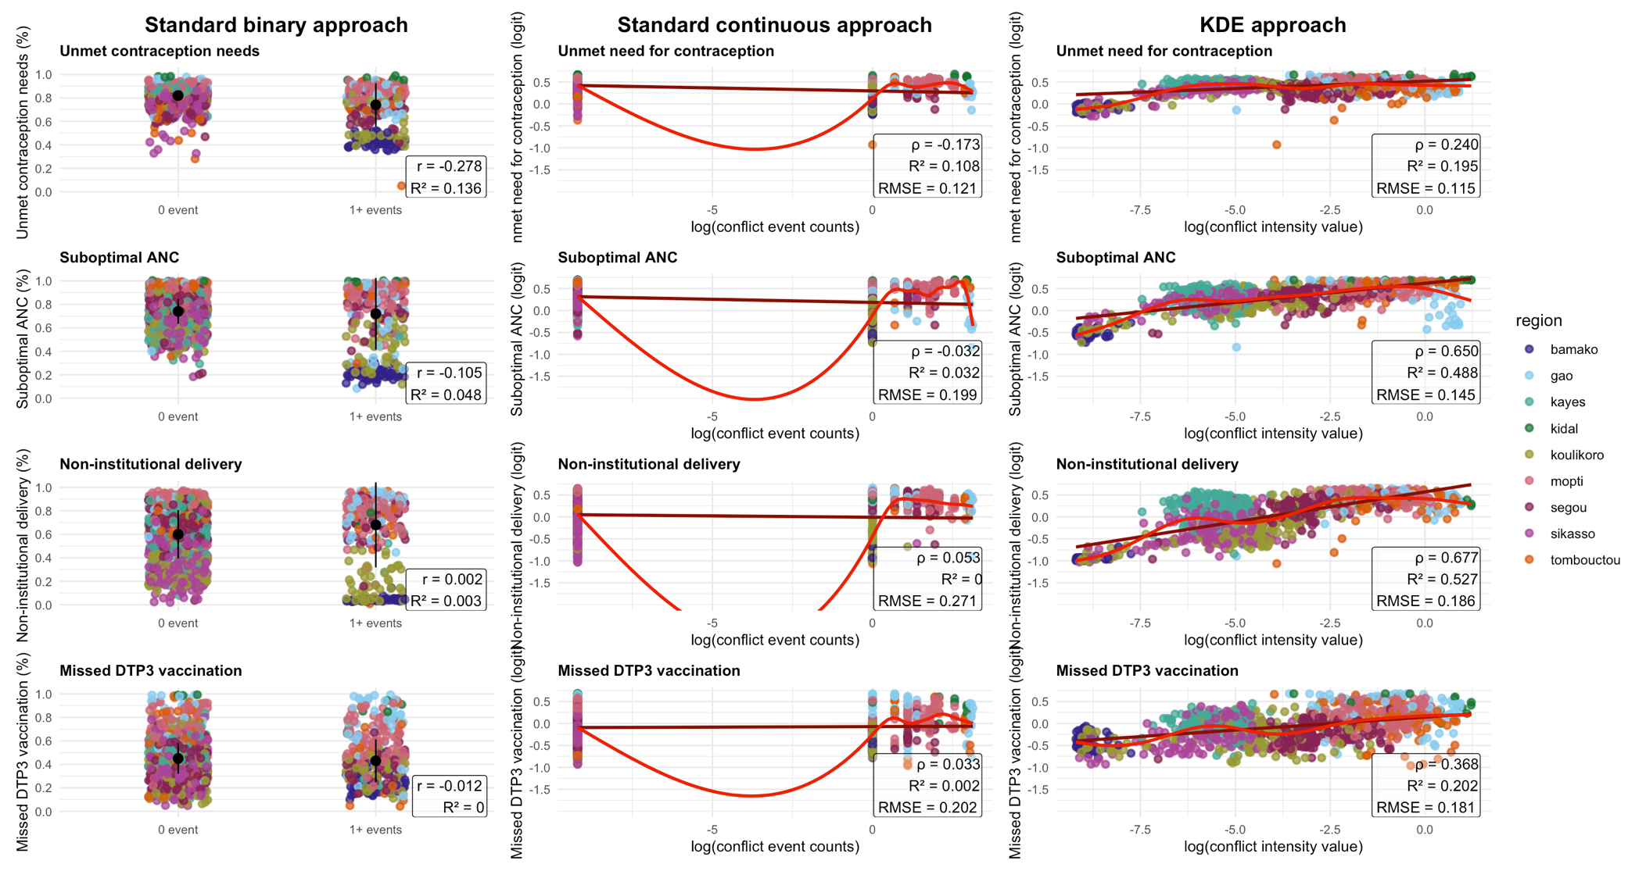

Figure S17. Association between conflict exposure measures and reproductive, maternal, and child health outcomes at the community health centre level, 2012. Legend: The left column displays RMCH indicator (%) distributions by the binary conflict exposure, obtained using the standard approach. The middle column shows distributions of the RMCH indicator (logit) by conflict counts on the log scale, obtained using the standard approach. The right column presents distributions of the RMCH indicator (logit) by continuous conflict intensity on the log scale, estimated using kernel density estimation (KDE). The correlation coefficients (r for the bi-serial correlation coefficient and ρ for the Spearman correlation coefficient), coefficients of determination (R²), and root mean square error (RMSE) are also provided. The linear regression lines are shown in light red, and the non-linear lines from generalized additive models are shown in dark red.
References
1. ACLED. Armed Conflict Location & Event Data (ACLED) Codebook. 2024.
2. Raleigh C, Kishi R, Linke A. Political instability patterns are obscured by conflict dataset scope conditions, sources, and coding choices. Humanities and Social Sciences Communications 2023 10:1. 2023;10:74-. https://doi.org/10.1057/s41599-023-01559-4.
3. Davies S, Pettersson T, Sollenberg M, Öberg M. Organized violence 1989–2024, and the challenges of identifying civilian victims. Journal of Peace Research. 2025;62.
4. Sundberg R, Melander E. Introducing the UCDP Georeferenced Event Dataset. J Peace Res. 2013;50.
5. Raleigh C, Kishi R. Comparing Conflict Data: Similarities and Differences Across Conflict Datasets. 2019.
6. ACLED | Bringing Clarity to Crisis. https://acleddata.com/#/dashboard. Accessed 6 Oct 2020.
7. Silverman BW. Density Estimation for Statistics and Data Analysis. First edition. CRC Press; 1998.
8. Chen YC. A tutorial on kernel density estimation and recent advances. Biostat Epidemiol. 2017;1:161–87. https://doi.org/10.1080/24709360.2017.1396742.
9. Moraga Paula. Spatial statistics for data science : theory and practice with R. CRC Press; 2024.
10. Davies TM, Marshall JC, Hazelton ML. Tutorial on kernel estimation of continuous spatial and spatiotemporal relative risk. Stat Med. 2018;37:1191–221. https://doi.org/10.1002/SIM.7577.
11. Groupe de Recherche en Economie Appliquée et Théorique (GREAT). Résumé des résultats: Enquête d’Afrobarometer Round 10 au Mali, 2024. 2025.
12. AfroBarometer. La majorité des Maliens se sentent en insécurité, tout en reconnaissant les efforts du gouvernement en matière de sécurité – Afrobarometer. 2025.
13. Tapsoba A. The cost of fear: Impact of violence risk on child health during conflict. J Dev Econ. 2023;160:102975. https://doi.org/10.1016/J.JDEVECO.2022.102975.
14. Diggle PJ. Statistical Analysis of Spatial and Spatio-Temporal Point Patterns. 3rd edition. Chapman and Hall/CRC; 2013. https://doi.org/10.1201/b15326.
15. Hu Y, Wang F, Guin C, Zhu H. A spatio-temporal kernel density estimation framework for predictive crime hotspot mapping and evaluation. Applied Geography. 2018;99:89–97. https://doi.org/10.1016/J.APGEOG.2018.08.001.

