Supporting Information:
A multiplexed targeted mass spectrometric assay for quantifying obesity-associated biomarkers in human plasma

Authors:
Tai-Tu Linª, Panshak Dakupª, Athena A. Schepmoesª, Thomas L. Fillmore^{b}, Adam C. Swensenª,
Shane S Kellyª, Tong Zhangª, Jie Pu^{c}, Jon M. Jacobs^{b}, James P. Delany^{d}, Bret H. Goodpaster^{d}, Tujin Shiª, Jun Qu^{c} and Wei-Jun Qian^{a*}

ª Biological Sciences Division, Pacific Northwest National Laboratory, Richland, WA, USA
^{b} Environmental Molecular Sciences Division, Pacific Northwest National Laboratory, Richland, WA, USA
^{c} Department of Pharmaceutical Sciences, University at Buffalo, State University of New York, Buffalo, NY, USA
^{d} Translational Research Institute, Advent Health, Orlando, FL, USA

*Correspondence:
Dr. Wei-Jun Qian
Biological Sciences Division
Pacific Northwest National Laboratory
Richland, WA 99354, USA.
Tel: (509) 371-6572
Email: Weijun.Qian@pnnl.gov

Contents:
(A) Standard Operating Procedure for sample preparation (pg. S3–5)
(B) Supplementary Figures (pg. S6–11)

- Standard Operating Procedure
Integrative Omics | PNNL

Principle
The global prevalence of obesity has dramatically increased in recent decades, reaching epidemic levels in both children and adults. This epidemic fuels serious comorbidities such as cardiovascular disease, type 2 diabetes, and certain cancers. Effective strategies for prevention and personalized intervention require a deeper understanding of its complex pathophysiology. A critical component of this effort is the ability to precisely monitor panels of protein biomarkers that reflect the underlying biological state. To address this need, we developed a high-throughput, robust, multiplexed LC-SRM assay for the direct quantification of approximately 40 circulating protein markers associated with obesity.

Sample
Plasma. Specimens should be stored at -80 °C. Allow the specimens to come to room temperature and mix. If necessary, aliquot, to avoid repeated thawing and freezing. Do not attempt to thaw frozen specimens by heating them in a water bath.
Chemical Supplies
- 50 mM NH₄HCO₃, pH ~8 buffer
- Urea (Sigma)
- Dithiothreitol (DTT) - Pierce No-Weigh Format (A39255)
- Iodoacetamide (IAA) – Pierce, Single-Use (A39271)
- 0.5 M CaCl₂
- Trypsin, Sequencing Grade (Promega, V5113)
- 10% trifluoroacetic acid (TFA)
- HPLC-grade Methanol
- 0.1% TFA in nanopure water
- 95:5 H2O:Acetonitrile (ACN), 0.1% TFA
- 80:20 ACN:H2O, 0.1% TFA
- 5% ACN, 0.1% TFA
- 80% ACN
- BCA Protein Assay Reagents (Promega)

Non-Chemical Supplies
- Eppendorf epMotion 5075 Liquid Handler
- Bulldog BioShake IQ
- Centrifuge 5810 R with Swinging Bucket Rotor (Eppendorf)
- ThermoSavant SpeedVac SC250 Express
- Tecan Infinite M200 plate reader
- Rainin E4 XLS 8-channel electronic pipette
- 1 mL Deepwell Plate, Protein LoBind (Eppendorf)
- 0.5 mL Deepwell Plate (Axygen)
- 25 mg/well Strata C18-E SPE 96-well plate (Phenomenex 8E-S001_CGB)
- Breathe-Easy adhesive membranes
- Speware Corporation CEREX SYSTEM 96 PROCESSOR

Procedure
In-solution Urea digestion (Up to 88 samples were digested on one plate)
- Add 45 µl of 8 M urea in 50 mM NH₄HCO₃ to each well that will contain a sample. Add 5 µl of plasma sample.
- Add 5 µl of 100 mM DTT to reach 10 mM DTT concentration in sample solution using epMotion.
- Incubate sample at 37 °C for 30 min with 1200 rpm constant shaking in Bio Shaker.
- Alkylate with 40 mM Iodoacetamide using 400 mM IAA stock solution (5.5 µl per sample, epMotion) at 37 °C in the dark with 1200 rpm constant shaking in Shaker for 1 hour.
- Make Master mix that includes 50 mM Ammonium Bicarbonate, pH 8.0, 1 mM CaCl₂ and Trypsin
- Dilute samples 6-fold with this master Mix. epMotion
- Add Trypsin to achieve an enzyme-to-substrate ratio of 1 µg of Trypsin per 50 µg of total protein.
- Digest sample for 6 hours at 37 °C with constant shaking at 1100 rpm in Bio Shaker
- Stop digestion by acidifying sample with TFA to ~pH 3.0 (final TFA concentration of 0.1% TFA). The final volume of each sample is approximately 500 µL.
- Prepare the heavy peptide mixture (calculate the volume for 100 wells).
Note: The stock of heavy peptide mixture is 500 fmol/µl.
Premix 50µl heavy peptide mixture stock and 450 µl 0.1% FA (The concentration is 50 fmol/µl).
- Add 5 µl of heavy peptide mixture to the 500 µl Axygen plates.

C18 SEP clean-up
- Prepare C18 SPE plate using the Positive Pressure Manifold (CEREX SYSTEM 96 PROCESSOR). Use low flow setting (3 psi is usually sufficient).
- Condition SPE plate columns by rinsing with 1.5 mL of MeOH.
- Let MeOH pass through the SPE plate.
- Condition SPE plate columns by rinsing with 1.5 mL of 80% ACN, 0.1% TFA.
- Let 80% ACN, 0.1% TFA pass through the SPE plate.
- Finish plate columns conditioning by rinsing with 1 mL of 0.1% TFA.
- Let solution completely go through the columns.
- Load 50 µl of each sample on the plate columns with 5 µl of heavy peptide mixture. Collect and store flow through.
- Wash columns containing samples with 2 mL of 0.1% TFA into 2 mL Deepwell Plate (Eppendorf).
- Elute samples into 1 mL Deepwell Plate (Axygen) with 0.4 mL of 80% ACN, 0.1% TFA.
- Cover plate with Breathe-Easy adhesive membrane and place it into Speed-Vac.
- Dry samples to complete dryness.
- Rehydrate samples in 50 µl of nano pure H₂O.
- Transfer 10 µl of each sample to a new 96 well plate (500 µl Axygen plates).
Note: This plate is used for LC-SRM analysis.
- Storage at -80 °C until needed for LC-SRM analysis.

- Supplementary Figures

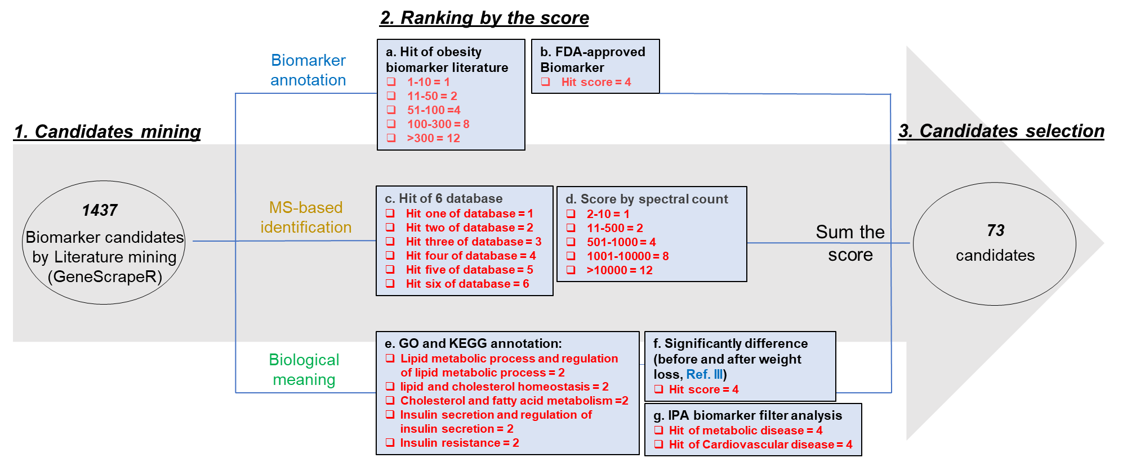

Supplemental figure 1. Workflow for selecting a panel of obesity biomarker candidates based on prior literature, knowledge bases, and plasma proteomics data.

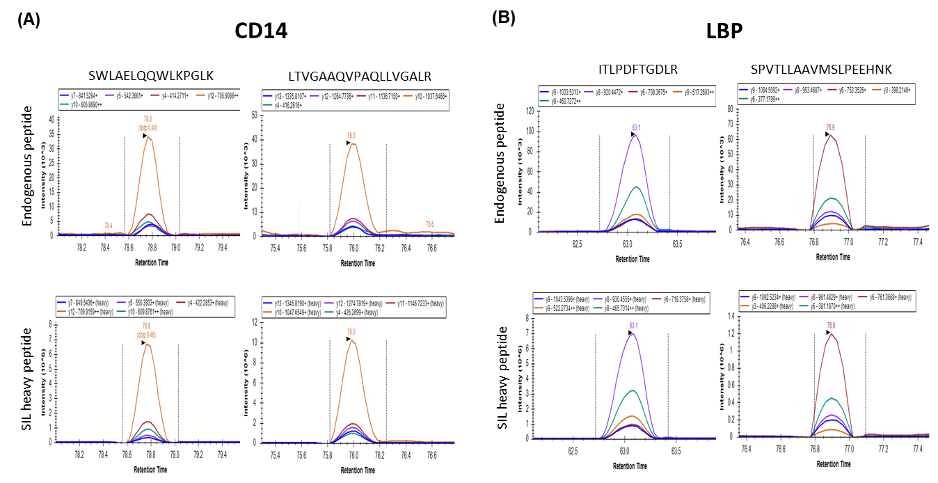
Supplemental figure 2. Representative examples of XICs demonstrating peptide detectability. The chromatograms of light and heavy peptides were manually inspected in Skyline. Detectability of candidate proteins was determined using the following criteria: a ratio dot product (rdotp) > 0.9 between the transition peak areas of light and heavy peptides for at least five transitions in at least two distinct peptides.

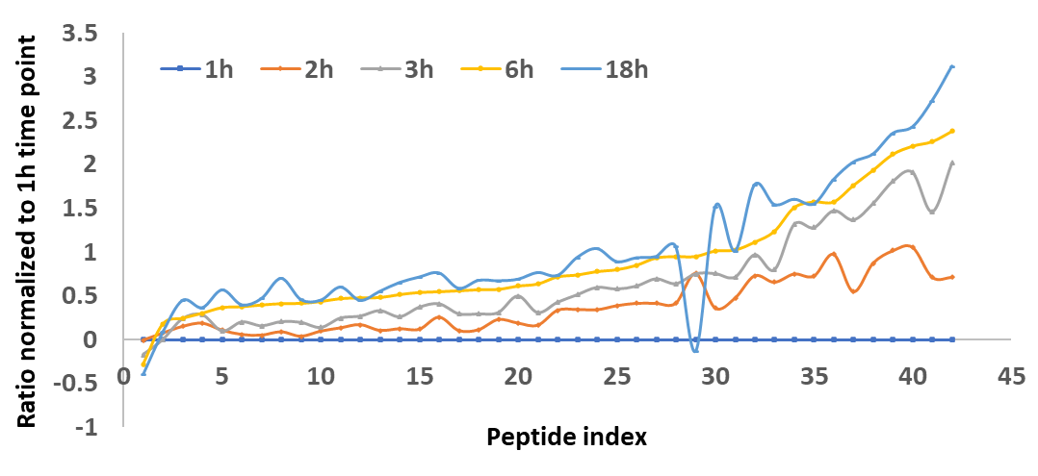
Supplemental figure 3. Optimization of digestion time. To assess digestion kinetics, pooled human plasma was digested with trypsin for 1, 2, 3, 6, and 18 hours and analyzed by LC–SRM. The resulting light-to-heavy (L/H) ratio for each peptide was then expressed as a fold-change relative to the 1-hour time point.

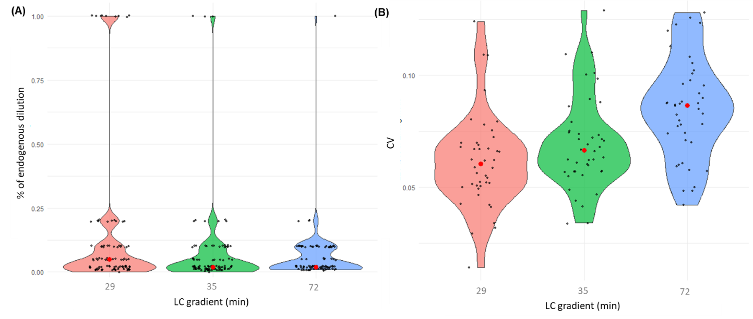
Supplemental figure 4. LC gradient optimization. Violin plots of the percentage of endogenous dilution used for LLOQ estimation (A) and CVs (B) for three different LC gradients (29, 35, and 72 minutes).

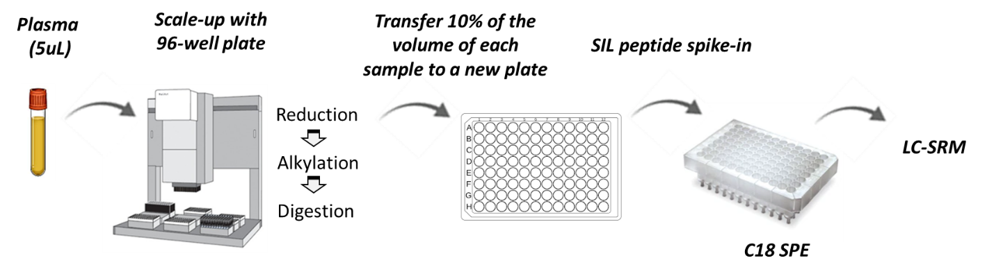
Supplemental figure 5. Workflow for 96-well plate-based sample preparation.

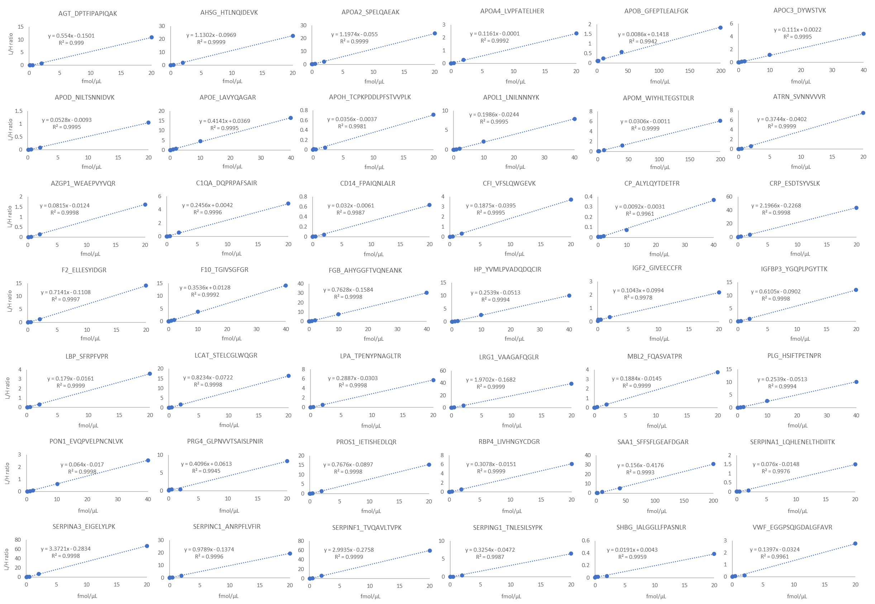
Supplemental figure 6. Calibration curves for 42 obesity biomarkers.
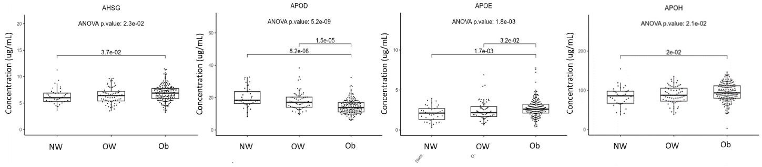
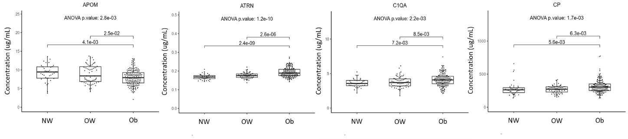
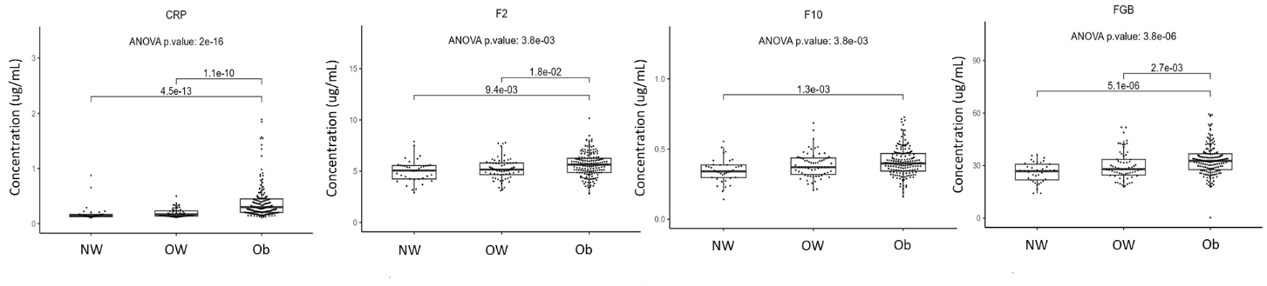
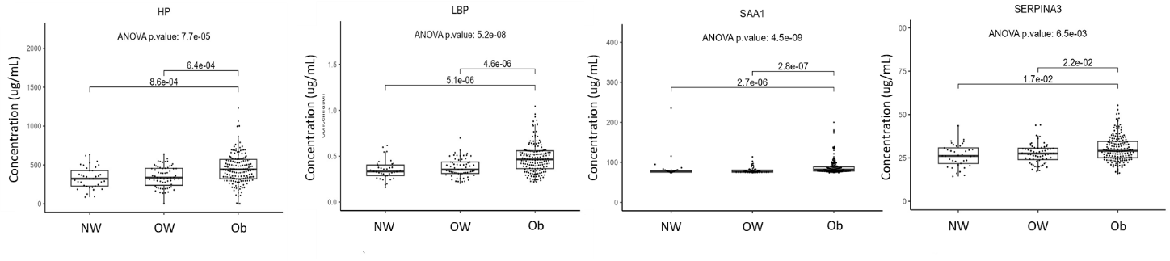
Supplemental figure 7. Concentrations of sixteen candidate biomarkers were significantly altered in the obesity group relative to the overweight and control groups. Statistically significant group comparisons were determined using the one-way ANOVA test, with p-values represented by asterisks. NW: normal weight; OW: overweight; Ob: obesity.

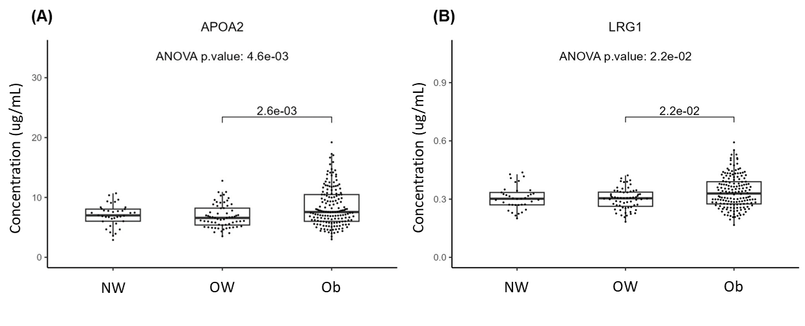
Supplemental figure 8. Concentrations of two candidates, APOA2 (A) and LRG1 (B) were significantly altered in the obesity group relative to the overweight group. Statistically significant group comparisons were determined using the one-way ANOVA test, with p-values represented by asterisks. NW: normal weight; OW: overweight; Ob: obesity.

