SUPPLEMENTARY TABLE 1
CHRONIC MIGRAINE
Outcomes | M0  (184) | M3  (184) | M6  (145) | M12  (80)
R ≥50%, n (%) | - | 66 (35.9) | 60 (41.4) | 43 (53.8)
R ≥30%, n (%) | - | 89 (48.4) | 78 (53.8) | 51 (63.8)
R ≥75%, n (%) | - | 19 (10.3) | 24 (16.6) | 24 (30.0)
MHDs  Change/M0 | 23.5 ± 5.1 | 17.5 ± 9.1*  6.0 ± 7.9 | 15.8 ± 9.5*  7.7 ± 8.5 | 12.8 ± 9.0*  10.1 ± 9.0
MMDs  Change/M0 | 21.4 ± 6.2 | 15.4 ± 9.1*  6.0 ± 8.8 | 14.2 ± 9.3*  6.9 ± 9.1 | 10.6 ± 8.8*  9.8 ± 9.7
MATD  Change/M0 | 19.9 ± 8.0 | 14.2 ± 9.9*  5.6 ± 8.6 | 12.9 ± 9.7*  6.6 ± 9.5 | 10.7 ± 9.0*  9.1 ± 9.9
HIT-6  Change/M0 | 67.2 ± 5.7 | 62.8 ± 8.3*  4.4 ± 7.4 | 60.4 ± 9.7*  6.8 ± 8.2 | 58.2 ± 9.5*  8.3 ± 7.5
EQ-5Di  Change/M0 | 0.50 ± 0.30 | 0.6 ± 0.3*  -0.1 ± 0.2 | 0.6 ± 0.3*  -0.1 ± 0.2 | 0.7 ± 0.3*  -0.2 ± 0.3
EQ-5Dvas  Change/M0 | 53.9 ± 19.2 | 59.4 ± 19.9*  -5.2 ± 17.6 | 63.3 ± 20.8*  -9.2 ± 19.7 | 68.8 ± 19.0  -13.2 ± 18.7
MIBS-4  Change/M0 | 6.7 ± 4.0 | 5.7 ± 4.1*  1.0 ± 3.4 | 4.8 ± 3.8*  1.8 ± 3.3 | 4.5 ± 4.0*  2.3 ± 4.4
HADS-A  Change/M0 | 9.7 ± 4.4 | 9.1 ± 4.3**  0.7 ± 2.8 | 8.6 ± 4.4*  1.1 ± 3.1 | 8.0 ± 3.9*  1.3 ± 3.1
HADS-D  Change/M0 | 7.6 ± 4.8 | 7.4 ± 5.0  0.2 ± 3.2 | 7.0 ± 4.8**  0.6 ± 3.1 | 5.7 ± 4.3*  1.8 ± 3.2
MO, n (%) | 161 (87.5) | 96 (53.6)* | 68 (48.9)* | 31 (39.2)*
EM, n (%) | 0 (100) | 87 (47.3) | 77 (53.1) | 55 (68.8)
HIGH FREQUENCY EPISODIC MIGRAINE
Outcome | M0  (118) | M3  (118) | M6  (101) | M12  (58)
R ≥50%, n (%) | - | 41 (34.7) | 36 (35.6) | 20 (34.5)
R ≥30%, n (%) | - | 58 (49.2) | 60 (59.4) | 36 (62.1)
R ≥75%, n (%) | - | 14 (11.9) | 14 (13.9) | 8 (13.8)
MHDs  Change/M0 | 10.8 ± 3.3 | 8.9 ± 6.3*  2.0 ± 6.8 | 8.0 ± 5.5*  2.7 ± 6.0 | 8.1 ± 5.3*  2.9 ± 4.8
MATD  Change/M0 | 10.4 ± 3.9 | 7.6 ± 5.9*  2.8 ± 6.6 | 7.1 ± 5.5*  3.3 ± 5.8 | 6.9 ± 4.6*  3.8 ± 4.3
HIT-6  Change/M0 | 66.6 ± 7.5 | 61.1 ± 8.3*  5.5 ± 9.6 | 59.4 ± 8.5*  7.2 ± 10.1 | 58.5 ± 7.9*  7.2 ± 9.3
EQ-5Di  Change/M0 | 0.64 ± 0.25 | 0.7 ± 0.3**  0.0 ± 0.2 | 0.7 ± 0.3**  -0.1 ± 0.2 | 0.7 ± 0.2**  -0.1 ± 0.2
EQ-5Dvas Change/M0 | 59.3 ± 17.4 | 66.7 ± 15.2*  -7.3 ± 16.3 | 69.5 ± 15.5*  -8.9 ± 17.2 | 70.3 ± 14.4*  -12.0 ± 16.0
MIBS-4  Change/M0 | 5.7 ± 4.0 | 4.5 ± 3.7*  1.2 ± 3.7 | 4.4 ± 4.0*  1.2 ± 3.3 | 4.1 ± 3.6*  1.4 ± 3.1
HADS-A  Change/M0 | 10.4 ± 4.4 | 9.4 ± 4.1*  1.0 ± 3.0 | 9.0 ± 4.2*  1.2 ± 3.7 | 8.3 ± 3.8*  2.0 ± 3.8
HADS-D  Change/M0 | 6.9 ± 4.1 | 5.9 ± 3.8*  1.1 ± 3.1 | 5.8 ± 4.2*  1.2 ± 3.8 | 5.2 ± 3.5*  2.1 ± 3.8
MO, n (%) | 68 (57.6) | 28 (23.9)* | 19 (19.0)* | 12 (21.1)*

Supplementary Table 1 (ST1). Longitudinal evolution of diary-based outcomes according to migraine subtype at baseline: monthly headache days (MHDs), monthly migraine days (MMDs), and monthly acute treatment days (MATD) in patients with chronic migraine and high frequency episodic migraine at baseline. Data are presented as mean±SD or n(%) as appropriate. *Wilcoxon signed-rank test vs M0: p < 0.001; **Wilconson signed rank test vs M0: p<0.05. Change/M0, change from baseline; EM, episodic migraine; EQ-5Di, EuroQol 5-Dimension index; EQ-5Dvas, EuroQol 5-Dimension index; HADS-A, Hospital Anxiety and Depression Scale-Anxiety; HADS-D, Hospital Anxiety and Depression Scale-Depression; HIT-6, Headache Impact Test-6; MATD, monthly acute treatment days; MHDs, monthly headache days; MIBS-4, Migraine Interictal Burden Scale-4; MMDs, monthly migraine days; MO, medication overuse; R, response; VAS, visual analogue scale.

SUPPLEMENTARY TABLE 2
OVERALL POPULATION (n=302)
Outcome | M0 | M3 | M6 | M12
R ≥50%, n (%) | - | 107 (35.4) | 109 (36.1) | 111 (36.8)
R ≥30%, n (%) | - | 147 (48.7) | 162 (53.6) | 158 (52.3)
R ≥75%, n (%) | - | 33 (10.9) | 43 (14.2) | 50 (16.6)
MHDs | 18.6 ± 7.7 | 14.1 ± 9.1* | 13.3 ± 9.1* | 13.5 ± 9.3*
MMDs | 17.0 ± 7.6 | 12.5 ± 8.7* | 12.1 ± 8.9* | 12.0 ± 9.1*
MATD | 16.2 ± 8.1 | 11.8 ± 9.2* | 11.5 ± 9.1* | 11.2 ± 9.2*
CHRONIC MIGRAINE (n=184)
Outcome | M0 | M3 | M6 | M12
R ≥50%, n (%) | - | 66 (35.9) | 70 (38.0) | 72 (39.1)
R ≥30%, n (%) | - | 89 (48.4) | 95 (51.6) | 91 (49.5)
R ≥75%, n (%) | - | 19 (10.3) | 28 (15.2) | 36 (19.6)
MHDs | 23.5 ± 5.1 | 17.5 ± 9.1* | 16.4 ± 9.4* | 16.5 ± 9.7*
MMDs | 21.4 ± 6.2 | 15.4 ± 9.1* | 14.8 ± 9.5* | 14.5 ± 9.8*
MATD | 19.9 ± 8.0 | 14.5 ± 9.8* | 13.9 ± 9.9* | 13.4 ± 10.0*
HIGH FREQUENCY EPISODIC MIGRAINE
Outcome | M0 | M3 | M6 | M12
R ≥50%, n (%) | - | 41 (34.7) | 39 (33.1) | 39 (33.1)
R ≥30%, n (%) | - | 58 (49.2) | 67 (56.8) | 67 (56.8)
R ≥75%, n (%) | - | 14 (11.9) | 15 (12.7) | 14 (11.9)
MHDs | 10.8 ± 3.3 | 8.9 ± 6.3* | 8.5 ± 6.0* | 8.8 ± 6.0*
MMDs | 10.0 ± 3.0 | 8.0 ± 5.8* | 7.8 ± 5.9* | 8.0 ± 5.9*
MATD | 10.4 ± 3.9 | 7.6 ± 5.9* | 7.7 ± 5.6* | 7.7 ± 5.6*

Supplementary Table 2 (ST2). LOCF sensitivity analysis in the overall population and according to migraine subtype at baseline. Data are presented as mean ± SD or n (%), as appropriate. *Wilcoxon signed-rank test vs M0: p < 0.001. LOCF, last observation carried forward; MATD, monthly acute treatment days; MHDs, monthly headache days; MMDs, monthly migraine days; R, response.
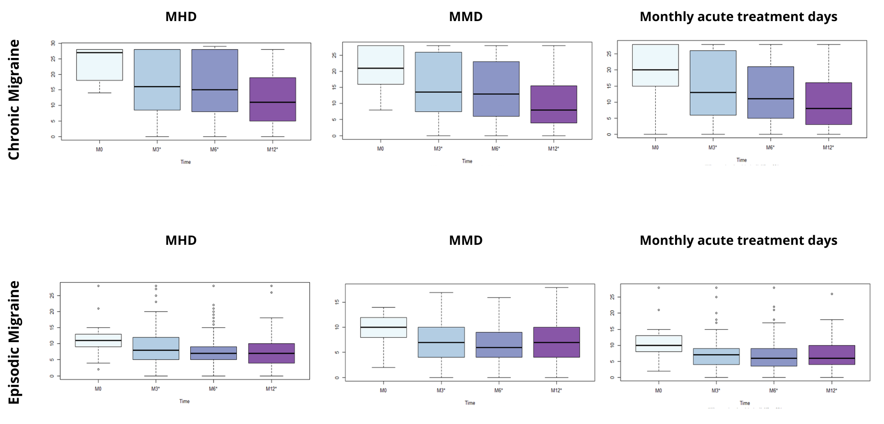
SUPPLEMENTARY FIGURE 1

Supplementary Figure 1 (SF1). Longitudinal evolution of diary-based outcomes according to migraine subtype at baseline. *Wilcoxon signed-rank test vs M0: p < 0.001. MHDs, monthly headache days; MMDs, monthly migraine days.

