Supporting Information
Multidimensional study on the corrosion inhibition of polypyrrole-chitosan (PPy-CTS) composites for carbon steel in acid medium
Baiyi Chen^{1,+}, Guohe Xu^{2,+}, Luyao Wang¹, Chen Zhang¹, Congcong Li¹, Guannan Ju^{3,*}, Huixia Feng^{1,*}
¹ School of Prtrochemical Engineering, Lanzhou University of Technology, Lanzhou 730050, China.
² College of Science and Technology, Hebei Agricultural University, Cangzhou 061100, China.
³ School of Materials Science and Engineering, Shandong University of Technology, Zibo, 255000, China.
+ These authors contributed equally to this work.
* Corresponding author: ju@sdut.edu.cn; fenghx66@163.com

Results
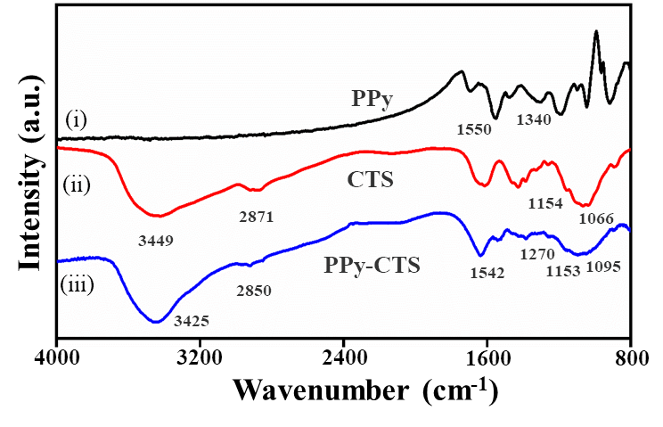
Figure S1. FT-IR spectra of PPy, CTS and PPy-CTS.

FT-IR spectrum of the PPy-CTS (iii) showed that the broad peak at around 3425 cm⁻¹ belonged to the O-H and N-H stretching vibration and the peak at 2850 cm⁻¹ belonged to the C-H stretching vibration of the polysaccharide. The peaks at 1153 cm⁻¹ and 1095 cm⁻¹ could be attributed to C-O-C stretching vibration. These nearby peaks were characteristic absorption peaks on the main chain of CTS. Meanwhile, the peak at 1270 cm⁻¹ of PPy-CTS belonged to C-N stretching vibration and the peak at 1542 cm⁻¹ corresponded to the C=C stretching vibration of the pyrrole ring. It can be seen that the FT-IR spectra of PPy-CTS contained the characteristic absorption bands of CTS and PPy. In addition, the peaks corresponding to C-N stretching vibrations shifted from 1340 cm⁻¹ to 1270 cm⁻¹, which could be attributed to the bonding between CTS and PPy chains. The results revealed that the PPy-CTS composites have been successfully synthesized¹⁻³.
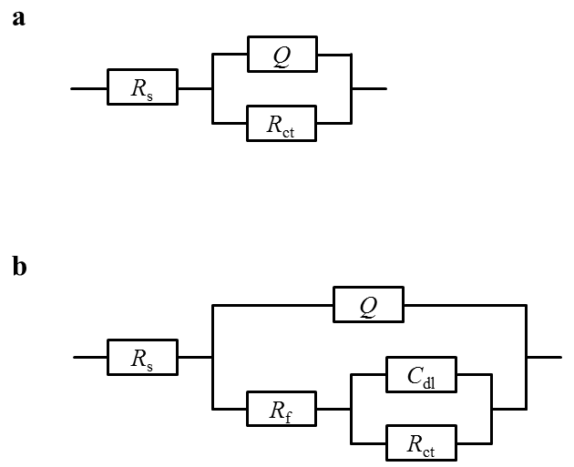
Figure S2. EIS equivalent electrical circuit diagrams for fitting (a) control group and (b) adding PPy-CTS. Key: R_{s}, the solution resistance; R_{ct}, charge transfer resistance; C_{dl}, the capacitor; Q, constant phase element; R_{f}, membrane resistance.

Fig. S2 was the equivalent electrical circuit diagrams that fitted the best impedance data of Q235 carbon steel in HCl solution without PPy-CTS and containing PPy-CTS corrosion inhibitor, respectively. In addition, (a) was R(Q)R model, and (b) was R(Q(R(CR))) model.

Table S1. Tafel parameters of Q235 carbon steel in 1 M HCl solution containing PPy-CTS with different Py/CTS mass ratios for 30 min.
m(Py):m(CTS) | β_{a}  (mV/decade) | β_{c}  (mV/decade) | I_{corr}  (A/cm²) | E_{corr}  (V vs SCE) | η
0.02:1 | 11.079 | 7.222 | 1.112×10⁻³ | -0.448 | 80.23％
0.05:1 | 11.587 | 7.444 | 9.612×10⁻⁴ | -0.430 | 82.91％
0.1:1 | 11.173 | 7.753 | 8.118×10⁻⁴ | -0.433 | 85.57％
0.15:1 | 11.292 | 6.210 | 1.100×10⁻³ | -0.417 | 80.44％
0.2:1 | 9.842 | 7.762 | 1.376×10⁻³ | -0.424 | 75.54％

Table S2. EIS fitting parameters of Q235 carbon steel in 1 M HCl solution containing PPy-CTS with different Py/CTS mass ratios for 30 min.
m(Py):m(CTS) | R_{s}  (Ω·cm²) | Y₀×10⁻⁴  (s^{n}Ω⁻¹·cm⁻²) | n  (0＜n＜1) | R_{p}  (Ω·cm²)
0.02:1 | 1.847 | 2.081 | 0.8470 | 20.76
0.05:1 | 1.885 | 2.478 | 0.8419 | 24.40
0.1:1 | 1.570 | 1.841 | 0.8589 | 29.82
0.15:1 | 1.697 | 2.219 | 0.8446 | 24.02
0.2:1 | 1.611 | 2.671 | 0.8643 | 18.03

Table S3. Tafel parameters of Q235 carbon steel in 1 M HCl solution containing PPy-CTS with different polymerization temperature for 30min.
Temperature | β_{a}  (mV/decade) | β_{c}  (mV/decade) | I_{corr}  (A/cm²) | E_{corr}  (V vs SCE) | η
5℃ | 11.173 | 7.753 | 8.118×10⁻⁴ | -0.433 | 85.57％
20℃ | 11.153 | 6.715 | 9.836×10⁻⁴ | -0.431 | 82.51％
40℃ | 9.198 | 6.105 | 1.203×10⁻³ | -0.426 | 78.61％

Table S4. EIS fitting parameters of Q235 carbon steel in 1 M HCl solution containing PPy-CTS with different polymerization temperature for 30 min.
Temperature | R_{s}  (Ω·cm²) | Y₀×10⁻⁴  (s^{n}Ω⁻¹·cm⁻²) | n  (0＜n＜1) | R_{p}  (Ω·cm²)
5℃ | 1.570 | 1.841 | 0.8589 | 29.82
20℃ | 1.819 | 2.362 | 0.8408 | 25.93
40℃ | 2.124 | 2.193 | 0.8421 | 21.96

Table S5. Tafel parameters of Q235 carbon steel in HCl containing different concentrations of PPy-CTS
Concentration (ppm) | β_{a}  (mV/decade) | β_{c}  (mV/decade) | I_{corr}  (A/cm²) | E_{corr}  (V vs SCE) | η%
0 | 7.699 | 4.461 | 5.625×10⁻³ | -0.387 | -
50 | 11.173 | 7.753 | 8.118×10⁻⁴ | -0.433 | 85.57％
100 | 10.684 | 6.103 | 7.209×10⁻⁴ | -0.429 | 87.18％
150 | 10.733 | 7.232 | 6.462×10⁻⁴ | -0.430 | 88.51％
200 | 11.104 | 7.152 | 5.740×10⁻⁴ | -0.431 | 89.80％
250 | 11.191 | 7.167 | 5.009×10⁻⁴ | -0.430 | 91.10％

References
[1] Chen Y, Long W, Xu H. Efficient removal of acid red 18 from aqueous solution by in-situ polymerization of polypyrrole-chitosan composites[J]. Journal of Molecular Liquids, 2019, 287: 110888.
[2] Ramasamy P, Subhapradha N, Shanmugam V, et al. Extraction, characterization and antioxidant property of chitosan from cuttlebone sepia kobiensis (Hoyle 1885) [J]. International Journal of Biological Macromolecules, 2014, 64: 202-212.
[3] Wang J, Lian Z, Wang H, et al. Synthesis and antimicrobial activity of schiff base of chitosan and acylated chitosan[J]. Journal of Applied Polymer Science, 2012, 123: 3242-3247.

