Graphical Abstract
Multidimensional study on the corrosion inhibition of polypyrrole-chitosan (PPy-CTS) composites for carbon steel in acid medium
Baiyi Chen^{1,+}, Guohe Xu^{2,+}, Luyao Wang¹, Chen Zhang¹, Congcong Li¹, Guannan Ju^{3,*}, Huixia Feng^{1,*}
¹ School of Prtrochemical Engineering, Lanzhou University of Technology, Lanzhou 730050, China.
² College of Science and Technology, Hebei Agricultural University, Cangzhou 061100, China.
³ School of Materials Science and Engineering, Shandong University of Technology, Zibo, 255000, China.
+ These authors contributed equally to this work.
* Corresponding author: ju@sdut.edu.cn; fenghx66@163.com

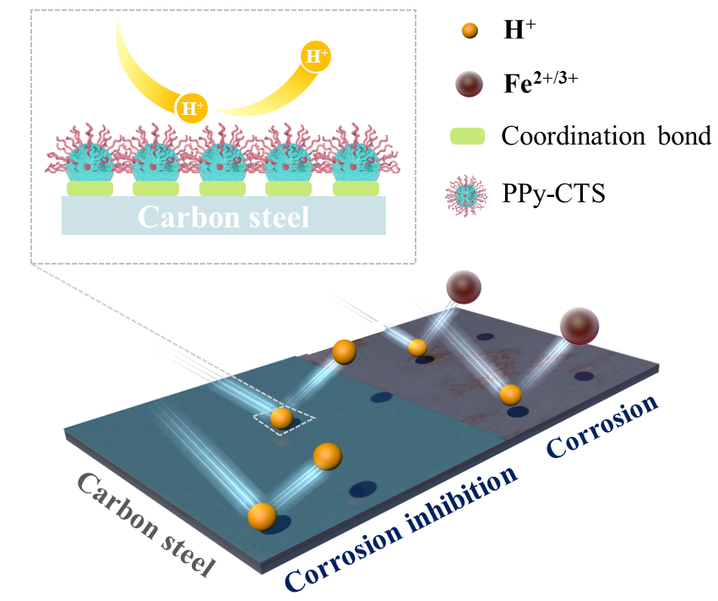
We have developed a mixed type corrosion inhibitor by incorporating the good solubility and adsorption capacity of chitosan into the excellent corrosion inhibition performance of polypyrrole. Ultimately, it effectively suppressed the corrosion reaction of carbon steel in harsh acidic environment through the synergistic effect of physical barrier and anodic protection.

