Supplementary file

Table 1 Database Search Strategies and Exact Query Terms

Engine | Exact Search Query
PubMed | cholera*[Title/Abstract] AND (vaccine*[Title/Abstract]) AND (effectiveness* [Title/Abstract] OR efficacy [Title/Abstract] OR protect*[Title/Abstract]) OR (cholera AND prevalence OR incidence [Title/Abstract])  cholera[MeSH Terms] AND vaccine*[MeSH Terms] AND ((effectiveness[MeSH Terms]) OR (efficacy[MeSH Terms])) OR (protect*[MeSH Terms]) AND oral cholera vaccine[MeSH Terms] AND (cholera prevalence[MeSH Terms]) OR (incidence[MeSH Terms])
Scopus | ( ( TITLE-ABS-KEY ( cholera* ) AND TITLE-ABS-KEY ( oral AND vaccines* ) AND TITLE-ABS-KEY ( killed OR live AND oral AND cholera AND vaccines* ) OR TITLE-ABS-KEY ( efficacy OR effectiveness* ) ) OR ( ( TITLE-ABS-KEY ( cholera* ) AND TITLE-ABS-KEY ( oral AND vaccines* ) AND TITLE-ABS-KEY ( killed OR live AND oral AND cholera AND vaccines* ) AND TITLE-ABS-KEY ( efficacy OR effectiveness* ) AND TITLE-ABS-KEY ( cholera AND prevalence OR incidence ) )
ISI Web of Science | ((((((TI=(cholera*)) AND AB= (Oral Vaccines*)) AND AB= (killed or live oral cholera vaccines*)) AND AB= (efficacy or effectiveness*)))) AND AB= (cholera prevalence or incidence)
Cochrane Review  Library | cholera* in Title Abstract Keyword OR Oral Vaccines* in Title Abstract Keyword OR killed or live oral cholera vaccines* in Title Abstract Keyword OR efficacy and effectiveness* in Title Abstract Keyword AND cholera prevalence in Title Abstract Keyword
EMBASE | cholera*:ab,ti AND vaccine*:ab,ti AND (efficacy: ab,ti OR effect*:ab,ti OR protect*:ab,ti) AND (prevalence: ab,ti OR incidence*:ab,ti)

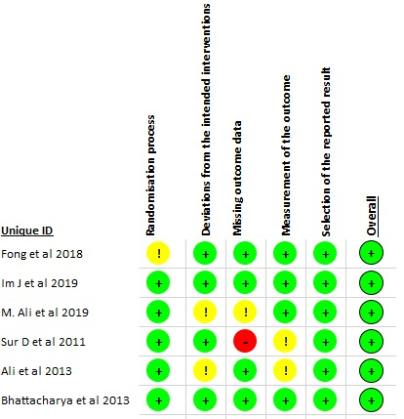

Figure 1 Risk of Bias Assessment of Included Randomized Controlled Trials
Risk of bias summary for randomization trials following the Cochrane Collaboration Tool. Green dots represent low risk of bias, yellow indicate unclear risk of bias and red dots indicate high risk of bias.

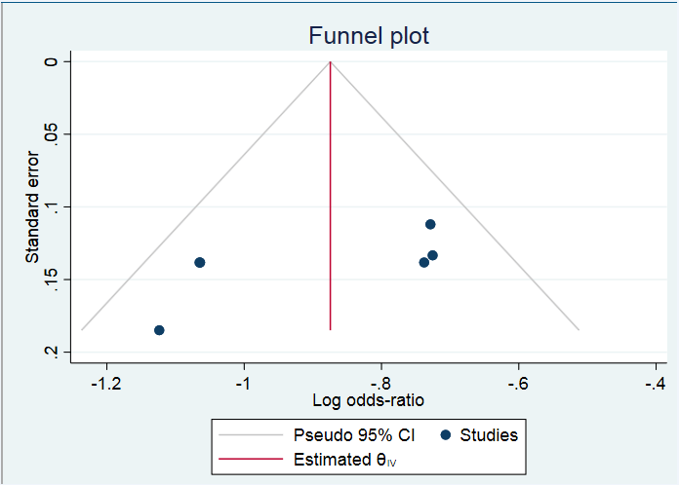

Figure 2 Funnel Plot for Assessment of Publication Bias
The symmetrical distribution around the pooled effect suggests absence of small-study or publication bias.

