Supplementary tables (1), (2) and (3).
Table 1. VITEK 2 system biochemical results of E. coli.
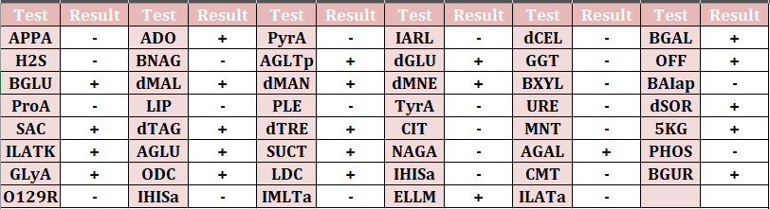

Table 2. VITEK 2 system biochemical results of klebsiella pneumonia.
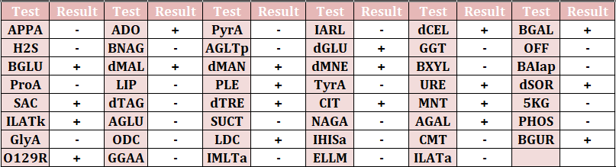

Table 3. VITEK 2 system biochemical results of Staphylococcus haemolyticus.
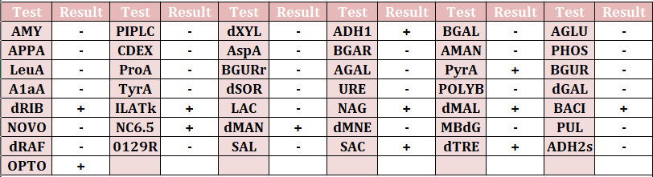

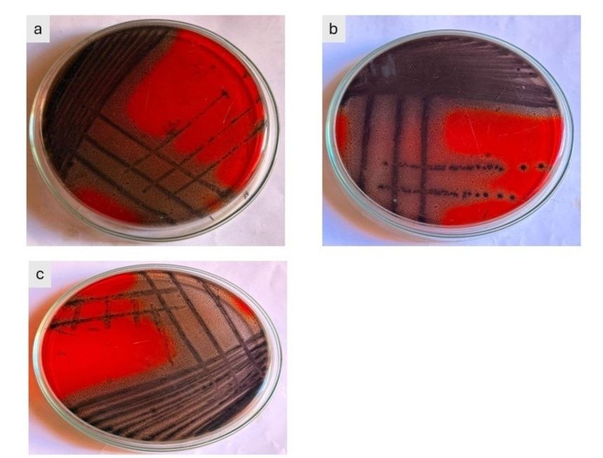
Fig 1. Biofilm formation by a) E. coli b) klebsiella pneumonia c) Staphylococcus haemolyticus

