Supplementary legends:

Supplementary Figure 1: Quiescent Axin2cre labelled cells form the main body of the new membrane during repair

(A-B’) Axin2cre;ERT2;TdTomato mouse10 days post perforation (dpp) after a 5 month wait between tamoxifen injection and perforation. Red fluorescent protein, RFP (red) and pancytokeratin, PCK (green) showing RFP positive cells in all layers of the healing TM. White boxes in L and M denote zoomed regions for A’,B’. White arrow in A points to RFP positive cell in the OEL, white arrow in A’ points to RFP positive cell in the IML. White arrow in B points to RFP positive cell in the LP. Scale bar in B = 100um. n=1 (2TMs).
IML = inner mucosal layer, OEL = outer epithelial layer, LP =Lamina propria
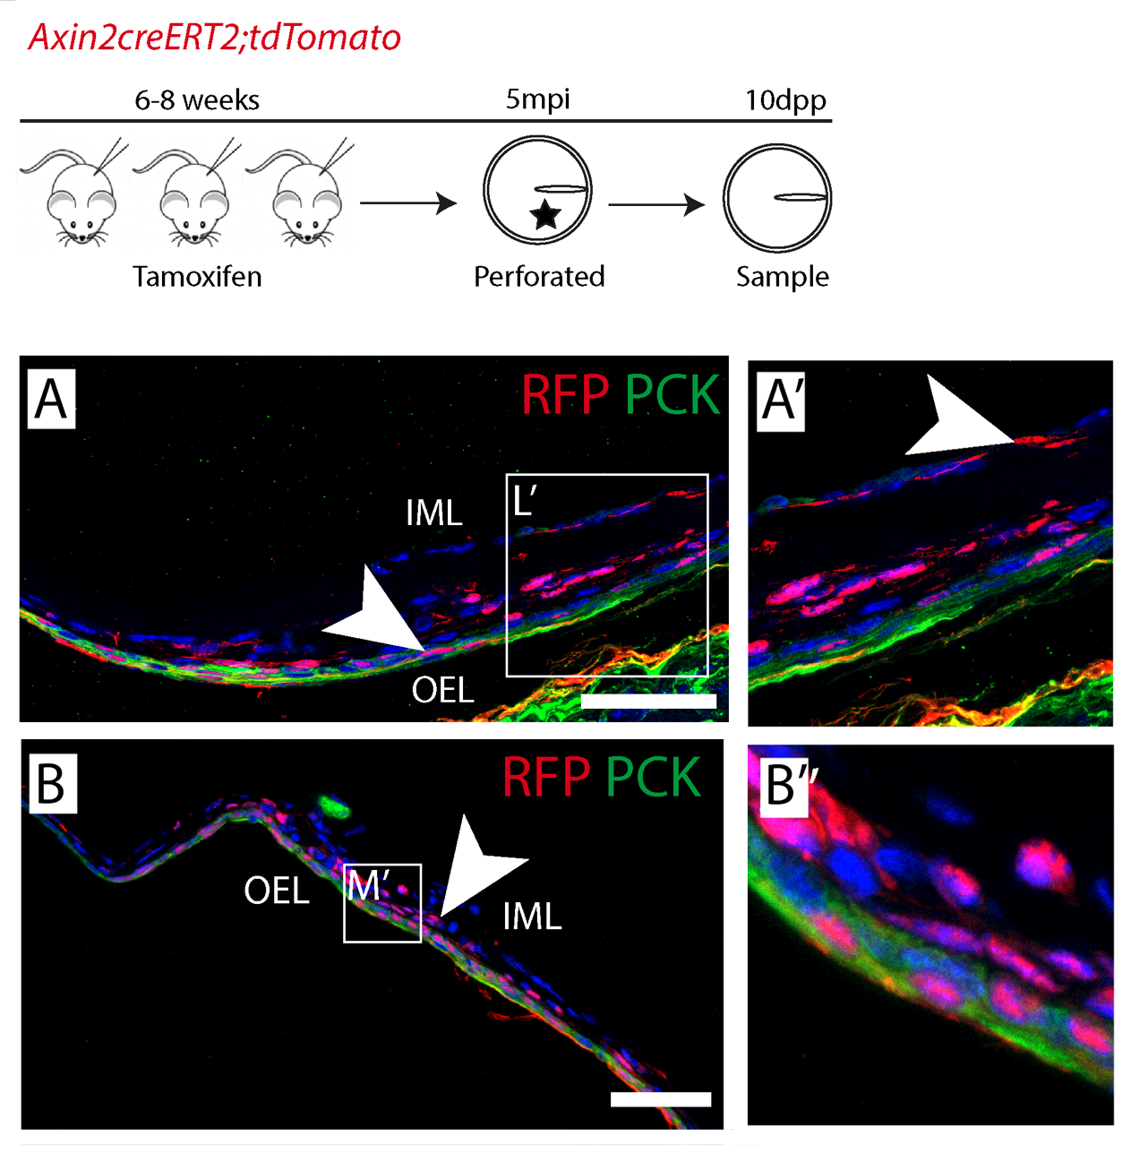
Supplementary Figure 2: Repair defects in LOF mutant mice

(A-D) Sections of the LOF mouse model at 10dpp (A,B) and 15dpp (C,D). (A) Pancytokeratin (PCK), red-fluorescent protein (RFP) and DAPI show gap where the outer epithelial layer (OEL), has failed to extend. White arrowhead. (B) PCK highlights epithelial invasion into the middle ear cavity (white arrowhead). N= 1 mouse. (C) Break still evident in the TM. White arrowhead denotes site of perforation. (D) Some TMs at 15 dpp were shown to exhibit a bi-layered phenotype. White arrowhead shows area of lack of mesenchyme. N=4 unhealed, N=2 bi-layered. Scale bars =100um.
IML = inner mucosal layer, OEL = outer epithelial layer

Supplementary Material:
Table of Antibodies
Antibody | Species | Manufacturer | Catalogue Number | Immunofluorescence Dilution
BrDU | Rat | Abcam | Ab6326 | 1:200
Pan-cytokeratin | Rabbit | Abcam | Ab217916 | 1:200
RFP | Goat | Sicgen | Ab1140-100 | 1:200
LEF-1 | Rabbit | Cell signaling | C12A5 | 1:200
PCNA | Rabbit | Abcam | Ab19166 | 1:200
Non-phospho (active) B-catenin | Rabbit | Cell Signaling | D13A1 | 1:1500
Anti-goat Secondary Antibody, Alexa Fluor 488 | Donkey | Invitrogen | A-11055 | 1:500
Anti-Rabbit Secondary Antibody, Alexa Fluor 488 | Goat | Invitrogen | A-11008 | 1:500
Anti-Rabbit Secondary Antibody, Alexa Fluor 568 | Donkey | Invitrogen | A10042 | 1:500
Anti-rabbit biotinylated secondary | Goat | Thermofisher | E0432 | 1:500
Hoechst | Na | Thermofisher Scientific | 62249 | 1:1000

