Supporting Information for
Chronology, morphometric analysis and grainsize distributions of the sequence of lahars occurred on the ESE flank of Stromboli (Italy) in 2024 - 2025.
Andrea Bevilacqua¹, Alessandro Fornaciai¹, Lucas Corna¹, Massimiliano Favalli¹, Pietro Gabellini², Luca Nannipieri¹, Augusto Neri¹, Massimo Pompilio¹

⁽¹⁾ Istituto Nazionale di Geofisica e Vulcanologia, Sezione di Pisa, Pisa, Italia.
⁽²⁾ Università di Firenze, Dipartimento di Scienze della Terra, Firenze, Italia.

Contents of this file

Figures S1 to S12
Table S1 to S2
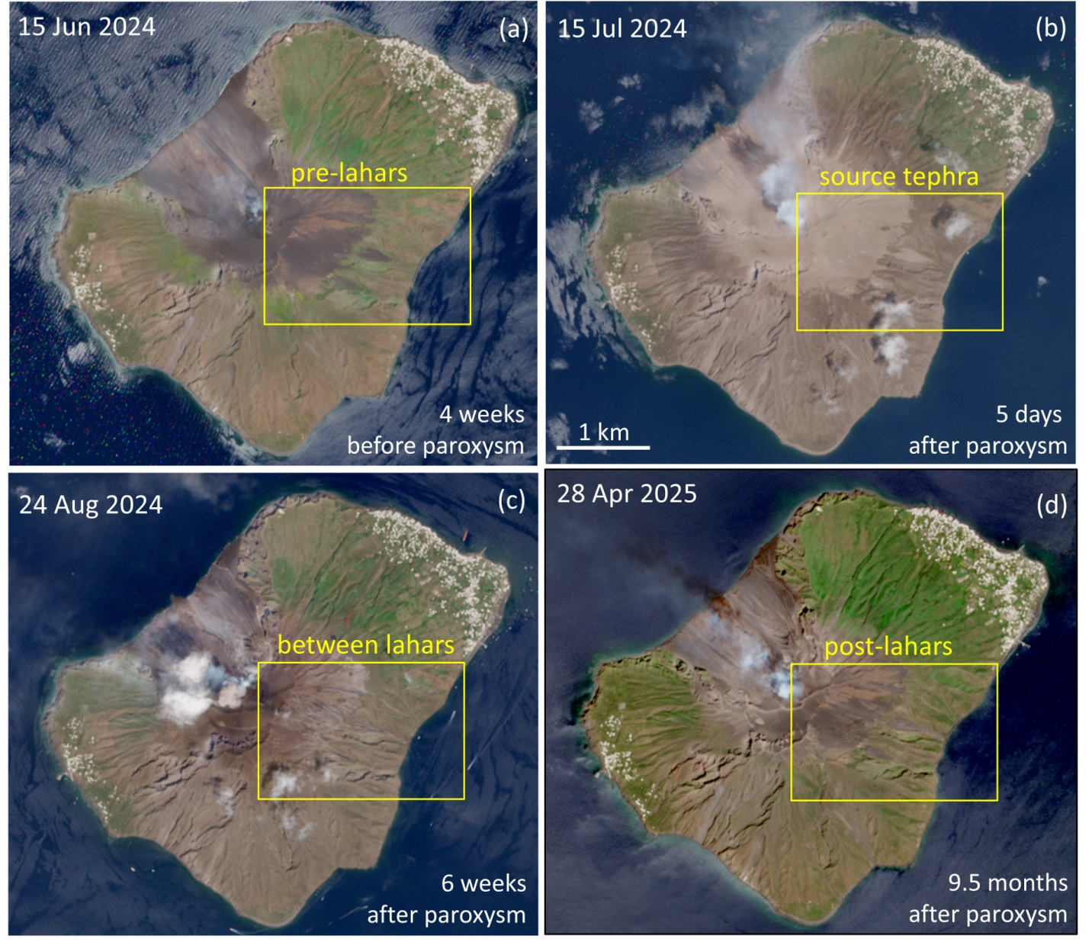
Figure S1. Selection of Sentinel-2 Level-2A imagery from June 2024 to April 2025 (ESA, 2025). A yellow box marks the area that we studied.

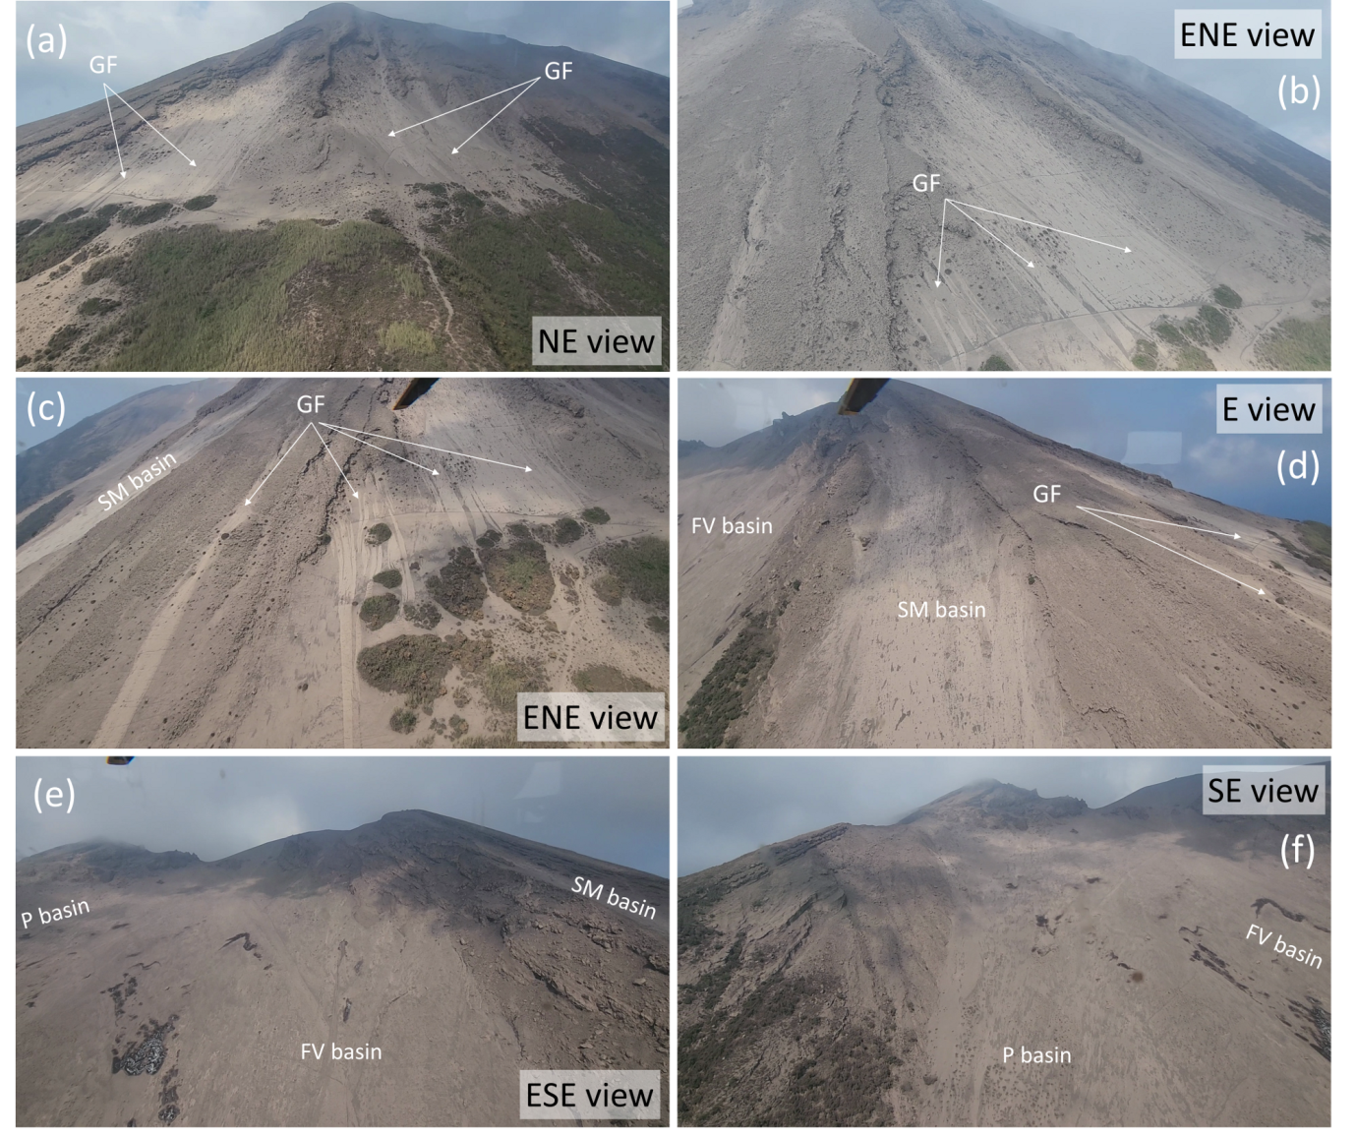
Figure S2. Selection of photograms from the video shot during a helicopter survey on July 30th 2024, ca. 2 weeks after the paroxysm (D. Russo Ph.). In (a-f) we show the views from NE (a), ENE (b,c), E (d), ESE (e), SE (f), respectively. In (a-c) we show the upper portions of basins on the NE flank of Stromboli, where several deposit lobes of gravity-driven flow (GF) are labeled. In (d) we show the upper portion of SM basin, and in (e-f) the upper portions of Forgia Vecchia and Portedduzza basins, respectively.

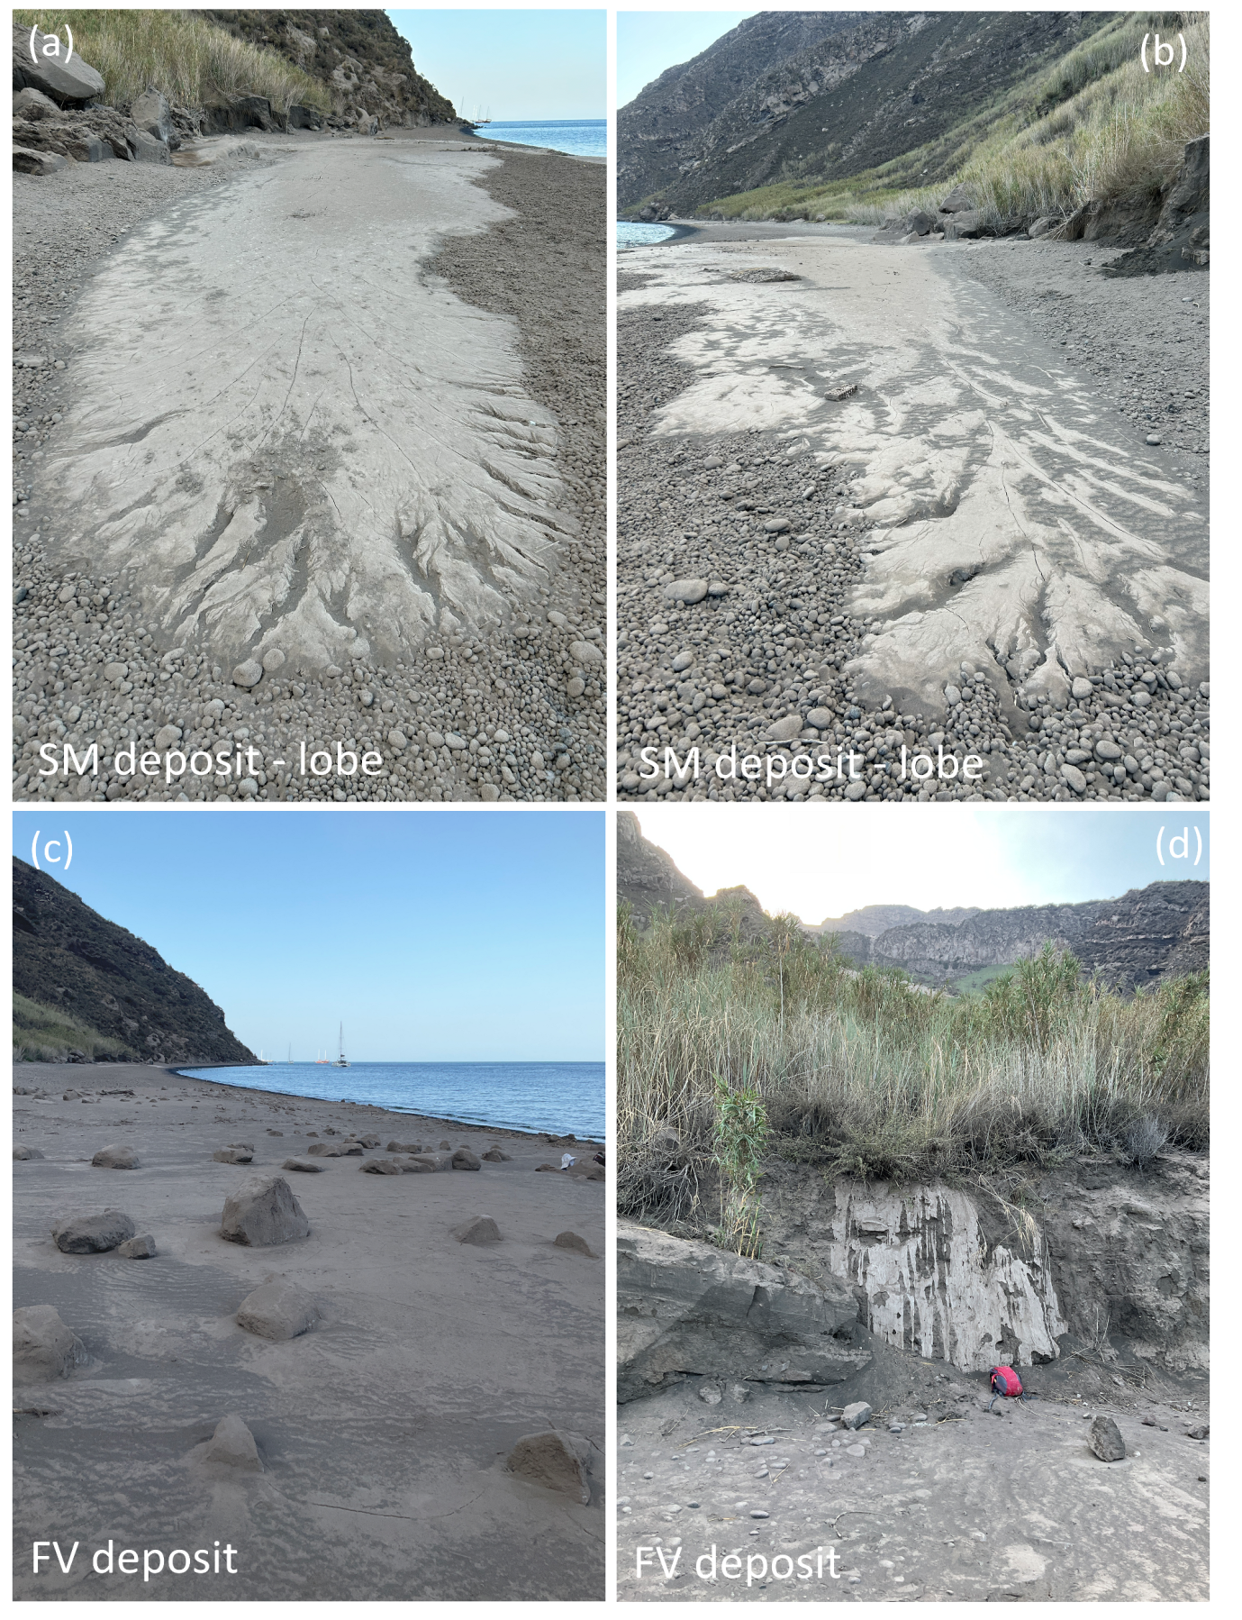
Figure S3. Pictures of Forgia Vecchia beach shot on July 28th 2024, ca. 2 weeks after the paroxysm. In (a,b) we show the initial July lahars deposits from Serra delle Mandre (SM) basin, whereas (c,d) show the deposit from the Forgia Vecchia (FV) basin. (M. Pompilio Ph.). In particular, in (a) we show the ca. 20 m long deposit lobe laterally-spread to the S, in (b) a similar lobe laterally-spread to the N. In (c) a close view of decimetric to metric-sized boulders moved by the lahar, and in (d) the mud deposit where the lahar left the reeds in the southern area.
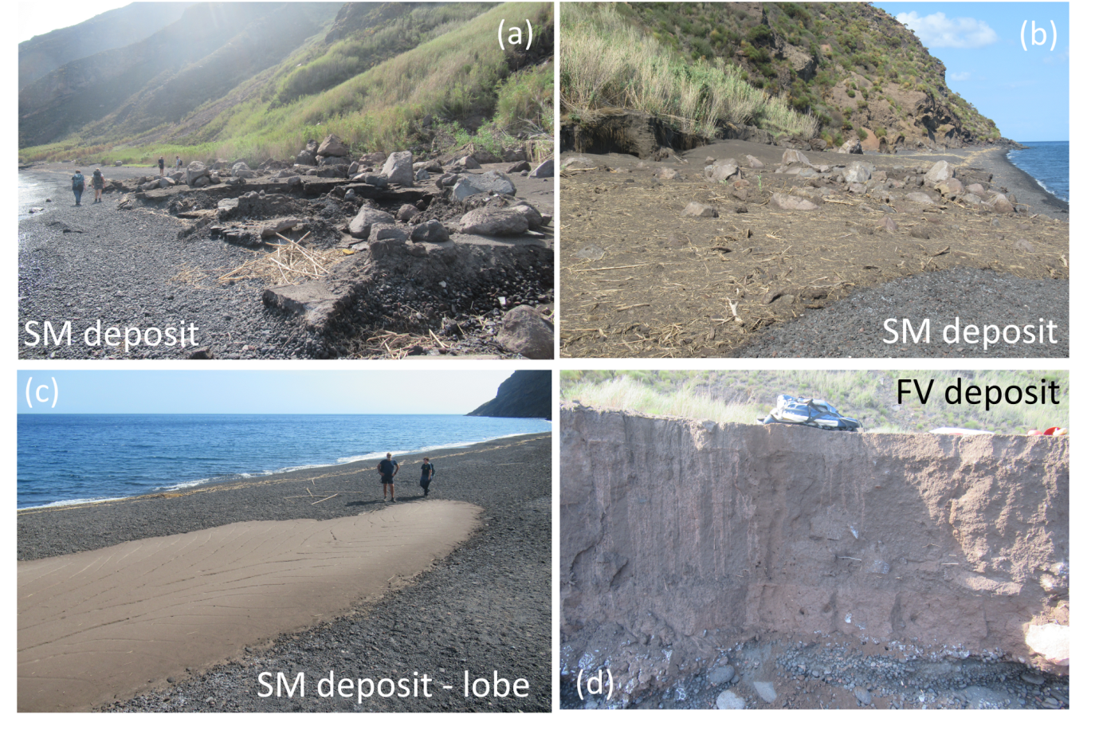
Figure S4. Pictures of Forgia Vecchia beach shot on September 12th 2024, ca. 2 months after the paroxysm. In (a-c) we show the deposits of the lahars occurred in August-Early September 2024 from Serra delle Mandre (SM) basin, whereas (d) shows those from the Forgia Vecchia (FV) basin. (L. Corna Ph.). In particular, in (a,b) we show the North and South view, respectively, of the deposit from the northernmost basin. In (c) we show a laterally spread lobe on the beach already observed in July. In (d) the three units described in the main text are evident.

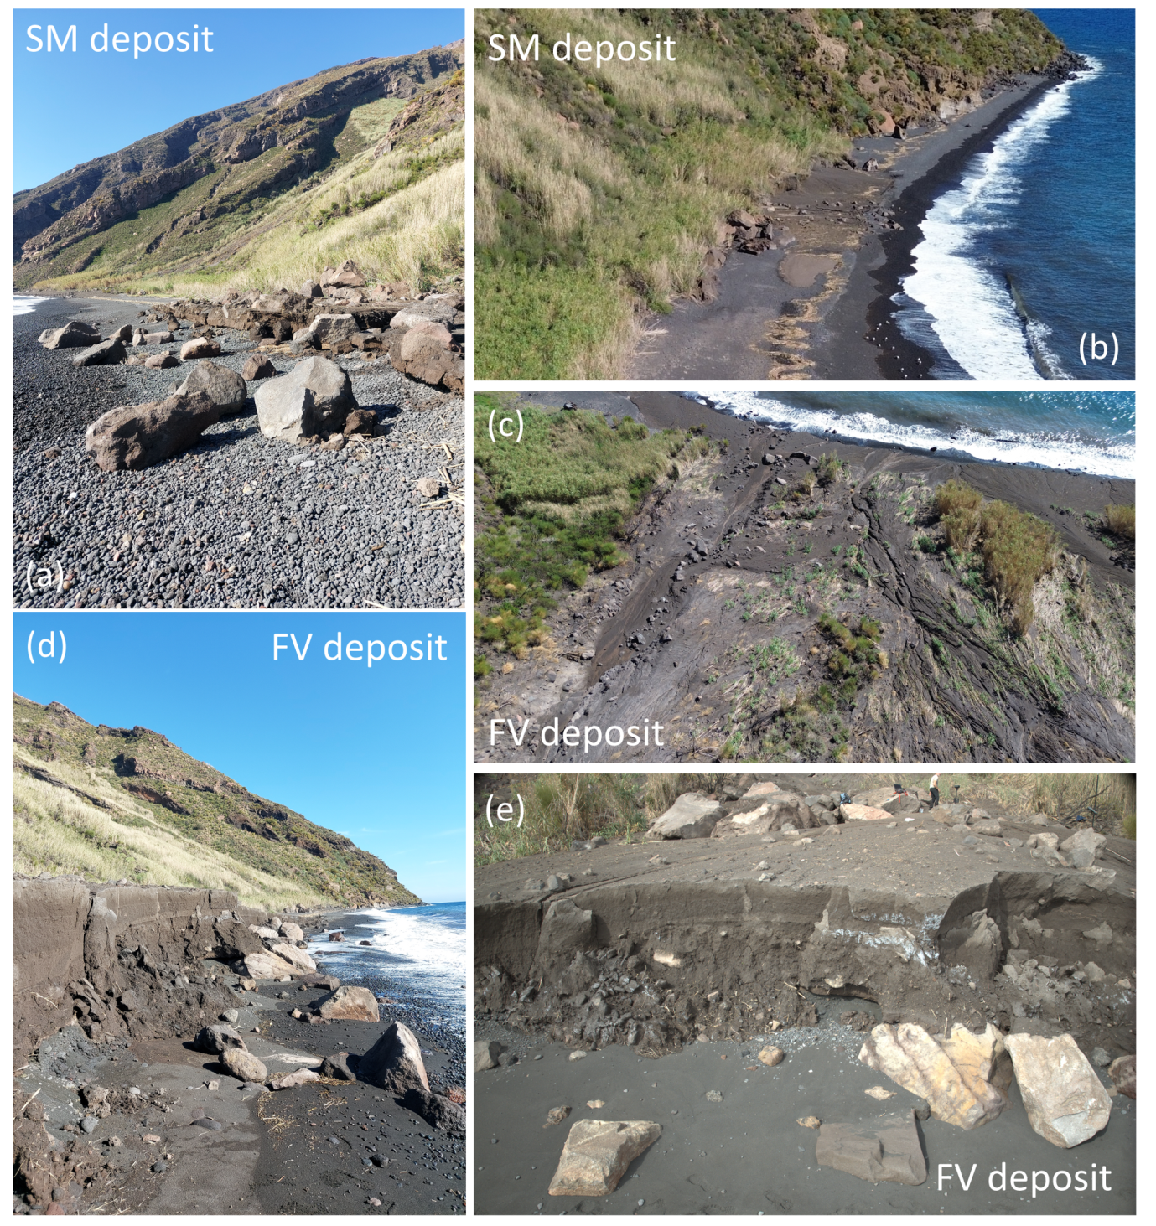Figure S5. Pictures of Forgia Vecchia beach shot on 9th - 10th September 2024, ca. 3 months after the paroxysm. In (a,b) we show the deposits of the lahars occurred between August and early October 2024 from the Serra delle Mandre (SM) basin, whereas (c-e) show those from the Forgia Vecchia (FV) basin. (A. Bevilacqua Ph.). In particular, in (a) we show a view from the North and in (b) an aerial view from the South of the northernmost deposits. In (c) we show an aerial view from ca. 50 m altitude of the eroded surface of the north side of the FV deposit. In (d) and (e) we show the view of the eroded FV deposits from the South (side) and from the East (front), respectively.
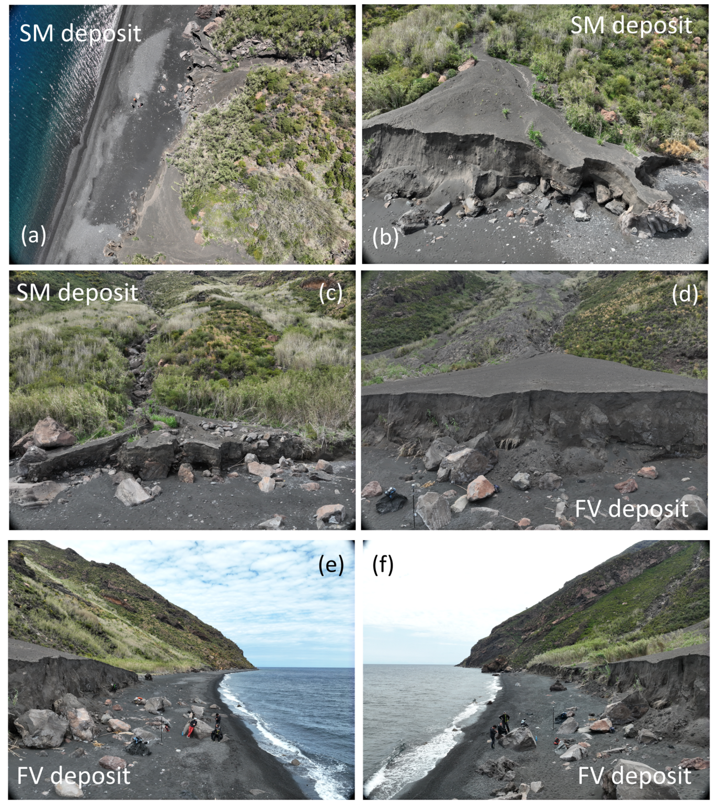
Figure S6. Pictures of Forgia Vecchia beach shot on 7th – 10th May 2025, ca. 10 months after the paroxysm. In (a-c) we show the cumulative deposits of the lahars occurred between August 2024 and early May 2025 from Serra delle Mandre (SM) basin, whereas (d-f) show those from the Forgia Vecchia (FV) basin. (A. Bevilacqua and L. Nannipieri Ph.). In particular, in (a) we show an aerial view from ca. 100 m altitude of the northernmost deposits, and in (b) and (c) the East (front) view of the same area. In (d,e,f) we respectively show the East (front), South (side) and North (side) aerial views, at 6 m altitude, of the FV deposits.

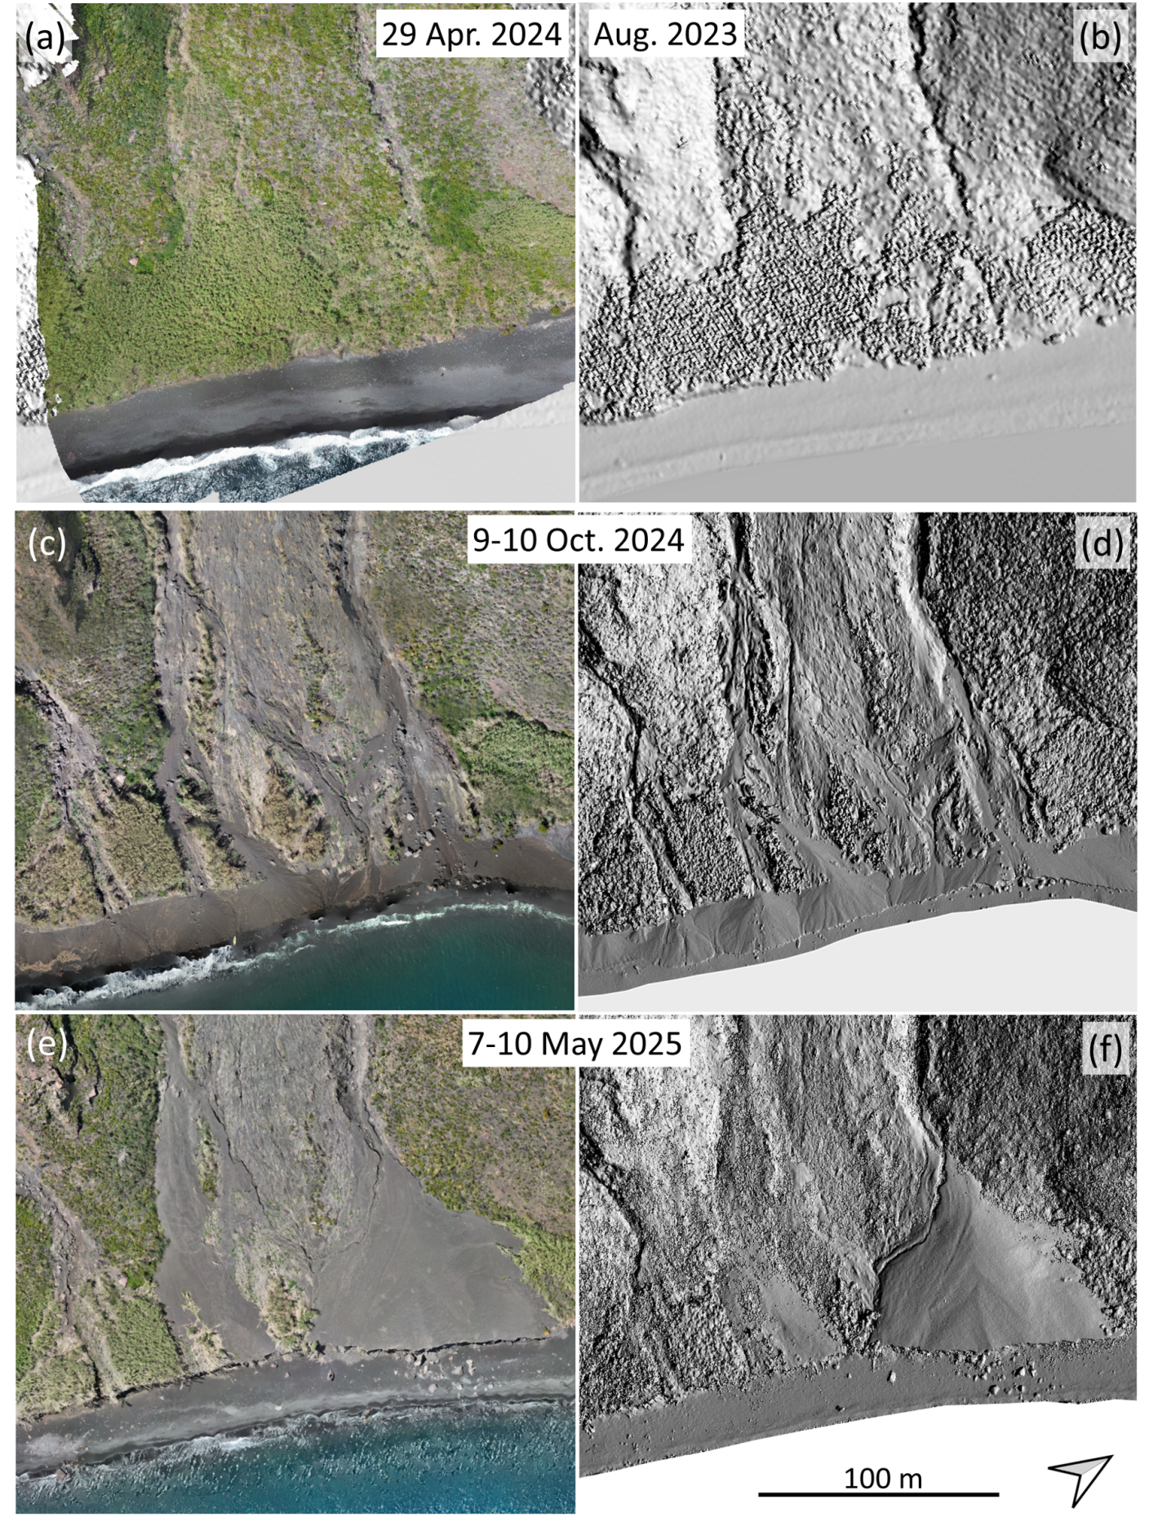
Figure S7. Orthomosaics (a,c,e) and hillshaded DSM (b,d,f) of the Forgia Vecchia (FV) deposit area. The times of data acquisition are (a) April 29th, 2024, (b) Aug. 2023, (c,d) 9th-10th October 2024, (e,f) 7th-10th May 2025.
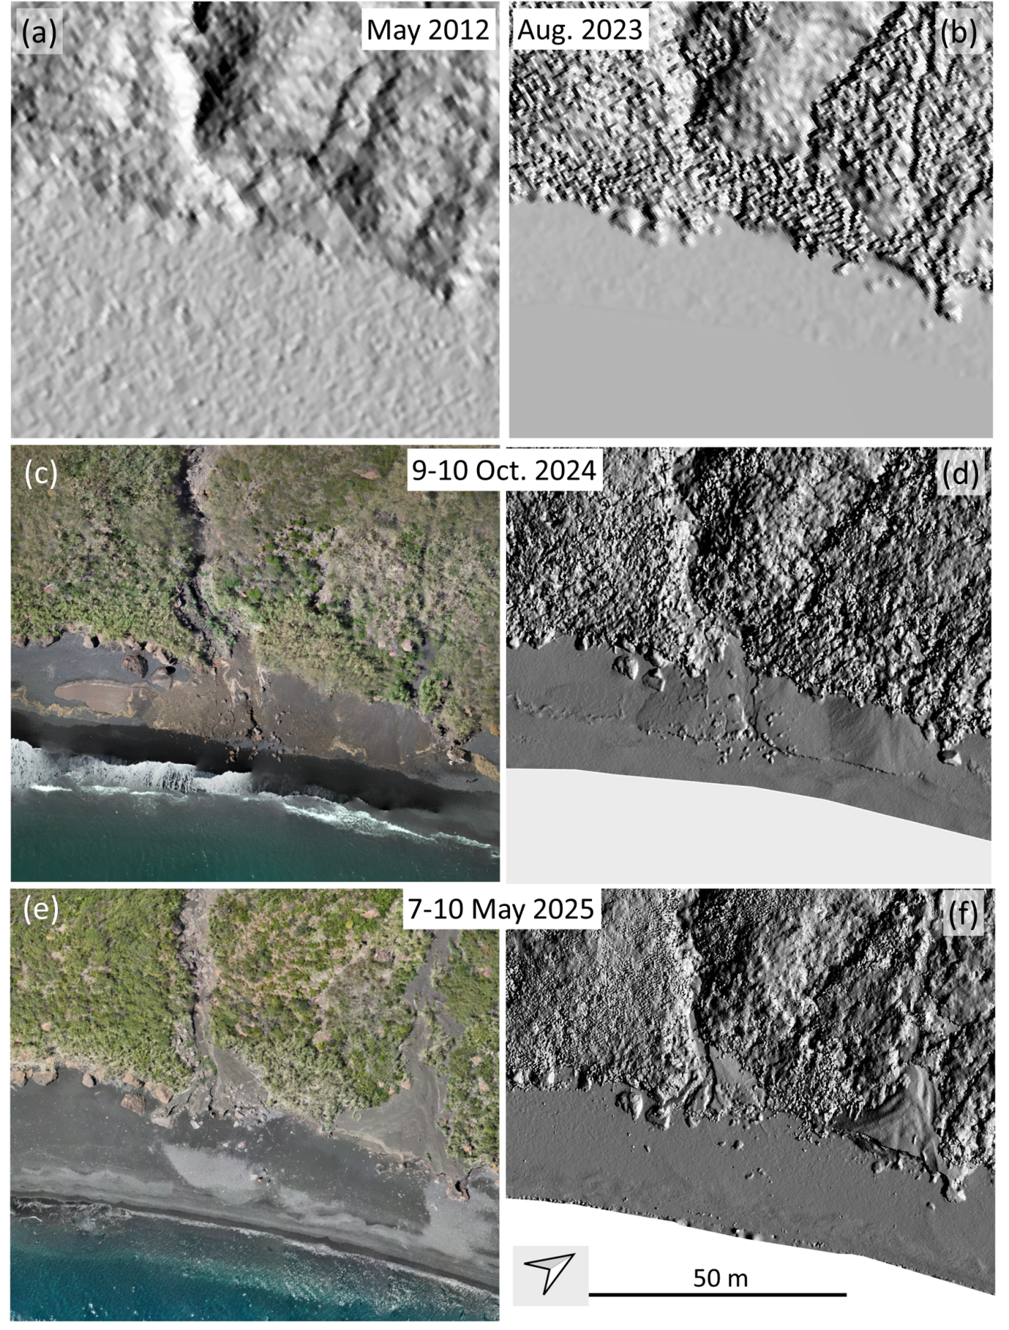
Figure S8. Orthomosaics (a,c,e) and hillshaded DSM (b,d,f) of the Serra delle Mandre (SM) deposit area. The times of data acquisition are (a) May 2012, (b) Aug. 2023, (c,d) 9th-10th October 2024, (e,f) 7th-10th May 2025.

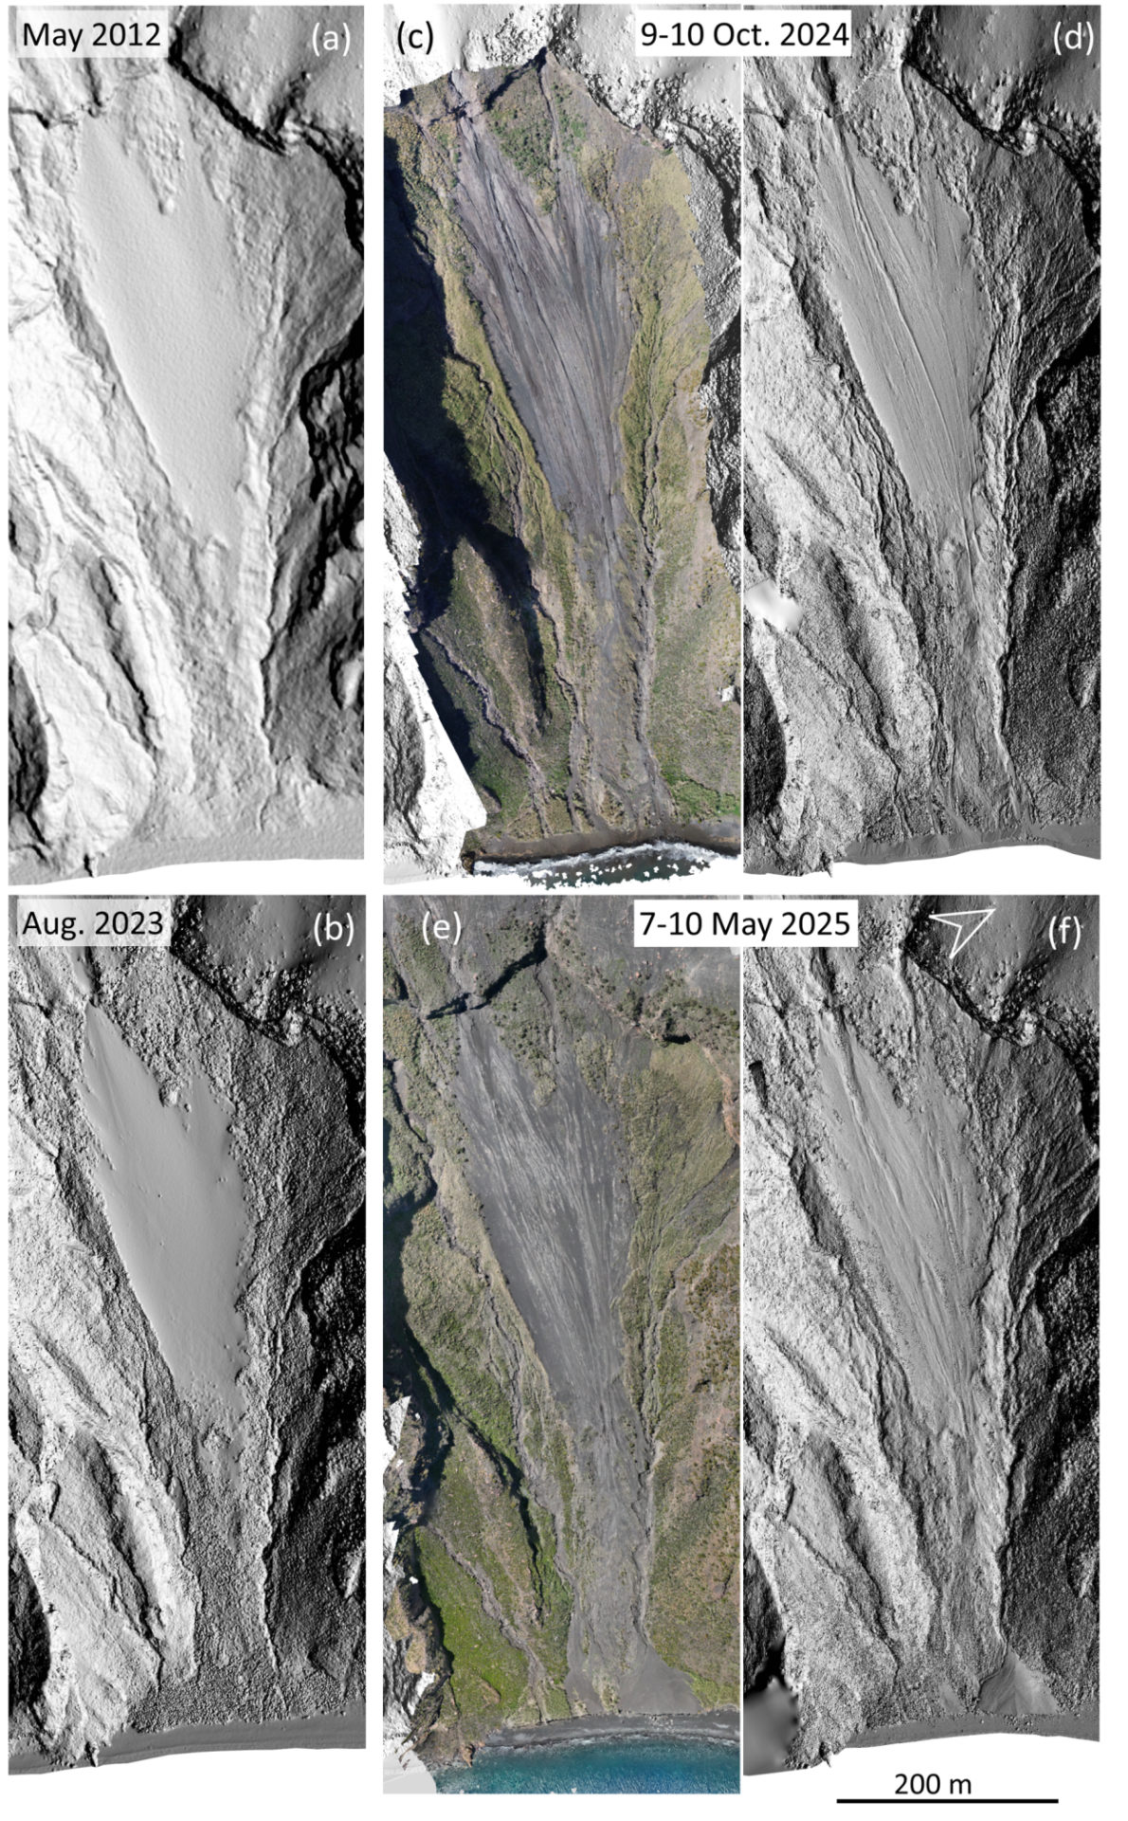
Figure S9. Hillshaded DSM (a,b,d,f) and orthomosaics (c,e) of the portion of Forgia Vecchia (FV) basin below 400 m a.s.l. They illustrate the chronology of our morphometric surveys. The times of data acquisition are (a) May 2012, (b) Aug. 2023, (c,d) 9th - 10th October 2024, (e,f) 7th - 10th May 2025. Note that (a) is a DTM and not a DSM.
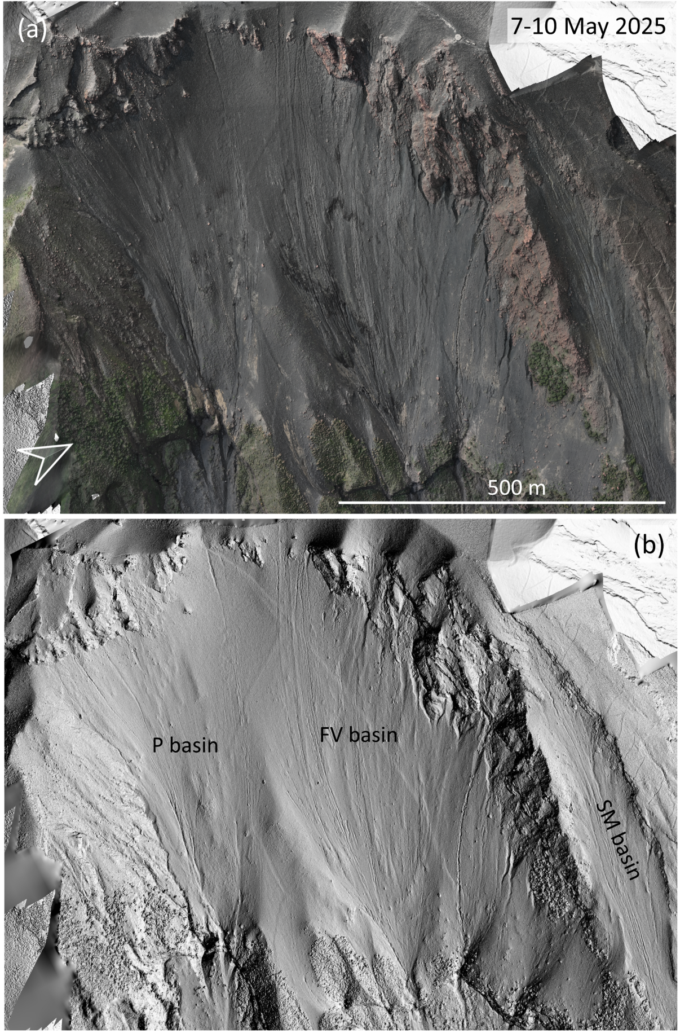
Figure S10. Orthomosaic (a) and hillshaded DSM (b) of the Rina Grande area, above ca. 400 m a.s.l. (see Fig. 1). They illustrate the significant erosive structures described in section 4.1. The time of data acquisition is 7th - 10th May 2025. Note that in (a) we multiplied the orthomosaic by an hillshaded with a similar illumination to enhance the visible details.
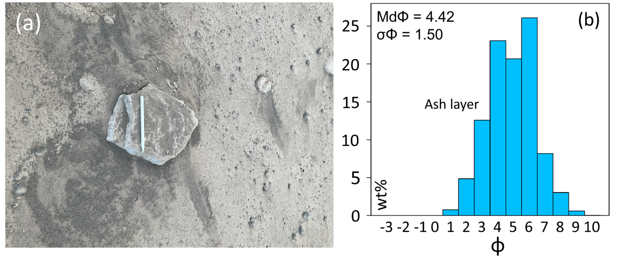
Figure S11. (a) Picture of ash layer sampled from above a flat block on the beach, which deposited after the lahar emplacement (M. Pompilio Ph.). (b) Grainsize distribution of the ash layer.

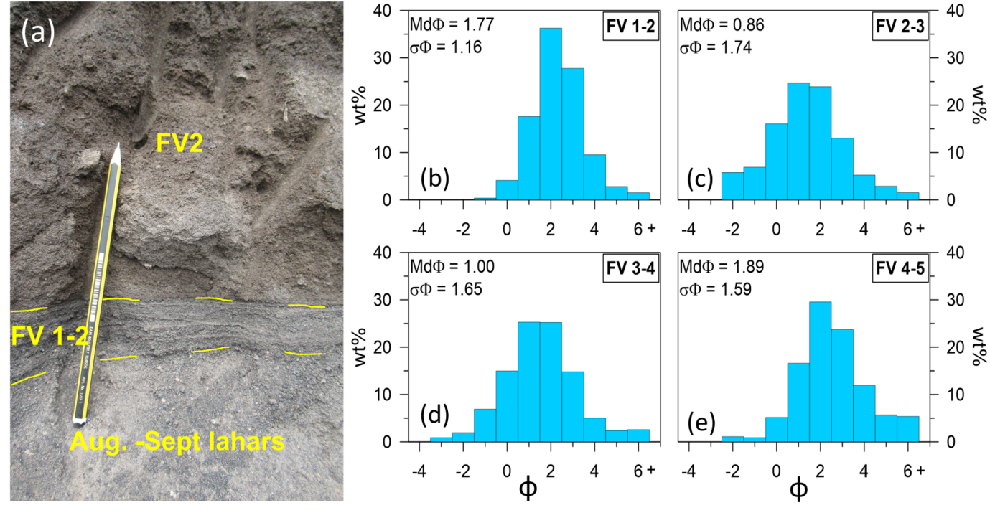
Figure S12. (a) Picture of the cross-stratified layer FV 1-2 (L. Corna Ph.). (b-e) Grainsize distributions of the thinner cross-stratified sections intermediate between main lahar units (see Fig. 10).

Table S1. Chronology of events reported in Figure 2 indicating source information references.
Date | Event | Source Information
June 15, 2024 | Sentinel photo | Figure S1
July 4, 2024 | major explosion | Zuccarello et al. (2024)
July 11, 2024 | paroxysm | INGV (2024)
July 15, 2024 | Sentinel photo | Figure S1
July 26, 2024 | major explosion | INGV bulletins
July 28, 2024 | field survey | Figure S3
July 30, 2024 | helicopter survey | Figure S2
August 19, 2024 | news on lahars | GdL (2024)
August 24, 2024 | Sentinel photo | Figure S1
September 12, 2024 | field survey | Figure S4
September 13, 2024 | news on lahars | Fotia (2024)
September 24, 2024 | news on lahars | Raso (2024)
October 6, 2024 | major explosion | INGV bulletins
October 9-10, 2024 | UAS/GPS survey | Table 2, Figure S5
October 19, 2024 | news on lahars | ANSA (2024)
November 6, 2024 | news on lahars | Tavernini (2024)
November 11, 2024 | news on lahars | Berté (2024)
March 28, 2025 | state of emergency | GdL (2025a)
April 28, 2025 | Sentinel photo | Figure S1
May 7-10, 2025 | UAS/GPS survey | Table 2, Figure S6

Table S2. Summary of grain size and thickness parameters of the cross-stratified units studied, using the Folk and Ward (1957) method.
 |  | d10 | Median | d90 | Sorting | Thickness
July 2024 | ash cover | 2.35 | 4.42 | 6.20 | 1.50 | < 1 cm
Oct. 2024 - May 2025 cross stratified layers | FV 1-2 | 0.31 | 1.77 | 3.40 | 1.16 | 5 cm
Oct. 2024 - May 2025 cross stratified layers | FV 2-3 | -1.39 | 0.86 | 2.97 | 1.74 | 2 cm
Oct. 2024 - May 2025 cross stratified layers | FV 3-4 | -0.98 | 1.00 | 3.00 | 1.65 | 12 cm
Oct. 2024 - May 2025 cross stratified layers | FV 4-5 | 0.17 | 1.89 | 4.18 | 1.59 | 5 cm

