Supplemental Information

Maternal stress shapes offspring innate immunity via milk leptin

Ella L. Sommer^{1,†}, Niilo V. Valtakari^{2,†}, Maes J. Holleman¹, Carmen S.D. Peters¹, Sarah A.M. Linsen¹, Martijn Zegelaar¹, Nicky Markus¹, Claire Mackaaij³, Suzan Thijssen⁴, Olaf Perdijk⁴, Laurens Witter¹, Cindy G.J. Cleypool³, Michael A. van der Kooij^{1,*}

Figure S1
Figure S1. Distance between dam and nest, related to Figure 1. Automated mouse tracking shows that dams exposed to LBN are in closer proximity to their nest than dams kept under CTRL conditions (n= 6-8 cages/group). Data are shown as mean + SEM. Grey shading indicates night phase; white indicates day phase. Statistical analyses were performed using a mixed-effects model. *P<0.05, **P<0.01, ***P<0.001.

Figure S2
Figure S2. LBN does not affect maternal prolactin or levels of pup glucose and hepatic triglycerides, related to Figure 2.
(A) Maternal prolactin plasma levels, when pups are P9 (CTRL: n= 6 dams, LBN: n= 3 dams).
(B) Glucose concentrations in peripheral P9 pup blood (n= 39-40 mice/group).
(C) Triglyceride levels in hepatic tissue from P9 pups (n= 11-12 pups/group).
Data are shown as mean + SEM (A) or as individual data points (B,C). Statistical analyses were performed using a two-way ANOVA (A) and unpaired t-tests (B,C).
Figure S3
Figure S3. Corticosterone levels in maternal milk, related to Figure 2. Corticosterone concentrations in maternal milk from the stomach of the pups at P9 were not affected after LBN exposure (n= 6-8 mice/group). Data are shown as individual data points. Statistical analyses were performed using an unpaired t-test.

Figure S4
Figure S4. Impact of LBN on lymphocyte, monocyte and eosinophil numbers, related to Figure 3. Relative abundances of lymphocytes, monocytes and eosinophils in circulating blood at P9, P16 and P100 (P9: n= 15-16 mice/group, P16: n= 7 mice/group; P100: n= 13-15 mice/group). Data are shown as individual data points. Statistical analyses were performed using a two-way ANOVA and Šidák’s post hoc test. *P<0.05, **P<0.01.

Figure S5
Figure S5. Neutrophil maturation state in pups at P9, related to Figure 3. LBN did not impact the number of nuclear neutrophil indentations at P9 (n= 10 mice/group).

Figure S6
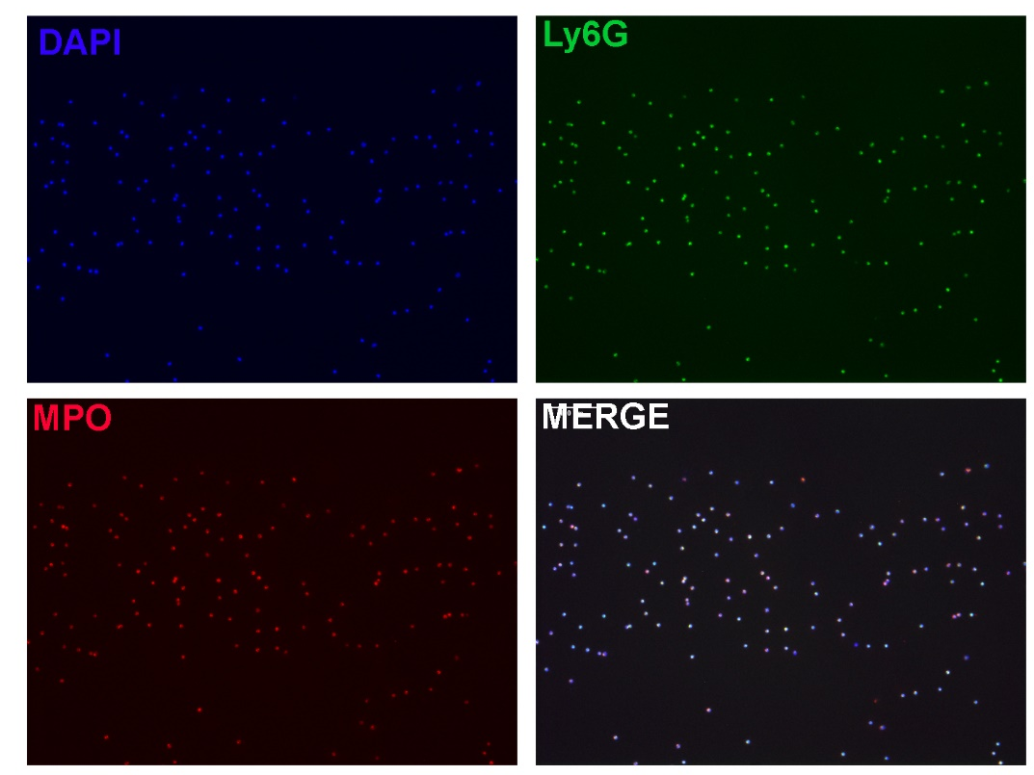Figure S6. Sorting for neutrophils, related to Figure 3. MACS sorting from whole blood, obtained from P120 pups, yielded pure neutrophil populations (99.1% were DAPI⁺/MPO⁺/Ly6G⁺).

Figure S7
Figure S7. No difference in oxidative burst between stimulated neutrophils from LBN and CTRL, related to Figure 3.
(A) Oxidative burst (ΔH₂O₂, 0-30 min) in PMA (phorbol 12-myristate 13-acetate)-stimulated neutrophils at P100 (n= 3-4 mice/group).
(B) Area under the curve (AUC) of ΔH₂O₂ in PMA-stimulated neutrophils at P100 (n= 3-4 mice/group).
Data are shown as mean ± SEM and as individual data points. Statistical analyses were performed using an unpaired t-test comparing the AUC’s (B).

Figure S8
Fig. S8. Adding corticosterone (CORT) to the drinking water does not affects overall water intake, nest exit duration or dam-nest distance, related to Figure 4.
(A) Water intake from P2-9 (n= 3-4 cages/group).
(B) Duration of nest exits from P2-9 (n= 3-4 cages/group)
(C) Average distance between dam and nest from P2-9 (n= 3-4 cages/group).
Data are shown as individual data points. Grey shading indicates night phase; white indicates day phase. Statistical analyses were performed using an unpaired t-test and a mixed-effects model.

Figure S9
Fig. S9. Early-life LBN exposure induces leptin-sensitive neural and behavioral phenotypes, related to Figure 5.
(A) Hypothalamic neuropeptide Y (NPY) expression at P9, showing the effect of LBN and rescue by exogenous leptin administration (n= 9-10 mice/group).
(B) Adult locomotor activity showing the effect of LBN and rescue by exogenous leptin administration (n= 9-10 mice/group).
Data are shown as individual data points. Statistical analyses were performed using a one-way ANOVA. *P<0.05; **P<0.01.

Figure S10
Fig. S10. LBN does not affect plasma levels of G-CSF, CXCL1 and CXCL12 in the pup, related to Figure 5. G-CSF, CXCL1 and CXCL12 were measured in blood plasma of P9 pups (n= 10-15 mice/group). Data are shown as individual data points. Statistical analyses were performed using unpaired t-tests.

Figure S11
Fig. S11. Developmental leptin administration and long term neutrophilia after LBN, related to Figure 5. Leptin injected at P2,4,6,8 partially prevented the neutrophilia at P120 (n= 9-10 mice/group). Data are shown as individual data points. Statistical analysis were performed using a one-way ANOVA. ****P<0.0001.

Figure S12
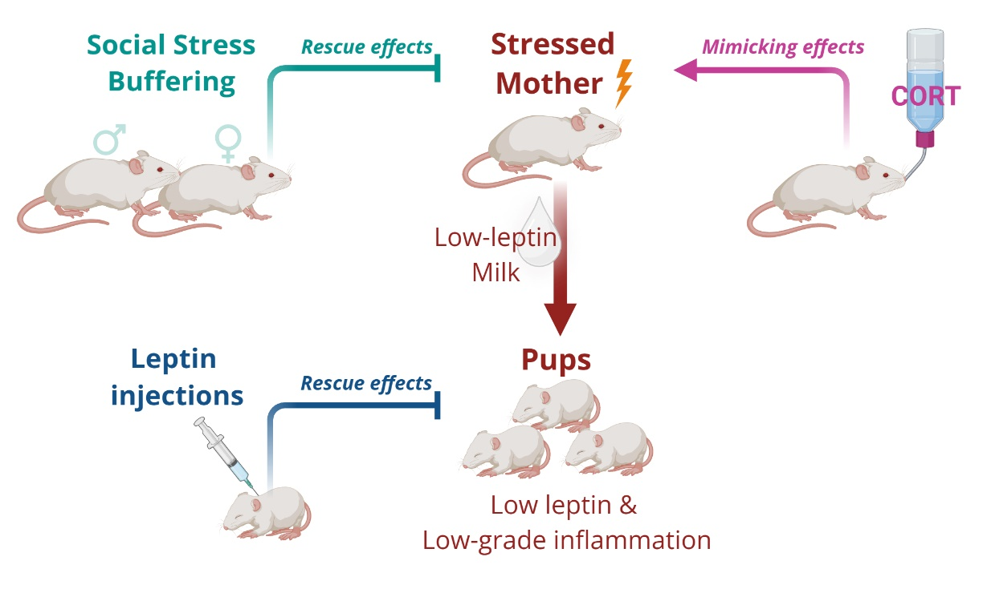
Fig. S12 Model of maternal stress–induced leptin deficiency and offspring inflammation.
Maternal stress lowers milk leptin, resulting in reduced leptin exposure and low-grade inflammation in pups. Social buffering prevents, whereas corticosterone (CORT) mimics, these effects. Leptin supplementation rescues the phenotype, identifying leptin as a key mediator.

Video S1. Sire grooming pups, related to Figure 6. A sire engages in grooming behavior toward pups in the home cage under limited bedding and nesting conditions.

Video S2. Sire retrieving pups, related to Figure 6. A sire retrieves pups back to the nest, illustrating paternal retrieval behavior under limited bedding and nesting conditions.

Video S3. Sire allogrooming the dam, related to Figure 6. A sire performs allogrooming of the dam in the home cage under limited bedding and nesting conditions.

