Supplemental material
Parsimonious analysis of confounders effects on the self-perceived influence of OPOCUS on clinical decision making

Using the DAG, we identified all the unblocked paths that linked the outcome (decision-making) with the exposure (GUSI vs. OJT). Two plausible pathways through which training modality could influence decision-making ability were identified:- (1) by providing the technical knowhow to identify pregnancy complications early, and (2) by increasing HCP’s confidence in the accuracy of their obstetric assessments.

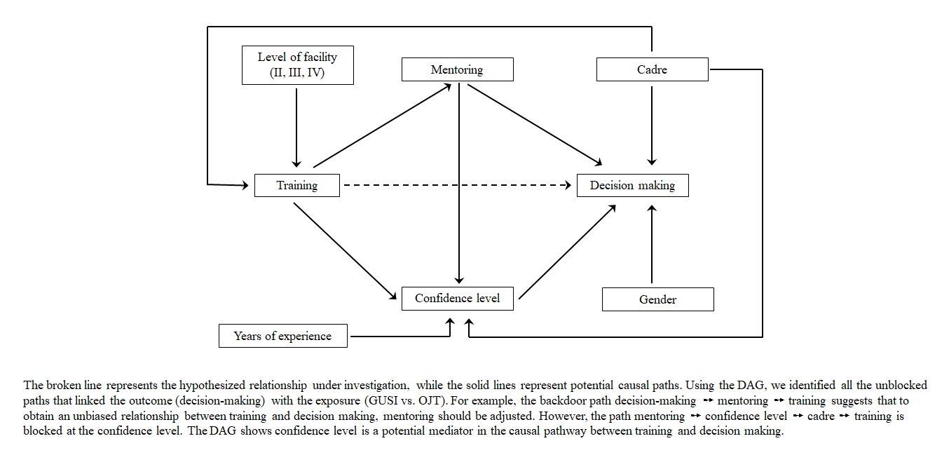
Supplemental Figure 1: Directed Acyclic Graph (DAG)

