Source Apportionment and Characterization of Water Insoluble Single Particulate Matters in Rain Sequences Using Particle Size Analyzer and Scanning Electron Microscopy
Ercan Berberler^{a,b}, Betül Tuba Gemiciª, Handan Ucun Özelª, Tuğçe Demir^{b}, Duran Karakaş^{b}*
ªDepartment of Environmental Engineering, Faculty of Engineering, Architecture and Design, Bartın University, 74100 Bartın, Turkey.
^{b}Department of Environmental Engineering, Faculty of Engineering, Bolu Abant Izzet Baysal University, 14030 Bolu, Turkey.

Table S1. Sum of measured non-seal salt ionic concentrations in the rainfall event samples (μg/mL)
Event | F⁻ | Cl⁻ | NO₃⁻ | SO₄²⁻ | NH₄⁺ | K⁺ | Mg²⁺ | Ca²⁺
1 | nd | 4.41 | 1.44 | 2.01 | 0.19 | 0.41 | 0.47 | 0.29
2 | 0.54 | 1.96 | 3.64 | 5.79 | 1.21 | 0.50 | 0.16 | 15.1
3 | nd | 7.21 | 5.05 | 5.67 | 0.12 | 0.45 | 0.47 | 2.57
4 | nd | 1.64 | 3.19 | 3.14 | nd | 0.34 | 0.08 | 0.34
5 | 0.67 | 9.35 | 15.52 | 25.42 | 4.75 | 1.97 | 1.06 | 12.4
6 | nd | 1.11 | 4.88 | 5.01 | 0.92 | 0.59 | 0.53 | 28.1
7 | nd | 1.91 | 6.06 | 4.94 | 2.20 | 1.22 | 0.56 | 17.2
8 | 0.33 | 0.95 | 4.06 | 5.19 | 1.29 | 1.68 | 0.06 | 2.05
nd: Not detected.
*Na ion was used as a reference element for non-sea salt calculations.

Table S2. Concentrations of elements in the rainfall events (ng/mL)
Element | RF Event 4 | RF Event 5 | RF Event 6 | RF Event 7
Ag | 2.68 | 0.48 | nd | 0.21
Al | 495 | 1082 | 489 | 30.5
As | 34.2 | 43.8 | 14.7 | 9.08
Ba | 5.55 | 51.2 | 19.0 | 21.0
Be | nd | nd | nd | nd
Bi | 2.79 | 7.24 | 2.74 | 2.70
Cd | 0.80 | 1.35 | 0.33 | 0.17
Co | 0.13 | 0.66 | 0.20 | nd
Cr | 9.45 | 19.3 | 11.9 | 7.81
Cs | 2.71 | 9.15 | 1.69 | 2.48
Cu | 5.57 | 16.7 | 10.6 | 10.2
Fe | 76.2 | 550 | 298 | 62.1
Ga | 15.8 | 41.4 | 12.0 | 2.14
Li | 38.7 | 154 | 123 | 36.1
Mg | 8220 | 42700 | 14700 | 6320
Mn | 2.87 | 25.6 | 13.5 | 6.06
Mo | nd | 0.74 | 0.71 | 0.26
Ni | 97.1 | 29.3 | 18.2 | 10.9
Pb | 8.88 | 21.4 | 7.59 | 14.2
Sb | 1.97 | 1.97 | 0.99 | 0.14
Se | 0.97 | 2.60 | 1.14 | 1.16
Sn | 6.12 | 8.21 | 1.64 | 1.04
Sr | 13.3 | 45.8 | 48.1 | 55.2
Tl | nd | 0.26 | 0.15 | 0.06
V | 44.0 | 46.0 | 12.9 | 3.96
Zn | 4.05 | 113.1 | 54.1 | 75.1
nd: Not detected, RF: Rainfall.
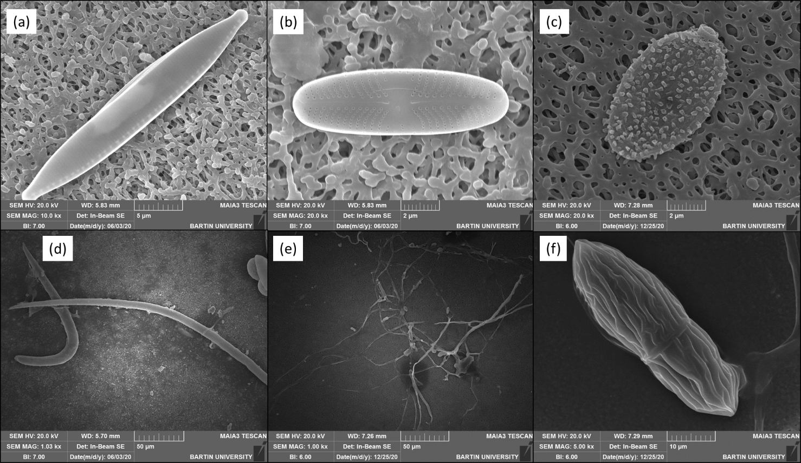
Fig. S1. SEM images of biological organisms and spores observed in the sequences of rainfall event 1 (a, b, and d) and 8 (c, e, and f). (a)-(b) diatoms (Navicula species), (c) a spindle fungal spore, (d) worm-like biological organisms, most probably picozoans (Not et al., 2007), (e) hyphae/ inter-branched hyphal filaments (Gkoutselis et al., 2021), and (f) a fungal spore with a layer of strips.

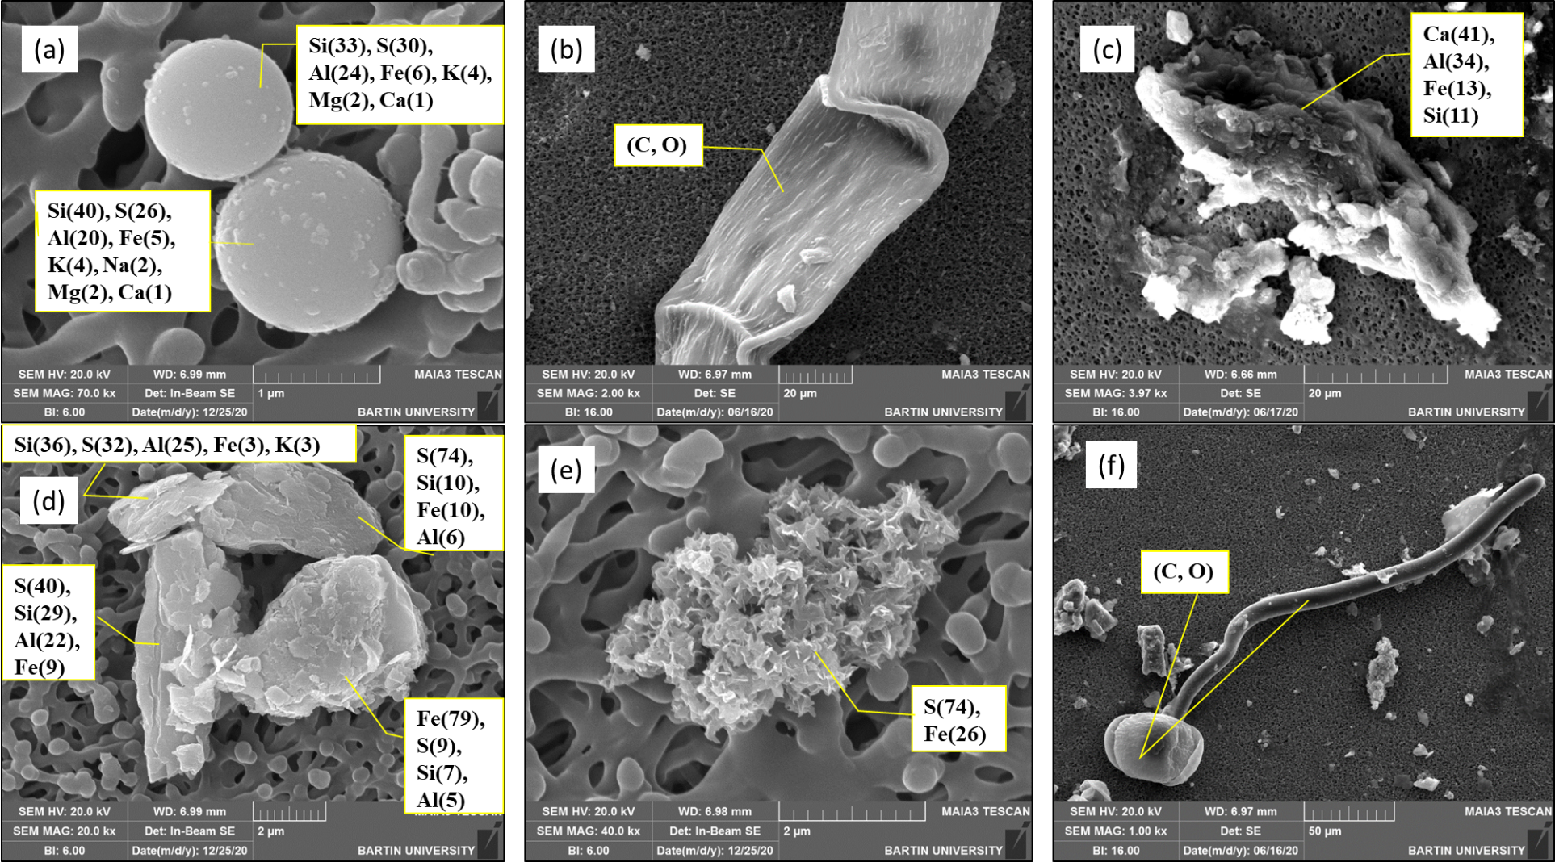
Fig. S2. SEM-EDS results and morphologies of PMs from the first sequential samples of rainfall events 5 and 8. Numbers in the parenthesis following the elements show atomic percentages. (a) two spherical fly ash particles (8-1), (b) part of a biological microfiber (5-1), (c) irregularly shaped earth crust PM (5-1), (d) a mix of elemental sulfur (Moon et al., 2016) and two sulfur-rich and an iron-rich irregularly shaped fly ash PMs (8-1), (e) Pyrite (FeS₂) (8-1), (f) an unidentified biological particle (5-1). First number in parenthesis shows the rainfall event number and the second number represents the sequence number.
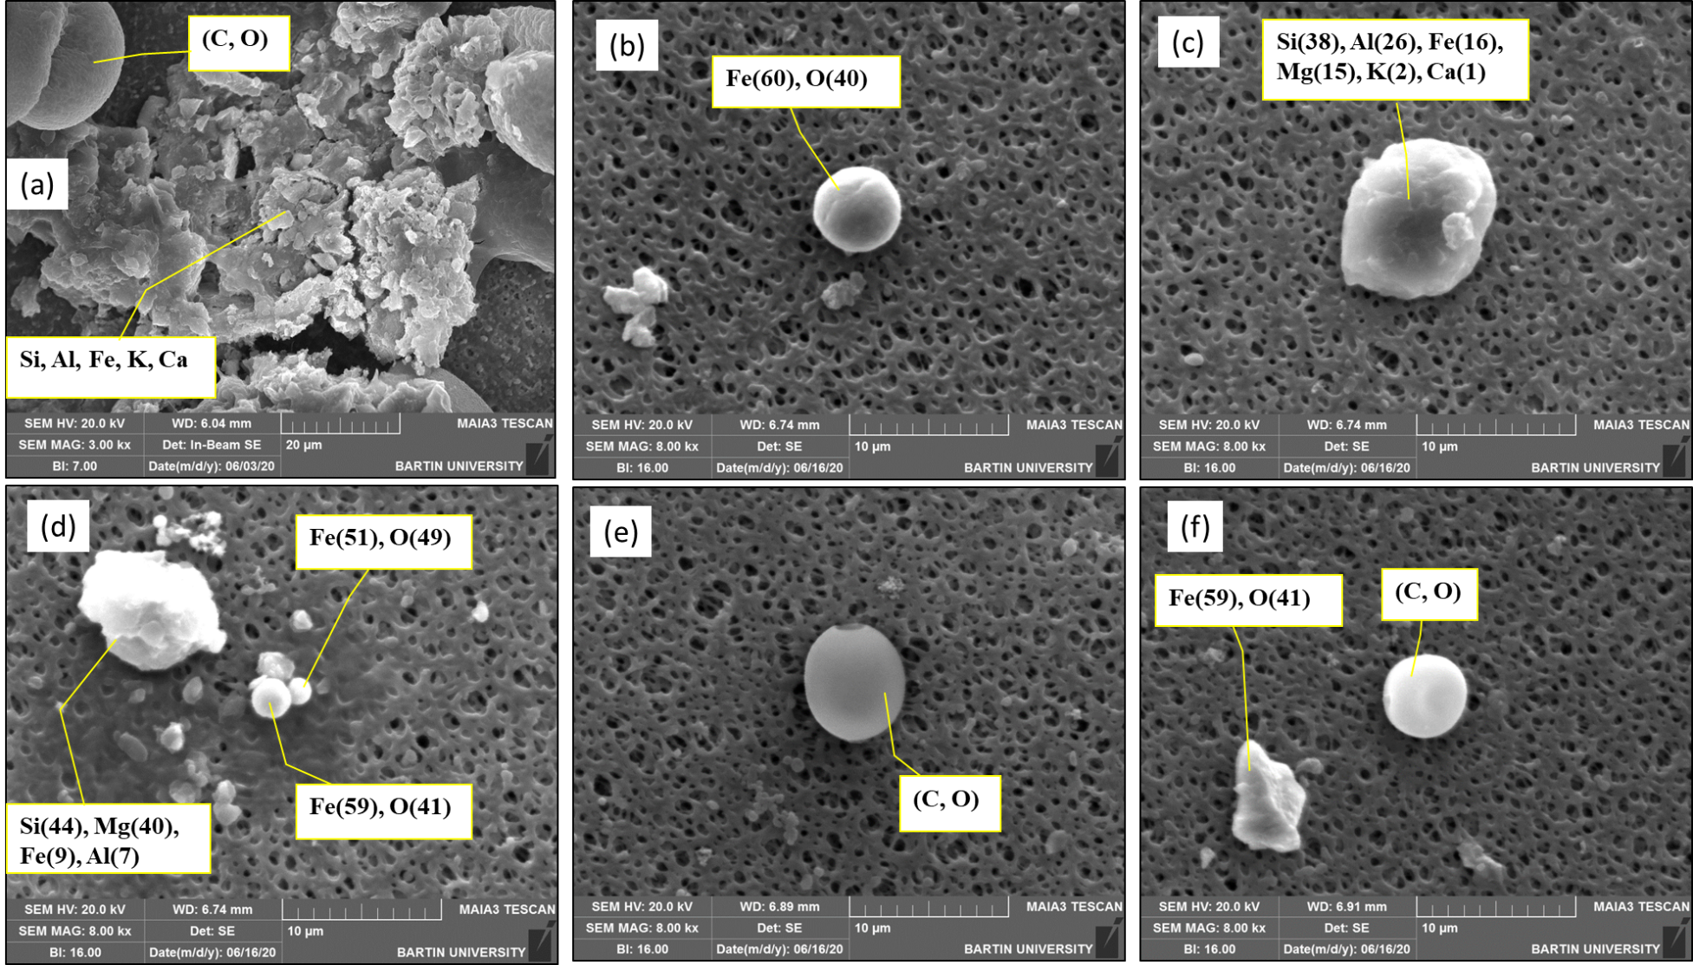
Fig. S3. SEM-EDS results and morphologies of PMs from the first sequential samples of rainfall events 1 and 7. Numbers in the parenthesis following the elements show atomic percentages. (a) a pollen grain (top-left) and earth crust materials (1-1), (b) a spherule of iron oxide having a diameter of 5.2 µm (7-1), (c) a silicate mineral of Fe, Al and Mg (7-1), (d) a silicate mineral with similar composition in (c) and iron oxide spherules (7-1), (e) grain of a pollen (7-1), (f) triangular pyramidal iron oxide particle and an spherical organic particle (7-1) (Makonese et al., 2019).
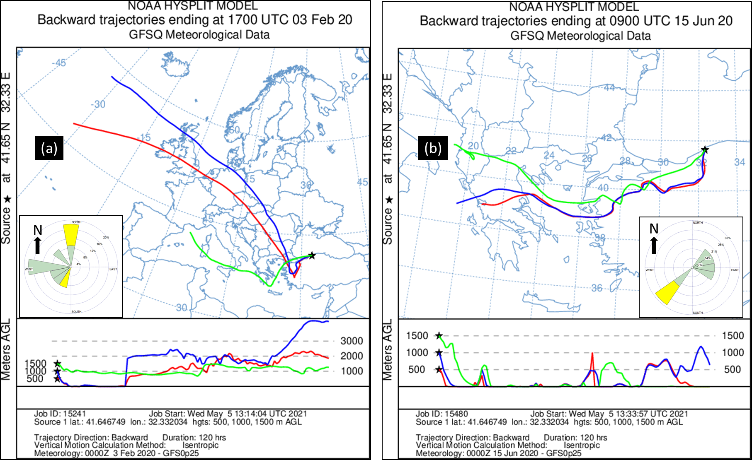
Fig S4. Upper atmospheric backtrajectories icluding embedded local windrose plots for the rainfall events 5 (a) and 8 (b)
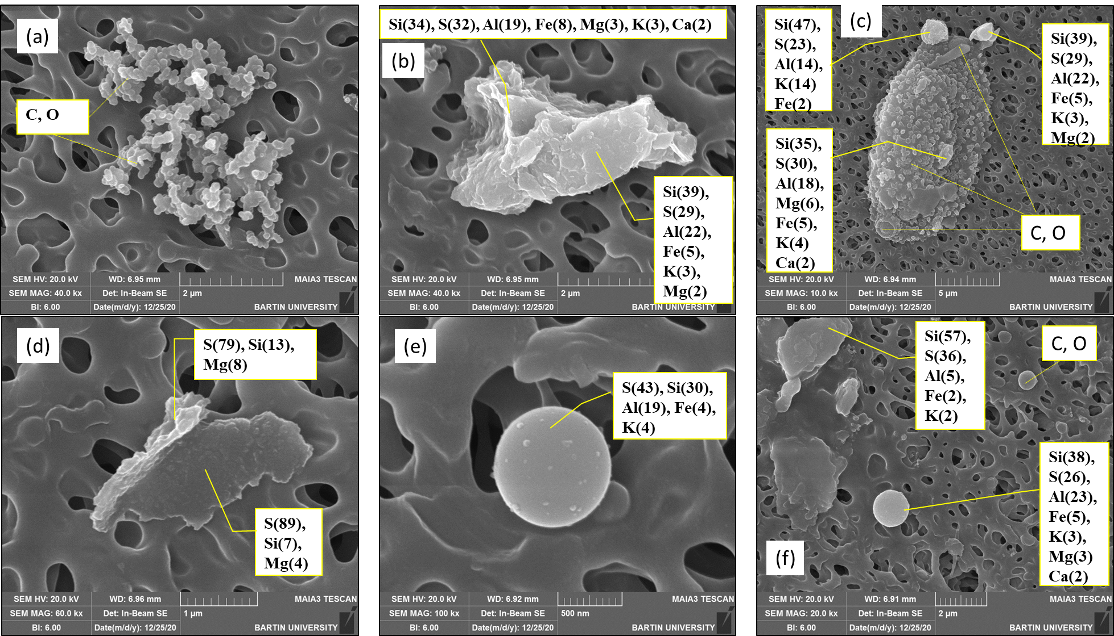
Fig. S5. SEM-EDS results and morphologies of PMs from the second sequential sample of rainfall event 8. Numbers in the parenthesis following the elements show atomic percentages. (a) agglomerated soot particles, (b) sulfurous alumina silicate mineral, (c) fungal spore contaminated with sulfurous alumina silicates, (d)-(f) sulfurous fly ash PMs having spherical and irregular morphologies.
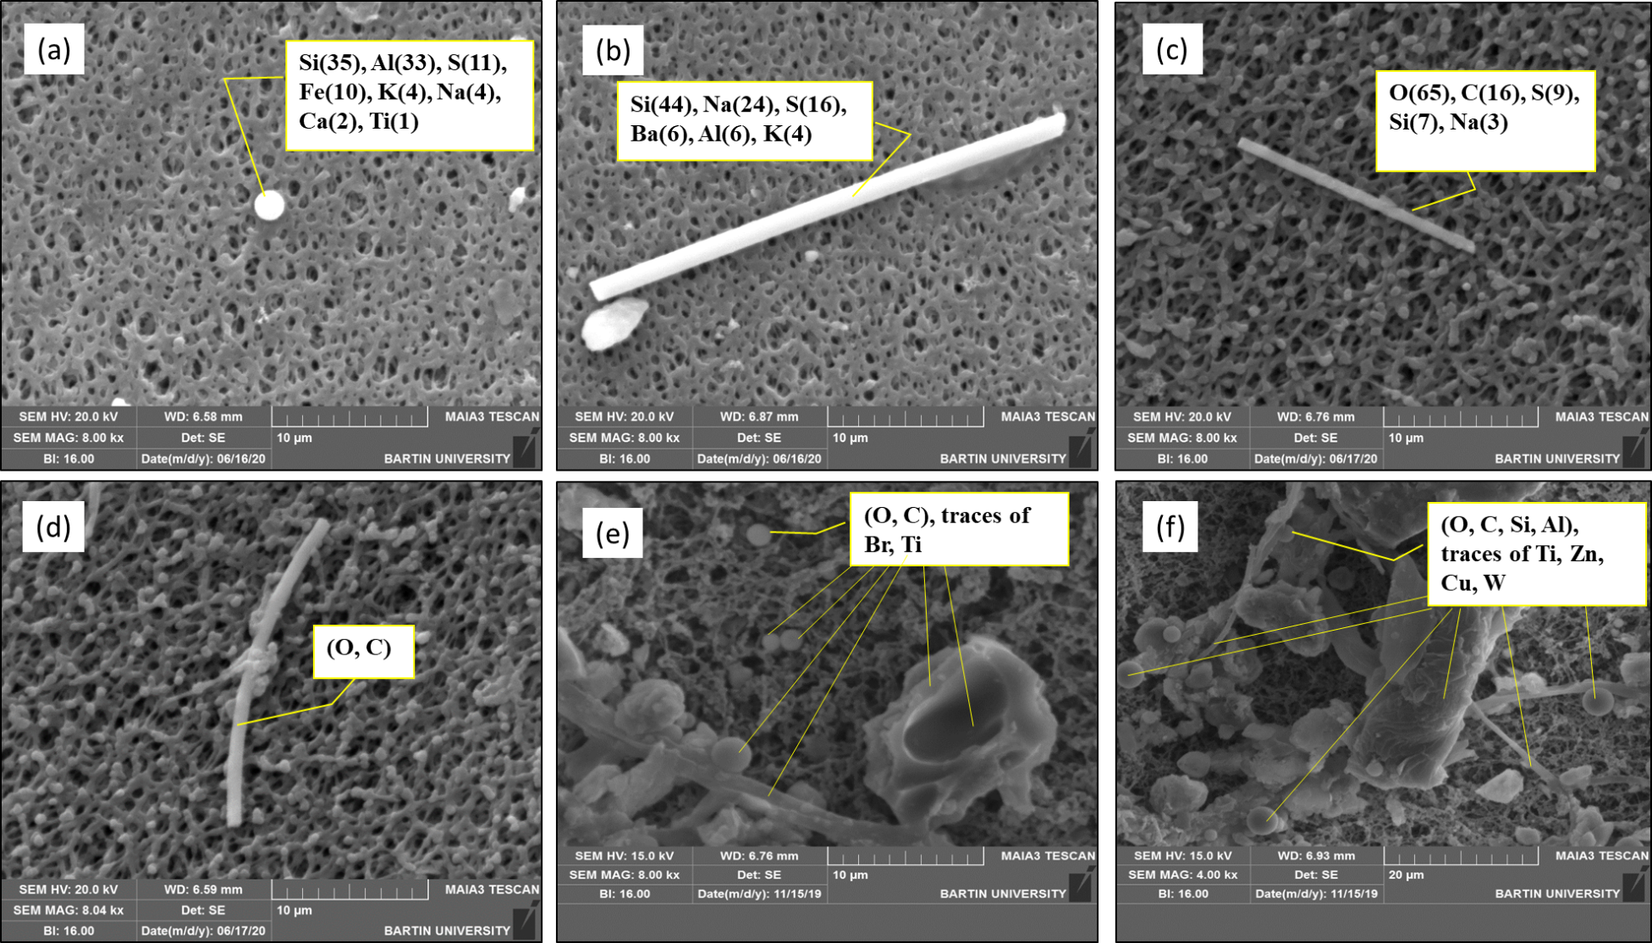
Fig. S6. SEM-EDS results and morphologies of PMs from the second sequential samples of rainfall events 2, 5 and 7. Numbers in the parenthesis following the elements show atomic percentages. (a) fly ash, (b) a silicon fiber with an aspect ratio of 20, (c) and (d) organic fibers having aspect ratios of 17 and 21, respectively, (e) and (f) road dust particles containing both earth crust materials, spherical organic particles and a bird nest shaped organic particle that might be a sintered fly ash (Bakri et al., 2013) from vehicle exhaust emission.

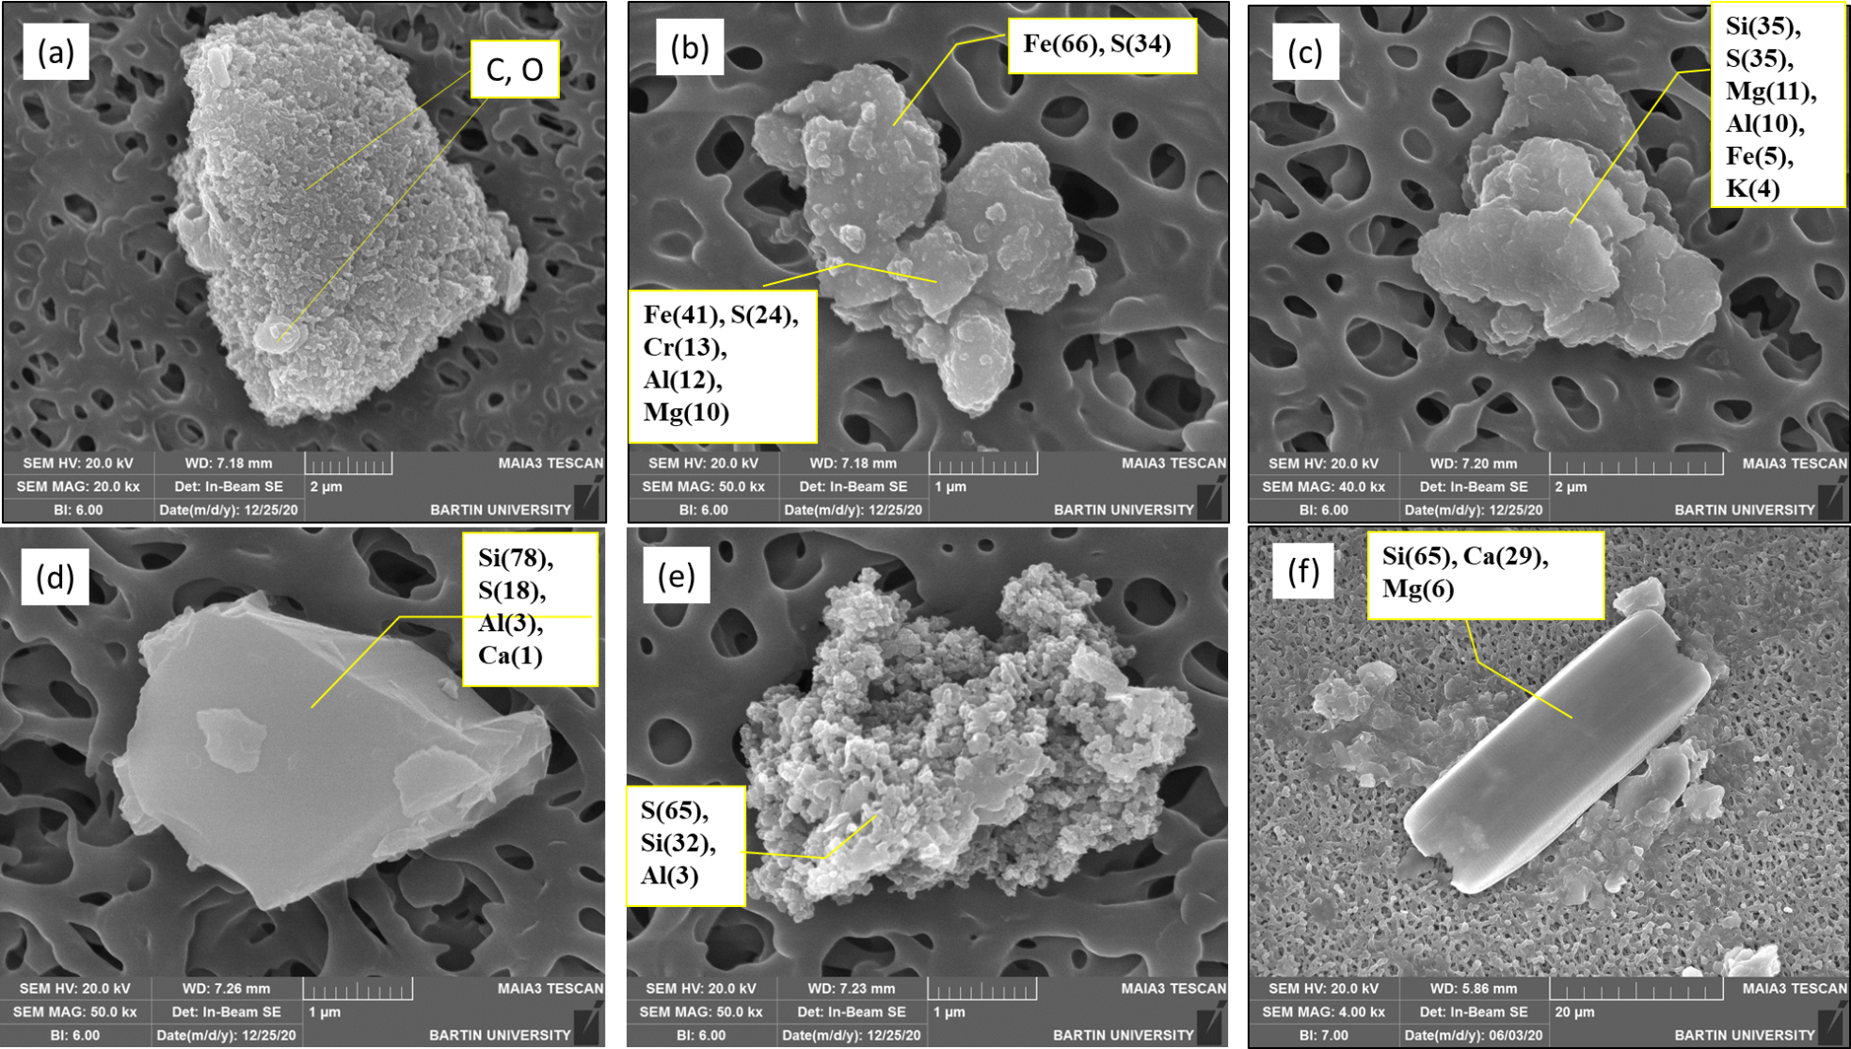
Fig. S7. SEM-EDS results and morphologies of PMs from the third sequential sample of rainfall event 8. Numbers in the parenthesis following the elements show atomic percentages. (a) an unknown carbon particle with a convex pentagonal prism morphology, (b) particles from natural iron ore, (c) sulfurous Mg-Al silicate mineral (fly ash), (d) quartz particle, (e) pristine sulfur, (f) a rectangular prism shaped quartz particle.

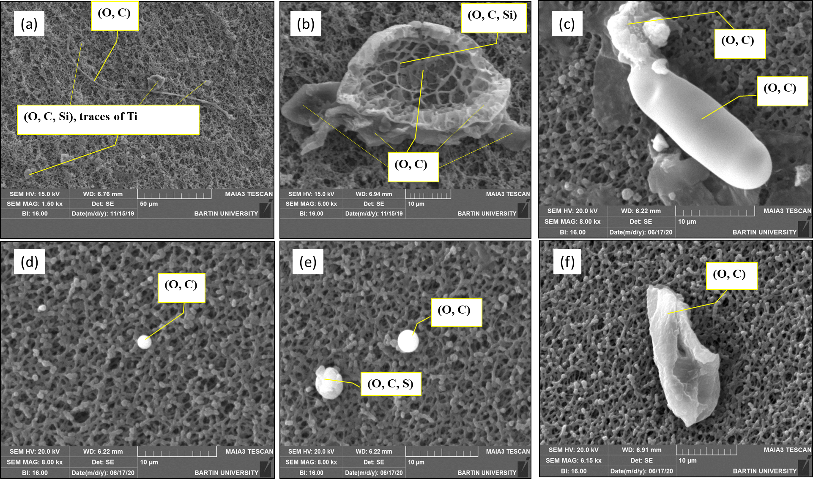
Fig. S8. SEM-EDS results and morphologies of PMs from the fourth and the fifth sequential samples of rainfall events 2, 4 and 7. Numbers in the parenthesis following the elements show atomic percentages. (a) road dust particles and a cellulose or cotton fiber (Kafle et al., 2014) (2-4), (b) biochar particle or an unburnt coal particle (Xing et al., 2019) (2-5), (c) partially deformed microplastic fiber (4-4), (d)-(e) spherical organic particles, most probably soot particles (4-4), (f) a microplastic fragment (7-4).

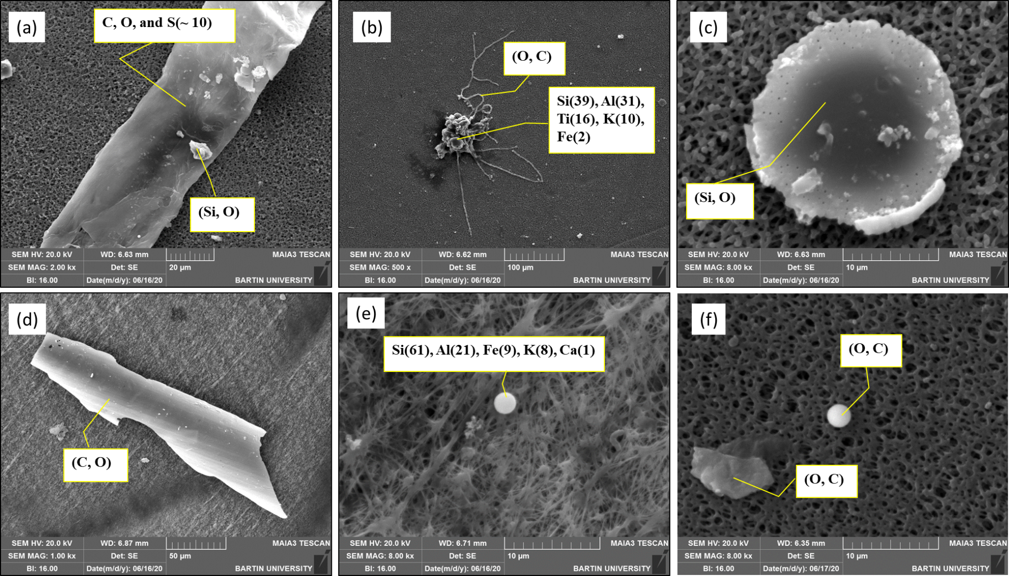
Fig. S9. SEM-EDS results and morphologies of PMs from the sixth, seventh and the eighth sequential samples of rainfall event 7. Numbers in the parenthesis following the elements show atomic percentages. (a) microplastic fiber (7-6), (b) microplastic fibers contaminated with road dust (7-6), (c) silicon dioxide spherule (7-6), (d) microplastic fragment (7-7), (e) fly ash spherule (7-7), (f) spherical soot particle and a fragment of microplastic (7-8).
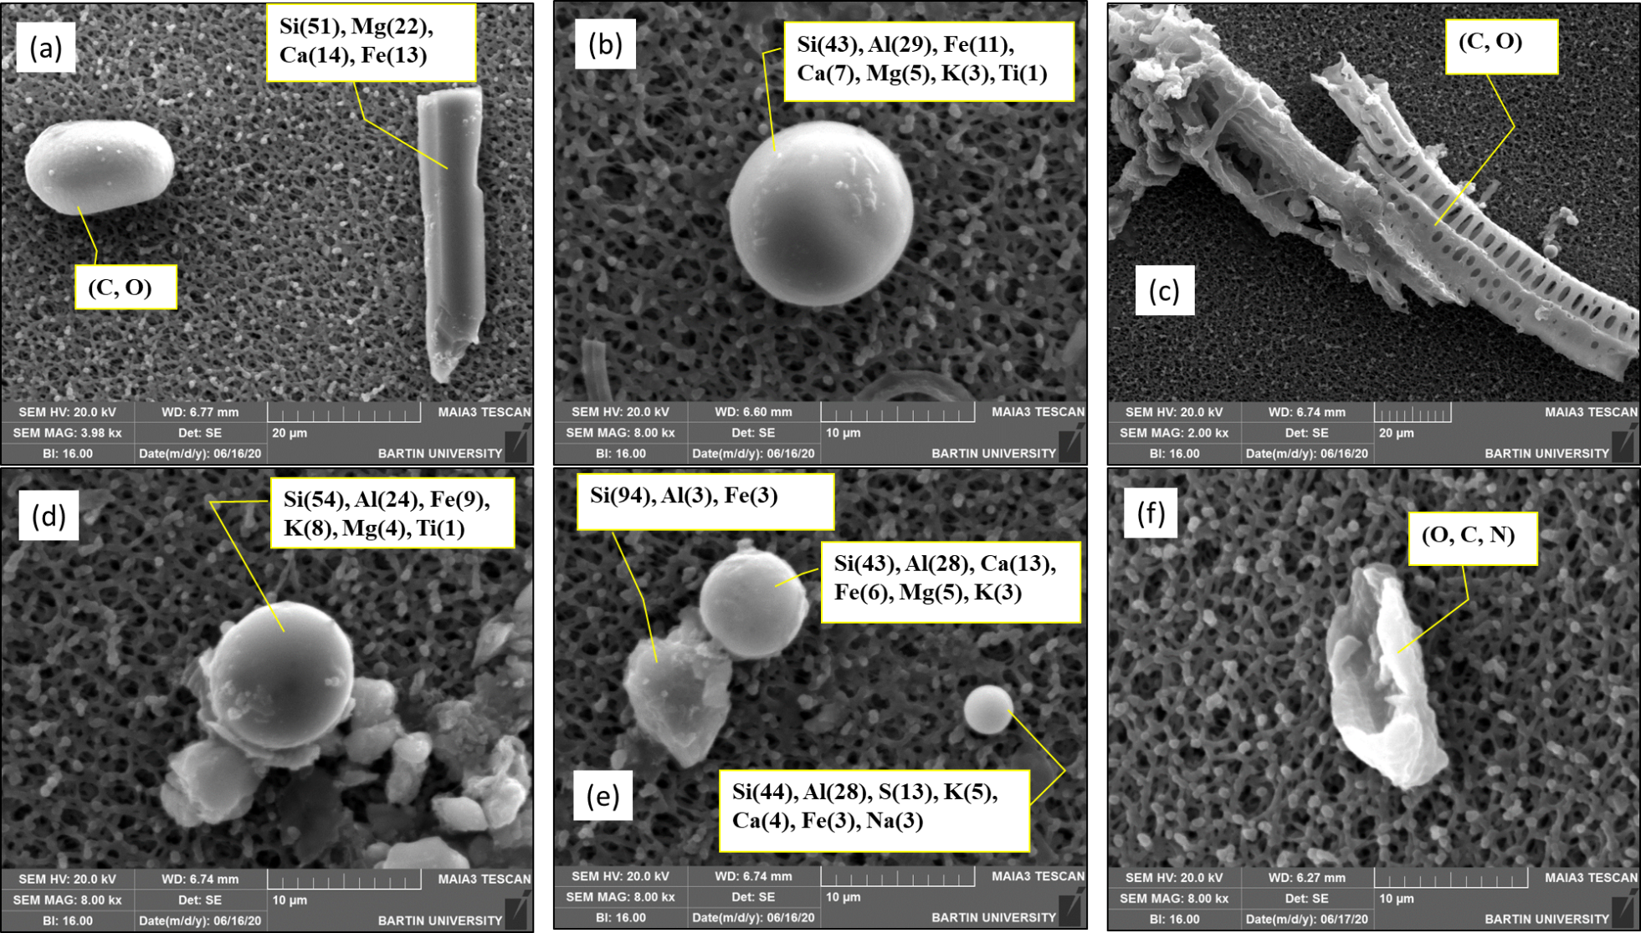
Fig. S10. SEM-EDS results and morphologies of PMs obtained from the ninth to twelfth sequences of rainfall event 7. Numbers in the parenthesis following the elements show atomic percentages. (a) an oval shaped organic particle (most probably a pollen grain) and a mineral fiber of Si-Mg-Ca-Fe, (b), (d), (e) fly ash particles, (c) biochar or charcoal fragment (Ottosen et al., 2005; Peresani et al., 2018) combined with vegetative detritus (5-9), (f) a biopolymer/chitin fragment (7-10).

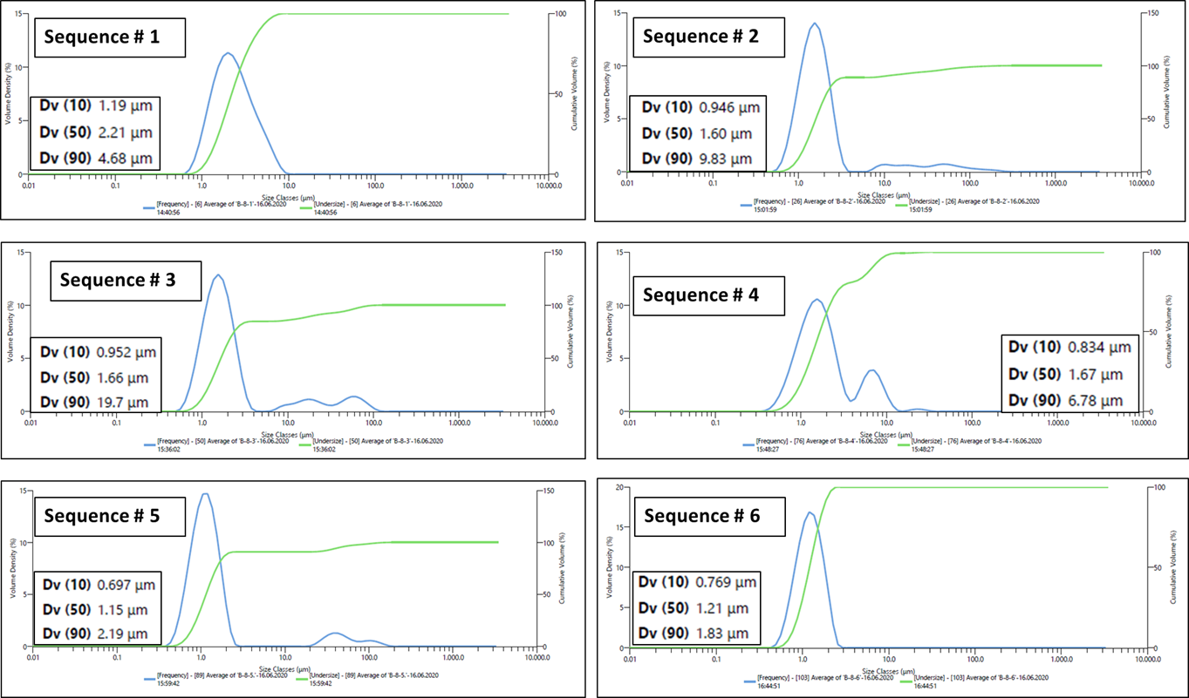
Fig. S11. Particle size distributions in the sequential samples of rainfall event 8.
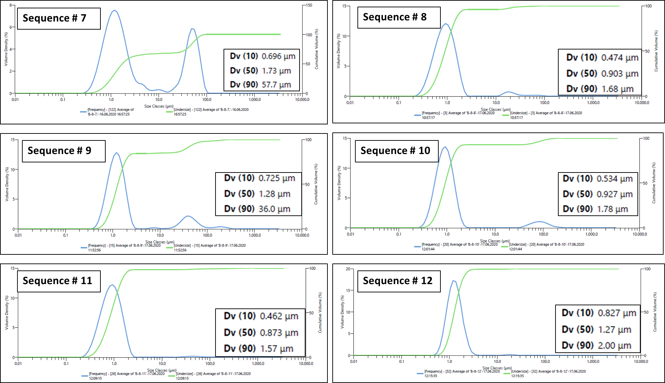
Fig. S11 (Continued).

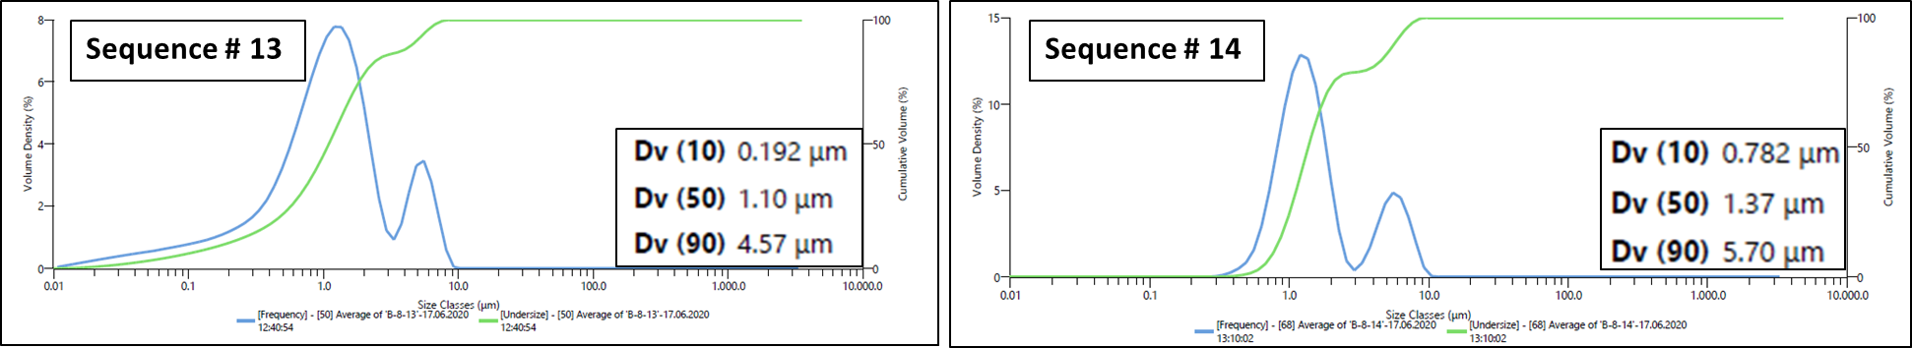
Fig. S11 (Continued).

References
Bakri A M M, Kamarudin H, Nizar I K, Sandu A V, Binhussain M, Zarina Y, & Rafiza A R (2013) Design, processing and characterization of fly ash-based geopolymers for lightweight concrete application. Rev. Chim 64(4):382–387.
Gkoutselis G, Rohrbach S, Harjes J, Obst M, Brachmann A, Horn M A, & Rambold G (2021) Microplastics accumulate fungal pathogens in terrestrial ecosystems. Sci Rep 11(1):1–13. https://doi.org/10.1038/s41598-021-92405-7.
Kafle K, Greeson K, Lee C, & Kim S H (2014) Cellulose polymorphs and physical properties of cotton fabrics processed with commercial textile mills for mercerization and liquid ammonia treatments. Text Res J 84(16):1692–1699. https://doi.org/10.1177/0040517514527379.
Makonese T, Meyer J, & von Solms S (2019) Characteristics of spherical organic particles emitted from fixed-bed residential coal combustion. Atmosphere 10(8):https://doi.org/10.3390/atmos10080441.
Moon J, Kalb P D, Milian L, & Northrup P A (2016) Characterization of a sustainable sulfur polymer concrete using activated fillers. Cem Concr Compos 67:20–29. https://doi.org/10.1016/j.cemconcomp.2015.12.002.
Not F, Valentin K, Romari K, Lovejoy C, Massana R, Töbe K, Vaulot D, & Medlin L K (2007) Picobiliphytes: A marine picoplanktonic algal group with unknown affinities to other eukaryotes. Science, 315(5809):253–255. https://doi.org/10.1126/science.1136264.
Ottosen L M, Pedersen A J, & Christensen I V (2005) Characterization of residues from thermal treatment of treated wood and extraction of Cu, Cr, As and Zn. Wood Sci Technol39(2):87–98. https://doi.org/10.1007/s00226-004-0270-4.
Peresani M, Ravazzi C, Pini R, Margaritora D, Cocilova A, Delpiano D, Bertola S, Castellano L, Fogliazza F, Martino G, Nicosia C, & Simon P (2018) Human settlement and vegetation-climate relationships in the Greenland Stadial 5 at the Piovesello site (Northern Apennines, Italy). Quat Res (United States) 90(3):503–528. https://doi.org/10.1017/qua.2018.76.
Xing Y, Guo F, Xu M, Gui X, Li H, Li G, Xia Y, & Han H (2019) Separation of unburned carbon from coal fly ash: A review. Powder Technol 353:372–384. https://doi.org/10.1016/j.powtec.2019.05.037.

